Manheim Phoenix
201 N 83rd Ave
Tolleson, AZ 85353-3323
(623) 907-7000

VEHICLE DETAILS - 2004 LEXUS RX330
VIN: | 2T2HA31U44C013201 | Body Style: | 4CUV | Top Type: | Sun Roof
Ext Color: | SILVER | Int Color: | GRY | Odometer: | 86,768
Work Order: | 1374099 | Seller: | HUGHES FCU | Received Date: | 01/25/2010
Sale Number: | 8 | Lane Number: | 6 | Run Number: | 45
Inspector: | CERKENBRAC 01/29/2010 | InService Date: | N/A

VEHICLE IMAGES
 |  |  | GRADING
  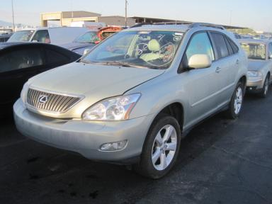 | 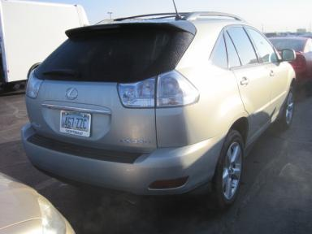
  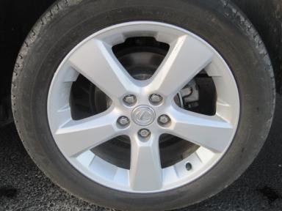 | 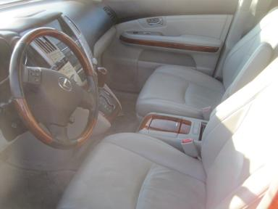
  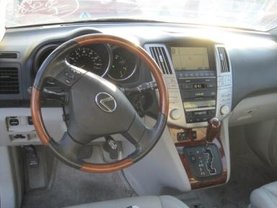 | 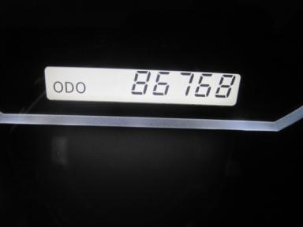
  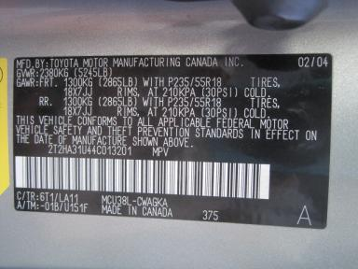
  
  Grade 3.5 Average
  More About Auto Grade
  MSRP - Not Available
  Certified - No
  Drivable - Yes

VEHICLE INFORMATION
OPTIONS
Pwr Locks  Tilt Steering  Tape/CD  50 State Emissions  Tinted Windows  Rear Wiper  NO Third Seat  HomeLink  Telescopic Steering Wheel |  | Pwr Steering  A/C  Side Air Bags  Power Mirrors  4 Door  NO Rear Air Conditioning  5 Passenger Seating  Heated Seats  Navigation System |  | Pwr Windows  Cruise Ctl  Dual Air Bags  Owner's Manual  Fog Lamps  Trip Computer  Floor Mats  Memory Seat |  | Pwr Seats - Both  Rear Defrost  CD Changer - OEM - 6  ABS Brakes  Trip Counter  Luggage Rack  Steering Wheel Audio Control  Woodgrain Interior Package

MECHANICAL | INTERIOR
  6 Cylinder Gas
  Automatic
  AWD
  Pwr Brakes
  3.3 L
  Odometer - 6 Digits Digital - Operable
  Leather - GRY
  Int Odor: OK
  Wood Trim Dash
TIRES AND WHEELS
  Tire Condition: | Average | Wheels: | Alloy
  Tire | Tread Depth | Brand | Size
  Left Front: | 5/32" | MICHELIN | 235/55R18
  Left Rear: | 7/32" | MICHELIN | 235/55R18
  Right Front: | 5/32" | MICHELIN | 235/55R18
  Right Rear: | 7/32" | MICHELIN | 235/55R18
  Spare: | 0/32"
  KEYS
  Master Key - 1
  OTHER
  Title State: AZ
  Title Received Date: 02/01/2010

ADDITIONAL INFORMATION
WET WHEN INSPECTED
Common Abbreviations

DAMAGES - SUGGESTED REPAIRS
Suggested repairs are based on Manheim professional inspector's recommendation.
Total labor hours include paint, body or repair estimates.
 | DESCRIPTION | CONDITION | SEVERITY | SUGGESTED  REPAIR | TOTAL  LABOR  HOURS
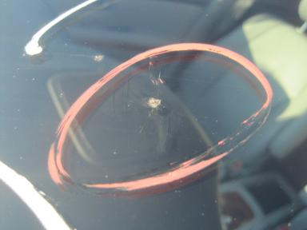 | Windshield | Cracked | 1/2" to 1" | Replace | .00
 | Front Bumper Cover | Scratched | 4" to 5" | Refinish | 3.50
 | LF Fender | Scratched | 1/2" to 1" | Airbrush | .50
 | LF Door | Scratch Light | 2" to 3" | Wet Sand | .50
 | RF Fender | Scratched | 1/2" to 1" | Airbrush | .50
 | RR Door | Mult Dents/No Paint Dmg | PDR/1 | PDR | .00
 | RR Door | Scratched | 3" to 4" | Refinish | 2.80
 | R Qtr Panel | Scratch Light | 3" to 4" | Wet Sand | .50
 | Battery | Dead | Unacceptable | Replace | .20
 |  |  |  | TOTALS | 8.50

VIN: 2T2HA31U44C013201, Work Order: 1374099


© 2010 Manheim

