Manheim Chicago
20401 Cox Ave
Matteson, IL 60443
(815) 806-4222

VEHICLE DETAILS - 2003 LEXUS GX470
VIN: | JTJBT20X830004582 | Body Style: | 4SUV | Top Type: | Pwr Glass Sun Roof
Ext Color: | SILVER | Int Color: | GRY | Odometer: | 96,440
Work Order: | 4323308 | Seller: | MCGRATH LEXUS OF CHICAGO | Received Date: | 02/16/2010
Sale Number: | 8 | Lane Number: | 7 | Run Number: | 121
Inspector: | ESHOYRER 02/19/2010 | InService Date: | N/A

VEHICLE IMAGES
 |  |  | GRADING
  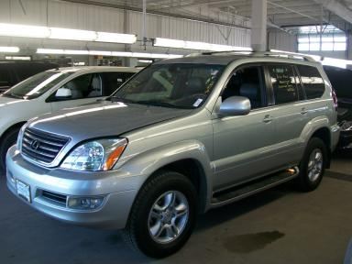 | 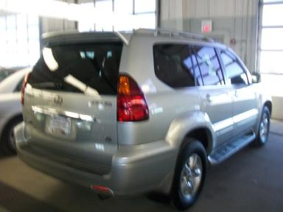
  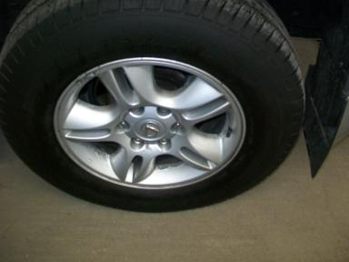 | 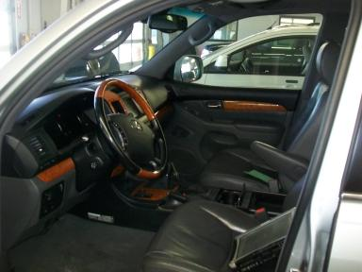
  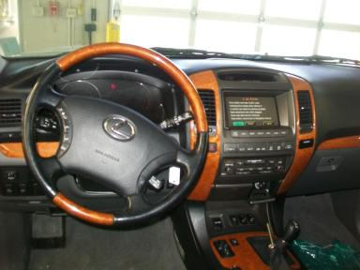 | 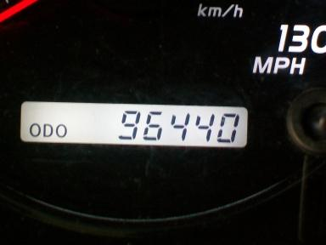
  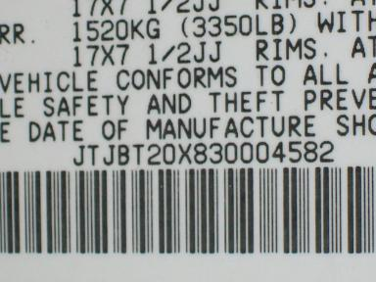
  
  Grade 2.9 Below Average
  More About Auto Grade
  MSRP - Not Available
  Certified - No
  Drivable - Yes

VEHICLE INFORMATION
OPTIONS
Pwr Locks  A/C  Dual Air Bags  Tinted Windows  Rear Air Conditioning  Spoiler  Running Board  HomeLink  Memory Seat  Navigation System |  | Pwr Steering  Cruise Ctl  CD Changer - FACT - 6  4 Door  Rear Wiper  7 Passenger Seating  Steering Wheel Audio Control  Rear Tail/Lift Gate  Woodgrain Interior Package  Ride Control |  | Pwr Windows  Tape/CD  Power Mirrors  Fog Lamps  Third Seat  US EPA Label  Traction Control  Front Center Console  Power Telescopic Steering  Electronic Damping Control |  | Pwr Seats - Both  Side Air Bags  ABS Brakes  Trip Counter  Luggage Rack  Step Bumper  Dual Air Conditioning  Heated Seats  Power Tilt Steering  Rear Radio Controls

MECHANICAL | INTERIOR
  8 Cylinder Gas
  Automatic
  4X4
  Pwr Brakes
  4.7 L
  Odometer - 6 Digits Digital - Operable
  Leather - GRY
  Int Odor: OK
  Wood Trim Dash
  Interior Condition - Average
TIRES AND WHEELS
  Tire Condition: | Good | Wheels: | Alloy
  Tire | Tread Depth | Brand | Size
  Left Front: | 16/32" | DUNLOP | 265/65R17
  Left Rear: | 13/32" | MICHELIN | 265/65R17
  Right Front: | 14/32" | DUNLOP | 265/65R17
  Right Rear: | 16/32" | MICHELIN | 265/65R17
  Spare: | 11/32" | (Mini)
  KEYS
  Combo Key - 1
  OTHER
  Title State:
  Title Received Date: N/A

ADDITIONAL INFORMATION
AG TA,
Common Abbreviations

DAMAGES - SUGGESTED REPAIRS
Suggested repairs are based on Manheim professional inspector's recommendation.
Total labor hours include paint, body or repair estimates.
 | DESCRIPTION | CONDITION | SEVERITY | SUGGESTED  REPAIR | TOTAL  LABOR  HOURS
 | Front Bumper Cover | Chipped | 6 | Included | .00
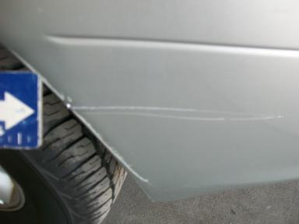 | Front Bumper Cover | Gouged | 4" to 5" | Repair | 6.10
 | Hood | Chipped | 10 or More | Refinish | 3.80
 | Roof | Chipped | 4 | Included | .00
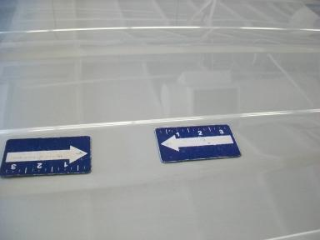 | Roof | Mult Dents/No Paint Dmg | 1" to 2" | Repair | 10.30
 | LF Wheel Opening Mldg | Chipped | 3 | Paint Chip Repair | .00
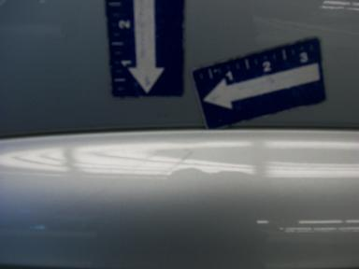 | L Qtr Panel | Dent/Paint Dmg | 1/8" to 1/2" | Repair | 5.60
 | Rear Bumper Cover | Chipped | 5 | Paint Chip Repair | .00
 | Rear Bumper Cover | Mult Scratches/Heavy | 1" to 2" | Included | .00
 | R Bumper Step Pad | Gouged | 1/8" to 1/2" | Repair | 2.00
 | RF Fender | Chipped | 2 | Paint Chip Repair | .00
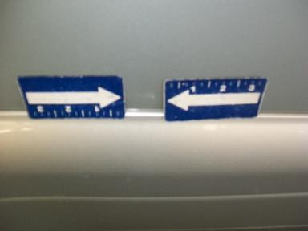 | RR Door | Dent/Paint Dmg | 1/8" to 1/2" | Repair | 5.10
 | R Lug Rack Rail End Cap | Cracked | Replacement Required | Replace | 1.00
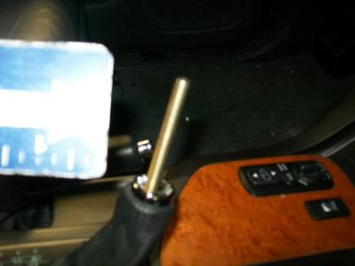 | Shifter Handle | Missing | Replacement Required | Replace | .20
 | Warranty Books | Missing | Replacement Required | Replace | .00
 | Owners manuals | Missing | Replacement Required | Replace | .00
 | Oil | Dirty | Unacceptable | Replace | .00
 |  |  |  | TOTALS | 34.10

VIN: JTJBT20X830004582, Work Order: 4323308



