Manheim Imperial Florida
3300 County Line Rd
Lakeland, FL 33811
(863) 607-6000

VEHICLE DETAILS - 2003 TOYOTA 4 RUNNER 4X4 SR5
VIN: | JTEBU14RX30013897 | Body Style: | 4SUV | Top Type: | Sun Roof
Ext Color: | GREEN | Int Color: | TAN | Odometer: | 115,066
Work Order: | 321182 | Seller: | WESTFALL AUTO SALES | Received Date: | 03/01/2010
Sale Number: | 10 | Lane Number: | 6 | Run Number: | 15
Inspector: | DHELMS 03/01/2010 | InService Date: | N/A

VEHICLE IMAGES
 |  |  | GRADING
  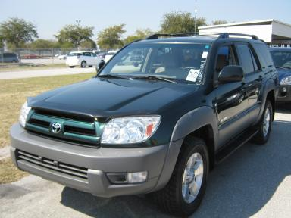 | 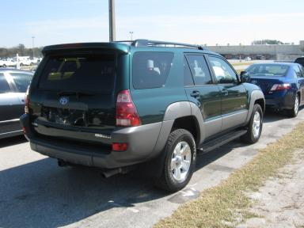
  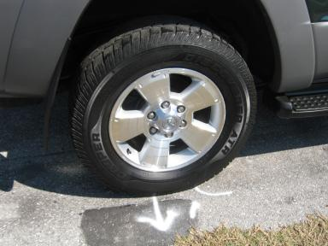 | 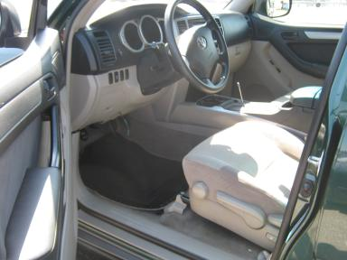
  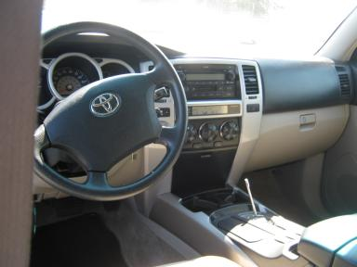 | 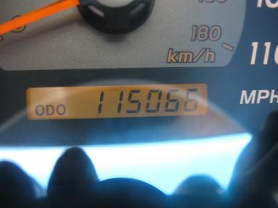
  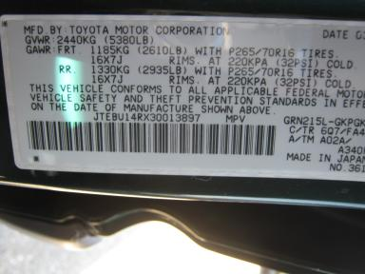 | 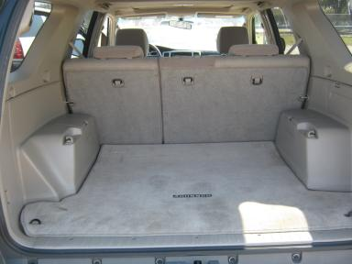
  
  Grade 4.5 Clean
  More About Auto Grade
  MSRP - Not Available
  Certified - No
  Drivable - Yes

VEHICLE INFORMATION
OPTIONS
Pwr Locks  A/C  Dual Air Bags  ABS Brakes  NO Rear Air Conditioning  Spoiler  Running Board  Trailer Plug |  | Pwr Steering  Cruise Ctl  50 State Emissions  4 Door  Luggage Rack  US EPA Label  Trailer Hitch - Bolt On  Power Rear Sliding Glass |  | Pwr Windows  Rear Defrost  Power Mirrors  Trip Counter  NO Third Seat  Security System  Traction Control |  | Tilt Steering  Tape/CD  Owner's Manual  Rear Wiper  5 Passenger Seating  Step Bumper  Bug Deflector

MECHANICAL | INTERIOR
  6 Cylinder Gas
  Automatic w O/D
  4X4
  Pwr Brakes
  4.0 L
  Odometer - 6 Digits Digital - Operable
  Cloth - TAN
  Regular Dash
  Int Odor: OK
  Interior Condition - Average
TIRES AND WHEELS
  Tire Condition: | Average | Wheels: | Alloy
  Tire | Tread Depth | Brand | Size
  Left Front: | 5/32" | COOPER | 265/65R17
  Left Rear: | 5/32" | COOPER | 265/65R17
  Right Front: | 5/32" | COOPER | 265/65R17
  Right Rear: | 5/32" | COOPER | 265/65R17
  Spare: | 11/32" | DUNLOP | 265/65R17
  KEYS
  Master Key - 1
  OTHER
  Title State: WI
  Title Received Date: 03/02/2010

ADDITIONAL INFORMATION
SHIFT KNOB IN VEH REG 100K,
Common Abbreviations

DAMAGES - SUGGESTED REPAIRS
Suggested repairs are based on Manheim professional inspector's recommendation.
Total labor hours include paint, body or repair estimates.
 | DESCRIPTION | CONDITION | SEVERITY | SUGGESTED  REPAIR | TOTAL  LABOR  HOURS
 | Hood | Chipped | 7 | Paint Chip Repair | .00
 | Roof | Chipped | 5 | Paint Chip Repair | .00
 | LF Fender | Dent/No Paint Dmg | PDR/1 | PDR | .00
 | LF Door | Chipped | 2 | Paint Chip Repair | .00
 | Rear Door | Mult Scratches/Heavy | 3 | Touch Up | .00
 | RF Fender | Chipped | 7 | Paint Chip Repair | .00
 | RR Door | Chipped | 4 | Paint Chip Repair | .00
 | R Qtr Panel | Chipped | 3 | Paint Chip Repair | .00
 |  |  |  | TOTALS | .00

VIN: JTEBU14RX30013897, Work Order: 321182

