2001 LEXUS RX300 - GREY
VIN: JTJHF10U410189888 Work Order: 3513217
Manheim Kansas City 3901 N Skiles Ave
Kansas City, MO 64161
(816) 452-4084

VIN:
  JTJHF10U410189888
  Body Style: | 4CUV - Sun Roof
  Ext Color/Code: | GREY
  Int Color/Code: | TAN
  Odometer: | 127,766
  ECM Mileage:
  Seller: | LEXUS FINANCIAL SERVICES/TORRANCE
  Title State: | MO
  Certified: | No
  Condition/Grade: | 3.0, Average
  Sale: | 9
  Lane: | 1
  Run: | 69
  Inspection: | GHOLCOMB 08/31/2009
  Drivable: | Yes
  MSRP: | $0
  Factory Category: | R
  InService Date: | N/A
  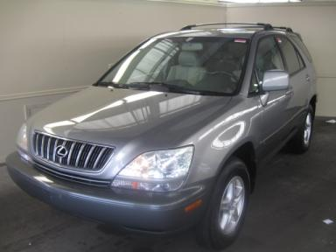 | 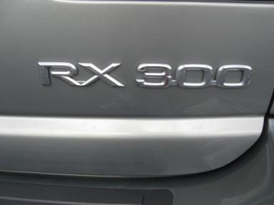
  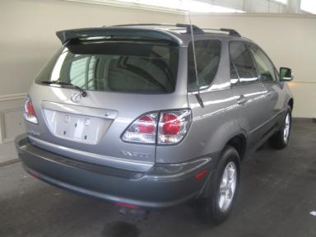 | 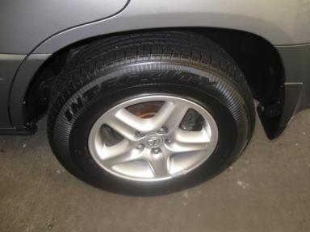
  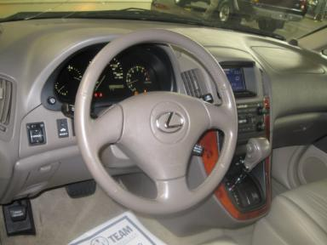 | 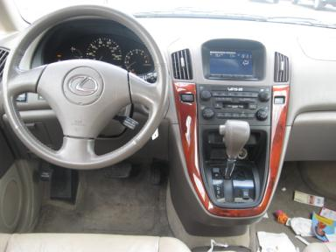
  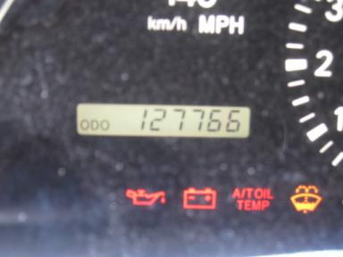 | 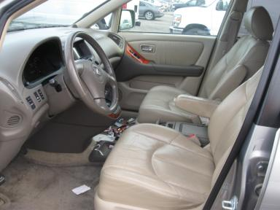
  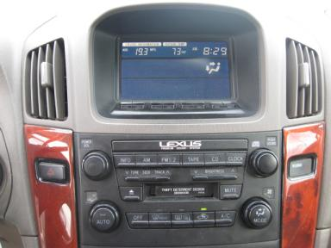 | 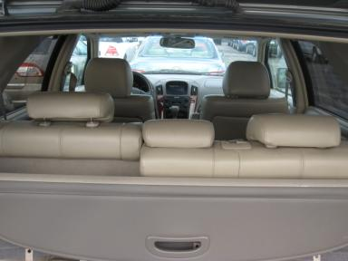

VEHICLE INFORMATION
  MECHANICAL
  6 Cylinder Gas
  Automatic
  AWD
  Pwr Brakes
  3.0 L
  INTERIOR
  Odometer - 6 Digits Digital Operable
  Leather - TAN
  Regular Dash
  OPTIONS
  Pwr Locks  Pwr Windows  Tilt Steering  Cruise Ctl  Tape/CD  Power Mirrors  ABS Brakes  4 Door  Rear Wiper  Trip Computer  NO Third Seat  Security System  HomeLink  Memory Seat |  | Pwr Steering  Pwr Seats - Drivers Only  A/C  Rear Defrost  Dual Air Bags  Heated Mirrors  Tinted Windows  Fog Lamps  NO Rear Air Conditioning  Luggage Rack  Spoiler  Traction Control  Cargo Cover
FLUID LEVELS
Fuel Level: Unknown

  TIRES AND WHEELS
  Tire | Tread Depth | Brand | Size
  Left Front: | 6/32" | GOODYEAR | 225/70R16
  Left Rear: | 6/32" | GOODYEAR | 225/70R16
  Right Front: | 6/32" | GOODYEAR | 225/70R16
  Right Rear: | 6/32" | GOODYEAR | 225/70R16
  Spare: | 9/32" | BRIDGESTONE
  Tire Condition: Good
  Wheels: Alloy
  KEYS
  Combo Key - 1
  OTHER

ANNOUNCED CONDITION: AS IS, Shift Knob Present Buyer Fee includes a $10 TFS/LFS Administrative Fee.
INTERNET REMARKS:
REMARKS/ADDITIONAL DAMAGE:
DISCLOSURES:
NOTES TO CONSIGNOR:
REMARKS:
COMMENTS FOR CONSIGNOR:

2001 LEXUS RX300 - GREY
VIN: JTJHF10U410189888 Work Order: 3513217
Manheim Kansas City 3901 N Skiles Ave
Kansas City, MO 64161
(816) 452-4084

DAMAGES
 | DESCRIPTION | CONDITION | SEVERITY | REPAIR  HOURS | PAINT  HOURS | PART  HOURS | TOTAL  HOURS
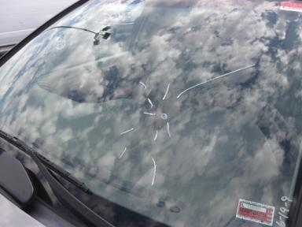 | Windshield | Cracked | Replacement Required | .00 | .00 | .00 | .00
 | LF Door | Dent/No Paint Dmg | PDR/2 | .00 | .00 | .00 | .00
 | LR Door | Dent/No Paint Dmg | PDR/3 | .00 | .00 | .00 | .00
 | RF Door | Dent/No Paint Dmg | PDR/1 | .00 | .00 | .00 | .00
 | RR Door | Dent/No Paint Dmg | PDR/1 | .00 | .00 | .00 | .00
 | R Qtr Panel | Dent/Paint Dmg | Body Damage | 1.00 | 2.80 | .00 | 3.80
 |  |  | TOTALS | 1.00 | 2.80 | .00 | 3.80



