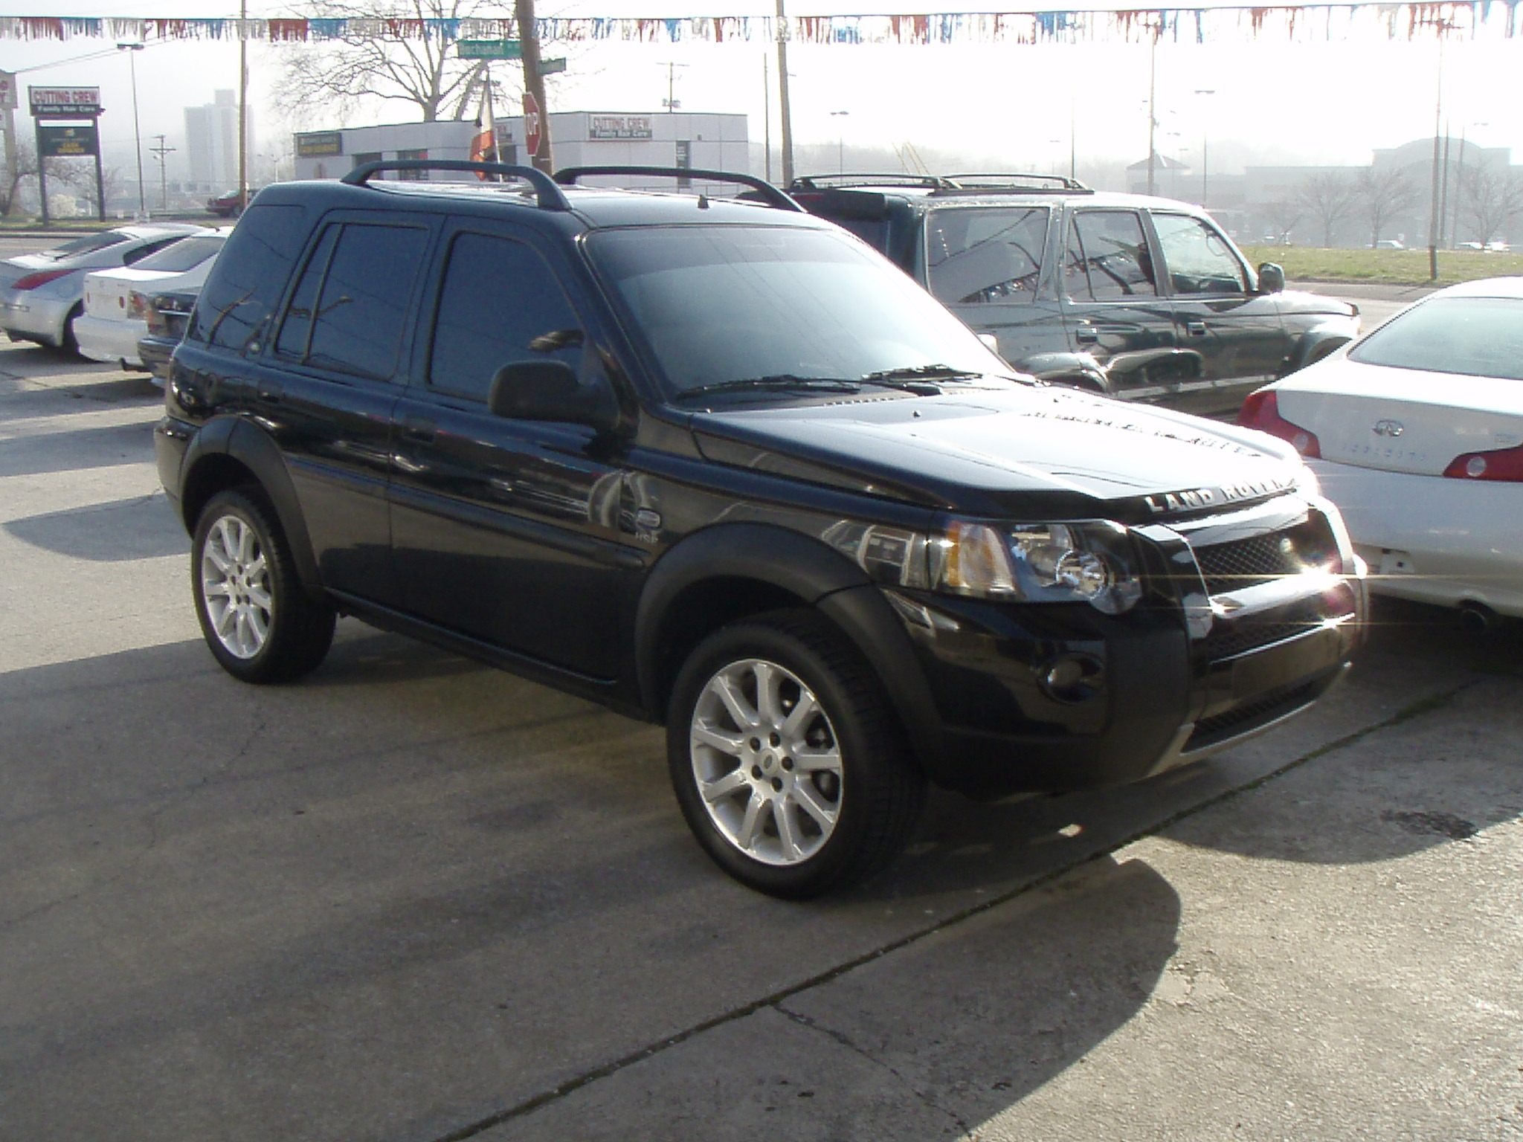

Condition Report
No Condition Report Available

Seller Disclosure
LOCAL NEW CAR TRADE IN, ALL BOOKS, KEYS, AND RECORDS, PERFECT CONDITION, LOADED WITH OPTIONS, MUST SEE !!!!

2004 Land Rover Freelander HSE
Sold Via Sell Now
Mileage: | 67,654
Transmission: | 5 Speed Automatic
Engine: | 2.5 Liter 6 Cylinder
Drive Train: | All-wheel drive
Fuel Used: | Regular Unleaded
Gas Mileage: | 18 mpg city / 21 mpg hwy
Ext Color: | Black
Int Color: | Tan
Interior Type: | Leather
Body Style: | SUV
Doors: | 4 Doors
Top Style: | Sunroof

VIN: | SALNE22234A411564
Title Status: | Clean
Title State: | TN

Vehicle Location | At Dealership  KNOXVILLE, TN
Frame Damage: | Not Specified
Prior Paint: | Not Specified

Equipment
Hide
Equipment Included:
- Air Bag - Side Curtain
- Air Conditioning
- Airbags
- Alloy Wheels
- Antilock Brakes
- Cruise Control
- Power Brakes
- Power Door Locks
- Power Mirrors
- Power Seats
- Power Steering
- Power Windows
- Rear Window Defroster
- Tilt/Telescope Wheel
- Tinted Glass

