**CAMMP Week (10.06 - 15.06): Group 7**

**Problem 1**

**1.1 Introduction**

Our climate is rapidly changing and the global warming becomes an increasingly urgent problem. One of the major contributors for the global warming is the emissions of greenhouse gases, e.g. CO2 and NOx, by power generation and manufacturing industries etc. The development of new, low-emissions power generation technologies becomes significantly important. One such technology is the solid oxide fuel cell (SOFC), which is one of the most efficient and environmental-friendly technologies available for generating power from hydrogen, natural gas, biogas and other renewable fuels. Basically, a SOFC single cell t is composed of a dense electrolyte that is sandwiched by a porous cathode and a porous anode (Fig.1). It requires the fuel, such as hydrogen or natural gas, and oxidant reactants, such as oxygen or air to electrochemically react at high temperature and generate electrical energy.

**O2-**

**O2-**

**O2-**

**Fuel**

**(e.g. H2 or CO or CH4)**

**Excess fuel & H2O, CO2**

**Air**

**(O2)**

**O2-**

**e-**

**e-**

**Cathode**

**Electrolyte**

**Anode**

Figure 1: Working principle of SOFC.

During the operation, oxygen is reduced at the cathode side into oxygen ions that subsequently diffuse through the electrolyte to the anode. The cathode reaction is:

Fuel (e.g. H2, CO or CH4) is fed to the anode, where it is oxidized. Simultaneously, electrons are generated. The electricity is, thus, produced by the flow of electrons in the external circuit. As an example, if H2 is fed to the anode, then the anode reaction is:

Thus, the overall reaction, like combustion, yields water vapor as reaction product:

In this case, the reversible cell potential or the theoretical open circuit voltage, , can be calculated by the Nernst equation:

Where n is the number of electrons (n=4 in this case) that transfers during the reaction (in mole), is the standard reversible cell potential which can be calculated from , F is the Faraday constant (F=96485 C mol-1), is the ideal gas constant (R=8.314 J mol-1 K-1), and is the temperature in K. If the cathode gas is air (i.e. pO2=0.21 bar) and anode gas is 3% H2O humidified hydrogen (i.e. pH2O=0.03 bar and pH2=0.97 bar), then at 800 °C, when H2O(g) is the reaction product, the reversible cell potential of an SOFC single cell is about 1.1 V. The real potential of the cell is reduced when the current is drawn due to the different polarizations. To obtain higher voltage, the SOFC single cells are connected by interconnects in series and constructed into a stack.

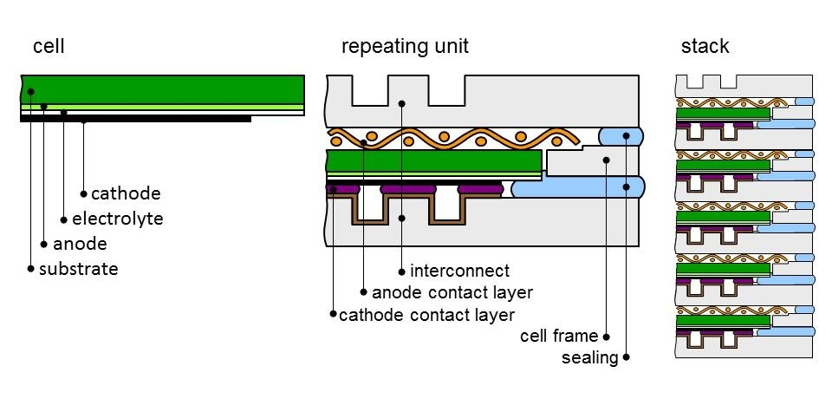

Figure 2: Construction of SOFC stacks.

In SOFC stacks, chromium containing steels, e.g. Crofer® 22 APU, are representative candidates of interconnect materials. During operation, a Cr2O3 containing scale forms on the metallic interconnect and leads to the evaporation of gaseous Cr species (e.g. CrO3 or CrO2(OH)2) from this scale. (La,Sr)(Co,Fe)O3-δ (LSCF) is a state-of-art cathode material. Sr is a reactive element in the LSCF cathode. As shown in Fig. 3, Sr tends to segregate out from the LSCF cathode in the form of SrO and becomes a reaction partner of volatile Cr species. The reaction will produce Sr-Cr-O secondary phases that can block the area for oxygen reduction, and subsequently leads to pronounced performance degradation of the SOFC.

**Interconnect: Cr2O3-forming alloy**

**gaseous Cr species**

**Sr-Cr-O**

**Cathode: (La,Sr)(Co,Fe)O3-δ**

**Electrolyte: 8mol% Y2O3-ZrO2 (8YSZ)**

**Anode: Ni-YSZ**

Figure 3: Cr-poisoning of LSCF cathode.

If the cathode gas is dry air, then CrO3 will be the dominant gaseous Cr species. The possible reactions between the segregated SrO and CrO3(g) are:

If the temperature is fixed as 700 °C, these 4 reactions are dependent on partial pressure of CrO3 (pCrO3) and local oxygen partial pressure (pO2) in the cathode. With the given pCrO3 and pO2, **if SrO reacts with CrO3(g)**, then we **say the cathode is poisoned** by the Cr (Cr-poisoning of LSCF cathode). With the given pCrO3 and pO2, if SrO doesn’t react with CrO3(g), then we say our LSCF cathode is not poisoned.

**1.2 Task**

Based on the given data (**Cr-poisoning.xlsx**), solving the following two classification problems:

1) Whether the cathode is poisoned by Cr or not.

2) Classify different poisoning products.

**Problem 2**

**2.1 Introduction**

Gibbs free energy (G) is one of the thermodynamic potentials. At constant temperature and pressure, the G of a system is the sum of the chemical potential of it constituents. For a system, if we know the **G as a function of composition at various temperature**, then using them, we can construct the phase diagram. Phase diagrams are a concise way to indicate the stable phases in any system. For example, the Fe-C phase diagram (Fig.4). The x-axis is the mass percentage of carbon, the y-axis is the temperature. If the mass percentage of carbon is 0.5% and temperature is 1000 °C, then Austenite (γ-Fe) will be the stable phase.

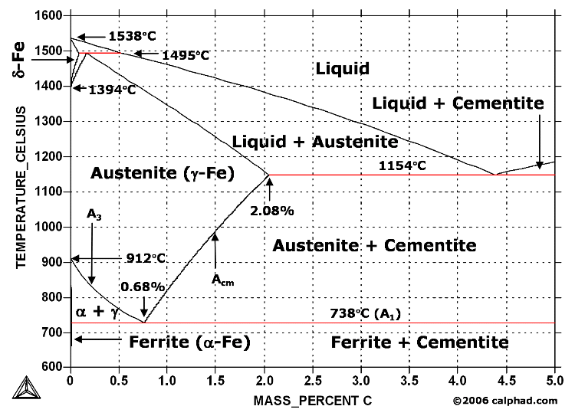

Figure 4: Fe-C phase diagram

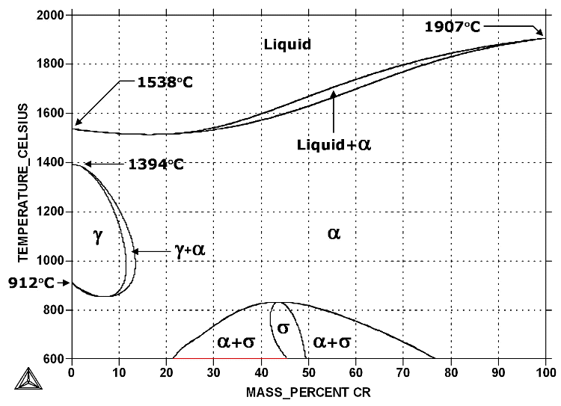

Figure 5: Fe-Cr phase diagram

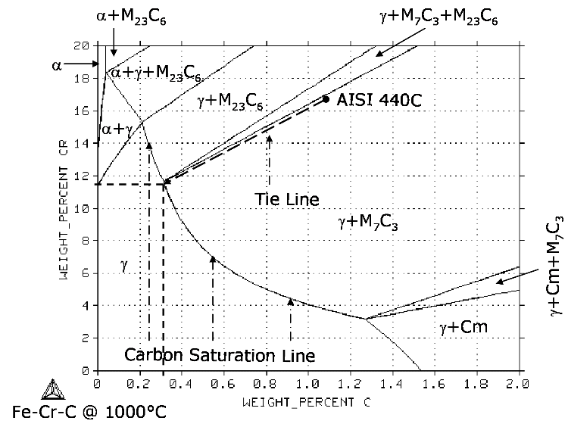

Figure 6: Fe-Cr-C phase diagram at 1000°C

**2.2 Task**

Is it possible to train a machine learning algorithm with the data (wt.-% of C, T and Gibbs free energy) of Fe-C system and the data (wt.-% of Cr, T and Gibbs free energy) of Fe-Cr system, then using the trained model to predict Gibbs free energy of Fe-C-Cr system by given wt.-% of C, wt.-% of Cr and T? (You can find prepared data in **Gibbs energy inference.xlsx**)

**Problem 3 (optional)**

**3.1 Introduction**

**Perovskite oxides** are promising candidates for the **cathode materials** in Solid Oxide Fuel Cells (SOFCs). The chemical formula of a typical perovskite oxide is **ABO3**, where A is the larger cation and B is the smaller cation. The ideal structure of perovskite oxide has a cubic symmetry. It can be viewed either as corner-sharing A-site cations with B-site cations at the center of cubic (Fig. 7a) or corner-sharing BO6 octahedral with A-site cations located in twelve-coordinated interstices (Fig. 7b). For most of the perovskite oxides applied as cathode in SOFCs, the A-site cation is a mixture of rare earth and alkaline earth atoms (such as La and Sr, Ca or Ba), while the B-site cation is a reducible transition metal (such as Mn, Fe, Co, or Ni).

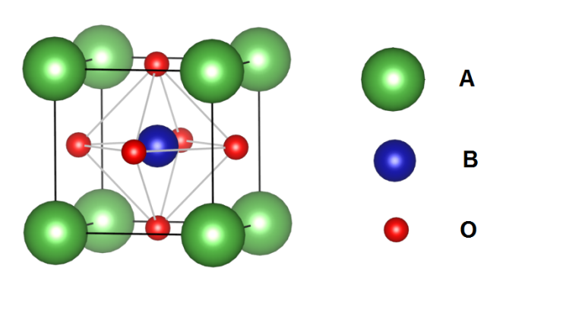 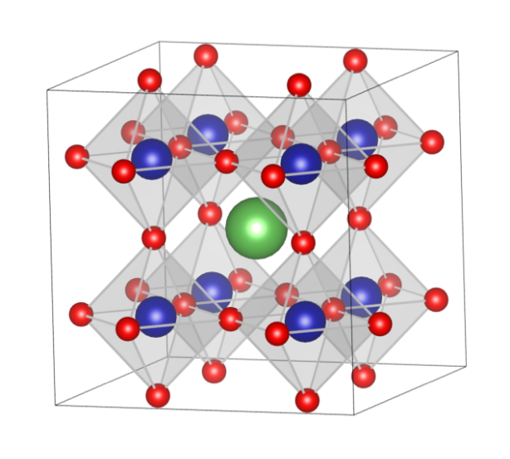

(a) (b)

Figure 7: The cubic perovskite ABO3 with a) B cation at the center of the cell and b) corner-sharing BO6 octahedral with A cation located in 12-coordinated interstices.

In SOFC application, O2 is reduced into O2- at cathode surface (e.g. (La,Sr)(Co,Fe)O3 cathode). Then the O2- will diffuse through the bulk cathode to the electrolyte. The **diffusion of O2- in bulk cathode is dependent on the oxygen vacancies** that generated in bulk cathode. Therefore, to be a potential cathode material, it should be easier to form oxygen vacancy, i.e. **lower oxygen vacancy formation energy** is expected. There are also other requirements for cathode material, e.g. sufficient porosity for rapid diffusion of molecular oxygen, mechanically and chemically compatible with other cell components, and good tolerance towards impurities in the surrounding atmosphere…

**(La,Sr)(Co,Fe)O3-δ (LSCF) perovskite oxide** has sufficient electronic conductivity, high oxygen ionic conductivity, and high catalytic activity for the O2 reduction reaction in temperature range from 600 °C to 800 °C. It is a promising cathode material for intermediate-temperature solid oxide fuel cells (IT-SOFC). **By substituting Sr2+ for La3+ at A-sites** in La(Co,Fe)O3, in order to maintain electronic neutrality, the substitution of Sr ions must be compensated by one or both of the following ways: i) electronic compensation by oxidizing B3+ to B4+ and ii) ionic compensation by formation of oxygen vacancies. The ionic and electronic compensations occur simultaneously and compete with each other. The electro-neutrality condition is expressed as:

(1)

Therefore, LSCF has mixed electronic and ionic conductivity. The oxygen reduction process therefore takes place at the LSCF cathode surface by producing oxygen ions and consuming electrons. The produced oxygen ions are then transported through the bulk LSCF cathode to the electrolyte, while the electrons are supplied from the current-collector.

An appropriate stoichiometry of LSCF should be chosen, to guarantee sufficient ionic and electronic conductivity and to have a matched thermal expansion coefficient (TEC) with the adjacent layers. A higher amount of Sr atoms instead of the trivalent La on A-sites increases the ionic and electronic conductivity and the surface change of oxygen, which can be explained by the larger number of oxygen vacancies and electronic holes. Meanwhile, with increasing of Fe content at the B-sites, the TEC of LSCF is reduced that can be matched with the Y2O3-ZrO2 electrolyte or the gadolinium-doped ceria oxide diffusion barrier layer. The composition La0.6Sr0.4Co0.2Fe0.8O3-δ or the composition with slightly A-site deficiency La0.58Sr0.4Co0.2Fe0.8O3-δ is preferentially applied as the cathode material in SOFCs. La0.6Sr0.4Co0.2Fe0.8O3-δ has the highest electronic conductivity with the peak value of 330 S cm-1 at 550 °C. The TEC of La0.6Sr0.4Co0.2Fe0.8O3-δ in the temperature range from 100 °C to 600 °C is about 15.3*10-6 K-1, which is thermally compatible with the Gd0.9Ce0.1O2-δ diffusion barrier layer (αl = 13.4*10-6 K-1). The stability and durability for LSCF cathode is one of the decisive factors for the SOFC performance. The degradations issues of LSCF cathode (e.g. Cr-poisoning) limits the lifetime and commercialization of SOFC. Therefore, we want to find new potential cathode materials. The potential cathode materials should meet some requirements, e.g. it should have low oxygen vacancy formation energy.

**3.2 Task**

If we know the oxygen vacancy formation energy of AFeO3 perovskite and ACoO3 perovskite (A = element in periodic system), can we make a prediction of the oxygen vacancy formation energy of AxX1-x(Co, Fe)O3 perovskite?

**Hint:**

* You can find some information in the data (**2017 high throughout DFT calculations of formation energy stability and oxygen vacancy formation energy of ABO3 prerovskites.csv**) that generated by *A. A. Emery and C. Wolverton, Scientific Data, 4:170153, 201*.
* You should think about which features variables will be used.
* To validate and test your model, oxygen vacancy formation energies of some AxX1-x(Co, Fe)O3 perovskites are prepared (**E_Vo_dopedPerovskites.xlsx**)