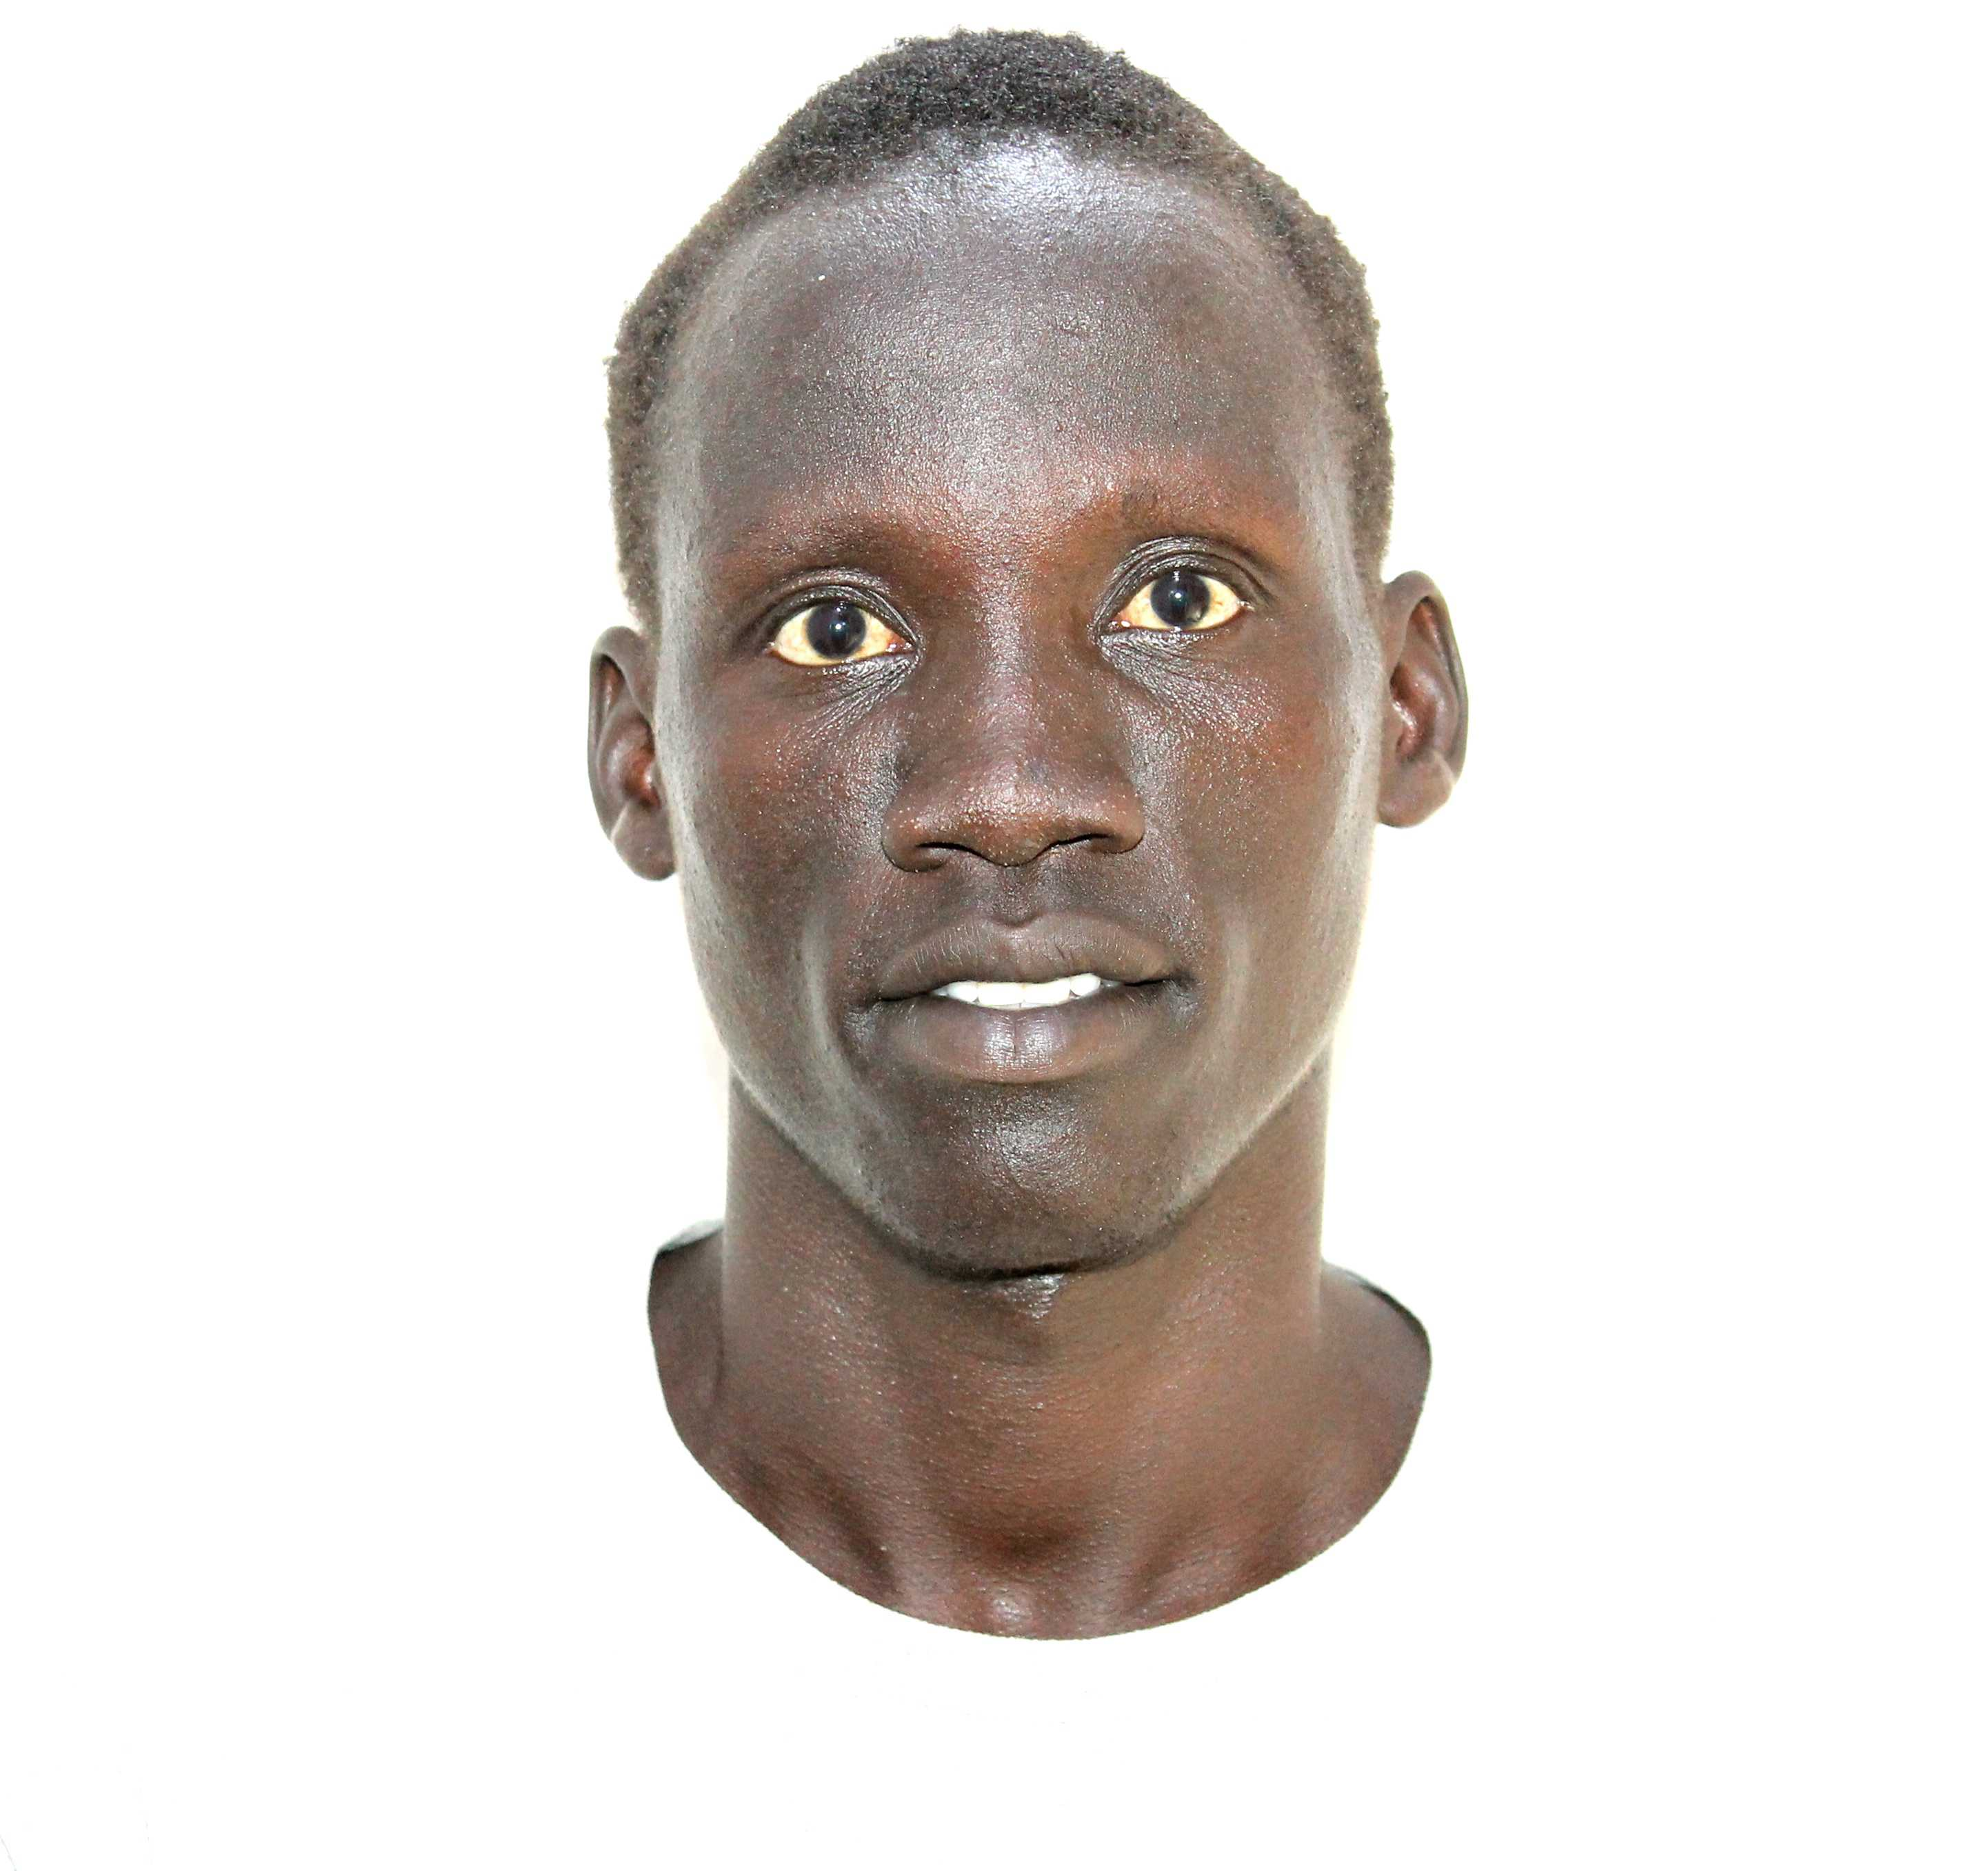

**Name:** Bol Ghak Nhomrom

**Contact:** +254794771671

**Email address:** [**bolghak43@gmail.com**](mailto:bolghak43@gmail.com)

**LinkedIn:** [linkedin.com/in/bol-ghak-2aba95262](https://www.linkedin.com/in/bol-ghak-2aba95262)

**Location:** Kakuma Refugee Camp, Kenya

**Institution:** Action for Refugee Life **(**AReL)

**Report: Environmental Data Analysis for Sustainability Insights**

**Subsection: Demographic Overview - Age Distribution**

The analysis revealed a detailed age distribution among participants in the Kakuma refugee camp. Out of 203 valid responses, the average age was 27.4 years, with a standard deviation of 5.83 years, indicating moderate variation in the age range. The age distribution shows that 25% of respondents were 24 years or younger, while half of the respondents were aged 26 or below. Additionally, 75% of respondents were 31 years or younger. This youthful demographic underscores the importance of tailoring sustainability initiatives to align with the perspectives and energy of a predominantly younger population.

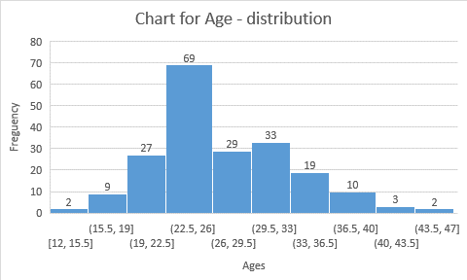

### Gender Distribution in Kakuma Refugee Camp

An analysis of gender distribution among respondents in the Kakuma refugee camp revealed that 55.2% identified as male, while 44.8% identified as female. Out of a total of 203 valid responses, there were 112 males and 91 females.

This relatively balanced gender distribution highlights the need to consider the perspectives and needs of both genders when designing and implementing sustainability initiatives in the camp. Gender-sensitive approaches can help ensure inclusivity and equitable access to resources, fostering a more holistic approach to sustainability.

### Nationality Distribution in Kakuma Refugee Camp

The nationality distribution among respondents in the Kakuma refugee camp reveals a diverse population, with the majority of respondents identifying as Kenyan (43.3%), followed by South Sudanese (37.9%). Other notable nationalities include Sudanese (9.4%), Congolese (7.4%), Somalian (1.5%), and Burundian (0.5%).

This distribution underscores the multicultural environment of the camp, where individuals from various national backgrounds coexist. Understanding the demographic diversity is crucial for tailoring sustainability initiatives to address the unique needs and challenges of each nationality, ensuring inclusive and effective solutions.

### Educational Attainment in Kakuma Refugee Camp

The educational attainment of respondents in the Kakuma refugee camp shows a varied but notable level of education. A significant portion of participants, 39.4%, reported having some college education or an associate degree. Additionally, 30% of respondents have completed high school or its equivalent, while 28.6% hold a bachelor's degree.

A small number of respondents, 1.5%, have obtained a graduate degree (Master's, Doctorate, etc.), while only 0.5% mentioned having a graduate degree in combination with some college education.

These findings highlight a relatively high level of educational attainment within the camp, suggesting that many individuals possess the foundational knowledge and skills that could be leveraged for various sustainability initiatives, provided that opportunities for further education and skill-building are made accessible.

### Residential Area Distribution in Kakuma Refugee Camp

The distribution of respondents by residential area within the Kakuma refugee camp shows diverse settlement patterns. The majority of respondents live in **Kakuma 1** (30.5%), followed by **Kakuma Town** (29.1%), and **Kakuma 2** (19.7%). Smaller populations are found in **Kakuma 3** (10.8%), **Kakuma 4** (5.9%), **Kalobeyie** (3.4%), and **Kakuam 1** (0.5%).

This data reflects the varying population densities across the camp, highlighting areas that may require more focused resources and sustainability efforts. Understanding where people live can help direct targeted interventions to improve environmental and social sustainability in these specific areas.

### Occupation and Field of Expertise in Kakuma Refugee Camp

The occupational distribution among respondents in the Kakuma refugee camp highlights a diverse range of roles. The largest group of respondents (37.9%) identified as students, followed by **teachers** (31.0%) and **facilitators** (28.1%). A smaller portion of the population includes **community leaders** (2.5%) and **student teachers** (0.5%).

This distribution suggests that education plays a central role in the camp, both in terms of those actively learning and those involved in teaching and facilitating education. Understanding these roles is important for designing sustainable programs that leverage local knowledge and expertise, especially in the areas of education and community leadership.

### Concern About Environmental Issues in Kakuma Refugee Camp

The responses regarding concern for environmental issues in the Kakuma refugee camp indicate a varying level of awareness and urgency. Nearly **50%** of respondents (49.8%) expressed being **concerned**, acknowledging the importance of environmental issues such as pollution and climate change and supporting efforts to address them.

Additionally, **27.6%** of respondents stated they are **somewhat concerned**, recognizing the issues but feeling less urgency. A smaller group, **22.2%**, reported being **very concerned**, viewing environmental issues as critical and requiring immediate action. Only **0.5%** of respondents indicated they were **not concerned**, feeling these issues do not significantly impact their lives or community.

This data reflects a general awareness and concern for environmental matters within the camp, with a strong inclination towards support for sustainable initiatives and urgent action. This could guide efforts aimed at raising awareness and taking proactive measures to address local environmental challenges.

### Awareness of Climate Change and Its Impact in Kakuma Refugee Camp

The level of awareness regarding climate change and its impact among respondents in the Kakuma refugee camp varies. A majority of respondents, **57.6%**, feel they are **50% informed** about climate change and its effects. A significant portion, **21.7%**, reported being **90% informed**, indicating a higher degree of awareness.

Smaller groups feel they are **25% informed** (16.7%) or **100% informed** (2.5%), while a very small percentage (1.5%) feel they are only **0.9% informed**.

This distribution suggests that while most individuals have a moderate understanding of climate change, there is room for further education and awareness-building initiatives. Increasing awareness across the camp could improve community engagement and drive more effective action towards climate resilience and sustainability.

### Engagement with Environmental News and Research in Kakuma Refugee Camp

The frequency with which respondents follow news or research on environmental topics shows a mixed level of engagement. The majority, **76.4%**, follow environmental topics **partially**, indicating occasional interest or limited engagement. A smaller proportion, **19.7%**, follow these topics **regularly**, suggesting a higher level of interest and commitment to staying informed.

However, **3.9%** of respondents reported that they do not follow environmental news or research at all, indicating a small segment of the population with little to no engagement on environmental issues.

This data highlights the potential for increasing awareness and engagement around environmental topics, particularly by targeting the **76.4%** who are partially engaged, offering them more accessible and relevant information to foster deeper understanding and action.

### Belief in the Impact of Individual Actions on the Environment in Kakuma Refugee Camp

The overwhelming majority of respondents in the Kakuma refugee camp, **93.6%**, believe that individual actions can **positively impact the environment**. This demonstrates a strong conviction among the population that personal efforts, no matter how small, can contribute to environmental sustainability.

In contrast, a small percentage of respondents, **5.4%**, disagreed with this belief, and just **1.0%** of respondents expressed uncertainty or a nuanced view.

This high level of belief in individual action presents an opportunity to further empower the community with knowledge and tools to act sustainably, fostering a collective commitment to improving the local environment.

### Lifestyle Changes in Response to Environmental Concerns in Kakuma Refugee Camp

In response to environmental concerns, a significant portion of respondents in the Kakuma refugee camp have made lifestyle changes aimed at reducing their environmental impact. The most common change was **recycling practices**, with **46.8%** of respondents adopting this behavior. **Minimizing waste** was another common change, reported by **36.9%** of participants.

A smaller group, **14.8%**, have made efforts to **reduce energy use**, reflecting growing awareness of energy conservation. Only a small number, **0.5%**, reported making a combination of lifestyle changes, including minimizing waste, recycling, and reducing energy use.

These findings suggest a strong inclination towards adopting sustainable practices, particularly in the areas of waste management and recycling. However, there is potential for further promoting energy conservation efforts and other environmentally friendly behaviors.

### Prioritized Sustainability Practices in Daily Life in Kakuma Refugee Camp

Among respondents in the Kakuma refugee camp, **water conservation** is the most prioritized sustainability practice, with **69.0%** of participants focusing on conserving water in their daily lives. This is followed by efforts to **reduce plastic use**, reported by **15.3%**, and **reducing air pollution**, which was prioritized by **14.3%** of respondents.

A small group, **0.5%**, reported combining all three practices—reducing air pollution, plastic use, and conserving water—demonstrating a holistic approach to sustainability.

These results indicate a strong emphasis on water conservation, a key resource in the region, with some attention also given to reducing plastic waste and air pollution. Expanding efforts in these areas could further enhance sustainability in the community.

### Changes in Air and Water Quality in Kakuma Refugee Camp

A vast majority of respondents in the Kakuma refugee camp, **94.1%**, have noticed changes in **air or water quality** in their area over recent years. This indicates widespread awareness of environmental changes affecting the local environment.

In contrast, **4.9%** of respondents have not observed any changes, and a very small proportion, **1.0%**, indicated uncertainty or a nuanced view on the matter.

These findings highlight the significant environmental concerns within the camp, particularly regarding air and water quality, which could be addressed through targeted sustainability initiatives aimed at improving these essential resources.

### Impact of Pollution Levels on Health and Well-being in Kakuma Refugee Camp

The belief that pollution levels in the region have an impact on health and well-being is widespread among respondents in the Kakuma refugee camp. **56.7%** of participants believe that pollution levels primarily affect the **well-being of future generations**, reflecting concerns for long-term environmental sustainability.

A smaller group, **41.9%**, feel that pollution levels directly impact their **health**. Only a few respondents, **1.0%**, believed that pollution affects the **well-being of future generations**, while **0.5%** viewed it as impacting both **health and future generations**.

This data underscores a significant concern about the long-term effects of pollution, highlighting the importance of addressing environmental issues that affect both current and future generations.

### Specific Pollutants and Pollution Sources in Kakuma Refugee Camp

Respondents in the Kakuma refugee camp identified several key pollutants and pollution sources of concern in their area. The most commonly cited concern was **water pollution**, particularly from **heavy metals and pesticides**, with **55.2%** of participants highlighting this as a major issue. **Plastic waste**, including **litter and microplastics**, was the second most identified pollution source, mentioned by **20.7%** of respondents.

Other concerns included **air pollutants** such as particulate matter and nitrogen oxides (**18.7%**), and **soil contamination** from agricultural runoff and hazardous waste (**3.9%**). A very small number of respondents (**0.5%**) were concerned about both **water pollutants** and **plastic waste**.

This data indicates a significant focus on water pollution and plastic waste, with implications for both environmental and public health initiatives in the camp. Addressing these specific concerns could have a substantial impact on improving local sustainability and living conditions.

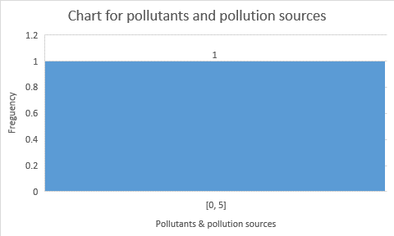

**Changes in Local Weather Patterns in Kakuma Refugee Camp**

A significant majority of respondents in the Kakuma refugee camp, **96.6%**, have noticed changes in **local weather patterns**, such as **hotter summers** and **unpredictable rainfall**. This suggests widespread awareness of climate-related shifts that may be impacting the community's daily life and overall sustainability.

In contrast, a small percentage, **3.4%**, reported that they have not observed any changes in the local weather patterns.

These findings highlight the need for climate adaptation strategies in the camp, as the changes in weather patterns could affect agriculture, water resources, and overall living conditions. Addressing these challenges will be crucial for building resilience to climate variability in the region.

### Support for Climate Initiatives in Kakuma Refugee Camp

The majority of respondents in the Kakuma refugee camp, **59.6%**, expressed strong support for **climate initiatives focused on mitigating extreme weather patterns**, demonstrating a high level of engagement with climate action. Additionally, **38.9%** indicated partial support for such initiatives, suggesting that many are open to or somewhat in favor of efforts to address extreme weather.

A small group, **1.5%**, reported that they would not support these initiatives, reflecting minimal opposition to climate-focused actions.

This overwhelming support for climate initiatives highlights the community's willingness to engage in efforts aimed at mitigating the impacts of extreme weather, which is critical for developing effective climate resilience strategies in the camp.

### Familiarity with the Impact of Climate Change on Biodiversity and Ecosystems in Kakuma Refugee Camp

Respondents in the Kakuma refugee camp show varying levels of familiarity with the impacts of climate change on **biodiversity and natural ecosystems** in their area. The largest group, **46.8%**, reported being **somewhat familiar**, meaning they have a general understanding but not in-depth knowledge of the topic. A significant portion, **32.0%**, indicated they are **very familiar**, possessing a strong understanding of how climate change affects biodiversity and ecosystems.

However, a smaller percentage of respondents were **not very familiar** (20.2%) or **not familiar at all** (1.0%) with the issue.

These findings suggest that while there is a solid base of awareness about the impacts of climate change on local ecosystems, there remains room for further education and engagement to deepen understanding, particularly among those less familiar with the issue.

### Willingness to Provide Data on Personal Environmental Metrics in Kakuma Refugee Camp

The willingness of respondents to provide data on their **energy use** or other **personal environmental metrics** for analysis varies. **46.3%** of participants indicated that they are **willing to provide their data**, reflecting a significant openness to contributing to sustainability efforts.

A substantial portion, **35.5%**, would consider sharing their data **if there are clear benefits to sustainability**, showing a conditional willingness based on the perceived impact. However, **17.2%** of respondents expressed a preference to **not share their data**, while **1.0%** stated they would need more information about how their data will be used before making a decision.

These findings suggest a general openness to participating in sustainability initiatives that involve data sharing, but also highlight the importance of clear communication and ensuring participants understand the benefits and privacy concerns related to data usage.

### Importance of Data Privacy in Environmental Research in Kakuma Refugee Camp

Data privacy is a significant concern for many respondents in the Kakuma refugee camp when it comes to participating in **environmental research**. The largest group, **38.4%**, considers data privacy to be **important**, expressing some concerns but still being open to sharing data under certain conditions. A notable portion, **35.5%**, emphasized that **data privacy is very important**, prioritizing it above all else.

**24.6%** of participants described data privacy as **somewhat important**, indicating they would be willing to share data if certain safeguards are in place. Only **1.5%** of respondents stated that data privacy is **not important** to them in the context of environmental research, showing minimal concern in this regard.

These findings highlight that while there is a general willingness to share data for environmental research, **privacy concerns** are central to many participants' decisions. Ensuring strong data protection measures and clear communication about how data will be used will be essential to gain trust and support for future research initiatives.

### Support for Real-Time Environmental Data Collection in Kakuma Refugee Camp

A significant majority of respondents in the Kakuma refugee camp express support for **collecting more real-time environmental data** if it leads to **improved sustainability measures**. **44.8%** of participants indicated that they **fully support** such initiatives, emphasizing a strong commitment to sustainability efforts.

An additional **43.8%** support real-time data collection, but with the condition that **strict data privacy measures** are implemented, reflecting the importance of protecting personal information in the process.

However, **11.3%** of respondents expressed **neutrality**, stating that they need more information before making a decision.

These results demonstrate a clear majority favoring increased environmental data collection, provided that privacy concerns are adequately addressed. This suggests a readiness among the community to engage in data-driven sustainability efforts, provided transparency and safeguards are in place.