CSCI 4100 Assignment 1

Boliang Yang 661541863

1. Exercise 1.3 in LFD

(a) Since $x(t)$ is misclassified by $w(t)$, then $y\left(t\right)≠sign(w^{T}\left(t\right)x\left(t\right))$. Since the signs of $y\left(t\right)$ and $w^{T}\left(t\right)x(t)$ are opposite, then $y\left(t\right)w^{T}\left(t\right)x\left(t\right)<0$.

(b) By 1.3, we know $w\left(t+1\right)=w\left(t\right)+y\left(t\right)x(t)$. Then,

$y\left(t\right)w^{T}\left(t+1\right)x\left(t\right)=y\left(t\right){\left(w\left(t\right)+y\left(t\right)x\left(t\right)\right)}^{T}x\left(t\right)=y\left(t\right)w^{T}\left(t\right)x\left(t\right)+y\left(t\right){\left(y\left(t\right)x\left(t\right)\right)}^{T}x\left(t\right)=y\left(t\right)w^{T}\left(t\right)x\left(t\right)+y{\left(t\right)}^{2}x^{T}\left(t\right)x\left(t\right)>y\left(t\right)w^{T}\left(t\right)x\left(t\right)+0=y\left(t\right)w^{T}\left(t\right)x\left(t\right)$. Thus, we have $y\left(t\right)w^{T}\left(t+1\right)x\left(t\right)>y\left(t\right)w^{T}\left(t\right)x(t)$.

(c) Since $y\left(t\right)w^{T}\left(t\right)x\left(t\right)<0$ and $y\left(t\right)w^{T}\left(t+1\right)x\left(t\right)>y\left(t\right)w^{T}\left(t\right)x(t)$, then moving from $w\left(t\right)$ to $w\left(t+1\right)$ will help update the $y\left(t\right)w^{T}\left(t\right)x(t)$ larger and become greater than 0 eventually. Therefore, we have $y\left(t\right)w^{T}\left(t\right)x\left(t\right)>0$ and makes the hypothesis $h\left(x\right)=y=sign(w^{T}x)$, then the move from **w**(t) to **w**(t+1) is a move ‘in the right direction’.

2. Exercise 1.5 in LFD

(a) Learning approach. Because we don’t know the relationship between age and whether the particular medical test should be performed. And pretty much that is known in medical field was based on careful trial and error. Thus, in order to know such new medical test, we need to use learning approach.

(b) Design approach. Since we know exactly what a prime or non-prime number is, we can just use design approach to classify them.

(c) Learning approach. Because we don’t know the pattern between potential fraud in credit card charges, we need learning approach to learn from the data.

(d) Design approach. Because we know the pattern involving the falling object, such as the gravity and air resistance, we can use design approach to determine.

(e) Learning approach. The traffic model is complicated and there are no clear specifications for the traffic lights change.

3. Exercise 1.6 in LFD

(a) Supervised learning. This is similar to the Netflix example in class. Training data are the user viewing history including input of the book and the output of user’s rating. We recommend books based on the books viewing history and the rating for each book.

(b) Reinforcement learning. Training data are the previous moves, feedback and state of the game, and our actions. We pick a reasonable move next round based on the feedback and our action.

(c) Unsupervised learning. There are no defined categories for the movies and we want to separate them. Training data are information and details of movies.

(d) Supervised learning. Training data are information of human instruments playing techniques. Then machine can learn to play music as a human would.

(e) Supervised learning. This is similar to credit problem in class. The training data are all the information about the bank customers and their credit limit. We can use the data to find the pattern to set the credit limit.

4. Exercise 1.7 in LFD

(a) Pick the hypothesis that always return black dot. It has 1 target function $f_{8}$ agree with all three points; 3 target functions $f_{4}, f_{6}, f_{7}$ agree with two of them; 3 target functions $f_{2}, f_{3}, f_{5}$ agree with one of them; 1 target function $f_{1}$ agree with none of them.

(b) Pick the hypothesis that always return white dot. It has 1 target function $f_{1}$ agree with all three points; 3 target functions $f_{2}, f_{3}, f_{5}$ agree with two of them; 3 target functions $f_{4}, f_{6}, f_{7}$ agree with one of them; 1 target function $f_{8}$ agree with none of them.

(c) The result would be white dot, white dot, black dot. Then the hypothesis has 1 target function $f_{2}$ agree with all three points; 3 target functions $f_{1}, f_{4}, f_{6}$ agree with two of them; 3 target functions $f_{3}, f_{5}, f_{8}$ agree with one of them; 1 target function $f_{7}$ agree with none of them.

(d) The result disagrees the most with the XOR is black dot, black dot, white dot. Then the hypothesis has 1 target function $f_{7}$ agree with all three points; 3 target functions $f_{3}, f_{5}, f_{8}$ agree with two of them; 3 target functions agree with one of them; 1 target function agree with none of them.

5. Problem 1.1 in LFD

P(both are black) = 0.5

P(first is black) = $0.5×1+0.5×0.5=0.75$

P(second is black | first is black) = =

6. Problem 1.2 in LFD

(a) ${h\left(x\right)=sign(w}^{T}x)=sign\left(\sum_{i=0}^{2}{ω_{i}x_{i}}=ω_{0}+ω_{1}x_{1}+ω_{2}x_{2}\right)$. Then the line separating the regions where $h\left(x\right)=+1$ and $h\left(x\right)=-1$ is $ω_{0}+ω_{1}x_{1}+ω_{2}x_{2}=0$.

We rewrite it as a form of $x_{2}=ax_{1}+b$, then we have $x_{2}=-\frac{ω_{1}}{ω_{2}}x_{1}-\frac{ω_{0}}{ω_{2}}$. Thus, $a=-\frac{ω_{1}}{ω_{2}}$, $b=-\frac{ω_{0}}{ω_{2}}$.

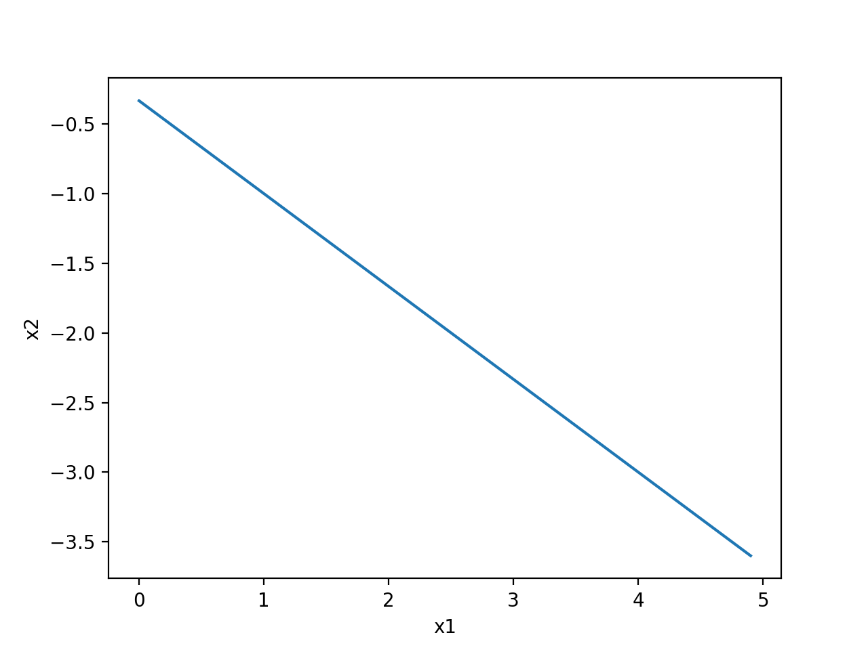 (b) When $w={\left[1,2,3\right]}^{T}, a=-\frac{2}{3}, b=-\frac{1}{3}$.

h(x)=-1

h(x)=1

 When $w={-\left[1,2,3\right]}^{T}, a=-\frac{2}{3}, b=-\frac{1}{3}$.

h(x)=-1

h(x)=1

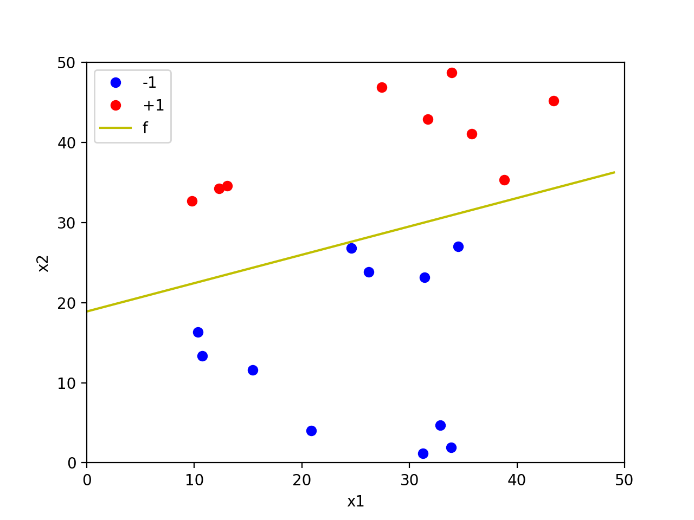7. Problem 1.4 (a – e) in LFD

(a)

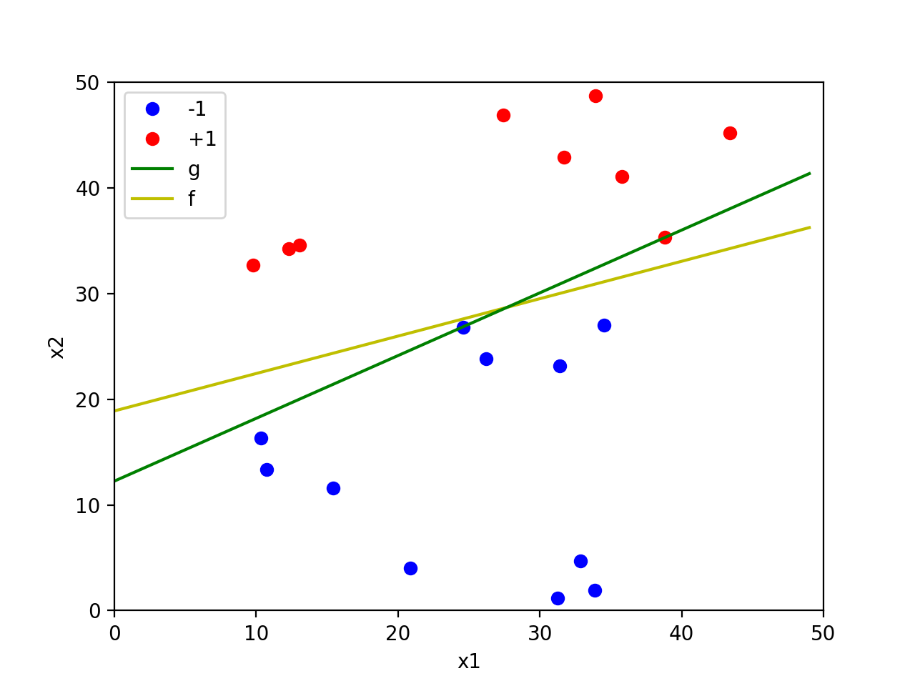

(b)

The number of updates that the algorithm takes before converging is 11864, $f\left(x\right)=0.3541x+18.8955$, $g\left(x\right)=0.5940x+12.2529$. $f$ is not close to $g$ because red and blue points are sparser between the line.

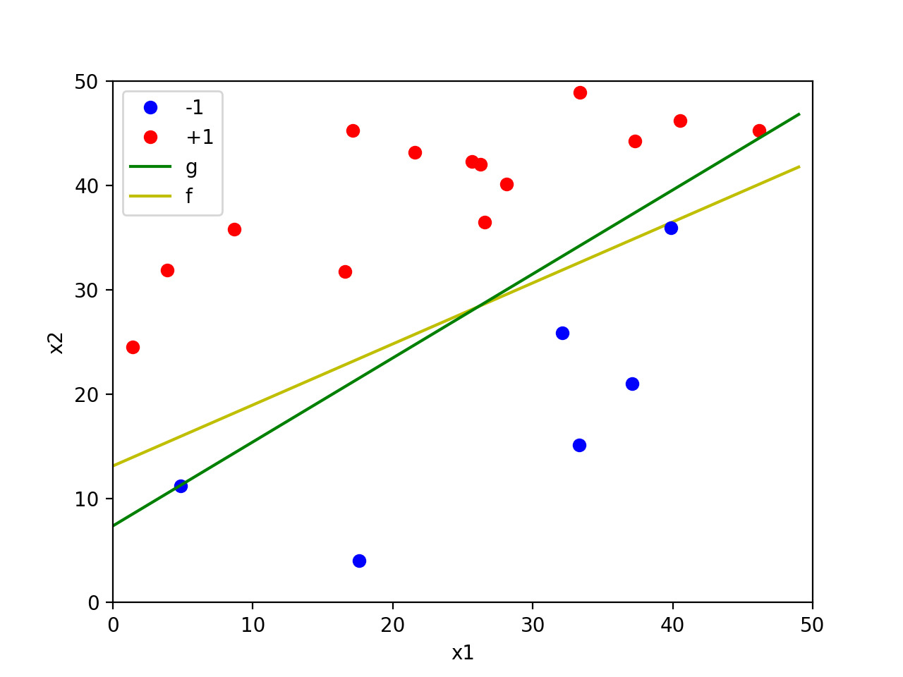(c)

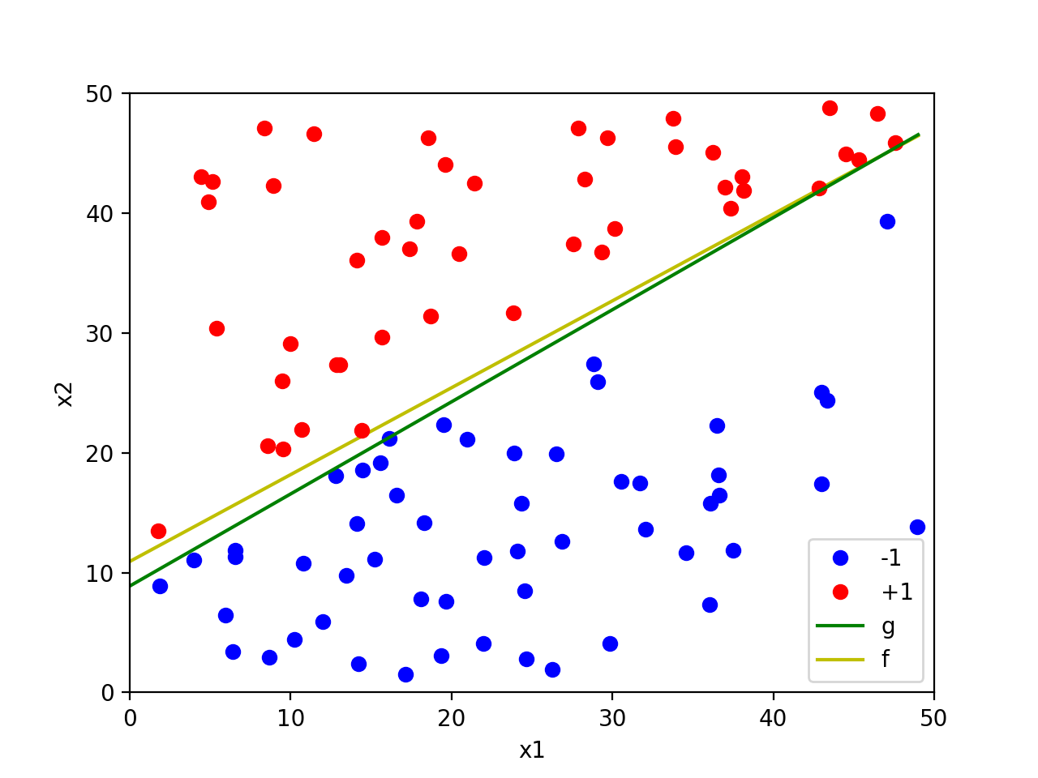The number of updates that the algorithm takes before converging is 2989, $f\left(x\right)=0.5851x+13.1021$, $g\left(x\right)=0.8055x+7.3508$. $f$ is closer to $g$ than in (b).

(d)

The number of updates that the algorithm takes before converging is 3179, $f\left(x\right)=0.7251x+10.9283$, $g\left(x\right)=0.7688x+8.8784$. $f$ is much closer to $g$ than in (b).

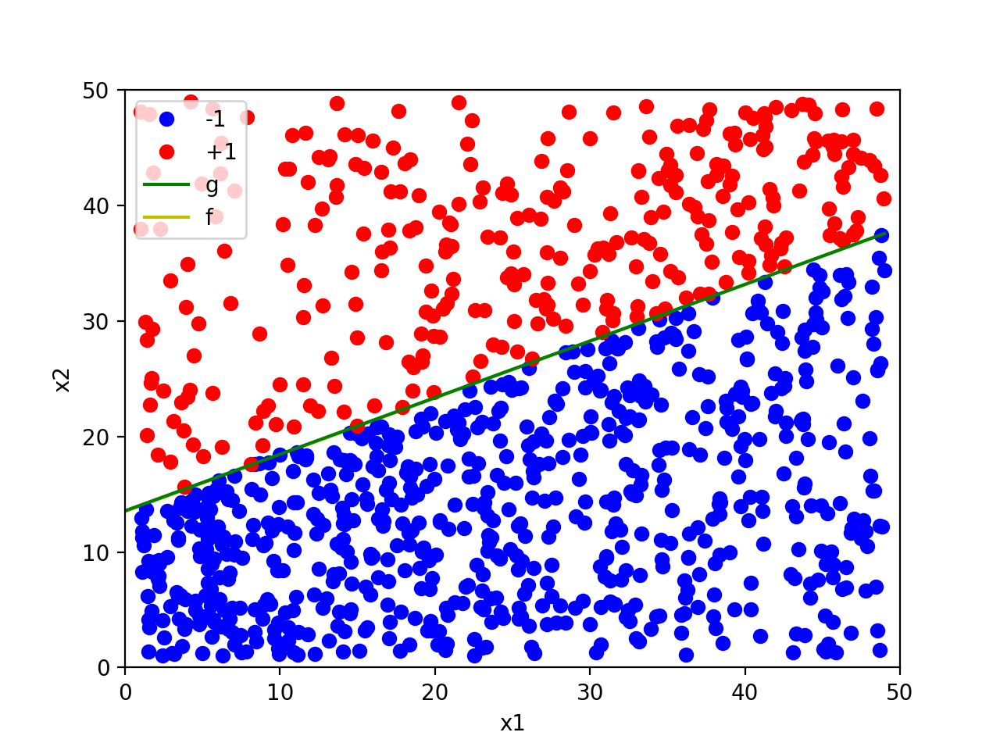 (e)

The number of updates that the algorithm takes is 10761, $f\left(x\right)=0.4915x+13.5103$, $g\left(x\right)=0.4900x+13.5643$. $f$ is almost identical to $g$ than in (b).