CSCI 4100 Assignment 12

Boliang Yang 661541863

1. Neural Networks and Backpropagation
2. For identity:

The forward propagation is $x_{1}=\left[1,1\right], { s}_{1}=\left[0.75,0.75\right],$

$$x_{2}=\left[1. , 0.635149, 0.635149\right], h\left(x\right)=0.567574$$

The backpropagation is $δ_{2}=-0.216213,$ $δ_{1}=[-0.032247, -0.032247]$,

$\frac{de}{dW_{2}}=[-0.216213, -0.137327, -0.137327]$,

$$\frac{de}{dW_{1}}=\left[\begin{matrix}-0.032247 & -0.032247 \\ -0.032247 & -0.032247 \\ -0.032247 & -0.032247\end{matrix}\right]$$

For sigmoid transformation:

The forward propagation is $x_{1}=\left[1,1\right], { s}_{1}=\left[0.75,0.75\right],$

$$x_{2}=\left[1. , 0.635149, 0.635149\right], s_{2}=0.567574, h\left(x\right)=0.513576$$

The backpropagation is $δ_{2}=-0.179062,$ $δ_{1}=[-0.026707, -0.026707]$,

$\frac{de}{dW_{2}}=[-0.179062, -0.113731, -0.113731]$,

$$\frac{de}{dW_{1}}=\left[\begin{matrix}-0.026707 & -0.026707 \\ -0.026707 & -0.026707 \\ -0.026707 & -0.026707\end{matrix}\right]$$

1. For identity:

$\frac{de}{dW_{2}}=[-0.216213, -0.137327, -0.137327]$,

$$\frac{de}{dW_{1}}=\left[\begin{matrix}-0.032247 & -0.032247 \\ -0.032247 & -0.032247 \\ -0.032247 & -0.032247\end{matrix}\right]$$

For sigmoid transformation:

$\frac{de}{dW_{2}}=[-0.179062, -0.113731, -0.113731]$,

$$\frac{de}{dW_{1}}=\left[\begin{matrix}-0.026707 & -0.026707 \\ -0.026707 & -0.026707 \\ -0.026707 & -0.026707\end{matrix}\right]$$

The results are the same as the previous results.

1. 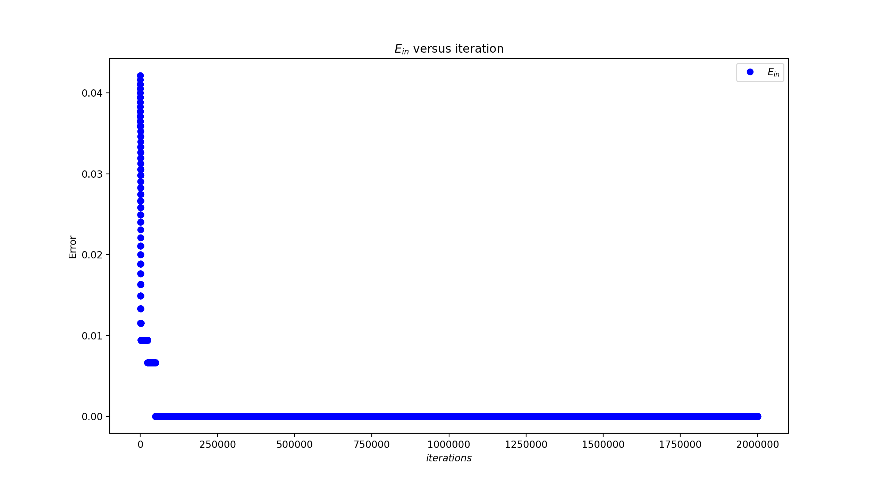Neural Network for Digits
2. The plot for $2×{10}^{6}$ iterations:

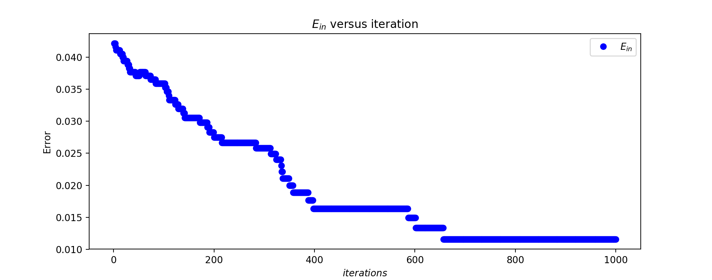And here is plot for 1000 iterations: it converges at about 650 iterations.

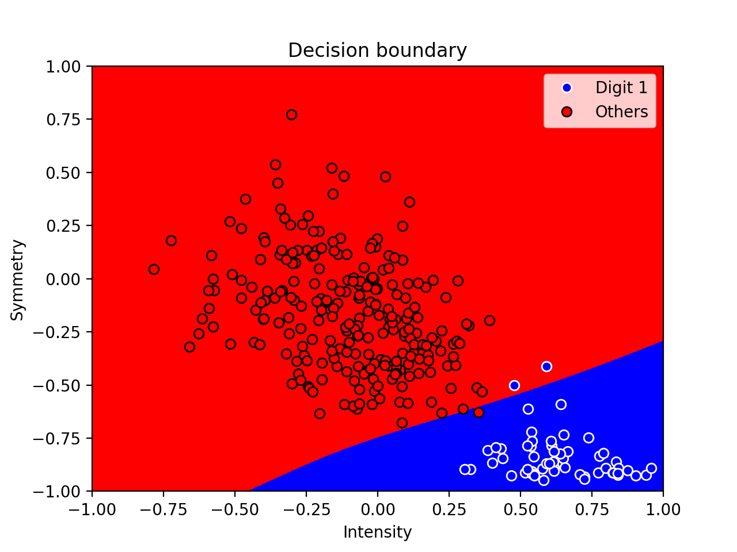The plot for decision boundary for the resulting classifier:

1. 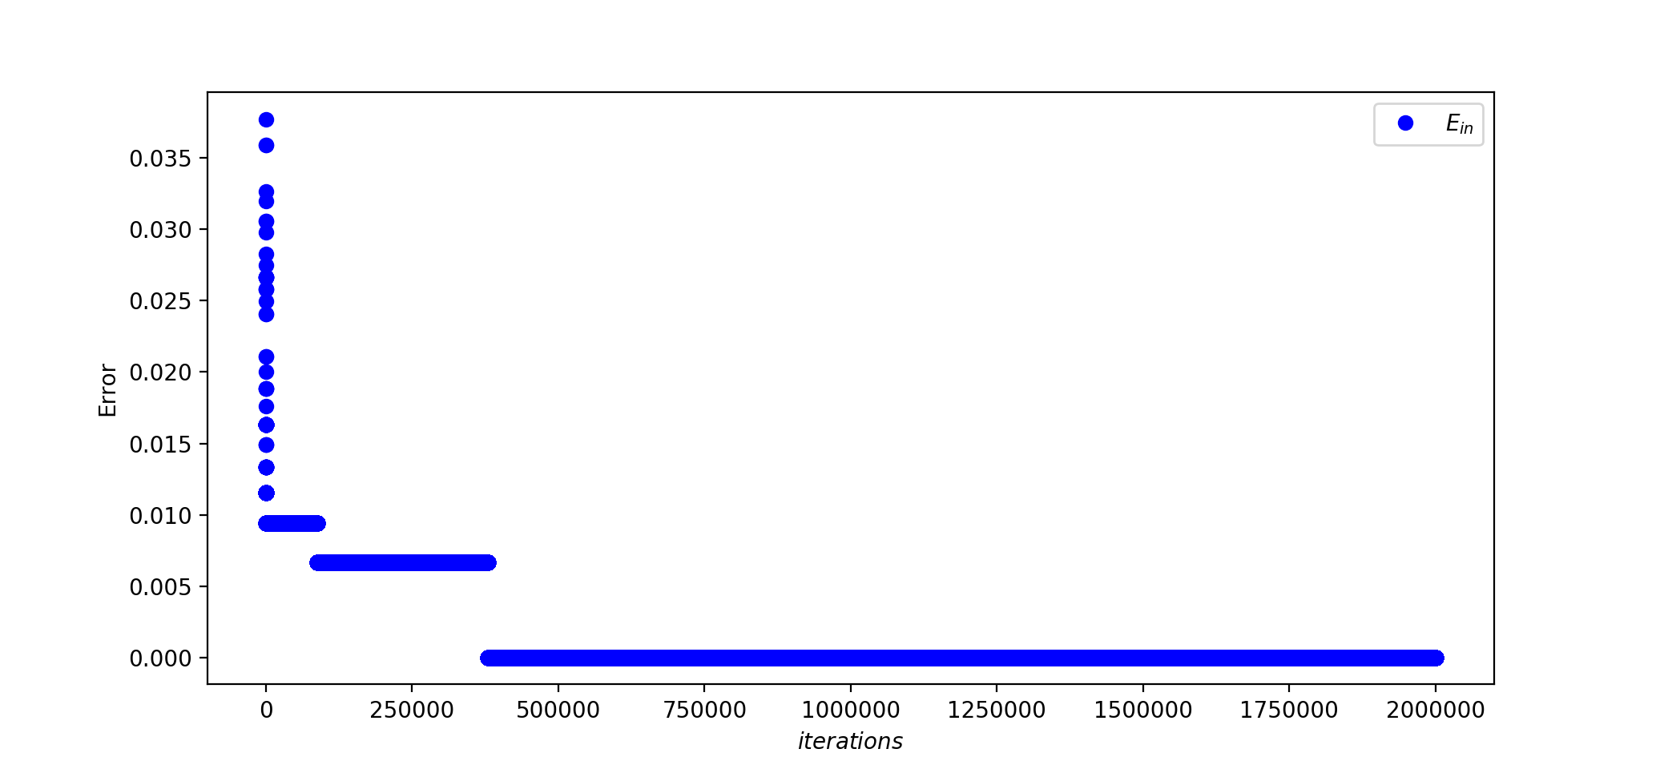With weight decay, here is the plot for $2×{10}^{6}$ iterations:

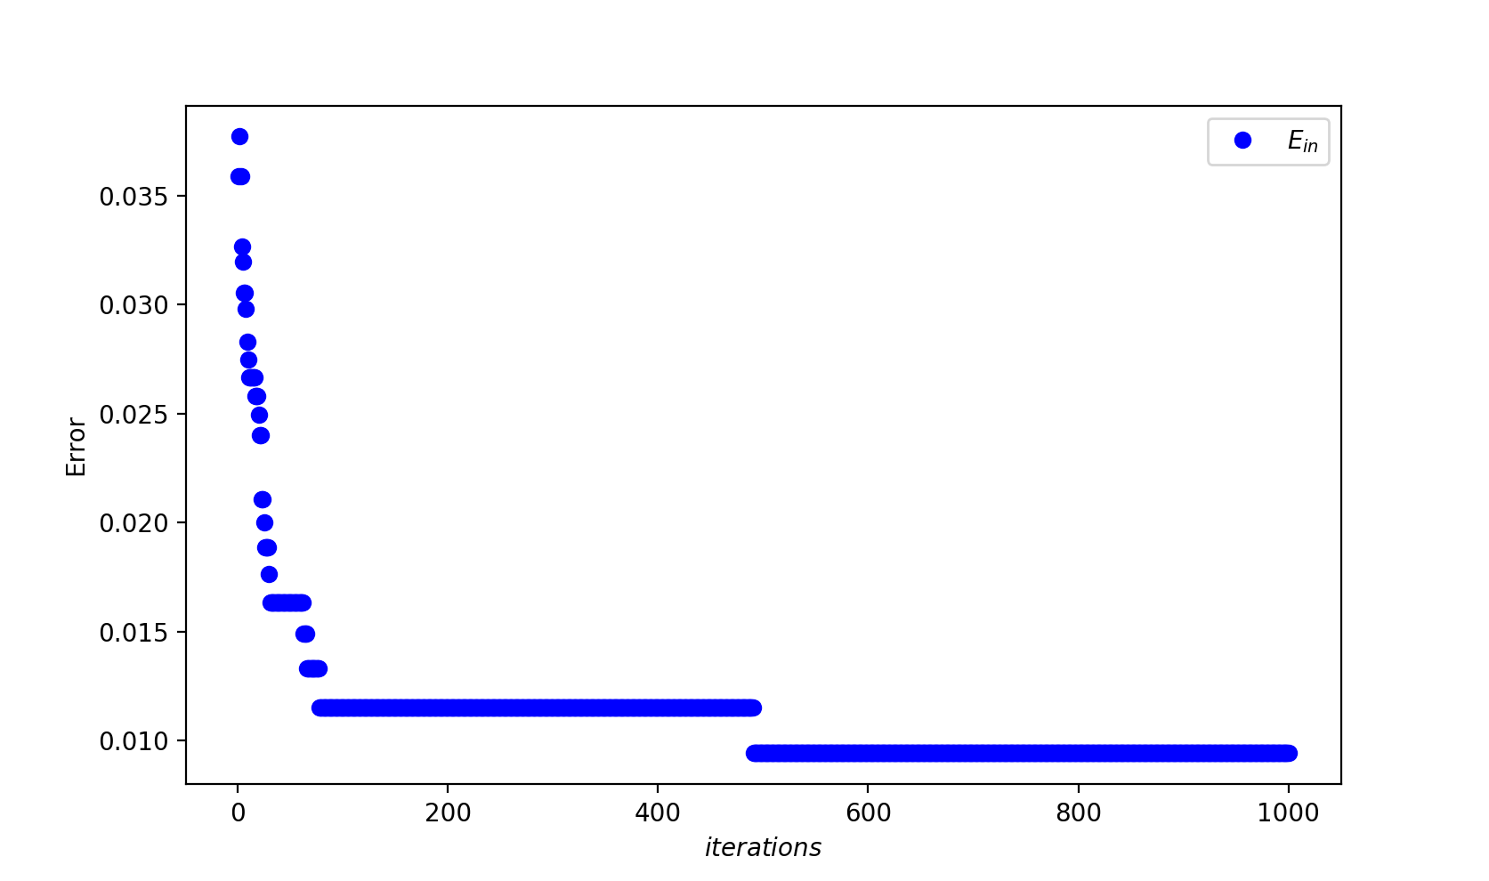The plot for 1000 iterations: it converges at about 500 iterations.

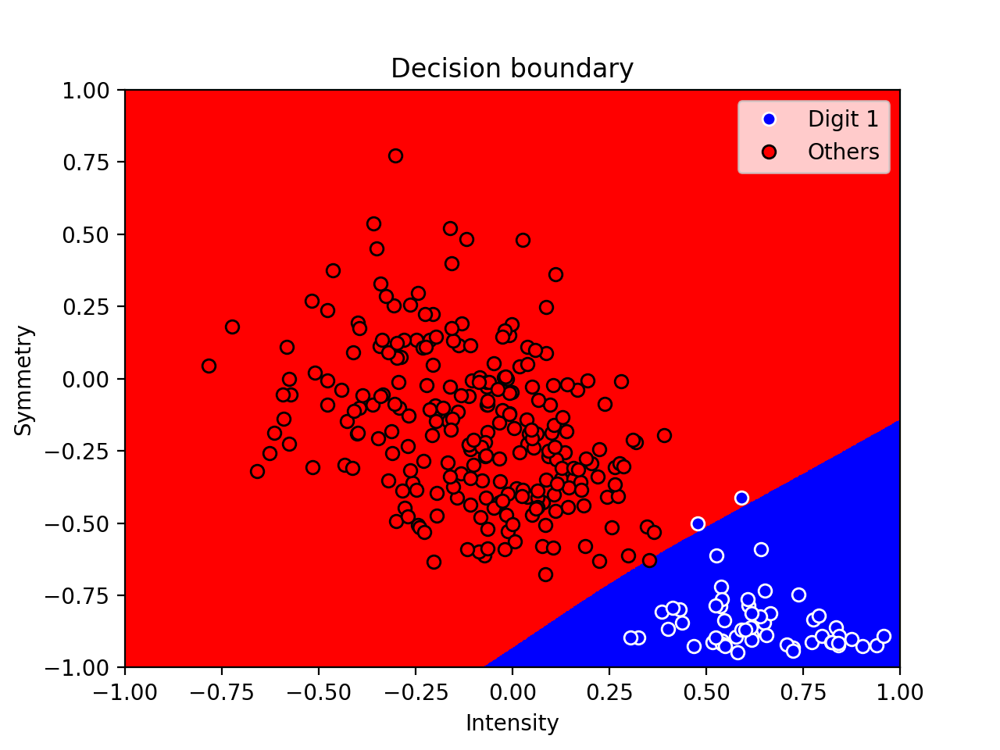

The plot for decision boundary for the resulting classifier:

1. 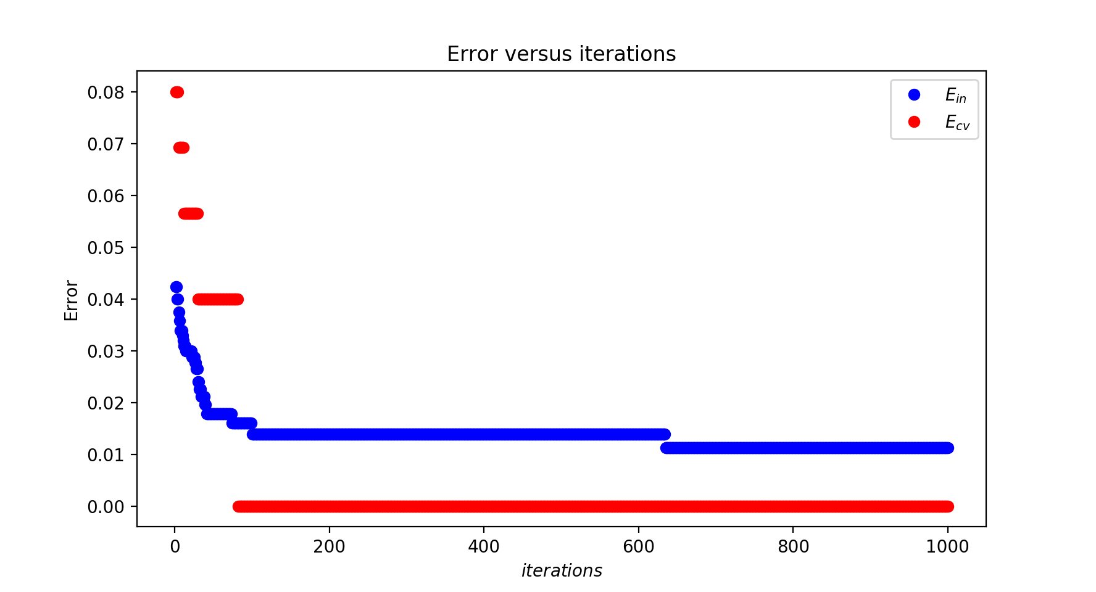Use early stopping with validation, here is the plot: the minimum validation error is at about 50 iterations.

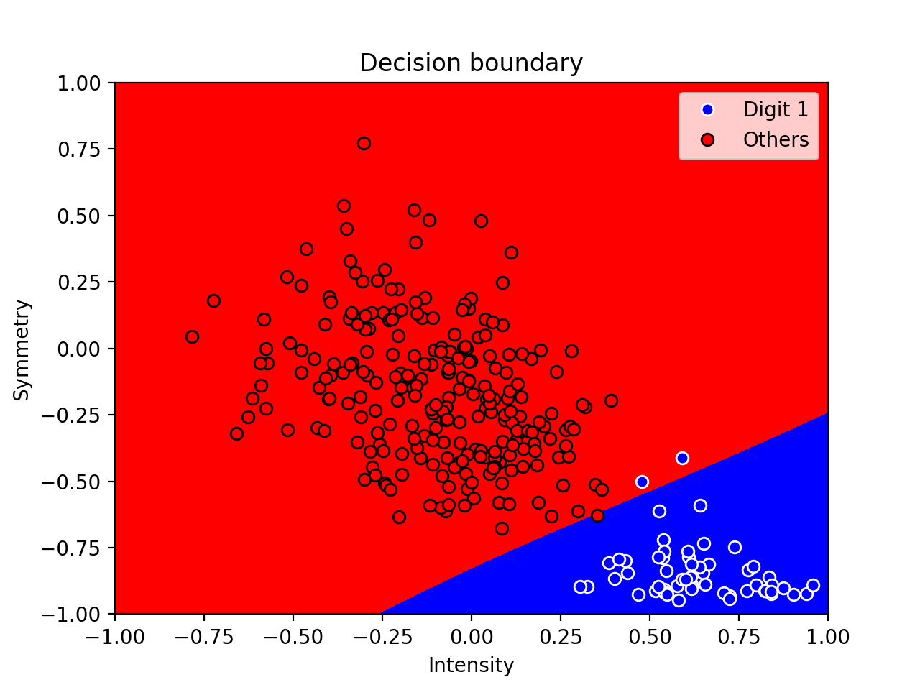

The plot for decision boundary for the resulting classifier:

1. Support Vector Machines
2. We solve optimization problem in order to get optimal separating hyperplane:

$\min_{w,b}{\frac{1}{2}w^{T}w}$ subject to: $y_{n}\left(w^{T}x_{n}+b\right)≥1 (n=1,…,N)$

Since $x_{1}=\left(1,0\right), y_{1}=+1, x_{2}=\left(-1,0\right), y_{2}=-1$, then the problem becomes:

$\min{\frac{1}{2}{(w}_{1}^{2}+w_{2}^{2})}$ subject to: $1\left(w_{1}+b\right)≥1$ and $-1\left({-w}_{1}+b\right)≥1$

We get $w_{1}=1, w_{2}=0, b=0$. Thus, the optimal hyperplane is $g\left(x\right)=sign\left({\left[\begin{matrix}1 \\ 0\end{matrix}\right]}^{T}x\right)=sign(x_{1})$. Since the equation for plane is $x_{1}=0$, and the line segment equation is $x_{2}=0$, then the hyperplane is perpendicular to the line segment.

1. i. For $x_{1}=\left(1,0\right), y_{1}=+1$, we have $z_{1}=\left(1,0\right), y_{1}=+1$;

For $x_{2}=\left(-1,0\right), y_{2}=-1$, we have $z_{2}=\left(-1,0\right), y_{2}=-1$.

ii. We need to solve

$\min{\frac{1}{2}{(w}_{1}^{2}+w_{2}^{2})}$ subject to: $1\left(w_{1}+b\right)≥1$ and $-1\left({-w}_{1}+b\right)≥1$

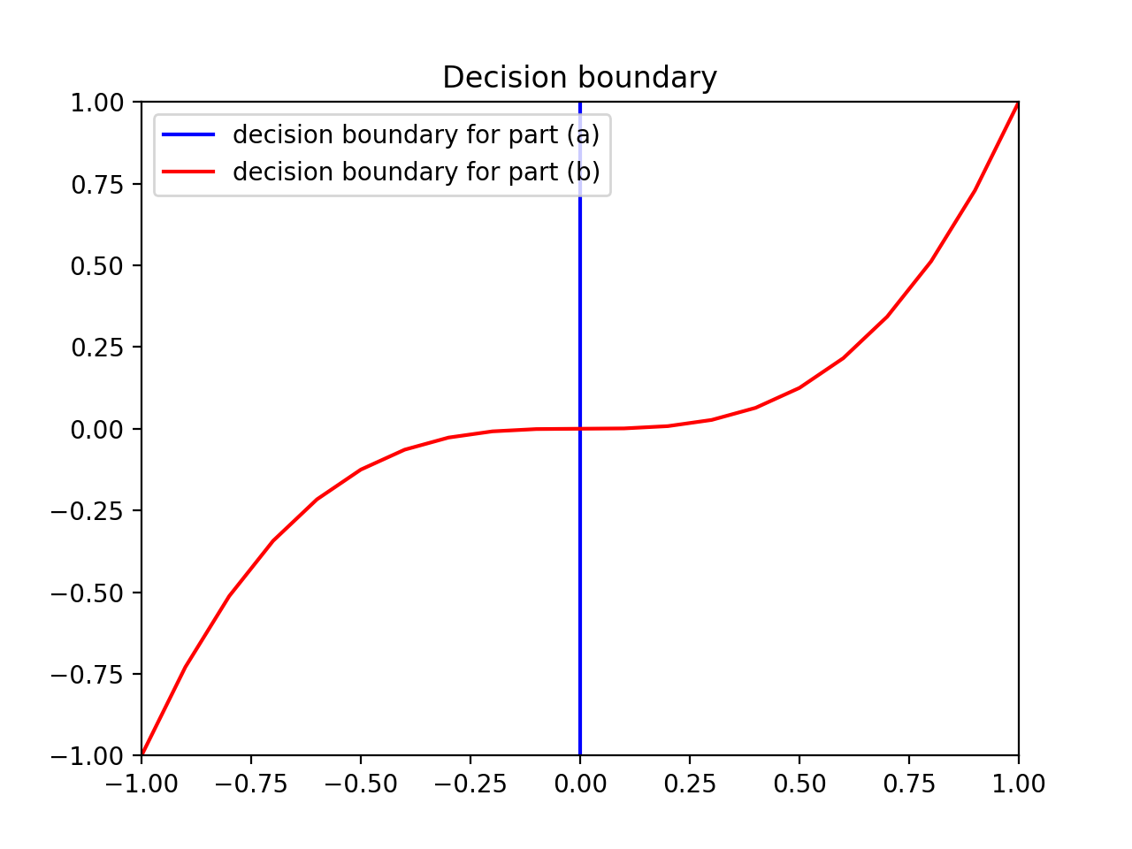 We get $w_{1}=1, w_{2}=0, b=0$. Thus, the optimal hyperplane is $g\left(z\right)=sign\left({\left[\begin{matrix}1 \\ 0\end{matrix}\right]}^{T}z\right)$.

1. The plot of the decision boundary: -1 on the left and +1 on the right
2. Since $x=\left(x_{1},x_{2}\right), y=(y_{1},y_{2})$, after transformation, we have $z_{x}=\left(x_{1}^{3}-x_{2},x_{1}x_{2}\right), z_{y}=(y_{1}^{3}-y_{2},y_{1}y_{2})$, then $z_{x}z_{y}=\left(x_{1}^{3}-x_{2}\right)\left(y_{1}^{3}-y_{2}\right)+x_{1}x_{2}y_{1}y_{2}=x_{1}^{3}y_{1}^{3}-x_{1}^{3}y_{2}-x_{2}y_{1}^{3}+x_{2}y_{2}+x_{1}x_{2}y_{1}y_{2}$
3. Since $g\left(z\right)=sign\left({\left[\begin{matrix}1 \\ 0\end{matrix}\right]}^{T}z\right)$, then in X-space, $g\left(x\right)=sign(x_{1}^{3}-x_{2})$.
4. SVM with digits data
5. 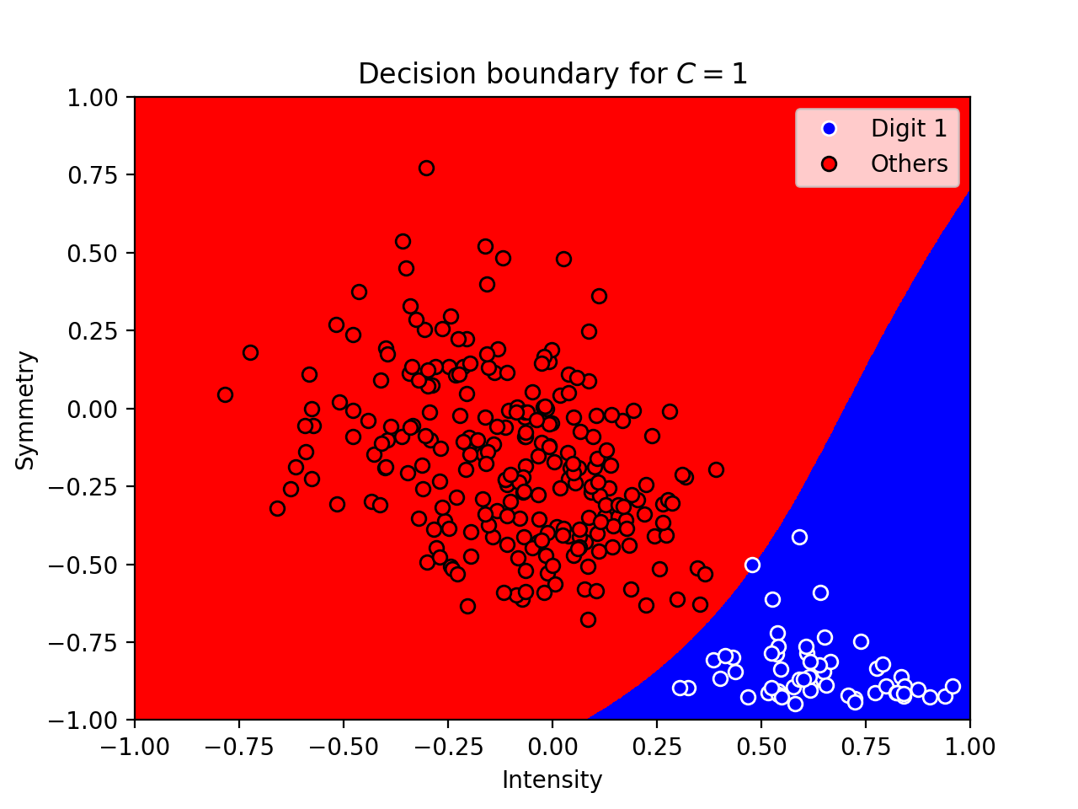I choose C = 1 as a small C:

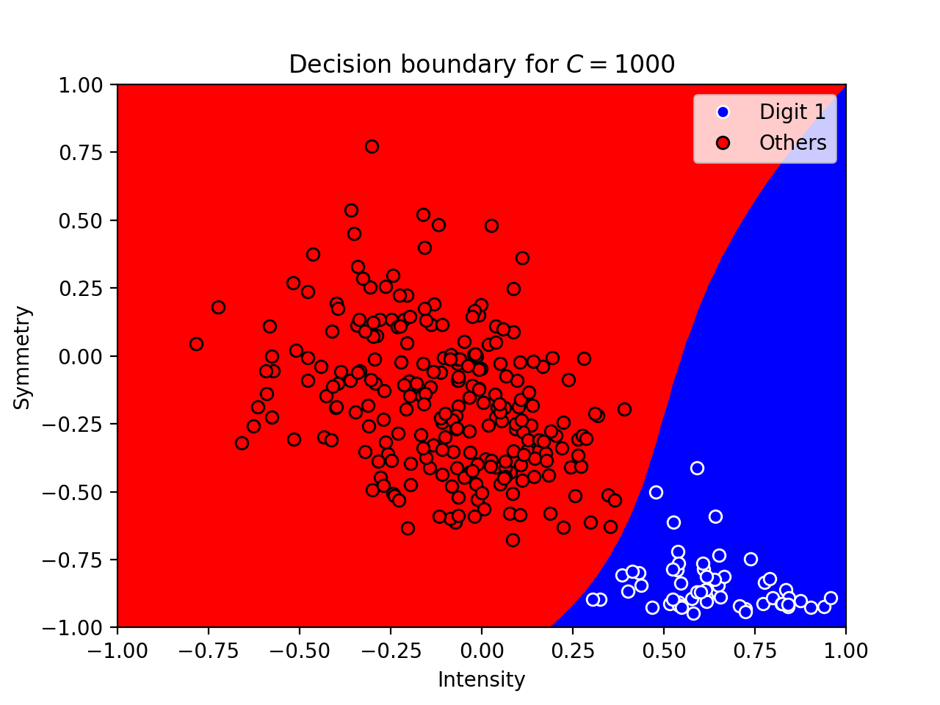I choose C = 1000 as a large C:

1. As C gets larger, the complexity of the decision boundary becomes larger. For example, in the second graph where C is larger, the top-right region is occupied by “blue” region.
2. Grid of values for C and cross validation errors:

|  |  |  |  |  |  |  |  |  |
| --- | --- | --- | --- | --- | --- | --- | --- | --- |
| $$C$$ | $$1$$ | $$2$$ | $$3$$ | $$4$$ | $$5$$ | $$6$$ | $$7$$ | $$8$$ |
| $$E_{cv}$$ | $$0.003344$$ | $$0.003344$$ | $$0.0$$ | $$0.003344$$ | $$0.003344$$ | $$0.003344$$ | $$0.003344$$ | $$0.003344$$ |
| $$C$$ | $$9$$ | $$10$$ | $$15$$ | $$20$$ | $$25$$ | $$30$$ | $$40$$ | $$50$$ |
| $$E_{cv}$$ | $$0.003344$$ | $$0.003344$$ | $$0.003344$$ | $$0.003344$$ | $$0.003344$$ | $$0.003344$$ | $$0.003344$$ | $$0.003344$$ |

When C = 3, $E_{cv}$ is the smallest. And here, $E_{test}=0.009012$.

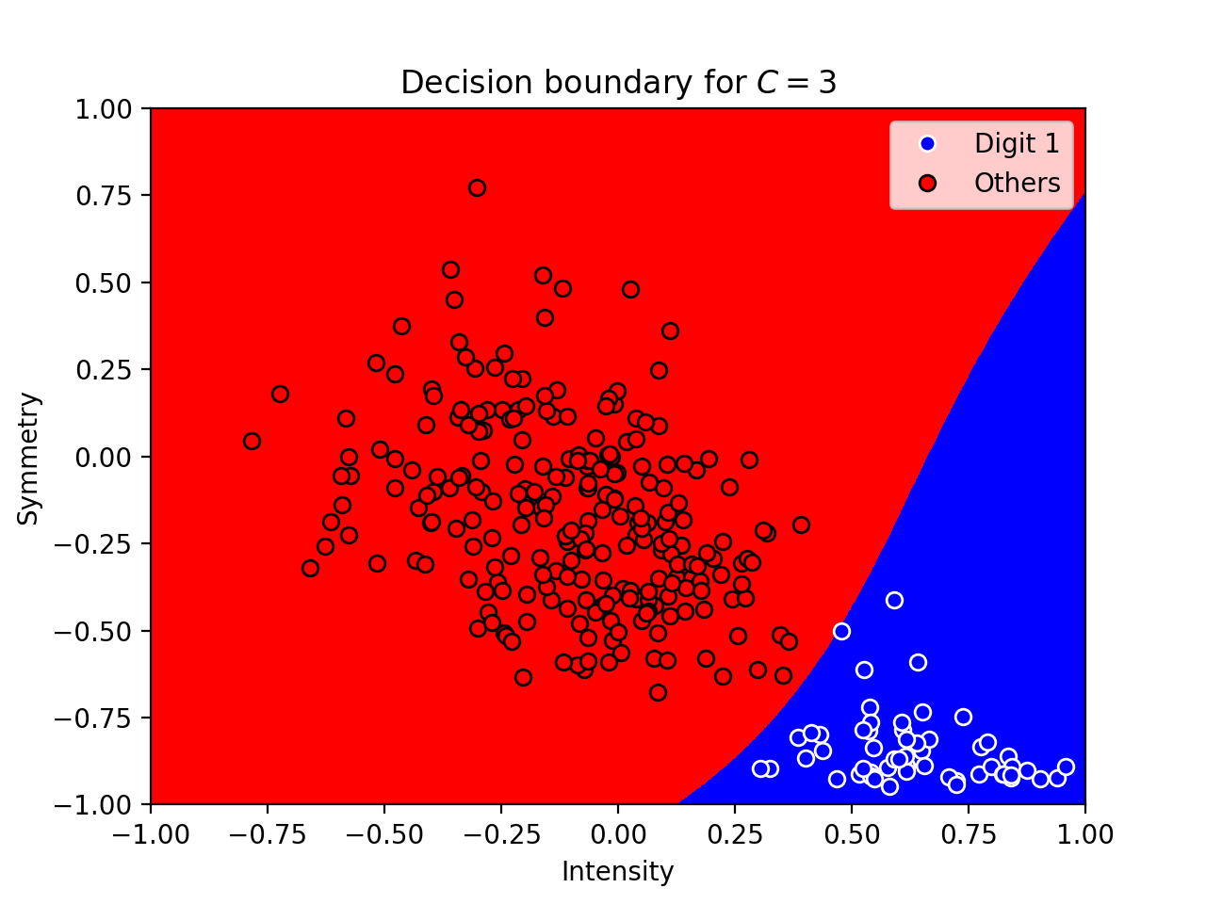

1. Compare Methods: Linear, k-NN, RBF-network, Neural Network, SVM

The final test errors are:

for Linear model with 8th order polynomial transform, $E_{test}=0.057199$;

for k-NN rule, $E_{test}=0.009441$;

for RBF-network, $E_{test}=0.009726$;

for Neural network with early stopping, $E_{test}=0.009853$;

for SVM with 8th order polynomial kernel, $E_{test}=0.009012$.

We can see that SVM with 8th order polynomial kernel gives us the smallest test error.

It also has a fast running time. Thus, SVM with 8th order polynomial kernel should be the best choice.

For Neural network and RBF-network, the running time is fast and both have small

test errors. Therefore, these two can be the second choice.

However, k-NN is the slowest among these five algorithms and requires the largest

memory space. Thus, k-NN is not a good choice.

The regularized linear model with 8th order polynomial transform is not a good choice

as well. Not only it has the largest test error, but it also has a higher order polynomial transform which results in an increase in complexity.