[Working title]: Foliar fungal symbionts in sympatric yellow moenkeyflowers in the Sierra Nevada, CA, USA

Bolívar Aponte Rolón1,✉, Kathleen G. Ferris2, and Sunshine A. Van Bael2

February 11, 2024

1 Tulane University  
2 Department of Ecology and Evolutionary Biology, Tulane University, 6823 St. Charles Avenue, New Orleans, LA 70118  
3 School of Plant Sciences, University of Arizona, Tucson, AZ 85721  
4 Department of Ecology and Evolutionary Biology and the Bio5 Institute, University of Arizona, Tucson, AZ 85721

✉ Correspondence: [Bolívar Aponte Rolón <baponterolo@tulane.edu>](mailto:baponterolo@tulane.edu)

## 0.1 Keywords

# 1. Abstract

# 2. Introduction

# 3. Materials and Methods

## 3.1 Sample Collection

We collected plant specimens populations of *M. guttatus*, *M. laciniatus*, and *M. nasutus* (syn. *Erythranthe guttata* , *Erythranthe laciniata*, and *Erythranthe nasuta*) across Stanislaus National Forest (SNF), Sierra National Forest (SINF) and Yosemite National Park (YNP), CA, USA. during We haphazardly selected sites close to the main roads based on the presence of a viable population of at least ~ 50 individuals per species. Samples collected from YNP were collected from non-wilderness areas on the side of the road. We determined population viability ensuring that they had individuals flowering or close to flowering stage. We collected between 6 - 12 individuals per species per site. We selected individuals that possessed healthy looking leaves, no visible signs of pathogen damage or senescence. At sites were two species were present we collected individuals that were at least ~ 25 meters apart. We collected sample specimens by carefully uprooting the plant and placing into individual plastic bags (Ziploc® ) and preserving in an ice chest until return to the field laboratory at the UC Merced Yosemite Field Station, YNP, CA, USA. Plant specimens were processed within 8 hrs of collection.

## 3.2 Leaf traits measurement

From each plant, we measured leaf traits: leaf thickness (LT), leaf punch strength (LPS), leaf mass per area (LMA), anthocyanin content index (ACI) which are known to be associated with FEF communities (Tellez et al., 2022) as well as leaf lobe index (LBI) (Ferris et al., 2015). We cleaned plants with tap water to remove all soil and debris remnants from the leaves and roots. We removed all healthy leaves (~ 5 - 10) from the stems and took three measurements per trait from three haphazardly selected leaves from individual plants, with the exception of LBI, only one leaf per plant. We used a transparency film to hold the leaf in place and flatten, after which we took a digital photograph for analysis in ImageJ [v1.52r; Schneider et al. (2012)]. To calculate the LBI, we followed (2015). Leaf lobing is calculated as the convex hull area minus the true leaf area divided by convex hull area. We measured ACI content with ACM-200plus (Opti-Sciences Inc. Hudson, New Hampshire, U.S.A.) on haphazardly selected locations of the leaf surface (working from the petiole out to the leaf tip) (Tellez et al., 2022). The ACM-200 calculates an ACI value from the ratio of % transmittance at 931 nm/% transmittance at 525 nm (Inc., n.d.), effectively accounting for leaf thickness. We measured LT (μm) with a Mitutoyo 7327 Micrometer Gauge (Mitutoyo, Takatsu-ku, Kawasaki, Japan) on haphazardly selected locations of the leaf lamina, taking care to avoid major and secondary veins. We used an Imada DST-11a digital force gauge (Imada Inc., Northbrook, IL, United States) to measure LPS, a measure of leaf toughness, on the lamina of each leaf selected, avoiding minor leaf veins when possible (Tellez et al., 2022). It functions by conducting punch-and-die tests with a sharp-edged cylindrical steel punch (2.0 mm diameter) and a steel die with a sharp-edged aperture of small clearance (0.05 mm). Once LPS was measured, we used a 4 mm diameter punch hole to puncture disks for LMA measurements. We collected one disk per leaf (see Supplementary material for details). The disk punches dried were shipped to Tulane University, New Orleans, LA, USA to dry at 60 ℃ for 48-72 hours before being weighed.

## 3.3 Molecular Work

### 3.3.1 Tissue preservation

Upon completion of the leaf traits measurements, we prepared and preserved samples at the UC Merced Yosemite Field Station. We started by removing the main vein and margins from photosynthetic tissue. The leaf lamina was haphazardly cut with a sterile blade into 2 mm wide strip in parallel to the main vein (Arnold et al., 2003; Higgins et al., 2014; Tellez et al., 2022). Leaf strips were then sterilized with sequential washes in 95% EtOH (10 s), 0.5% sodium hypochlorite (NaOCl) (60 s), and 70% EtOH (60 s) and air dried under sterile conditions. Due to the small size of monkeyflower plants, the maximum amount of leaf lamina was preserved in sterile 15 mL tubes with ~ 10 mL CTAB solution (1 M Tris–HCl pH 8, 5 M NaCl, 0.5 M EDTA, and 20 g CTAB). The leaf tissue in CTAB solution was used for amplicon sequencing (described in detail below). All leaf tissue handling was performed in a sterile environment with an alcohol burner lamp inside a portable biosafety cabinet. All surfaces were previously sterilized sequentially with 0.5% NaOCl, 95% EtOH, and 70% EtOH. We surface sterilized surfaces and instruments in between sample handling to prevent cross contamination.

### 3.3.2 Amplicon sequencing

We stored leaf tissue in CTAB solution for 2 months at room temperature before extracting DNA at Tulane University. To prepare for sample DNA extraction procedure, we decontaminated all instruments, materials, and surfaces in biosafety cabinet with 0.5 % NaOCl, 70 % EtOH, and 95% EtOH, and subsequently treated with UV light for 30 minutes. We subsampled 0.2 - 0.3 g of leaf tissue from each sample and placed into a sterile 2 mL tubes containing an assortment of beads: 3.2 mm stainless steel beads (Next Advance, Cat# SSB32), 100 µL stainless steel bead blend, 0.9-2.0mm (NextAdvance, Cat# SSB14B) and 2-3 of the autoclaved 2 mm zirconium oxide beads (Next Advance, Cat# ZRoB20). The 2 mL tubes with beads were previously prepared. We then proceeded to lyophilize samples for 72 hours to fully remove CTAB content from tissue. After, we submerged the sample tubes in liquid nitrogen for 30 s and homogenized samples at 30 Hz for 3 minutes in a TissueLyser LT (QIAGEN, Valencia, CA, USA). We stored samples in 20 ℃ until DNA extraction procedure.

We used a DNA extraction protocol for high-molecular weight DNA extraction adapted from Russo et al., (2022). Briefly, it is a CTAB:chloroform:isoamyl extraction combined with a solid-phase reversible immobilization (SPRI) bead step (Liu et al., 2023; Rohland & Reich, 2012; Russo et al., 2022). Protocol modifications allowed us to optimize extractions for fungal DNA from preserved leaf tissue (see details in Aponte Rolón, 2023). After all genomic DNA was extracted, we quantified the DNA using Quant-iT™ dsDNA HS Assay kit with Qubit Flourometer (Thermo Fisher Scientific, Waltham, MA, USA., Cat# Q33120) and followed a two-step amplification approach described by (2017) and (2017). We used standard primers ITS1F (Gardes & Bruns, 1993) and ITS2 (White et al., 1990) modified with the Illumina TruSeq adaptor. The modified primers for the first PCR (adapter ligation and ITS1 amplification) were as follows: 5’ CACTCTTTCCCTACACGACGCTCTTCCGATCTCTTGGTCATTTAGAGGAAGTAA 3’ (forward) and 5’ GTGACTGGAGTTCAGACGTGTGCTCTTCCGATCTGCTGCGTTCTTCATCGATGC 3’ (reverse). Every sample was amplified in three parallel reactions at the annealing temperatures 52 ℃, 54 ℃, and 56 ℃ to amplify a wide range of fungal taxa and reduce amplification bias for short ITS sequences (Lumibao et al., 2018; U’Ren & Arnold, 2017). Each PCR (PCR1) reaction contained 2 µL of sample DNA template. We visualized PCR1 reactions with SYBR™ Safe DNA Gel Stain (Thermo Fisher Scientific, Waltham, MA, USA., Cat# S33102) on 2% agarose gel (Oita et al., 2021). We combined 5 µL of amplicon product from parallel reactions in to a single tube per sample and purified using Sera-Mag™ SpeedBead Carboxylate-Modified Magnetic Particles (Hydrophobic) (Thermo Fisher Scientific, Waltham, MA, USA., Cat#09-981-123) prepared as per Liu et al. (2023) and used a ratio of 1.2x:1 with 80% EtOH following manufacturers instructions. We used 3 µL of PCR1 product from samples, DNA extraction controls, and PCR1 negative controls for a second PCR (PCR2) with barcoded adapters (IDT, Coralville, Iowa, USA). Each PCR2 reaction (total 30 µL) contained 1X Phusion Flash High Fidelity PCR Master Mix (Thermo Fisher Scientific, Waltham, MA, USA., Cat# F548L), 0.075 µM of barcoded primers (forward and reverse pooled at an initial concentration of 2 µM) and 0.20mg/mL of BSA (Thermo Fisher Scientific, Waltham, MA, USA., Cat# B14) following U’Ren & Arnold (2017). Before final pooling for sequencing, we purified and concentrated amplicons using SPRRI beads to a total volume of 20 µL. We quantified PCR2 product with Quant-iT™ PicoGreen™ dsDNA Assay Kit (Thermo Fisher Scientific, Waltham, MA, USA., Cat# P7589) with the BioTek Synergy LX plate reader (Agilent, Santa Clara, CA) and combined equimolar amounts of libraries, including DNA extraction controls, PCR1, and PCR2 negative controls into a 10nM library pool. We did not detect any contamination visually or fluorometrically. Libraries were sequenced on the Illumina MiSeq platform with Reagent Kit v3 (2 0D7 300 bp) at Duke Genome Sequencing and Analysis Core Facility (Durham, NC, USA) we included the DNA extraction blanks and two PCR1 negatives and sequenced with samples. Throughtout al these steps, we used a separate set of sterile pipettes, tips, and equipment to reduce contamination in a designated PCR area to restrict contact with pre-PCR materials (Oita et al., 2021).

### 3.3.3 Bioinformatic analyses

We assessed the quality of the reads using FastQc v0.12.1 [ v0.12.1; Andrews et al. (2010)] and MultiQC (Ewels et al., 2016) tools. A total of 60,696,808 total ITS1 reads yielded from 343 (including 27 controls) libraries sequenced in two separate sequencing events. The first sequencing event yielded 32,117,684 and the second 28,579,124 ITS1 reads. We tailored the open-source DADA2 (Callahan et al., 2016) bioinformatic pipeline for our data set. We filtered our reads for ambiguous calls before removing the adapters by using filterAndTrim function and argument maxN = 0 from the dada2 package [v1.28.0; Callahan et al. (2016)] in *R* programming language (R Core Team, 2023). We removed forward and reverse primer adapters (and their reverse compliments) and eliminated reads shorter than 20 bp using the cutadapt tool (v4.6, Martin, 2011). Based on our initial quality assessment, both forward and reverse reads were of low quality, with base calls deteriorating after 100bp. We applied stringent filter and truncation parameters to ensure quality of reads when assigning taxonomy. We filtered and truncated reads based on maximum expected errors (maxEE) rather than read length as it provides a reliable quality filtering (Edgar & Flyvbjerg, 2015). For this we set set the arguments trunQ = 2, maxEE = c(2,20) for forward and reverse reads, and minimum read length of 50 bp with minLen = 50 in the used the filterAndTrim function (Callahan et al., 2016). These parameters eliminated 151 samples from our data set, all from our second sequencing event. After this filter, we dereplicated reads with the derepFastq function and merged pairs using mergePairs functions with an overlap of 20 bp, minimum. We then inferred composition of the samples with dada function, which applies the DADA algorithm (Callahan et al., 2016; Rosen et al., 2012). We removed chimeras via the “consensus”method with the removeBimeraDenovo function and ultimately we used the assignTaxonomy function to assign taxonomy the amplicon sequence variants (ASV) referenced against the UNITE database (Abarenkov et al., 2023). After taxonomy assignment we used the phyloseq package (McMurdie & Holmes, 2013) to create a phyloseq object for downstream analyses.

We used the decontam package [v1.20.0; Davis et al. (2018)] to statistically determine which ASVs are likely contaminants based on their frequency in our samples and remove them using prune_taxa function from the phyloseq package [v1.44.0; McMurdie & Holmes (2013)]. After which, we calculated the average read count found in DNA and PCR extraction controls, considered to be laboratory contaminants, and subtracted that from the samples’ read counts. We then used custom scripts to remove any ASV that represented less than 0.1% of the abundance per sample on the assumption that it originates from contamination throughout handling of samples in the DNA and PCR processes. We removed singletons ASVs with the prune_taxa function (McMurdie & Holmes, 2013). All these steps were performed in *R* [v.4.3.2; R Core Team (2023)].

## 3.4 Statistical Analyses

# 4. Results

# 5. Discussion

# 6. Conclusion

# 7. References

Abarenkov, K., Zirk, A., Piirmann, T., Pöhönen, R., Ivanov, F., Nilsson, R. H., & Kõljalg, U. (2023). *UNITE general FASTA release for Fungi 2* [Application/gzip]. UNITE Community. <https://doi.org/10.15156/BIO/2938068>

Andrews, S., Krueger, F., Segonds-Pichon, A., Biggins, L., Krueger, C., & Wingett, S. (2010). *FastQC* (Version 0.12.1) [Computer software]. Babraham Institute.

Aponte Rolón, B. (2023, July 3). *High-Molecular-Weight SPRI-aided DNA extraction from Mimulus (Phrymaceae) leaf tissue.* <https://doi.org/dx.doi.org/10.17504/protocols.io.bp2l6xn8rlqe/v2>

Arnold, A. E., Mejía, L. C., Kyllo, D., Rojas, E. I., Maynard, Z., Robbins, N., & Herre, E. A. (2003). Fungal endophytes limit pathogen damage in a tropical tree. *Proceedings of the National Academy of Sciences*, *100*(26), 15649–15654.

Callahan, B. J., McMurdie, P. J., Rosen, M. J., Han, A. W., Johnson, A. J. A., & Holmes, S. P. (2016). DADA2: High-resolution sample inference from Illumina amplicon data. *Nature Methods*, *13*(7), 581–583. <https://doi.org/10.1038/nmeth.3869>

Davis, N. M., Proctor, D. M., Holmes, S. P., Relman, D. A., & Callahan, B. J. (2018). Simple statistical identification and removal of contaminant sequences in marker-gene and metagenomics data. *Microbiome*, *6*(1), 226. <https://doi.org/10.1186/s40168-018-0605-2>

Edgar, R. C., & Flyvbjerg, H. (2015). Error filtering, pair assembly and error correction for next-generation sequencing reads. *Bioinformatics*, *31*(21), 3476–3482. <https://doi.org/10.1093/bioinformatics/btv401>

Ewels, P., Magnusson, M., Lundin, S., & Käller, M. (2016). MultiQC: Summarize analysis results for multiple tools and samples in a single report. *Bioinformatics*, *32*(19), 3047–3048. <https://doi.org/10.1093/bioinformatics/btw354>

Ferris, K. G., Rushton, T., Greenlee, A. B., Toll, K., Blackman, B. K., & Willis, J. H. (2015). Leaf shape evolution has a similar genetic architecture in three edaphic specialists within the Mimulus guttatus species complex. *Annals of Botany*, *116*(2), 213–223. <https://doi.org/10.1093/aob/mcv080>

Gardes, M., & Bruns, T. D. (1993). ITS primers with enhanced specificity for basidiomycetes ‐ application to the identification of mycorrhizae and rusts. *Molecular Ecology*, *2*(2), 113–118. <https://doi.org/10.1111/j.1365-294X.1993.tb00005.x>

Higgins, K. L., Arnold, A. E., Coley, P. D., & Kursar, T. A. (2014). Communities of fungal endophytes in tropical forest grasses: Highly diverse host- and habitat generalists characterized by strong spatial structure. *Fungal Ecology*, *8*(1), 1–11. <https://doi.org/10.1016/j.funeco.2013.12.005>

Inc., O.-S. (n.d.). *ACM-200plus*. ACM-200plus. Retrieved November 29, 2023, from <https://www.optisci.com/acm-200.html>

Liu, D., Li, Q., Luo, J., Huang, Q., & Zhang, Y. (2023). An SPRI beads-based DNA purification strategy for flexibility and cost-effectiveness. *BMC Genomics*, *24*(1), 125. <https://doi.org/10.1186/s12864-023-09211-w>

Lumibao, C. Y., Formel, S., Elango, V., Pardue, J. H., Blum, M., & Van Bael, S. A. (2018). Persisting responses of salt marsh fungal communities to the Deepwater Horizon oil spill. *Science of The Total Environment*, *642*, 904–913. <https://doi.org/10.1016/j.scitotenv.2018.06.077>

Martin, M. (2011). Cutadapt removes adapter sequences from high-throughput sequencing reads. *EMBnet.journal*, *17*(1), 10. <https://doi.org/10.14806/ej.17.1.200>

McMurdie, P. J., & Holmes, S. (2013). Phyloseq: An R Package for Reproducible Interactive Analysis and Graphics of Microbiome Census Data. *PLoS ONE*, *8*(4), e61217. <https://doi.org/10.1371/journal.pone.0061217>

Oita, S., Ibáñez, A., Lutzoni, F., Miadlikowska, J., Geml, J., Lewis, L. A., Hom, E. F. Y., Carbone, I., U’Ren, J. M., & Arnold, A. E. (2021). Climate and seasonality drive the richness and composition of tropical fungal endophytes at a landscape scale. *Communications Biology*, *4*(1), 313. <https://doi.org/10.1038/s42003-021-01826-7>

R Core Team. (2023). *R: A Language and Environment for Statistical Computing* [Computer software]. R Foundation for Statistical Computing. <https://www.R-project.org/>

Rohland, N., & Reich, D. (2012). Cost-effective, high-throughput DNA sequencing libraries for multiplexed target capture. *Genome Research*, *22*(5), 939–946. <https://doi.org/10.1101/gr.128124.111>

Rosen, M. J., Callahan, B. J., Fisher, D. S., & Holmes, S. P. (2012). Denoising PCR-amplified metagenome data. *BMC Bioinformatics*, *13*(1), 283. <https://doi.org/10.1186/1471-2105-13-283>

Russo, A., Mayjonade, B., Frei, D., Potente, G., Kellenberger, R. T., Frachon, L., Copetti, D., Studer, B., Frey, J. E., Grossniklaus, U., & Schlüter, P. M. (2022). Low-Input High-Molecular-Weight DNA Extraction for Long-Read Sequencing From Plants of Diverse Families. *Frontiers in Plant Science*, *13*, 883897. <https://doi.org/10.3389/fpls.2022.883897>

Sarmiento, C., Zalamea, P. C., Dalling, J. W., Davis, A. S., Simon, S. M., U’Ren, J. M., & Arnold, A. E. (2017). Soilborne fungi have host affinity and host-specific effects on seed germination and survival in a lowland tropical forest. *Proceedings of the National Academy of Sciences of the United States of America*, *114*(43), 11458–11463. <https://doi.org/10.1073/pnas.1706324114>

Schneider, C. A., Rasband, W. S., & Eliceiri, K. W. (2012). NIH Image to ImageJ: 25 years of image analysis. *Nature Methods*, *9*(7), 671–675. <https://doi.org/10.1038/nmeth.2089>

Tellez, P. H., Arnold, A. E., Leo, A. B., Kitajima, K., & Van Bael, S. A. (2022). Traits along the leaf economics spectrum are associated with communities of foliar endophytic symbionts. *Frontiers in Microbiology*, *13*, 927780. <https://doi.org/lutzoni>

U’Ren, J. M., & Arnold, A. E. (2017). 96 well DNA Extraction Protocol for Plant and Lichen Tissue Stored in CTAB. *Protocols.io*, 1–5. <https://doi.org/dx.doi.org/10.17504/protocols.io.fscbnaw>

White, Bruns, Tom, Lee, S., & Taylor, J. (1990). *White, T. J., T. D. Bruns, S. B. Lee, and J. W. Taylor. Amplification and direct sequencing of fungal ribosomal RNA genes for phylogenetics* (pp. 315–322).

# 8. Figures

## 8.1 Figure 1

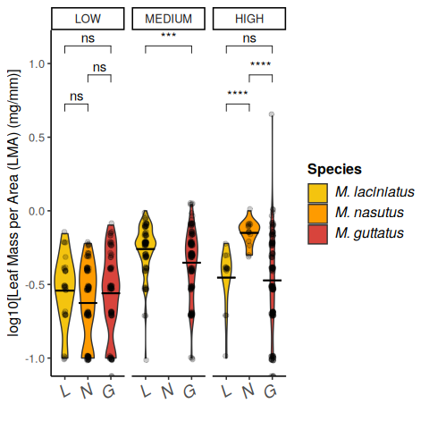

Violin plots of Leaf Mass per Area (LMA) by species and elevation category.

# 9. Figure 2

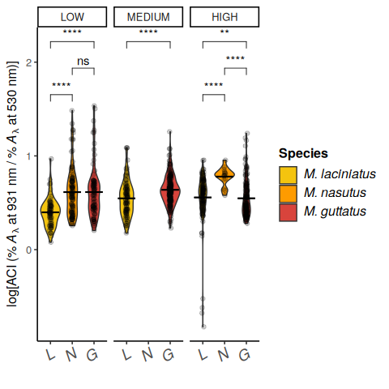

Violin plots of Anthocyanin Content Index (ACI) by species and elevation category.

## 9.1 Figure 3

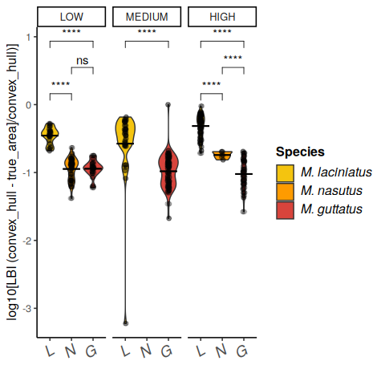

Violin plots of Leaf Lobe Index (LBI) by species and elevation category.

## 9.2 Figure 4

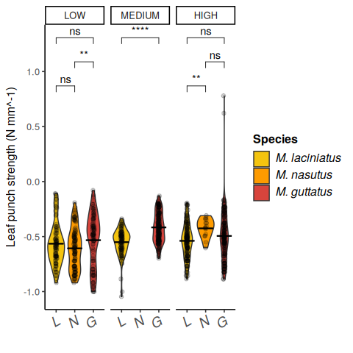

Violin plots of leaf toughness by species and elevation category.

## 9.3 Figure 5

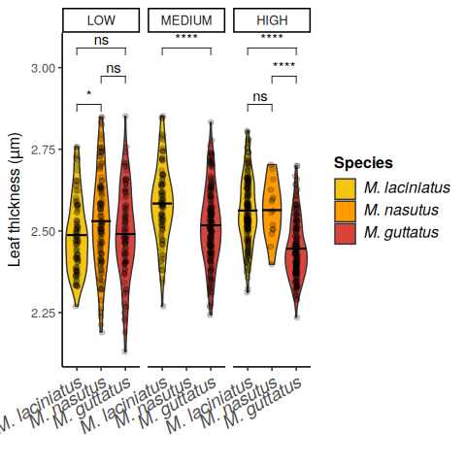

Violin plots of leaf thickness by species and elevation category.

## 9.4 Figure 6

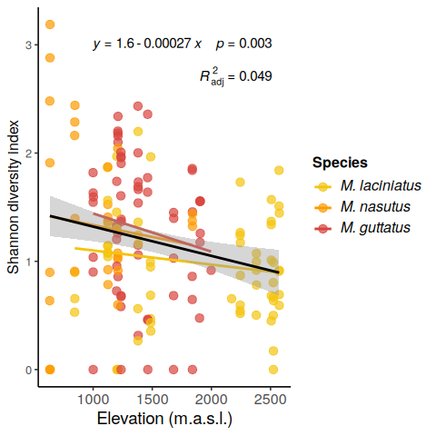

Scatter plots of leaf traits by elevation category.

## 9.5 Figure 7

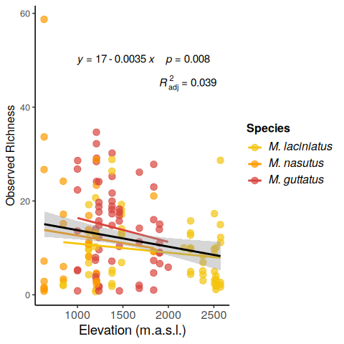

Scatter plot of Shannon diversity by elevation.

## 9.6 Figure 8

## 9.7 Figure 9

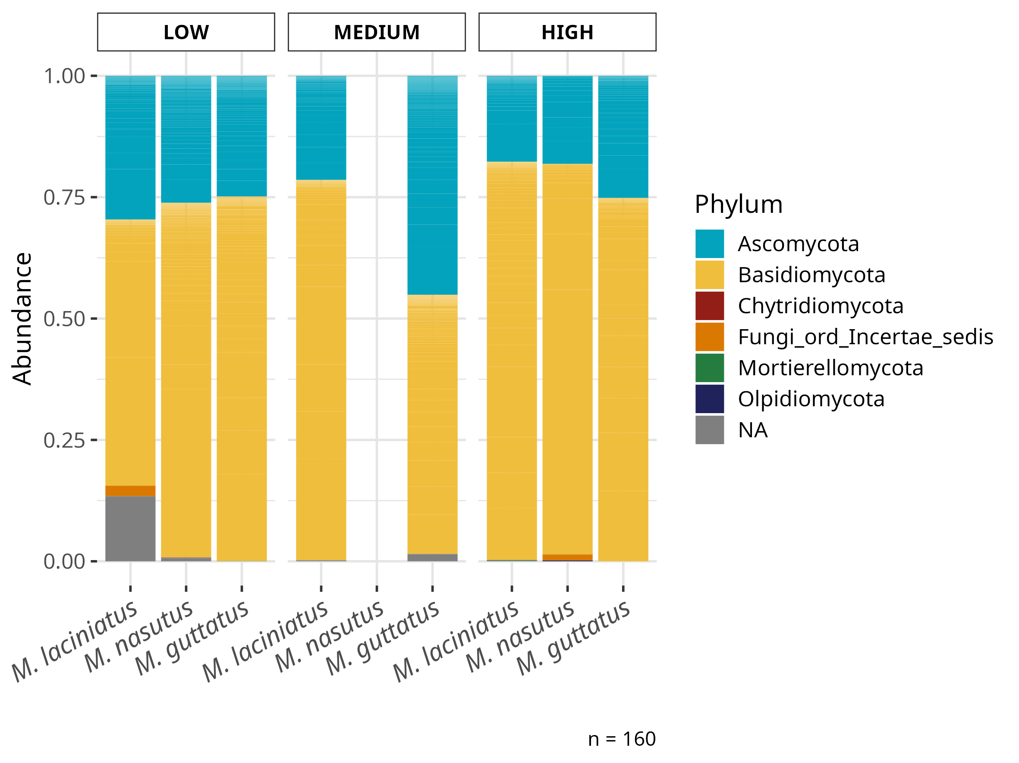

Bar plot of relative abundance of fungal phyla by species and elevation category.

## 9.8 Figure 10

INSERT dbRDA HERE

## 9.9 Figure 11

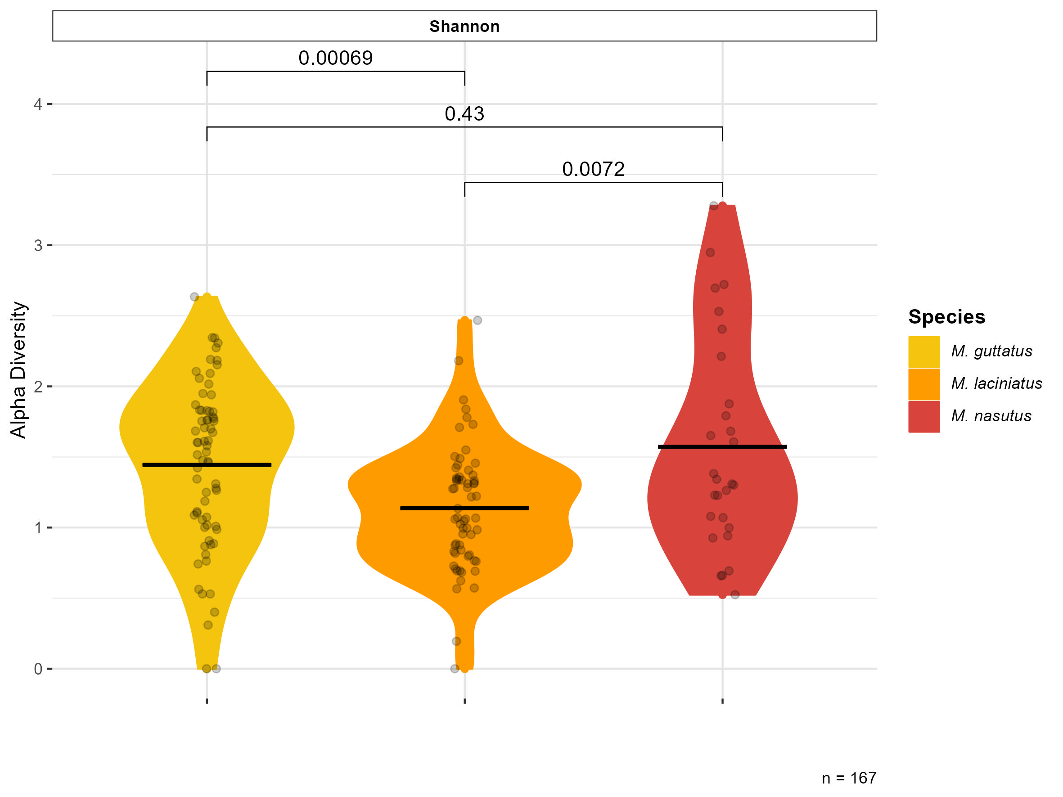

Alpha diversity index by elevation category.

## 9.10 Figure 12

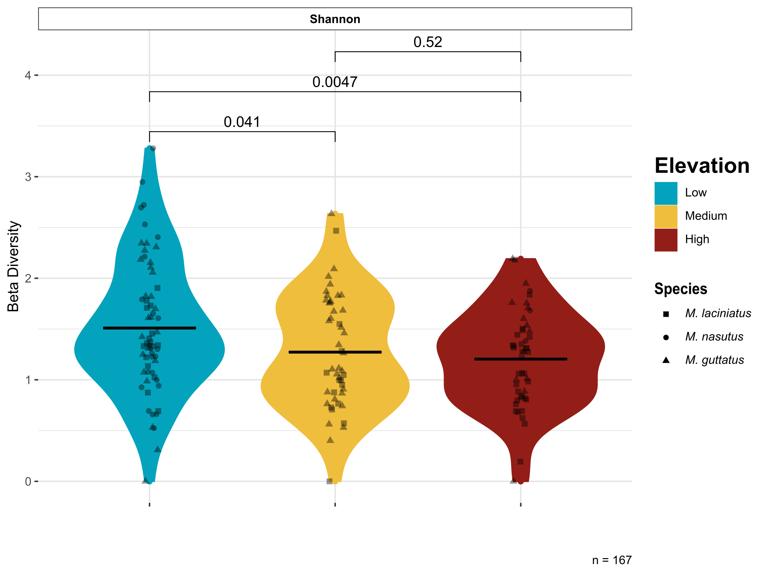

Beta diversity by elevation category.

# 10. Supplementary Material