Actian Vector Schema Conversion Tool Challenge

Verification Guide

## Introduction

The following document will guide through installation and verification of the Actian Vector DB migration tool.

## Setup

1. Actian Vector - I have used an evaluation edition for windows ( <http://esd.actian.com/product/Vector/5.0/Windows_64-Bit/Vector_5.0_Evaluation_Edition/actian-vector-5.0.0-507-eval-win-x86_64.zip/http>)

Used the following Authentication String for trial installing: TCYQYK6Y JMCRM73R CKUNXK7F VDXYS222

1. Actian Vector 32 bit client runtime: <http://esd.actian.com/product/drivers/Client_Runtime/Windows_32-Bit/Client_Runtime>

Note that 32 bit version was used as the reference DB conversion tool (<https://github.com/ActianCorp/dbmv>) is assuming 32 bits.

1. Python 2.7 (<https://www.python.org/download/releases/2.7/>)
2. Ingresdbi – Vector DB driver for Python, it had to be recompiled locally from source code (<https://github.com/grantc/python-ingresdbi>) as the official package download (<https://pypi.python.org/pypi/ingresdbi/2.0.0>) is not working
3. Setup an SQL Azure DB (for the purpose of verification, a test instance with limited/low resources will be provided).
4. Northwind DB is used as a sample for DB migration – already preloaded in the sample Azure DB (<https://northwinddatabase.codeplex.com/downloads/get/269239>)
5. Microsoft® ODBC Driver 13.1 for SQL Server® (<https://www.microsoft.com/en-us/download/details.aspx?id=53339> )

## Verification

### Have the Azure SQL DB prepared (source)

Make sure an existing Azure SQL DB is setup, note that I have used an S0 instance with 10DTUs and 250GB maximum storage (hosted in region US East), the loaded database it’s Northwind DB, sample publicly available

**Important**: In order to use the script against the Azure SQL DB instance I’ve setup, please let me know your IP address in the Topcoder challenge forum so that I can whitelist it. If you are using your own instance, then ignore this.

Here is how the Northwind DB looks like when connecting to Azure SQL DB (using MSSQL Management Studio):

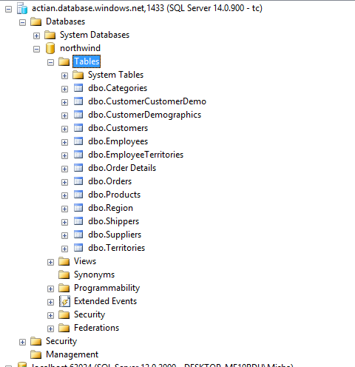

### Create a new DB in Actian Vector (destination)

I have used Actian Director as a tool (included in the Actian Vector installation)

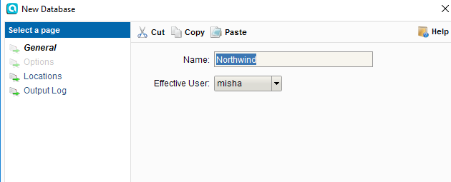

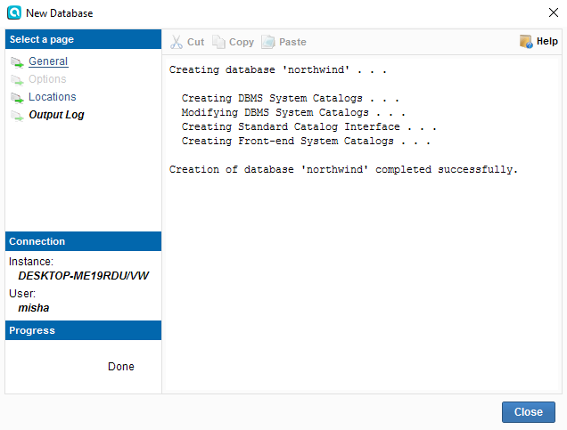

### Run the migration tool

The migration tool is in /dbmv/ folder, and the main python file is bin/dbmv.py. This is a command line tool and below is a sample on how to use it:

The migration is run in 3 steps: tables, data, constraints, to avoid conflicting constraints when inserting data.

Note that the migration tool has defined data types mappings between different DBs in the dbmv.py file. For MSSQL to Vectorwise the mapping is represented beginning with line 358, declared as **ms2vw**.

#### Migrate the schema

Execute the following:

& python dbmv/bin/dbmv.py --src=mssql-odbc://actian.database.windows.net/Northwind?tc"&"T0pcoder --dest=vectorwise://localhost/northwind?misha"&"T0pcoder --cretab --loaddl --quote='\"'

Note that the --loaddl parameter is creating text files with the sql queries that will be run against the destination database (e.g. dbmv_tab.txt for tables)

The console will show the actions that are taken, e.g. table creation:

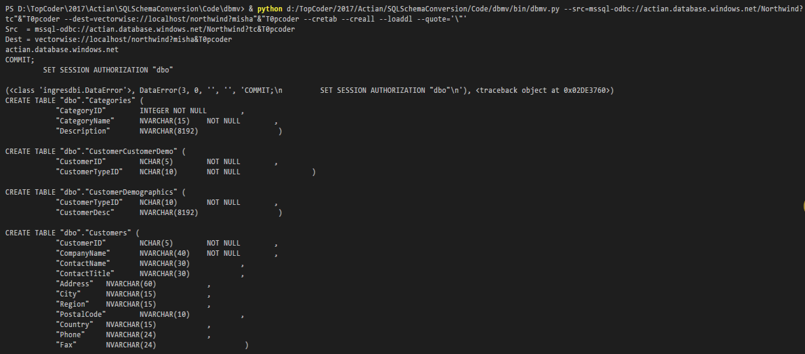

After the scripts are run, login in Actian Director using “dbo” as user and the same password “T0pcoder”. This will allow us to see the created tables. (Note that you might need to create the user by clicking “User->New User” menu item). Not sure why the initial user (‘misha’) can’t access the new DB, I’ve tried a few GRANT clauses, it didn’t worked so I just ended up creating this new user (‘dbo’).

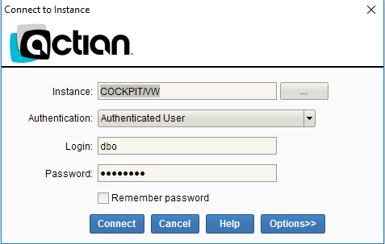

See the table details:

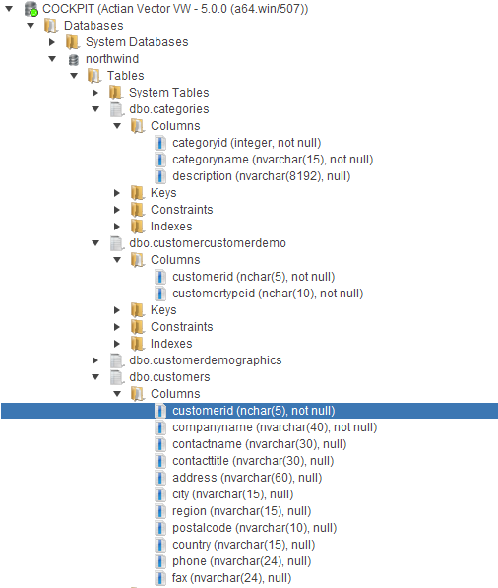

Default column values are populated correctly:

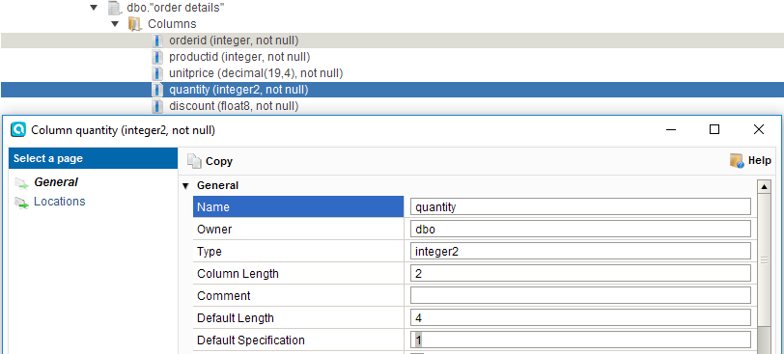

#### Migrate the data

Execute the following script (note that this operation also reads the data from Azure, so there might be delays by waiting to read):

& python dbmv/bin/dbmv.py --src=mssql-odbc://actian.database.windows.net/Northwind?tc"&"T0pcoder --dest=vectorwise://localhost/northwind?dbo"&"T0pcoder --loadata --quote='\"'

Look at the console output:

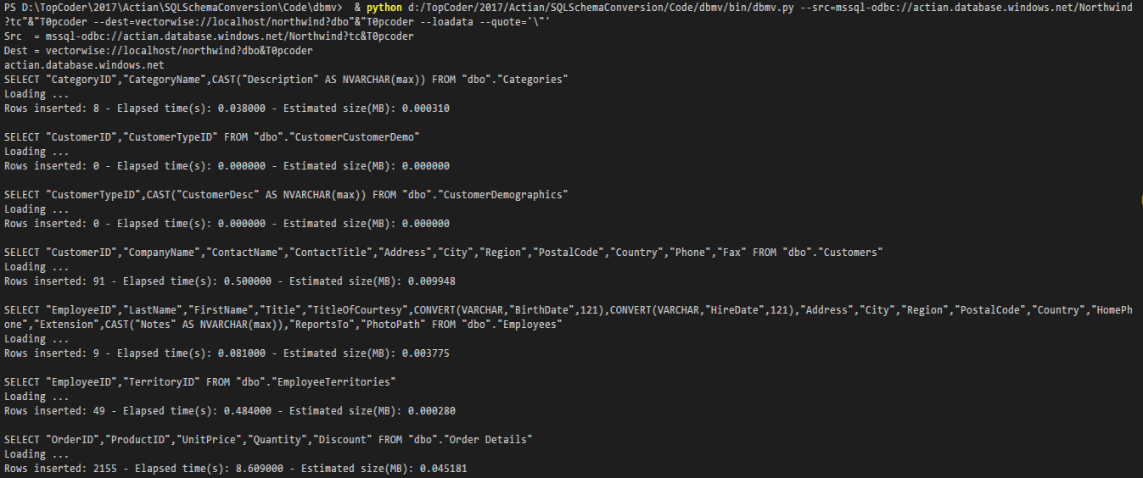

Using Actian Director, login as dbo and run a few select statements to verify the migration:

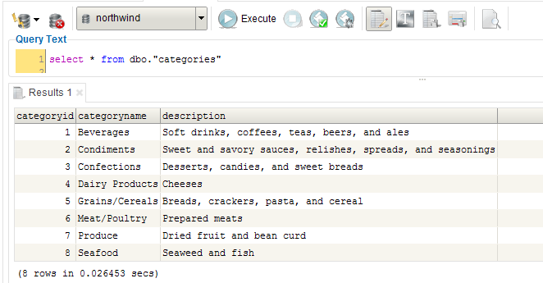

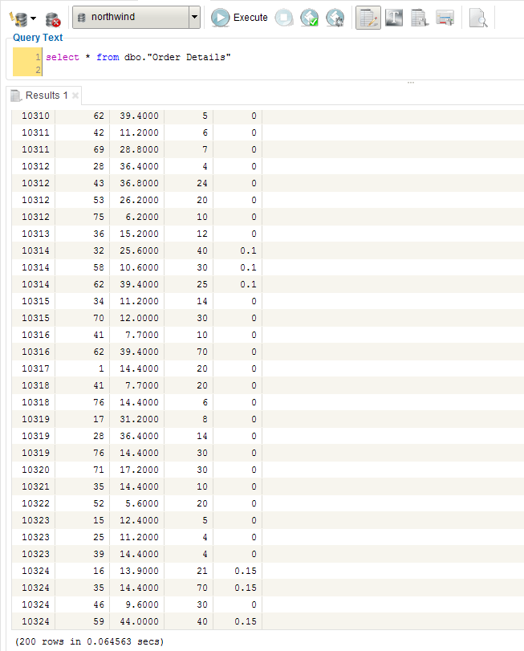

#### Migrate the constraints

Execute the command:

& python dbmv/bin/dbmv.py --src=mssql-odbc://actian.database.windows.net/Northwind?tc"&"T0pcoder --dest=vectorwise://localhost/northwind?dbo"&"T0pcoder --creall --loaddl --quote='\"'

Check the console to see the scripts that are run:

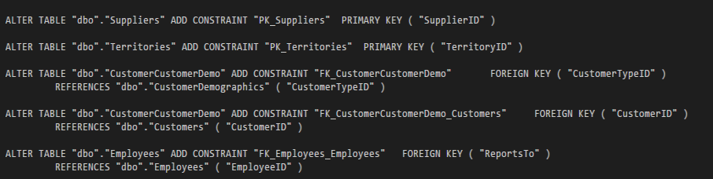

If you check Actian Vector, the constraints are there:

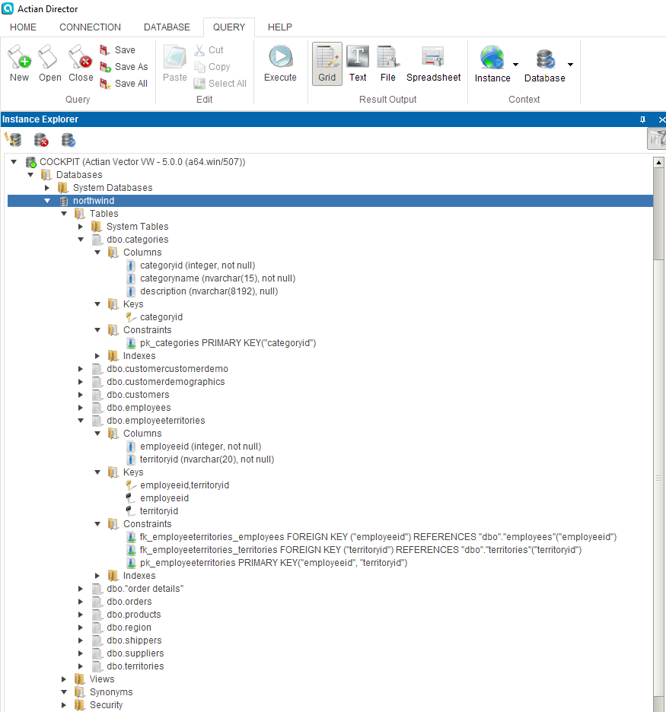

To run the migration steps again, you should first drop the tables:

DROP TABLE "dbo"."Categories";

DROP TABLE "dbo"."CustomerCustomerDemo";

DROP TABLE "dbo"."CustomerDemographics";

DROP TABLE "dbo"."Customers";

DROP TABLE "dbo"."Employees";

DROP TABLE "dbo"."EmployeeTerritories";

DROP TABLE "dbo"."Order Details";

DROP TABLE "dbo"."Orders";

DROP TABLE "dbo"."Products";

DROP TABLE "dbo"."Region";

DROP TABLE "dbo"."Shippers";

DROP TABLE "dbo"."Suppliers";

DROP TABLE "dbo"."Territories";