Signal Detection Theory (SDT) has come to be an invaluable tool to psychology and other disciplines. The underlying theory suggests that a discriminator (be it human, machine classifier, or diagnostic test) detects the presence of a signal buried in noise. The performance of the discriminator is usually described in terms of sensitivity and response bias. Sensitivity describes how well the signal + noise distribution is segregated from the noise distribution. Response bias or decision bias describes systematic over- or underestimation in the probability of an event.

In signal detection theory, a gamut of metrics have been devised to assess sensitivity and response bias. The classic metrics are parametric in that they assume Gaussian noise distributions with equivalent variance between the noise and signal + noise distributions. For sensitivity, the *gold standard* parametric measure is d’. The classic parametric measure of response bias is beta, but has been supplanted by c. beta has been shown to be dependent of d’. When the parametric assumptions of c do not hold a non-parametric alternative is needed. In the literature a variety of measures are available, including but not limited to: $B^{'}H$, $B^{''}$, and $B^{''}d$. Of these $B^{''}d$ is the most highly recommended. It’s creator and origins stem from memory recognition research but in an empirical comparison it was found to be the best nonparametric measure with vigilance experiments. $B^{''}d$ is calculated from hit and false alarm rates and is well behaved over most of its domain. The exception being at the hit and false alarm rates boundaries $B^{''}d$ loses sensitivity. The plot below depicts $B^{''}d$ versus *c*. The 121 points reflect factorial combinations of hit rates between 0 and 1 at .1 increments and false alarm rates between 0 and 1 at .1 increments.

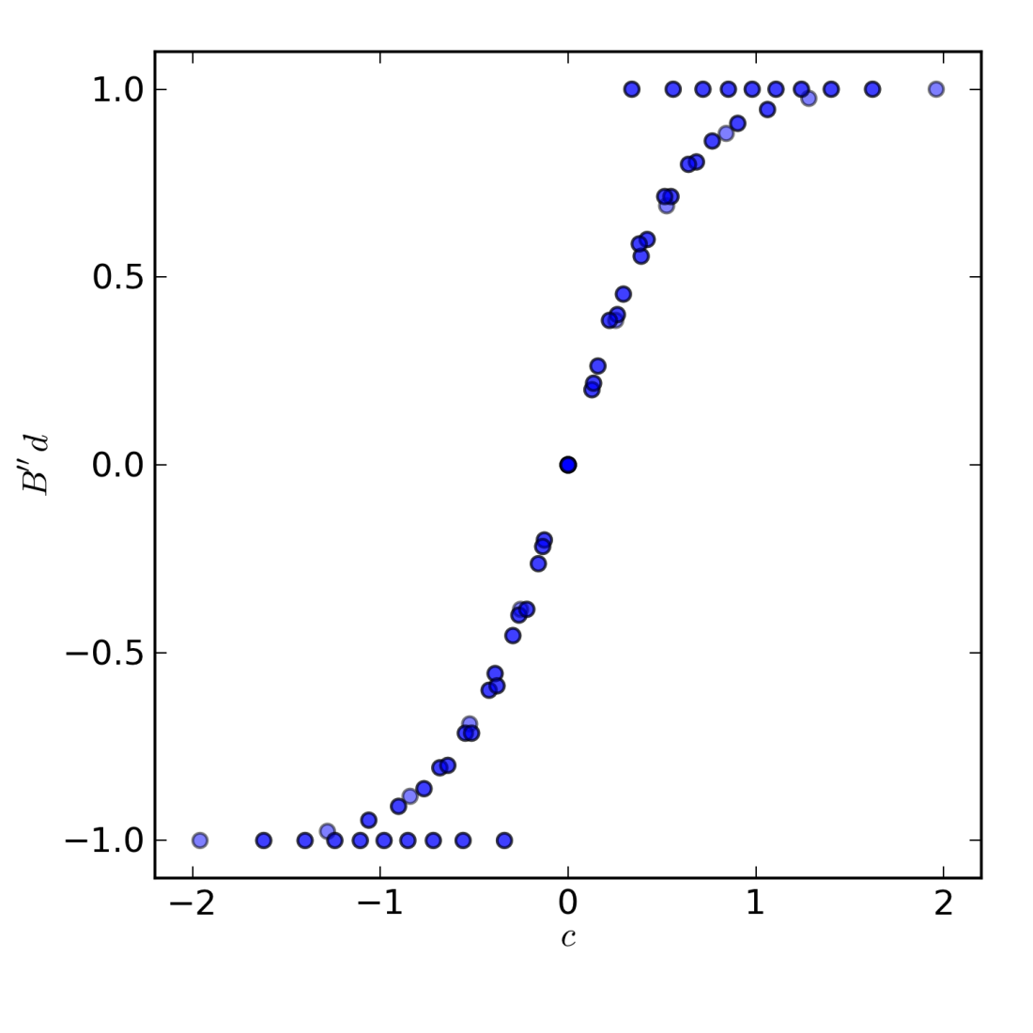

The formula for $B^{''}d$ reveals some insight into this phenomena. $B^{''}d$ is a function of $pHI$ and $pFA$ (hit rate and false alarm rate respectively) and is given by,

$$B^{''}d(pFA, pHI)=\frac{\left(1-pHI\right)\left(1-pFA\right)-pHI*pFA}{\left(1-pHI\right)\left(1-pFA\right)+pHI*pFA}$$

where,

$$pHI=HI/(HI+MI)$$

$$pFA=FA/(CR+FA)$$

When both $pHI=0$ and the $0 <pFA<1$ the above simplifies to,

$$B^{''}d(0 <pFA<1, pHI=0)=\frac{\left(1-pFA\right)}{\left(1-pFA\right)}=1$$

Regardless of the actually false alarm rate $B^{''}d$ yields 1. An valid measure of response bias should correlate with the false alarm rate under these circumstances.

Similarly when $pFA=0$ and the $0 <pHI<1$ the formula simplifies to, $$B^{''}d(pFA=0, 0 <pHI<1)=\frac{\left(1-pHI\right)}{\left(1-pHI\right)}=1$$

and the measure does not reflect differences in hit rate.

Another problem occurs when $pHI=1$ and the $0 <pFA<1$,

$$B^{''}d(0 <pFA<1, pHI=1 )=\frac{-pFA}{ pFA}=-1$$

and when $pFA=1$ and the $0 <pHI<1$: $$B^{''}d(pFA=1, 0 <pHI<1)=\frac{-pHI}{ pHI}=-1$$

Here a correction to $B^{''}d$ is suggested. When calculating d’ a common treatment of extreme values is to apply a loglinear transformation to the hit rate and false alarm rates (Hautus, 1995). The transformation calculates hit rate $pHI'$ as,

$pHI^{'}=(HI + 0.5) / (HI + MI+ 1)$

and $p{FA}^{'}$ as,

$p{FA}^{'}=(FA+ 0.5) / (FA + CR+ 1)$

The effect is that the rates are compressed but maintain interval scaling. The loglinear corrected values of dprime will always be of slightly lower magnitude due to the compression but the result is a well accepted measure of sensitivity. Similar treatments also apply to *β* and *c*. Here, I suggest the loglinear transformation can be applied to $B^{''}d$ to correct the boundary condition problems describe above and the consequences to non-boundary values of $pHI$ and $pFA$ are negligible.

The following scatter matrix demonstrates how the loglinear transformation corrects the boundary of $B^{''}d$. It also demonstrates that over most of its range $B^{''}d$ and the loglinear $B^{''}d$ are highly correlated.

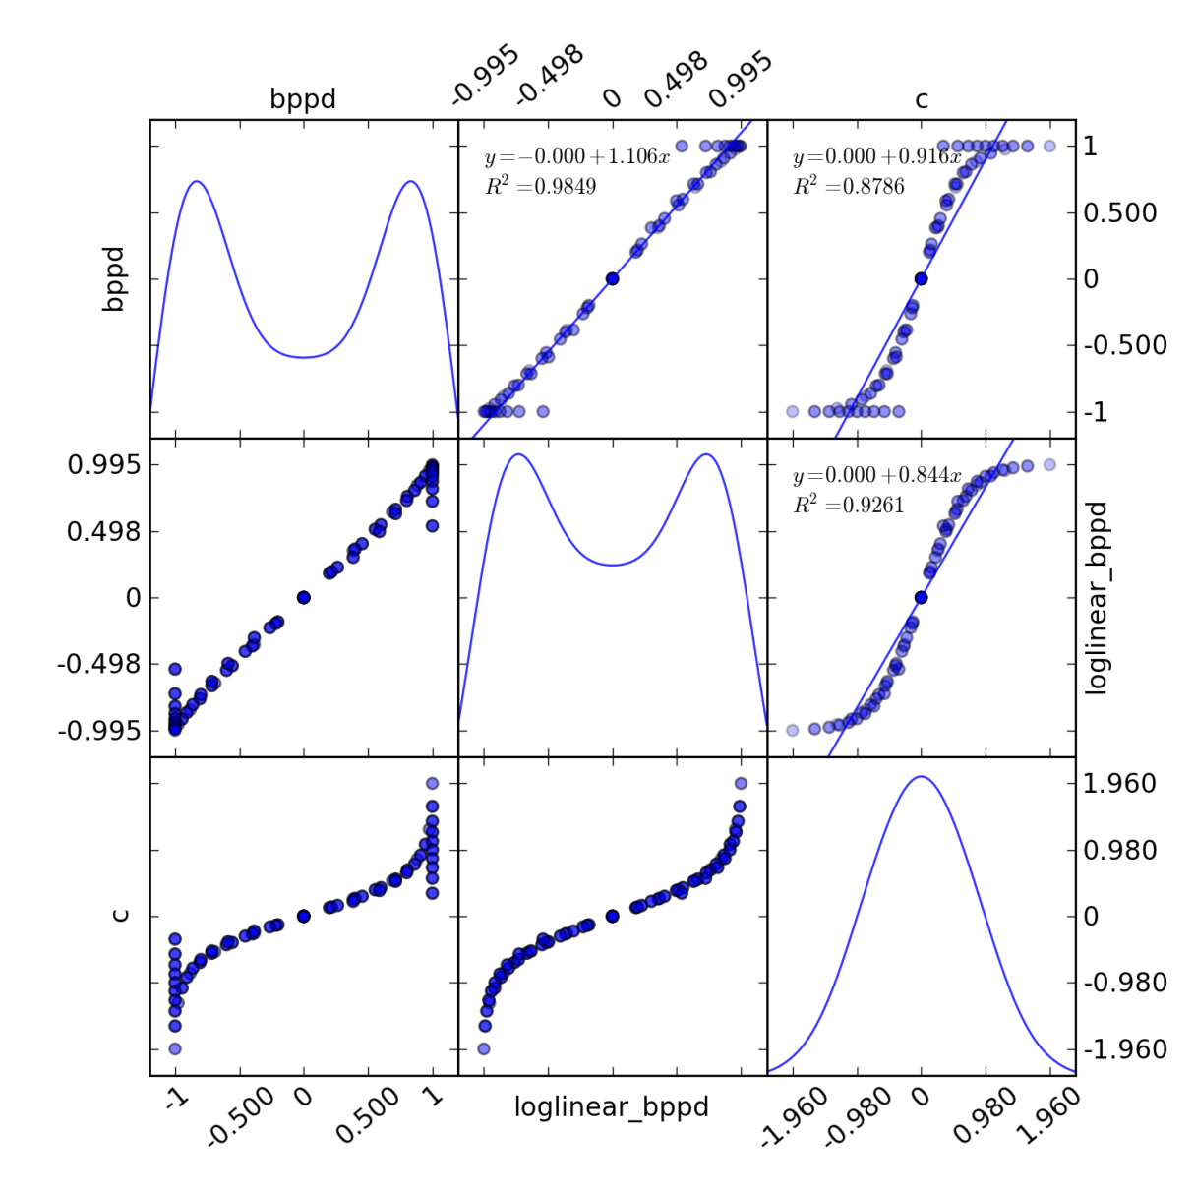

With $B^{''}d$ applying the transformation alleviates the boundary sensitivity problems. Examining $B^{''}d(pFA, pHI)$ (bppd) and $B^{''}d(pFA', pHI')$ (bppdp) in ROC space provides further reassurance.

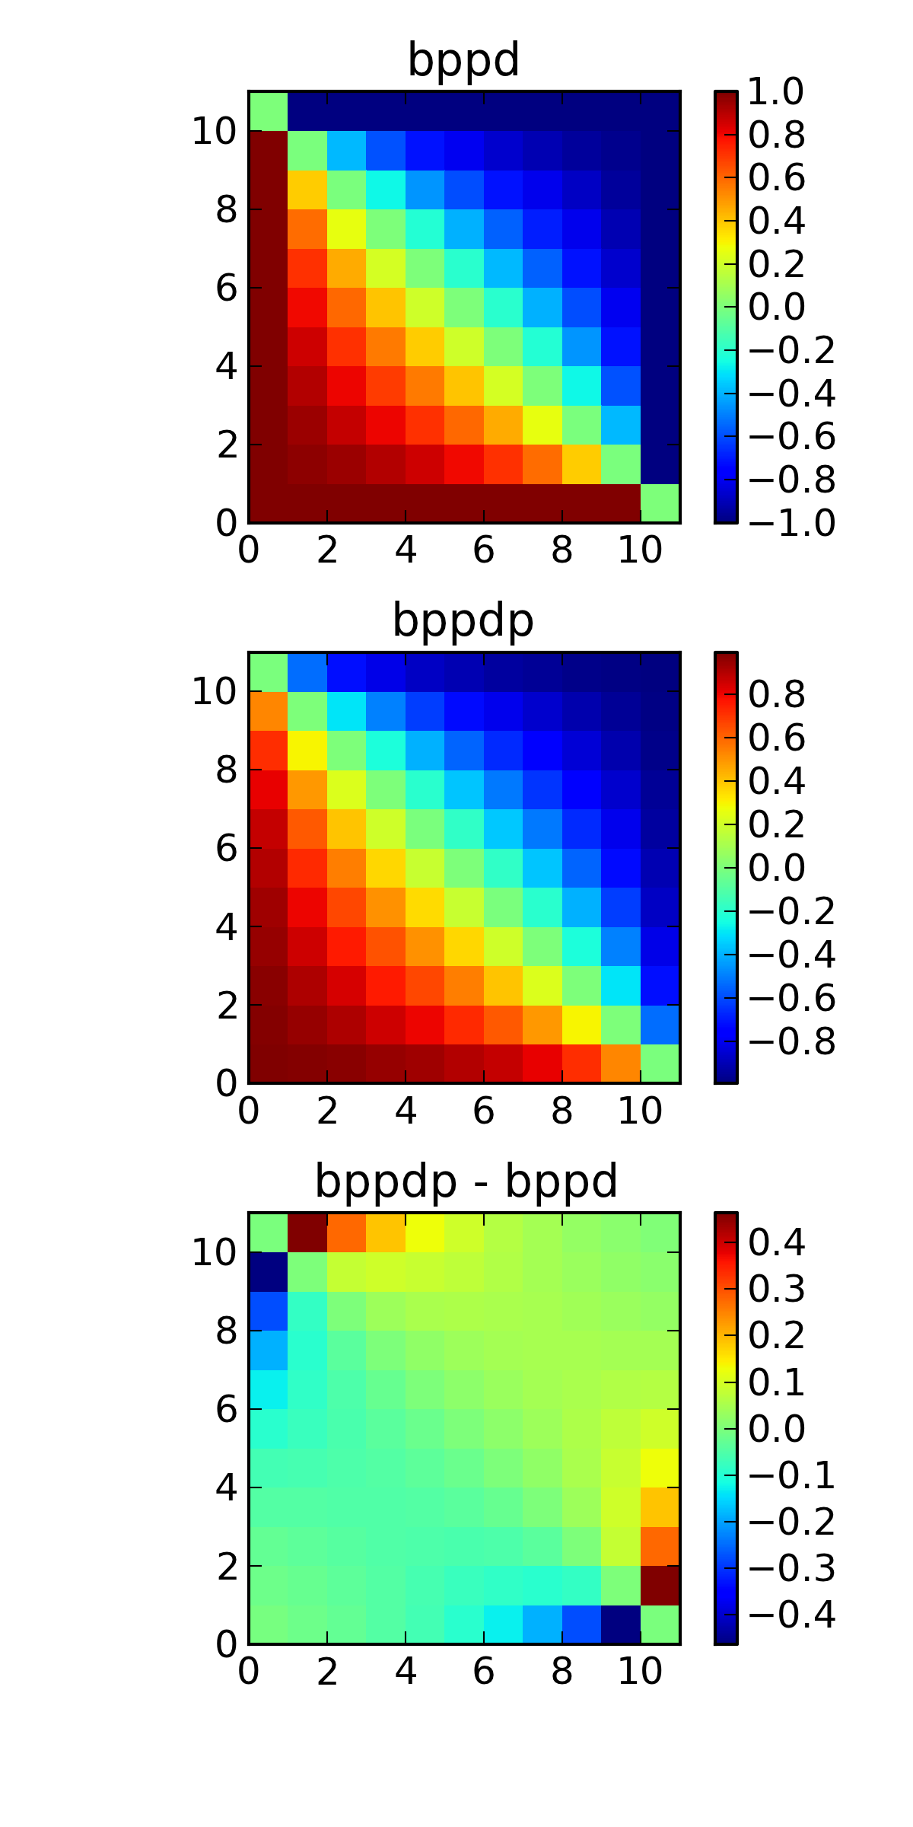

The x and y axes are showing false alarm counts and hit counts respectively.

Addendums

The new measure asymptotically approaches -1 when the observed hit rate is 1 and the observed false alarm rate is 1 as the number of events increases, and asymptotically approaches 1 when the observed hit rate is 0 and the observed false alarm rate is 0. In the above figure, note that loglinear_bppd has a maximum value of .995 while bppd has a maximum of 1.

$B^{''}d$ reaches its maximum when the observed hit rate is zero and the observed false alarm rate is also zero.

$B^{''}d_{max}=B^{''}d\left(pHI_{min},p{FA}_{min}\right)$,

where,

$pHI_{min}=\frac{1}{2(HI+MI+1)}$

$p{FA}_{min}=\frac{1}{2(CR+FA+1)}$

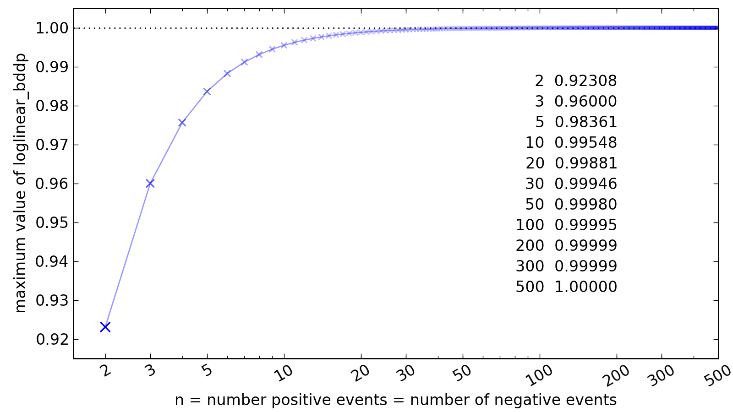

Bias to non-equivalent prevalence

When the prevalence rate is 50% the response bias is as expected to an observed hit rate of 1 and false alarm rate of 0 is the prevalence rate shifts from 50% the response bias also shifts:

>>> # HI, MI, CR, FA

>>> loglinear_bppd(10, 0, 10, 0)

-3.9981245827275e-16

>>> loglinear_bppd(10, 0, 11, 0)

0.045454545454545026

>>> loglinear_bppd(10, 0, 12, 0)

0.08695652173912993

>>> loglinear_bppd(10, 0, 13, 0)

0.12499999999999958

>>> loglinear_bppd(10, 0, 14, 0)

0.15999999999999956

The loglinear transformed false alarm rates decrease in proportion to the loglinear hit rate the bias shifts quite quickly because the isopleths in this region of ROC space are particularly steep.

This also occurs with loglinear_c although the isopleths are not quite as problematic:

>>> loglinear_c(10,0,10,0)

-1.0436096431476471e-14

>>> loglinear_c(10,0,11,0)

0.020521384119198904

>>> loglinear_c(10,0,12,0)

0.0391017058301415

>>> loglinear_c(10,0,13,0)

0.056060731747756054

>>> loglinear_c(10,0,14,0)

0.07164650351337443

Sometimes the distinction between a *bug* and a *feature* is solely in the documentation.