**UI Design Diagrams**

1. Homepage: ‘ ’

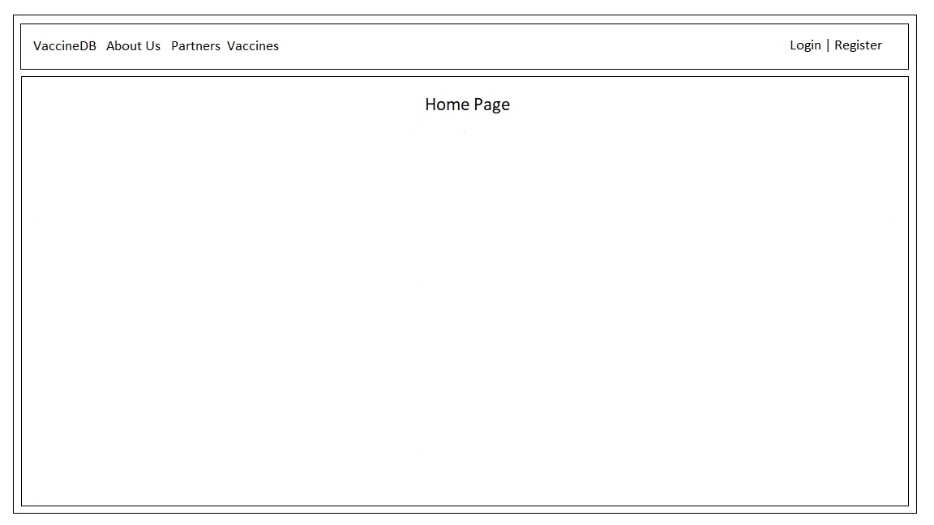

1. About Us: ‘about’

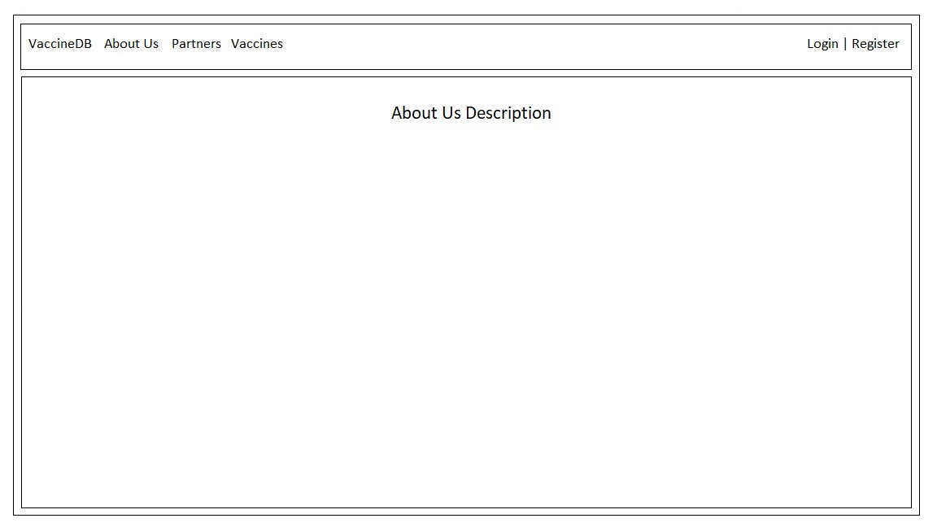

1. Partners: ‘partners’

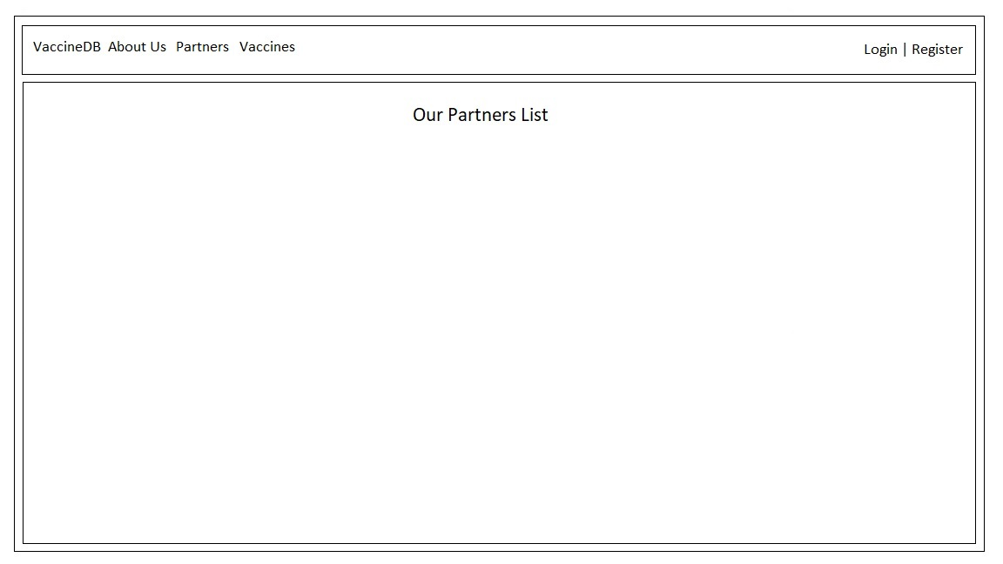

1. Vaccines: ‘vaccines’

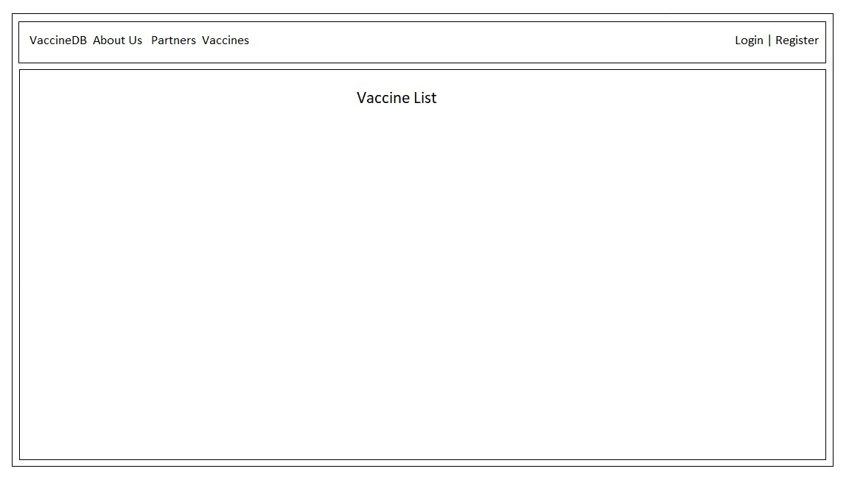

1. Sign In: ‘signin’

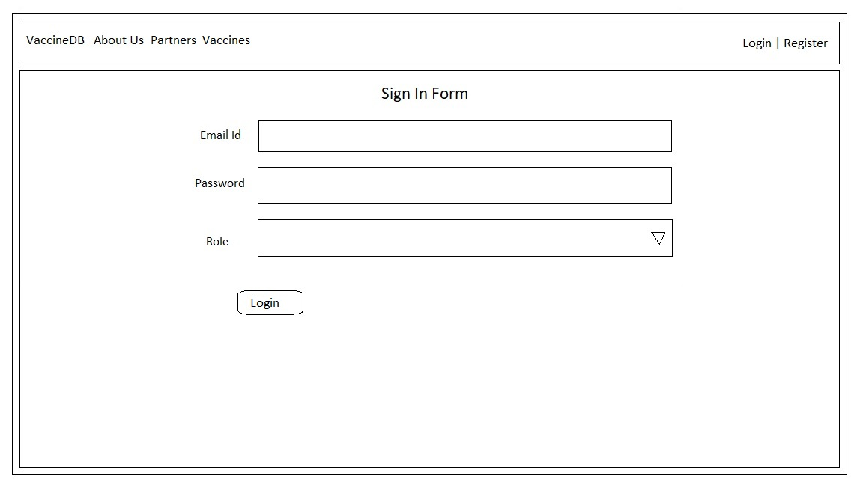

1. Register: ‘register’

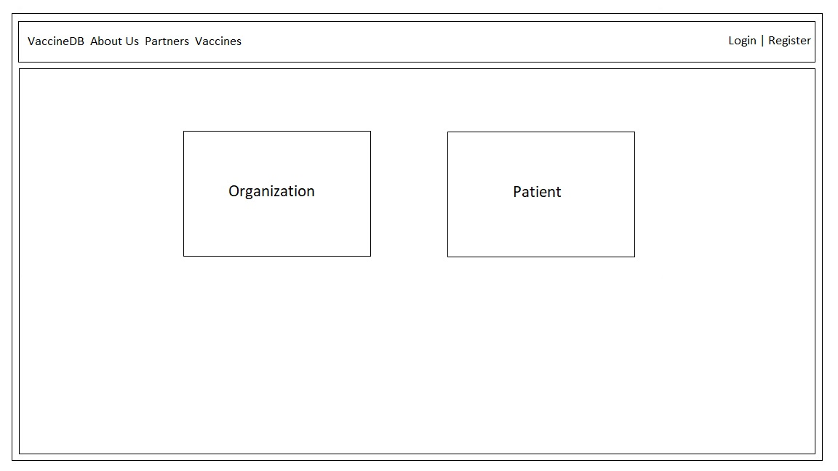

1. Organization Sign up: ‘register/org’

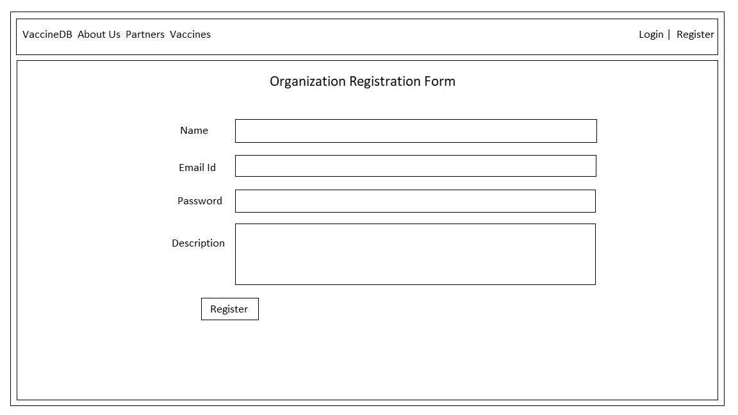

1. Organization home: ‘home/org’

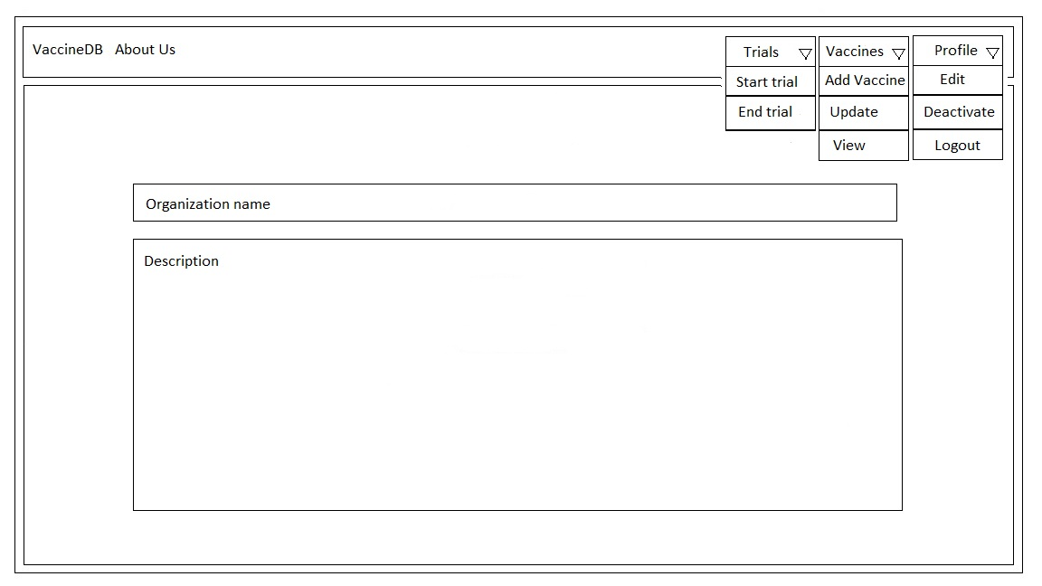

1. Organization Start Trial: ‘start/trial’

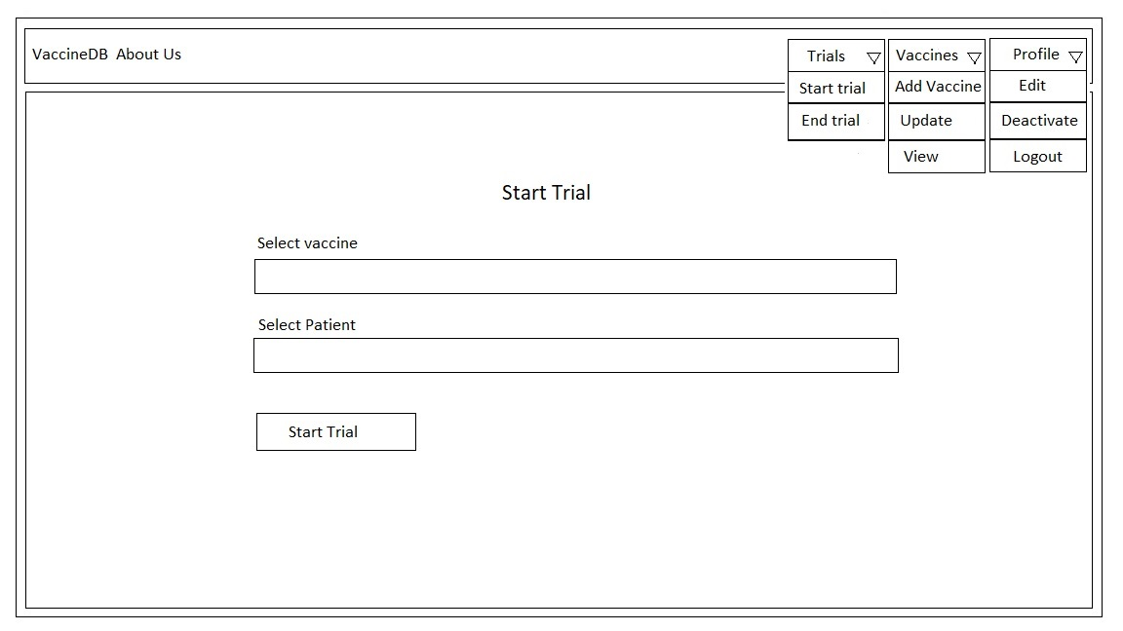

1. Organization End Trial: ‘end/trial’

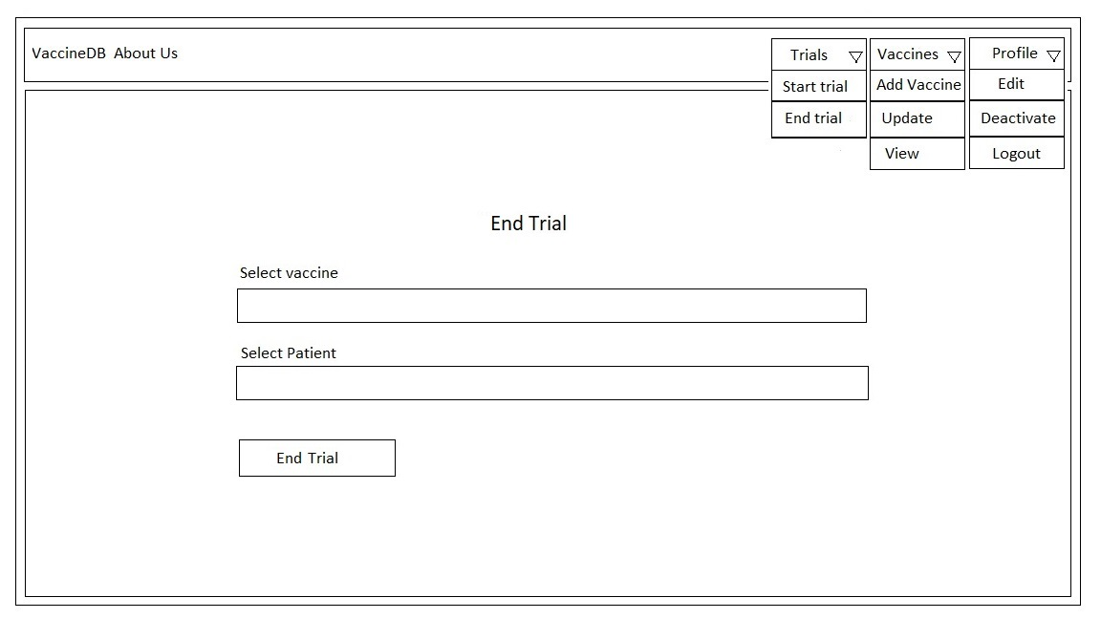

1. Organization Add Vaccine: ‘org/vacc/add’

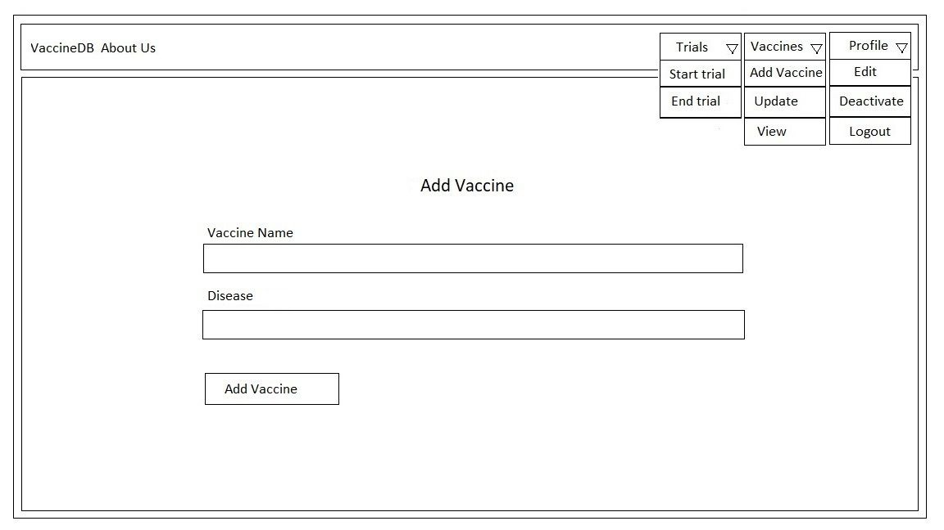

1. Organization Update Vaccine: ‘org/vacc/edit’

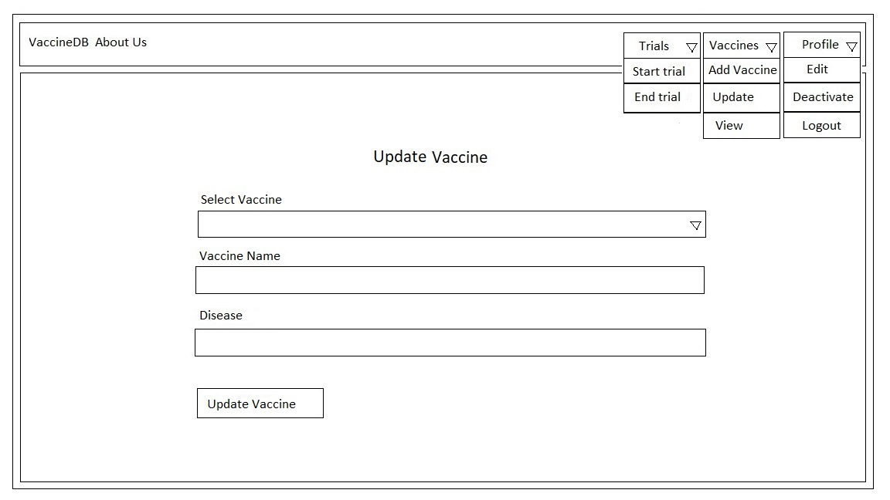

1. Organization View Vaccines: ‘org/vacc’

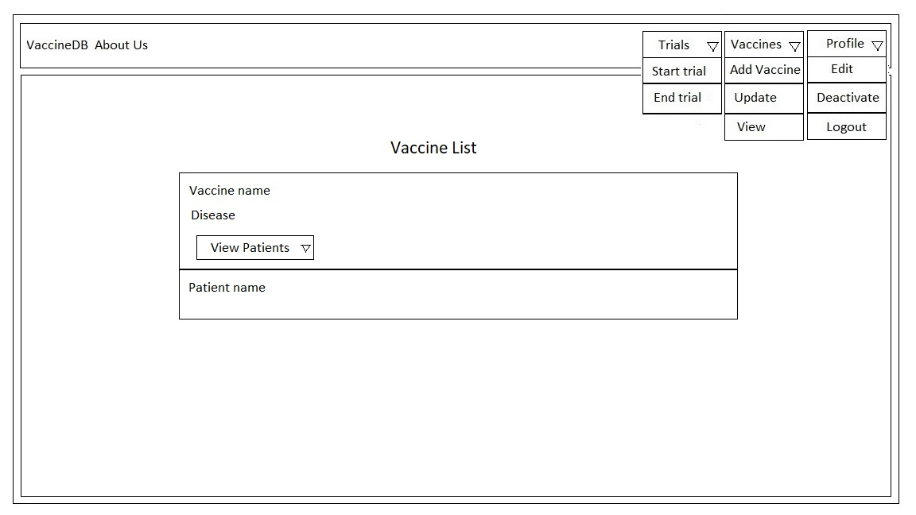

1. Organization Edit Profile: ‘edit/profile/org’

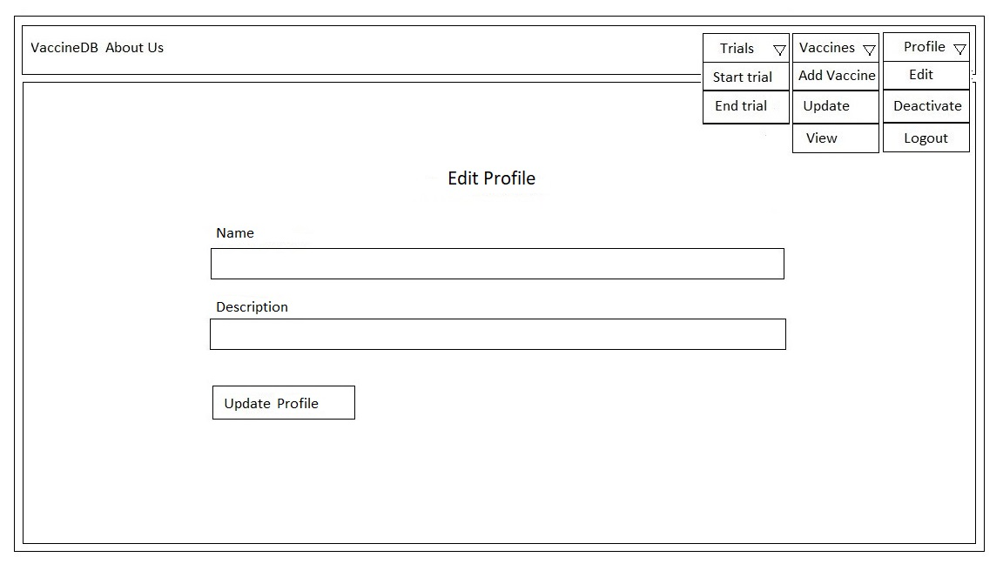

1. Organization Deactivate Profile: ‘delete/org’

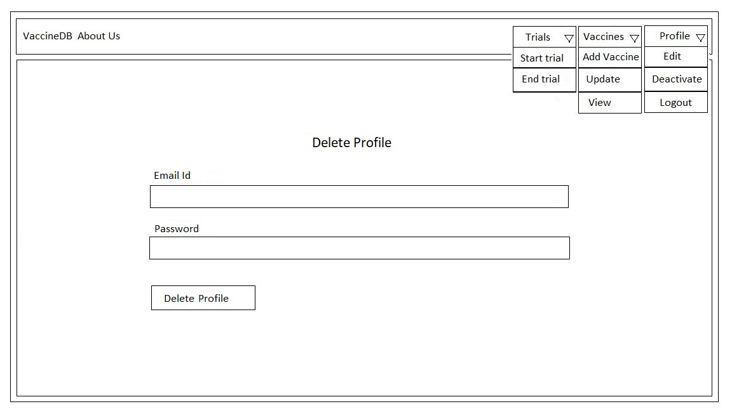

1. Patient Sign Up: ‘register/patient’

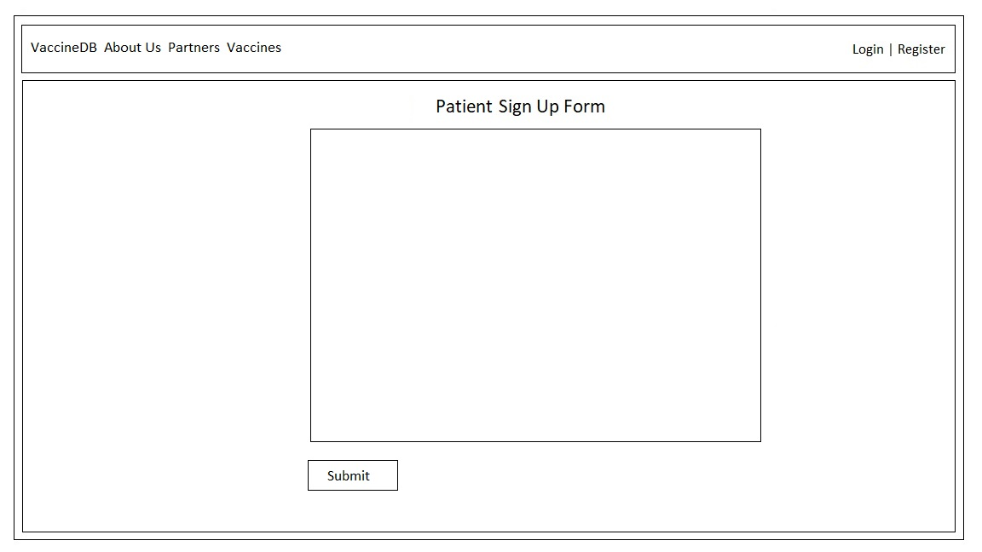

1. Patient Home: ‘home/patient’

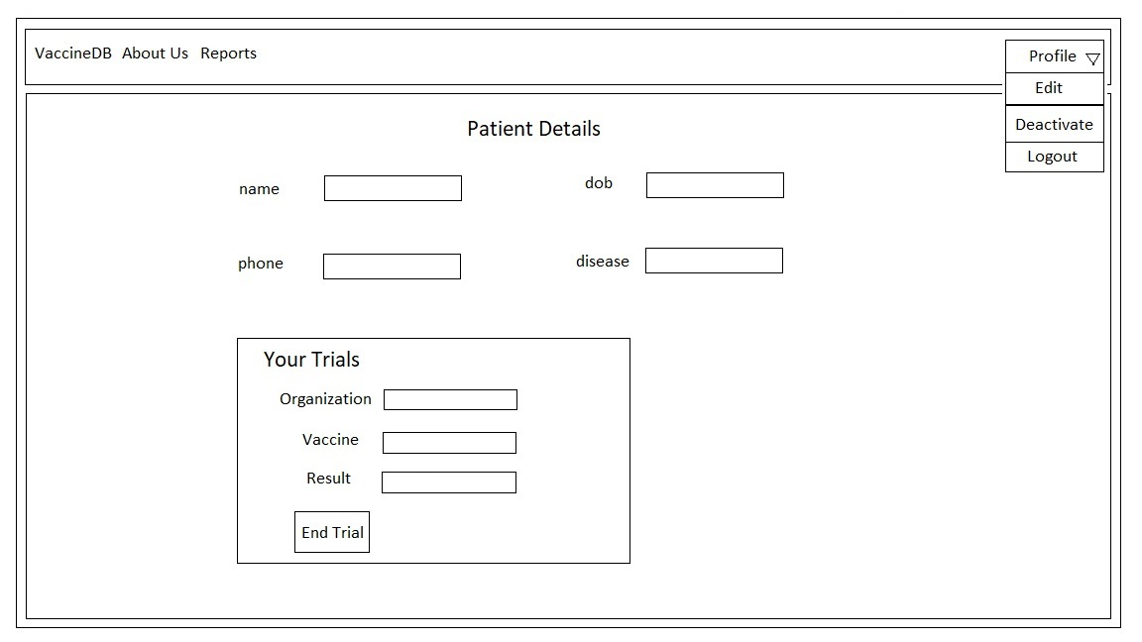

1. Patient Reports: ‘report/patient’

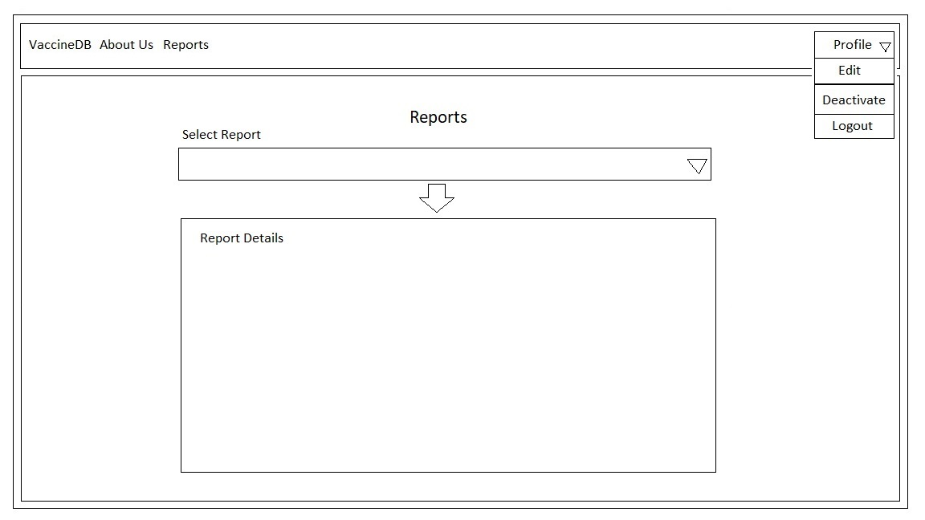

1. Patient Edit Profile: ‘edit/profile/patient’

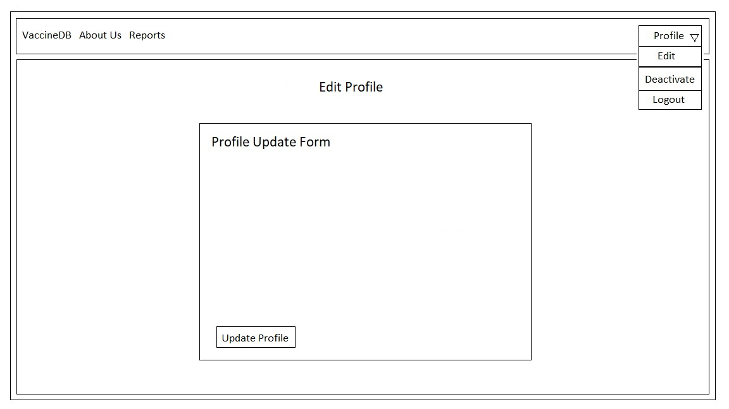

1. Patient Deactivate Profile: ‘delete/patient’

