****************

Task App Tutorial

****************

Slac Chat :

First we need to make sure that the server and client sides of the application have python 3.6 installed, as well as all the namespaces (modules, libraries) used by the application.

A tool useful for this purpose is PIP (https://pypi.org/project/pip/). It will make package installation quick and easy.
Once we have PIP we have to simply run the command “pip install -r ‘server_requirements.txt’”. The same needs to be done for the client side: “pip install -r ‘client_requirements.txt’”

Slac Chat Application Manual:

In order to to use the program, the server side of the app must be running previously starting the client side.

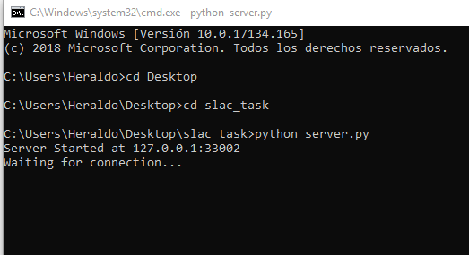

Then any client who wants to chat can start their local client-side app.

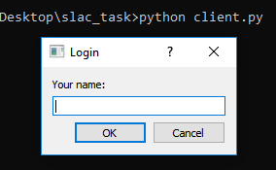

Client app first window asks for login name and automatically tries to connect with server-side.

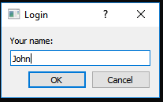

User login name will be available on the superior bar of the chat interfaces.

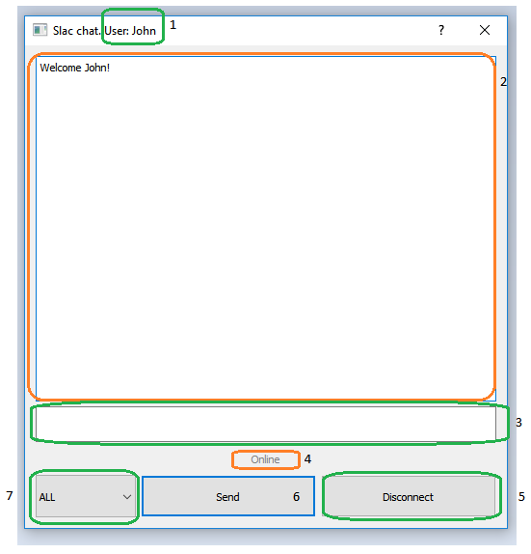

#1) User name. 2) chat output. 3) chat input. 4) connexion status.
5)Connection/Disconnection button. 6)Send message button.
7)Message receiver.list.

Any online user will be added to combo box menu of the user chat interface.
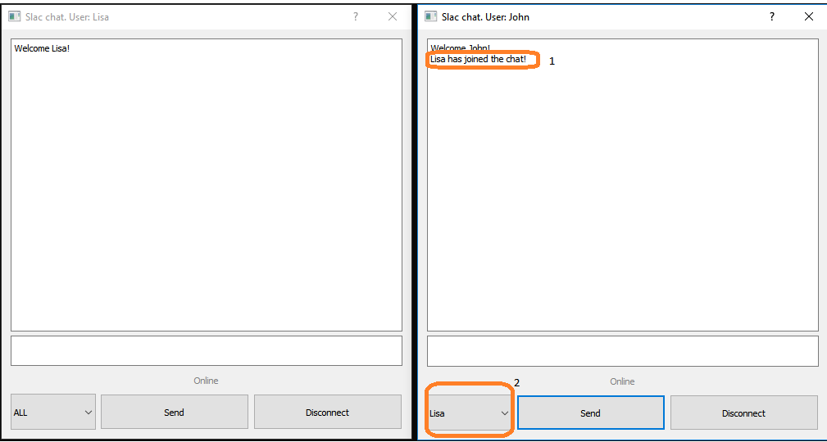

1)Message announce new user connected..
2) new user is added to the receiver list selection for private communication.

User may send a general message or a particular message to any user.

Particular messages are shown with an extra header on the message. So the user may tell when conversation is private.

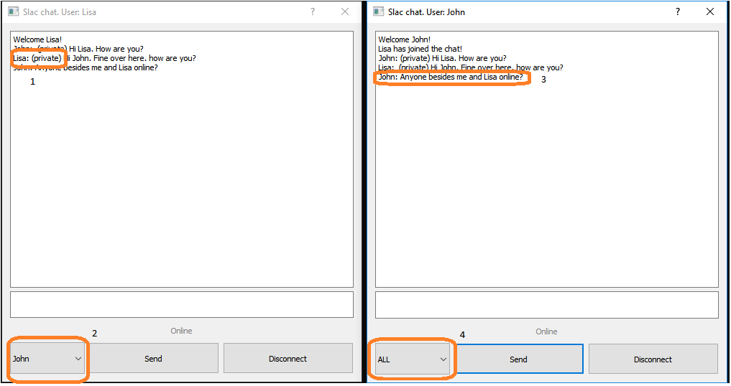

1)Private message in chat. 2) Particular user selected for particular message.
3) Broadcast message (no header) in chat. 4) All users selected for a broadcast message.

