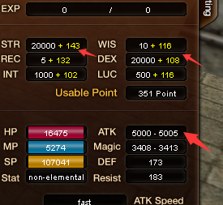
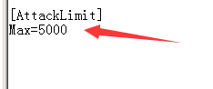
I have no idea how to fix the attack power bug,bcz I can not catch it
If I can catch I am sure I can fix,so this just a tempora method

