# 1 Setup Database

Microsoft SQL Server Management Studio:

Make sure that NETWORK SERVICE has Login access to the server by running the below query;

sp_grantlogin 'NT AUTHORITY\NETWORK SERVICE'

## Procedure for setting up the db

See the following video: <http://www.dotnetnuke.com/portals/25/videos/DNNTestConfig/TestingConfiguration.html>

Or follow the procedure specified below:

Create the DB:

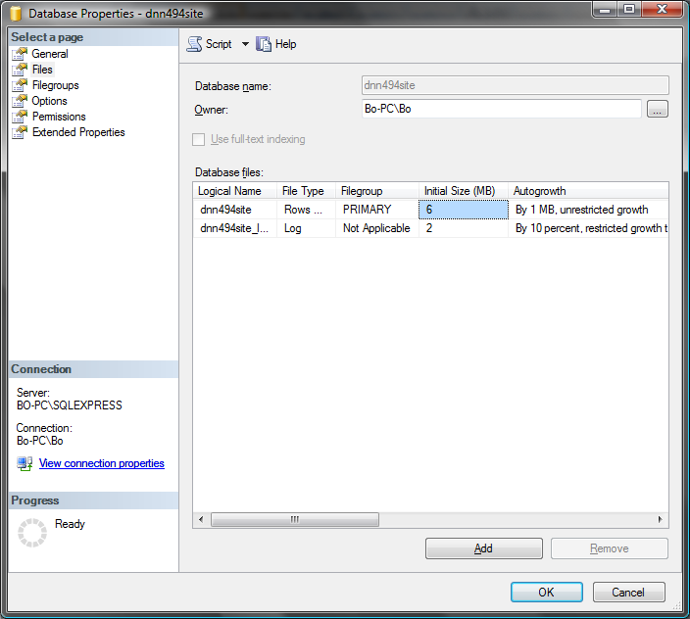

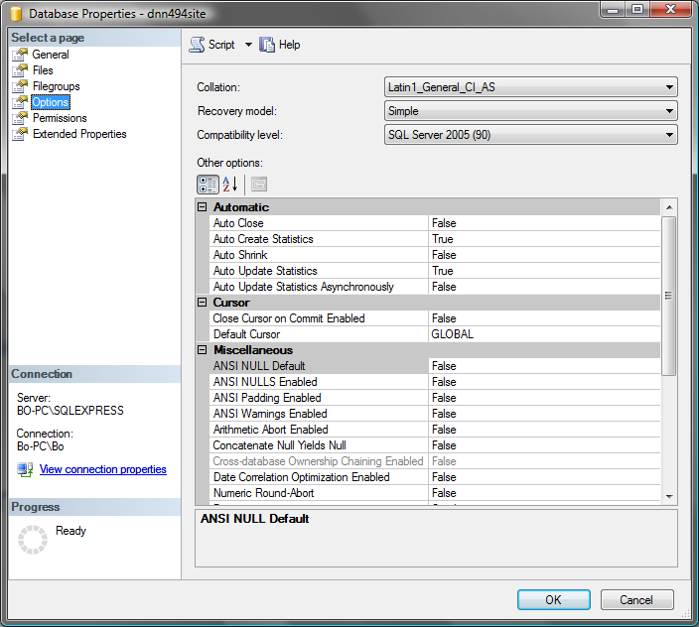

Create the Schema

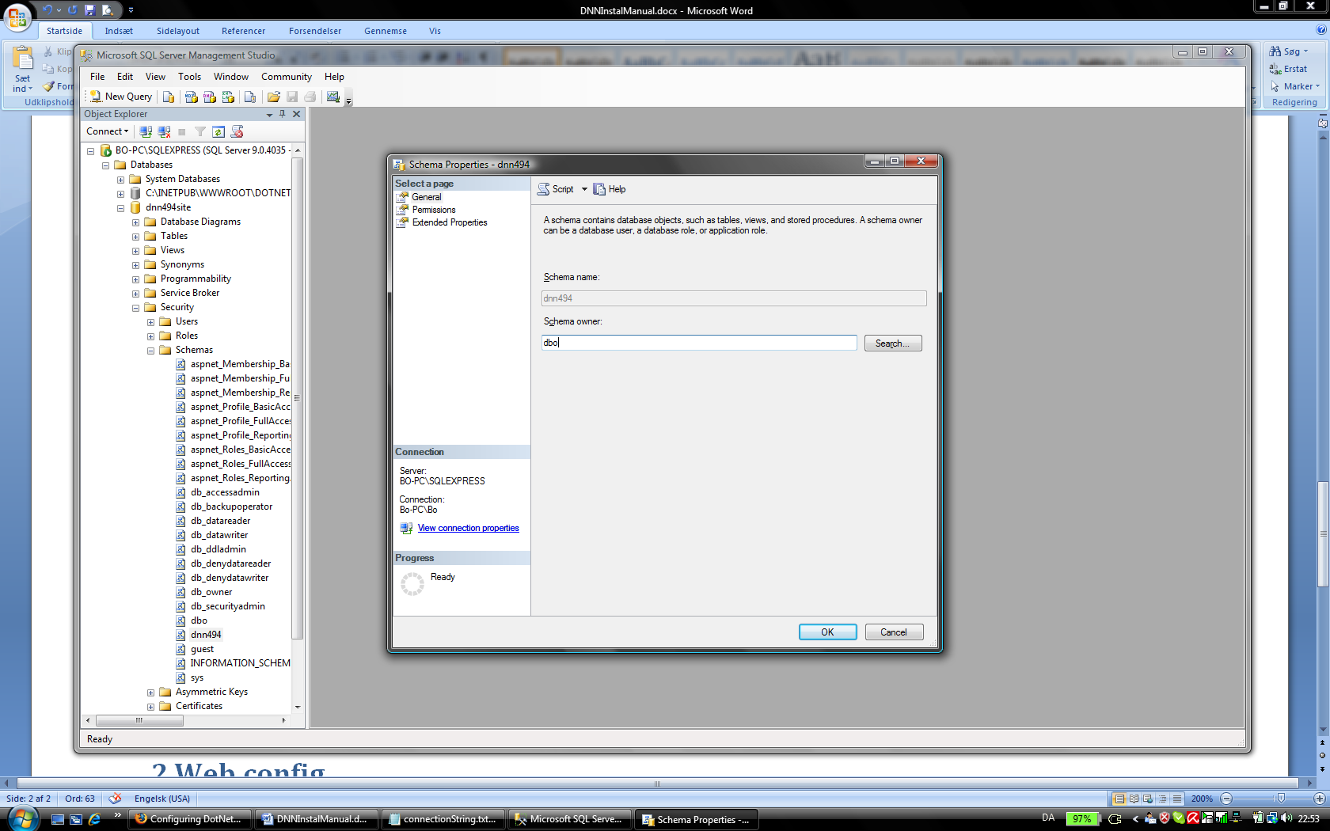

Create the following login:

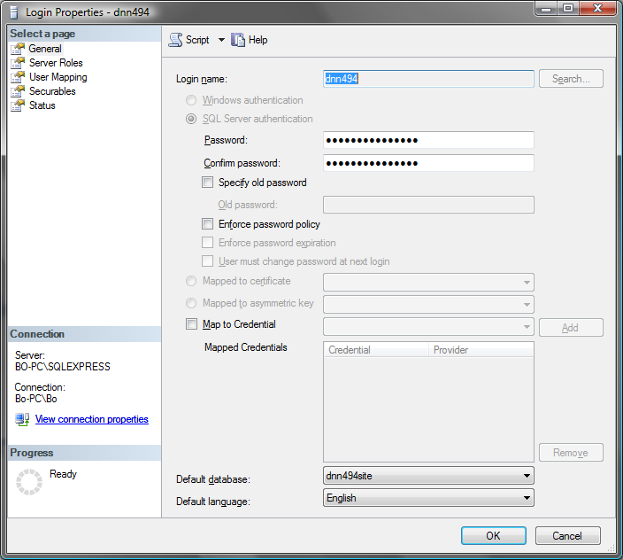

Set the permission.

NOTE: in DNN440 – DNN45X you need to check the db_owner during install. See here: http://www.dotnetnuke.com/Community/Forums/tabid/795/forumid/107/threadid/93768/scope/posts/threadpage/2/Default.aspx

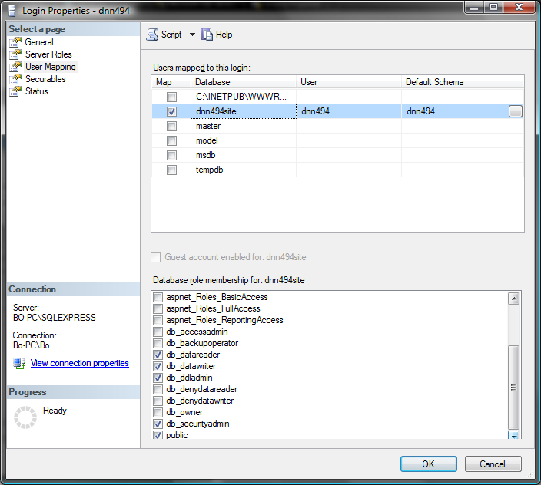

Finally change the Schema owner to the now created login:  
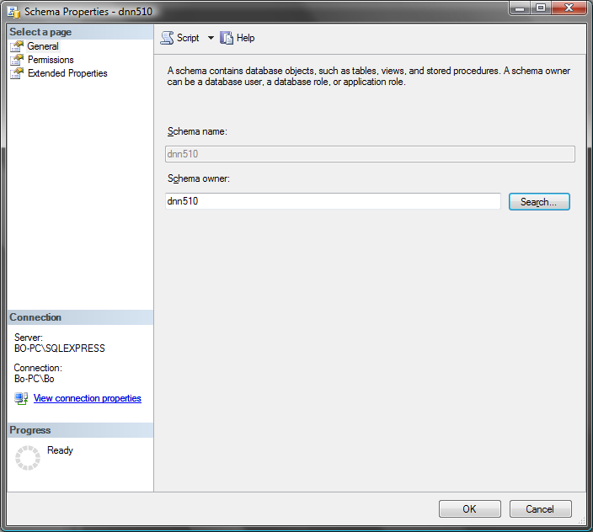

Grant Execute permissions to the user:

Right click on the database and select “Properties” from the pop-down menu.   
In the opened window select “Permissions” from the left hand menu.  
Then scroll down the list of permission and check the “Execute” option.

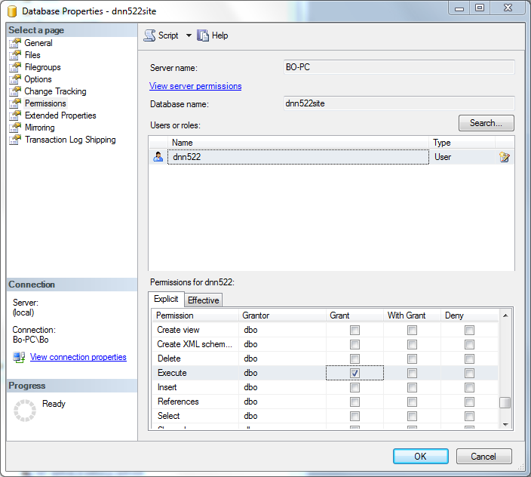

# 2 Web.config

In the web.config file insert the following connection string under the connectionstring tag:

<connectionStrings>

<!-- Connection String for SQL Server 2005 Express -->

<add name="SiteSqlServer" connectionString="Data Source=(local);Initial Catalog=dnn494site;User ID=dnn494;Password=dnn494" providerName="System.Data.SqlClient" />

Under the appsettings tag insert:

<appSettings>

<!-- Connection String for SQL Server 2005 Express - kept for backwards compatability - legacy modules -->

<add key="SiteSqlServer" value="Data Source=(local);Initial Catalog=dnn494site;User ID=dnn494;Password=dnn494" />

Change the forms name and the cookie names to allow for multiple installs:

<!-- Forms or Windows authentication -->  
<authentication mode="Forms">  
<forms name=".*FF*DOTNETNUKE" protection="All" timeout="60" cookieless="UseCookies"/>  
</authentication>

And,

<anonymousIdentification   
enabled="true"   
cookieName=".*FF*ASPXANONYMOUS"   
cookieTimeout="100000"   
cookiePath="/"   
cookieRequireSSL="false"   
cookieSlidingExpiration="true"   
cookieProtection="None" domain=""/>

Change the owner to:

<add name="SqlDataProvider" type="DotNetNuke.Data.SqlDataProvider, DotNetNuke.SqlDataProvider" connectionStringName="SiteSqlServer" upgradeConnectionString="" providerPath="~\Providers\DataProviders\SqlDataProvider\" objectQualifier="" databaseOwner="*dbo*" />

## In DNN ca. 470 and earlier add: (is not compulsory)

<system.webServer>

<validation validateIntegratedModeConfiguration="false" />

</system.webServer>

# 3 IIS

In the IIS convert the folder to a web application as in the fig below:

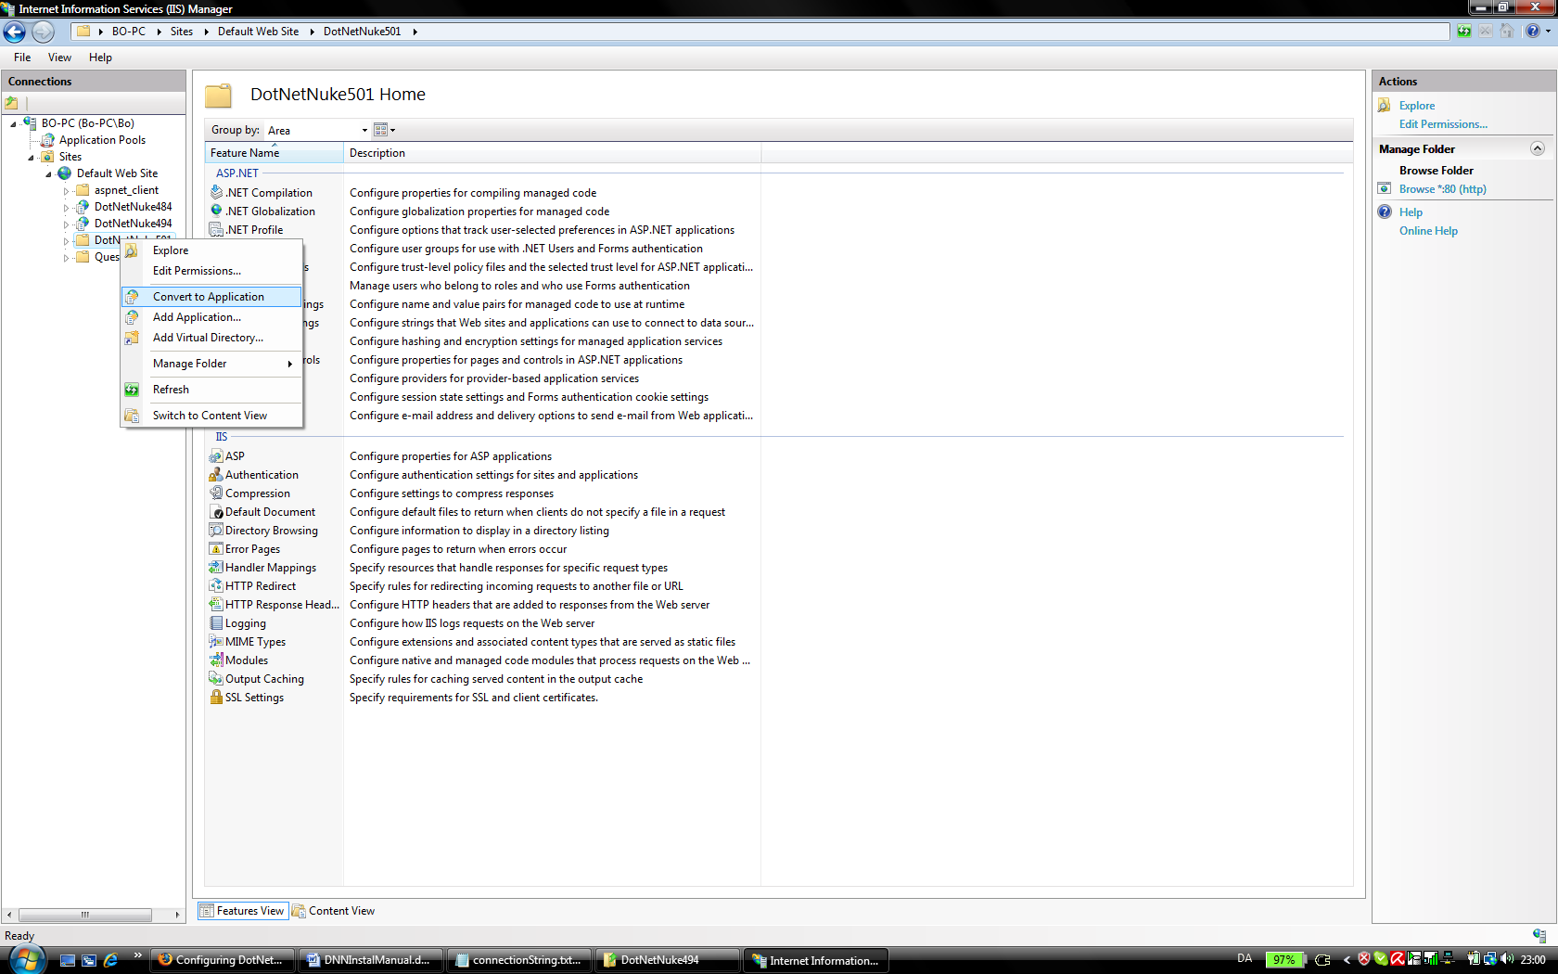

That is all.

## In DNN ca. 470 and earlier:

Change the “default” application pool to “Classic .NET AppPool”

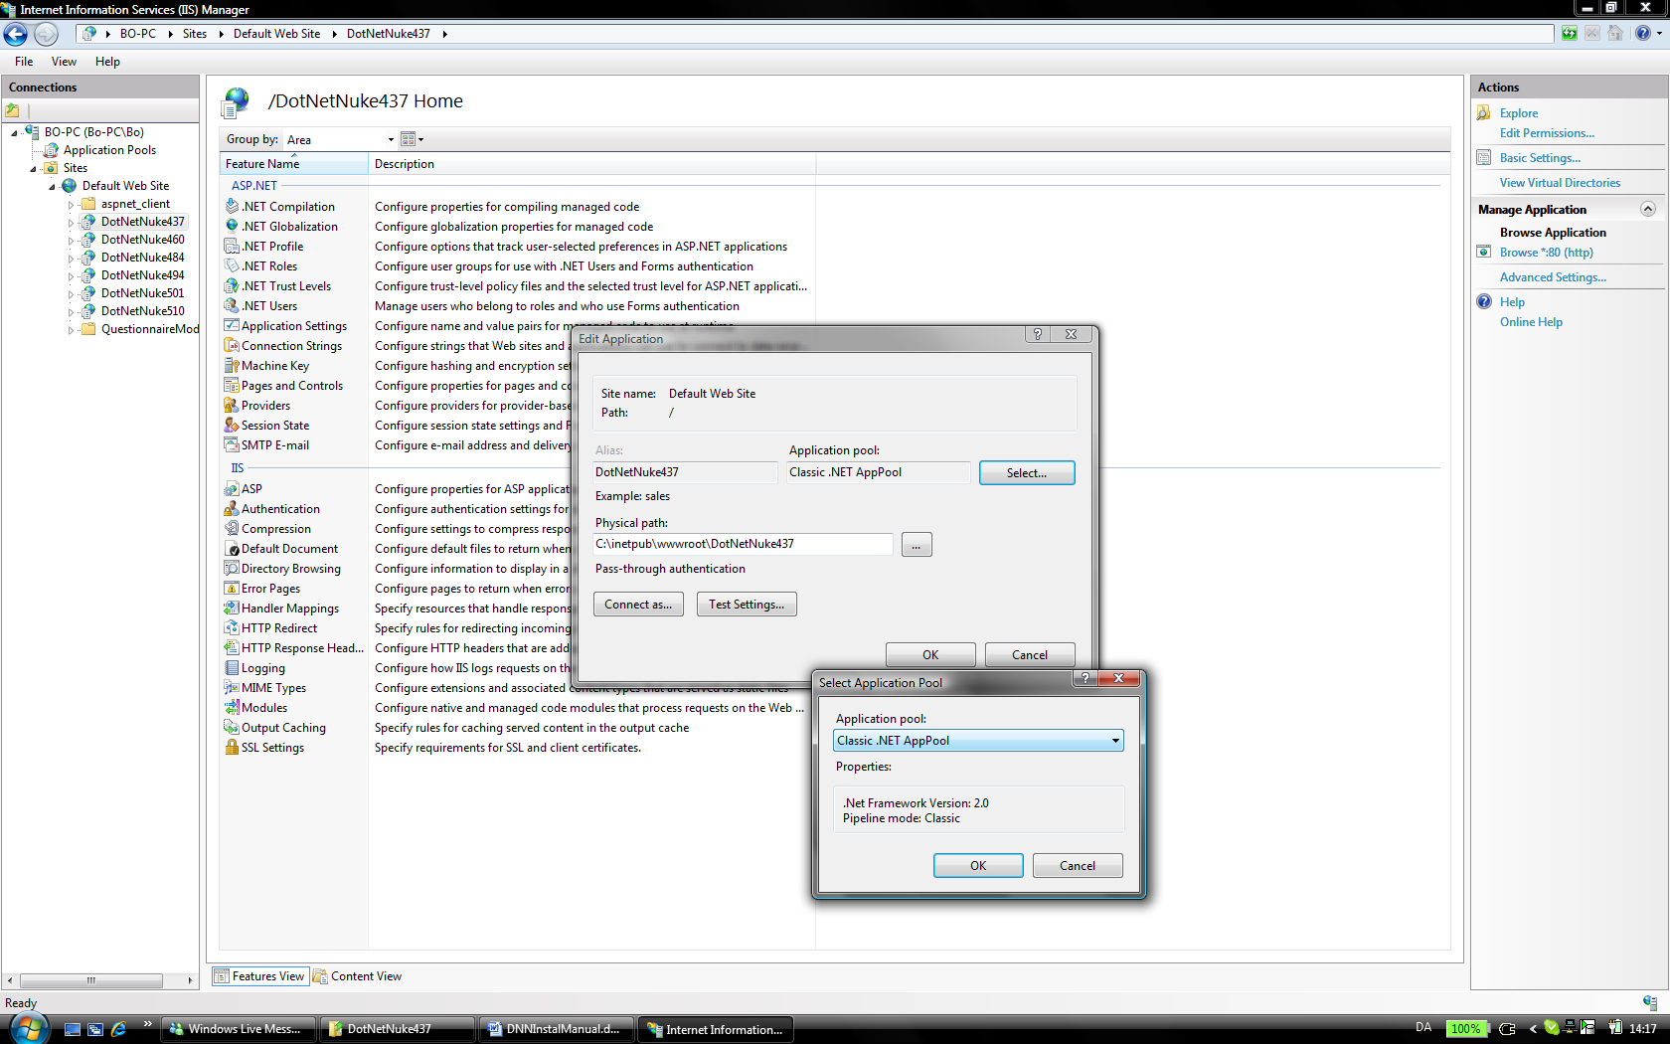

# 4 Folder Permission

Now set up the folder permission for the the NETWORK SERVICE:

Remember NETWORK SERVICE must be setup as a login in the DB as well.

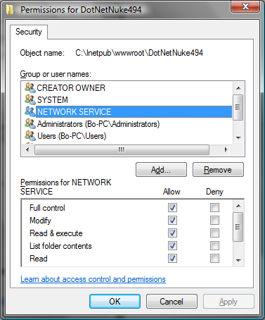

# 5 Run Install in browser

Now go to the site in the browser and run it under manual mode (See this link for further instructions): <http://www.dnncreative.com/tabid/289/Default.aspx?PageContentID=132>

