1. Turn on Windows Features under World Wide Web Services. Use the example figure below and turn on most other services including all scripting type services. This is on gefühl, but it works.  
   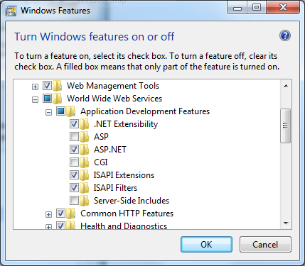  
   *source:* <http://blog.laksha.net/2009/08/http-error-50019-internal-server-error.html>
2. Setting up the IIS application pool access. Open IIS and add the security tab that gives access to Network Services, see fig below.  
     
   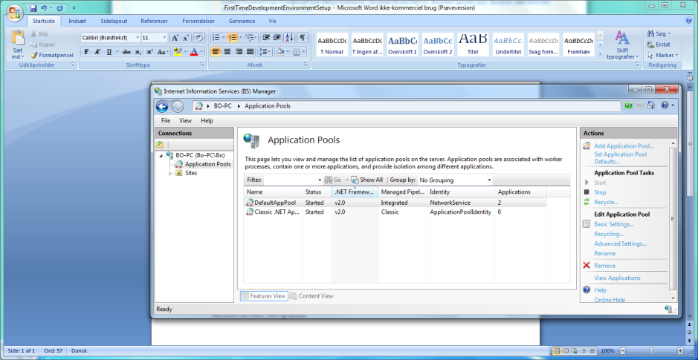  
     
   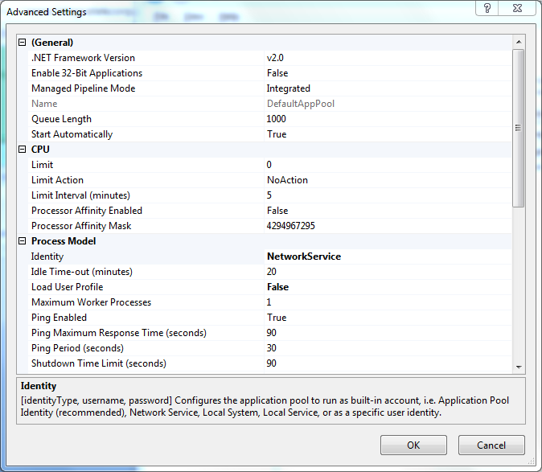

*Source:* <http://www.integratekcorp.com/Community/KnowledgeCenter/tabid/301/forumid/6/postid/6/scope/posts/Default.aspx>  
*info:* <http://www.dotnetnuke.com/Community/Blogs/tabid/825/EntryId/2420/Windows-7-Windows-2008-R2-cross-application-pool-isolation.aspx>

1. Enabling SQL server to run over a network and not as a (local) only machine do the following:  
   - Open SQL Server Configuration Manager  
   - Go to the SQL Server 2008 Network Manager  
   - Ensure that TCP/IP is enabled  
     
   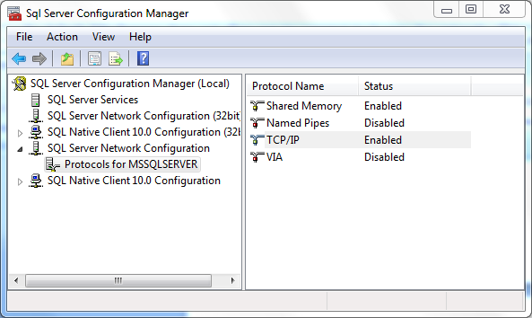

*Source:* <http://social.msdn.microsoft.com/Forums/en-US/sqldatabaseengine/thread/bd4ab9ac-ad0b-4aa3-ad7b-cb700ef4cc68>

1. To use Visual Studio 2008 to work with Web sites and applications on your local machine, do the following:  
     
   1. Install IIS 7.0  
     
   2. Install ASP.NET  
     
   3. Install IIS 6.0 Metabase Compatibility  
     
   On Windows Vista, open the Control Panel, click Programs and Features, click the Turn Windows features on and off link, check the “Internet Information Services” check box, as well as the “Web Management Tools \ IIS 6 Management Compatibility \ IIS Metabase and IIS 6 configuration compatibility” and “World Wide Web Services \ Application Development Features \ ASP.NET” check boxes under it.     
     
   [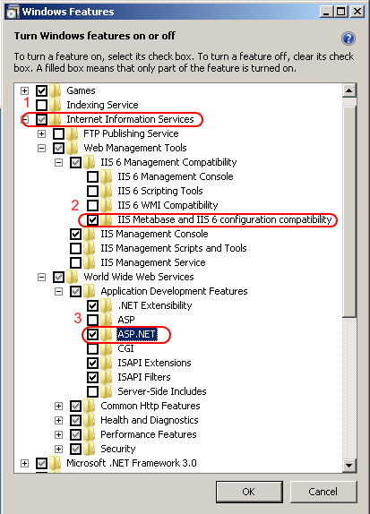](http://learn.iis.net/file.axd?i=812)  
     
   On Windows Server 2008, use the Server Manager tool to install the Web Server (IIS) role, and add the “Management Tools \ IIS 6 Management Compatibility \ IIS 6 Metabase Compatibility” and “Application Development \ ASP.NET“ role services  
   *source:* <http://learn.iis.net/page.aspx/387/using-visual-studio-2008-with-iis-70/>