# Introduction

For unknown reasons it is not possible to build and assembly of the DotNetNuke 484 site. To overcome this dnn packages are created in DotNetNuke and then installed as source packages on DotNetNuke 494 and later DotNetNuke 501 when a DNN 5 package has been created.

Once all module DNN source packages has been moved to DotNetNuke 494 a build assembly can be created using MS VS 2008. VWD 2008 cannot be used for building assemblies.

# Procedure

## Creating the manisfest

To create the manifest and module installer package open the project in DotNetNuke and go to: Host -> Module Definitions ->

And select the module you wish to pack from the list of installed modules:

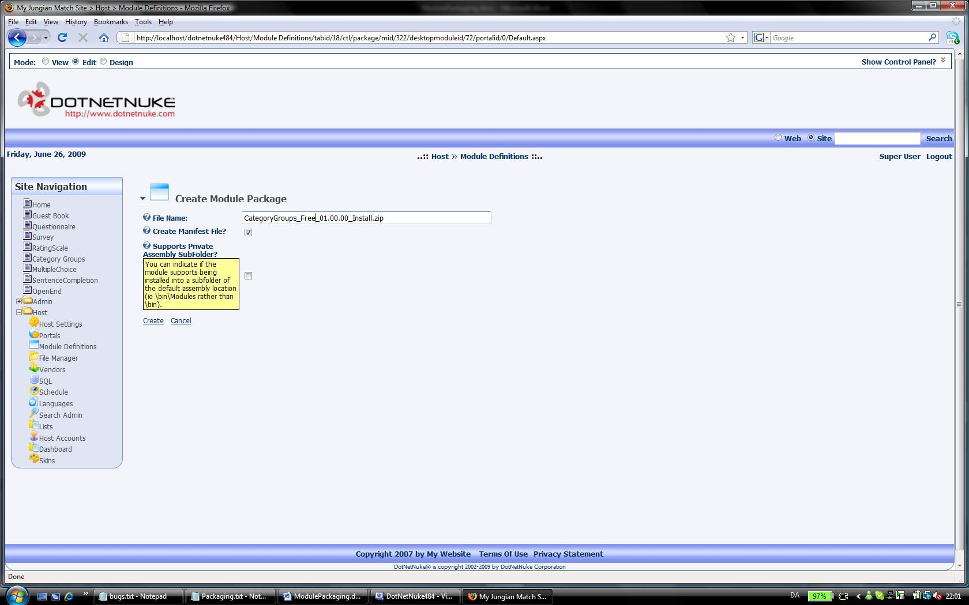

The module should install successfully:

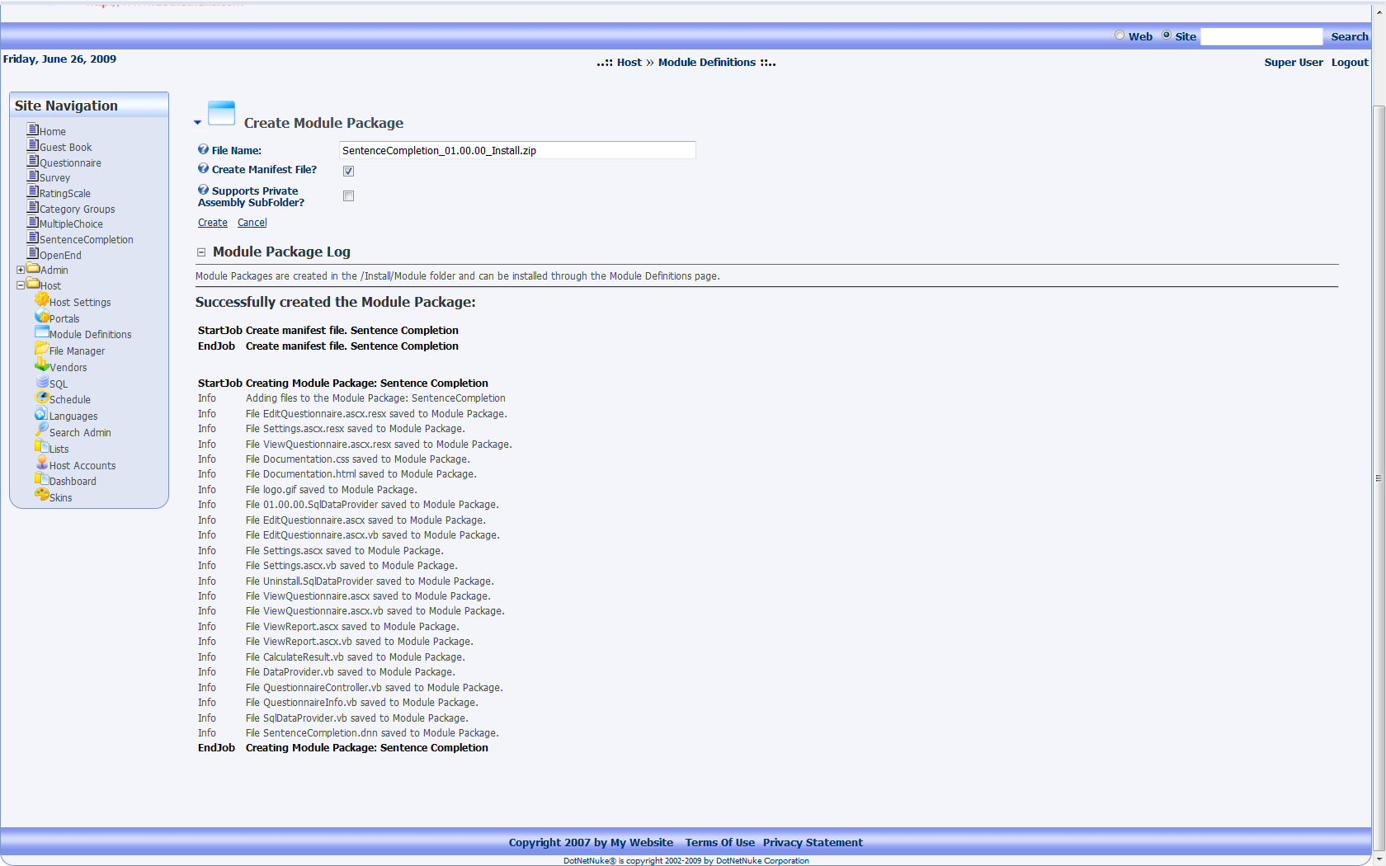

## Alter the installer package and manifest

The now created zip file contains the .ascx, .resx, .vb files. These files needs no altering for the source version of the installer package.

The XX.XX.XX.SqlDataProvider file and the Uninstall.SqlDataProvider file are generically created by dnn on the fly and needs revision in order to create, update and delete the database tables, stored procedures and view correctly.

In order for the latest AJAX functionality to work correctly the AJAXContolToolkit.dll from the bin folder must be added to the installer package and the manifest. This file will then install correctly in the bin folder on install.

Now install the newly created source package in DNN 494:

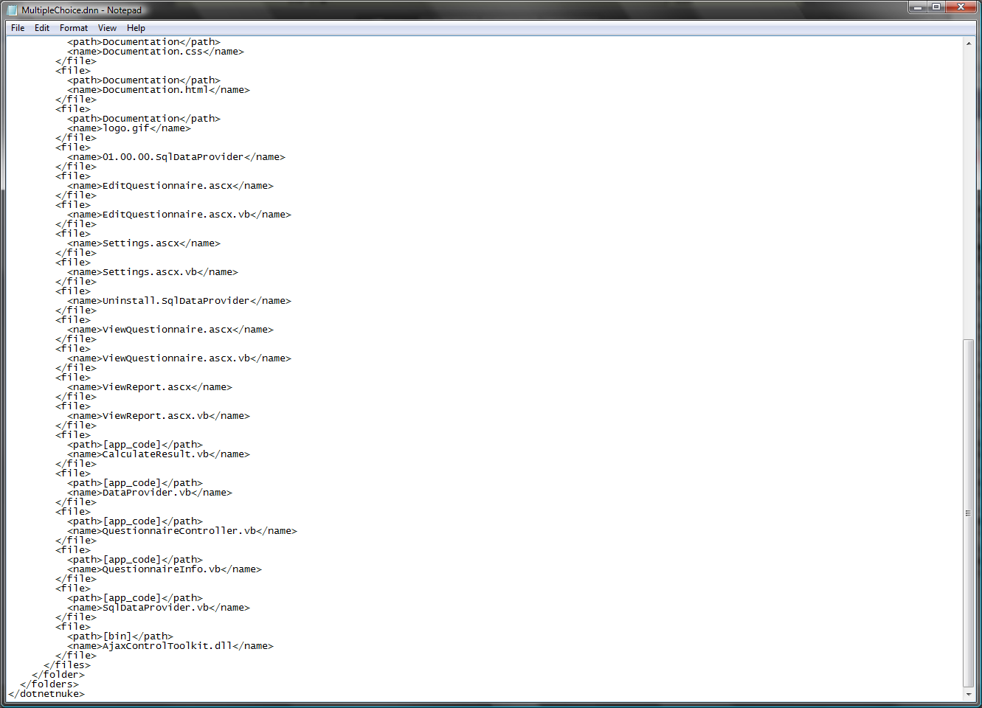

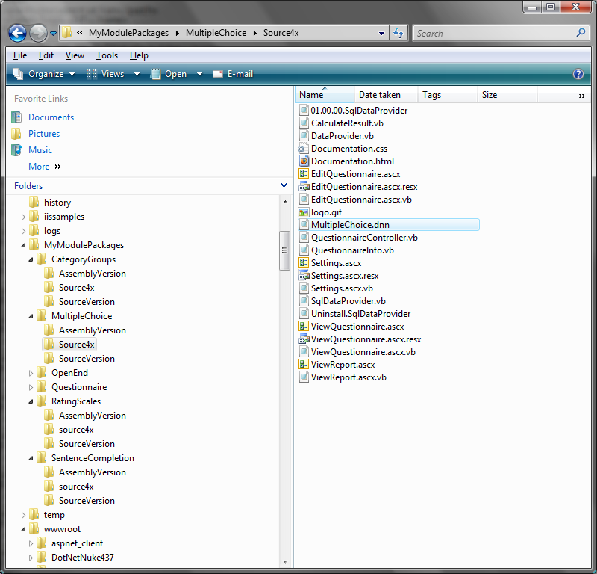

Create a .zip source install module file:

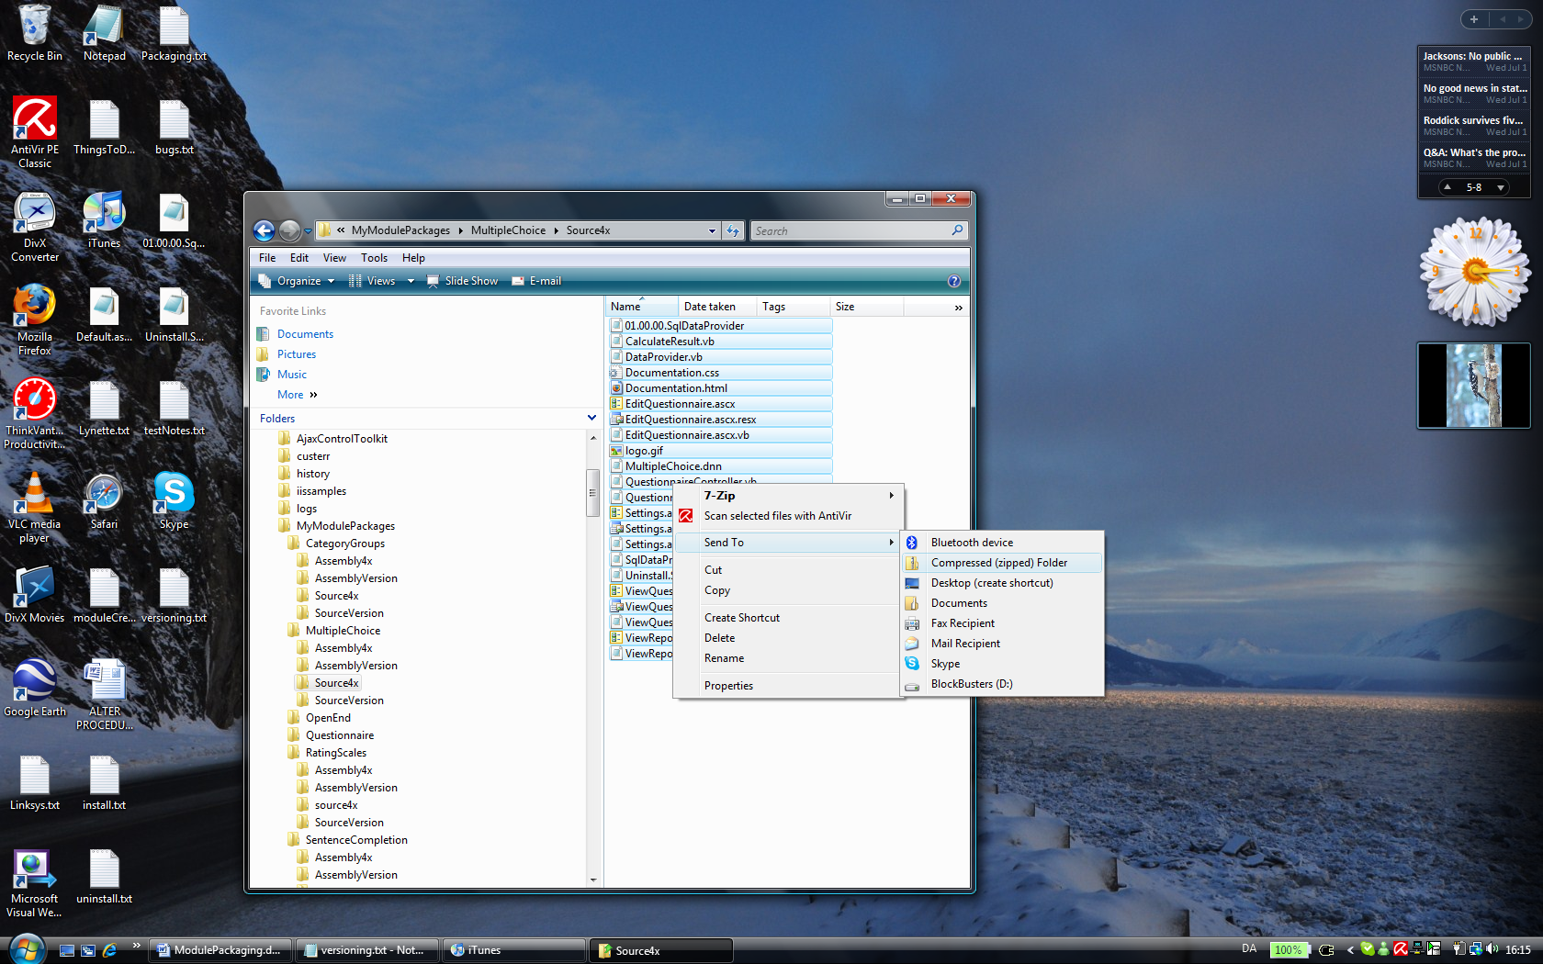

Install that you wish to package into assemblies into dnn. It is simpler if you install only the modules that you wish to pack.

IMPORTANT: When publishing the build to create the assemblies be aware that the Dotnetnuke.dll file is compatible into future Dotnetnuke versions. This means that you should pack against as low a dnn version as possible.

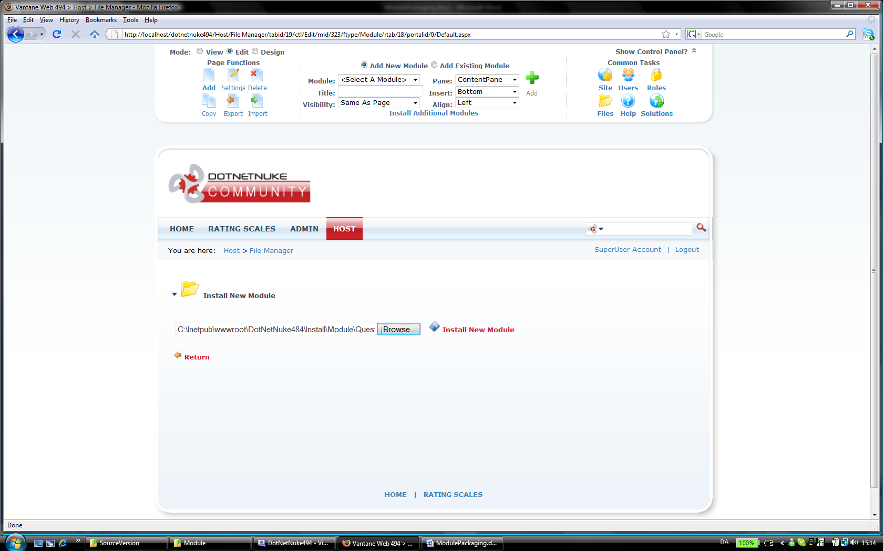

## Packaging assembly files

When packaging the assembly files, make sure to publish the website with only one module installed at the time otherwise dll files can be hard to distinguish.

When searching for the compiled dll files look in the /bin folder of the compiled directory. Look for files with the name “questionnaire” and “*[module name]”* , f.ex. MultipleChoice or RatingScales.

Install source version module into dnn  
Build assembly  
Create .dnn assembly version file from .dnn source version file

*These comprise of 4 dll files, one for each .vb file…*  
Delete source module from dnn  
Install assembly version module into dnn

