The application is highly configurable with a number of very useful setting options.

You can use this application as a general questionnaire a test or even a timed test, you decide.

The user interface is very easy to setup and offers validation on controls, forcing users to fill out fields before submission.

A timer can be set up, turning your questionnaire into a test. When the time is up the test stops and a report is shown presenting the results.

The test pass mark is set in points or percent.

All questions have values internally in the system, these values can be weighed differently so that some questions count more than others.

Reports are user configurable and can include statistical results or individual results introductory text, number of questionnaire entries, results tables, results diagrams, footer and more…

Both registered users as well as non registered users (setting a cookie) can fill out the questionnaire.

Questionnaires can be filled out only once by each user. Registered users however can redo the questionnaire if the administrator allows.

The questionnaire can be activated/deactivated and reactivated at any time by the administrator.

Export of user input to excel and text file is only one button away.

The questionnaire has a small foot print, when hovering over the charts bar full length questions are shown.

## Category groups

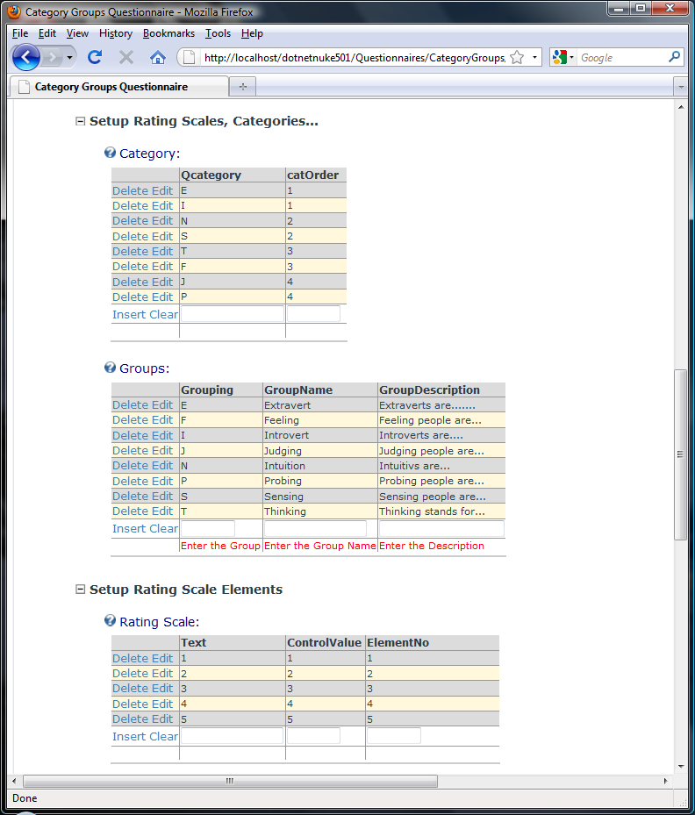

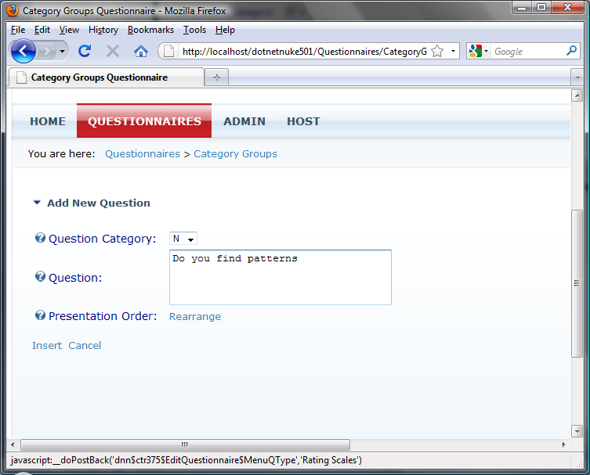

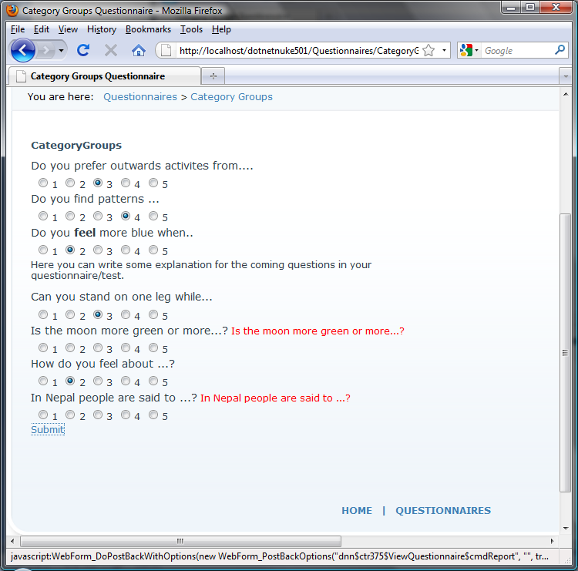

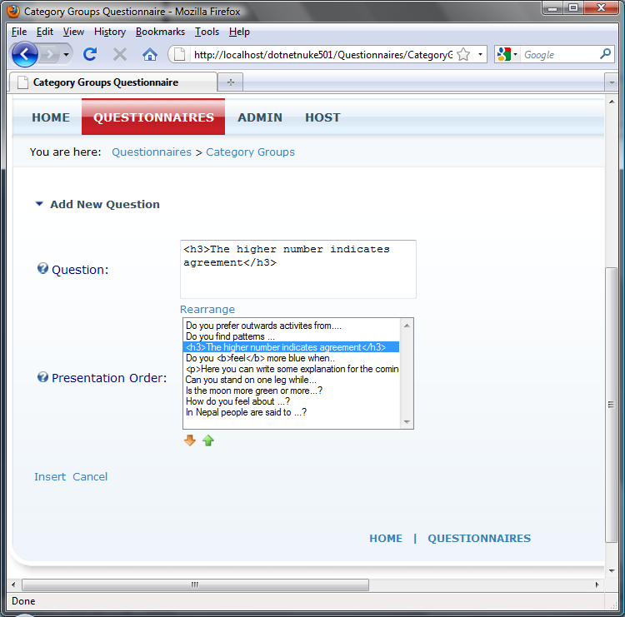

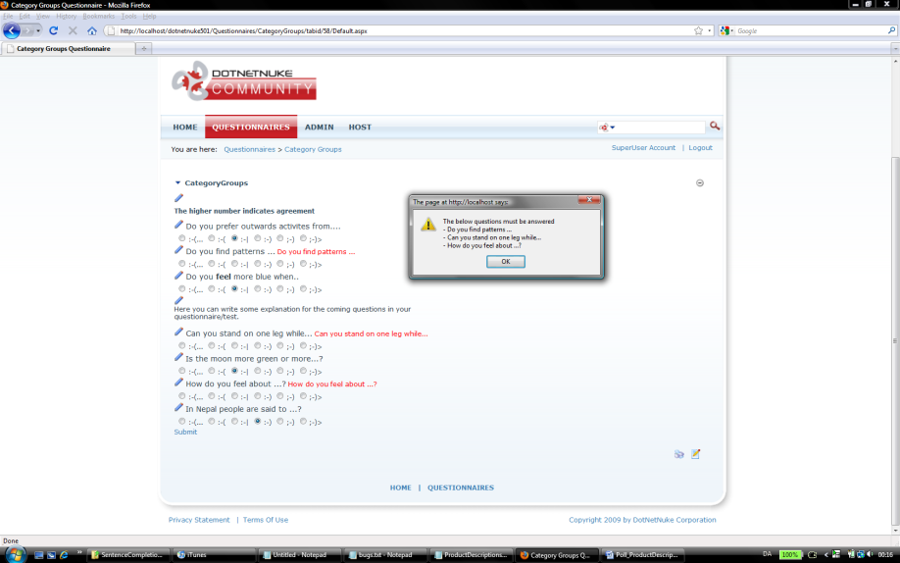

### Sentence completion

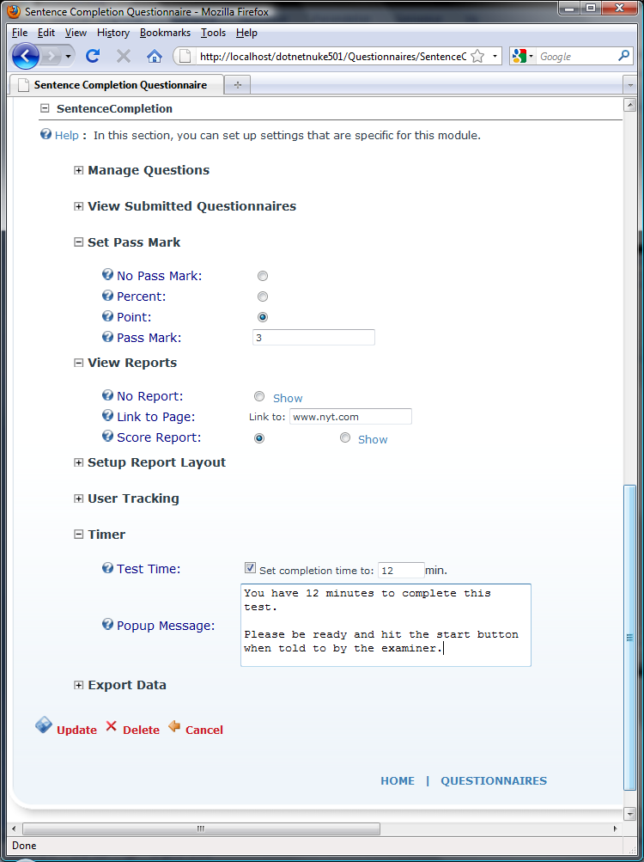

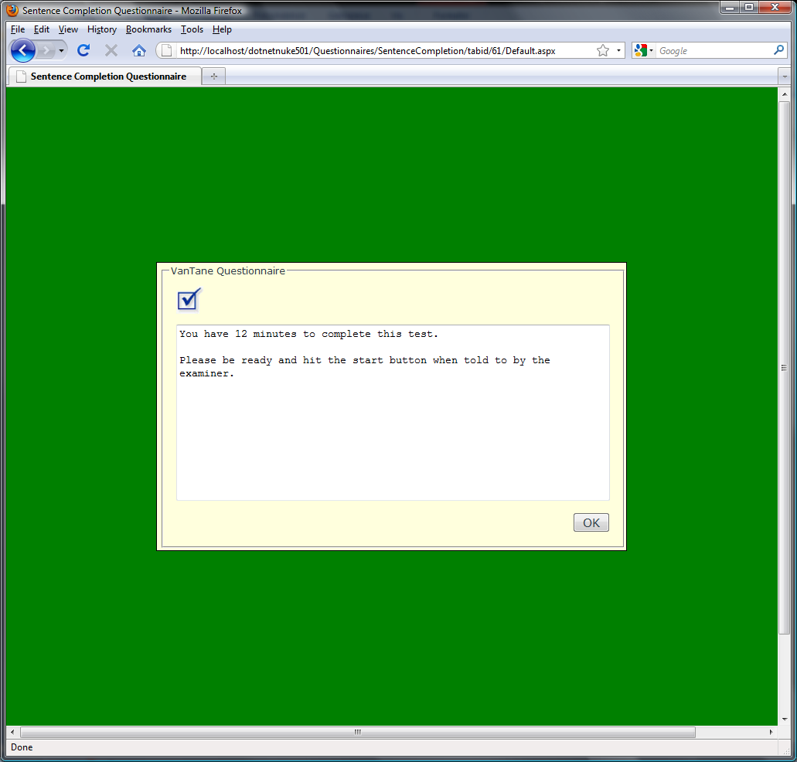

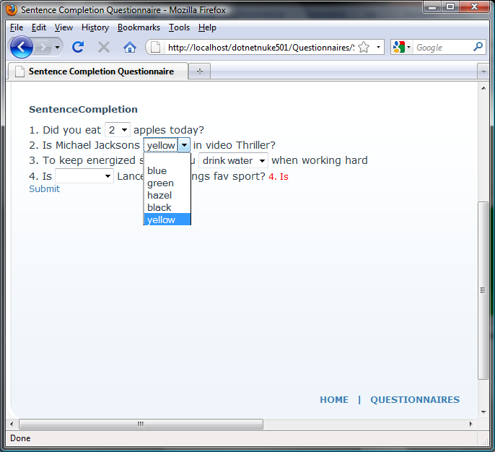

### Poll

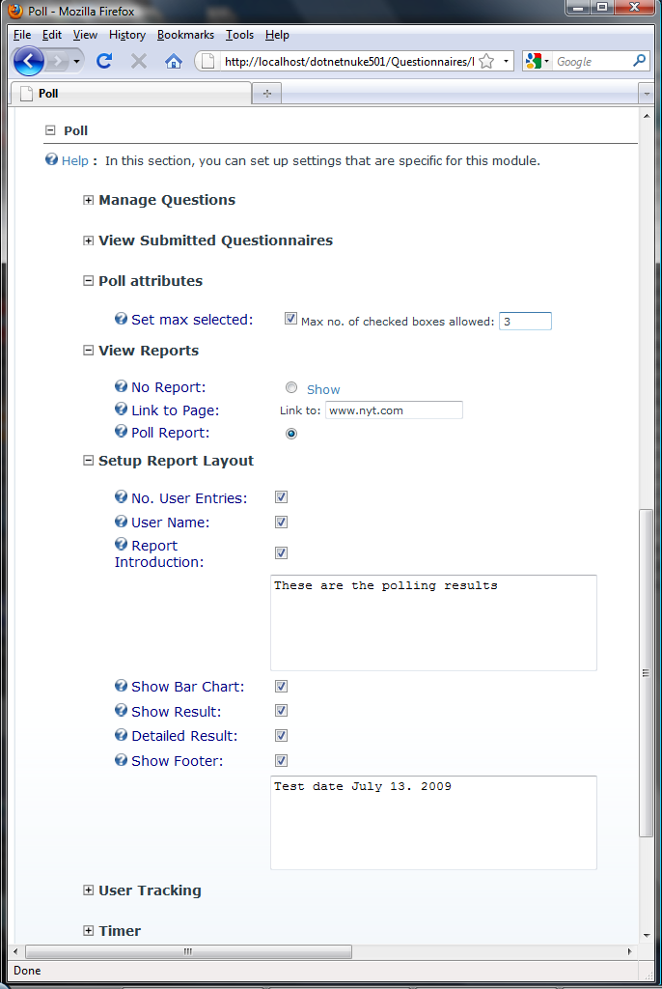

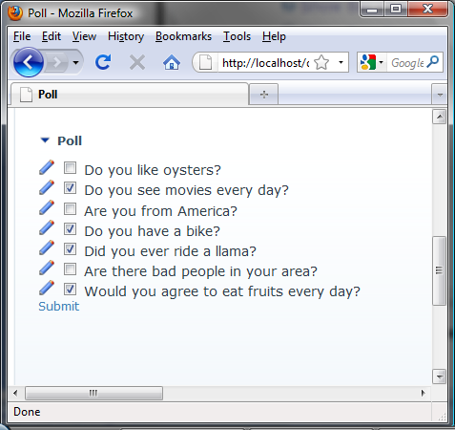

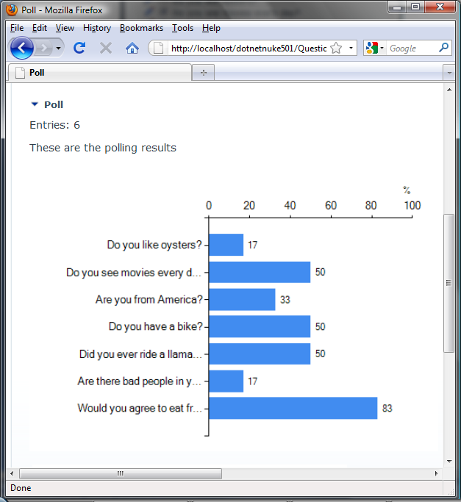

### Multiple Choice

