Indy Roof Scheduling
Intelligence System
User Manual
Prepared for Indy Roof & Restoration
Version 1.0 — April 2026
CONFIDENTIAL

Table of Contents
1. Getting Started
2. Initial Setup (Settings)
3. Syncing Jobs from JobNimbus
4. Dashboard Overview
5. Running AI Scoring
6. Map View
7. Weekly Plan (Scheduling)
8. Weather Checks
9. Not Built Workflow
10. Creating & Editing Jobs
11. Troubleshooting

1. Getting Started
The Indy Roof Scheduling Intelligence System is a web-based application that helps your scheduling team decide which roofing jobs to build each week. It reads job data from JobNimbus, applies AI-powered scoring and geographic clustering, checks weather conditions, and presents recommended build plans grouped by Project Manager.

Key Principles:
- JobNimbus is always the source of truth — this system never overrides JN data
- Humans make all final scheduling decisions — the AI recommends, you decide
- All decisions are logged with court-admissible notes
- Weather intelligence uses a two-stage system (free API + Clarity Wx/BamWx)

Accessing the Application:
Open your web browser and navigate to the application URL provided by your administrator. The application works on desktop, tablet, and mobile browsers.

2. Initial Setup (Settings)
Before using the scheduling system, you need to configure your team and preferences. Click 'Settings' in the left sidebar.
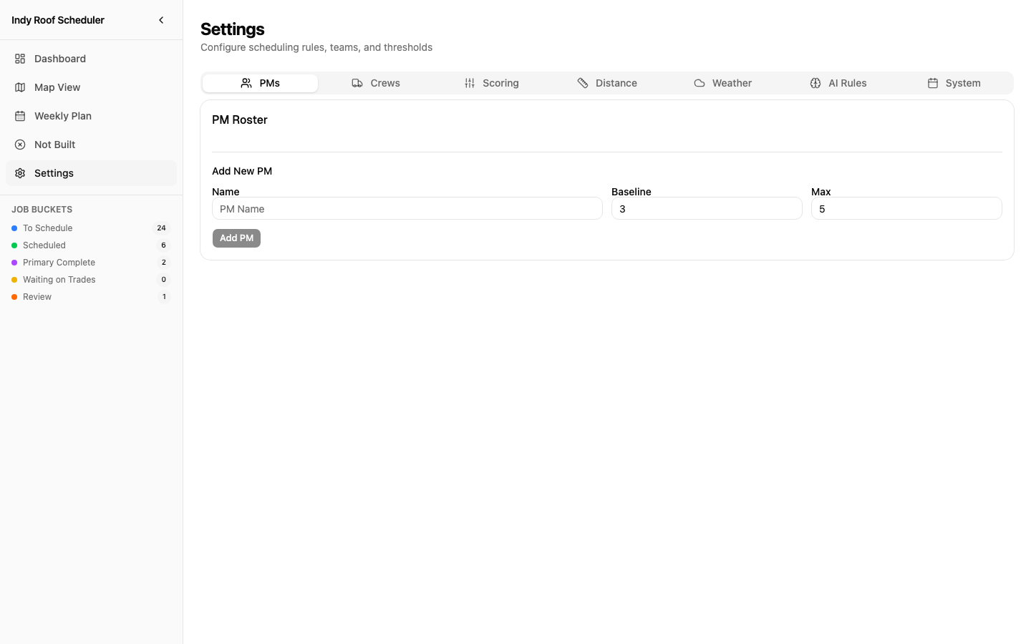
Figure 1: Settings Page — PM Roster Tab

2.1 PM Roster
Add your Project Managers who will be assigned to daily build plans.
Step 1: Click the 'PMs' tab in Settings
Step 2: Enter the PM's name, baseline capacity (typical daily jobs), and max capacity (absolute maximum)
Step 3: Click 'Add PM'

Field | Description
Name | Project Manager's name (e.g., 'Mike')
Baseline | Normal daily job count (e.g., 3). Green zone on capacity bars.
Max | Absolute maximum jobs per day (e.g., 5). Red zone if exceeded.
TIP: Start with your actual PM team. You can adjust baseline/max capacity as you learn the system.

2.2 Crew Roster
Add crews with their specialty capabilities. Crews are required for specialty materials like slate, TPO, and wood shake.

2.3 Scoring Weights
Configure how much each factor matters when the AI scores and ranks jobs. Use the sliders to adjust weights (0–100).
Weight | What it Controls
Days in Queue | Priority for jobs waiting longest (vs. rolling average)
Payment Type | Cash jobs score higher than insurance (faster payment)
Proximity | Jobs near each other score higher (clustering efficiency)
Material-Weather | Jobs with weather-compatible materials score higher
Rescheduled | Bump for jobs that were previously not-built

2.4 AI Rules
Write plain-English rules that the AI scoring engine follows. No programming required.
Example: "Prioritize cash payment jobs over insurance. If a job has been in queue more than 60 days, treat it as urgent."

2.5 Weather Thresholds
Set temperature, wind, and precipitation limits for each material type.
Material | Key Thresholds
Asphalt Shingles | Min 40°F, Max 20mph wind, no rain
TPO/EPDM | Min 40°F, Max 15mph wind, 24hr rain window
Coatings | Min 50°F, 48hr rain window, max 85% humidity
Siding | Max 15mph wind (gust-sensitive)
Metal | Min 40°F, Max 15mph wind

3. Syncing Jobs from JobNimbus
The system pulls job data from JobNimbus automatically every 30 minutes. You can also trigger a manual sync.

3.1 Manual Sync
Step 1: Go to the Dashboard
Step 2: Click 'Sync JN' in the top-right action bar
Step 3: Wait for the sync to complete (button shows 'Syncing...')
Step 4: A notification appears: 'Synced: X new, Y updated from JN, Z AI-scanned'

What happens during sync:
- New jobs are created with all JN data (customer, address, material, payment, etc.)
- Existing jobs are updated if JN data changed
- New jobs are AI-scanned for duration hints, material type, and permit signals
- Job addresses are geocoded for map plotting
TIP: The AI scan runs only for new jobs to save costs. Already-scanned jobs are never re-scanned.

4. Dashboard Overview
The Dashboard is your primary workspace. It shows all jobs organized by status, with tools for scoring, weather checks, and job management.
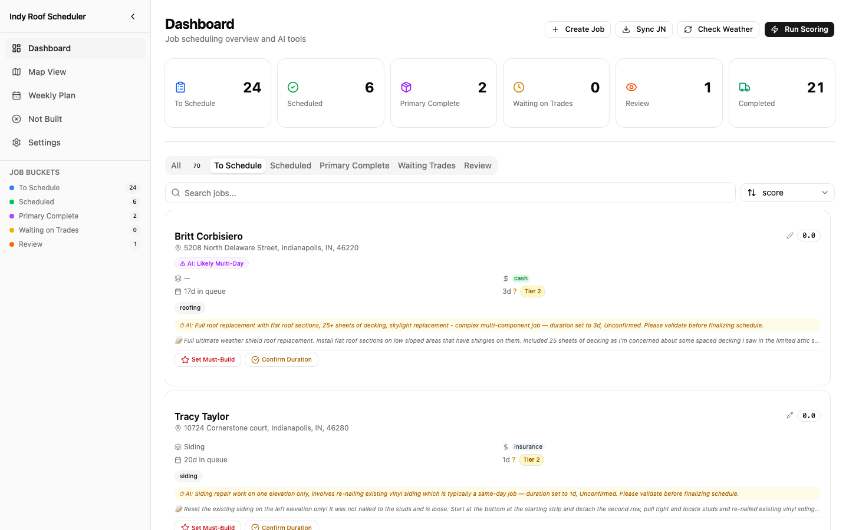
Figure 2: Dashboard — Job Cards with Bucket Summary

4.1 Bucket Summary Cards
Six cards across the top show job counts by status:
Bucket | Meaning
To Schedule | Jobs ready to be scheduled (pulled from JN)
Scheduled | Jobs assigned to a specific date and PM
Primary Complete | Primary trade done, secondary trades may remain
Waiting on Trades | Waiting for secondary trades to complete
Review | Ready for final review before marking complete
Completed | Fully done
Click any bucket card to filter the job list below.

4.2 Job Cards
Each job card displays all scheduling-relevant information:
- Customer name and address
- Material type with duration tier badge (Tier 1/2/3)
- Payment type (green = cash, blue = finance, gray = insurance)
- Days in queue
- Duration (confirmed ✓ or unconfirmed ?)
- AI duration hint (yellow bar if AI detected duration signals)
- JN note preview (job description from JN)
- Weather status badge (Clear / Decision Needed / Do Not Build)

Job Card Actions:
- Click the pencil icon to edit job details
- 'Set Must-Build' — flags a job with a deadline
- 'Confirm Duration' — validates the AI-estimated build duration
- Click the card to expand/collapse full details

4.3 Must-Build Jobs
Jobs flagged as Must-Build appear with a red ring and star badge. Must-Build jobs are always scheduled first.
Step 1: Find the job card you need to prioritize
Step 2: Click 'Set Must-Build'
Step 3: Enter a deadline date and reason (e.g., 'Real estate closing April 15')
Step 4: Click 'Flag as Must-Build'

5. Running AI Scoring
The scoring engine analyzes all jobs and creates a recommended build plan grouped by Project Manager with geographic clusters.

5.1 How to Run Scoring
Step 1: Ensure PMs are configured in Settings (the system will prompt you if not)
Step 2: Click 'Run Scoring' on the Dashboard
Step 3: Wait 15–30 seconds for the AI to analyze all jobs
Step 4: Results appear: AI Explanation, PM Plan Cards, and Job Queue

5.2 PM Plan Cards
Each PM gets a card showing their recommended daily load:
- PM name with capacity bar (green = under baseline, yellow = over, red = over max)
- Jobs grouped by cluster with distance info (e.g., 'Cluster 1 — tight • 3 jobs • 1.2mi')
- Standalone jobs listed separately with amber indicator
- Unassigned jobs (overflow beyond PM capacity) shown at bottom

5.3 Score Tooltip
Hover over any job's score badge to see the full breakdown: queue time, payment type, proximity, weather compatibility, and other factors.
TIP: After scoring, go to Map View > Build Plan to see the clusters on the map.

6. Map View
The Map View shows all jobs plotted on Google Maps with three viewing modes.
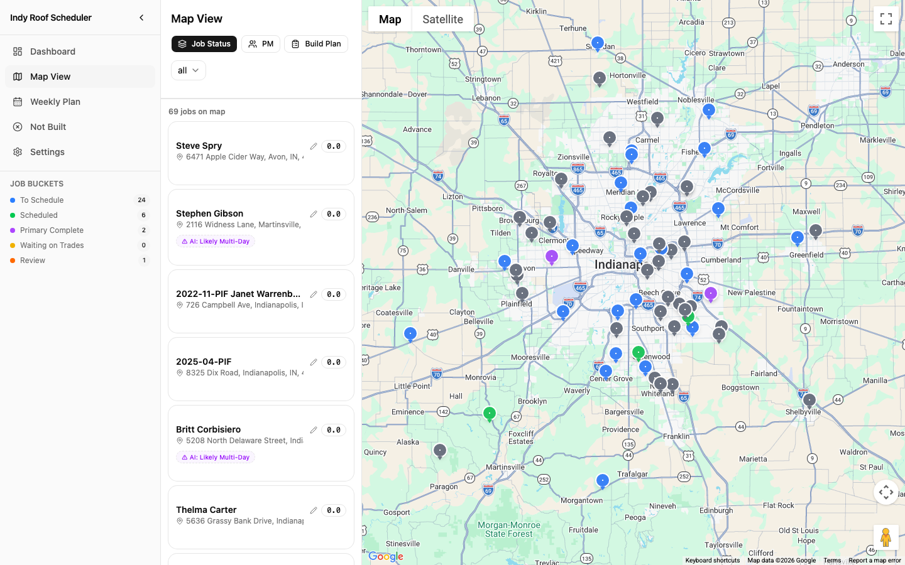
Figure 3: Map View — Job Status Mode with Sidebar

6.1 Job Status Mode
Default view. Jobs colored by status: Blue = To Schedule, Green = Scheduled, Amber = Standalone, Red = Must-Build.

6.2 PM Assignments Mode
After running scoring, colors jobs by assigned PM. Click a PM name in the legend to filter.

6.3 Build Plan Mode
The most detailed view. Shows PM > Cluster > Jobs hierarchy in the left panel:
- Click a PM name to zoom to their jobs on the map
- Click a cluster to highlight those specific pins (others fade)
- Each cluster shows tier (tight/close/standard), job count, and max distance
- Click any pin on the map to see full job details
TIP: Build Plan mode auto-activates after scoring. If no scoring has been run, defaults to Job Status.

7. Weekly Plan (Scheduling)
The Weekly Plan page is where you build the actual schedule by dragging jobs into days.

7.1 Selecting the Week
Step 1: Use the left/right arrows to navigate between weeks
Step 2: The current week shows with date range

7.2 Selecting Available PMs
Step 1: Click PM buttons at the top to select who is available this week
Step 2: Selected PMs appear as capacity bars in each day column
Step 3: You must select at least one PM before dragging jobs

7.3 Scheduling Jobs
Step 1: Unassigned jobs appear in the left sidebar
Step 2: Drag a job from the sidebar into a day column (Monday–Sunday)
Step 3: The job is assigned to the selected PM and the capacity bar fills
Step 4: A scheduling decision note is automatically generated
Step 5: Drag jobs between days to reschedule
TIP: PM capacity bars turn yellow when over baseline and red when over max capacity.

8. Weather Checks
The system uses a two-stage weather architecture to protect scheduled jobs.

8.1 Manual Weather Check
Step 1: Click 'Check Weather' on the Dashboard
Step 2: The system checks all scheduled jobs against material thresholds
Step 3: Red banner: Jobs auto-removed due to 'Do Not Build' weather
Step 4: Yellow banner: Jobs needing your decision (marginal conditions)

8.2 Scheduler Decision
When weather is marginal, click the yellow 'Decision Needed' badge on the job card:
- 'Include (Override)' — keep the job scheduled despite marginal weather
- 'Exclude (Not Built)' — remove the job and return to queue

8.3 Automated Checks
Check | Time | What It Does
Morning Check | 6:00 AM | Checks all jobs for today and tomorrow
Night-Before | 8:00 PM | Final authority check using Clarity Wx
5am Spot Check | 5:00 AM | Last-minute sanity check on today's builds

9. Not Built Workflow
When a scheduled job cannot be built, mark it as 'Not Built' with a reason.
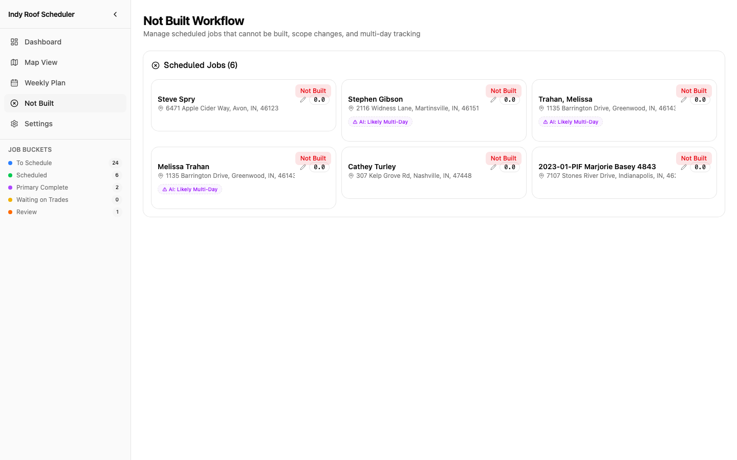
Figure 4: Not Built Page — Scheduled Jobs with Not Built Actions

9.1 Marking a Job as Not Built
Step 1: Go to the 'Not Built' page in the sidebar
Step 2: Find the scheduled job
Step 3: Click 'Not Built' on the job card
Step 4: Select a reason:
Reason | When to Use
Weather Pre-Build | Weather turned bad before build day
Weather Mid-Build | Weather changed during the build
Scope Change | Job scope expanded (needs more days/crew)
Crew Unavailable | Assigned crew can't make it
Material Issue | Materials not delivered or wrong
Customer Related | Customer canceled or rescheduled
Other | Any other reason
The job gets a priority bump (+5 points) and returns to the To Schedule queue.

9.2 Standalone Jobs
Jobs located far from all other jobs (>40 miles) are flagged as 'Standalone' with two options:
- Saturday Build — schedule on Saturday when it won't impact weekday clusters
- Sales Rep Managed — hand off to the sales rep to coordinate directly

10. Creating & Editing Jobs

10.1 Creating a Manual Job
Step 1: Click '+ Create Job' on the Dashboard
Step 2: Fill in: Customer Name, Address, Payment Type, Material Type
Step 3: Optionally add: square footage, sales rep, duration, notes, secondary trades
Step 4: Click 'Create Job'

10.2 Editing an Existing Job
Step 1: Find the job card on the Dashboard
Step 2: Click the pencil icon in the top-right corner
Step 3: Edit any field and click 'Save Changes'
TIP: Editing material type or square footage automatically recalculates the duration tier.

11. Troubleshooting
Issue | Solution
'No PMs configured' when scoring | Go to Settings > PMs and add at least one PM
Jobs not appearing after sync | Wait for sync to complete. Refresh the page.
Map not loading | Verify Google Maps API key is set and Maps JavaScript API is enabled in GCP
Weather shows 'No data' | Jobs need lat/lng coordinates. Re-sync or edit the address.
Scoring takes too long | Normal: 15-30 seconds. Check Anthropic API key if it fails.
Drag-drop not working | Select at least one PM from the buttons at the top.
Need a fresh start | Settings > System > 'Reset Database'

Support:
For technical issues, contact your system administrator.

