CAR RENTAL PROJECT

By Kartikey Sharma & Sahil Bajaj

Requirements:

* UNIX or Linux Machine
* PHP 7.0 + installed
* mySQL 8.0 required.

Steps to install the interface:

* Open the query.php file and change the $username, $dbname and $password variables to your mySQL credentials.

* To enter into the mySQL Command Line, open terminal and input the following command: **mysql -u yourusername -p yourpassword** where yourusername and yourpassword are the username and password of your mySQL respectively.

* Run the CarRental2019.sql file either by uploading it straight to the MySQL Work Bench or by inputting each query one by one on mySQL Command Line.
* After successfully creating the tables and inserting data into them, open terminal, go to the directory in which the php files are located using the ‘cd’ command. Here my files are in the folder ‘downloads’.

* After that type `php -S localhost:8080` without the single quotes.

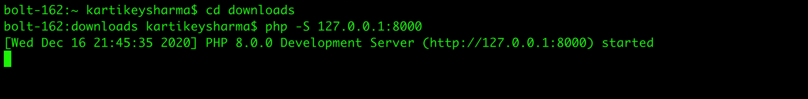

This will activate your php server.

* After executing the php command, go to your browser and type on the URL bar the following: <http://localhost:8000/home.php> and you will be able to visit the home page of the website.

