BOLTZMANN LABS
20 Specialized Single-Point Energy
Agent Environments
Implementation Plan, Scientific Contracts, Validation Strategy and Delivery Roadmap

ONE SHARED SPE FRAMEWORK • TWENTY SCIENTIFIC TASK CONTRACTS
Version 1.0 | 2026-10-19 | Planning baseline

Document control
Field | Value
Purpose | Implementation plan for 20 specialized SPE agent environments using shared calculation infrastructure
Scope | Environment contracts, shared services, phased implementation, verification, governance and delivery gates
Audience | Boltzmann Labs scientific software, computational chemistry, ML platform, QA and program leadership teams
Source of truth | Version-controlled contracts in environments/<id>-<slug>/agent.json
Current status | All 20 contracts defined; all intended tool integrations remain unverified
Decision principle | Promote capabilities only when execution and scientific-acceptance evidence both pass

Contents

1. Executive summary
This plan establishes twenty specialist agent environments for Single-Point Energy work. An environment is a scientific contract: it defines the problem it owns, required inputs, supported tool adapters, outputs, validation checks, evidence needed for acceptance, bounded recovery actions and escalation boundaries. The environments reuse a common SPE execution framework; they are not twenty duplicated quantum-chemistry engines.
The implementation starts with the highest-leverage environments—small molecules, drug-like molecules, conformer comparison, DFT method comparison, basis convergence and independent quality control. It then adds orbital and property extraction, interaction-energy workflows, metal systems, prepared QM/MM calculations and MLIP reference comparisons. Every adapter remains unverified until representative end-to-end, invalid-input, failure, parser and scientific-evaluation tests pass.

1.1 Outcomes
- A single versioned framework for parsing, validation, routing, execution tracking, extraction, provenance and evaluation.
- Twenty individually addressable specialists with explicit capability boundaries and no silent scientific-setting changes.
- Structured SPE results whose execution state is separate from scientific acceptance.
- Independent quality control that can audit every other environment and recommend only bounded, recorded recovery.
- A promotion process that moves integrations from unverified to prototype and validated only with evidence.

1.2 Explicit non-goals
- Building twenty calculation backends or twenty isolated Python environments.
- Treating electronic energies as free energies, binding affinities, pKa values or thermal observables without the required additional calculations.
- Locating transition states, optimizing geometries or sampling conformations unless a separate supported workflow is invoked.
- Automatically changing charge, multiplicity, chemical identity, method, basis, fragment partition or QM region to force a result.
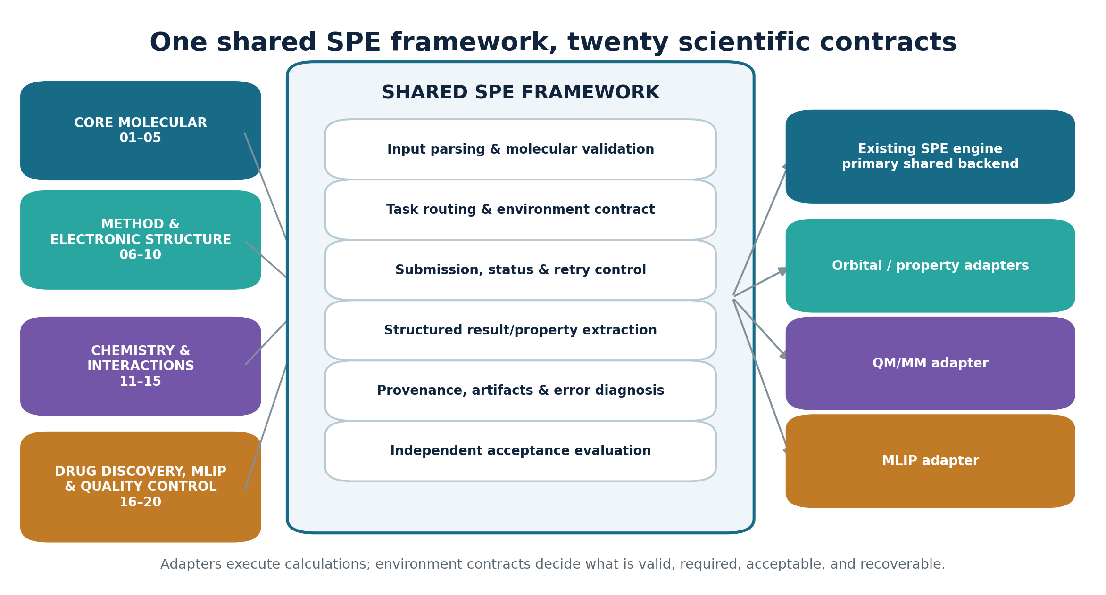
Figure 1. Shared execution infrastructure with environment-specific scientific ownership.

2. Program architecture

2.1 Separation of shared and specialist responsibilities
Shared framework responsibility | Environment-specific responsibility
Input parser and molecular-structure validation | Allowed system types; charge, spin, fragment and partition rules
Calculation submission and status tracking | Supported methods, basis/ECP requirements and adapter selection
Structured result and artifact extraction | Required energies, orbitals, properties, components and units
Failure taxonomy, retry accounting and provenance | Scientific warnings, permitted recovery and escalation policy
Independent evaluator interface | Acceptance criteria and evidence required for pass/fail/review
Registry, routing and prompt composition | Task vocabulary, capability boundaries and handoff conditions

2.2 Common execution lifecycle
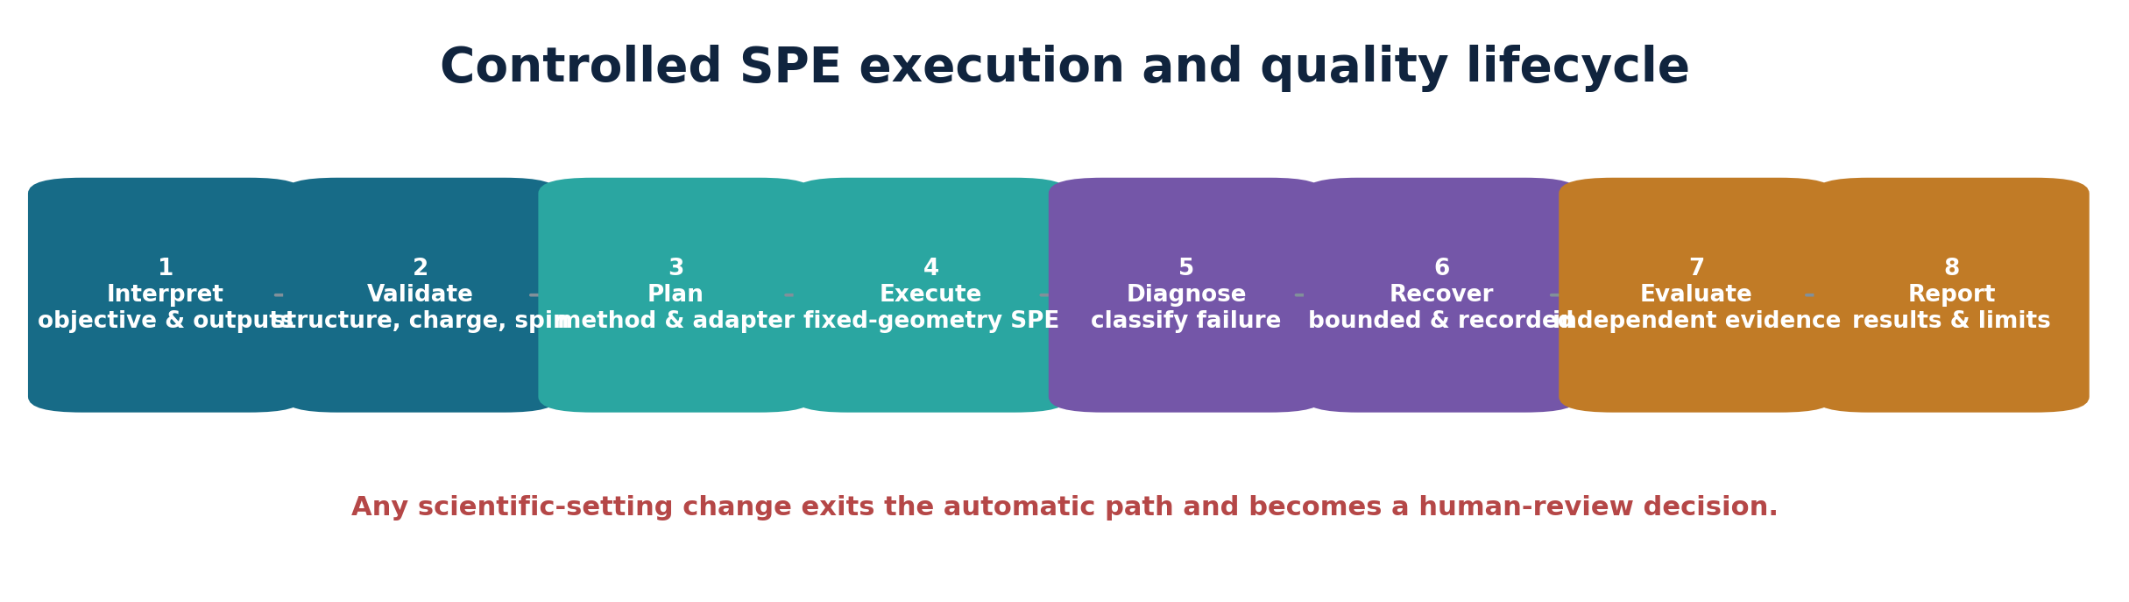
Figure 2. Every specialist follows the same controlled lifecycle.
- Interpret the objective and requested outputs without broadening the scientific claim.
- Validate structure, units, electron count, charge, multiplicity, method and all environment-specific definitions.
- Resolve only declared adapters and record the exact calculation plan and expected artifacts.
- Execute fixed-geometry calculations while preserving settings, logs, versions and inputs.
- Classify failures before correction; never treat a retry as a scientific redesign.
- Apply only declared bounded recovery within the retry ceiling and record each change.
- Evaluate every acceptance criterion using explicit evidence independent of process completion.
- Report results, provenance, warnings, limitations and unresolved review conditions.

2.3 Core state model
Layer | Allowed states | Rule
Integration maturity | unverified • prototype • validated • blocked | Describes adapter readiness, not a single job result
Execution | completed • failed • blocked • needs-review | Describes the calculation workflow
Independent evaluation | pass • fail • needs-review • not-evaluated | Describes scientific and evidence acceptance
Failure class | input • capability • tool • configuration • execution • convergence • parsing • scientific • review | Determines whether recovery is allowed

3. SPE environment portfolio
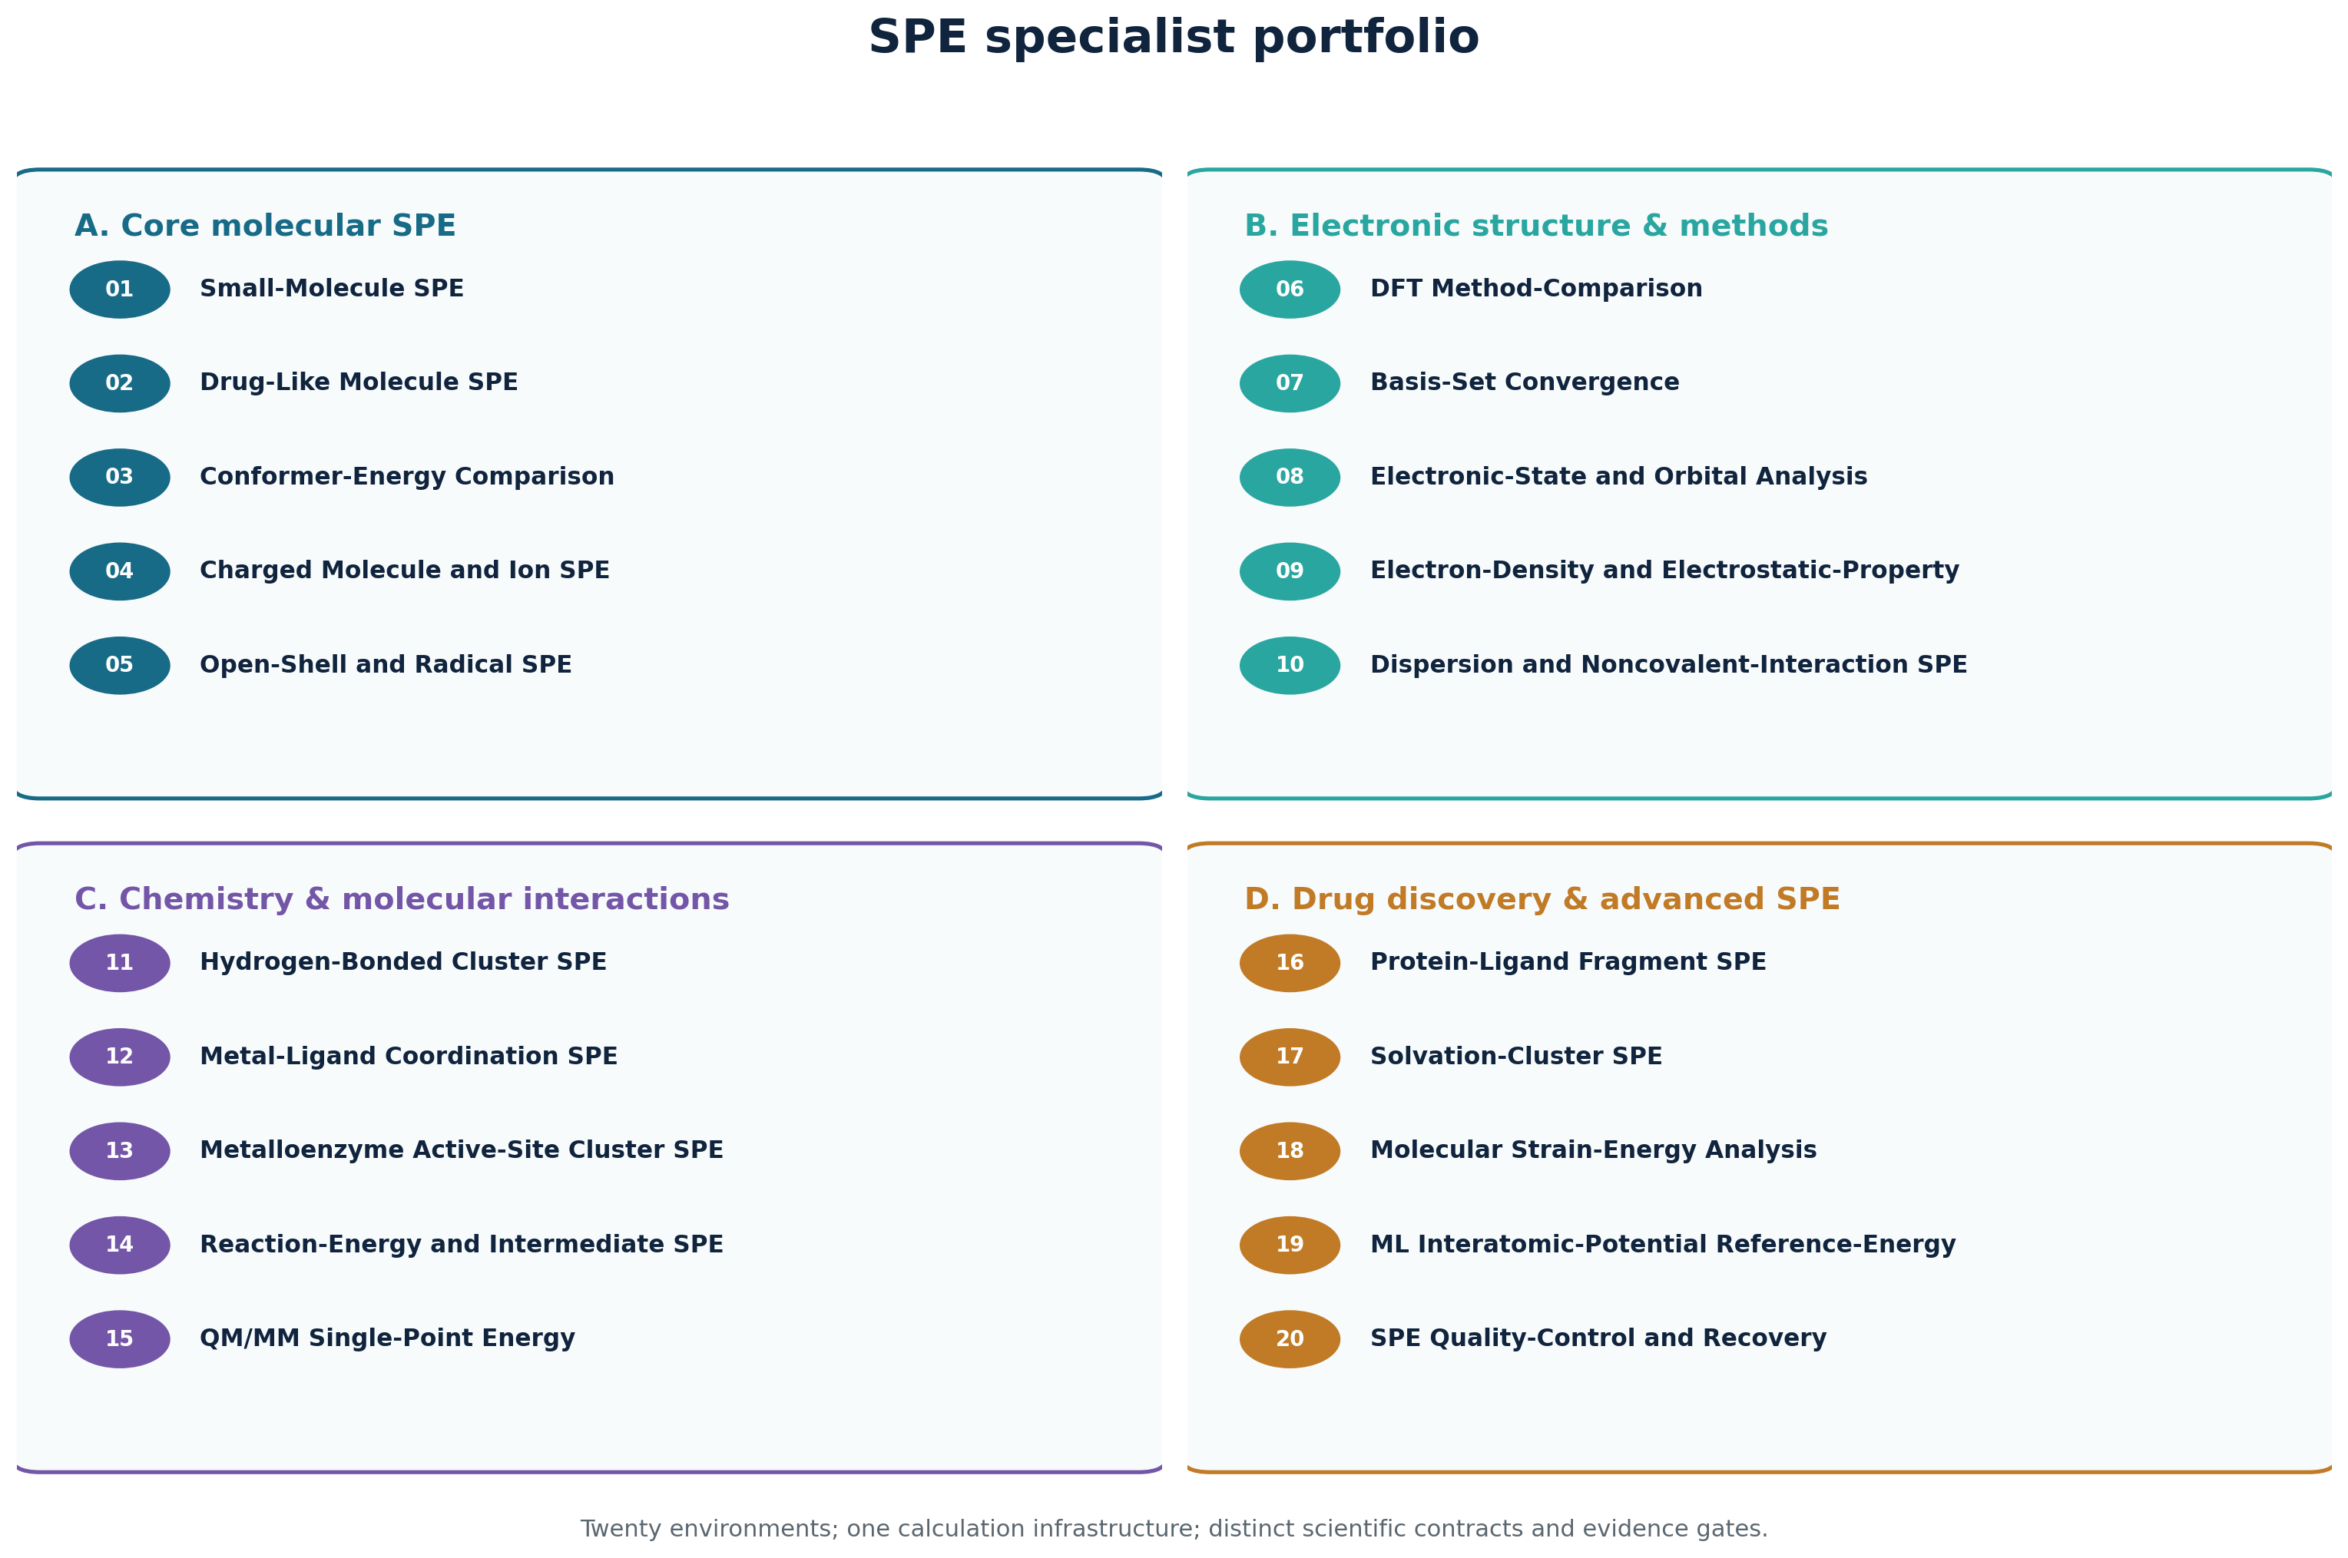
Figure 3. The twenty specialist environments grouped by scientific purpose.
ID | Environment | Group | Intended adapter(s) | Status
01 | Small-Molecule SPE | spe-core | boltzmann-spe-api | unverified
02 | Drug-Like Molecule SPE | spe-core | boltzmann-spe-api | unverified
03 | Conformer-Energy Comparison | spe-core | boltzmann-spe-api | unverified
04 | Charged Molecule and Ion SPE | spe-core | boltzmann-spe-api | unverified
05 | Open-Shell and Radical SPE | spe-core | boltzmann-spe-api, boltzmann-homo-lumo-api | unverified
06 | DFT Method-Comparison | spe-method | boltzmann-spe-api | unverified
07 | Basis-Set Convergence | spe-method | boltzmann-spe-api | unverified
08 | Electronic-State and Orbital Analysis | spe-method | boltzmann-spe-api, boltzmann-homo-lumo-api | unverified
09 | Electron-Density and Electrostatic-Property | spe-method | boltzmann-spe-api, boltzmann-dft-properties-adapter | unverified
10 | Dispersion and Noncovalent-Interaction SPE | spe-method | boltzmann-spe-api, boltzmann-dft-properties-adapter | unverified
11 | Hydrogen-Bonded Cluster SPE | spe-chemistry | boltzmann-spe-api | unverified
12 | Metal-Ligand Coordination SPE | spe-chemistry | boltzmann-spe-api, boltzmann-homo-lumo-api | unverified
13 | Metalloenzyme Active-Site Cluster SPE | spe-chemistry | boltzmann-spe-api, boltzmann-dft-properties-adapter | unverified
14 | Reaction-Energy and Intermediate SPE | spe-chemistry | boltzmann-spe-api | unverified
15 | QM/MM Single-Point Energy | spe-chemistry | boltzmann-qmmm-api | unverified
16 | Protein-Ligand Fragment SPE | spe-drug-discovery | boltzmann-spe-api, boltzmann-dft-properties-adapter | unverified
17 | Solvation-Cluster SPE | spe-drug-discovery | boltzmann-spe-api | unverified
18 | Molecular Strain-Energy Analysis | spe-drug-discovery | boltzmann-spe-api | unverified
19 | ML Interatomic-Potential Reference-Energy | spe-drug-discovery | apex-md-mlip, boltzmann-spe-api | unverified
20 | SPE Quality-Control and Recovery | spe-quality-control | boltzmann-spe-api, boltzmann-homo-lumo-api, boltzmann-dft-properties-adapter, boltzmann-qmmm-api, apex-md-mlip | unverified

4. Phased implementation roadmap
The roadmap is deliberately evidence-gated. Week labels are planning targets, not permission to promote an environment. A phase can finish only when its code, fixtures, failure behavior and independent scientific evaluation satisfy the gate.
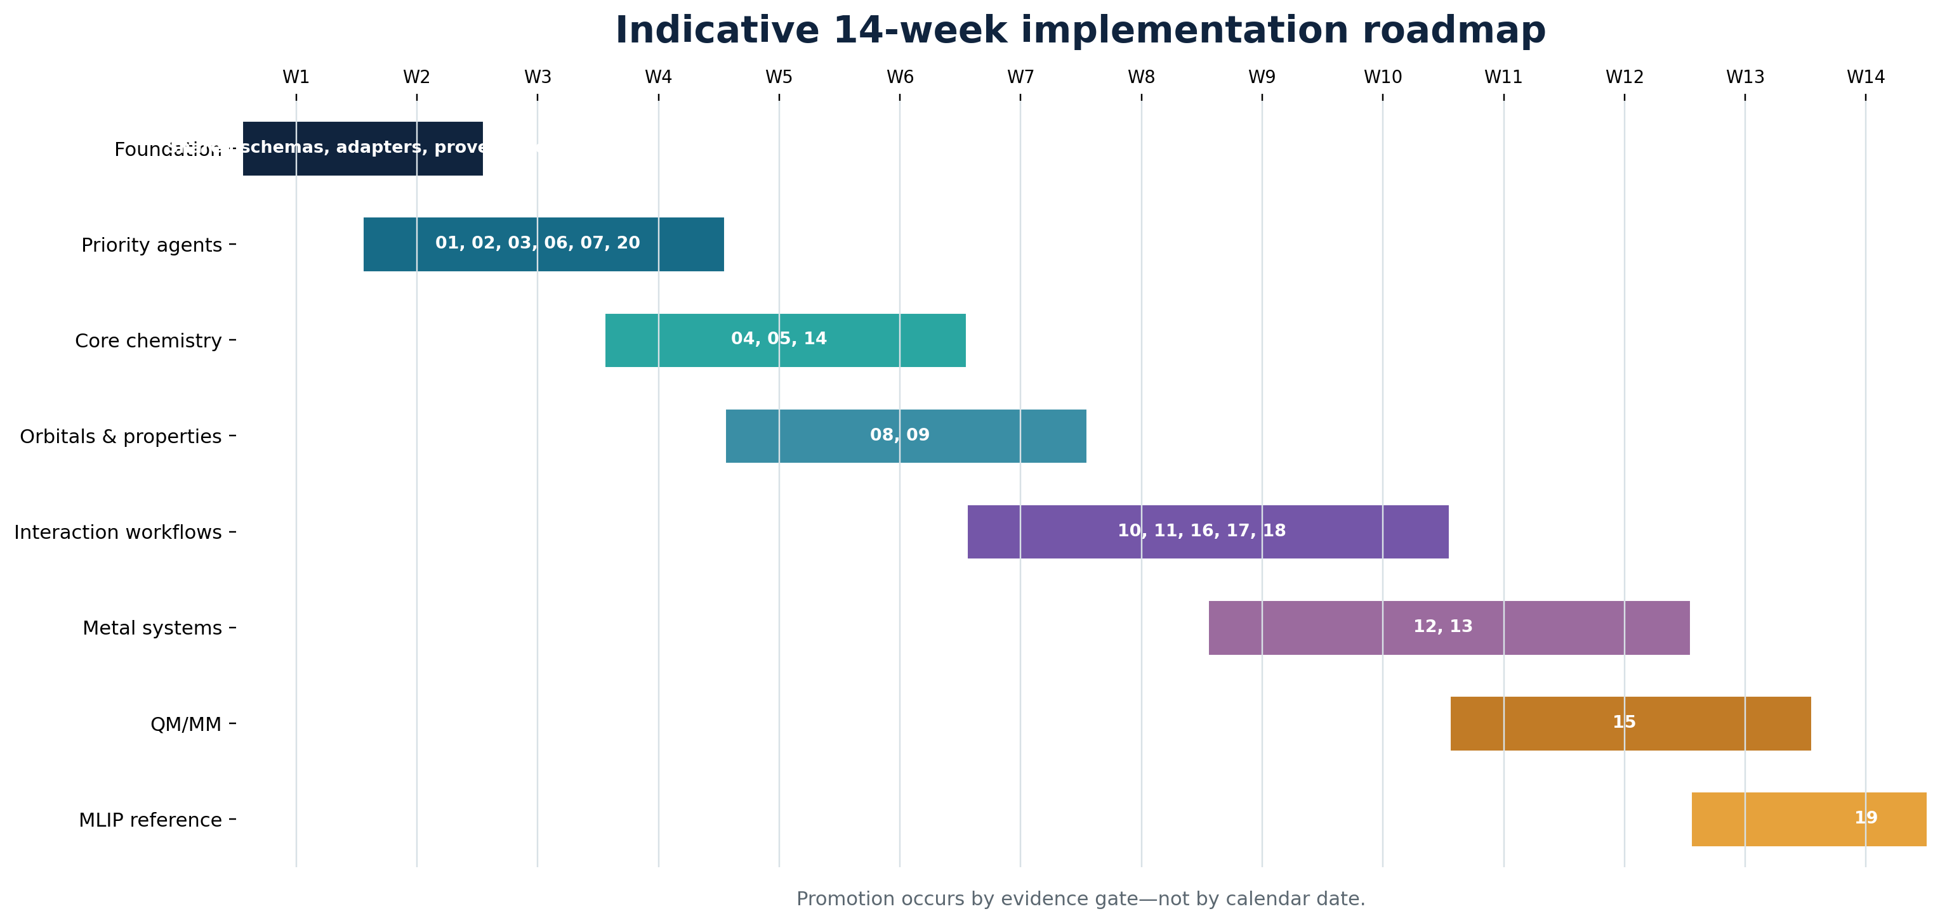
Figure 4. Indicative sequence; workstreams overlap where interfaces are stable.
Phase | Target | Workstream | Scope | Exit evidence
0 | Weeks 1–2 | Shared foundation | Schemas; adapter protocol; parser bridge; job states; artifact/provenance model; evaluator; mock adapter | Framework can validate, execute a mock, fail, recover, evaluate and report
1 | Weeks 2–4 | Priority specialists | 01, 02, 03, 06, 07, 20 | Representative valid, invalid, failure and evidence tests pass
2 | Weeks 4–6 | Charged/open-shell/reaction | 04, 05, 14 | Electron-count, spin and stoichiometric bookkeeping verified
3 | Weeks 5–7 | Orbitals and properties | 08, 09 | Wavefunction compatibility and visualization-artifact schemas stable
4 | Weeks 7–10 | Interaction workflows | 10, 11, 16, 17, 18 | Fragment/reference arithmetic, sign conventions and BSSE paths tested
5 | Weeks 9–12 | Metal systems | 12, 13 | Oxidation/spin/ECP/relativistic and cluster-boundary review gates proven
6 | Weeks 11–13 | Prepared QM/MM | 15 | Partition, boundary, embedding and energy-component consistency validated
7 | Weeks 13–14 | MLIP reference | 19 | Reliable reference dataset, energy alignment and OOD policy available

4.1 Priority build sequence
- First operational candidates: 01, 02, 03, 06, 07 and 20.
- Add 04, 05 and 14 early enough that charge, open-shell and reaction bookkeeping shape the shared schemas.
- Do not begin metal-system promotion until method/ECP support and spin-state review policy are explicit.
- Do not promote QM/MM until a prepared, parameterized system and stable partition contract exist.
- Do not promote MLIP comparison until model-domain metadata and compatible QM reference data are available.

5. Detailed environment contracts
The following implementation specifications are generated from the version-controlled environment contracts. The JSON files remain the machine-readable source of truth.

01. Small-Molecule SPE Agent
Calculates fixed-geometry electronic energies for well-defined small molecules such as water, methane, ammonia, and ethanol.
Contract field | Environment-specific rule
Group / status | spe-core / unverified
Required inputs | molecular geometry with element identities and coordinate units • total charge • spin multiplicity • electronic-structure method • basis set
Optional inputs | dispersion treatment • solvation model • SCF settings • resource limits
Outputs | total electronic energy with units • convergence status • calculation settings and engine provenance • warnings and validation result
Intended adapters | boltzmann-spe-api
Validation | geometry is parseable and finite • atom and coordinate counts agree • charge and multiplicity have valid electron-count parity • method and basis are supported by the selected engine
Acceptance evidence | engine terminates normally • SCF convergence is explicitly demonstrated • one finite total electronic energy is extracted • input settings and output artifacts are reproducible
Scientific boundary | does not optimize geometry • does not calculate thermal or entropic corrections unless separately requested from a supported environment • does not infer missing chemical identity
Bounded recovery | increase SCF iterations within configured limits • use an engine-supported conservative SCF convergence aid without changing method, basis, charge, multiplicity, or geometry
Human review | charge or multiplicity is ambiguous • method or basis is unsupported • SCF remains unconverged after bounded recovery • geometry appears chemically invalid
Retry ceiling | 2

02. Drug-Like Molecule SPE Agent
Evaluates conformer-specific electronic energies of drug-like compounds containing heterocycles, aromatic systems, and common medicinal-chemistry functional groups.
Contract field | Environment-specific rule
Group / status | spe-core / unverified
Required inputs | explicit 3D molecular geometry • total charge • spin multiplicity • electronic-structure method • basis set
Optional inputs | compound identifier • protonation and tautomer annotation • dispersion treatment • solvation model • resource limits
Outputs | conformer-specific total electronic energy with units • molecular-validity findings • method suitability warnings • settings and provenance
Intended adapters | boltzmann-spe-api
Validation | bonding and valence implied by the supplied structure are plausible • protonation and tautomer state are explicit when relevant • charge and multiplicity are consistent • elements method and basis are supported
Acceptance evidence | molecular graph and geometry pass validity checks • SCF converges • finite electronic energy and complete method metadata are extracted • all warnings are retained
Scientific boundary | does not select a biologically dominant protonation state • does not generate or rank conformers unless delegated to the conformer environment • does not predict binding affinity
Bounded recovery | increase SCF iterations within limits • apply a supported SCF convergence aid • retry a parser-safe representation without changing molecular identity
Human review | protonation tautomerism or stereochemistry is ambiguous • structure validation fails • the chosen method is unsuitable for the chemistry • SCF recovery would change the electronic state
Retry ceiling | 2

03. Conformer-Energy Comparison Agent
Calculates fixed-geometry energies for multiple conformers of the same chemical species and ranks their relative electronic energies.
Contract field | Environment-specific rule
Group / status | spe-core / unverified
Required inputs | two or more labeled conformer geometries • common molecular identity and atom mapping • total charge • spin multiplicity • common method and basis set
Optional inputs | dispersion treatment • solvation model • reference conformer label • relative-energy output unit
Outputs | absolute electronic energy for each conformer • relative energies against the lowest or requested reference • energy ranking • per-conformer convergence and provenance
Intended adapters | boltzmann-spe-api
Validation | all conformers have identical stoichiometry charge and multiplicity • atom mappings are consistent • all calculations use identical energy settings • every conformer geometry is valid
Acceptance evidence | at least two matched conformers converge • every ranked conformer has a finite energy • relative energies reproduce direct subtraction from recorded absolute values • ties and excluded structures are reported
Scientific boundary | does not claim solution-phase populations • does not include zero-point thermal or entropic corrections • does not perform conformer generation or geometry optimization
Bounded recovery | retry only failed members with the same scientific settings • increase SCF iterations consistently • apply the same supported SCF aid to affected calculations and record the difference
Human review | conformers differ in composition protonation tautomer or spin state • settings cannot be made identical • ranking depends on unconverged results • the requested interpretation requires free energies
Retry ceiling | 2

04. Charged Molecule and Ion SPE Agent
Calculates fixed-geometry electronic energies for cations, anions, and charged molecular intermediates with explicit charge and spin controls.
Contract field | Environment-specific rule
Group / status | spe-core / unverified
Required inputs | molecular geometry • nonzero total charge • spin multiplicity • electronic-structure method • basis set
Optional inputs | solvation model • diffuse-function requirement • dispersion treatment • SCF settings
Outputs | total electronic energy with units • electron-count and spin validation • SCF diagnostics • settings and provenance
Intended adapters | boltzmann-spe-api
Validation | total charge is explicit and nonzero • electron count is positive • multiplicity parity is consistent with electron count • basis suitability for anions and diffuse density is assessed
Acceptance evidence | SCF converges to a finite energy • electron count matches composition and charge • wavefunction diagnostics available from the engine do not show an invalid solution • all settings are preserved
Scientific boundary | does not determine pKa redox potential or ionization free energy from a lone SPE • does not assume a counterion or solvent • does not choose among competing spin states
Bounded recovery | increase SCF iterations • apply a supported SCF convergence aid • request human confirmation before adding diffuse functions or changing the electronic method
Human review | charge assignment is uncertain • multiple spin states are plausible • anion treatment lacks adequate basis support • SCF converges to a questionable electronic solution
Retry ceiling | 2

05. Open-Shell and Radical SPE Agent
Evaluates fixed geometries of radicals and other molecules with unpaired electrons while checking spin multiplicity and available wavefunction diagnostics.
Contract field | Environment-specific rule
Group / status | spe-core / unverified
Required inputs | molecular geometry • total charge • spin multiplicity greater than one or explicit open-shell specification • open-shell-capable method • basis set
Optional inputs | restricted-open-shell or unrestricted reference choice • expected spin-squared value • stability-analysis request • dispersion and solvation settings
Outputs | total electronic energy with units • electronic-state metadata • spin expectation and contamination diagnostics when supported • convergence and provenance
Intended adapters | boltzmann-spe-api, boltzmann-homo-lumo-api
Validation | multiplicity is explicit and parity-compatible • selected reference supports open-shell calculations • requested state is distinguishable in the engine • spin diagnostics are requested when available
Acceptance evidence | SCF converges • finite energy is extracted • reported electronic state matches the requested multiplicity • spin contamination is within a declared tolerance or flagged for review
Scientific boundary | does not prove the global ground state from one calculation • does not silently repair spin contamination by changing method or multiplicity • does not locate crossings between electronic states
Bounded recovery | increase SCF iterations • use a supported open-shell SCF convergence aid • run a stability check when supported without changing charge multiplicity method or geometry
Human review | spin state is ambiguous • spin contamination exceeds tolerance • wavefunction stability fails • bounded recovery finds a different electronic solution
Retry ceiling | 2

06. DFT Method-Comparison Agent
Compares fixed-geometry single-point energies from supported density functionals and basis sets using controlled, consistent settings.
Contract field | Environment-specific rule
Group / status | spe-method / unverified
Required inputs | one fixed molecular geometry • total charge • spin multiplicity • two or more supported DFT method specifications
Optional inputs | common basis set or per-method basis sets • dispersion treatments • solvation model • comparison reference
Outputs | energy for each complete method specification • pairwise and reference-relative differences • method-sensitivity summary • per-run convergence and provenance
Intended adapters | boltzmann-spe-api
Validation | geometry charge and multiplicity are identical across runs • each method basis and dispersion combination is supported • all energy conventions and units are compatible • comparison labels are unique
Acceptance evidence | at least two requested methods converge • each comparison includes its full settings • reported differences reproduce the recorded total energies • failed methods remain visible
Scientific boundary | does not establish method accuracy without reference data • does not optimize geometries independently for each method • does not compare energies of different compositions
Bounded recovery | retry a failed calculation with increased SCF iterations • apply an engine-supported SCF aid while preserving each declared method specification
Human review | methods use incompatible energy definitions • only one method converges • a requested functional or basis is unsupported • method ranking is interpreted as benchmark accuracy without references
Retry ceiling | 2

07. Basis-Set Convergence Agent
Measures how a fixed-geometry electronic energy changes across an ordered series of increasingly complete basis sets.
Contract field | Environment-specific rule
Group / status | spe-method / unverified
Required inputs | one fixed molecular geometry • total charge • spin multiplicity • one electronic-structure method • two or more ordered basis sets
Optional inputs | convergence tolerance • extrapolation request and formula • dispersion treatment • solvation model
Outputs | total energy for each basis set • successive energy changes • convergence assessment • bounded recommendation for further calculation
Intended adapters | boltzmann-spe-api
Validation | basis sequence is meaningful for the selected elements and method • method geometry charge multiplicity and other settings remain fixed • every basis is supported • requested tolerance has explicit energy units
Acceptance evidence | at least two basis calculations converge • successive changes are computed in a common unit • trend classification is supported by recorded energies • recommendation cites the requested tolerance and observed change
Scientific boundary | does not guarantee the complete-basis-set limit from a short or mixed series • does not change geometry between basis sets • does not infer property convergence from energy convergence
Bounded recovery | retry failed members with increased SCF iterations • apply a supported SCF aid • recommend but do not automatically substitute a different basis
Human review | basis families are not comparable • heavy elements require unresolved ECP choices • convergence is nonmonotonic or insufficient • resource limits prevent the requested series
Retry ceiling | 2

08. Electronic-State and Orbital Analysis Agent
Extracts supported electronic-state information, orbital energies, HOMO-LUMO gaps, occupations, and wavefunction diagnostics from compatible SPE results.
Contract field | Environment-specific rule
Group / status | spe-method / unverified
Required inputs | molecular geometry or compatible SPE artifact • charge • spin multiplicity • method and basis metadata • requested orbital or state observables
Optional inputs | wavefunction file • orbital subset • stability analysis • diagnostic tolerances
Outputs | requested orbital energies and occupations • HOMO-LUMO or spin-resolved gaps • available wavefunction diagnostics • physical-solution assessment and provenance
Intended adapters | boltzmann-spe-api, boltzmann-homo-lumo-api
Validation | upstream artifacts match the declared geometry and settings • orbital occupations are present • closed-shell and spin-resolved frontier definitions are distinguished • energy units are explicit
Acceptance evidence | source SPE is converged • requested orbital values are finite and occupation-consistent • gap arithmetic is independently reproduced • available stability and spin diagnostics pass or are flagged
Scientific boundary | does not calculate excited states unless an explicitly supported method is added • does not equate a Kohn-Sham gap with an optical gap • does not invent unavailable wavefunction diagnostics
Bounded recovery | reparse the original output with a compatible parser • request a supported orbital-output option and rerun with unchanged scientific settings • run a supported wavefunction stability check
Human review | occupations are ambiguous • wavefunction is unstable • spin contamination is material • orbital data or provenance are incomplete
Retry ceiling | 1

09. Electron-Density and Electrostatic-Property Agent
Computes and validates supported electron-density, electrostatic-potential, population, and related properties from a compatible SPE calculation.
Contract field | Environment-specific rule
Group / status | spe-method / unverified
Required inputs | molecular geometry or compatible wavefunction artifact • charge and multiplicity • method and basis metadata • requested properties
Optional inputs | grid extent and spacing • population-analysis scheme • cube-file settings • surface definition
Outputs | requested scalar properties with units • density or potential grid artifacts • grid and analysis metadata • validation findings and provenance
Intended adapters | boltzmann-spe-api, boltzmann-dft-properties-adapter
Validation | wavefunction and geometry provenance match • requested property is supported by the method and engine • grid encloses the molecule at requested resolution • artifact format units and coordinate frame are explicit
Acceptance evidence | source wavefunction is converged • all requested supported properties are present and finite • density or potential artifacts are nonempty and parseable • electron-count consistency is checked when supported
Scientific boundary | does not claim observables that the selected method cannot provide • does not treat population charges as unique physical charges • does not visualize files inside the execution result unless a visualization adapter is available
Bounded recovery | regenerate a missing supported property from the preserved wavefunction • expand or refine the grid within configured resource limits • reparse artifacts without modifying scientific settings
Human review | property definition or population scheme is ambiguous • grid convergence is inadequate • wavefunction provenance is missing • electron-count or density validation fails
Retry ceiling | 1

10. Dispersion and Noncovalent-Interaction SPE Agent
Evaluates fixed-geometry dimers and selected noncovalent complexes with explicit dispersion treatment, fragment references, and optional counterpoise correction.
Contract field | Environment-specific rule
Group / status | spe-method / unverified
Required inputs | complex geometry with explicit fragment membership • fragment charges and multiplicities • complex charge and multiplicity • method basis and dispersion specification
Optional inputs | counterpoise request • ghost-atom definitions • solvation model • reference fragment geometries
Outputs | complex and fragment electronic energies • uncorrected interaction energy • counterpoise-corrected interaction energy when supported • component convergence and provenance
Intended adapters | boltzmann-spe-api, boltzmann-dft-properties-adapter
Validation | fragment partition covers each atom exactly once • fragment charges multiplicities and stoichiometry combine consistently • complex and fragment settings are matched • dispersion and counterpoise conventions are explicit
Acceptance evidence | all energy components converge • interaction energy independently reproduces complex minus fragment sum • counterpoise components use the correct ghost basis when requested • settings and fragment definitions are preserved
Scientific boundary | does not calculate binding free energy • does not include deformation energy unless explicit relaxed references are supplied • does not perform energy decomposition unless a supported adapter is declared
Bounded recovery | retry failed components with matched SCF recovery settings • reparse fragment labels • recommend but do not silently add counterpoise or dispersion treatment
Human review | fragment charges or multiplicities are ambiguous • covalent bonds cross the requested partition • counterpoise support is unavailable • component convergence or bookkeeping fails
Retry ceiling | 2

11. Hydrogen-Bonded Cluster SPE Agent
Evaluates fixed geometries of water clusters and other hydrogen-bonded complexes using consistent complex and fragment reference calculations.
Contract field | Environment-specific rule
Group / status | spe-chemistry / unverified
Required inputs | cluster geometry • explicit monomer or fragment definitions • cluster and fragment charges and multiplicities • common method basis and dispersion settings
Optional inputs | counterpoise correction • many-body decomposition request • solvation model • reference convention
Outputs | cluster total electronic energy • fragment reference energies • total interaction energy • optional supported correction or decomposition with provenance
Intended adapters | boltzmann-spe-api
Validation | fragment definitions cover the cluster • cluster and fragment electronic states are consistent • all energy settings match • hydrogen-bond geometry is reported without being automatically altered
Acceptance evidence | cluster and all required fragment jobs converge • interaction energy reproduces component arithmetic • fragment identities and geometries are traceable • BSSE status is stated
Scientific boundary | does not provide a thermodynamic association free energy • does not optimize the hydrogen-bond network • does not infer missing fragment definitions
Bounded recovery | retry failed components with matched SCF aids • increase SCF iterations consistently • recommend counterpoise analysis without enabling it silently
Human review | proton transfer makes fragments ambiguous • fragment states are inconsistent • many-body decomposition is incomplete • results are strongly basis-sensitive
Retry ceiling | 2

12. Metal-Ligand Coordination SPE Agent
Calculates supported metal complexes with explicit oxidation-state, charge, spin-state, coordination-geometry, and method-suitability checks.
Contract field | Environment-specific rule
Group / status | spe-chemistry / unverified
Required inputs | metal-complex geometry • total charge • spin multiplicity • metal oxidation-state assignment • method basis and ECP specification
Optional inputs | ligand charge assignments • alternative spin states • relativistic treatment • dispersion and solvation settings
Outputs | total electronic energy with units • electronic-state and oxidation-state audit • coordination-geometry findings • wavefunction diagnostics and provenance
Intended adapters | boltzmann-spe-api, boltzmann-homo-lumo-api
Validation | oxidation states and ligand charges reconcile with total charge • multiplicity is explicit • method basis ECP and relativistic choices support every element • coordination geometry has no obvious invalid contacts
Acceptance evidence | SCF converges to the requested state • finite energy and available spin diagnostics are extracted • method and element coverage checks pass • coordination and electronic-state warnings are reported
Scientific boundary | does not assign oxidation state from geometry alone • does not guarantee multireference systems are described adequately • does not compare spin states unless matched alternative-state jobs are supplied
Bounded recovery | increase SCF iterations • apply a supported level shift damping or orbital guess strategy while preserving the scientific state • run a supported stability check
Human review | oxidation or spin state is ambiguous • multireference character is suspected • metal basis ECP or relativistic treatment is unsupported • SCF converges to the wrong state
Retry ceiling | 2

13. Metalloenzyme Active-Site Cluster SPE Agent
Evaluates a well-defined extracted metalloenzyme active-site cluster, including selected metal-binding inhibitor models, without claiming a complete protein calculation.
Contract field | Environment-specific rule
Group / status | spe-chemistry / unverified
Required inputs | capped active-site cluster geometry • atom provenance and residue mapping • total charge and multiplicity • metal oxidation state • method basis and boundary-cap specification
Optional inputs | inhibitor fragment definition • alternative protonation models • embedding charges • dispersion and solvation settings
Outputs | cluster total electronic energy • model composition and boundary audit • electronic-state diagnostics • limitations and complete provenance
Intended adapters | boltzmann-spe-api, boltzmann-dft-properties-adapter
Validation | cluster atoms map to the source structure • truncation points and caps are explicit • protonation oxidation charge and spin assignments reconcile • metal coordination sphere is complete for the intended model
Acceptance evidence | model-integrity checks pass • SCF converges to the requested state • finite energy and electronic diagnostics are extracted • cluster limitations and source mapping are included
Scientific boundary | is not a complete protein calculation • does not yield whole-protein binding affinity • does not choose the QM cluster protonation or oxidation model automatically
Bounded recovery | increase SCF iterations • use supported convergence aids • repair only representational boundary metadata when atom identity and geometry remain unchanged
Human review | cluster selection or caps are ambiguous • protonation oxidation or spin alternatives are plausible • coordination sphere is incomplete • embedding changes the scientific model
Retry ceiling | 2

14. Reaction-Energy and Intermediate SPE Agent
Calculates fixed-geometry electronic energies for supplied reactants, products, and intermediates with explicit stoichiometric and energy-reference bookkeeping.
Contract field | Environment-specific rule
Group / status | spe-chemistry / unverified
Required inputs | labeled species geometries • stoichiometric coefficients • charge and multiplicity for every species • common energy protocol
Optional inputs | reaction-step definitions • reference species • dispersion and solvation settings • requested output unit
Outputs | electronic energy for each species • electronic reaction energies for declared steps • intermediate energy profile • component convergence and provenance
Intended adapters | boltzmann-spe-api
Validation | each declared reaction conserves elements and total charge • spin treatment is scientifically compatible • all species use a consistent method basis dispersion and solvent protocol • stoichiometric signs are explicit
Acceptance evidence | all required species converge • each reaction energy independently reproduces the stoichiometric sum • units and sign convention are explicit • failed or omitted species prevent rather than partially populate affected steps
Scientific boundary | does not locate a transition state • does not report activation barriers without a supplied validated transition-state structure • does not include zero-point thermal entropic or standard-state corrections
Bounded recovery | retry failed species with consistent SCF recovery settings • correct purely syntactic stoichiometric formatting with an audit record • reparse outputs without changing the energy protocol
Human review | stoichiometry charge or spin is not conserved • species require incompatible methods • a requested value is actually a free energy or barrier • any required component remains unconverged
Retry ceiling | 2

15. QM/MM Single-Point Energy Agent
Evaluates a prepared QM/MM system with explicit QM-region, boundary, embedding, and energy-component definitions using an available implementation.
Contract field | Environment-specific rule
Group / status | spe-chemistry / unverified
Required inputs | complete prepared system • explicit QM atom selection • QM-region charge and multiplicity • QM and MM methods • boundary and embedding scheme
Optional inputs | link atoms • frozen atoms • electrostatic cutoffs • component-energy convention
Outputs | QM/MM total energy under a declared convention • available component energies • QM-region and boundary record • convergence and full provenance
Intended adapters | boltzmann-qmmm-api
Validation | QM selection maps uniquely to the full system • boundary placement and link atoms are valid • QM charge multiplicity and MM parameters are consistent • embedding and energy convention are supported
Acceptance evidence | QM and MM inputs pass integrity checks • QM SCF and overall job converge • reported total and component energies are internally consistent • partition boundary settings and engine versions are preserved
Scientific boundary | requires a prepared parameterized QM/MM system • does not optimize the structure • does not compare results across different QM regions as if directly equivalent
Bounded recovery | increase supported QM SCF iterations • apply a supported SCF aid without changing the partition • retry transient execution or output-parsing failures
Human review | QM region or link placement is ambiguous • MM parameters are missing • embedding support is unavailable • recovery would alter the partition charge spin or boundary
Retry ceiling | 1

16. Protein-Ligand Fragment SPE Agent
Performs supported QM single-point calculations on extracted ligand fragments, nearby residues, or carefully defined local interaction clusters.
Contract field | Environment-specific rule
Group / status | spe-drug-discovery / unverified
Required inputs | extracted cluster geometry • source-structure atom mapping • fragment definitions • charges and multiplicities • common method basis and boundary-cap protocol
Optional inputs | embedding charges • counterpoise correction • dispersion and solvation settings • matched comparison cluster
Outputs | cluster and fragment electronic energies • defined local interaction energy • model and boundary audit • limitations convergence and provenance
Intended adapters | boltzmann-spe-api, boltzmann-dft-properties-adapter
Validation | all extracted atoms map to the source structure • caps and fragment boundaries are explicit • fragment charges and multiplicities reconcile • compared models use chemically consistent atom sets and settings
Acceptance evidence | cluster and required fragment calculations converge • interaction-energy arithmetic is reproducible • source mapping and truncation metadata are complete • model limitations are prominent
Scientific boundary | does not calculate whole-protein binding affinity • does not include conformational entropy or bulk solvent sampling • does not automatically choose residues or protonation states
Bounded recovery | retry failed components with matched SCF aids • repair representational atom mappings without changing the model • reparse preserved outputs
Human review | cluster selection caps protonation or residue states are ambiguous • charged fragments create inconsistent references • embedding or counterpoise support is unavailable • local energy is requested as a binding free energy
Retry ceiling | 2

17. Solvation-Cluster SPE Agent
Evaluates selected solute-solvent clusters or matched gas-phase and solvated models with explicitly defined energy references.
Contract field | Environment-specific rule
Group / status | spe-drug-discovery / unverified
Required inputs | solute-solvent cluster or matched model geometries • solute and solvent fragment definitions • charges and multiplicities • common method and basis • energy-difference definition
Optional inputs | continuum solvent model • counterpoise correction • gas-phase reference • solvent-shell labels
Outputs | electronic energy of each declared model • defined cluster or phase-model energy differences • fragment reference energies when requested • convergence provenance and limitations
Intended adapters | boltzmann-spe-api
Validation | solute and solvent identities are explicit • reference calculations have consistent composition or declared stoichiometric corrections • charge spin method basis and geometry conventions are consistent • implicit and explicit solvent treatments are not double-counted unintentionally
Acceptance evidence | all components required by the declared difference converge • energy differences reproduce component arithmetic • solvent model and reference conventions are explicit • cluster composition is validated
Scientific boundary | a cluster SPE is not a full solvation free energy • does not sample solvent configurations • does not add entropic thermal or standard-state corrections
Bounded recovery | retry failed components with consistent SCF settings • reparse composition and fragment metadata • recommend but do not silently change the solvent model
Human review | reference cycle is incomplete • cluster compositions are inconsistent • explicit and implicit solvent choices conflict • the requested interpretation requires ensemble free energies
Retry ceiling | 2

18. Molecular Strain-Energy Analysis Agent
Compares a molecular geometry with a scientifically suitable reference geometry using a single consistent electronic-energy protocol.
Contract field | Environment-specific rule
Group / status | spe-drug-discovery / unverified
Required inputs | target molecular geometry • reference molecular geometry • proof of common chemical identity • charge and multiplicity • common method and basis
Optional inputs | reference-selection rationale • dispersion and solvation settings • atom mapping • relative-energy output unit
Outputs | target and reference electronic energies • defined strain energy • reference suitability findings • convergence and provenance
Intended adapters | boltzmann-spe-api
Validation | target and reference share composition connectivity charge multiplicity and atom mapping • both use identical calculation settings • reference choice is scientifically justified • strain-energy sign convention is explicit
Acceptance evidence | both calculations converge • energy difference independently reproduces the reported strain value • chemical identity and settings match • reference rationale and limitations are retained
Scientific boundary | does not find the global minimum • does not include reorganization entropy or solvent sampling • does not compare different protonation tautomers or compositions as strain
Bounded recovery | retry failed calculations with matched SCF recovery • repair atom mapping metadata without changing coordinates • request a better reference rather than selecting one silently
Human review | reference geometry is unsuitable • chemical identities differ • one structure requires different settings • the target contains severe contacts or an unstable electronic solution
Retry ceiling | 2

19. ML Interatomic-Potential Reference-Energy Agent
Evaluates fixed structures with a supported machine-learning interatomic potential and compares predictions with compatible reference QM/SPE data when available.
Contract field | Environment-specific rule
Group / status | spe-drug-discovery / unverified
Required inputs | one or more fixed atomic structures • MLIP model identifier and version • model element and domain metadata • requested energy or force observables
Optional inputs | reference QM/SPE results • uncertainty or OOD threshold • device preference • energy-reference alignment rule
Outputs | MLIP energies and forces when supported • domain and out-of-distribution assessment • errors against compatible references • model settings units and provenance
Intended adapters | apex-md-mlip, boltzmann-spe-api
Validation | all elements and charge conventions are supported by the model • structures are inside the declared chemical and configurational domain or flagged • MLIP and reference energy conventions are alignable • energy and force units and atom ordering agree
Acceptance evidence | inference completes with finite values • unit and shape checks pass • domain status is reported for every structure • comparison metrics reproduce recorded predictions and references when references exist
Scientific boundary | does not establish QM accuracy without a compatible reference set • does not extrapolate silently outside the training domain • does not train or fine-tune a model
Bounded recovery | retry on a supported device • normalize declared units and atom ordering with an audit record • fall back to reference-only reporting when MLIP execution is unavailable
Human review | system is out of distribution • model domain metadata are missing • energy references cannot be aligned • error or uncertainty exceeds the declared threshold
Retry ceiling | 1

20. SPE Quality-Control and Recovery Agent
Independently audits calculations from SPE environments 01 through 19 and proposes evidence-based bounded recovery without silently changing scientific settings.
Contract field | Environment-specific rule
Group / status | spe-quality-control / unverified
Required inputs | source environment identifier • original normalized input • calculation settings • engine version and execution log • structured outputs and artifact references
Optional inputs | checksums • retry history • reference result • environment-specific tolerance overrides
Outputs | independent pass fail needs-review or not-evaluated decision • evidence for every check • classified errors and warnings • ordered bounded recovery proposal or escalation
Intended adapters | boltzmann-spe-api, boltzmann-homo-lumo-api, boltzmann-dft-properties-adapter, boltzmann-qmmm-api, apex-md-mlip
Validation | source contract and required evidence are present • input output and settings provenance are internally consistent • SCF and requested-property completion signals are explicit • retry history obeys the source environment limit
Acceptance evidence | all mandatory source-environment checks have evidence • required outputs are present finite and unit-labeled • convergence and provenance checks pass • the result is reproducible from preserved settings and artifacts
Scientific boundary | does not execute an unapproved scientific change • does not mark an unverified adapter operational • does not fabricate missing logs diagnostics artifacts or references
Bounded recovery | classify the failure before proposing action • allow only source-contract recovery actions within its retry limit • stop repeated identical attempts • escalate any scientific-setting change for human review
Human review | required evidence is missing • scientific settings would need to change • diagnostics conflict • bounded retries are exhausted • physical validity remains uncertain despite successful execution
Retry ceiling | 0

6. Shared framework work packages
WP | Area | Implementation content | Verification artifact
WP1 | Contracts and schemas | Versioned task/result schemas; contract validation; status vocabularies; unit conventions | Schema fixtures and backward-compatibility tests
WP2 | Structure ingestion | JSON/XYZ and approved external parsers; atom/coordinate checks; unit normalization; immutable original input | Golden parsing fixtures and malformed-input suite
WP3 | Scientific preflight | Electron count; charge/multiplicity parity; method/basis/element support; fragment/QM-region rules | Per-environment valid and invalid matrices
WP4 | Adapter layer | Common submit/status/cancel/result interface over existing SPE and specialist services | Mock contract tests plus versioned real-adapter smoke tests
WP5 | Result extraction | Energies, units, orbitals, properties, component arithmetic, logs and visualization artifacts | Parser fixtures including malformed and partial outputs
WP6 | Diagnosis and recovery | Failure classification, bounded actions, retry ceiling, duplicate-attempt prevention and audit log | Known-failure and retry-exhaustion tests
WP7 | Independent evaluation | Exact acceptance evidence, pass/fail/review semantics and environment evaluator plugins | Evaluator tests independent of adapter mocks
WP8 | Observability and provenance | Task IDs, timestamps, engine versions, full settings, artifact checksums and lineage | Reproduction drill from preserved record
WP9 | Security and operations | Resource limits, input size limits, timeouts, cancellation, secret isolation and sandbox policy | Operational readiness checklist

6.1 Proposed adapter interface
Each engine integration should implement a small common surface: capability discovery, request translation, submission, status polling or completion, cancellation, structured result translation and artifact collection. Capability discovery must report engine/version, supported elements, methods, basis/ECP options, open-shell support, property outputs and hard resource limits. An adapter must reject unsupported settings before submission rather than approximate them.

6.2 Provenance minimum
- Original and normalized input digests, structure identifiers and all transformations.
- Environment ID and contract version used to validate and evaluate the task.
- Adapter, engine and engine version; full method, basis, dispersion, solvent, SCF and resource settings.
- Execution timestamps, host/device class where relevant, attempt number and recovery change log.
- Raw outputs, structured outputs, warnings, logs, artifact paths and checksums.
- Criterion-by-criterion independent evaluation evidence and final decision.

7. Verification and scientific acceptance

7.1 Test pyramid
Layer | Required coverage | Cadence
Contract | All 20 load; IDs/slugs unique; required fields complete; status and retry values valid | Every change
Schema | Valid tasks/results accepted; missing, extra, wrongly typed and unitless fields rejected | Every change
Scientific preflight | Geometry, electron count, spin, composition, fragments, references and partitions | Per environment
Adapter | Capability discovery, translation, timeout, failure, cancellation and malformed output | Per engine/version
Extraction | Energy/property values, units, arrays, artifacts and warnings from golden outputs | Per output format
Recovery | Allowed action succeeds; forbidden scientific change escalates; retries stop at ceiling | Per failure class
Evaluator | Pass, fail, needs-review and not-evaluated from explicit evidence | Per acceptance criterion
End to end | Representative real calculation with reproducible provenance | Before promotion
Regression | Reference cases remain within declared tolerances across releases | Release gate

7.2 Minimum fixture set per environment
- One representative valid input and expected structured result shape.
- One missing-required-input case and one scientifically inconsistent input case.
- One unsupported method, element, basis, property or partition case where applicable.
- One engine/tool failure and one malformed or incomplete output case.
- One bounded recovery success and one retry-exhaustion or forbidden-change escalation case.
- One acceptance pass, one scientific fail and one needs-review evidence set.

7.3 Acceptance arithmetic that must be independently reproduced
Workflow | Independent check
Conformer ranking | Recompute all relative energies from recorded absolute energies and common units
Method/basis series | Recompute pairwise and successive differences; verify fixed geometry and settings
Interaction energy | E(complex) − ΣE(fragments), with explicit geometry and BSSE convention
Reaction energy | ΣνproductsE − ΣνreactantsE, preserving stoichiometric coefficients and sign
Strain energy | E(target geometry) − E(reference geometry) for the same chemical state
MLIP comparison | Recompute aligned errors after units, atom order and energy-zero convention are verified

8. Recovery policy
Recovery is an auditable response to a classified failure, not permission to alter the scientific question. The quality-control agent can recommend recovery, but the source environment owns its allowed action list and retry ceiling.
May be automatic when declared | Must require human review
Increase SCF iteration ceiling within configured bounds | Change charge, multiplicity or target electronic state
Use a documented conservative SCF convergence aid | Change method, functional, basis, ECP or relativistic model
Retry transient transport/execution failure | Move atoms, optimize geometry or change molecular identity
Reparse preserved output or regenerate a supported property | Change fragments, stoichiometry, QM region, boundary or embedding
Normalize exact units or atom ordering with an audit record | Change solvent, dispersion, counterpoise or acceptance threshold
Repair representation-only metadata | Suppress warnings, omit failed components or claim unsupported observables

8.1 Recovery decision sequence
- Classify the failure and identify the evidence supporting that classification.
- Check whether the source contract declares a corresponding recovery action.
- Confirm that the proposed action preserves scientific identity and has not already failed identically.
- Record the before/after setting, rationale, confidence and attempt number.
- Run within the remaining retry budget; independently evaluate the new result.
- Escalate if evidence remains incomplete, diagnostics conflict or any scientific setting must change.

9. Risk register and mitigations
ID | Risk | Impact | Primary mitigation
R1 | A completed calculation is mistaken for a valid solution | High | Independent acceptance state and criterion evidence; QC environment 20
R2 | Charge/spin or electronic state is wrong | High | Electron-count parity, explicit multiplicity, spin diagnostics and mandatory review
R3 | Incompatible settings corrupt comparisons | High | Immutable comparison protocol and machine-checked settings fingerprint
R4 | Interaction/reaction arithmetic uses inconsistent references | High | Explicit fragment/stoichiometric graph and independent recomputation
R5 | Metal calculation converges to a questionable state | High | Oxidation/spin/ECP checks, stability diagnostics and no automatic state change
R6 | Cluster results are overinterpreted | Medium | Prominent environment boundaries and model provenance in every result
R7 | Adapter drift changes parsed outputs | High | Engine-version pinning, golden output fixtures and release regression
R8 | Recovery loop hides failures | High | Retry ceilings, duplicate-attempt detection and immutable audit history
R9 | MLIP is used outside its domain | High | Model cards, element/domain checks, uncertainty/OOD thresholds and QM references
R10 | Resource costs grow unexpectedly | Medium | Preflight estimates, atom/basis limits, queue policy, timeouts and cancellation

9.1 Critical external dependencies
- Documented capability/version endpoint for the existing Boltzmann SPE engine.
- Stable output artifacts for orbital and electron-density/property extraction.
- Validated metal/ECP and open-shell method support with representative benchmark cases.
- Prepared-system contract and component-energy convention for QM/MM.
- Versioned MLIP model metadata and a compatible reference QM dataset.

10. Promotion and release governance
Status | Meaning | Required evidence
unverified | Contract exists; integration has not been demonstrated | Complete contract only; no operational claim
prototype | Adapter works on controlled fixtures or dry runs | Translation, parsing, negative tests and known limitations
validated | Representative real workflows and scientific evaluation pass | End-to-end, failures, recovery, reproducibility and independent review
blocked | A precise missing capability prevents supported execution | Named blocker, affected scope and resolution condition

10.1 Environment promotion checklist
- The intended adapter resolves to an actual installed or reachable service and reports its version.
- Supported methods, basis sets, elements, charge/spin modes, properties and limits are machine-readable.
- Request and response translation preserve all scientific settings and units.
- Valid, invalid, tool-failure, non-convergence, malformed-output and review fixtures pass.
- Every acceptance criterion has an executable or explicitly reviewed evidence check.
- Recovery behavior respects the declared action list and maximum retries.
- A representative run can be reproduced from stored inputs, settings, versions and artifacts.
- Capability boundaries and unresolved limitations are present in user-facing results.

10.2 Release deliverables
Release | Deliverable
R0 — Contract baseline | Twenty reviewed JSON contracts, schemas, CLI registry/router, prompt builder and independent evaluator
R1 — Priority prototype | 01, 02, 03, 06, 07 and 20 connected to controlled adapter fixtures
R2 — Core operational candidate | Priority set plus 04, 05, 08, 09 and 14 on representative real cases
R3 — Interaction expansion | 10, 11, 16, 17 and 18 with verified reference bookkeeping
R4 — Advanced chemistry | 12, 13 and 15 with explicit review-heavy gates
R5 — MLIP comparison | 19 with domain metadata, uncertainty policy and reference benchmark

11. Current repository implementation
The planning baseline already provides a standalone SPE package. This document does not mark engine integrations operational; it maps the existing contract scaffold to the work required for implementation and validation.
Repository path | Purpose
environments/<id>-<slug>/agent.json | Twenty machine-readable specialist contracts
src/spe_agents/models.py | Contract model and configuration validation
src/spe_agents/registry.py | Loading, lookup and keyword routing
src/spe_agents/prompts.py | Composition of shared rules with one specialist contract
src/spe_agents/evaluation.py | Independent evidence evaluation interface
src/spe_agents/cli.py | Validate, list, show, route, prompt and evaluate commands
schemas/task.schema.json | Structured task exchange contract
schemas/result.schema.json | Structured result, provenance and acceptance-evidence contract
tests/ | Registry, routing, prompt and evaluator baseline tests

11.1 Immediate next actions
- Inventory the existing SPE engine's actual method, basis, element, open-shell, property and artifact capabilities.
- Implement a versioned adapter protocol and a mock adapter contract test suite.
- Connect environment 01 to the engine using water, methane, ammonia and ethanol fixtures.
- Implement comparison orchestration for 03, 06 and 07 with settings fingerprints and independent arithmetic.
- Implement environment 20 as a separate evaluator/recovery service before broadening execution.
- Promote only the paths supported by recorded real-run and failure evidence; leave the rest unverified or blocked.

Appendix A. Definition of done
- All 20 contracts remain version-controlled and validate against the shared model.
- At least the priority six environments run end to end through an actual versioned adapter.
- No environment fabricates or infers unsupported scientific results.
- Every completed result carries units, settings, versions, artifacts, warnings and criterion evidence.
- Independent evaluation can disagree with execution success and force fail or needs-review.
- Recovery never changes scientific settings silently and always stops at the retry ceiling.
- Representative benchmarks and limitations are documented before operational use.

Appendix B. Generated visual asset
The cover illustration was generated specifically for this plan using the built-in image-generation workflow. The architecture, portfolio, roadmap and quality-lifecycle diagrams are deterministic project-local figures generated by this build script so their labels remain accurate and reproducible.

