RML stability — benchmark report
Agent-alone candidates, published prediction values and reference variants calculated in this work.
Agent Scientist: gpt-6.1-sol. Predictor names and units are listed with each measurement.

Published predictions and our predictions
Property / predictor | Published prediction | Our candidates
Vina docking score, pNPL (kcal/mol) | WT −5.5; N120M/E230I/N264M −5.6 | RML_R2_01 −5.221; RML_R2_02 −5.193
Folding-stability predictions | FoldX: N120M −0.35775; E230I −1.59876; N264M −0.77627 kcal/mol (single mutants). Additional Table 1 predictors in references. | DDGun_SEQ: RML_R2_02 −0.1; RML_R2_01 −0.2 kcal/mol ΔΔGunfold
Predicted Tm change (°C) | Not reported | RML_R2_02 +1.0722; RML_R2_01 +1.0096
Source: Teng et al., Tables 1 and sections 3.4/3.7

Our stability predictions
Candidate | Mutations | DDGun unfolding ΔΔG (kcal/mol)
RML_R2_02 | S11Q,S71K,E72D,S135D,R160L,E161K,E162Q | -0.1
RML_R2_01 | S11Q,S71K,E72T,S135D,R160L,E161K,E162Q | -0.2
Change is relative to our selected parent. Positive DDGun unfolding ΔΔG indicates predicted stabilization; negative indicates predicted destabilization.

Stability change from our parent
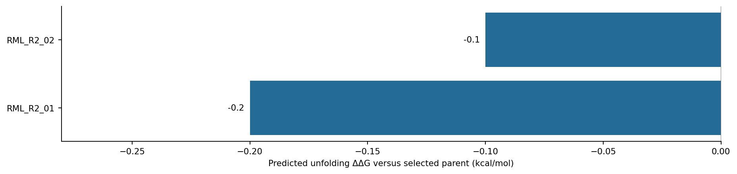
All bars use DDGun_SEQ and the same selected parent within this task.

Property predictions calculated in this work
Sequence | Group | Parent / background | Predicted Tm (°C) | ΔTm (°C) | NetSolP | pHPred (raw)
RML_R2_02 | Our candidate | RML_WT | 48.0504 | 1.0722 | 0.573641 | 6.9071
RML_R2_01 | Our candidate | RML_WT | 47.9878 | 1.0096 | 0.577789 | 6.8929

Candidate and reference property predictions
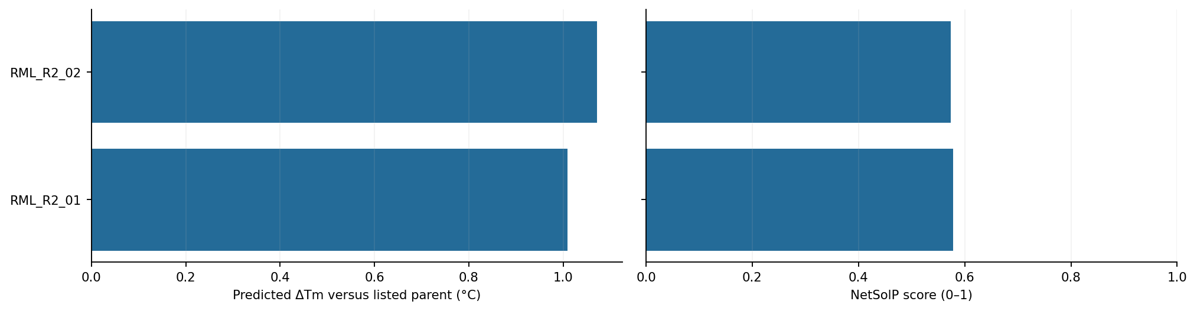
Blue: our candidates. Amber: reference variants calculated in this work. Changes use the parents listed in the table.
Parent identity, preparation details and run records: results/task_001_rml_stability/agent-alone/README.md.

