LEH stability — benchmark report
Agent-alone candidates, published prediction values and reference variants calculated in this work.
Agent Scientist: gpt-6.1-sol. Predictor names and units are listed with each measurement.

Published predictions and our predictions
Property / predictor | Published prediction | Our candidates
Predicted stability change | FoldX: T85I −20; T85V −14 kJ/mol ΔΔGfold | DDGun_SEQ: LEH_R004 +0.2; LEH_R003 +0.5 kcal/mol ΔΔGunfold
Predicted Tm change (°C) | Not reported | LEH_R004 +1.2498; LEH_R003 +0.3552
Source: Wijma et al., Figure 1 and methods

Our stability predictions
Candidate | Mutations | DDGun unfolding ΔΔG (kcal/mol)
LEH_R004 | K42R,P107A,E124D | 0.2
LEH_R003 | K42Y,P107A,E124D | 0.5
Change is relative to our selected parent. Positive DDGun unfolding ΔΔG indicates predicted stabilization; negative indicates predicted destabilization.

Stability change from our parent
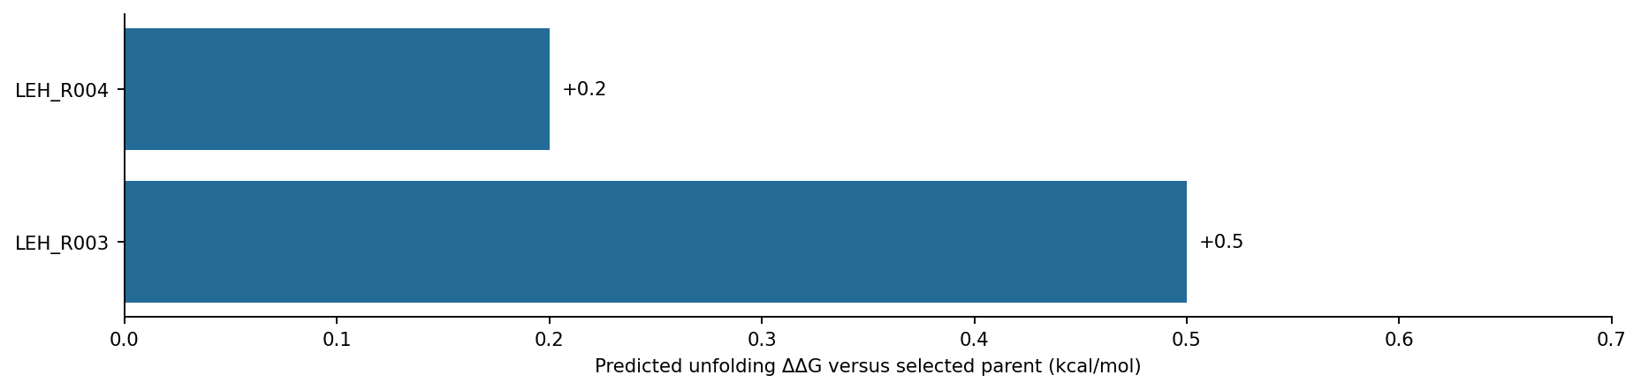
All bars use DDGun_SEQ and the same selected parent within this task.

Property predictions calculated in this work
Sequence | Group | Parent / background | Predicted Tm (°C) | ΔTm (°C) | NetSolP | pHPred (raw)
LEH_R004 | Our candidate | LEH_WT | 53.4325 | 1.2498 | 0.898987 | 7.3929
LEH_R003 | Our candidate | LEH_WT | 52.5379 | 0.3552 | 0.902987 | 7.3786

Candidate and reference property predictions
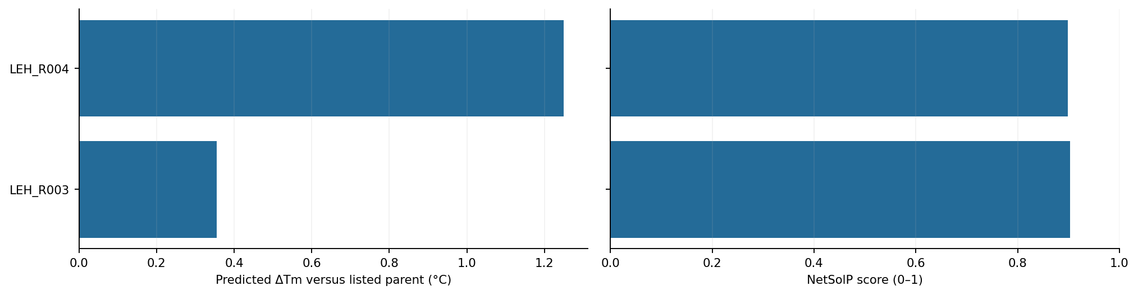
Blue: our candidates. Amber: reference variants calculated in this work. Changes use the parents listed in the table.
Parent identity, preparation details and run records: results/task_002_leh_stability/agent-alone/README.md.

