BLA high-temperature performance — benchmark report
Agent-alone candidates, published prediction values and reference variants calculated in this work.
Agent Scientist: gpt-6.1-sol. Predictor names and units are listed with each measurement.

Property predictions calculated in this work
Sequence | Group | Parent / background | Predicted Tm (°C) | ΔTm (°C) | NetSolP | pHPred (raw)
BLA_R2_001 | Our candidate | BLA_PARENT_WP061576039_mature30_512 | 52.7676 | 2.0042 | 0.595761 | 7.3500
Fan2024_K319W | Reference | BLA_PARENT_WP061576039_mature30_512 | 51.1367 | 0.3734 | 0.585213 | 7.3357
Fan2024_E336S | Reference | BLA_PARENT_WP061576039_mature30_512 | 50.6193 | -0.1441 | 0.580433 | 7.3357

Candidate and reference property predictions
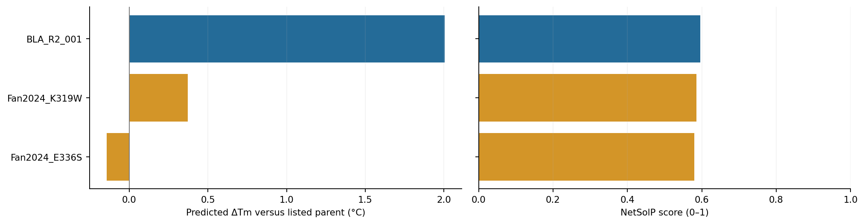
Blue: our candidates. Amber: reference variants calculated in this work. Changes use the parents listed in the table.
Parent identity, preparation details and run records: results/task_003_bla_high_temperature/agent-alone/README.md.

