AtHOL1 substrate expansion — benchmark report
Agent-alone candidates, published prediction values and reference variants calculated in this work.
Agent Scientist: gpt-6.1-sol. Predictor names and units are listed with each measurement.

Property predictions calculated in this work
Sequence | Group | Parent / background | Predicted Tm (°C) | ΔTm (°C) | NetSolP | pHPred (raw)
ATH_R2_09 | Our candidate | AtHOL1_3LCC_construct235 | 47.1996 | -0.2375 | 0.651168 | 7.0714
Shao2025_V140T_construct235 | Reference | AtHOL1_3LCC_construct235 | 47.0402 | -0.3969 | 0.667472 | 7.0286

Candidate and reference property predictions
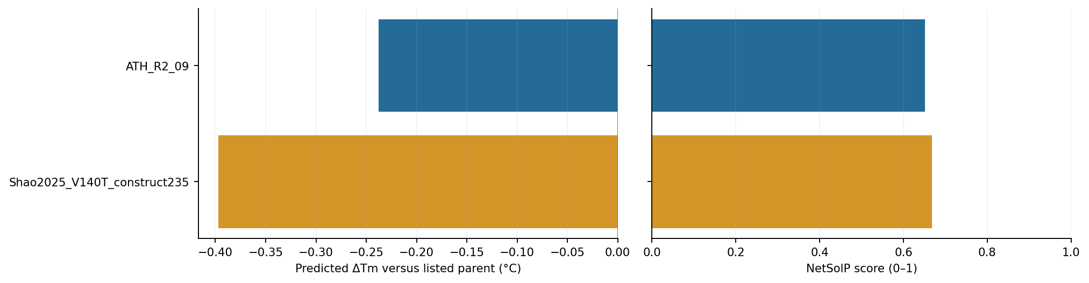
Blue: our candidates. Amber: reference variants calculated in this work. Changes use the parents listed in the table.
Parent identity, preparation details and run records: results/task_004_athol1_substrate/agent-alone/README.md.

