Sun LEH / Pythia reproduction — benchmark report
Agent-alone candidates, published prediction values and reference variants calculated in this work.
Agent Scientist: gpt-6.1-sol. Predictor names and units are listed with each measurement.

Published predictions and our predictions
Property / predictor | Published prediction | Our candidates
Pythia score (unitless) | Candidate score not reported | D101V −12.93692160; T85V −7.93473864 (summed score)
Pythia selection cutoff | < −2 | 33 selected mutations using summed-score implementation
Predicted Tm change (°C) | Not reported | D101V +0.3770; T85V +0.3236
Source: Sun et al., LEH case study

Property predictions calculated in this work
Sequence | Group | Parent / background | Predicted Tm (°C) | ΔTm (°C) | NetSolP | pHPred (raw)
Sun_LEH_D101V | Our candidate | LEH_WT | 52.5597 | 0.3770 | 0.886254 | 7.3929
Sun_LEH_T85V | Our candidate | LEH_WT | 52.5063 | 0.3236 | 0.899697 | 7.4071
Sun_LEH_P57A | Reference | LEH_WT | 52.1758 | -0.0069 | 0.895321 | 7.3857

Candidate and reference property predictions
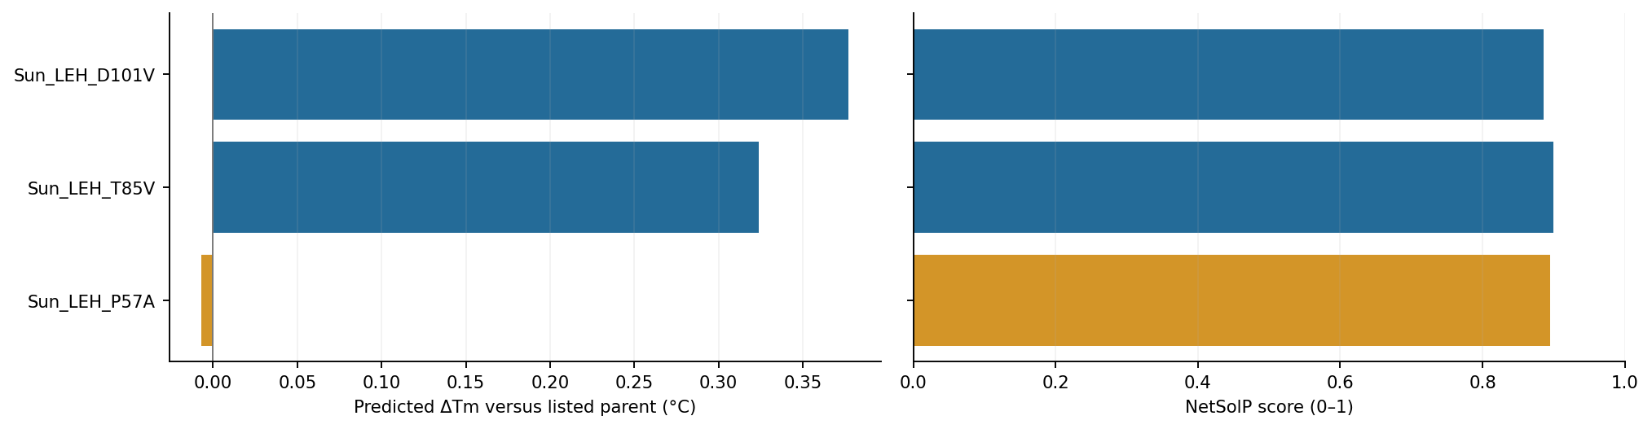
Blue: our candidates. Amber: reference variants calculated in this work. Changes use the parents listed in the table.
Parent identity, preparation details and run records: results/task_005_sun_leh_pythia/agent-alone/README.md.

