Zhang cellulase and β-glucanase reproduction — benchmark report
Agent-alone candidates, published prediction values and reference variants calculated in this work.
Agent Scientist: gpt-6.1-sol. Predictor names and units are listed with each measurement.

Published predictions and our predictions
Property / predictor | Published prediction | Our candidates
Cellulase WT: Pythia (unitless) | T131D −12.587 | T131D −12.79070377
Cellulase M2: ESM (unitless) | M2 + T257K −8.872 | M2 + T257K −8.87227321
β-glucanase WT: Pythia (unitless) | N65I −10.762 | Same variant N65I −11.32239389; retained leader M30P −14.53135109
β-glucanase M5: ESM (unitless) | M5 + I65Y −8.583; M5 + P10D −6.767 | Same I65Y −2.72094822; retained leader P10D −6.70656031
Source: Zhang et al., original supplementary tables S1/S3/S5/S7

Same-variant prediction comparison
Background | Predictor | Mutation | Published score | Our score
Predictor / background | Rows | Mean absolute difference | Rank correlation
Pythia / cellulase_WT | 47 | 2.030403 | 0.310130
ESM2 / cellulase_M2 | 20 | 0.000221 | 0.999624
Pythia / beta_glucanase_WT | 24 | 1.059948 | 0.744348
ESM2 / beta_glucanase_M5 | 17 | 0.417425 | 0.917229

Published versus recalculated scores
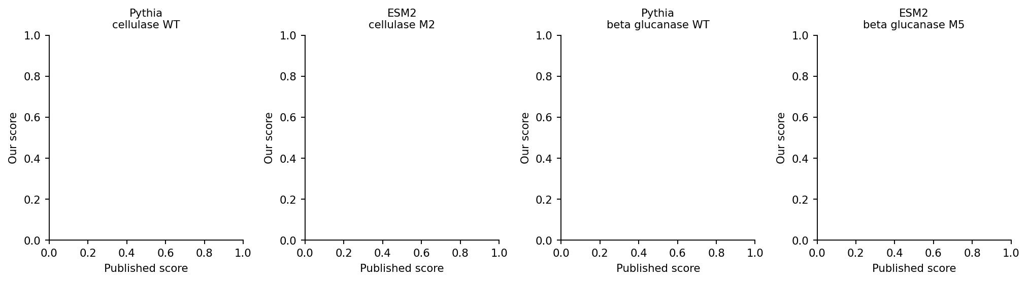
Each panel compares the same variants and scoring background. Scores are unitless; the dashed line marks equal values.

Property predictions calculated in this work
Sequence | Group | Parent / background | Predicted Tm (°C) | ΔTm (°C) | NetSolP | pHPred (raw)
Zhang_cellulase_WT_T131D | Our candidate | Zhang_cellulase_WT | 47.2853 | 0.0444 | 0.750243 | 7.3643
Zhang_cellulase_M2_T257K | Our candidate | Zhang_cellulase_M2 | 47.4771 | 0.1533 | 0.757610 | 7.3643
Zhang_beta_glucanase_WT_M30P | Our candidate | Zhang_beta_glucanase_WT | 48.1294 | 0.4176 | 0.710361 | 7.1286
Zhang_beta_glucanase_M5_P10D | Our candidate | Zhang_beta_glucanase_M5 | 47.1254 | -0.1853 | 0.725672 | 7.1286
Zhang_published_cellulase_M5 | Reference | Zhang_cellulase_WT | 47.0161 | -0.2248 | 0.755299 | 7.3643
Zhang_published_beta_glucanase_M7 | Reference | Zhang_beta_glucanase_WT | 48.0782 | 0.3664 | 0.708764 | 7.1286
Zhang_reported_beta_glucanase_WT_N65I | Reference | Zhang_beta_glucanase_WT | 47.7586 | 0.0468 | 0.707348 | 7.1286
Zhang_reported_beta_glucanase_M5_I65Y | Reference | Zhang_beta_glucanase_M5 | 47.2043 | -0.1065 | 0.719984 | 7.1143

Candidate and reference property predictions
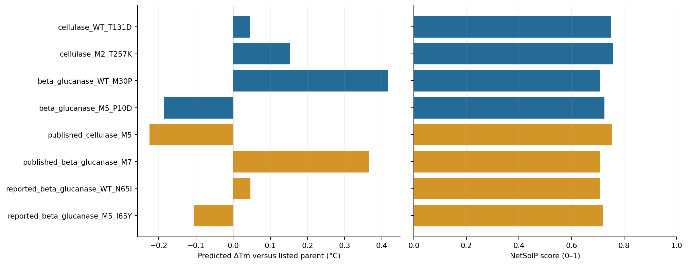
Blue: our candidates. Amber: reference variants calculated in this work. Changes use the parents listed in the table.
Parent identity, preparation details and run records: results/task_006_zhang_hydrolases/agent-alone/README.md.

