White Paper

ChatGPT

By Boluwatife Morolari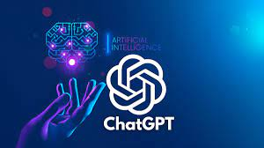

Content

1. Introduction
2. Use cases
3. How ChatGpt was trained
4. How does ChatGpt Work
5. Limitations of ChatGpt
6. Conclusion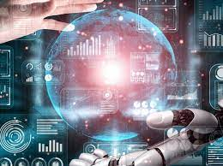

# Introduction

For thousands of years, humans have sought knowledge and information in order to understand the world around them. In the early days, before the advent of modern technology and communication tools, people relied on oral tradition to acquire knowledge and stories. These stories were transmitted through spoken word, songs, and performances, and in some cultures, information was also communicated through visual art forms, such as cave paintings. In addition to oral tradition and visual art forms, people would often rely on personal experience and observation, as well as word of mouth from travelers and traders to obtain new information. As societies evolved and became more complex, the need for more advanced information sources arose. Over time humans developed new technologies to enhance their ability to acquire and share information printed materials such as books, newspapers, magazines, encyclopedias, and libraries became important sources of information. These printed materials enabled people to access knowledge and stories from across the world, expanding their horizons and opening up new opportunities for learning.

However, it was not until the revolution of the internet that access to information truly exploded. With the development of the World Wide Web, people can now access vast amounts of information easily and quickly, from anywhere in the world. The creation of large online databases, search engines, and social media platforms has made it possible for people to find and share information on an unprecedented scale.creating a digital landscape that is continuously evolving and expanding. In the midst of this rapidly changing technological landscape, ChatGPT stands out as a powerful tool for obtaining information and knowledge. As a large language model trained by OpenAI, ChatGPT is capable of processing vast amounts of information and providing insights and answers to a wide range of questions. Whether you are looking to learn something new or simply want to explore the world of knowledge, ChatGPT is a reliable and convenient resource that is available at your fingertips.

## Use Cases

Artificial intelligence is making impressive strides, and one of the most fascinating advances is the emergence of advanced language models. These large language models, or LLMs, are powered by deep learning algorithms that allow them to recognize, summarize, translate, predict, and generate text and other content based on knowledge gained from massive datasets. These models aren't just limited to teaching AIs human languages they have a wide range of applications, such as understanding proteins or even writing software code.

One of the most notable LLMs in the field today is ChatGPT, a highly sophisticated AI system that has been engineered to comprehend and produce natural language text in a way that closely resembles human communication. Using complex algorithms, ChatGPT is capable of mimicking the patterns and structures of human language to an impressive degree, making it a valuable tool for a range of applications. Whether it's creating chatbots or virtual assistants, or even helping with creative writing, ChatGPT and other advanced language models are poised to play an increasingly vital role in our daily lives as AI technology continues to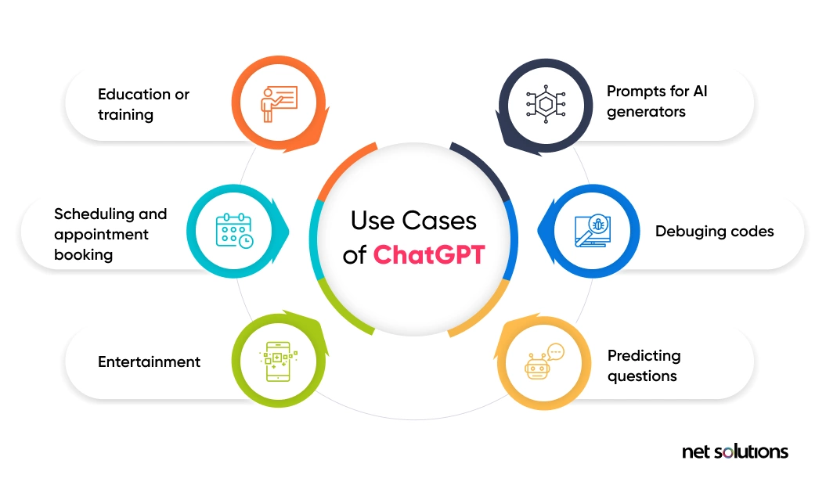 evolve.

The range of tasks that ChatGPT can perform is vast and varied, making it a powerful tool with numerous applications. Some use cases of ChatGpt:

* Customer Service: ChatGpt can be used as virtual assistant to provide customers with 24/7 support without the need for human operators.
* Healthcare: ChatGpt can also provide a valuable tool for doctors and patients. ChatGpt can help patients to answer common health questions, assessing and prioritising patients based on the severity of their symptoms or injuries, and also to schedule appointments.
* Education: By leveraging its advanced natural language processing capabilities, ChatGPT can be programmed to comprehend the specific learning requirements of each individual student. This feature enables ChatGPT to offer personalized support and feedback to learners, aiding them in achieving their academic objectives in a way that is tailored to their individual needs.

Beyond these industries, it has also been used for a variety of other applications, such as Language translation, Content creation, Creative writing, Code debugging, Text summarization etc. As technology continue advancing and improving. it is foreseeable that we will witness increasingly innovative applications for ChatGPT that have the potential to revolutionize the way we engage with technology and communicate with each other.

**How ChatGpt was Trained**

GPT 3.5, a version of GPT-3 and the language model behind the ChatGPT, was trained on an Azure AI supercomputing infrastructure.

ChatGPT was was trained using a variant of a machine learning technique called "unsupervised learning" on a vast corpus of text data. Unlike traditional supervised learning, unsupervised learning doesn't require labeled data (such as input-output pairs) to train a model. Instead, it involves training the model to find patterns and structure within the input data on its own.

For this to be accomplished Open Ai used a large dataset of text from the internet, including websites, books, and other sources. They then used a variant of a neural network called a "transformer" to process the text data and learn the patterns and structures within it. The transformer model is capable of processing very large amounts of text and extracting meaningful information from it.

GPT-3, a language model, has a massive amount of data and parameters that make it stand out from other similar models. It has 170 billion parameters and was trained on 570 GB of text data, which is why it can understand language better. The reason this is possible is due to the use of specialized computer chips for AI that can perform computations much faster and more efficiently than regular computer chips.

**How does ChatGpt work**

ChatGPT is the brainchild of OpenAI, an artificial intelligence research company. Its mission is to develop a "safe and beneficial" artificial general intelligence system or to help others do so. It works by processing input text, such as questions or prompts and generating an output text that is related to the input text. At a high level ChatGPT works by using a pre-trained transformer neural network architecture to generate text. it is capable of processing large amounts of text data.

The model includes an encoder, which takes in the input text, and a decoder, which generates the output text:

* **Encoder:** Converts the input text into a fixed-length vector representation, which captures the meaning of the input text.
* **Decoder:** Uses this vector representation to generate the output text, one word at a time.

When ChatGPT is given a prompt or question as input, it first processes the text using its pre-trained model. It then generates an output text that is related to the input text, based on the patterns and structures it has learned. The output text can take a variety of forms, including responses to questions, summaries of text, and even creative writing.

Overall, ChatGPT works by leveraging the power of advanced machine learning techniques, specifically deep learning and neural networks, to process and generate text data. Its pre-training and ability to learn patterns and structures in text make it a powerful tool for a wide range of language-related tasks. It's essential to consider that ChatGPT's capacity to comprehend and react to user inputs is restricted by the data it was trained on, as well as its ability to generalize from that data. Therefore, if a user prompts the model with a question or topic that is outside of its training data, it may not be able to provide an accurate or helpful response. This is because the model's understanding is based solely on what it has learned from the vast amount of text data it was trained on, and it does not have the ability to "think" or reason like a human.

**Limitations of ChatGpt**

Despite being an advanced language model with numerous potential applications, ChatGpt also has some limitations that should be considered. Some of the most significant limitations are

* **Potential for bias:** ChatGPT is only as unbiased as the data it was trained on. If the data contains biases, such as stereotypes or prejudices, ChatGPT may unintentionally perpetuate them.
* **Limited understanding of emotions:** While ChatGPT can generate language related to emotions, it may not fully understand the nuances of human emotions or be able to accurately interpret the emotional tone of a conversation.
* **Lack of common sense:** While ChatGPT is great at generating language, it lacks a common sense understanding of the world. This means that it may sometimes provide responses that are technically correct, but not contextually appropriate.
* **harmful instructions:** Even though efforts have been made to prevent ChatGPT from responding to inappropriate requests, it can still generate harmful responses in some cases. OpenAI has implemented the Moderation API to identify and prevent unsafe content, and is using human feedback to refine the model. To gather this feedback, users are given the option to evaluate the responses.

Overall, while ChatGPT is a powerful tool for generating language and providing information, it is important to recognise its limitations and use it in appropriate ways.

**Conclusion**

As ChatGPT continues to evolve and advance, the possibilities for natural language processing and AI are becoming increasingly vast and varied. With emerging technologies and new developments on the horizon, it is clear that the future of AI is one of continued growth, innovation, and potential.

The potential applications of chatGpt are numerous , ranging from chatbots and customer service tools to virtual assistants and education al resources. This white paper as touched outlining the details of the model and why it is a valuable contribution to the field of Ai, and also provides insights into how this powerful language model was developed, how it functions, and how it can be adapted for specific applications.

In conclusion, the development of ChatGPT is a significant breakthrough that has paved the way for more advanced and sophisticated language models in the field of AI. As time goes on, we can expect to see the continued development and refinement of language models like ChatGPT, as well as new and innovative applications for this technology. Nonetheless, it is important to remain cognizant of the potential risks and limitations of these models, and to ensure that they are developed and used responsibly in order to maximize their benefits and minimize potential negative consequences.