

Discord:
- Create a Discord channel that only you have access to.

- Go to the gear of the text channel you want; you can create one per account or one for all.

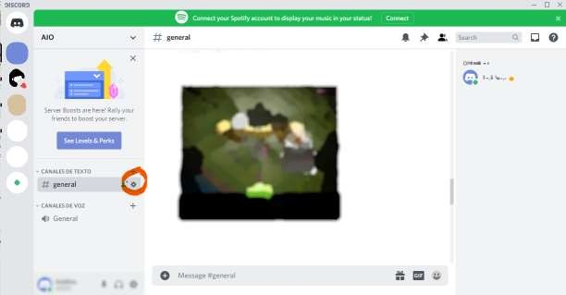

- Create a Webhook.

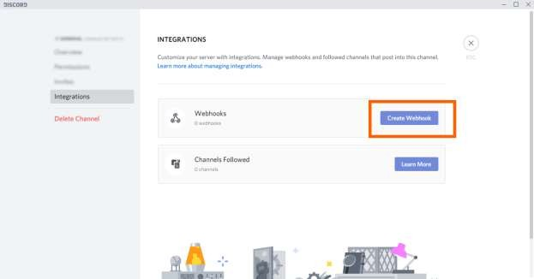
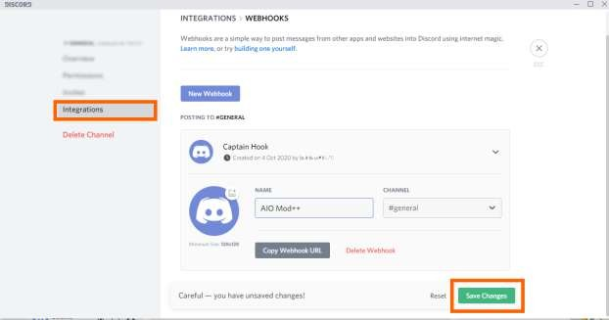

- Click to copy Webhook URL.
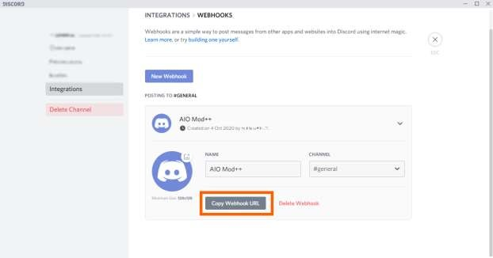
- In MBR AIO Mod++ in ‘Village> Notify’, select Discord and enable this, paste Webhook URL, everything is ready.
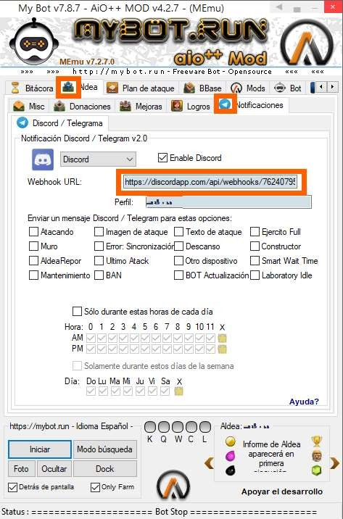

* Please note: since Discord Webhook is only capable of receiving messages, you can continue to send
commands through Telegram and have both agents active.

