R handout: Monte Carlo Method and Application
Yuhui Yao

1 Methodology
1. Motivation
In practice, we may meet some hard integrations which is really hard to solve. For example, in one of my working papers, we have this integrand

where k, c and are constants. Φ is the c.d.f. of the standard normal distribution. is the quantile function the standard normal distribution. is the quantile function of with k−1 degrees of freedom.
The analytical solution probably is desperate, but we can use other methods to obtain the numerical solution. This handout will show a way to solve integrations numerically.
2. Example. Y=|X| where X∼N(0,1). Find out E(Y)
(a) Method 1: Direct Integration (By hand)
As we know, the p.d.f. of Y

where φ is the p.d.f. of the standard normal distribution. The expectation

[Sorry. Ignored \begin{split} ... \end{split}]
(b) Method 2: Direct Integration (In R)
• R code

# define the p.d.f. of Y
Y.pdf <- function(y) 2 * dnorm(y)

# define the integrand of the expecation of Y
E.Y <- function(y) y * Y.pdf(y)

# Integrate the integrand
integrate(E.Y, lower = 0, upper = Inf)
# Result: 0.7978846

(c) Monte Carlo Method
Suppose X is a random variable with a p.d.f. f and a c.d.f. F over a domain D. Also, we have a sample from X with n observations.

Besides, because of Central Limit Theorem, ̄X asymptotically follows where μ=E(X) is the mean of X and is the variance of X. So, when , ̄XpE(X). Hence, intuitively, the result is more precise with a larger sample size.
i. Method 3: Monte Carlo Method with Transformation 1
• Motivation
Our target distribution may be hard to be found, but the original distribution may be not. Hence, we simulate a sample from the original distribution and transform it to our target, and then, calculate the expectation.
•
The analytical part
Because

where n is the number of simulation and is a sample from N(0,1).
• R code

# set seed to make this process repeatable
set.seed(12345)

# set the number of simulation
n <- 1000

# simulate a sample from the standard
# normal distribution
X.s <- rnorm(n)

# calculate the mean of the absoluate values
mean(abs(X.s))
# Result: 0.7944

ii. Method 4: Monte Carlo Method with Transformation 2
• Motivation
Both of our target distribution and the original distribution may be hard to be found, so we use other relatively simple distributions which have same domains as the ones of our target distribution or the original distribution, to simulate our target, and then, calculate the expectation.
•
The analytical part
Because exp(1) has a same domain as Y,

where n is the number of simulation and is a sample from exp(1).
• R code

# set seed to make this process repeatable
set.seed(12345)

# set the number of simulation
n <- 1000

# define the p.d.f. of Y
Y.pdf <- function(y) 2 * dnorm(y)

# simulate a sample from the standard
# normal distribution
Y.s <- rexp(n)

# calculate the mean of the absoluate values
mean(Y.s * Y.pdf(Y.s) / dexp(Y.s))
# Result: 0.7729

3. Summary
(a) Comparison of these methods

Methods | Method 1 | Method 2 | Method 3* | Method 4*
Results | 0.7979 | 0.7979 | 0.7944 | 0.7729

* Method 3 and Method 4 have 1000 simulations.
(b) Steps of Monte Carlo Method
i. Check the domain
ii. Simulate an appropriate sample over the domain
iii. Calculate the mean via an appropriate transformation
4. Practice: suppose , where . Use Monte Carlo Method to find E(Y).
Hint: You need to show the analytical part and the coding part in R, separately. Also, you may need to use rchisq and help(rchisq) in R

2 Application
1. Data description1 ()
This data comes from the Vancouver Open Data Catalogue. It has 530,652 records regarding to different types of crimes between Jan 01, 2003 and July 13, 2017. The original data set contains coordinates in UTM Zone 10 with Latitude and Longitude.
2. Suppose our target is to predict the monthly frequency of the type of crimes "Break and Enter Commercial" in the future and we are not very interested in the exact locations of crimes. The frequency during the period between Jan 01, 2003 and July 13, 2017 can be showed as the following plot:
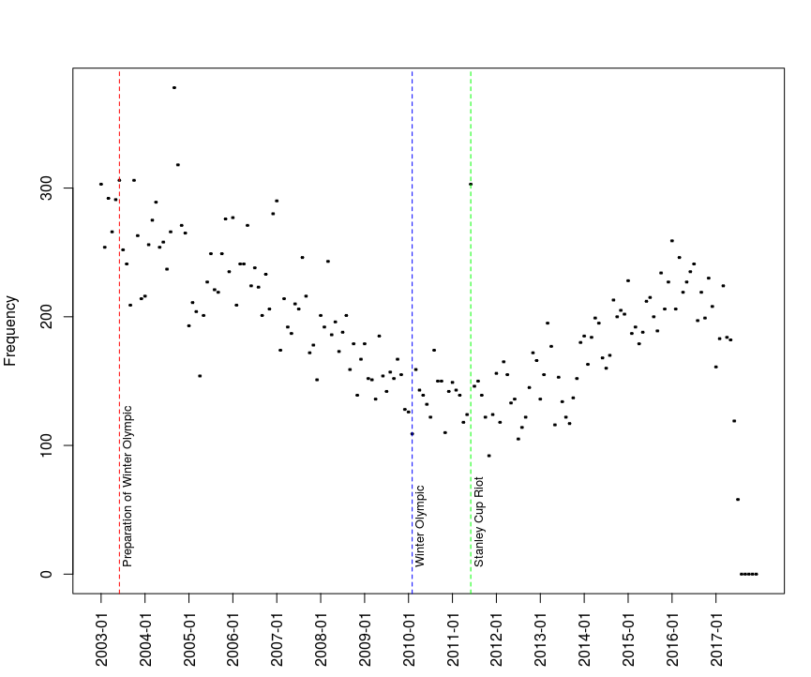
where on July 2, 2003, Vancouver won the bid to host the Winter Olympic (the vertical red dashed line). The game was hosted from February 12 to 28, 2010 (the vertical blue dashed line). So I called the period between July 2, 2003 and February, 28, 2010 as the preparation of Winter Olympic. Also, on June 15, 2011, there was a riot, 2011 Vancouver Stanley Cup riot (the vertical green dashed line). It is obvious for us to observe that the frequency has a convex shape and one of possible reasons causing this phenomenon is the Winter Olympic. Besides, the fraction of data after 2017 may be not trustful, because the trend of this fraction is supposed to be increasing or maintain the same level.
Intuitively, I will guess the frequency of crimes are increasing until reaching the situation before the preparation of Winter Olympic. Hence, I will use the fraction of the data before July 2003, as my training data, to predict the frequency after 2017.
3.
Suppose X={303,254,292,266,291,306} is from my training data and this data follows a Poisson distribution with parameter λ. Find out the 2.5% and 97.5% quantile. The p.d.f. of X

By m.l.e, ̂λ=̄X=285.3333, so the 2.5% and 97.5% quantile

[Sorry. Ignored \begin{cases} ... \end{cases}]
⇒[Sorry. Ignored \begin{cases} ... \end{cases}]
They can be showed on the plot
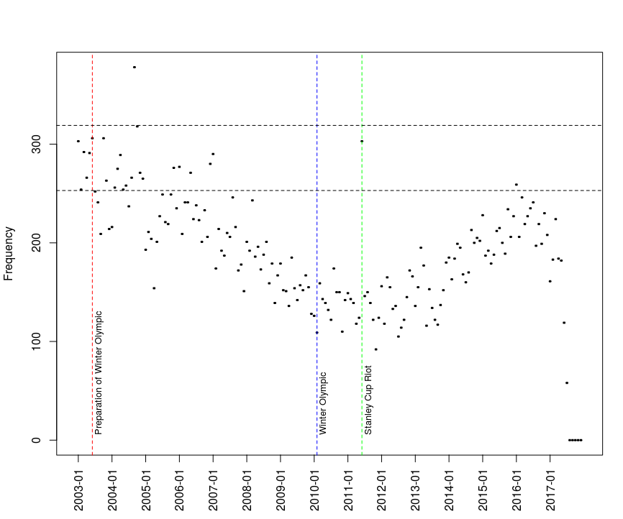
where the upper horizontal dashed line is the 97.5% quantile, 319 and the lower horizontal dashed line is the 2.5% quantile, 253.
4. Because X is a sample, ̂λ=̄X shall have its own distribution. Suppose ̂λ∼gamma(α=1349.507,β=0.2115). Find out the 2.5% and 97.5% quantile.
The p.d.f. of X given ̂λ

And the p.d.f. of ̂λ

Then

[Sorry. Ignored \begin{split} ... \end{split}]
So, the 2.5% and 97.5% quantile

[Sorry. Ignored \begin{cases} ... \end{cases}]
The analytical solution is complicated, but it is relatively easy if we use numerical methods. By Monte Carlo Method,

where is a sample following gamma(α=1349.507,β=0.2115). Also, the equation can be expressed as the following (the root searching form)

where and . The quantiles and are roots of the equation. After the computation, we can show the quantiles on the plot:
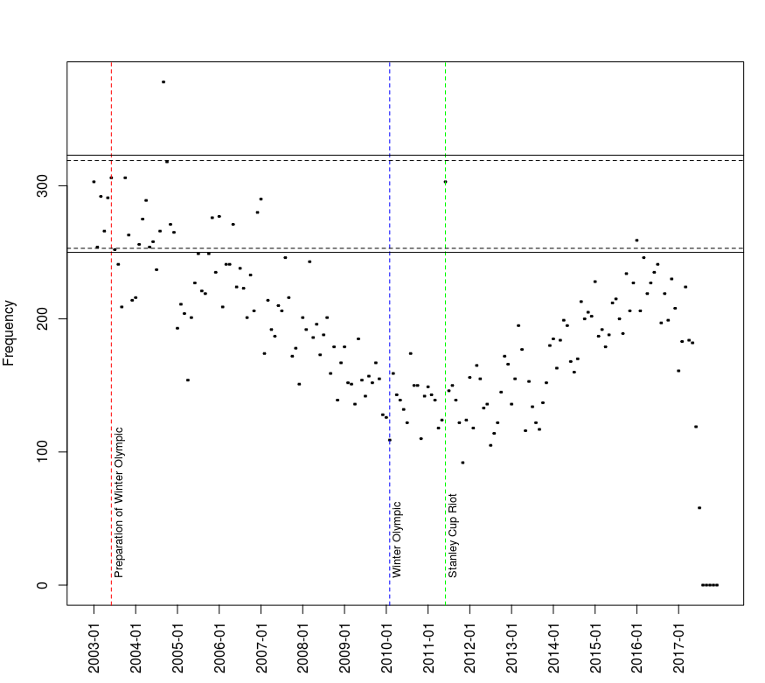
where the upper horizontal solid line is the 97.5% quantile, 323, and the lower horizontal solid line is the 2.5% quantile, 250.
5. R code for the whole process

#################################################
# describe BEC during the period
#################################################
# load the new data
addr <- paste('https://raw.githubusercontent.com/bolus123',
'/R-handout/master/MCandApp/BEC.csv', sep = '')
BEC.monthly.freq <- read.csv(file = addr)[, -1]

# add a new column combining YEAR with MONTH
BEC.monthly.freq <- cbind(BEC.monthly.freq,
paste(BEC.monthly.freq$YEAR,
substr(
as.character(
as.numeric(
BEC.monthly.freq$MONTH) +
100), 2, 3)
, sep = '-'))

# build a basic scatter frequency plot
# during the period
plot(BEC.monthly.freq[, 5], BEC.monthly.freq[, 4],
xaxt="n", ylab = 'Frequency')
# define the tick of x-axis
labs <- sort(BEC.monthly.freq[, 5])[rep(c(T, F, F,
F, F, F, F, F, F, F, F, F), 15)]
for (i in 1:15){

axis(1, at = (12 * (i - 1) + 1),
labels = labs[i], las = 2)

}

# specify special months
prepare.Winter.Olympic <- BEC.monthly.freq[, 5] == '2003-06'
Winter.Olympic <- BEC.monthly.freq[, 5] == '2010-02'
Stanley.Cup.riot <- BEC.monthly.freq[, 5] == '2011-06'

# show Preparation of Winter Olympic on the plot
abline(v = BEC.monthly.freq[prepare.Winter.Olympic, 5],
col = 'red', lty = 2)
text(BEC.monthly.freq[prepare.Winter.Olympic, 5], 5,
'Preparation of Winter Olympic', pos = 4,
srt = 90, cex = 0.8)

# show Winter Olympic on the plot
abline(v = BEC.monthly.freq[Winter.Olympic, 5],
col = 'blue', lty = 2)
text(BEC.monthly.freq[Winter.Olympic, 5], 5,
'Winter Olympic', pos = 4, srt = 90, cex = 0.8)

# show Stanley Cup Riot on the plot
abline(v = BEC.monthly.freq[Stanley.Cup.riot, 5],
col = 'green', lty = 2)
text(BEC.monthly.freq[Stanley.Cup.riot, 5], 5,
'Stanley Cup Riot', pos = 4, srt = 90, cex = 0.8)

# set the maximun date of the training data
x1.max.date <- which(
BEC.monthly.freq[
order(BEC.monthly.freq[, 5]), 5] == '2003-06')

# cut it off from the original data
x1 <- BEC.monthly.freq[
order(BEC.monthly.freq[, 5]), 4][1:x1.max.date]

# fit a poisson model for the training data
lambda1 <- mean(x1)

# show the 2.5% and 97.5 quantiles on the plot
abline(h = qpois(0.975, lambda1), lty = 2)
abline(h = qpois(0.025, lambda1), lty = 2)

#################################################
# find the gamma distribution for lambda
# by the nonparametric bootstrap
#################################################
set.seed(12345)

# the number of times for bootstrapping
n <- 100000
# set a vector to carry the means
xs.means <- rep(NA, n)

for (i in 1:n){
# resample from the training data
xs <- sample(x1, 6, replace = T)
# calculate their means
xs.means[i] <- mean(xs)
}

# calculate the grand mean
mu <- mean(xs.means)
# calculate the grand variance
sigma2 <- var(xs.means)

# fit a gamma distribution by the method of moment
alpha <- mu^2 / sigma2
beta <- sigma2 / mu

# check the gamma distribution
#x <- 1:1000
#plot(x, dgamma(x, alpha, 1/beta), type = 'l')

#################################################
# fit a new poisson distribution
# with a parameter lambda
# which is a random variable
#################################################
# set a seed make this process repeatable
set.seed(12345)

# define a user-defined function
# p is P(X <= x)
# alpha is the alpha for gamma(alpha, beta)
# beta is the beta for gamma(alpha, beta)
# interval is the range of searching the quantile
# rnum is the number of simulations
X.quantile <- function(p, alpha, beta,
interval = c(100, 500), rnum = 10000){

root.finding <- function(x, p, lambda){
# The root searching form
p - mean(ppois(x, lambda))
}

# simulate a sample from gamma distribution
lambda <- rgamma(rnum, alpha, scale = beta)

# search the root by the bisection method
uniroot(root.finding, interval = interval,
p = p, lambda = lambda)$root

}

# calcualte the 2.5% quantile
q0025 <- X.quantile(p = 0.025,
alpha = alpha, beta = beta)
# calcualte the 97.5% quantile
q0975 <- X.quantile(p = 0.975, alpha = alpha, beta = beta)

# add horizontal lines on the plot
abline(h = q0025)
abline(h = q0975)

References
Kaggle, Crime in Vancouver, Link: https://www.kaggle.com/wosaku/crime-in-vancouver 2017.

