The purpose of this section is to examine the robustness of two-sided tolerance limits in the 3 methods. Canavos (1984) showed us a strategy examining the robustness using simulation for the robustness of two-sided tolerance limits for normal distributions. We will following his strategy and set up our performance comparison. Notice that the performance in tolerance interval was measured by the simulated confidence level $γ$ instead of the average run length (ARL) which is widely used as a measurement of performance of control charts. So we will simulate the confidence level $γ$ with different parameters for our discussion of robustness. To clarify our definition of simulation, we start at equation (1) and (2) using Monte Carlo Method. Then, the estimated confidence level can be carried out by

$$P_{{\hat{σ}}^{2}}\left(P_{S^{2}}\left({\hat{S}}_{L}^{2}≤S^{2}≤{\hat{S}}_{U}^{2} | {\hat{σ}}^{2}\right)≥1-α\right)=P_{Y}\left(P_{W}\left(L\frac{Y}{m\left(n-1\right)}≤\frac{W}{n-1}≤U\frac{Y}{m\left(n-1\right)}\right)≥1-α\right)=\sum_{i=1}^{r}{I(\sum_{j=1}^{k}{I\left(L\frac{Y_{i}}{m\left(n-1\right)}≤\frac{W_{j}}{n-1}≤U\frac{Y_{i}}{m\left(n-1\right)}\right)}≥1-α)}=\hat{γ}$$

where $\hat{γ}$ is the simulated confidence level, $L$ and $U$ are the lower and upper tolerance factors, respectively, defined by Exact Method, CE Method or KMM Method, $Y_{i},i=1,2,…,r$ are the simulated Phase I estimators and $W_{j},j=1,2,…,k$ are the simulated Phase II estimators, $I(*)$ is the indicator function defined by

$$I\left(a<b\right)=\left\{\begin{aligned}\begin{matrix}1 & if a<b\end{matrix} \\ \begin{matrix}0 & otherwise\end{matrix}\end{aligned}\right.$$

We will control four kinds of variables 1) the nominal values $α$ and $γ$, 2) the numbers related to sample sizes, $m$ and $n$, 3) the amount of simulation of Phase II estimators, 4) the shape of Phase I and Phase II estimators. When the process is in-control, Phase I estimator $Y$ is following a chi-square distribution with $m(n-1)$ df equivalent to a gamma distribution with shape $m\left(n-1\right)/2$ and scale $2$, and Phase II estimator $W$ is following a chi-square distribution with $(n-1)$ df equivalent to a gamma distribution with shape $(n-1)/2$ and scale $2$. These four parameters of Phase I and Phase II estimators will be changed one by one for the parametric robustness. We also are interested in the dramatic change of distribution of Phase II estimators, so we will provide Phase II estimators simulated by Weibull distributions with shape $κ$ and scale $λ$ which are carried out by

$$\left\{\begin{aligned}\frac{1}{B(1+1/κ,1+1/κ)(1+2/κ)}=\frac{n+1}{n-1} \\ λΓ\left(1+1/κ\right)=n-1\end{aligned}\right.$$

where $B(*)$ is the beta function and $Γ(*)$ is the gamma function (for example, see Hogg et al. (2005)). And Phase II estimators are simulated by lognormal distribution with log mean $μ$ and log variance $σ^{2}$ which are carried out by

$$\left\{\begin{aligned}μ=\log\left(n-1\right)-σ^{2}/2 \\ \left[e^{σ^{2}}-1\right]e^{2μ+σ^{2}}=2(n-1)\end{aligned}\right.$$

Then we will discuss our findings of the robustness. We will use two kinds of graphs to demonstrate our results. The first sort of graphs is based on the in-control setting. The second sort of graphs is based on the out-of-control setting which is majorly related to the variability of distribution of estimators in Phase I and Phase II.

Figure XXX: Means of simulated confidence levels $\hat{γ}$ for the three methods, the sample size $n=5$ and nominal coverages $α=0.05, 0.1$ categorized by nominal confidence levels $γ=0.9, 0.95$ under the in-control process simulation with the amount of simulated confidence levels $1000$, the amount of simulating $Y$ $r=250$ and the amount of simulating $W$ $k=1000$ 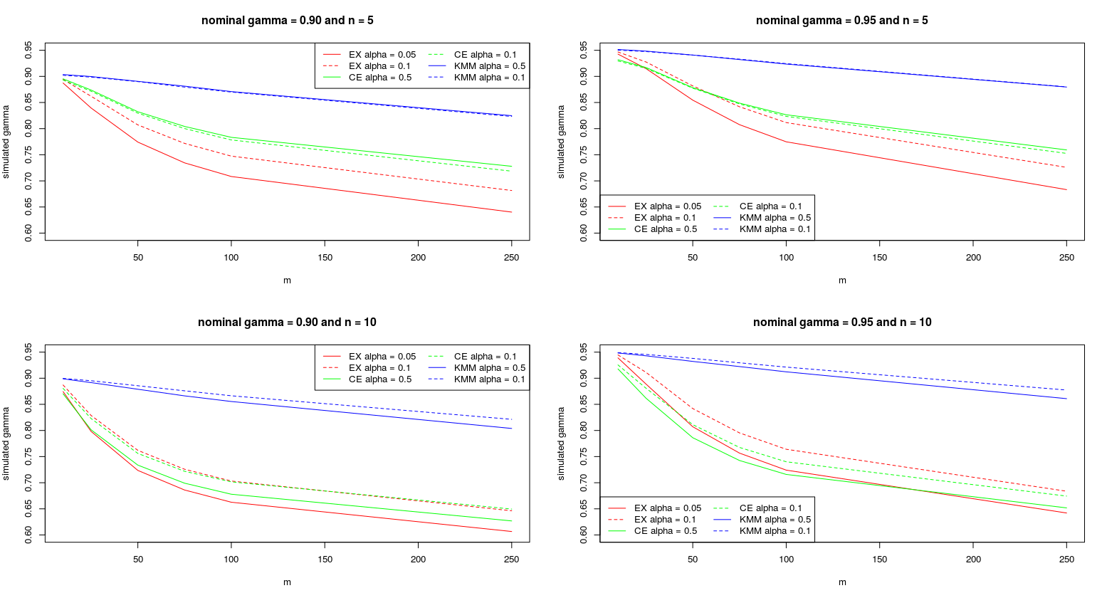

where ‘EX’ stands for Exact method on the legends.

From figure XXX, we can observe the following findings: 1) In general, the reduction between the nominal confidence levels and the nominal confidence levels of all three methods keeps increasing and KMM method maintains the highest confidence level compared with other two methods, during the increasing number of subgroups. 2) The nominal coverage $α$ has different influence on the three methods. Take the simulation for $n=5$ as an example. The effect of nominal coverage $α$ is trivial for KMM method. For CE method, the confidence level is decreased slightly by increasing coverages compared with the fact that the confidence level is increased for Exact method. This situation is different from the situation that $n$ equates to 10. All methods are improved by increasing coverages. Exact method is improved most and KMM method is improved least. 3) Increasing sample sizes $n$ have a negative effect on the confidence levels. 4) Besides, CE method gets closer to Exact method with increasing nominal confidence levels and sample sizes.

Figure YYY: Means of simulated confidence levels $\hat{γ}$ for the three methods, the sample size $n=5$, the nominal coverage $α=0.05$ and the nominal confidence level $γ=0.9$ categorized by change of Phase I shape, Phase I scale, Phase II shape or Phase II scale under the Phase II out-of-control process simulation with the amount of simulated confidence levels $1000$, the amount of simulating $Y$ $r=250$ and the amount of simulating $W$ $k=1000$

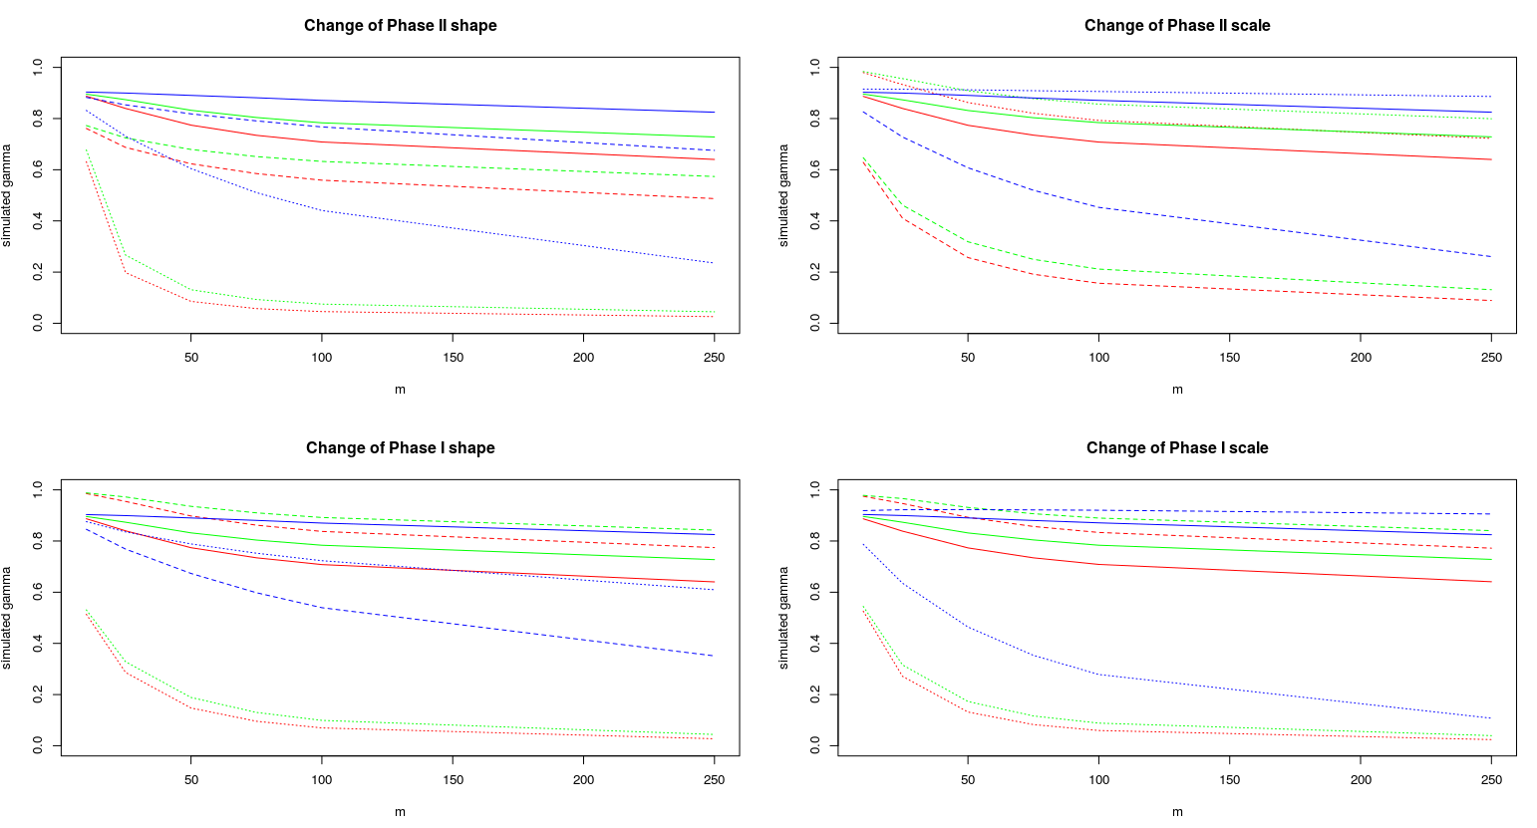

where red curves stand for Exact method, green curves stand for CE method and blue curves stand for KMM method. Solid curves stand for no change in the specific parameter, dashed curves stand for 25% increase in the specific parameter and dotted curves stand for 25% decrease in the specific parameter

From figure YYY, we can consider that the top-left plot is for the performance of our methods and others are for the detections of robustness. First, we discuss the performance of our methods. the top-left plot presents the following points: 1) Exact method and CE method for monitoring the change of Phase II shape are more aggressive than KMM method. We can see that the reduction of confidence levels is more gradual in KMM method compared with Exact method and CE method. In other words, Exact method and CE method respond quicker when the process is out-of-control especially for relative small numbers of subgroups. Also, this performance in KMM method can be enhanced by increasing numbers of subgroups, but this fact is not true for Exact method and CE method, because of their drops of in-control performance. 2) all three methods are more sensitive in the negative change of Phase II shape, since the dashed curves are always below their corresponding dotted curves. Second, we talk about the robustness of our methods. From the top-right plot, the three methods are more sensitive for the positive change of Phase II scale. They can maintain a relatively similar confidence level in the negative change of Phase II scale especially for KMM method which has a very stable performance. From the bottom-right plot, the phenomenon is opposite to the plot above. The confidence levels are changed dramatically if Phase I scale decreases. Their performance can tolerate the positive change of Phase I scale especially for KMM method. From the bottom-left plot, Exact method and CE method have similar results as the bottom-right one, but KMM method gets a disadvantage here. Both of directions, especially for the increase, of changes of Phase I shape can lead KMM method to have a suspicious outcome.

In summary, KMM method is more robust than others not only for varieties of combinations of nominal coverages, nominal confidence levels, number of subgroups and sample sizes, but also for the violations of assumptions. However, Exact method and CE method can have a quicker response for the case of small numbers of subgroups. Thus, we recommend users should apply Exact method or CE method with KMM method in monitoring process, since KMM method has less problems about the violation of assumptions. For example, if there is a signal in both Exact method and KMM method, users may need to stop and examine the process with high confidence. If there is a signal in Exact method, this signal may be a false alarm and users may need to wait for more signals to confirm the alarm.