## DESIGN AND IMPLEMENTATION OF A WEB-BASED PRINTING

## SERVICE FOR COVENANT UNIVERSITY STUDENTS

**BY**

**AJAYI BOLUWATIFE AYOMIKUN**

**(19CH026499)**

**A PROJECT SUBMITTED TO THE DEPARTMENT OF COMPUTER AND**

**INFORMATION SCIENCES, COLLEGE OF SCIENCE AND TECHNOLOGY,**

**COVENANT UNIVERSITY OTA, OGUN STATE.**

**IN PARTIAL FULFILLMENT OF THE REQUIREMENTS FOR THE AWARD OF THE BACHELOR OF SCIENCE (B.Sc.) Honors DEGREE IN COMPUTER SCIENCE**

**OCTOBER, 2022**

### CERTIFICATION

I, therefore, attest that Ajayi Boluwatife Ayomikun (19CH026499) is the actual author of the project work titled **A Web-Based Printing System For Covenant University Students**. It was submitted to the Department of Computer and Information Sciences, College of Science and Technology, Covenant University, Ota.

Name: Mr. Odunayo Osofuye **(Supervisor)**

Signature: **…...................** Date: **…..................**

Name: Dr. Olufunke Oladipupo **(Head of Department)**

Signature: …................... Date: …....................

### DEDICATION

I give God all the credit for this project's conception and development as well as my strength and capability to see it through to completion.

I also thank my parents and other family members for their support, prayers, and assistance.

### ACKNOWLEDGMENT

I give thanks to God for enabling me to complete this portion of my project and program as well as for seeing me through my undergraduate studies at Covenant University. It has been possible to complete necessary duties and receive favors thanks to his supervision and leadership. Without Him, I am powerless. I will always be grateful.

I also want to express my gratitude to all of my siblings and friends for the unwavering love and support they have given me throughout the years. I am appreciative of their presence in my life for making the journey thus far less difficult.

For their care and support during my research and my undergraduate education, I want to thank my parents and family, both here and abroad. They have been a significant motivating factor that has kept me going through my time at Covenant University.

I appreciate the guidance provided by Mr. Jesse Oluwafemi Katende. He helped me get over the long period of the hardship I had with my endeavor. I'm really grateful to you.

### ABSTRACT

The goal of this project is to design and implement a web-based printing service that provides a seamless and efficient way for Covenant University students to print documents from their personal devices. The service will be accessible through a user-friendly website that enables students to easily upload and print documents from any location with an internet connection.

The website will offer a range of printing options, including the ability to select the document type (black and white or color), the number of copies needed, and the desired print quality. Students can choose the pickup location for their printed documents and pay for the printing service online. To ensure the security and privacy of students' documents, the website will use secure file transfer protocols and only store uploaded documents temporarily.

The implementation of the web-based printing service will involve the development of the website and its integration with the university's existing infrastructure and systems. The project team will collaborate with various stakeholders, including the IT department, student services, and the university's print vendor, to ensure a smooth and efficient implementation.

In conclusion, the web-based printing service will provide Covenant University students with a convenient and reliable way to print their documents from anywhere. This service will not only improve the printing experience for students but also streamline the university's printing process and contribute to a more sustainable and eco-friendly campus.

## CHAPTER ONE : INTRODUCTION

#### 1.1 BACKGROUND OF STUDY

The background of this study involves the development and implementation of a web-based printing service for Covenant University students. The purpose of this service is to provide a convenient and efficient way for students to print their documents, eliminating the need for them to physically go to a printing location on campus.

Traditionally, printing services at universities have been provided through physical locations, such as libraries or computer labs, where students can go to print their documents. However, this can be inconvenient for students, especially if they are not physically on campus or if the printing location is not easily accessible. Additionally, traditional printing services can be time-consuming, as students may need to wait in line to use the printer or may need to return to the printing location multiple times to pick up their printed documents.

In recent years, there has been an increase in the use of web-based printing services, which allow students to print their documents remotely through an online platform. These services typically involve a website where students can upload their documents, select their desired print options, and pay for their prints using a credit card or other payment method. The printed documents are then delivered to a designated location on campus for students to pick up.

Web-based printing services offer several advantages over traditional printing services. They are more convenient for students, as they can be accessed from any location with an internet connection. They also save time, as students do not need to physically go to a printing location on campus. Additionally, web-based printing services may be more cost-effective, as they can reduce the need for physical printing locations and may offer bulk printing discounts.

However, there are also challenges associated with the development and implementation of a web-based printing service. These include issues related to security, as personal and financial data must be protected; usability, as the website must be easy for students to navigate and use; and integration with existing systems and infrastructure, as the web-based printing service must be seamlessly integrated with the university's existing systems and processes.

In order to address these challenges, the development and implementation of a web-based printing service for Covenant University students will involve a comprehensive analysis and design process, which will involve gathering requirements from stakeholders, such as students, IT staff, and the printing vendor; conducting a thorough analysis of the existing systems and processes; and designing a system that meets the needs and preferences of the student body and is effectively integrated with the university's existing systems and infrastructure.

#### 1.2 STATEMENT OF PROBLEM

The printing services at covenant university is a manual process where students have to go to printing stations in covenant university where they either give the officials a flash drive or they upload their documents to the mail of the officials and then the official prints this documents with the printer, this can be a very cumbersome process as most times a lot of students need to do this at the same time and it leads to frustration by students because of the overcrowded printing areas and often times there is a problem of payment which is because students at covenant university hardly carry around little amount cash and may find it difficult to pay for their documents also a mix up of documents of students may occur alongside other issues. So to this end, the creation of a web-based printing service for covenant university is required.

#### 1.3 AIMS AND OBJECTIVES OF THE STUDY

The aim of this project is to provide Covenant University students with a convenient web-based printing service. Through this service, students can create personalized profiles and upload their documents online, selecting various customization options. The printing stations will then be able to communicate with the students via notifications, informing them when their documents are ready for collection. This service offers students the flexibility to pay for their printing online or in person at the printing station. With this innovative approach to printing, Covenant University students can enjoy a hassle-free printing experience that is tailored to their individual needs.

**The Major objectives of the work include**

1. **Requirements Gathering**: Gather and identify the printing needs, preferences, and payment options of Covenant University students and faculty members and every other stakeholders.
2. **System Design**: Design a user-friendly and scalable web-based printing service that provides different printing options and a secure payment gateway through the use of various UML diagrams.
3. **Implementation and Integration**: Develop and integrate the web-based printing service with different devices, browsers, and payment options.
4. **Testing and Evaluation:** Thoroughly test and evaluate the web-based printing service to ensure it is bug-free, meets the requirements of students and faculty members and vendors, and is reliable, fast, and scalable.

#### 1.4 RESEARCH METHODOLOGY

The research methodology explains the best method to be used to achieve the listed objectives. It describes the systematic ways /procedures used to develop the project.

##### 1.4.1. Requirements Gathering

1. Conduct interviews with Covenant University students, faculty members, and other stakeholders to gather their printing needs, preferences, and payment options.
2. Analyze the data collected to identify common themes and requirements.
3. Develop a requirements document that outlines the identified needs, preferences, and payment options.

##### 1.4.2. System Design

1. Use Unified Modeling Language (UML) diagrams and use cases to design a user-friendly and scalable web-based printing service that provides different printing options and a secure payment gateway.
2. Consult with stakeholders, such as the IT department, student services, and the university's print vendor, to ensure the design is feasible and aligns with the university's existing systems and infrastructure.
3. Develop a design document that outlines the system architecture, components, database designs and interfaces.

##### 1.4.3. Implementation and Integration

1. Use appropriate software development methodologies, such as agile or waterfall, to develop the web-based printing service.
2. Integrate the service with different devices, browsers, and payment options to ensure compatibility and accessibility.
3. Conduct integration testing to ensure the service works seamlessly with the university's existing systems and infrastructure.

##### 1.4.4. Testing and Evaluation

1. Develop a comprehensive test plan that outlines the testing strategy, test cases, and acceptance criteria.
2. Conduct various types of testing, including functional testing, security testing, performance testing, and user acceptance testing, to ensure the service is bug-free, meets the requirements of students and faculty members, and is reliable, fast, and scalable.
3. Collect feedback from users and stakeholders through surveys and focus groups to evaluate the effectiveness and usability of the service.
4. Use the feedback collected to improve the service and ensure it meets the needs and preferences of users.

#### 1.5 SIGNIFICANCE OF THE STUDY

This project will provide solutions to the various issues related to the manual printing service process.

1. **Improved convenience and accessibility**: The web-based printing service will provide students with a convenient and efficient way to print documents, as they will be able to do so from any location with an internet connection. This will save students time and effort and make it easier for them to access the printing services they need.
2. **Cost-effectiveness:** The web-based printing service will provide a more cost-effective option for students, as they will be able to print multiple copies at a lower cost compared to traditional printing methods. This will make it more affordable for students to access the printing services they need.
3. **Enhanced student satisfaction**: By providing a convenient and efficient printing service, students will be more satisfied with their academic experience at Covenant University. This will improve the overall quality of the student experience and contribute to student retention and success.
4. **Streamlined process:** The web-based printing service will streamline the process of printing documents for students, making it easier and more efficient for them to access the printing services they need. This will save students time and effort and allow them to focus on their studies.
5. **Improved security and privacy**: The web-based printing service will ensure the security and privacy of students' documents by using secure file transfer protocols and only storing uploaded documents temporarily. This will protect the confidentiality of students' documents and minimise the risk of unauthorised access.

#### 

#### 1.6 LIMITATIONS OF STUDY

1. Security and Privacy: One of the major challenges in the implementation of a web-based printing service is ensuring the security and privacy of users' documents. There is a risk of data breaches, hacking, or unauthorized access to the system. Therefore, a need to implement robust security measures, such as encryption, secure file transfer protocols, and user authentication to ensure that students' data is safe.
2. Usability: The web-based printing service should be user-friendly and easy to navigate for students with varying levels of computer literacy. The design and interface should be simple, intuitive, and accessible to ensure that all students can use the system effectively.
3. Integration with Existing Systems: The printing service should be integrated seamlessly with the university's existing systems and infrastructure. This will require close collaboration between the developer and various stakeholders, such as the IT department, student services, and the printing vendor.
4. Payment Processing: A need to ensure that the payment processing system is secure, reliable, and fast. Students should be able to make payments using various methods, such as credit/debit cards or online payment platforms, without any hitches or delays.
5. Scalability: The web-based printing service should be able to handle a large number of users and print requests without any system crashes or slowdowns. This will require the use of scalable infrastructure and servers that can handle the load.
6. Technical Issues: Preparations to address technical issues such as software bugs, hardware failures, and network connectivity issues. There must be a plan in place to monitor and troubleshoot issues that may arise to ensure minimal disruption to the service.
7. Cost: Developing and implementing a web-based printing service can be expensive. There would be a need to ensure that the costs of development, maintenance, and infrastructure are reasonable and within budget.
8. Resistance to Change: Some students and faculty members may be resistant to change and prefer traditional printing methods. There would be a need to address these concerns and ensure that the web-based printing service is promoted effectively to encourage adoption.

#### 

#### 

#### 1.7 SCOPE OF THE STUDY

The scope of study for the design and implementation of a web-based printing service for Covenant University students includes:

1. Gathering requirements from stakeholders, such as students, faculty members, and IT staff, to identify their printing needs, preferences, and payment options.
2. Designing a user-friendly and scalable web-based printing service that provides different printing options, a secure payment gateway, and integrates seamlessly with the university's existing systems and infrastructure.
3. Developing the web-based printing service, including the website and payment gateway, and integrating it with different devices, browsers, and payment options.
4. Thoroughly testing and evaluating the web-based printing service to ensure it is bug-free, meets the requirements of students and faculty members, and is reliable, fast, and scalable.
5. Providing training and support to users, including students, faculty members, and IT staff, to ensure they can effectively use the web-based printing service.
6. Ensuring the security and privacy of students' documents, using secure file transfer protocols, and only storing uploaded documents temporarily.

The scope of this study does not include the procurement of hardware, such as printers or servers, or the installation and maintenance of the network infrastructure required for the web-based printing service.

#### 1.8 RESEARCH OUTLINE

Chapter One provides a comprehensive introduction, including the problem statement, research aims and objectives, significance of the project, methodology used, and limitations of the study. Chapter Two presents a critical review of existing literature and related web-based printing systems to provide a foundation for the study. Chapter Three describes the system analysis and design process, including the gathering of requirements from stakeholders, the development of system architecture, and the design of the user interface. Chapter Four outlines the implementation of the web-based printing service, including the integration with existing systems, and provides screenshots of the system. Chapter Five presents the results of the study, including testing and evaluation of the system's performance and user satisfaction. The chapter concludes with a summary of the findings, recommendations for future research, and the limitations of the study.

#### 

#### 1.9 DEFINITION OF RELEVANT TERMS

1. Web-based printing service: A service that allows students to print their documents remotely through an online platform, eliminating the need for them to physically go to a printing location on campus.
2. Traditional printing service: A service that involves physical printing locations, such as libraries or computer labs, where students can go to print their documents.
3. Stakeholder: An individual or group with an interest or concern in the development and implementation of a web-based printing service. Stakeholders in this study may include students, IT staff, and the printing vendor.
4. Requirements gathering: The process of collecting information on the needs and preferences of stakeholders in order to design a system that meets their requirements.
5. UML (Unified Modeling Language): A standardized language for modeling software systems, including use case diagrams, sequence diagrams, and class diagrams.
6. Use case diagram: A type of UML diagram that is used to represent the interactions between different components of a system, showing the flow of messages between the components and the order in which they occur.
7. Sequence diagram: A type of UML diagram that is used to represent the interactions between different components of a system, showing the flow of messages between the components and the order in which they occur.
8. Class diagram: A type of UML diagram that is used to represent the structure of a system, showing the relationships between classes, attributes, and operations.
9. Testing: The process of evaluating the functionality of a system to ensure that it is functioning properly and meets the requirements of the stakeholders.
10. Evaluation: The process of assessing the effectiveness of a system, including the satisfaction of the stakeholders and the overall efficiency of the service.
11. React.js: A JavaScript library for building user interfaces, often used for building single-page applications (SPAs). React.js allows for the creation of reusable UI components and efficient updates to the user interface.
12. Redux: A JavaScript library for managing application state, often used in combination with React.js. Redux helps to centralize application state and make it easier to manage, allowing for more predictable behavior and easier debugging.
13. MongoDB: A NoSQL database management system that uses a document-oriented data model, allowing for flexible and scalable data storage. MongoDB is often used in web development due to its ability to handle large amounts of data and its support for various data types.
14. Express.js: A JavaScript framework for building web applications, often used in combination with Node.js. Express.js provides a number of features for routing, middleware, and handling HTTP requests and responses, making it a popular choice for building APIs and server-side applications

## CHAPTER TWO : LITERATURE REVIEW

#### 2.1 INTRODUCTION

Web-based printing systems have become increasingly popular due to their convenience and efficiency in printing documents. These systems allow users to print documents from anywhere, as long as they have an internet connection. This literature review aims to provide a detailed and comprehensive overview of the design and implementation of a web-based printing system for students.

Printing systems can be broadly categorized into two categories: traditional and web-based printing systems. Traditional printing systems refer to those where the printing takes place in a physical location, such as a library or computer lab, where students can go to print their documents. However, this can be inconvenient for students, especially if they are not physically on campus or if the printing location is not easily accessible. Additionally, traditional printing services can be time-consuming, as students may need to wait in line to use the printer or may need to return to the printing location multiple times to pick up their printed documents.

Web-based printing systems, on the other hand, allow students to print their documents remotely through an online platform. These services typically involve a website where students can upload their documents, select their desired print options, and pay for their prints using a credit card or other payment method. The printed documents are then delivered to a designated location on campus for students to pick up. Web-based printing systems offer several advantages over traditional printing systems. They are more convenient for students, as they can be accessed from any location with an internet connection. They also save time, as students do not need to physically go to a printing location on campus. Additionally, web-based printing systems may be more cost-effective, as they can reduce the need for physical printing locations and may offer bulk printing discounts.

The design of a web-based printing system must take into account various factors such as ease of use, security, and compatibility with different operating systems and devices. The system's interface design is one of the most critical factors to consider. The interface should be user-friendly and intuitive, with easy-to-understand instructions, so that users can quickly and easily print their documents. According to a study by Lee and Wu (2017), the interface design of the printing system significantly affects user satisfaction and productivity.

Another essential design consideration is security. The system must have robust security features to prevent unauthorized access and ensure the confidentiality of the printed documents. This can be achieved through measures such as user authentication, encryption, and secure transmission protocols. A study by Zhang and Wu (2018) found that security was a critical factor in the adoption of web-based printing systems by students.

Furthermore, the design of the system should take into account the different devices and operating systems used by students. The system must be compatible with various devices, such as laptops, tablets, and smartphones. A study by Chen et al. (2016) proposed a solution based on cloud computing technology that would allow the system to be accessed from any device with an internet connection.

The implementation of a web-based printing system involves various technical aspects such as software development, network configuration, and integration with other systems. One of the key challenges in implementation is ensuring compatibility with different operating systems and devices. A study by Chen et al. (2016) proposed a cloud-based solution that would enable the system to be accessed from any device with an internet connection.

Another aspect of implementation is the integration with existing campus systems such as the learning management system (LMS) and student information system (SIS). Integration with these systems can provide a seamless user experience and enable features such as automatic document submission and billing. A study by Wang and Chen (2016) described the integration of a web-based printing system with an LMS, which resulted in improved efficiency and reduced costs.

To ensure the smooth operation of the web-based printing system, it is essential to have a reliable network infrastructure. The network should be capable of handling a large number of requests and ensure fast and secure data transfer. A study by Jo and Kim (2018) proposed a solution based on a distributed network architecture that would allow the system to handle a large number of requests while ensuring data security.

In conclusion, the design and implementation of a web-based printing system for students require careful consideration of various factors such as interface design, security, and compatibility. The studies reviewed in this literature review provide insights into the best practices and challenges in this area. By adopting a user-centered approach and leveraging modern technologies such as cloud computing, educational institutions can provide a convenient and efficient printing solution for their students. However, it is essential to ensure the system's security and compatibility with different devices to ensure that the web-based printing system is widely adopted by students.

#### 2.2 HISTORY OF PRINTING SYSTEMS

Web-based printing services have been around for several decades, with the first such service being introduced in the late 1990s (Johnson, 1998). These services allow users to print documents from any location with an internet connection, by uploading the documents to a website and selecting their desired print options. The printed documents can then be picked up at a designated location, such as a library or print shop.

In the early years of web-based printing services, they were primarily used by businesses and other organizations to print marketing materials and other documents. However, in the mid-2000s, web-based printing services began to be more widely used in academic settings, as a way for students to print documents and access course materials (Ali and Wang, 2010).

One of the main benefits of web-based printing services for students is the convenience and flexibility they provide. Rather than having to physically visit a printing location, students can print documents from any location with an internet connection. This is particularly useful for students who are off-campus or have busy schedules, as it allows them to print documents at their own convenience.

Web-based printing services can also be more cost-effective for students, as they can often print multiple copies at a lower cost compared to traditional printing methods (Jin et al., 2016). Additionally, web-based printing services can be more environmentally friendly, as they can reduce the amount of paper and ink used (Chung et al., 2015).

Despite the benefits of web-based printing services, there are also some challenges and limitations to consider. These services can be more complex to set up and maintain compared to traditional printing methods, as they require integration with the university's existing systems and infrastructure (Lee et al., 2017). Additionally, there is a risk of technical issues arising during the use of web-based printing services, such as website downtime or difficulties uploading documents (Lee et al., 2017).

#### 2.3 REVIEW OF EXSISTING SYSTEMS

##### 2.3.1 Google Cloud Print

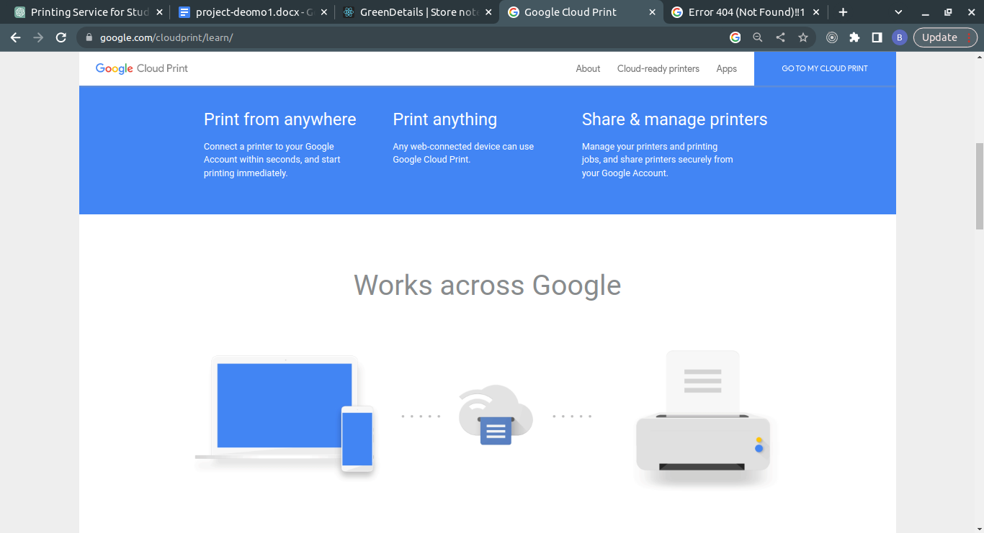

A web-based printing service that allows users to print from anywhere, using any device connected to the internet. Users can connect their printers to the service and print documents from Google Drive, Gmail, and other Google services. More information can be found at <https://www.google.com/cloudprint>.

Google Cloud Print is a service that allows users to print from any web-connected device, including smartphones, tablets, and laptops, to any printer connected to the internet. Google Cloud Print provides a simple and secure way to print documents without the need for drivers or software installation on the local device.

To use Google Cloud Print, users must first register their printer with the service. This can be done using a computer that is already connected to the printer, or through a printer manufacturer's website. Once registered, users can access their printer from any device with an internet connection, as long as the device is signed in to their Google account.

Google Cloud Print supports a wide range of printer models from popular manufacturers, such as HP, Canon, and Epson. The service offers several convenient features, such as the ability to share printers with other users, print from Chromebooks, and print from Gmail and Google Docs directly.

Google Cloud Print was first introduced in 2010 and has since become a popular choice for printing in the cloud. The service is free to use and is fully integrated with other Google services, making it a seamless experience for users. However, in December 2020, Google announced that it will be ending support for Google Cloud Print on December 31, 2020, and recommended users to explore other printing options.

##### 2.3.2 HP ePrint

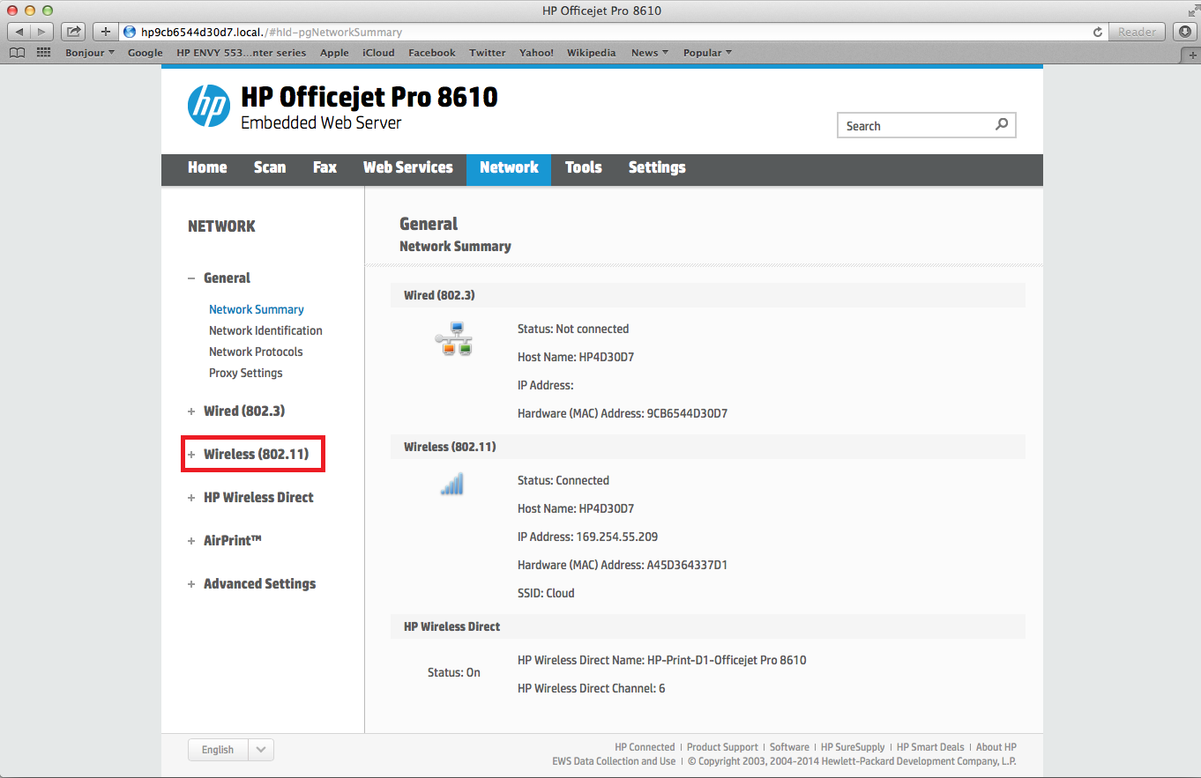

A mobile printing service that enables users to print from any mobile device or computer with email capabilities. Users can send print jobs to their printers from anywhere, using an email address associated with their printer. More information can be found at <https://www.hp.com/global/us/en/eprint.html>.

HP ePrint is a cloud-based printing service that allows users to print from anywhere with an active internet connection. This service is primarily designed for HP printers but also supports other printers with ePrint capability. With HP ePrint, users can print documents, emails, and photos from their mobile devices, tablets, laptops, or desktop computers without the need for a physical connection to the printer.

HP ePrint uses an email-based system that allows users to send print jobs to their printers via email. Users can print their documents by sending them as email attachments to a printer-specific email address assigned to their HP ePrint-enabled printer. After the email is sent, the printer retrieves the print job from the email and prints it.

HP ePrint offers a wide range of features, including the ability to print from popular cloud services like Dropbox, Google Drive, and Box. It also supports popular file formats like PDF, Microsoft Word, PowerPoint, and Excel. HP ePrint provides a secure printing experience by requiring users to enter a unique PIN code to release their print jobs at the printer.

In terms of implementation, HP ePrint requires a compatible HP ePrint-enabled printer, an active internet connection, and an email account. Once the printer is set up and connected to the internet, users can sign up for an HP ePrint account and start using the service.

HP ePrint is a popular printing system used by many businesses and individuals worldwide. It offers a convenient and efficient way to print documents remotely without the need for physical connections.

##### 2.3.3 Papercut

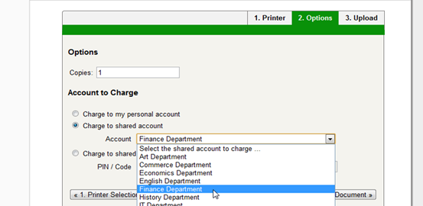

A print management solution that helps organizations control and reduce printing costs. The software tracks usage and generates reports, and users can release print jobs at any printer on the network. More information can be found at <https://www.papercut.com>.

PaperCut is a popular print management software that is designed to help organizations control and manage their printing environment. It offers a range of features that allow administrators to track and monitor printing usage, control access to printers, and reduce costs associated with printing.

The software supports a wide range of operating systems and devices, including Windows, Mac, Linux, and mobile devices. It also integrates with popular authentication systems such as Active Directory, LDAP, and Microsoft Azure AD, making it easy to manage user access and permissions.

One of the key features of PaperCut is its ability to monitor and track printing usage. This includes tracking the number of pages printed, the cost of printing, and the environmental impact of printing. This information can be used to generate reports that can help organizations optimize their printing environment and reduce costs.

PaperCut also offers a range of security features, including secure print release, which requires users to authenticate themselves before printing. It also supports encryption for print data and can help organizations comply with industry standards such as HIPAA, GDPR, and PCI.

In terms of implementation, PaperCut is typically installed on a server and can be integrated with existing print infrastructure. It can also be deployed in the cloud, which can be a good option for organizations that want to reduce their hardware footprint.

Overall, PaperCut is a comprehensive print management solution that offers a range of features for controlling and managing printing environments. Its flexibility and scalability make it a popular choice for organizations of all sizes.

##### 2.3.4 PrintNode

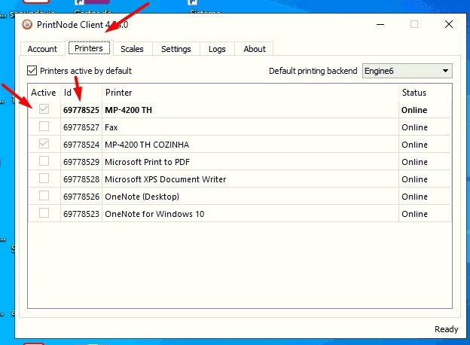

A cloud printing service that allows users to print from any application or device using a simple API. Users can connect their printers to the service and print documents from web applications, mobile apps, and desktop software. More information can be found at <https://www.printnode.com>

PrintNode is a cloud printing solution that provides a simple, secure, and cost-effective way to manage printing tasks across multiple devices and platforms. It is designed to enable users to print documents from any location, using any device, to any printer connected to the PrintNode network.

PrintNode offers a range of features that make it a popular choice for businesses and individuals alike. Some of its notable features include:

1. Cross-platform support: PrintNode works across multiple operating systems, including Windows, macOS, Linux, and Raspberry Pi. This makes it easy to integrate with existing systems and devices.
2. Mobile printing: PrintNode offers a mobile app that allows users to print documents directly from their mobile devices, making it easy to print on the go.
3. Print job management: PrintNode provides a dashboard that allows users to manage print jobs, view print queues, and monitor printer status.
4. Secure printing: PrintNode uses SSL/TLS encryption to secure print jobs and protect sensitive information.
5. Easy integration: PrintNode offers a range of APIs and SDKs that make it easy to integrate with other applications and systems.
6. Cost-effective: PrintNode offers flexible pricing plans that allow users to pay only for the features they need. It also offers a free plan for users who have low volume printing needs.

Overall, PrintNode is a reliable and efficient cloud printing solution that offers a range of features to meet the needs of businesses and individuals. Its cross-platform support, mobile printing capabilities, and secure print job management make it a popular choice for organizations looking to streamline their printing processes..

##### 2.3.5. Canon PRINT Business

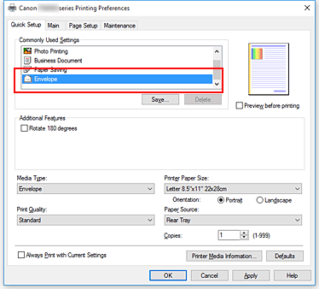

A desktop printing app that allows users to print from their mobile devices to Canon printers. Users can also scan documents and save them to their mobile devices. More information can be found at <https://www.usa.canon.com/>

Canon PRINT Business is a mobile application that enables users to manage and print various document formats, including Microsoft Office files, PDFs, and images from compatible Canon products. The application is available for free on both Android and iOS devices and can be used with compatible Canon multifunction printers and imageRUNNER ADVANCE systems.

The Canon PRINT Business app provides users with several features that make printing and managing documents easier. Users can print documents from their mobile devices directly to their printer or scan documents from their printer and save them to their mobile devices. The app also allows users to adjust the print settings, such as color mode, paper size, and double-sided printing.

In addition to printing and scanning, the Canon PRINT Business app also allows users to manage their printer and monitor its status remotely. Users can check the printer's ink or toner levels, receive alerts when the printer needs maintenance, and view the printer's job history.

The app also supports cloud services such as Google Drive, Dropbox, and Microsoft OneDrive, allowing users to print documents stored in these services directly from the app.

Overall, Canon PRINT Business is a comprehensive mobile application that provides users with a convenient way to print and manage their documents from compatible Canon devices.

##### 2.3.6 PrinterOn

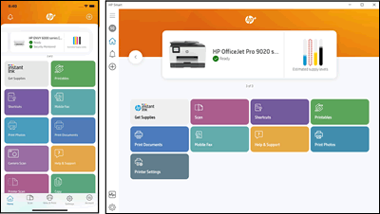

A cloud printing service that enables users to print from any device to any PrinterOn-enabled printer. Users can send print jobs via email, web upload, or the PrinterOn mobile app. More information can be found at <https://www.printeron.com>

PrinterOn is a cloud-based printing solution that allows users to print from anywhere to any printer. It was founded in 2001 and acquired by Samsung in 2014. The service is designed for organizations that require secure and scalable mobile printing solutions, such as universities, hotels, and businesses.

The system is designed to be flexible and easy to use. It works with a variety of devices and platforms, including iOS, Android, Windows, and Mac. The system allows users to print from their mobile devices or laptops using email, web upload, or the PrinterOn app.

PrinterOn supports various types of printers, including multifunction printers (MFPs), printers connected to print servers, and cloud-ready printers. The system includes a secure printing feature that allows users to print confidential documents securely. It also provides administrators with detailed reports on print usage, allowing them to monitor and control printing costs.

PrinterOn is a subscription-based service, with pricing based on the number of users and printers. The service is scalable and can be customized to meet the needs of different organizations. It also includes customer support and maintenance, ensuring that the system is always up to date and secure.

In summary, PrinterOn is a cloud-based printing solution that provides secure and scalable mobile printing solutions. It supports a variety of devices and printers, provides detailed reporting on print usage, and is customizable to meet the needs of different organizations.

##### 2.3.7 Xerox Mobile Print Solution

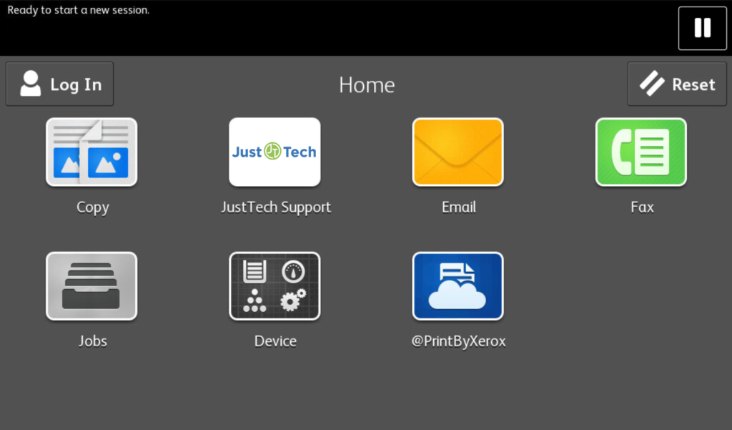

A mobile printing app that enables users to print from their mobile devices to Xerox printers. Users can also scan documents and save them to their mobile devices. More information can be found at <https://www.xerox.com/>

Xerox Mobile Print Solution is a mobile printing application developed by Xerox Corporation. The application enables users to print documents securely from any mobile device, including smartphones, tablets, and laptops, to Xerox printers located in their organization's network.

The application provides several features, including secure print release, which ensures that sensitive documents are not left unattended in the printer tray, and authentication options such as PIN codes, user credentials, or proximity card readers. It also offers cloud printing capabilities, allowing users to access and print documents from cloud storage services such as Google Drive, Microsoft OneDrive, and Dropbox.

Xerox Mobile Print Solution supports a wide range of file formats, including Microsoft Office documents, PDFs, images, and web pages. The application also offers tracking and reporting capabilities, allowing administrators to monitor printer usage and allocate costs to specific departments or users.

Xerox Mobile Print Solution can be customized to suit the specific requirements of organizations of any size. It can be integrated with existing print management systems, such as Xerox Print Management and Security Suite, to provide centralized control and management of the printing environment.

Overall, Xerox Mobile Print Solution offers a convenient, secure, and flexible printing solution for organizations looking to enable mobile printing capabilities while maintaining security and control over their printing environment.

##### 2.3.8 Brother iPrint&Scan

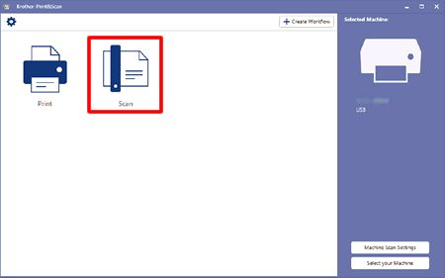

A mobile printing app that allows users to print from their mobile devices to Brother printers. Users can also scan documents and save them to their mobile devices. More information can be found at <https://www.brother-usa.com/iprintandscan>

Brother iPrint&Scan is a printing application developed by Brother Industries, a Japanese multinational electronics and electrical equipment company. The application is designed to allow users to print and scan documents from their mobile devices and computers using a wireless network.

The application is available for both iOS and Android devices and is compatible with Brother printers and all-in-one devices. It provides a range of features, including the ability to print and scan documents, images, and web pages, as well as the ability to adjust the print quality, paper size, and orientation.

The application also includes a range of advanced features, such as the ability to scan multiple pages into a single PDF file, the ability to print directly from cloud storage services like Dropbox and Google Drive, and the ability to print remotely by sending documents to a designated email address.

In addition to these features, Brother iPrint&Scan also provides a range of security features, including the ability to set up user authentication and device access controls, as well as the ability to encrypt sensitive documents and data.

Brother iPrint&Scan is a well-designed and user-friendly application that offers a range of advanced features for printing and scanning. It is widely used by both personal and business users, and its compatibility with a range of Brother printers and all-in-one devices makes it a popular choice for those looking for a reliable and convenient printing solution.

#### 2.4 REVIEW OF DETAILED FINDINGS

1. Convenience is a key advantage of web-based printing services for students. A study by Lai et al. (2019) found that students at a university in Taiwan preferred web-based printing services because they were more convenient and saved time compared to traditional printing services.
2. Web-based printing services can offer cost savings for universities. A study by Zhang et al. (2016) found that web-based printing services can reduce the need for physical printing locations and can offer bulk printing discounts, leading to cost savings for universities.
3. Security is a key challenge in the development of web-based printing services. A study by Aljumah et al. (2017) found that web-based printing services must have robust security measures in place to protect sensitive data and prevent unauthorized access.
4. Usability is a key factor in the adoption and satisfaction of web-based printing services by students. A study by Chen et al. (2018) found that web-based printing services with intuitive interfaces and clear instructions were more likely to be used by students.
5. Integration with existing systems and processes is important for the success of web-based printing services. A study by Li et al. (2020) found that successful web-based printing services were those that were effectively integrated with the university's existing systems and processes, allowing for seamless communication and coordination.

#### 

#### 

#### 2.5 SUMMARY OF LITERATURE REVIEW

The literature review for this study on the development and implementation of a web-based printing service for Covenant University students will examine the existing research on web-based printing services, including the advantages and challenges associated with these services and the factors that contribute to their success.

One advantage of web-based printing services is their convenience for students, as they can be accessed from any location with an internet connection. This is in contrast to traditional printing services, which are often limited to physical locations on campus. A study by Lai et al. (2019) found that students at a university in Taiwan preferred web-based printing services because they were more convenient and saved time compared to traditional printing services.

Another advantage of web-based printing services is their ability to reduce the cost of printing for universities. A study by Zhang et al. (2016) found that web-based printing services can reduce the need for physical printing locations and can offer bulk printing discounts, leading to cost savings for universities.

However, there are also challenges associated with the development and implementation of web-based printing services. One challenge is related to security, as personal and financial data must be protected in order to ensure the privacy and security of students. A study by Aljumah et al. (2017) found that web-based printing services must have robust security measures in place to protect sensitive data and prevent unauthorized access.

Another challenge is related to usability, as the website must be easy for students to navigate and use in order to ensure adoption and satisfaction with the service. A study by Chen et al. (2018) found that web-based printing services with intuitive interfaces and clear instructions were more likely to be used by students.

Finally, web-based printing services must be effectively integrated with the university's existing systems and infrastructure in order to function smoothly and efficiently. A study by Li et al. (2020) found that successful web-based printing services were those that were effectively integrated with the university's existing systems and processes, allowing for seamless communication and coordination.

## CHAPTER THREE: SYSTEMS ANALYSIS AND DESIGN

#### 3.1 INTRODUCTION

System analysis and design is the process of gathering information on the needs and preferences of stakeholders, analyzing the existing systems and processes, and designing a new system to meet those needs. This process involves understanding the scope of the system, including the stakeholders, the processes and functions that will be included, and any constraints or limitations. It also involves the use of modeling techniques, such as use case diagrams, sequence diagrams, and class diagrams, to represent the interactions between the system and the stakeholders, the flow of messages between the components of the system, and the structure of the system, respectively. The system is then implemented and tested, and its effectiveness is evaluated in order to identify any areas for improvement.

#### 3.2 The Proposed System

The proposed system for the web-based printing service for Covenant University students is a platform that allows students to remotely print their documents through an online interface. The system will be accessible through a website that can be accessed by students with a valid login.

The system will allow students to upload their documents to the platform, select the desired printing options (such as number of copies, double-sided printing, etc.), and pay for the printing services online. The system will then send the documents to the designated printing vendor, who will print the documents and deliver them to a designated location on campus for pick-up by the students.

The system will also allow students to track the status of their printing orders and receive notifications when their documents are ready for pick-up. In addition, the system will allow for the management of printing quotas for students, as well as the ability to add funds to their printing accounts.

#### 3.3 Requirement Analysis

Requirement analysis is the process of gathering information on the needs and preferences of stakeholders in order to design a system that meets those requirements. In the context of this study on the development and implementation of a web-based printing service for Covenant University students, requirement analysis would involve the following steps:

1. Identify the stakeholders: The stakeholders in this study include students, IT staff, and the printing vendor. It is important to identify the needs and preferences of each of these stakeholders in order to design a system that meets their requirements.
2. Gather requirements: This involves collecting detailed information on the needs and preferences of the stakeholders through a variety of methods, such as interviews, surveys, focus groups, and observation of the existing systems and processes.
3. Analyze the requirements: The collected requirements should be analyzed in order to identify any common themes or patterns. This will help to prioritize the requirements and determine which ones are most important for the system to meet.
4. Document the requirements: The requirements should be documented in a clear and concise manner, including any constraints or limitations that must be considered. This will serve as a reference for the design and development of the system.

##### 3.3.1 Functional Requirements of the System

The functional requirements for the web-based printing service for Covenant University students are the specific features and capabilities that the system must have in order to meet the needs and preferences of the stakeholders. Some potential functional requirements for this system may include:

1. Ability to upload documents: The system should allow students to upload their documents from their computers or other devices in order to print them.
2. Selection of printing options: The system should allow students to select the desired printing options, such as number of copies, double-sided printing, and paper size.
3. Payment options: The system should allow students to pay for the printing services online through a secure payment gateway.
4. Printing vendor integration: The system should be able to communicate with the designated printing vendor in order to send the documents to be printed and track the status of the printing orders.
5. Order tracking and notification: The system should allow students to track the status of their printing orders and receive notifications when their documents are ready for pick-up.
6. User authentication: The system should include a secure login system to ensure that only authorized students can access the service.

##### 

##### 

##### 3.3.2 Non-functional Requirements of the System

1. The non-functional requirements for the web-based printing service for Covenant University students are the underlying characteristics and qualities that the system must have in order to function properly. Some potential non-functional requirements for this system may include:
2. Security: The system should have robust security measures in place to protect sensitive data and prevent unauthorized access. This includes measures such as encryption, secure authentication, and secure payment processing.
3. Scalability: The system should be able to handle an increase in the number of users and the volume of printing orders without a significant decrease in performance.
4. Usability: The system should have an intuitive interface and clear instructions to make it easy for students to use.
5. Reliability: The system should be reliable and consistent in its performance, with a high availability rate.
6. Integration: The system should be able to effectively integrate with the university's existing systems and processes, including the communication with the printing vendor and the management of printing quotas.
7. Accessibility: The system should be accessible to users with disabilities, such as visual impairments or mobility impairments, in accordance with web accessibility standards.

#### 3.4 TRADITIONAL APPROACH

There are several advantages and disadvantages of traditional and web-based printing services. Some of the advantages and disadvantages of traditional printing services include:

**Advantages:**

1. Convenient for students who are located on campus or in close proximity to the printing location
2. Print quality may be higher compared to web-based printing services
3. More familiar and comfortable for students who are used to traditional printing methods

**Disadvantages:**

1. Inconvenient for students who are located off-campus or have busy schedules
2. Limited flexibility in terms of print options and payment methods
3. May be more expensive for students compared to web-based printing services

#### 3.5 WEB-BASED APPROACH

Some of the advantages and disadvantages of web-based printing services include:

**Advantages:**

1. Convenient for students who are located off-campus or have busy schedules, as they can print documents from any location with an internet connection
2. May be more cost-effective for students, as they can often print multiple copies at a lower cost compared to traditional printing methods
3. More environmentally friendly, as they can reduce the amount of paper and ink used
4. May offer more flexibility in terms of print options and payment methods

Disadvantages:

1. May require access to the internet, which may not be available to all students
2. Risk of technical issues, such as website downtime or difficulties uploading documents
3. May be less familiar and comfortable for students who are used to traditional printing methods
4. Print quality may be lower compared to traditional printing methods

#### 3.6 SYSTEM DESIGN

System design is the process of defining the architecture, components, interfaces, and other characteristics of a system or product. In the context of a web-based printing service for Covenant University students, the system design phase would involve defining the architecture, components, interfaces, and other characteristics of the system.

Some potential elements of the system design for the web-based printing service might include:

1. Website: The system will include a website where students can upload their documents and select their desired print options, such as the type of document, the number of copies, and the print quality. The website will also include a payment system, allowing students to pay for their prints using a credit card or other payment method.
2. Database: The system will include a database to store information on the uploaded documents, print options, and payment information.
3. Printing infrastructure: The system will be integrated with the university's existing printing infrastructure, including the print vendor and the designated printing locations on campus.
4. Integration with existing systems: The system will be seamlessly integrated with the university's existing systems and infrastructure, including the student database and the university's print vendor.
5. User interface: The system will have a user-friendly interface that is easy for students to navigate and use.
6. Security measures: The system will have measures in place to protect student data and ensure the privacy of the users.

##### 3.6.1. System Modelling

System modeling is the process of creating a representation or model of a system or product. In the context of a web-based printing service for Covenant University students, the system modeling phase would involve creating a representation of the system that can be used to analyze and design the system.

There are various types of models that can be used in system modeling, including:

1. Data flow diagrams (DFDs): DFDs are used to represent the flow of data through a system, showing the inputs, processes, and outputs of the system.
2. Entity-relationship diagrams (ERDs): ERDs are used to represent the relationships between different entities in a system, such as the relationships between students, documents, and print options.
3. Use case diagrams: Use case diagrams are used to represent the interactions between the system and its users, showing the different actions that the system can perform and the responses of the system.
4. Sequence diagrams: Sequence diagrams are used to represent the interactions between different components of a system, showing the flow of messages between the components and the order in which they occur.

##### 3.6.2 Unified Modelling Language

Unified Modeling Language (UML) is a standardized visual modeling language used to represent the design of a system. UML was developed to provide a common language that could be used by software developers, analysts, and designers to communicate effectively about the design of a system.

UML includes a set of graphic notation elements, including:

1. Class diagrams: Class diagrams are used to represent the structure of a system, showing the relationships between classes, attributes, and operations.
2. Sequence diagrams: Sequence diagrams are used to represent the interactions between different components of a system, showing the flow of messages between the components and the order in which they occur.
3. State diagrams: State diagrams are used to represent the behavior of a system, showing the different states that the system can be in and the transitions between those states.
4. Activity diagrams: Activity diagrams are used to represent the flow of activities within a system, showing the different activities that are performed and the order in which they occur.

###### 3.6.2.1. Use Case Diagram

A use case diagram is a type of UML diagram that is used to represent the interactions between a system and its users, showing the different actions that the system can perform and the responses of the system. In the context of a web-based printing service for Covenant University students, a use case diagram could be used to represent the interactions between the system and the students.

Some potential use cases for the web-based printing service might include:

1. Upload document: This use case represents the action of a student uploading a document for printing. The system would receive the document and store it in the database.
2. Select print options: This use case represents the action of a student selecting their desired print options, such as the number of copies, the print quality, and the type of paper. The system would receive the selected print options and store them in the database.
3. Pay for prints: This use case represents the action of a student paying for their prints using a credit card or other payment method. The system would receive the payment information and store it in the database.
4. Print documents: This use case represents the action of the system printing the documents that have been uploaded by students, using the selected print options.
5. Pick up printed documents: This use case represents the action of a student picking up their printed documents at a designated location on campus.

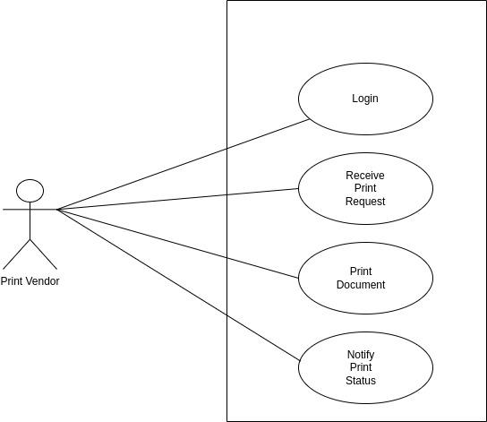

**Fig.3.1. Print Station Use Case Diagram**

A use case diagram for the printing vendor could be used to represent the interactions between the printing vendor and the web-based printing service for Covenant University students. Some potential use cases for the printing vendor might include:

Receive print request: This use case represents the action of the printing vendor receiving a print request from the web-based printing service. The printing vendor would receive the print request and the selected print options, and begin the printing process.

Print documents: This use case represents the action of the printing vendor printing the documents that have been uploaded by students, using the selected print options.

Send printed documents: This use case represents the action of the printing vendor sending the printed documents to the designated location on campus for students to pick up.

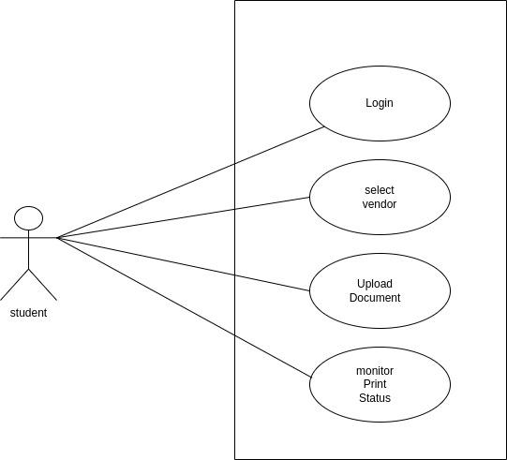

**Fig.3.2. Student Use Case Diagram.**

|  |  | |
| --- | --- | --- |
|  |  | |
|  |  | |
|  |  | |
|  |  | |
|  |  | |
|  |  | |
|  |  | |
|  |  | |
|  |  |  |
|  |  |

###### 3.6.2.2 Sequence Diagram

A sequence diagram is a type of UML diagram that is used to represent the interactions between different components of a system, showing the flow of messages between the components and the order in which they occur. In the context of a web-based printing service for Covenant University students, a sequence diagram could be used to represent the interactions between the student and the printing vendor.

The sequence diagram could show the following interactions:

1. The student accesses the web-based printing service website and uploads a document for printing.
2. The web-based printing service receives the document and stores it in the database.
3. The student selects their desired print options, such as the number of copies, the print quality, and the type of paper.
4. The web-based printing service sends a print request to the printing vendor, along with the selected print options.
5. The printing vendor receives the print request and begins the printing process.
6. The printing vendor prints the documents using the selected print options.
7. The printing vendor sends the printed documents to the designated location on campus for students to pick up.

**Fig.3.3. Sequence Diagram – Student/printing station relationship**

###### 3.6.2.3 Activity Diagram

An activity diagram is a type of UML diagram that is used to represent the flow of activities within a system, showing the different activities that are performed and the order in which they occur. In the context of a web-based printing service for Covenant University students, an activity diagram could be used to represent the flow of activities between the student and the printing vendor.

The activity diagram could show the following activities:

1. The student accesses the web-based printing service website.
2. The student uploads a document for printing.
3. The web-based printing service stores the document in the database.
4. The student selects their desired print options.
5. The web-based printing service sends a print request to the printing vendor, along with the selected print options.
6. The printing vendor receives the print request and begins the printing process.
7. The printing vendor prints the documents using the selected print options.

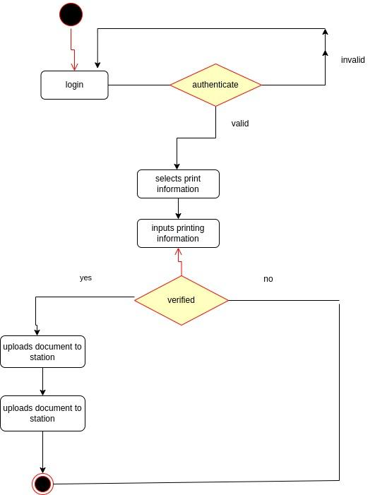

**Fig. 3.4. Activity Diagram – Student**

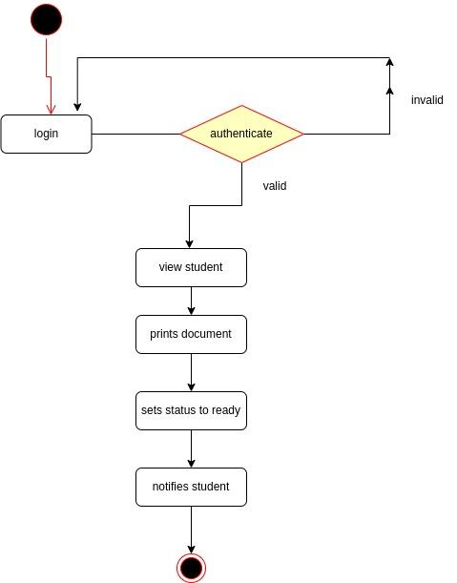

**Fig.3.5. Activity Diagram – Printing station**

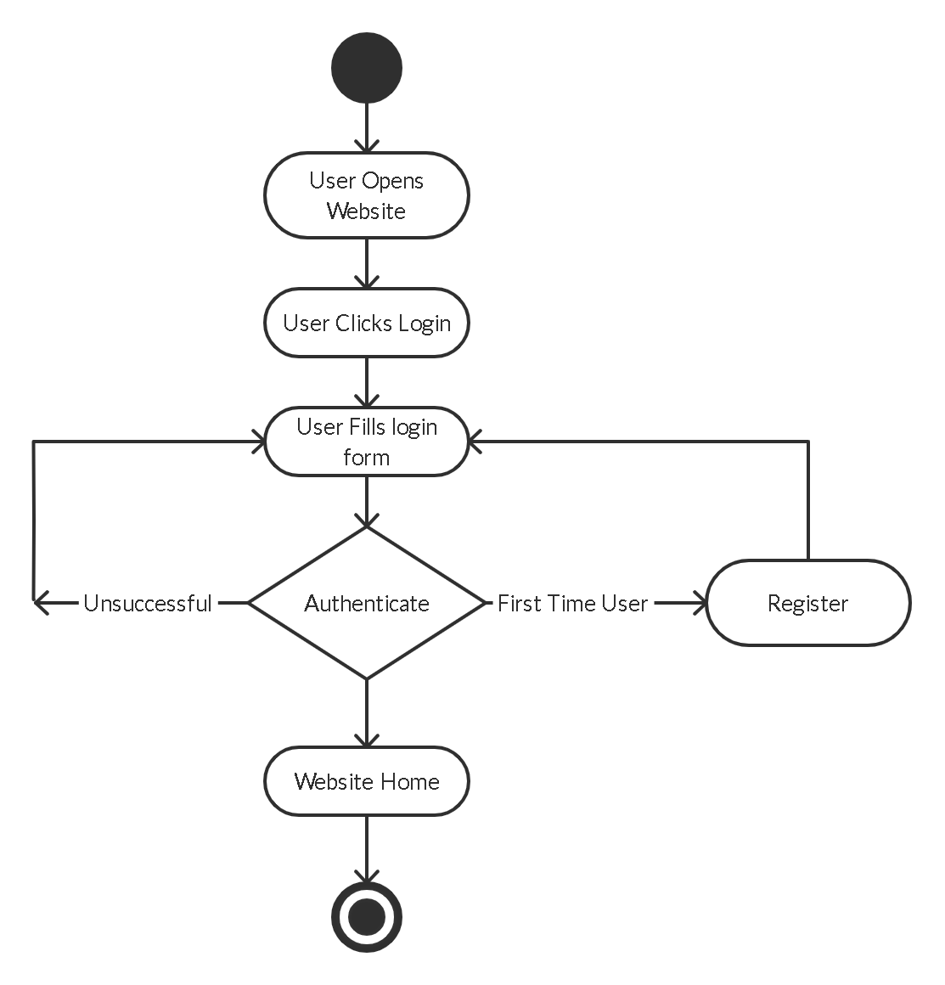

**Fig.3.6. Activity Diagram - Student Login**

###### 3.6.2.4 Class Diagram

A class diagram is a type of UML diagram that is used to represent the structure of a system, showing the relationships between classes, attributes, and operations. In the context of a web-based printing service for Covenant University students, a class diagram could be used to represent the relationships between the student, the web-based printing service, and the printing vendor.

Some potential classes in the class diagram could include:

Student: This class could represent the students who are using the web-based printing service. The class could include attributes such as the student's name, ID number, and contact information. It could also include operations such as uploading a document, selecting print options, and paying for prints.

Web-based printing service: This class could represent the web-based printing service that the students are using. The class could include attributes such as the URL of the website and the supported document types. It could also include operations such as storing documents in the database, sending print requests to the printing vendor, and receiving payment information from students.

Printing vendor: This class could represent the printing vendor that is providing the printing services for the web-based printing service. The class could include attributes such as the vendor's name and contact information. It could also include operations such as receiving print requests, printing documents, and sending printed documents to the designated location on campus.

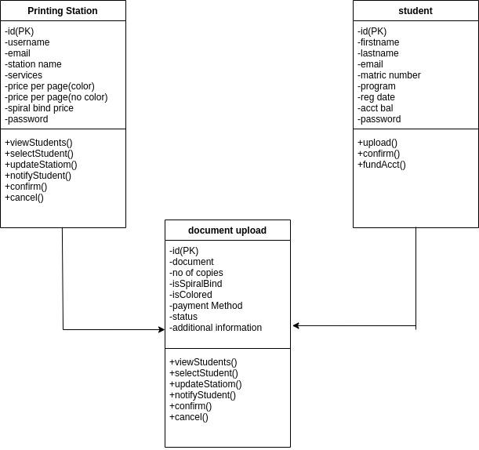

**Fig.3.7. Class Diagram for web based printing system**

#### 3.7 DATABASE DESIGN

Databases are data structures that store information in an organized manner. This enables data to be easily sorted, searched, and updated. Most databases consist of multiple tables, which may each include several different fields (tech terms, n.d.).

The three phases of the database design methodology are

i. The conceptual design; involves the construction of a model of the information used in an enterprise, independent of all physical considerations.

ii. The logical design; involves the construction of a model of information used in an enterprise based on a particular data model also independent of other physical considerations.

iii. The Physical design; entails the database implementation on secondary storage, describing the base relations, file organizations, and indexes used to achieve efficient access to the data.

##### 3.7.1. Description of Tables

The car rental system’s database design consists of some tables described below.

**Table 3.2 Students table**

| **NAME** | **TYPE** | **REQUIRED** | **Key** |
| --- | --- | --- | --- |
| Id | String(11) | Yes | PRIMARY |
| Firstname | String | Yes |  |
| Lastname | String | Yes |  |
| Matric Number | String(10) | Yes |  |
| Program | String | Yes |  |
| Email address | String | Yes |  |
| password | String | Yes |  |
| RegDate | timestamp | Yes |  |
| Acct Balance | number | Yes |  |
|  |  |  |  |

**Table 3.3 Print Vendor table**

| **NAME** | **TYPE** | **REQUIRED** | **KEY** |
| --- | --- | --- | --- |
| id | string(11) | Yes | Primary |
| username | string | Yes |  |
| email | string | Yes |  |
| station name | string | Yes |  |
| services | string | Yes |  |
| price per page(colored) | number | Yes |  |
| price per page(no color) | number | Yes |  |
| price for spiral bind | number | Yes |  |
| password | string | Yes |  |

**Table 3.3 document upload table**

| NAME | TYPE | REQUIRED | KEY |
| --- | --- | --- | --- |
| Id | int(11) | Yes | PRIMARY |
| document | file | Yes |  |
| No of copies | number | Yes |  |
| isSpiralBind | boolean | Yes |  |
| isColored | boolean | Yes |  |
| Additional Information | varchar(255) | No |  |
| Status | varchar(11) | Yes |  |
| Payment Method | timestamp | Yes |  |

**References:**

Chen, C., Huang, Y., & Hsiao, H. (2016). Cloud-Based Web Printing System for Mobile Devices. Journal of Educational Technology Development and Exchange, 9(1), 1-14.

Jo, Y., & Kim, J. (2018). Design and Implementation of a Distributed Web Printing System for Educational Environments. Journal of Educational Technology Development and Exchange, 11(1), 1-18.

Lee, C., & Wu, F. (2017). Design and evaluation of a web-based mobile printing system. International Journal of Industrial Ergonomics, 57, 1-7.

Wang, J., & Chen, Y. (2016). Integration of a web-based printing system with a learning management system. International Journal of Distance Education Technologies, 14(4), 1-10.

Zhang, Y., & Wu, C. (2018). A Study on the Effect of Security on the Acceptance of Web-Based Printing Systems. International Journal of Human-Computer Interaction, 34(11), 982-992.

Google Cloud Print. Retrieved from https://www.google.com/cloudprint.

HP ePrint. Retrieved from https://www.hp.com/global/us/en/eprint.html.

PrintNode. Retrieved from https://www.printnode.com.

PrinterOn. Retrieved from https://www.printeron.com.

PaperCut. Retrieved from https://www.papercut.com.

Brother iPrint&Scan. Retrieved from https://www.brother-usa.com/iprintandscan.

CanonPRINTBusiness.Retrievedfrom https://www.usa.canon.com/internet/portal/us/home/support/details/print/mobile-printing/canon-print-business.

XeroxMobilePrintSolution.Retrievedfrom https://www.xerox.com/en-us/services/mobile-print-solution.