**A Web-based payment system for Covenant University Strategic Business Unit**

**By**

**Ikpeawujor, Dominion Chukwuemeka**

**(18CG024749)**

**A project submitted to the department of computer and information sciences, college of science and technology, covenant university Ota, Ogun state.**

**In partial fulfilment of the requirements for the award of the bachelor of science (honours) degree in computer science.**

**July 2022**

**Certification**

I now certify that this project work, titled **A Web-Based Payment System For Covenant University Strategic Business Unit,** is a bona fide work carried out by IkpeawujorDominion Chukwuemeka (18CG024749). It was submitted to the Department of Computer and Information Sciences, College of Science and Technology, Covenant University, Ota.

| **Prof. Olufunke O. Oladipupo** |  |
| --- | --- |
| Supervisor | **Signature and Date** |
|  |  |
| **Prof. Olufunke O. Oladipupo** |  |
| Head of Department | **Signature and Date** |

**Dedication**

I dedicate this project to God, who gave me the inspiration and ideas to design and develop this project and the strength and ability to make it a success.

I also dedicate this project to my parents and family for their help, support, and prayers.

**Acknowledgement**

I am grateful to God for giving me the ability to have come this far with my project and programme and for keeping and sustaining me throughout my undergraduate period at Covenant University. His direction and guidance have made it possible to accomplish required tasks and favour. Without Him, I can do nothing. I am eternally grateful.

I also want to appreciate my siblings and friends far and wide for their continuous support and the love they have shown me since the beginning. Their presence in my life has made the journey thus far less of a burden, and I am grateful.

I want to appreciate my Parents and Family at home and abroad for their care and support through my project and my Undergraduate studies. They have been a major driving force that sustained me through my schooling here at Covenant University.

I am also grateful for the supervision from Prof. Olufunke O. Oladipupo, Dr Azubuike Ezenwoke, Dr Onyeka Emebo, Mr Stephen Adubi and Mr Ebuka. I struggled with my project for a significant period, but they helped me pull through. I cannot thank you enough.

**Table of Content**

**Certification i**

**Dedication ii**

**Acknowledgement iii**

**Table of Content iv**

**List of Figures ix**

**Abstract x**

**Chapter One: Introduction 1**

1.1. Background 1

1.2. Statement of the Problem 3

1.3. Aim and Objectives 3

1.3.1. Objectives Of the Study 4

1.4. Methodology 4

1.5. Significance of Study 4

1.6. Limitation Of The Study 5

1.7. Outline of the Project 5

**Chapter Two: Literature Review 7**

2.1. Introduction 7

2.2. Definition of Relevant Terms 7

2.2.1. Retail Management 8

2.2.2. Inventory Management 8

2.2.3. Point of Sales 9

2.2.4. Cloud Computing 9

2.3. Review Of Existing Systems 10

2.3.1. Lightspeed 10

2.3.2. Piggyvest 13

2.3.3. Sortly 13

2.3.4. Microsoft Dynamic Retail Management System. 14

2.4. Review of Existing Principles and Methods 15

2.4.1. Distributed Digital-Ticket Management for Rights Trading System 15

2.4.2. Digital-Ticket-Controlled Digital Ticket Circulation 16

2.4.3. Effectiveness of the E-Ticket System Using QR Codes for Smart Transportation Systems 17

2.5. Review of Related Findings 18

**Chapter Three: System Analysis and Design 20**

3.1. Introduction 20

3.2. System Architecture 20

3.2.1. Presentation layer 21

3.2.2. Business Logic 21

3.2.3. Data Access Layer 22

3.3. System Requirements 22

3.3.1. Functional Requirements 22

3.3.2. Non-Functional Requirements 23

3.4. System Design 23

3.4.1. Use Case Diagram 23

3.4.2. Activity Diagram 24

**Chapter Four: System Implementation 26**

:4.1. Introduction 26

4.2. System Requirements 26

4.2.1. Hardware Requirements 26

4.2.2. Software Requirements 26

4.2.3. Implementation tools 27

4.3. System Interfaces 28

4.3.1. Home Page 28

4.3.2. Admin Page 29

4.3.3. QR Generator Page 30

4.3.4. User Search 31

4.3.5. Ticket – QR Code 32

**Chapter Five: Summary, Recommendation and Conclusion 34**

5.1. Summary 34

5.2. Recommendations 34

5.3. Conclusion 34

**References 35**

**LIST OF TABLES**

Table 4.1 Software Requirements 26

**List of Figures**

Figure 2.1 Cashier's dashboard on the Lightspeed Solution 12

Figure 2.2 Cross-platform ability of the Lightspeed application. 13

Figure 2.3 Sortly Application Dashboard 15

Figure 2.4 Participants and Roles of a ticketing System 16

Figure 2.5 Differences between the Account-based, Smart-card based System and the Proposed System 17

Figure 3.1 Architecture of Proposed System 22

Figure 3.2 Use Case Diagram of Proposed System 25

Figure 3.3 Activity Diagram of the Proposed System 26

Figure 4.1 Home Page 30

Figure 4.2 Admin Page 31

Figure 4.3 QR Generator Page 32

Figure 4.4 User Search Page 33

Figure 4.5 Ticket Page - QR Code 34

**Abstract**

With the rise in technology and increase in the need to perform transactions, society has battled with new safe and convenient ways of making payments. From the introduction of paper money to the rise in cryptocurrencies, i.e., digital money, exchange in value, especially monetary terms, has taken a new direction. On the other hand, paper money becomes cumbersome and difficult to transact with, especially over long distances. Paper is also liable to get lost or destroyed due to natural factors. Also, getting an accurate balance from the purchase becomes difficult due to a lack of smaller currency denominations to break the currency. My system targets the Covenant University student market, involving students utilising a centralised means of making monetary payments within the school environment through a Web-Based Payment Application. This system generates QR codes specific to the transactions carried out. I developed this application with HTML and CSS in the front and the framework of JavaScript called NodeJS in the backend.

**Chapter One**

# Introduction

## Background

The financial system has experienced a series of evolutions in its modus operandi. It began from the barter system introduced by the Mesopotamia tribes in 600 BC to non-fungible tokens and cryptocurrency. The term "money" is often used interchangeably with "currency". The section theories, however, are two separate concepts and not identical. Money is the intangible representation of the created value attached to tangible and physical items.

On the other hand, the currency is the tangible means to represent these values physically. Money values around $420 trillion, but this depends on the value people place on it and its importance as a medium of exchange and a unit of wealth measurement. (Beattie, 2022).

The means of exchange dates back to 40,000 years, adopted by early human beings. Using archaeological methods, scientists have traced the commencement of trade and value exchange. It began with the Upper Palaeolithic, during which hunters made direct deals and commerce through exchanges in their best flint weapons and artefacts. (Kusimba, 2017). "Money" came afterwards, over which experienced changes in its form. Rarely occurring items with a well-regulated circulation evolved into value units for interactions and commerce. The Americas used items such as shells, and Asia, Africa, and Europe used cowry shells. Other materials include gold, copper, native iron, silver, lead ingots, obsidian, meteorites, etc. Some other sects of humans used live animals, predominantly cows, as a form of currency.' The currency began to take shape during the era of The Mesopotamian Shekel nearly 5,000 years ago. The 600 to 650 BC saw the known mints in the Asian Minor, which facilitated the use of stamped silver and gold coins by Lydian Elites and Ionians, respectively. (Kusimba, 2017)

By discovering throngs of coins made of copper, lead, gold, and silver around the world, Scientists suggest that this was a medium of commodity exchange in the first millennium AD. This form gave rise to the portability, durability, and mobility of money, as opposed to the heavy forms that could also be impacted by ecological factors, in the case of live animals. These factors made money an instrumental source of political control through the introduction of taxes, as they helped support the elites and armies.

In our modern times, the tangibility of money has shifted from physical objects to digital assets. The money went through 5 stages of evolution (Chand, n.d.):

1. Commodity money: This included goods like furs, skins, rice, wheat, weapons, etc., as means of exchange.

2. Metallic Money: As human civilization advanced, commodity money evolved into metallic money. Metallic money included gold, silver, copper, etc.

3. Paper Money: Due to the inconvenience of carrying around metallic assets in the form of money, the world adopted Paper money. This type is, however, regulated by Central Banks of specific to avoid possible cases of inflation, deflation, etc.

4. Credit Money: Here, people can deposit money into banks and then make transactions through the use of Cheques. These cheques are not money but are means to perform transactions.

5. Plastic Money: This is currently the latest type of money. Credit cards and Debit cards help to ease transactions without the need to carry paper money or cash in general; thus, a modern payment system. is the scope of this project.

The payments system is the infrastructure (which includes institutions, instruments, regulations, processes, standards, and technical means) that enables the exchange of monetary value between parties performing mutual obligations. Its technological efficiency determines how well the economy uses transaction money and its risks.

The interbank, money and capital markets cannot function without a well-functioning payments system, which minimises the cost of exchanging commodities and services.

On the other hand, Record keeping is an essential part of business operations. Trading and commerce began in prehistoric times (History of Trade, 2022.). This period is dated back to 150,000 years ago during the period of long-distance trades from circa. Trade has been a significant aspect of value exchange between individuals. Egypt traded jewellery during 3000 BC. Trading has always been an essential part of global economies as an exchange of essentials is needed.

## Statement of the Problem

The business systems adopted by cafeterias and restaurants deal with daily transactions as customers require their services. Manual systems have long carried out these systems. As the customer base of these establishments grows, the need to accurately keep track of such records becomes necessary. This necessity, however, becomes a painstaking process as companies employ people to carry out such activities and must carry out periodic audits on the company accounting systems to curb the possibility of inaccurate data and possible fraud. Data worked within the company are sensitive and require due diligence to avoid possible errors. Still, these tasks are essential to understudy the performance of the business, how well it can cater to its customers needs and how possible it is to make and maximise profits. Given its limited resources during such operations, business processes become difficult and impossible to carry out when there are errors. The processes around such business transactions require accurate data collection and efficient accounting systems to reduce operating costs. Problems will arise in business because of these issues.

Students face long queues in the cafeteria when purchasing food, sometimes because of the bank networks. As a result, they leave the cafeteria more drained than how they got there, sometimes unable to get food, leaving them hungry and relying on a less conducive way for survival or going far distances to withdraw money.

Furthermore, change in the cafeteria becomes an issue as attendants cannot break large denominations into small ones, leaving the concerned student without their expected change. This action sometimes negatively impacts the budget of such students, an issue most times overlooked.

### Objectives Of the Study

1. To review existing systems and literature **Aim and Objectives**

This project aims to design and implement a unified means of payment within the establishments, specifically Covenant University, that would facilitate an easy and digitalised system to aid transactions between Personnel in the system and keep a record of accounts and transactions.

1. on payment and ticketing systems currently available.
2. Gather user and functional and non-functional requirements, research, and analyse already existing systems.
3. To develop a payment and ticketing system for Covenant University.
4. Evaluate the efficiency of this application

## Methodology

In order to achieve the aim of this project:

1. **Objective 1:** Review of existing systems and literature.
2. **Objective 2:** Interviews will be conducted with staff and students to understand their needs better and implement the solution.
3. **Objective 3:** Development of a web application with HTML, CSS, JavaScript, and NodeJS.
4. **Objective 4**: to achieve this objective, tests will be carried out ranging from transaction speed, ticket validation, Data gathering, data visualisation, and Security.

## Significance of Study

The increase in the number of payment systems worldwide is on the rise. A singular unified payment system for an organisation such as the university is essential to facilitate easy data management concerning financial transactions within the school environment, thereby reducing the possibility of inefficient database management of periodic transactions

The world is becoming digital, and some are the system of payment. This system will give students a more convenient approach to making transactions within the cafeteria by reducing the queue line through QR code scanning and removing the latency of bank networks when validating transactions.

Also, this platform will help foster a budgeting system for students to easily track how and what they spend on a daily, weekly, and monthly visualised system. Also, to encourage saving in Covenant University amongst students, points will be awarded every time you recharge your account. These points incentives will increase depending on the financial goals you set. Through this, students are more accountable for what they spend money on, and they make informed decisions.

This system will help the Strategic Business Unit make speedy and informed decisions on what commodities and food items to purchase through student transactions. This system is also currently not used in Covenant University; the existing system is a manual one.

## Limitation Of The Study

As this project will potentially change the way to carry out transactions in the system, it will take some time to be fully accepted by the public and the management staff. A network must be put in place within payment areas to facilitate transactions. Again, students would require some form of device to perform quick transactions on the counter.

## Outline of the Project

The first chapter of this paper includes the study's background, the statement of the problem, aim, and objectives, the research methodology used and ends with the study's significance and limitations.

Chapter two explains the modern payment systems and how they have aided transactions and data management. It also contains summary details of existing systems that have solved some of the problems mentioned in chapter one.

Chapter three covers the physical and logical design of the system's multiple modules that make the payment system's design, System Analysis and Design. This chapter also covers the architecture of the system and the database design. The program's design, as well as the testing sessions, are covered in Chapter 4. Chapter 5 contains the conclusion, summary, and recommendations for further research.

**Chapter Two**

# Literature Review

## Introduction

With an increase in the number of customers businesses receive per time, Customer management, as well as other factors such as inventory management, sales management, accounting, etc., become a tedious yet sensitive activity to carry out. Industries and businesses often resort to manual ways of keeping records of their daily transactions. These systems prove inefficient as customers begin to increase. Accounting also factors in human error, and the effects can be dire as the transactions increase. Technology has created the possibilities around automated record keeping and easy summation of transactions. Technological advancement has led to easy business administration, and less worry concerning data integrity inputted and worked on in transactions. The sales and inventory system aims to create a platform that allows an easy flow of data collection around business transactions and record keeping facilitating easy and accurate transaction keeping.

Cloud systems and infrastructures allow businesses easy access to their business data. They conveniently manage their processes on the go (Intan et al., 2015). It is important to note that these platforms, provided by third-party organisations, have immensely reduced the possible business running costs, such as IT support, Computer hardware management, etc. Platforms like this help businesses scale effectively and aid national development on a larger scope as companies do not need to worry about technical issues.

I reviewed different pieces of literature, and similar systems are understudied to carry out this task. Below are methodologies and techniques to solve the problem around easy and accurate transaction record keeping and payment facilitation in businesses.

## Definition of Relevant Terms

Retail as a business model has become an essential way to run businesses. Retailing allows businesses and establishments to easily sell their contents in small quantities per need and capacity(Management Study Guide Content Team, 2015). The business's efficiency relies on the systems to facilitate business processes. Retail Management Systems are platforms that enable retail business processes to run retail-inclined businesses run smoothly. They cut across different aspects such as e-commerce, pharmacies, bookstores, and restaurants. The features necessary in developing this system may include inventory management, customer relationship management (CRM), Sales Management, Point of Sales, etc. They are deployed on the web or as a stand-alone service to aid easy access. These subsystems help create value for companies and establishments in data collection, accounting, customer relations and monitoring, tracking and transaction facilitation to broaden the business space and reduce strain and stress amongst company staff. Automating manual processes such as taking inventory and calculating daily transactions after the day ends, as well as reduces effectively human errors around transaction record keeping and sales. This way, companies do not have to rely on the data integrity of attendants in business completely; there is a system to validate such.

Different systems help to tackle problems, used by many industries to aid business operations. They have effective uses but within different scopes and contexts.

### Retail Management

Retail Management involves management schemes in distributing and selling products in day-to-day activity. It aids the daily business operations within a given retail store or department. (Masters, 2022). They manage the shelf life of items, coordinate workers, provide customer service, and maintain track of stocks.

### Inventory Management

The process of ordering, storing, using, and selling a company's inventory is known as inventory management. These processes range from storing available raw materials to finished products and warehousing. Inventory is important in the smooth running of operations within a company (Hayes, 2022). A reduction in the required number of items needed for business processes can have a detrimental effect on the output of its processes.

As critical as it is to possess an inventory within a system, inventory may pose a liability. The liability is because a large inventory unaccounted for can give rise to possible spoilage, theft, damage, and shift of demands. Inventories need to be insured.

Inventory insurance is one of the main reasons why inventories are important in business systems. Companies, both large and small, require an effective inventory management system. In some or most cases, small businesses use a manual approach to carry out their inventory. The manual approach is because of their size and the resources for managing such inventories. Software like Excel is easy to use in these cases. Knowing when to restock, how much to produce, the cost of raw materials, etc., helps reduce operating costs. As the customer base increases, the inventory becomes more complex. The increase in the Customer Base gives rise to Enterprise Resource Planning (ERP) Software. Big companies eventually use SaaS models to aid their inventory.

### Point of Sales

Point of Sales are times and places to carry out transactions. It involves registering the amount the concerned customer owes, generating an invoice, indicating the payment option conducive to the customer, and facilitating the payment. Proof of payment follows this payment, i.e., a receipt gave them physically as paper or sent electronically. The point of Sales system may include functionalities like inventory management systems, CRM – Customer Relationship Management systems, Financials, and warehousing. (Dyson, 2015). Point of Sales does not just create platforms for attendants to process customer payments. They also provide admin dashboards accessible to managers and business analysts to aid the business processes. It is a combination of both hardware and software. (Mercedes Diaz, 2020)

### Cloud Computing

Cloud computing provides services ranging from storage, database, analytics, intelligence, etc., to facilitate rapid and speedy innovation and flexible ways to scale business processes at economically friendly scales (Microsoft, 2022). It is an emerging technology with the potential to revolutionise the business space. It gives the average users access to high-performing computational resources on an affordable subscription basis. The benefits of Cloud Computing include subsidised costs of computational resources, the ability to scale businesses conveniently globally, reliability as Technology companies manage these resources, Security, speed in processing and high performance. There are different ways to deploy applications on the Cloud, i.e., the cloud computing architecture around the cloud deployment. They include public Cloud, private Cloud, and hybrid Cloud.

Public clouds are platforms managed and owned by third-party organisations. They provision computational resources useful to customers, from servers and storage to processing power over the internet. Microsoft Azure is a good example of a Public Cloud platform managed by the Microsoft Parent Company. Here, the cloud provider owns all hardware, software and other services. Google Cloud Platform (GCP) is another example of a third-party cloud provider. Its platforms are flexible and thus allow people easily utilise its services. Other public clouds include Salesforce, Amazon Web Services (AWS), etc.

Private Cloud is a platform used and managed solely by a singular business organisation. They exist in the physical location of the company's data centres. A private network maintains these resources.

A hybrid cloud is a combination of both the public and private Cloud. Through the help of existing technologies, businesses can scale their operations, utilising their infrastructure to better aid their services.

## Review Of Existing Systems

Systems performing similar operations were reviewed and observed to aid the given system's development better.

### Lightspeed

Lightspeed is a Cloud-based Point of Sales solution for retail companies. It is a system that offers a range of solutions revolving around retail. The goal of this solution is to make transactions with customers easier while keeping proper records of transactions periodically. It has services ranging from the Point of Sales, eCommerce, Payments, Loyalty, Accounting, hardware, integration, and pricing. Industries like restaurants, sports such as golf, fashion, repairs, etc., make use of their products. With the advantage of the Cloud, it is more convenient to store transaction records. This platform helps small businesses scale their stock with little to no attention to technicalities around these areas.

PoS solutions allow users to perform mobile transactions from their registered mobile devices such as tablets, phones, etc. It also supports a stand-alone Point of Sales Hardware designed specifically for transactions in stationary areas such as the checkout area of restaurants, retail shops, bicycle repair systems, etc.

The disadvantage of this system, however, is that this solution is functional and supported only in the United States of America. Establishments that use Lightspeed Cloud-based POS include Yale University, Eviivo Limited, Beats Electronics, etc.

**Figure 2.1 Cashier's dashboard on the Lightspeed Solution**

**Figure 2.2 Cross-platform ability of the Lightspeed application.**

Kuda Microfinance Bank is a digital banking system founded by a Nigerian CEO, Babs Ogundeyi, to make loans easily accessible for the average Nigerian to maximise and perform transactions with no transaction fee. (Kuda, 2022). It is a free bank with features that give Nigerians a good fallback plan if unforeseen circumstances occur. Aside from the function of readily providing accessible funds to people, Kuda also provides a platform where users can set financial goals they want to accomplish and save their money within the app. The bank then increases the percentage of their savings by 15% after 12 months, a percentage far higher than that of the traditional bank. It also allows systems that allow users to perform online and card-based transactions.

Setting up an account is simple with its guide and proper user interface. Customer care is also readily available to respond to complaints.

### Piggyvest

Piggyvest is an online investment and savings platform developed and owned by a Nigerian, one of who studied at Covenant University. It is known for its friendly user interface and investment opportunities that it provides for users. Piggyvest is a cross-platform system that ensures users discipline themselves with how they spend money. The safe lock functionality in the Piggyvest Application aids individuals with a system that ensures that money is kept the same within a given time without the possibility of spending the money. It also has automated saving options where users can set up a system that reimburses the Piggyvest account according to the percentage you specified. This way, people do not have to think before saving. Instead, the system does the job for you. It has a friendly dashboard with essentials and a money transfer system between other systems. It is not a payment gateway, nor is it trying to solve the payment issue. It is a virtual saving system.

### Sortly

Sortly is an Inventory Management System built for small businesses willing to scale their existing assets, as well as large companies. Companies like HP, Yale University, Lyft, etc., use this system to facilitate inventory management. With its existing features, companies can keep track of assets and materials by generating QR and barcodes specific to the products. This way, one can manage the existing assets, determine the health of such assets and make informed decisions around asset acquisition. This solution also gives users a platform to get alerts on the stock level of the company's inventory and carry out appropriate actions to ensure these levels do not negatively impact business operations.

Sortly is also a cross-platform solution to use mobile and web-based platforms, so Management of the company's inventory can be done anywhere and at any time. It makes scaling easy as one would not need to rely solely on the database from a stationary system, especially when the company operates on a mobile business model. It also allows team members within the company to stay aware of the existing assets in the company and work around what is available, as well as collaborate to make economic decisions. Again, Sortly has a report generation system, so getting periodic reports concerning the state of assets is easy and possible. These reports are CSV files.

Other use cases sortly include Home Inventory and Equipment Tracking.

The downside of sortly, however, is that sortly only keeps track of the amount of the existing assets and not necessarily transactions carried out within the organisation. 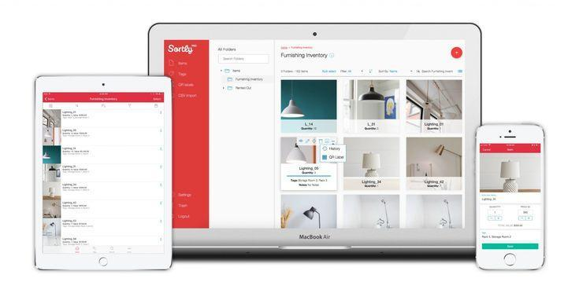

**Figure 2.3 Sortly Application Dashboard**

### Microsoft Dynamic Retail Management System.

Microsoft Dynamic Retail Management System is a system that gives users and businesses within the small and mid-size range a complete Point of Sales that is customised for the customer to fit their preferences (Intan et al., 2015). It gives users access to a centralised means of controlling retail stores. This system is integrated with Microsoft Office and makes it easy for users familiar with such services to access and use. It also gives the ability to automate some activities, with flexibility in reports and scalability. Retail companies range from Pharmaceuticals and grocery stores.

The negative side of this system is that it is not cloud-based and used only on Microsoft Windows machines, i.e., it is not cross-platform. The lack of a proper cloud-based architecture makes it difficult for scalability as databases cannot share over the platform. Mobility becomes difficult with this platform.

## Review of Existing Principles and Methods

### Distributed Digital-Ticket Management for Rights Trading System

This paper explores the possibilities of implementing a generalised digital-ticketing circulation system by studying and describing a digital-ticket management scheme. Studying these systems takes two main approaches: *Smart-card-based and account-based systems.* Although Ticket Management Systems have used these approaches over the years, they have problems in certain areas. The account-based ticket system requires a service provider's maintenance, which can negatively affect the overall prices of tickets. The smart-based approach limits computation power on the smart cards, the difficulty of asynchronous trading since the receiver has to be online while the sender is trying to carry out a transaction, and political issues around who issues the cards since the ticket system is generalised.

They defined three types of participants by design goals and assumptions: issuer, user and service provider.

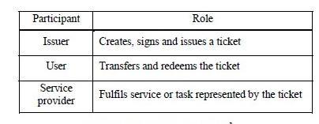

**Figure 2.4 Participants and Roles of a ticketing System**

To facilitate transactions: the issuer gives a certain user ownership over tickets, the user has the power to transfer ownership of the ticket to other users, and cases like renewing a Driving License, etc., are implemented in the redemption segment. Another limitation of the approaches discussed was their trust policies. Service providers could easily and maliciously alter the account-based approach, or the smart-card-based approach can have unfair systems as nobody controls who issues the cards.

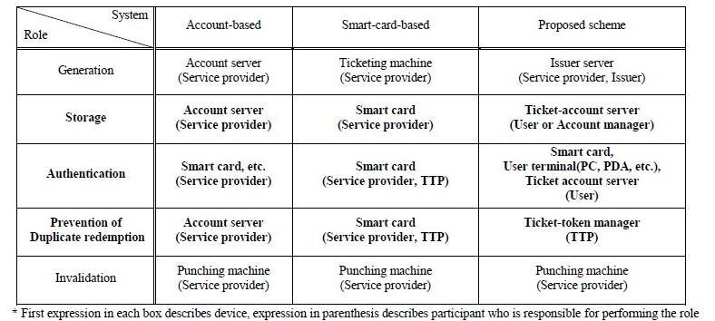

**Figure 2.5 Differences between the Account-based, Smart-card based System and the Proposed System**

The proposed system allows users to manage their tickets. It only gets the issued signatures from the issuer, reducing the possibility of fraud from Service Providers and the cost of maintaining these accounts from the Service Provider's end, thereby reducing costs incurred from the user's end on ticket prices.

The proposed system also introduces a *ticket-token manager* that aids the verification of duplicate tickets so there are no possibilities of tickets with the same ticket identification number or token, aiding the system's integrity.

### Digital-Ticket-Controlled Digital Ticket Circulation

This study diversifies the concept behind ticket management by focusing on the trust management scheme and digital ticket circulation scheme. This system helps to explain how Personnel can apply these concepts in the aspects of plane ticketing, events ticketing, etc.

Digital ticket circulation is made possible through the concept of the Generalized Ticket Definition Language. (Fujimura et al., 1999). This system requires the existence of three principal transaction types: Redemption, Transfer, and Issuance. These conditions facilitate the operations of these transactions. Examples may include using the scenario of a Shop keeper needing to be qualified to issue authentic tickets and a certain agent being the only one able to transfer such tickets. Circulation Control Tickets are the ticket that is required to facilitate transactions through ticketing. They help aid operations such as issuance, transfer, and redemption. The holder of the circulation control tickets is the only one responsible for performing the required operations in ticketing. These tickets can also be different types of digital tickets.

The trust management scheme is developed to reduce the possibility of double spending a ticket and helps generate system-verified digital certificates. In the ticket system, this concept is the base technology.

### Effectiveness of the E-Ticket System Using QR Codes for Smart Transportation Systems

This study aims to understudy the effectiveness of using QR codes in the Transportation sector, which can help to aid easy payment of tickets and booking seats, effectively reducing the queues in bus terminals and potentially increasing the purchase of tickets. It also aims to identify the research problems around the QR code system in the Ticketing and Booking system by extensively going through recent and past research on this topic to identify such areas and propose an efficient system.

This research aims to analyse the e-ticket bus system and how it can improve transportation services. The Mobile Ticketing system has brought benefits to the user. It allows for the availability of transportation services to users anywhere and anytime.

Malang City Station implemented the Rail Ticket System at PT Train. It used six factors to measure the effectiveness of the Information System implemented in their Rail system; support for ticket purchase activities, data integration of all online stations, the user display, the organisation and reporting system, access to clear and accurate information by passengers, and the completeness of the available features. The results were all positive from the users' perceptive, indicating the effectiveness this system has on the Transportation system as a whole(Putra, 2021).

The Electronic Game Machine (EGM) implements various technologies in verifying gaming tickets. They include; means of payment, a communication module, input devices, payment devices, ticket virtual interface converter module, executing processors stored in memory devices, and memory devices (Givan et al., 2021).

This study also highlights the effectiveness of QR Codes (Quick Response Codes). They are two-dimensional quick response codes. Technology is becoming popular in places like the United States of America because of its versatility and ease of use.

## Review of Related Findings

This study brings to light the possibilities that digital payment systems have brought. The need for physical bank notes or fiat currencies is beginning to deteriorate as payment systems help to facilitate transactions. It becomes easier to monitor and keep track of payments as these transactions stores data in their databases. Payments are also quicker to carry out and faster to validate. On the other hand, QR Codes are very effective, especially in transmitting large data. With few bytes of code storing large amounts of data, plus the speed at which this code verifies data, this technology gradually becomes a good way to transfer digital assets from place to place. (Tommy Kuncara et al., 2021). These systems also help to aid confidentiality as each transaction has unique identifications for each use case.

Digital Currencies Like Bitcoin are gradually becoming mainstream, especially after the Covid-19 Outbreak in the financial system(Chen & Bellavitis, 2020). These systems create "tangible digital assets. With this system in place, people can carry out transactions without

**Chapter Three**

# System Analysis and Design

## Introduction

This project aims to build an e-wallet platform that will allow users to simply purchase mean tickets on their devices that will be validated when they arrive at the cashier's point, as well as a dashboard of all transactions made with the platform.

This chapter delves deeper into the techniques, functional and non-functional requirements, and the model utilised in the system architecture utilising UML diagrams such as use cases, activity diagrams and architectural diagrams

This chapter will go over the architecture and design of the systems in further detail and provide additional information on the model's many components, network metrics, and formulas.

## System Architecture

In this context, the interaction of hardware and software components to produce a platform or computer system is called architecture. A system architecture is a mental model that describes a system's structure, behaviour, and other capabilities. The system's architecture will help with the logic and understanding of the system's design and model usage.

The architecture illustrates the system's components, indicating how they should interact to accomplish the overall system or model.

The system's architecture is split into four layers, as displayed in Figure 3.1:

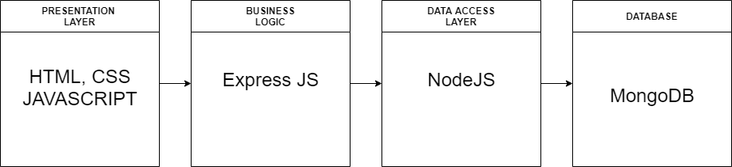

**Figure 3.1 Architecture of Proposed System**

### Presentation layer

The presentation layer is a system or application component that enables users to interact with it. It's the connection between the user and the web server. Users can interact with the development system using browsers with UI (User Interface) and UI process components. HTML, CSS, and JavaScript help to create the user interface. HTML will describe the web application's content, CSS will describe how it will appear (i.e., how it will look), and JavaScript will make it more interactive and responsive to the user's actions. Some sites with administrator credentials will be unavailable to users. The web application will use a variety of JavaScript frameworks, such as React or Angular, to create dynamic pages.

### Business Logic

The business logic layer includes objects that execute business tasks (James et al., 2003). It also acts as a link between the data access and presentation layers. The Business Logic Layer (BLL) keeps track of the business rules, computations, and logic that determine how an application works. To put it another way, the BLL outlines how the database uses data and what the application can and cannot do.

It receives requests from users through their browsers, processes them, and determines how Users access data. The business logic layer manages the operations that allow data and user requests to pass through the backend encoded in the business layer. The web application will utilise JavaScript and the Express JS framework to receive and deliver user requests or data (i.e., using the GET and POST function in the ExpressJS framework).

### Data Access Layer

The data access layer's role is to separate the data access logic from the business and presentation layers. The data access layer separates data retrieval code (database, flat files, web services, etc.) from business logic and display code. If you need to change the data storage, you won't have to start again. Your applications may transition from Oracle to MS SQL server. For example, since the database engine or other data storage is abstracted, it isolates the logical data model so that your Business Layer doesn't have to deal with it. Changing the logical data model without affecting the business layer is feasible. The data access layer ensures that different parts of our application have consistent access to the same data store.

It's tightly linked to the business logic layer, enabling the logic to choose which database to interface with and so improve data retrieval. System development requires using the Nodejs framework and MongoDB to access and connect with the web application database to comprehend and get data. A server, a database management system (DBMS), software to connect to the database, applications, and a user interface to acquire and handle data make up the data storage infrastructure.

## System Requirements

This section gives an overview of the proposed system requirements from the user's perspective.

1. The user should be able to gain access to their specific dashboard for the credentials supplied. i.e., Email Address and Password.
2. The user should be able to buy tickets on the system that can be verified and validated by the cashier.
3. The user should be able to track his transaction history on the given transaction page of the system.
4. The user should be able to fund his wallet with credits to be used when generating tickets.
5. The admin can also fund amounts to the wallet for use.

### Functional Requirements

* The admin shall be able to create users on the system
* The admin shall be able to sign up to gain authorisation to the payment system
* The admin shall be able to fund wallets
* The user shall be able to buy tickets for transactions

### Non-Functional Requirements

* The system should be friendly to the user.
* The system should authenticate only valid users.
* The system should update its database for possible changes without null fields.
* The system should be installable on the user's device.

## System Design

System Design is a process of designing aspects of a system, which includes the architecture, modules and components, as well as interfaces between those components and the data that flows through it. It is known as system design. (Odhiambo, 2018). Systems design is an interdisciplinary engineering activity that allows the realisation of effective systems (Rasmussen, 2003).

### Use Case Diagram

The Use Case Diagram shows the different users of a system and what they can do within the system.

These actions include:

1. Fund wallet: The user should be able to fund their wallet on their dashboard
2. Generate tickets: The user should be able to generate unique tickets they can use to make transactions within the system.
3. Delete ticket: The user should be able to delete tickets within the application.

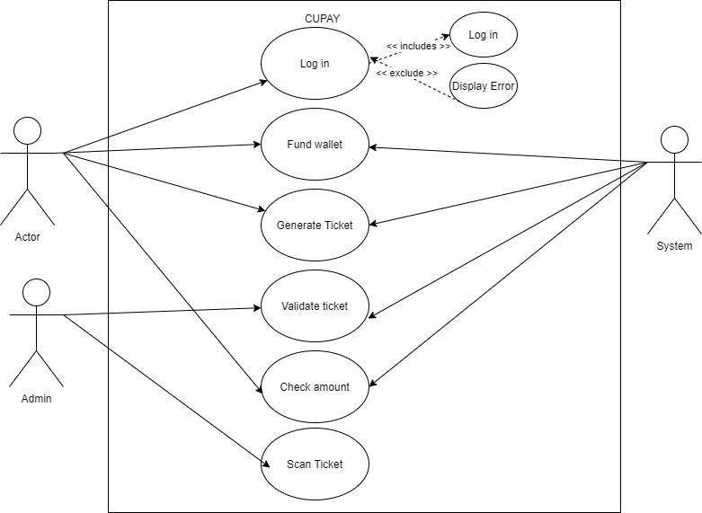

**Figure 3.2 Use Case Diagram of Proposed System**

### Activity Diagram

Activity Diagrams graphically represent how to carry out activities with the support of choice. It is simply a flowchart to show these activities. They may represent business activities instead of the functional perspective. The figure below shows the Activity Diagram.

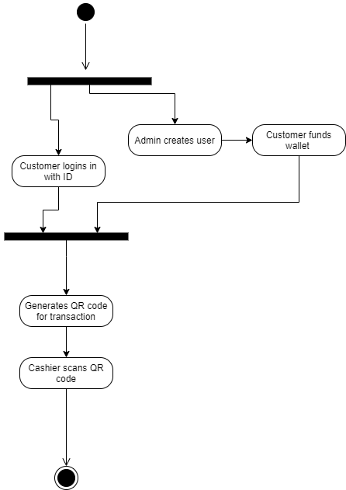

**Figure 3.3 Activity Diagram of the Proposed System**

**Chapter Four**

# System Implementation

## Introduction

This chapter describes the developed system's components, hardware and software requirements, and screenshots of each interface that makes up the system. This chapter describes the tools and techniques used to develop the CUPAY application. It also includes a description of the programming languages used and the reasons behind their usage.

## System Requirements

System requirements are a declaration that outlines the functionality a system must have to meet the needs of the clients (Bahill, A. Terry, 2009). The table shows the software, hardware, and software deployment criteria during the development of this system.

### Hardware Requirements

For the system to run effectively, the minimum hardware requirements include:

1. Internet Connection
2. 1 GB Device Memory
3. 512 MB device storage

### Software Requirements

**Table 4.1 Software Requirements**

| **Requirements** | **Software** |
| --- | --- |
| **Operating System** | Windows 10, macOS, Linux, Android |
| **Web Browser** | Internet Explorer, Microsoft Edge, Safari, Opera Mini, Google Chrome, Mozilla Firefox |
| **Database** | MongoDB |
| **Development Tool/IDE** | Visual Studio Code |
| **Programming Language** | JavaScript, Nodejs, MongoDB |
| **User Agent** | iPod, Smart Phones, Desktop Computers, Laptops, iPad and Tablets |
| **Nodejs version** | v16.15.0 |

### Implementation tools

1. **Visual Studio Code:** Microsoft's Visual Studio Code, sometimes known as VS Code, is a source-code editor for Windows, Linux, and macOS. The features are debugging, syntax highlighting, intelligent code completion, snippets, code refactoring, and integrated Git. Users may change the theme, keyboard shortcuts, and preferences and add new features via extensions.
2. **Figma:** Figma is a web-based vector graphics editor and prototype tool with desktop programs for macOS and Windows that provide the additional offline capability. Developers may use the Figma mobile app for Android and iOS to see and interact with Figma prototypes in real-time. Figma's feature set focuses on real-time collaboration, user interface, and user experience design.
3. **Node JS**: Node.js is a cross-platform, open-source backend JavaScript runtime environment that runs JavaScript code outside a web browser using the V8 engine. Developers may use Node.js to create command-line tools and server-side scripting, which includes executing scripts on the server before transmitting the page to the user's browser. Consequently, Node.js represents a "JavaScript everywhere" paradigm, uniting web application development under a single programming language rather than separate languages for server-side and client-side scripts.
4. **ExpressJs:** Express.js, or Express, is a backend web application framework for Node.js released as free and open-source software under the MIT License. Its purpose is to create web applications and APIs. It has been considered the de facto server framework for Node.js.

## System Interfaces

The System Interface is simply the medium through which the system user establishes communication and the system itself. It facilitates the processing and exchanging of data and information between the designated modules that make up the system.

This section covers the different interfaces that aid the communication between system entities as well as explains, in detail, the user's interaction process with the system.

### Home Page

The Home Page is the welcome page where new visitors view the platform, and existing users can also interact with it. It is also the page where the admin can create users and fund accounts.

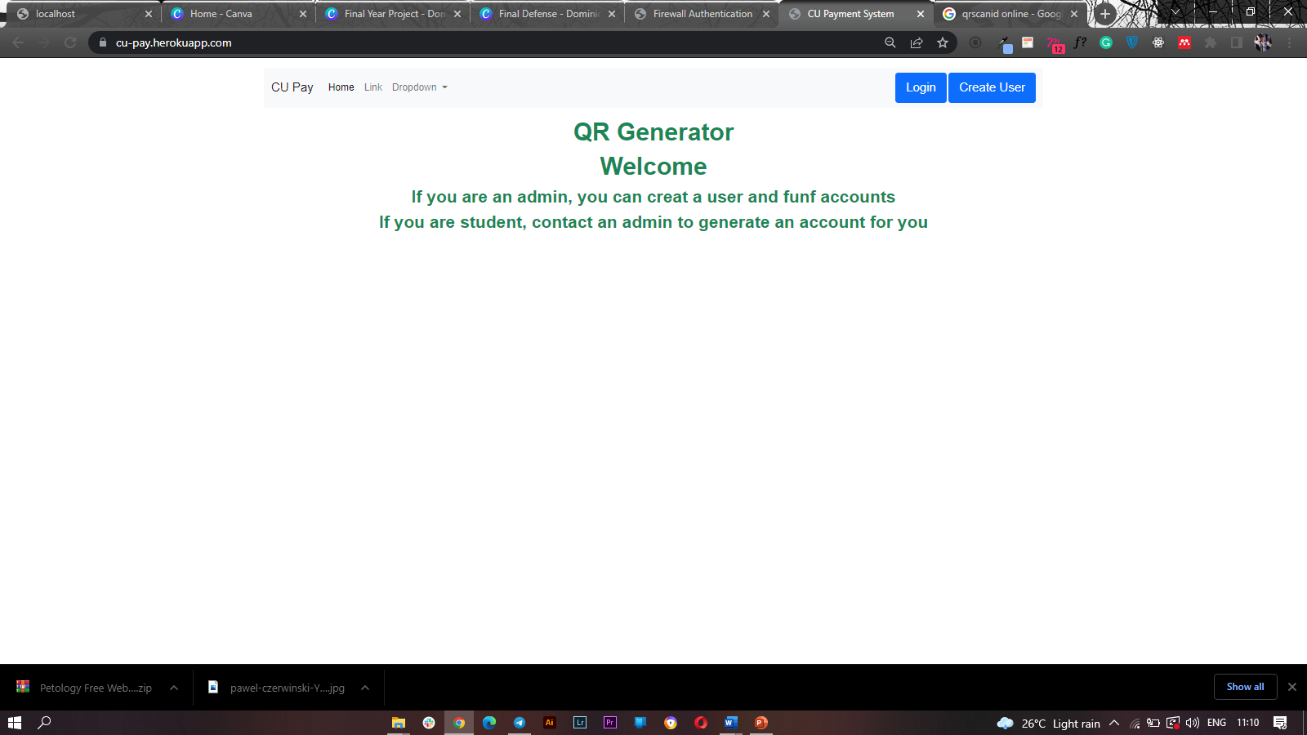

**Figure 4.1 Home Page**

### Admin Page

The Admin Page is where the admin can create and enrol users to the platform and fund the accounts of the created users. Here, Admins only have the power to create and not delete.

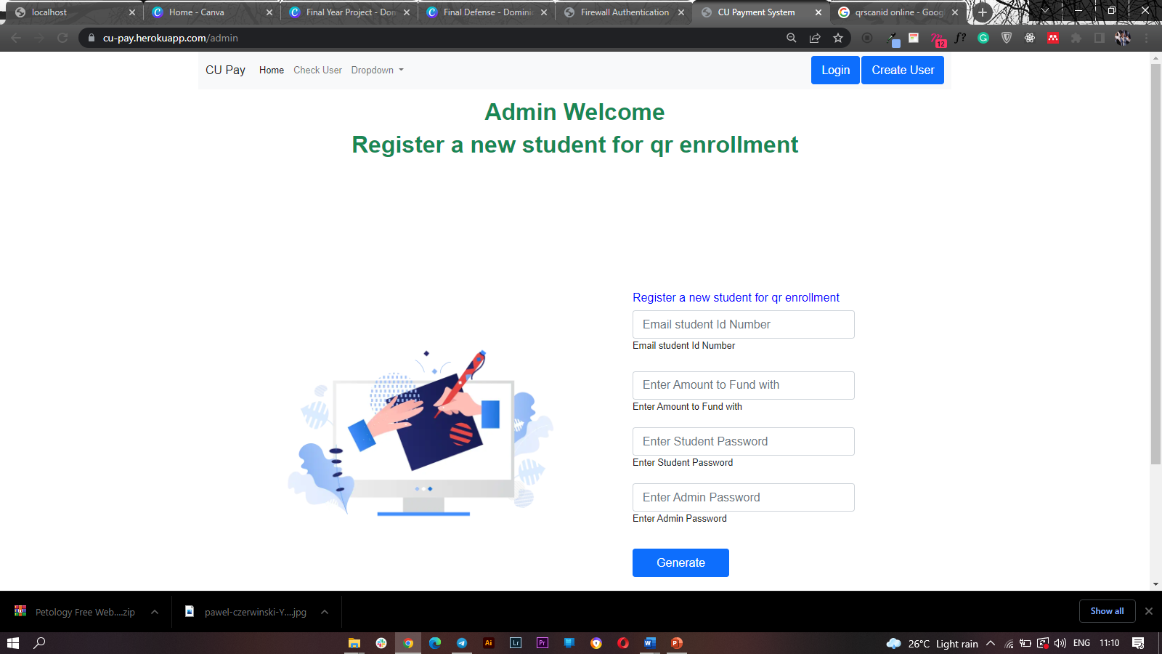

**Figure 4.2 Admin Page**

### teQR Generator Page

Once the Administrator creates users, the system redirects the user to this page so that they can see their unique Identification in the case of more transactions in subsequent times. The goal is to have users get their links and buy tickets if needed.

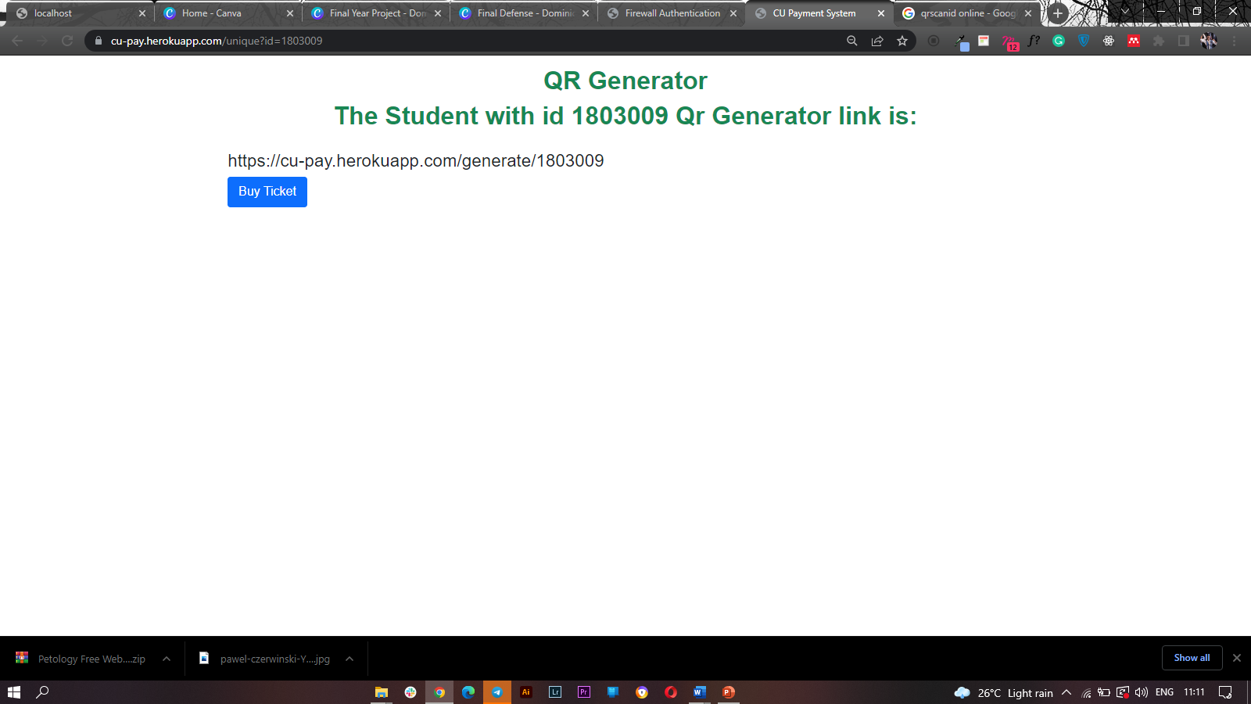

**Figure 4.3 QR Generator Page**

### User Search

The system also allows users to search for their IDs to interact with the platform. When seen, they can easily generate tickets specific to the amount they want to transact.

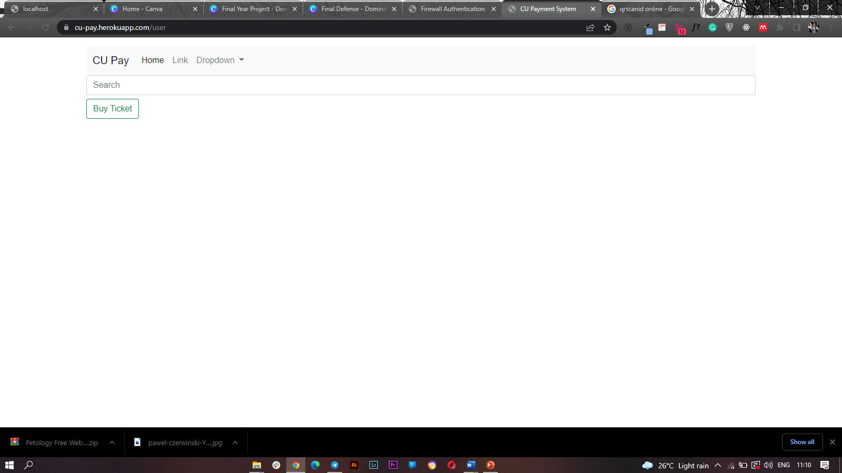

**Figure 4.4 User Search Page**

### Ticket – QR Code

The Ticket Page is where transactions take place. Here, QR codes in the form of tickets help to generate amounts used for the transaction. It also allows for scanning by the cashier as well.

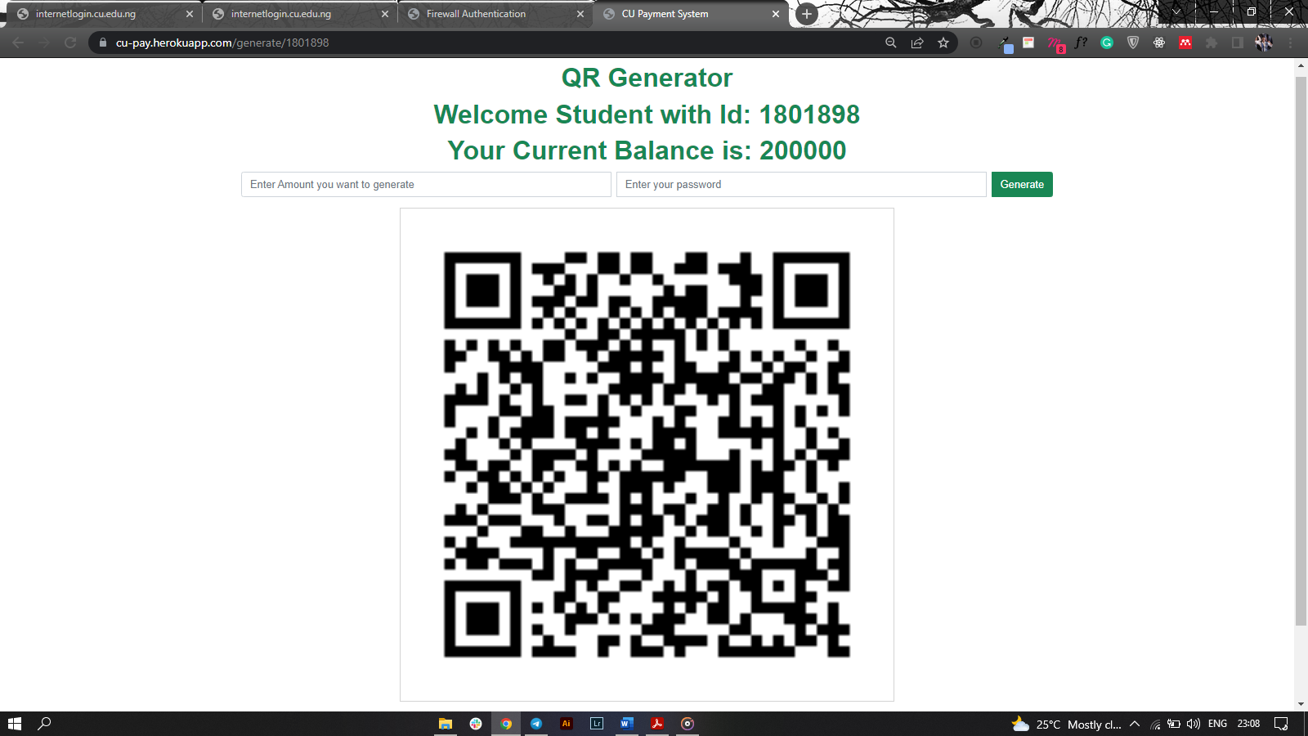

**Figure 4.5 Ticket Page - QR Code**

**Chapter Five**

# Summary, Recommendation and Conclusion

## Summary

This project was able to build a Covenant University-based payment system that involves the generation of unique IDs per transaction for each user through the development of a ticketing system to provide ease of transactions within the University environment. This web-based application used HTML, CSS, and JavaScript for development. I built the backend with the NodeJS and Express JS framework, and MongoDB stores the data.

## Recommendations

Although this system facilitated quick transactions by generating unique ticket IDs, utilising POS devices programmed to fit this context can improve the system so that students can manually carry out the ticket validation process without needing the intervention of attendants or staff.

Also, this system can greatly improve the internet readily accessible to users within the point of sale or inaccessible area

## Conclusion

Digital transactions are becoming an essential part of the economic systems today. Technology makes transactions easier and almost stress-free. The need to teach technology in business processes and financial systems is of high importance like no other.

**References**

Bahill, A. Terry, and F. F. D. (2009). Handbook of systems engineering and Management. *4 Discovering System Requirements*, 205.

Chen, Y., & Bellavitis, C. (2020). Blockchain disruption and decentralised finance: The rise of decentralised business models. *Journal of Business Venturing Insights*, *13*(November 2019), e00151. https://doi.org/10.1016/j.jbvi.2019.e00151

Dyson, J. (2015). *Paperless Receipt Solution (PRS) System*. James Dyson Foundation. http://www.jamesdysonaward.org/projects/paperless-receipt-solution-prs-system/

Fujimura, K., Kuno, H., & Terada, M. (1999). *Digital-Ticket-Controlled Digital Ticket Circulation*. 1–11.

Givan, B., Wirawan, R., Andriawan, D., & Aisyah, N. (2021). *Effect of Ease And Trustworthiness To Use E-Commerce for Purchasing Goods Online*. 277–282.

Hayes, A. (2022). *Inventory Management Definition*. https://www.investopedia.com/terms/i/inventory-management.asp

Intan, R., Chi, C. H., Palit, H. N., & Santoso, L. W. (2015). Preface. *Communications in Computer and Information Science*, *516*(November). https://doi.org/10.1007/978-3-662-46742-8

Kuda. (2022). *About Kuda. - Free Banking for Nigerians*. https://kuda.com/about

Management Study Guide Content Team. (2015). *Retail Mechanism - How does retail work ?* https://managementstudyguide.com/retail-mechanism.htm

Masters, S. (2022). *What is a Master in Retail Management? - Subject info - Mastersportal.com*. https://www.mastersportal.com/disciplines/244/retail-management.html

Mercedes Diaz. (2020). Fifteen ways a mobile point of sale can help your restaurant succeed — Poster. *Joinposter.Com*. https://joinposter.com/en/post/15-ways-a-mobile-point-of-sale-can-help-your-restaurant-succeed

Microsoft. (2022). *What Is Cloud Computing? A Beginner's Guide | Microsoft Azure*. https://azure.microsoft.com/en-us/overview/what-is-cloud-computing/

Odhiambo, D. (2018). *System Design in Software Development | by Didacus Odhiambo | The Andela Way | Medium*. https://medium.com/the-andela-way/system-design-in-software-development-f360ce6fcbb9

Putra, N. K. D. and A. S. (2021). Proceedings International Conference on Education of Suryakancana. *LAW ENFORCEMENT IN SMART TRANSPORTATION SYSTEMS ON HIGHWAY*, 321–326.

Rasmussen, J. (2003). *Systems Design - an overview | ScienceDirect Topics*. Encyclopedia of Information Systems. https://www.sciencedirect.com/topics/computer-science/systems-design

Tommy Kuncara, Arman Syah Putra, Nurul Aisyah, & VH. Valentino. (2021). Effectiveness of the E-Ticket System Using QR Codes For Smart Transportation Systems. *International Journal of Science, Technology & Management*, *2*(3), 900–907. https://doi.org/10.46729/ijstm.v2i3.236