## DESIGN AND IMPLEMENTATION OF A WEB-BASED PRINTING SYSTEM FOR COVENANT UNIVERSITY STUDENTS

**BY**

**AJAYI BOLUWATIFE AYOMIKUN**

**(19CH026499)**

**A PROJECT SUBMITTED TO THE DEPARTMENT OF COMPUTER AND** **INFORMATION SCIENCES, COLLEGE OF SCIENCE AND TECHNOLOGY,** **COVENANT UNIVERSITY OTA, OGUN STATE, NIGERIA.**

**IN PARTIAL FULFILMENT OF THE REQUIREMENTS FOR THE AWARD OF THE BACHELOR OF SCIENCE (B.Sc.) Honors DEGREE IN COMPUTER SCIENCE**

**JUNE, 2023**

**CERTIFICATION**

I, therefore, attest that Ajayi Boluwatife Ayomikun (19CH026499) is the actual author of the project work titled **A Web-Based Printing System For Covenant University Students**. It was submitted to the Department of Computer and Information Sciences, College of Science and Technology, Covenant University, Ota.

Name: Mr. Odunayo Damilola Osofuye **(Supervisor)**

Signature: **…...................** Date: **…..................**

Name: Prof. Mrs Olufunke Oladipupo **(Head of Department)**

Signature: …................... Date: …....................

**DEDICATION**

I give God all the credit for this project's conception and completion. I thank Him for the strength and capability He gave me to see it through to completion.

I also thank my parents and other family members for their support, prayers, and assistance.

**ACKNOWLEDGMENT**

I give thanks to God for enabling me to complete this portion of my project and program as well as for seeing me through my undergraduate studies at Covenant University. Without Him, I am powerless. I will always be grateful.

I also want to express my gratitude to all of my siblings and friends for the unwavering love and support they have given me throughout the years. I am appreciative of their presence in my life for making the journey thus far less difficult.

For their care and support during my research and my undergraduate education, I want to thank my parents and family, both here and abroad. They have been a significant motivating factor that has kept me going all through my time at Covenant University.

I appreciate the guidance provided by Mr. Jesse Oluwafemi Katende. He helped me with getting over the long period of hardness I had with my endeavours in Covenant University. I am really grateful to him.

Finally I want to appreciate my project supervisor Mr Osofuye Odunayo Damilola for his constructive criticisms, meaningful contributions, and gentle guidance to the course of completing this my final year project. He has been of immense help. May God continue to be with him in all his life’s pursuits. Amen.

**ABSTRACT**

This project aims to design and implement a cutting-edge web-based printing system for Covenant University, with the primary objective of providing an easy and convenient way for students to access printing services online. The proposed system will feature an intuitive user interface that allows users to select printing options, upload files, and securely pay for printing services online. Stringent security measures will be implemented to protect users' confidential information and prevent unauthorized access. Modern web development technologies such as ReactJs, Redux, NodeJs, and Mongo will be utilized to create a user-friendly and responsive web-based printing platform. A robust database will also be incorporated to efficiently store user data and printing-related information for accurate record-keeping. The successful implementation of this project will enable Covenant University to offer printing services that are not only convenient but also easily accessible to students, faculty, and staff members. Additionally, the project will contribute to the university's sustainability goals by reducing the need for physical printing stations on campus and promoting a paperless environment. The ultimate aim of this project is to develop an innovative and efficient web-based printing service that caters to the printing needs of Covenant University's community while also promoting environmental sustainability.

**CHAPTER ONE**

**INTRODUCTION**

#### 1.1 Background To Study

This study involves the development and implementation of a web-based printing service for Covenant University students. The purpose of this service is to provide a convenient and efficient way for students to print their documents, eliminating the need for them to physically go to a printing location on campus.

Traditionally, printing services at universities have been provided through physical locations, such as libraries or computer labs, where students can go to print their documents. However, this can be inconvenient for students, especially if they are not physically on campus or if the printing location is not easily accessible. Additionally, traditional printing services can be time-consuming, as students may need to wait in line to use the printer or may need to return to the printing location multiple times to pick up their printed documents.

In recent years, there has been an increase in the use of web-based printing services, which allow students to print their documents remotely through an online platform. These services typically involve a website where students can upload their documents, select their desired print options, and pay for their prints using a credit card or other payment method. The printed documents are then delivered to a designated location on campus for students to pick up.

Web-based printing services offer several advantages over traditional printing services. They are more convenient for students, as they can be accessed from any location with an internet connection. They also save time, as students do not need to physically go to a printing location on campus. Additionally, web-based printing services may be more cost-effective, as they can reduce the need for physical printing locations and may offer bulk printing discounts.

However, there are also challenges associated with the development and implementation of a web-based printing service. These include issues related to security, as personal and financial data must be protected; usability, as the website must be easy for students to navigate and use; and integration with existing systems and infrastructure, as the web-based printing service must be seamlessly integrated with the university's existing systems and processes.

In order to address these challenges, the development and implementation of a web-based printing service for Covenant University students will involve a comprehensive analysis and design process, which will involve gathering requirements from stakeholders, such as students, IT staff, and the printing vendor; conducting a thorough analysis of the existing systems and processes; and designing a system that meets the needs and preferences of the student body and is effectively integrated with the university's existing systems and infrastructure.

Web-based printing systems have become increasingly popular due to their convenience and efficiency in printing documents. These systems allow users to print documents from anywhere, as long as they have an internet connection. This literature review aims to provide a detailed and comprehensive overview of the design and implementation of a web-based printing system for students.

Printing systems can be broadly categorized into two categories: traditional and web-based printing systems. Traditional printing systems refer to those where the printing takes place in a physical location, such as a library or computer lab, where students can go to print their documents. However, this can be inconvenient for students, especially if they are not physically on campus or if the printing location is not easily accessible. Additionally, traditional printing services can be time-consuming, as students may need to wait in line to use the printer or may need to return to the printing location multiple times to pick up their printed documents.

Web-based printing systems, on the other hand, allow students to print their documents remotely through an online platform. These services typically involve a website where students can upload their documents, select their desired print options, and pay for their prints using a credit card or other payment method. The printed documents are then delivered to a designated location on campus for students to pick up. Web-based printing systems offer several advantages over traditional printing systems. They are more convenient for students, as they can be accessed from any location with an internet connection. They also save time, as students do not need to physically go to a printing location on campus. Additionally, web-based printing systems may be more cost-effective, as they can reduce the need for physical printing locations and may offer bulk printing discounts.

The design of a web-based printing system must take into account various factors such as ease of use, security, and compatibility with different operating systems and devices. The system's interface design is one of the most critical factors to consider. The interface should be user-friendly and intuitive, with easy-to-understand instructions, so that users can quickly and easily print their documents. According to a study by Lee and Wu (2017), the interface design of the printing system significantly affects user satisfaction and productivity.

Another essential design consideration is security. The system must have robust security features to prevent unauthorized access and ensure the confidentiality of the printed documents. This can be achieved through measures such as user authentication, encryption, and secure transmission protocols. A study by Zhang and Wu (2018) found that security was a critical factor in the adoption of web-based printing systems by students.

Furthermore, the design of the system should take into account the different devices and operating systems used by students. The system must be compatible with various devices, such as laptops, tablets, and smartphones. A study by Chen et al. (2016) proposed a solution based on cloud computing technology that would allow the system to be accessed from any device with an internet connection.

The implementation of a web-based printing system involves various technical aspects such as software development, network configuration, and integration with other systems. One of the key challenges in implementation is ensuring compatibility with different operating systems and devices. A study by Chen et al. (2016) proposed a cloud-based solution that would enable the system to be accessed from any device with an internet connection.

Another aspect of implementation is the integration with existing campus systems such as the learning management system (LMS) and student information system (SIS). Integration with these systems can provide a seamless user experience and enable features such as automatic document submission and billing. A study by Wang and Chen (2016) described the integration of a web-based printing system with an LMS, which resulted in improved efficiency and reduced costs.

To ensure the smooth operation of the web-based printing system, it is essential to have a reliable network infrastructure. The network should be capable of handling a large number of requests and ensure fast and secure data transfer. A study by Jo and Kim (2018) proposed a solution based on a distributed network architecture that would allow the system to handle a large number of requests while ensuring data security.

#### 1.2 Statement Of The Problem

The printing services at Covenant University currently rely on a manual process that can be burdensome for students. Students are required to physically visit printing stations on campus, where they either submit a flash drive or upload their documents to the officials' email for printing. However, this process often results in long queues, overcrowded printing areas, and frustration among students. Furthermore, issues related to payment, as students at Covenant University tend to carry minimal cash, and document mix-ups are common occurrences.

As a result, the current printing system at Covenant University is inefficient and inconvenient for students. It leads to lost productivity, delays, and challenges in record-keeping for university administrators. Therefore, there is a pressing need for a more efficient, user-friendly, and environmentally sustainable printing solution that utilizes modern web technologies to offer an online printing platform for students, staff, and faculty members.

The proposed solution would eliminate the need for physical visits to printing stations by providing an easy-to-use online platform. Students would be able to submit their print requests electronically, eliminating the need for flash drives or email uploads. The platform would also offer online payment options, reducing the hassle of carrying cash and facilitating smooth transactions. Additionally, the system would incorporate robust record-keeping features to enable efficient tracking of printing usage and expenses by university administrators.

With this new system, students would no longer face long queues or overcrowded printing areas, leading to improved productivity and reduced frustration. The online platform would also enhance transparency and accountability, providing a seamless and convenient printing experience for all stakeholders while reducing the environmental impact associated with paper waste. The implementation of a modern web-based printing solution would greatly enhance the printing services at Covenant University, benefiting both students and university administrators alike.

#### 1.3 Aim and Objectives Of Study

The aim of this project is to design and develop a web-based printing system for Covenant University students. Through this service, students can create personalized profiles and upload their documents online, selecting various customization options. The printing stations will then be able to communicate with the students via notifications, informing them when their documents are ready for collection. This service offers students the flexibility to pay for their printing online or in person at the printing station. With this innovative approach to printing, Covenant University students can enjoy a hassle-free printing experience that is tailored to their individual needs.

**The objectives of the work include:**

1. **Requirements Gathering**: to gather and identify the printing needs, preferences, and payment options of Covenant University students and faculty members and every other stakeholder.
2. **System Design**: to design a user-friendly and scalable web-based printing service that provides different printing options and a secure payment gateway through the use of various UML and E-R diagrams.
3. **Implementation**: Develop and deploy the web-based printing service on different devices, browsers and networks.
4. **Evaluation:** Thoroughly test the web-based printing service to ensure it is bug-free, reliable, fast, scalable, and meets the requirements of students and vendors.

#### 1.4 Research Questions

This project would be guided by the following research questions in order to the achieve the above-stated objectives:

1. What are the printing needs, preferences, and payment options of Covenant University students and faculty members, as well as other stakeholders?
2. How can the web-based printing service be designed to be user-friendly and scalable, considering different printing options and a secure payment gateway, using UML and E-R diagrams?
3. What technologies and frameworks should be used for implementing the web-based printing service to ensure compatibility with different devices, browsers, and networks?
4. How can the web-based printing service be thoroughly tested to ensure it is bug-free, reliable, fast, scalable, and meets the requirements of students and vendors?
5. What are the potential challenges and limitations in designing and implementing a web-based printing service for Covenant University, and how can they be addressed?
6. What are the security measures and best practices that should be implemented to protect sensitive information and transactions in the web-based printing service?
7. How can the performance and scalability of the web-based printing service be measured and optimized to ensure efficient and smooth printing processes for students and vendors?
8. What are the potential legal and ethical considerations in designing and implementing a web-based printing service for Covenant University, such as data privacy, intellectual property, and accessibility?

#### 1.5 Research Methodology

##### 1.5.1. Requirements Gathering

1. Conduct interviews with Covenant University students, faculty members, vendors and other stakeholders to gather their printing needs, preferences, and payment options.
2. Analyze the data collected to identify common themes and requirements.
3. Develop a requirements document that outlines the identified needs, preferences, and payment options.

##### 1.5.2. System Design

1. Use Unified Modeling Language (UML) and Entity-Relationship (E-R) diagrams to design a user-friendly and scalable web-based printing service that provides different printing options and a secure payment gateway.
2. Consult with stakeholders, such as the IT department, student services, and the university's print vendor, to ensure the design is feasible and aligns with the university's existing systems and infrastructure.
3. Develop a design document that outlines the system architecture, components, database designs and interfaces.

##### 1.5.3. Implementation and Integration

1. Use appropriate software development methodologies, such as agile or waterfall, to design the web-based printing system.
2. Use appropriate software development technologies, programming languages and tools such as (list all the ones you shall be using) to develop the web-based printing system
3. Integrate the proposed system with different devices, browsers, networks and payment options to ensure compatibility and accessibility.

#### 1.6 Significance Of The Study

This project will provide solutions to the various issues related to the manual printing service process. The significance of this study lies in the development of an innovative and efficient web-based printing service that meets the printing needs of Covenant University students' community while promoting environmental sustainability.

The proposed system will provide students, staff, and faculty members with a convenient and easily accessible online printing platform, reducing the need for physical printing stations on campus and improving overall printing efficiency. The implementation of this web-based printing service will have several significant benefits for Covenant University. Firstly, it will provide a more streamlined and efficient printing process, saving time and increasing productivity for students.

Moreover, the proposed web-based printing service will enable the university's administrators to better track printing usage and expenses, leading to more accurate and efficient record-keeping. This will enable the university to make data-driven decisions regarding its printing policies and procedures, resulting in cost savings and improved service delivery. The implementation of this web-based printing service will have a significant impact on Covenant University's community, improving its printing processes, reducing its environmental impact, and enhancing its record-keeping capabilities. Additionally, the findings and recommendations of this study may serve as a guide for other higher education institutions seeking to implement similar online printing services.

#### 1.7 Limitations Of The Study

1. Security and Privacy: One of the major challenges in the implementation of a web-based printing service is ensuring the security and privacy of users' documents. There is a risk of data breaches, hacking, or unauthorized access to the system. Therefore, a need to implement robust security measures, such as encryption, secure file transfer protocols, and user authentication to ensure that students' data is safe.
2. Usability: The web-based printing service should be user-friendly and easy to navigate for students with varying levels of computer literacy. The design and interface should be simple, intuitive, and accessible to ensure that all students can use the system effectively.
3. Integration with Existing Systems: The printing service should be integrated seamlessly with the university's existing systems and infrastructure. This will require close collaboration between the developer and various stakeholders, such as the IT department, student services, and the printing vendor.
4. Payment Processing: A need to ensure that the payment processing system is secure, reliable, and fast. Students should be able to make payments using various methods, such as credit/debit cards or online payment platforms, without any hitches or delays.
5. Scalability: The web-based printing service should be able to handle a large number of users and print requests without any system crashes or slowdowns. This will require the use of scalable infrastructure and servers that can handle the load.
6. Technical Issues: Preparations to address technical issues such as software bugs, hardware failures, and network connectivity issues. There must be a plan in place to monitor and troubleshoot issues that may arise to ensure minimal disruption to the service.
7. Cost: Developing and implementing a web-based printing service can be expensive. There would be a need to ensure that the costs of development, maintenance, and infrastructure are reasonable and within budget.
8. Resistance to Change: Some students and faculty members may be resistant to change and prefer traditional printing methods. There would be a need to address these concerns and ensure that the web-based printing service is promoted effectively to encourage adoption.

#### 1.8 Scope Of The Study

The scope of study for the design and implementation of a web-based printing service for Covenant University students include:

1. Gathering requirements from stakeholders, such as students, faculty members, and IT staff, to identify their printing needs, preferences, and payment options.
2. Designing a user-friendly and scalable web-based printing service that provides different printing options, a secure payment gateway, and integrates seamlessly with the university's existing systems and infrastructure.
3. Developing the web-based printing service, including the website and payment gateway, and integrating it with different devices, browsers, and payment options.
4. Thoroughly testing and evaluating the web-based printing service to ensure it is bug-free, meets the requirements of students and vendors, and is reliable, fast, and scalable.
5. Providing training and support to users, including students, faculty members, and IT staff, to ensure they can effectively use the web-based printing service.
6. Ensuring the security and privacy of students' documents, using secure file transfer protocols, and only storing uploaded documents temporarily.

The scope of this study does not include the procurement of hardware, such as printers or servers, or the installation and maintenance of the network infrastructure required for the web-based printing service.

#### 1.9 Research Outline

Chapter One provides a comprehensive introduction, including the problem statement, research aims and objectives, significance of the project, methodology used, and limitations of the study. Chapter Two presents a critical review of existing literature and related web-based printing systems to provide a foundation for the study. Chapter Three describes the system analysis and design process, including the gathering of requirements from stakeholders, the development of system architecture, and the design of the user interface. Chapter Four outlines the implementation of the web-based printing service, including the integration with existing systems, and provides screenshots of the system. Chapter Five presents the results of the study, including testing and evaluation of the system's performance and user satisfaction. The chapter concludes with a summary of the findings, recommendations for future research, and the limitations of the study.

#### 1.10 Operational Defination Of Relevant Terms

1. Web-based printing service: A service that allows students to print their documents remotely through an online platform, eliminating the need for them to physically go to a printing location on campus.
2. Traditional printing service: A service that involves physical printing locations, such as libraries or computer labs, where students can go to print their documents.
3. Stakeholder: An individual or group with an interest or concern in the development and implementation of a web-based printing service. Stakeholders in this study may include students, IT staff, and the printing vendor.
4. Requirements gathering: The process of collecting information on the needs and preferences of stakeholders in order to design a system that meets their requirements.
5. UML (Unified Modeling Language): A standardized language for modeling software systems, including use case diagrams, sequence diagrams, and class diagrams.
6. Use case diagram: A type of UML diagram that is used to represent the interactions between different components of a system, showing the flow of messages between the components and the order in which they occur.
7. Sequence diagram: A type of UML diagram that is used to represent the interactions between different components of a system, showing the flow of messages between the components and the order in which they occur.
8. Class diagram: A type of UML diagram that is used to represent the structure of a system, showing the relationships between classes, attributes, and operations.
9. Testing: The process of evaluating the functionality of a system to ensure that it is functioning properly and meets the requirements of the stakeholders.
10. Evaluation: The process of assessing the effectiveness of a system, including the satisfaction of the stakeholders and the overall efficiency of the service.
11. React.js: A JavaScript library for building user interfaces, often used for building single-page applications (SPAs). React.js allows for the creation of reusable UI components and efficient updates to the user interface.
12. Redux: A JavaScript library for managing application state, often used in combination with React.js. Redux helps to centralize application state and make it easier to manage, allowing for more predictable behavior and easier debugging.
13. MongoDB: A NoSQL database management system that uses a document-oriented data model, allowing for flexible and scalable data storage. MongoDB is often used in web development due to its ability to handle large amounts of data and its support for various data types.
14. Express.js: A JavaScript framework for building web applications, often used in combination with Node.js. Express.js provides a number of features for routing, middleware, and handling HTTP requests and responses, making it a popular choice for building APIs and server-side applications

## 

## CHAPTER TWO

## LITERATURE REVIEW

#### 2.1.1 Introduction

Web-based printing services have come a long way since their introduction in the late 1990s (Johnson, 1998). Initially, these services were primarily used by businesses and organizations for printing marketing materials and other documents. However, in the mid-2000s, web-based printing services gained popularity in academic settings, providing students with a convenient way to print documents and access course materials (Ali and Wang, 2010).

One of the key advantages of web-based printing services for students is the convenience and flexibility they offer. Gone are the days when students had to physically visit a printing location to get their documents printed. With web-based printing services, students can upload their documents to a website from any location with an internet connection and select their desired print options. This is particularly beneficial for off-campus students or those with busy schedules, as it allows them to print documents at their own convenience, saving them time and effort.

Another benefit of web-based printing services for students is cost-effectiveness. Many web-based printing services offer competitive pricing, allowing students to print multiple copies at a lower cost compared to traditional printing methods (Jin et al., 2016). Moreover, some web-based printing services offer discounts or special deals for students, further reducing the financial burden of printing course materials.

In addition to cost savings, web-based printing services can also be more environmentally friendly. Traditional printing methods often result in a significant amount of paper and ink waste, whereas web-based printing services allow for more efficient use of resources (Chung et al., 2015). Students can select their preferred print settings, such as double-sided printing or grayscale printing, which can help reduce the amount of paper and ink used, contributing to a greener printing solution.

However, it's important to acknowledge that web-based printing services also have some challenges and limitations. Setting up and maintaining web-based printing services can be more complex compared to traditional printing methods, as they require integration with the university's existing systems and infrastructure (Lee et al., 2017). This may involve coordination with IT departments, software installations, and ongoing technical support to ensure smooth operation of the service.

Moreover, there may be technical issues that arise during the use of web-based printing services. Website downtime, difficulties uploading documents, or compatibility issues with different file formats are some examples of challenges that students may face (Lee et al., 2017). This can potentially disrupt the printing process and cause inconvenience to students who rely on web-based printing services.

In conclusion, web-based printing services have emerged as a convenient and flexible option for students to print documents and access course materials. They offer potential cost and environmental benefits, but also come with challenges and limitations that need to be carefully considered and addressed. Institutions implementing web-based printing services should plan and allocate resources for setup, maintenance, technical support, and security measures to ensure smooth and secure operation of the service. With proper planning and execution, web-based printing services can enhance the printing experience for students and continue to evolve as a valuable tool in academic settings.

#### 2.1.2 Web Based Printing Systems

Several studies have explored the factors influencing the adoption and usage of web-based printing services. For example, research by Ali and Wang (2010) found that ease of use, perceived usefulness, and compatibility with existing systems were significant factors affecting the adoption of web-based printing services in academic settings. Similarly, Jin et al. (2016) identified cost savings, convenience, and flexibility as key drivers for the adoption and usage of web-based printing services among students. These findings suggest that students value the convenience and cost-effectiveness of web-based printing services, which may influence their decision to adopt and use these services.

User experience and satisfaction are critical factors in the success of web-based printing services. Lee et al. (2017) conducted a study on the user experience of web-based printing services in a university setting and identified factors such as system reliability, ease of use, and responsiveness of the service as key determinants of user satisfaction. Chung et al. (2015) also highlighted the importance of user-friendly interfaces, efficient upload and printing processes, and clear instructions for users in ensuring a positive user experience. Understanding and addressing user experience and satisfaction can help institutions optimize their web-based printing services and enhance overall user satisfaction.

Implementing and maintaining web-based printing services can pose technical challenges. Lee et al. (2017) identified technical issues such as website downtime, slow upload speeds, and compatibility issues with different file formats as common challenges faced by users. Research has also focused on potential solutions to these challenges, such as improving website performance, optimizing upload processes, and providing clear instructions to users to avoid technical issues (Chung et al., 2015; Lee et al., 2017). Institutions can benefit from understanding these technical challenges and implementing appropriate solutions to ensure smooth operation of web-based printing services.

Ensuring the security and privacy of printed materials is a critical concern in web-based printing services. Students may print confidential or sensitive documents, and it is essential to safeguard these materials from unauthorized access. Research has highlighted the importance of implementing appropriate security measures, such as encryption, authentication, and access controls, to protect printed materials and ensure compliance with data protection regulations (Ali and Wang, 2010; Lee et al., 2017). Institutions need to carefully consider and implement robust security measures to protect the privacy and confidentiality of printed materials and maintain user trust.

Web-based printing services can have environmental impacts, and research has explored the potential benefits in terms of reducing paper and ink waste. Chung et al. (2015) found that web-based printing services can reduce paper waste by enabling double-sided printing and reducing the need for unnecessary printouts. Jin et al. (2016) also highlighted the potential environmental benefits of web-based printing services in terms of reducing carbon emissions from transportation associated with physical visits to printing locations. These findings suggest that web-based printing services have the potential to contribute positively to environmental sustainability.

Web-based printing services have become a popular option for students to print documents and access course materials conveniently and cost-effectively. These services offer several benefits, such as flexibility, cost savings, and environmentally friendly options. However, there are also challenges and limitations, such as technical issues and the need for proper setup, maintenance, and security measures. Research has identified factors influencing the adoption and usage of web-based printing services, such as ease of use, perceived usefulness, and compatibility with existing systems. User experience and satisfaction are also critical factors in the success of these services, with reliability, ease of use, and responsiveness of the service being key determinants of user satisfaction. Technical challenges, such as website downtime and compatibility issues with different file formats, can also arise and need to be addressed. Institutions must also implement appropriate security measures to protect printed materials and ensure compliance with data protection regulations. Finally, web-based printing services have environmental impacts, and research has explored potential benefits in terms of reducing paper and ink waste.

#### 2.2 REVIEW OF RELATED WORKS

##### 2.2.1 HP ePrint

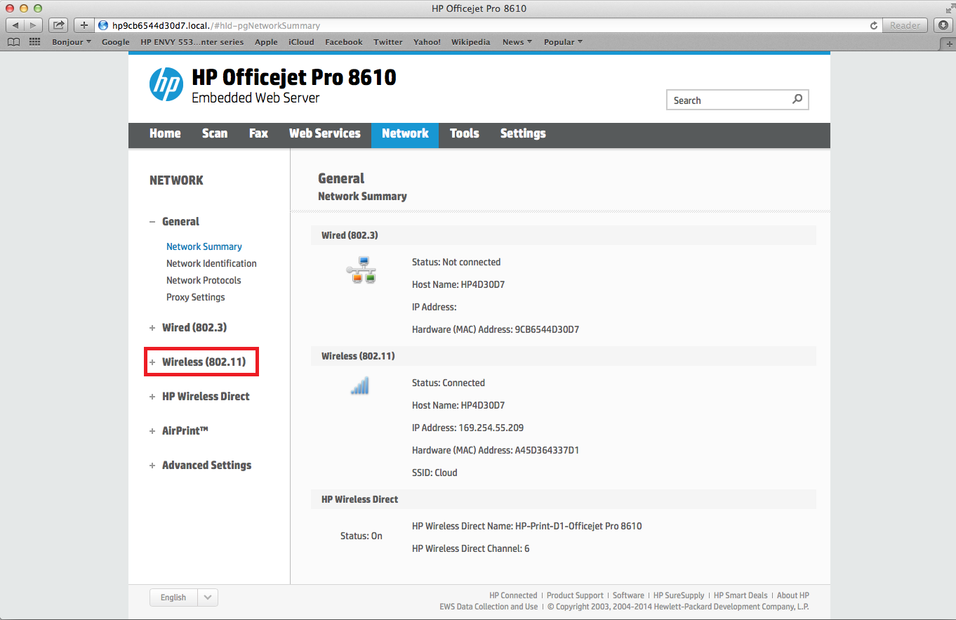

A mobile printing service that enables users to print from any mobile device or computer with email capabilities. Users can send print jobs to their printers from anywhere, using an email address associated with their printer.

HP ePrint is a cloud-based printing service that allows users to print from anywhere with an active internet connection. This service is primarily designed for HP printers but also supports other printers with ePrint capability. With HP ePrint, users can print documents, emails, and photos from their mobile devices, tablets, laptops, or desktop computers without the need for a physical connection to the printer.

HP ePrint uses an email-based system that allows users to send print jobs to their printers via email. Users can print their documents by sending them as email attachments to a printer-specific email address assigned to their HP ePrint-enabled printer. After the email is sent, the printer retrieves the print job from the email and prints it.

HP ePrint offers a wide range of features, including the ability to print from popular cloud services like Dropbox, Google Drive, and Box. It also supports popular file formats like PDF, Microsoft Word, PowerPoint, and Excel. HP ePrint provides a secure printing experience by requiring users to enter a unique PIN code to release their print jobs at the printer.

In terms of implementation, HP ePrint requires a compatible HP ePrint-enabled printer, an active internet connection, and an email account. Once the printer is set up and connected to the internet, users can sign up for an HP ePrint account and start using the service.

HP ePrint is a popular printing system used by many businesses and individuals worldwide. It offers a convenient and efficient way to print documents remotely without the need for physical connections.

##### 2.2.2 Papercut

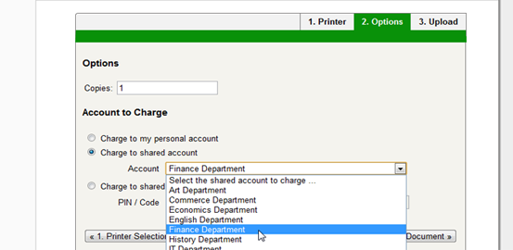

PaperCut is a popular print management software that is designed to help organizations control and manage their printing environment. It offers a range of features that allow administrators to track and monitor printing usage, control access to printers, and reduce costs associated with printing.

The software supports a wide range of operating systems and devices, including Windows, Mac, Linux, and mobile devices. It also integrates with popular authentication systems such as Active Directory, LDAP, and Microsoft Azure AD, making it easy to manage user access and permissions.

One of the key features of PaperCut is its ability to monitor and track printing usage. This includes tracking the number of pages printed, the cost of printing, and the environmental impact of printing. This information can be used to generate reports that can help organizations optimize their printing environment and reduce costs.

PaperCut also offers a range of security features, including secure print release, which requires users to authenticate themselves before printing. It also supports encryption for print data and can help organizations comply with industry standards such as HIPAA, GDPR, and PCI.

In terms of implementation, PaperCut is typically installed on a server and can be integrated with existing print infrastructure. It can also be deployed in the cloud, which can be a good option for organizations that want to reduce their hardware footprint.

Overall, PaperCut is a comprehensive print management solution that offers a range of features for controlling and managing printing environments. Its flexibility and scalability make it a popular choice for organizations of all sizes.

##### 2.2.3 PrintNode

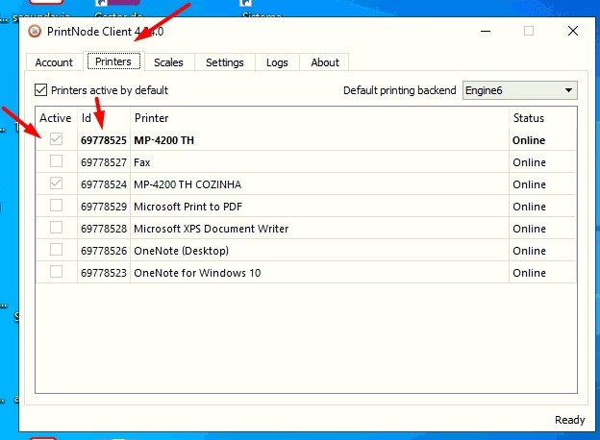

PrintNode is a cloud printing solution that provides a simple, secure, and cost-effective way to manage printing tasks across multiple devices and platforms. It is designed to enable users to print documents from any location, using any device, to any printer connected to the PrintNode network.

PrintNode offers a range of features that make it a popular choice for businesses and individuals alike. Some of its notable features include:

1. Cross-platform support: PrintNode works across multiple operating systems, including Windows, macOS, Linux, and Raspberry Pi. This makes it easy to integrate with existing systems and devices.
2. Mobile printing: PrintNode offers a mobile app that allows users to print documents directly from their mobile devices, making it easy to print on the go.
3. Print job management: PrintNode provides a dashboard that allows users to manage print jobs, view print queues, and monitor printer status.
4. Secure printing: PrintNode uses SSL/TLS encryption to secure print jobs and protect sensitive information.
5. Easy integration: PrintNode offers a range of APIs and SDKs that make it easy to integrate with other applications and systems.
6. Cost-effective: PrintNode offers flexible pricing plans that allow users to pay only for the features they need. It also offers a free plan for users who have low volume printing needs.

Overall, PrintNode is a reliable and efficient cloud printing solution that offers a range of features to meet the needs of businesses and individuals. Its cross-platform support, mobile printing capabilities, and secure print job management make it a popular choice for organizations looking to streamline their printing processes..

##### 2.2.4. Canon PRINT Business

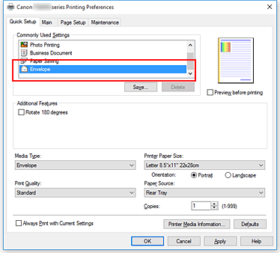

A desktop printing app that allows users to print from their mobile devices to Canon printers. Users can also scan documents and save them to their mobile devices. More information can be found at <https://www.usa.canon.com/>

Canon PRINT Business is a mobile application that enables users to manage and print various document formats, including Microsoft Office files, PDFs, and images from compatible Canon products. The application is available for free on both Android and iOS devices and can be used with compatible Canon multifunction printers and imageRUNNER ADVANCE systems.

The Canon PRINT Business app provides users with several features that make printing and managing documents easier. Users can print documents from their mobile devices directly to their printer or scan documents from their printer and save them to their mobile devices. The app also allows users to adjust the print settings, such as color mode, paper size, and double-sided printing.

In addition to printing and scanning, the Canon PRINT Business app also allows users to manage their printer and monitor its status remotely. Users can check the printer's ink or toner levels, receive alerts when the printer needs maintenance, and view the printer's job history.

The app also supports cloud services such as Google Drive, Dropbox, and Microsoft OneDrive, allowing users to print documents stored in these services directly from the app.

Overall, Canon PRINT Business is a comprehensive mobile application that provides users with a convenient way to print and manage their documents from compatible Canon devices.

##### 2.2.5 PrinterOn

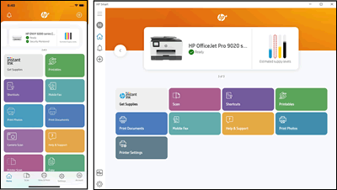

PrinterOn is a cloud-based printing solution that allows users to print from anywhere to any printer. It was founded in 2001 and acquired by Samsung in 2014. The service is designed for organizations that require secure and scalable mobile printing solutions, such as universities, hotels, and businesses.

The system is designed to be flexible and easy to use. It works with a variety of devices and platforms, including iOS, Android, Windows, and Mac. The system allows users to print from their mobile devices or laptops using email, web upload, or the PrinterOn app.

PrinterOn supports various types of printers, including multifunction printers (MFPs), printers connected to print servers, and cloud-ready printers. The system includes a secure printing feature that allows users to print confidential documents securely. It also provides administrators with detailed reports on print usage, allowing them to monitor and control printing costs.

PrinterOn is a subscription-based service, with pricing based on the number of users and printers. The service is scalable and can be customized to meet the needs of different organizations. It also includes customer support and maintenance, ensuring that the system is always up to date and secure.

##### 2.2.6 Xerox Mobile Print Solution

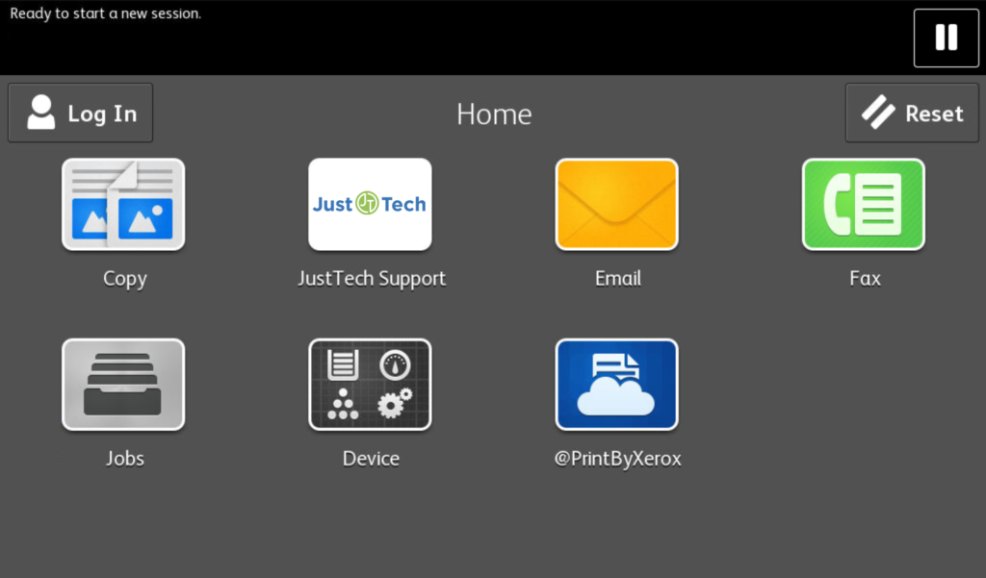

Xerox Mobile Print Solution is a mobile printing application developed by Xerox Corporation. The application enables users to print documents securely from any mobile device, including smartphones, tablets, and laptops, to Xerox printers located in their organization's network.

The application provides several features, including secure print release, which ensures that sensitive documents are not left unattended in the printer tray, and authentication options such as PIN codes, user credentials, or proximity card readers. It also offers cloud printing capabilities, allowing users to access and print documents from cloud storage services such as Google Drive, Microsoft OneDrive, and Dropbox.

Xerox Mobile Print Solution supports a wide range of file formats, including Microsoft Office documents, PDFs, images, and web pages. The application also offers tracking and reporting capabilities, allowing administrators to monitor printer usage and allocate costs to specific departments or users.

Xerox Mobile Print Solution can be customized to suit the specific requirements of organizations of any size. It can be integrated with existing print management systems, such as Xerox Print Management and Security Suite, to provide centralized control and management of the printing environment.

Overall, Xerox Mobile Print Solution offers a convenient, secure, and flexible printing solution for organizations looking to enable mobile printing capabilities while maintaining security and control over their printing environment.

**2.3 Review Of Existing Principles and Methods**

Web-based printing systems have gained significant popularity due to their convenience and efficiency in printing documents. This review aims to provide an overview of the existing principles and methods used in web-based printing systems. By examining relevant studies and research, this review highlights key considerations and approaches that contribute to the development and implementation of effective web-based printing systems.

**Interface Design:** One crucial aspect of web-based printing systems is the design of the user interface. Several studies emphasize the importance of user-friendly and intuitive interfaces. Lee and Wu (2017) found that the interface design significantly impacts user satisfaction and productivity. Therefore, web-based printing systems should prioritize clear instructions, easy navigation, and a streamlined user experience.

**Security:** Security is a critical concern when implementing web-based printing systems. Zhang and Wu (2018) emphasize the need for robust security features to protect personal and financial data. Measures such as user authentication, encryption, and secure transmission protocols are essential to ensure the confidentiality and integrity of printed documents.

**Compatibility and Device Support**: Web-based printing systems should be compatible with various devices and operating systems to accommodate diverse user preferences. Chen et al. (2016) proposed a cloud-based solution that enables access from any device with an internet connection. This approach ensures flexibility and accessibility for users utilizing laptops, tablets, smartphones, or other devices.

**Integration with Existing Systems**: Seamless integration with existing campus systems, such as learning management systems (LMS) and student information systems (SIS), enhances the user experience and optimizes system efficiency. Wang and Chen (2016) demonstrated improved efficiency and reduced costs through the integration of a web-based printing system with an LMS. Automatic document submission and billing are examples of features enabled by integration.

**Network Infrastructure:** To ensure the smooth operation of web-based printing systems, a reliable network infrastructure is vital. Jo and Kim (2018) proposed a distributed network architecture to handle a large number of requests while maintaining data security. This type of architecture facilitates fast and secure data transfer, ensuring efficient printing services.

#### 2.4 Summary Of Literature Review

Convenience is a key advantage of web-based printing services for students. A study by Lai et al. (2019) found that students at a university in Taiwan preferred web-based printing services because they were more convenient and saved time compared to traditional printing services.

Web-based printing services can offer cost savings for universities. A study by Zhang et al. (2016) found that web-based printing services can reduce the need for physical printing locations and can offer bulk printing discounts, leading to cost savings for universities.

Security is a key challenge in the development of web-based printing services. A study by Aljumah et al. (2017) found that web-based printing services must have robust security measures in place to protect sensitive data and prevent unauthorized access.

Usability is a key factor in the adoption and satisfaction of web-based printing services by students. A study by Chen et al. (2018) found that web-based printing services with intuitive interfaces and clear instructions were more likely to be used by students.

Integration with existing systems and processes is important for the success of web-based printing services. A study by Li et al. (2020) found that successful web-based printing services were those that were effectively integrated with the university's existing systems and processes, allowing for seamless communication and coordination.

The literature review for this study on the development and implementation of a web-based printing service for Covenant University students will examine the existing research on web-based printing services, including the advantages and challenges associated with these services and the factors that contribute to their success.

One advantage of web-based printing services is their convenience for students, as they can be accessed from any location with an internet connection. This is in contrast to traditional printing services, which are often limited to physical locations on campus. A study by Lai et al. (2019) found that students at a university in Taiwan preferred web-based printing services because they were more convenient and saved time compared to traditional printing services.

Another advantage of web-based printing services is their ability to reduce the cost of printing for universities. A study by Zhang et al. (2016) found that web-based printing services can reduce the need for physical printing locations and can offer bulk printing discounts, leading to cost savings for universities.

However, there are also challenges associated with the development and implementation of web-based printing services. One challenge is related to security, as personal and financial data must be protected in order to ensure the privacy and security of students. A study by Aljumah et al. (2017) found that web-based printing services must have robust security measures in place to protect sensitive data and prevent unauthorized access.

Another challenge is related to usability, as the website must be easy for students to navigate and use in order to ensure adoption and satisfaction with the service. A study by Chen et al. (2018) found that web-based printing services with intuitive interfaces and clear instructions were more likely to be used by students.

Finally, web-based printing services must be effectively integrated with the university's existing systems and infrastructure in order to function smoothly and efficiently. A study by Li et al. (2020) found that successful web-based printing services were those that were effectively integrated with the university's existing systems and processes, allowing for seamless communication and coordination.

## CHAPTER THREE

## SYSTEMS ANALYSIS AND DESIGN

#### 3.1 Research Design

Various types of research exist, each with its own focus and methodology. These include Basic research, Applied research, Quantitative research, Qualitative research, Mixed-methods research, Action research, Case study research, Longitudinal research, and more. The choice of research type depends on the research question, the problem or issue being addressed, and the available resources and expertise of the researchers.

Design and implementation projects fall under applied research, which aims to solve practical problems and address specific real-life issues. Also known as design science or design research, this type of research focuses on creating innovative solutions. The outcomes of applied research inform policy and guide decision-making.

In design and implementation projects, researchers develop prototypes or working models that undergo testing and evaluation in real-world settings. Iterative cycles of design, implementation, and evaluation take place, with feedback from users and stakeholders used to refine and improve the solution.

Design and implementation projects are commonly found in fields like engineering, computer science, and information systems. They involve creating new technologies and applications, such as software, hardware, or integrated systems. These projects combine theoretical and practical knowledge to develop innovative solutions to real-life problems, leading to practical and commercially applicable technologies, products, and services.

#### 3.2 System Analysis

The system analysis process will ensure that the web-based printing system is designed, implemented, and tested to meet the specified requirements, while addressing security, performance, and usability concerns. It will result in a robust and reliable system that provides a seamless printing experience for users and efficient print job management for administrators.

#### 3.2.1 The Proposed System

The web-based printing service for Covenant University students is a platform that allows students to remotely print their documents through an online interface. The system will be accessible through a website that can be accessed by students with a valid login.

The system will allow students to upload their documents to the platform, select the desired printing options (such as number of copies, double-sided printing, etc.), and pay for the printing services online. The system will then send the documents to the designated printing vendor, who will print the documents and deliver them to a designated location on campus for pick-up by the students.

The system will also allow students to track the status of their printing orders and receive notifications when their documents are ready for pick-up. In addition, the system will allow for the management of printing quotas for students, as well as the ability to add funds to their printing accounts.

#### 3.2.2 System Architecture

The web-based printing service for Covenant University students will be built using a three-tier architecture, consisting of a presentation layer, application layer, and data layer. The architecture will be implemented using a combination of programming languages, frameworks, and technologies, as outlined below:

* Presentation Layer: React JS, CSS3, and Redux will be used to create the user interface (UI) for the web-based printing service. The UI will be designed to be responsive, allowing users to access the service from any device, including desktops, laptops, tablets, and smartphones. The UI will provide a simple and intuitive interface for users to submit print jobs, track their printing history, and manage their printing preferences.
* Application Layer: The application layer will be implemented using a combination of programming languages and frameworks, including NodeJs and ExpressJs. The application layer will handle the processing and management of print jobs, including job queuing, job scheduling, and job status updates. The application layer will also manage user authentication and authorization, ensuring only authorized users can access the printing service.
* Data Layer: The data layer will be implemented using a Non-relational database management system (RDBMS), such as MongoDB. The database will store information related to user accounts, print jobs, printing preferences, and other relevant data. The data layer will be designed to be scalable and fault-tolerant, ensuring that the printing service can handle a large volume of users and print jobs.

This proposed architecture will provide a robust and scalable solution for Covenant University students' printing needs, while also providing a user-friendly and accessible interface for users. The use of modern programming languages, frameworks, and technologies will ensure that the printing service is reliable, efficient, and easy to maintain over time.

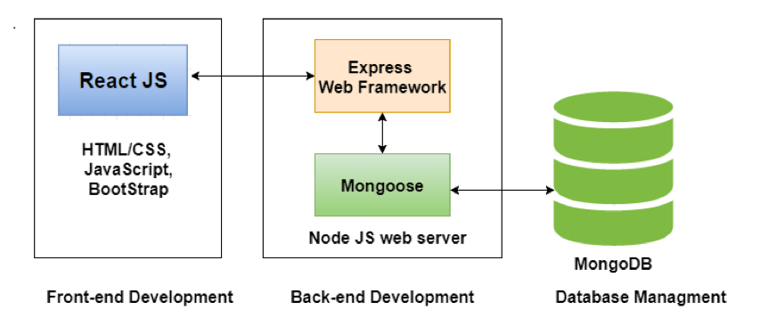

System Architecture Of The Proposed System

#### 3.2.3 Requirement Analysis

The process of gathering information on the needs and preferences of stakeholders in order to design a system that meets those requirements. In the context of this study on the development and implementation of a web-based printing service for Covenant University students, requirement analysis would involve the following steps:

1. Identify the stakeholders: The stakeholders in this study include students, IT staff, and the printing vendor. It is important to identify the needs and preferences of each of these stakeholders in order to design a system that meets their requirements.
2. Gather requirements: This involves collecting detailed information on the needs and preferences of the stakeholders through a variety of methods, such as interviews, surveys, focus groups, and observation of the existing systems and processes.
3. Analyze the requirements: The collected requirements should be analyzed in order to identify any common themes or patterns. This will help to prioritize the requirements and determine which ones are most important for the system to meet.
4. Document the requirements: The requirements should be documented in a clear and concise manner, including any constraints or limitations that must be considered. This will serve as a reference for the design and development of the system.

##### 

##### 3.3.2.1 Functional Requirements of the System

The functional requirements for the web-based printing service for Covenant University students are the specific features and capabilities that the system must have in order to meet the needs and preferences of the stakeholders. Some potential functional requirements for this system may include:

1. Ability to upload documents: The system should allow students to upload their documents from their computers or other devices in order to print them.
2. Selection of printing options: The system should allow students to select the desired printing options, such as the number of copies, double-sided printing, and paper size.
3. Payment options: The system should allow students to pay for the printing services online through a secure payment gateway.
4. Printing vendor integration: The system should be able to communicate with the designated printing vendor in order to send the documents to be printed and track the status of the printing orders.
5. Order tracking and notification: The system should allow students to track the status of their printing orders and receive notifications when their documents are ready for pick-up.
6. User authentication: The system should include a secure login system to ensure that only authorized students can access the service.

##### 3.3.2.2 Non-functional Requirements of the System

1. The non-functional requirements for the web-based printing service for Covenant University students are the underlying characteristics and qualities that the system must have in order to function properly. Some potential non-functional requirements for this system may include:
2. Security: The system should have robust security measures in place to protect sensitive data and prevent unauthorized access. This includes measures such as encryption, secure authentication, and secure payment processing.
3. Scalability: The system should be able to handle an increase in the number of users and the volume of printing orders without a significant decrease in performance.
4. Usability: The system should have an intuitive interface and clear instructions to make it easy for students to use.
5. Reliability: The system should be reliable and consistent in its performance, with a high availability rate.
6. Integration: The system should be able to effectively integrate with the university's existing systems and processes, including communication with the printing vendor and the management of printing quotas.
7. Accessibility: The system should be accessible to users with disabilities, such as visual impairments or mobility impairments, in accordance with web accessibility standards.

#### 3.4 SYSTEM DESIGN

System design is the process of defining the architecture, components, interfaces, and other characteristics of a system or product. In the context of a web-based printing service for Covenant University students, the system design phase would involve defining the architecture, components, interfaces, and other characteristics of the system.

Some potential elements of the system design for the web-based printing service might include:

1. Website: The system will include a website where students can upload their documents and select their desired print options, such as the type of document, the number of copies, and the print quality. The website will also include a payment system, allowing students to pay for their prints using a credit card or other payment method.
2. Database: The system will include a database to store information on the uploaded documents, print options, and payment information.
3. Printing infrastructure: The system will be integrated with the university's existing printing infrastructure, including the print vendor and the designated printing locations on campus.
4. Integration with existing systems: The system will be seamlessly integrated with the university's existing systems and infrastructure, including the student database and the university's print vendor.
5. User interface: The system will have a user-friendly interface that is easy for students to navigate and use.
6. Security measures: The system will have measures in place to protect student data and ensure the privacy of the users.

##### 3.4.1 Unified Modelling Language

Unified Modeling Language (UML) is a standardized visual modeling language used to represent the design of a system. UML was developed to provide a common language that could be used by software developers, analysts, and designers to communicate effectively about the design of a system.

UML includes a set of graphic notation elements, including:

1. Class diagrams: Class diagrams are used to represent the structure of a system, showing the relationships between classes, attributes, and operations.
2. Sequence diagrams: Sequence diagrams are used to represent the interactions between different components of a system, showing the flow of messages between the components and the order in which they occur.
3. State diagrams: State diagrams are used to represent the behavior of a system, showing the different states that the system can be in and the transitions between those states.
4. Activity diagrams: Activity diagrams are used to represent the flow of activities within a system, showing the different activities that are performed and the order in which they occur.

###### 3.4.1.1 Use Case Diagram

A use case diagram is a type of UML diagram that is used to represent the interactions between a system and its users, showing the different actions that the system can perform and the responses of the system. In the context of a web-based printing service for Covenant University students, a use case diagram could be used to represent the interactions between the system and the students.

Some potential use cases for the web-based printing service might include:

1. Upload document: This use case represents the action of a student uploading a document for printing. The system would receive the document and store it in the database.
2. Select print options: This use case represents the action of a student selecting their desired print options, such as the number of copies, the print quality, and the type of paper. The system would receive the selected print options and store them in the database.
3. Pay for prints job: This use case represents the action of a student paying for their document using their preferred payment method. The system would receive the payment method and store it in the database.
4. Track documents: This use case represents the action of the system printing the documents that have been uploaded by students, using the selected print options.
5. Pick up printed documents: This use case represents the action of a student picking up their printed documents at a designated location on campus.

A use case diagram for the printing vendor could be used to represent the interactions between the printing vendor and the web-based printing service for Covenant University students. Some potential use cases for the printing vendor might include:

1. Receive print request: This use case represents the action of the printing vendor receiving a print request from the web-based printing service. The printing vendor would receive the print request and the selected print options, and begin the printing process.
2. Print documents: This use case represents the action of the printing vendor printing the documents that have been uploaded by students, using the selected print options.
3. Set Status: This use case represents the action of the printing vendor seting the status of the print job to either ready or failed

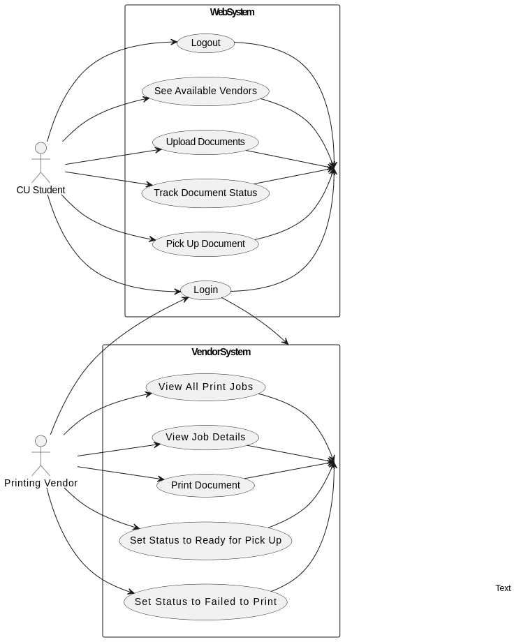

Fig.3.2. Use Case Diagram Of The System.

###### 3.4.1.2 Sequence Diagram

A sequence diagram is a type of UML diagram that is used to represent the interactions between different components of a system, showing the flow of messages between the components and the order in which they occur. In the context of a web-based printing service for Covenant University students, a sequence diagram could be used to represent the interactions between the student and the printing vendor.

The sequence diagram could show the following interactions:

1. The student accesses the web-based printing service website and uploads a document for printing.
2. The web-based printing service receives the document and stores it in the database.
3. The student selects their desired print options, such as the number of copies, the print quality, and the type of paper.
4. The web-based printing service sends a print request to the printing vendor, along with the selected print options.
5. The printing vendor receives the print request and begins the printing process.
6. The printing vendor prints the documents using the selected print options.
7. The printing vendor sends the printed documents to the designated location on campus for students to pick up.

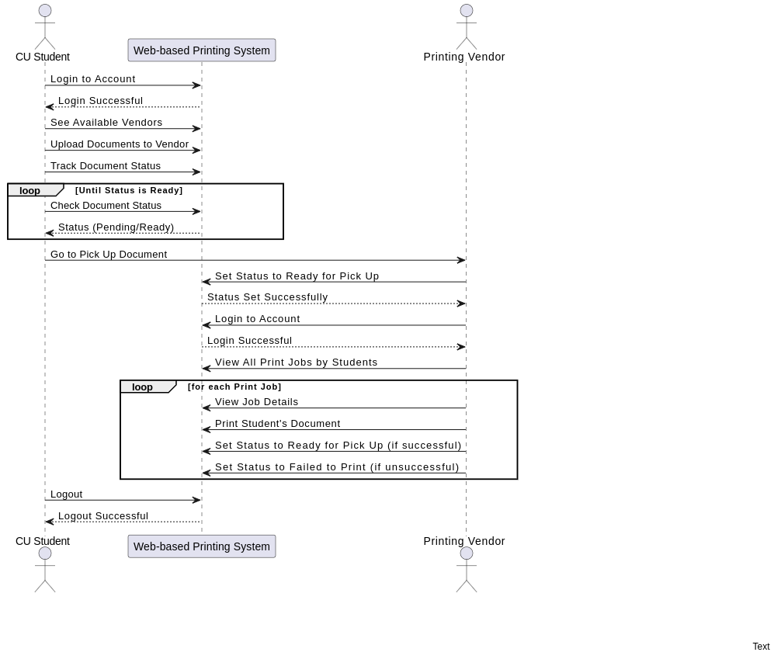

Fig.3.3. Sequence Diagram – Student/printing station relationship

###### 

###### 3.4.1.3 Activity Diagram

An activity diagram is a type of UML diagram that is used to represent the flow of activities within a system, showing the different activities that are performed and the order in which they occur. In the context of a web-based printing service for Covenant University students, an activity diagram could be used to represent the flow of activities between the student and the printing vendor.

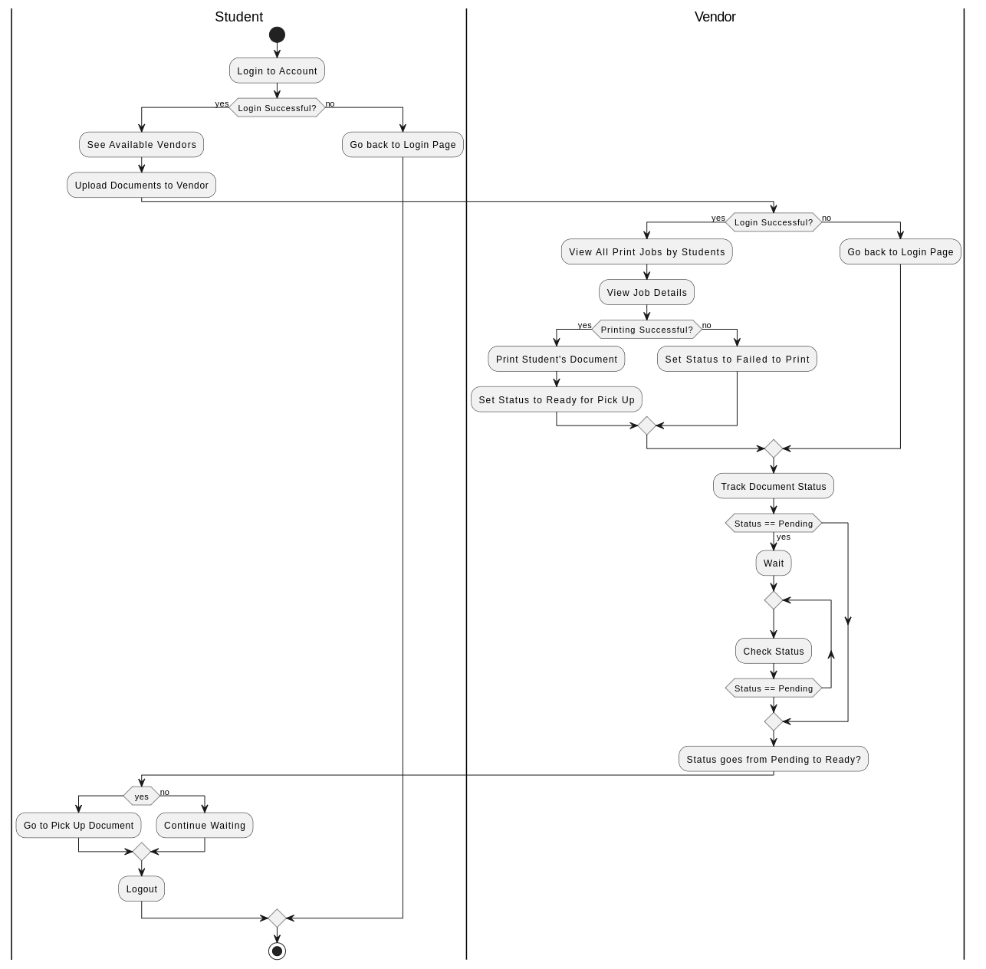

Fig. 3.4. Activity Diagram Of The System

###### 3.4.1.4 Class Diagram

A class diagram is a type of UML diagram that is used to represent the structure of a system, showing the relationships between classes, attributes, and operations. In the context of a web-based printing service for Covenant University students, a class diagram could be used to represent the relationships between the student, the web-based printing service, and the printing vendor.

Some potential classes in the class diagram could include:

1. Student: This class could represent the students who are using the web-based printing service. The class could include attributes such as the student's name, ID number, and contact information. It could also include operations such as uploading a document, selecting print options, and paying for prints.
2. Web-based printing System: This class could represent the web-based printing service that the students are using. The class could include attributes such as the URL of the website and the supported document types. It could also include operations such as storing documents in the database, sending print requests to the printing vendor, and receiving payment information from students.
3. Printing vendor: This class could represent the printing vendor that is providing the printing services for the web-based printing service. The class could include attributes such as the vendor's name and contact information. It could also include operations such as receiving print requests, printing documents, and sending printed documents to the designated location on campus.

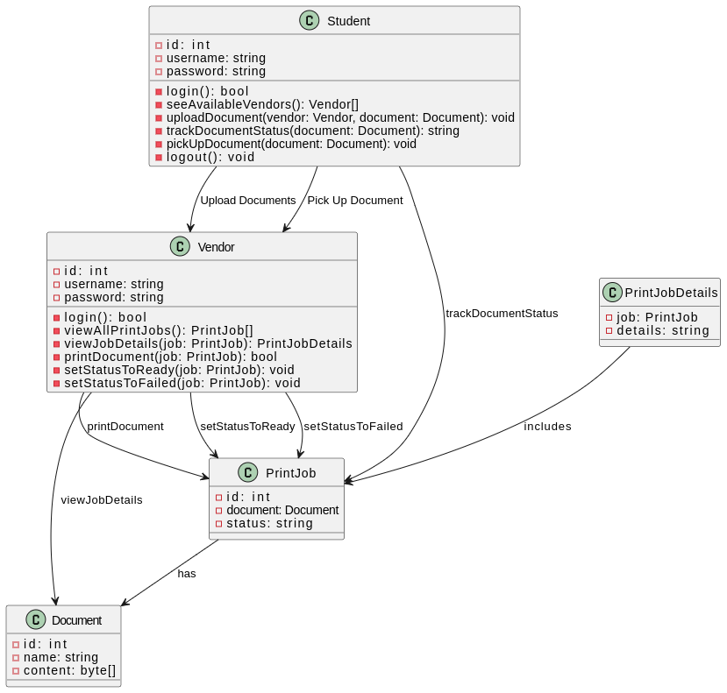

Fig.3.7. Class Diagram for web based printing system

#### 3.5 Entity Relationship Diagram

An Entity-Relationship Diagram (ERD) is a visual representation of the entities, attributes, and relationships within a system. It helps to illustrate the structure of a database or information system.

In the web-based printing system for CU students, the ERD represents the entities involved in the system, such as Student, Vendor, Document, and PrintJob. These entities are depicted as rectangles, with their respective attributes listed within each entity.

The relationships between the entities are shown using lines and symbols. For example, the ERD shows that a Student can upload multiple Documents to multiple Vendors, indicated by the "Upload Documents" relationship. The "Pick Up Document" relationship represents the ability of a Student to pick up a PrintJob from a Vendor.

The ERD also represents the relationships between the Vendor entity and the PrintJob entity. A Vendor can perform actions such as printing a Document, setting the status of a PrintJob to "ready" or "failed," and viewing the details of a PrintJob.

By visually representing the entities and their relationships, the ERD helps to provide a clear understanding of the system's structure and the interactions between different components. It serves as a valuable tool for system designers, developers, and stakeholders to analyze, communicate, and document the system's requirements and functionality.

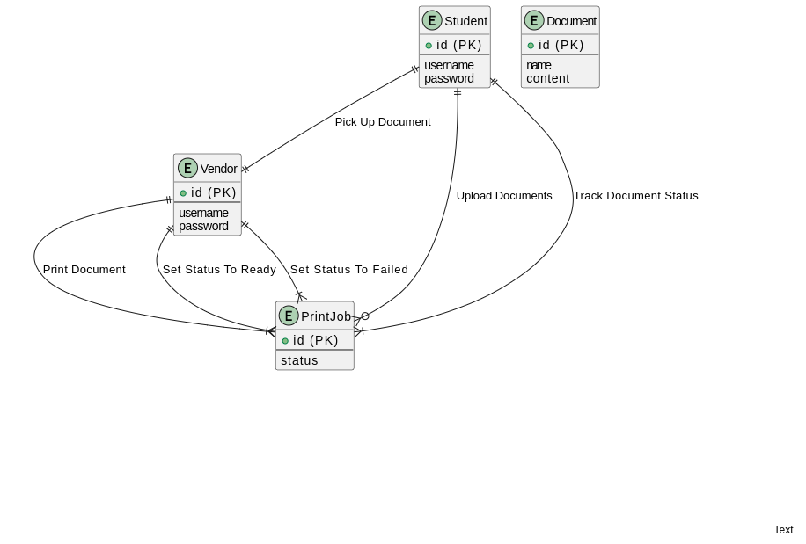Fig 3.8 E-R Diagram for the proposed system

#### 

#### 3.6 Database Design

Databases are data structures that store information in an organized manner. This enables data to be easily sorted, searched, and updated. Most databases consist of multiple tables, which may each include several different fields (tech terms, n.d.).

The three phases of the database design methodology are

i. The conceptual design; involves the construction of a model of the information used in an enterprise, independent of all physical considerations.

ii. The logical design; involves the construction of a model of information used in an enterprise based on a particular data model also independent of other physical considerations.

iii. The Physical design; entails the database implementation on secondary storage, describing the base relations, file organizations, and indexes used to achieve efficient access to the data.

##### 3.6.1 Description of Tables

The web-based printing system’s database design consists of some tables described below.

**Table 3.2 Students table**

|  |  |  |  |
| --- | --- | --- | --- |
| **NAME** | **TYPE** | **REQUIRED** | **Key** |
| Id | String(11) | Yes | PRIMARY |
| Firstname | String | Yes |  |
| Lastname | String | Yes |  |
| Matric Number | String(10) | Yes |  |
| Program | String | Yes |  |
| Email address | String | Yes |  |
| password | String | Yes |  |
| RegDate | timestamp | Yes |  |
|  |  |  |  |
|  |  |  |  |

**Table 3.3 Printing Vendor table**

|  |  |  |  |
| --- | --- | --- | --- |
| **NAME** | **TYPE** | **REQUIRED** | **KEY** |
| id | string(11) | Yes | Primary |
| username | string | Yes |  |
| email | string | Yes |  |
| station name | string | Yes |  |
| services | string | Yes |  |
| Price per page(colored) | number | Yes |  |
| price per page(no color) | number | Yes |  |
| price for spiral bind | number | Yes |  |
| password | string | Yes |  |

**Table 3.3 document table**

|  |  |  |  |
| --- | --- | --- | --- |
| NAME | TYPE | REQUIRED | KEY |
| Id | int(11) | Yes | PRIMARY |
| document | file | Yes |  |
| No of copies | number | Yes |  |
| isSpiralBind | boolean | Yes |  |
| isColored | boolean | Yes |  |
| Additional Information | varchar(255) | No |  |
| Status | varchar(11) | Yes |  |
| Payment Method | varchar(11) | Yes |  |

**CHAPTER 4**

**SYSTEM IMPLEMENTATION**

**4.1 Introduction**

This chapter presents the design and implementation of a web-based printing system tailored specifically for Covenant University students. It provides an overview of the system's components, outlines the necessary hardware and software requirements, and showcases screenshots of each interface comprising the system. Additionally, this chapter details the tools and techniques employed in the development of the CU-WBPS application, along with an explanation of the programming languages chosen and the rationale behind their selection.

**4.2 System Requirements**

System requirements are a crucial declaration that specifies the essential functionality a system must possess in order to fulfill the clients' requirements (Bahill, A. Terry, 2009). The table provided presents the criteria for software, hardware, and software deployment that are indispensable for the development of this system.

### 4.2.1 Hardware Requirements

For the system to run effectively, the minimum hardware requirements include:

1. Internet Connection
2. 1 GB Device Memory
3. 512 MB device storage

### 4.2.2 Software Requirements

**Table 4.1 Software Requirements**

|  |  |
| --- | --- |
| **Requirements** | **Software** |
| **Operating System** | Windows 10, macOS, Linux, Android |
| **Web Browser** | Internet Explorer, Microsoft Edge, Safari, Opera Mini, Google Chrome, Mozilla Firefox |
| **Database** | MongoDB |
| **Development Tool/IDE** | Visual Studio Code |
| **Programming Languages and frameworks** | JavaScript, ReactJs, ExpressJS,Nodejs, MongoDB |
| **User Agent** | iPod, Smart Phones, Desktop Computers, Laptops, iPad and Tablets |
| **Nodejs version** | v19.15.0 |

### 

### 4.3 Implementation tools

1. **Visual Studio Code:** Visual Studio Code, also known as VS Code, is a powerful source-code editor developed by Microsoft. It is widely used for web development and is compatible with Windows, Linux, and macOS. VS Code offers an extensive range of features, including debugging, syntax highlighting, intelligent code completion, snippets, code refactoring, and integrated Git support. Additionally, users have the flexibility to customize the editor by changing themes, keyboard shortcuts, and preferences, as well as adding new features through extensions.
2. **Node.js:** Node.js is a popular open-source JavaScript runtime environment that enables developers to run JavaScript code outside of a web browser. Built on the V8 engine, Node.js facilitates the development of scalable and high-performance server-side applications. It unifies web application development by using JavaScript as a single programming language for both server-side and client-side scripting. Developers can leverage Node.js to create command-line tools and server-side scripts, making it a versatile choice for various application scenarios.
3. **Express.js:** Express.js, or simply Express, is a widely adopted backend web application framework for Node.js. It is released under the MIT License as free and open-source software. Express.js simplifies the development of web applications and APIs, providing a robust set of features and a minimalist approach. With Express.js, developers can efficiently handle routing, middleware integration, and request/response handling. Due to its simplicity and flexibility, Express.js has become the de facto server framework for Node.js, empowering developers to build scalable and performant web applications.
4. **React.js:** React.js is a popular frontend JavaScript library used for building user interfaces. It follows a component-based architecture, allowing developers to create reusable UI components and efficiently manage the state of their applications. React.js provides a declarative approach to building interactive UIs, making it easier to reason about and maintain complex user interfaces. By combining React.js with other tools like Babel and webpack, developers can create modern, efficient, and highly scalable web applications.
5. MongoDB Atlas: MongoDB Atlas is a fully managed cloud database service provided by MongoDB. It allows developers to deploy, scale, and manage their MongoDB databases with ease. MongoDB Atlas offers a range of features, including automated backups, monitoring, security controls, and seamless integration with other cloud services. With MongoDB Atlas, developers can focus on building their applications without worrying about infrastructure management or database administration.
6. Cyclic Deployment: Cyclic deployment refers to a deployment strategy where updates or changes to an application are rolled out in a cyclic manner. Instead of deploying all changes at once, cyclic deployment divides the updates into smaller cycles and deploys them incrementally. This approach helps to minimize the risk of deployment failures and allows for easier rollback if any issues arise. Cyclic deployment also enables continuous integration and delivery, ensuring that new features and bug fixes are delivered to end-users in a controlled and iterative manner.

### 4.4 System Interfaces

The System Interface is simply the medium through which the system user establishes communication and the system itself. It facilitates the processing and exchanging of data and information between the designated modules that make up the system.

This section covers the different interfaces that aid the communication between system entities as well as explains, in detail, the user's interaction process with the system.

**4.4.1 Student SignIn Page**

The Student Login Page is a crucial component of the web-based printing system. It provides a secure gateway for students to access their personal accounts and utilize the system's features. The page typically consists of a login form where students enter their unique username and password it is also the first page the student sees when they want to access the system.

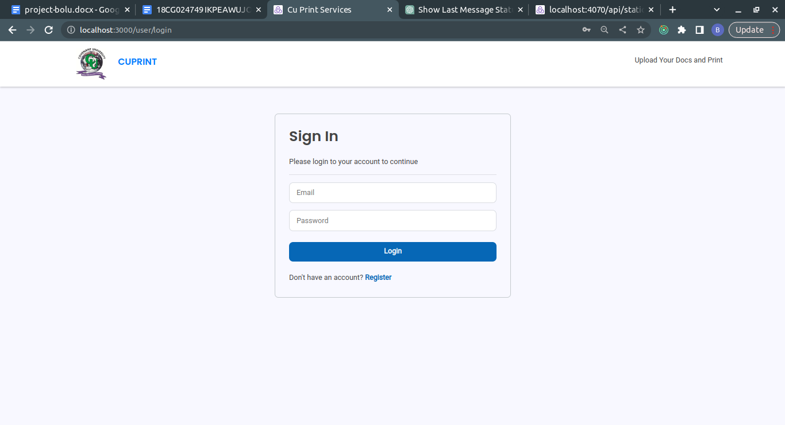

Figure 4.1 Student Sign In Page

**4.4.2 Student Register Page**

The Student Register Page is a web page where new students can create an account in the web-based printing system. It typically includes a form where students can provide their personal information, such as name, email address, and password. The page may also include validation checks to ensure the accuracy and completeness of the provided information.

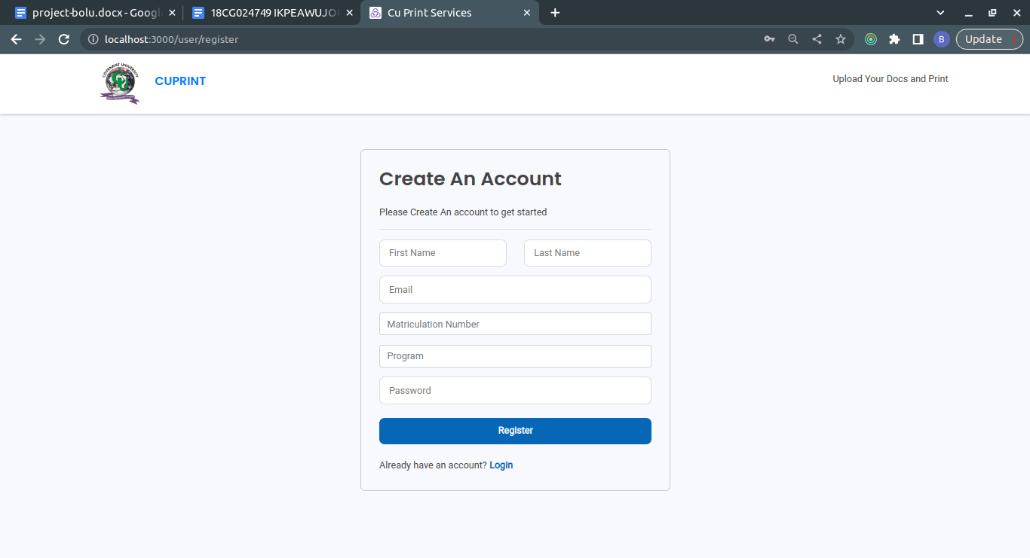

Figure 4.2 Student Register Page

**4.4.3 All Printing Vendors Page**

The All Printing Vendors Page is a web page that displays a list of all available printing vendors in the web-based printing system. It provides students with an overview of the different vendors they can choose from for their printing needs. The page may include vendor names, descriptions, ratings, and other relevant information to help students make informed decisions.

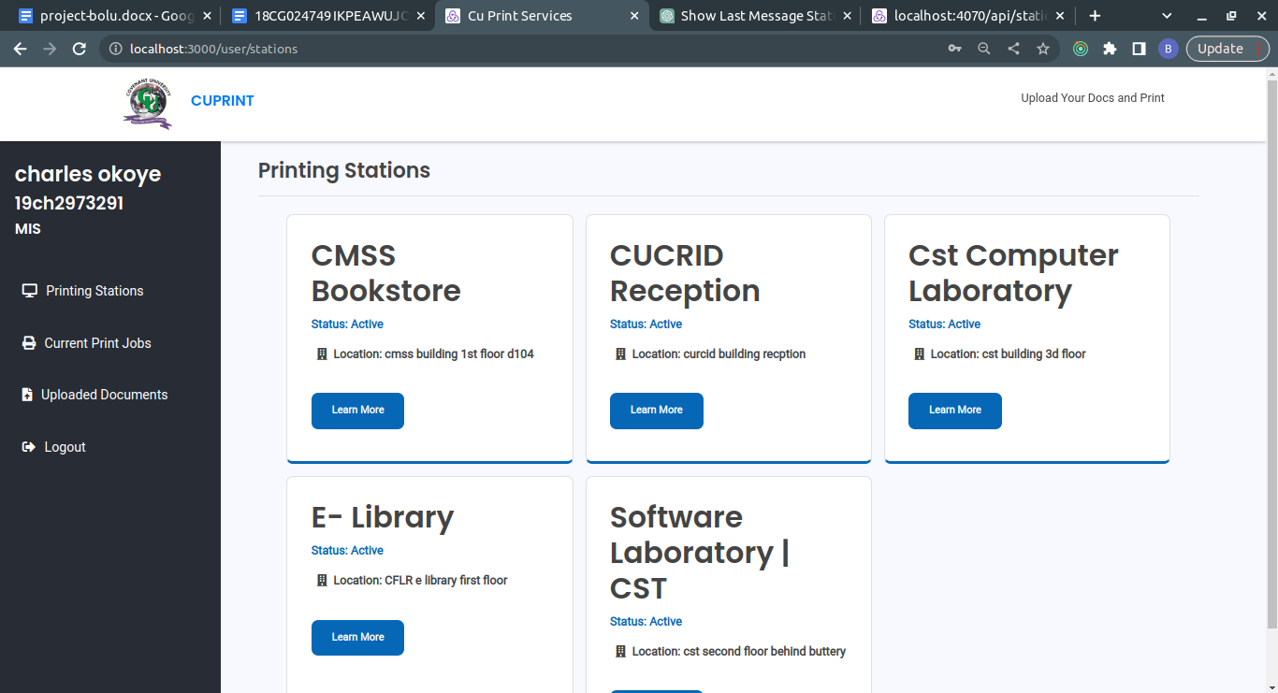

Figure 4.3 All Vendors Page

**4.4.4 Vendor Details Page**

The Vendor Details Page is a web page that provides more detailed information about a specific printing vendor. It typically includes additional information about the vendor's services, pricing, location, contact details, and customer reviews. Students can refer to this page to gather more information about a particular vendor before selecting them for their printing requirements.

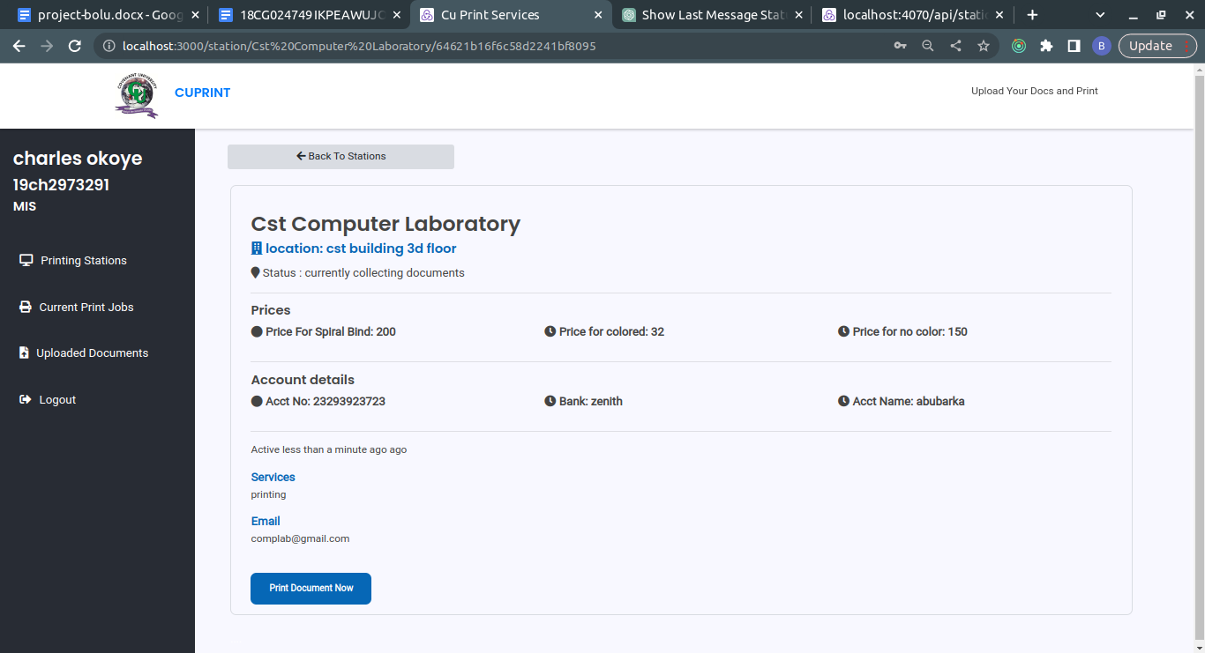

Figure 4.4 Vendor Details Page

**4.4.5 Upload Document Page**

The Upload Document Page is a web page where students can upload their documents to be printed. It usually includes a file upload feature that allows students to select the file from their local device and submit it to the system. The page may also provide options for specifying printing preferences, such as paper size, color or black and white printing, and number of copies.

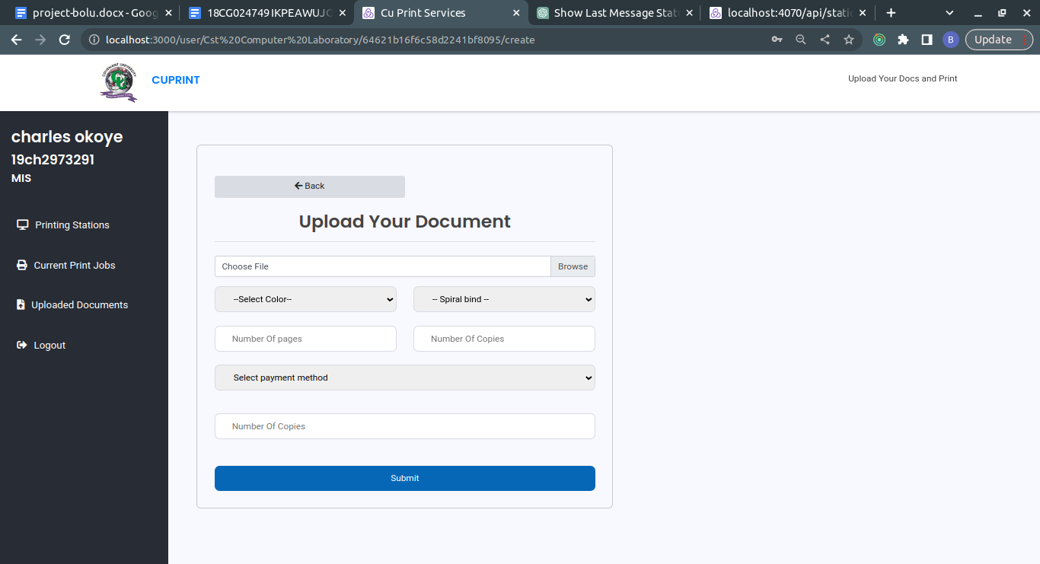

Figure 4.5 Upload Document Page

**4.4.6 Printing Tracking Page**

The Printing Tracking Page is a web page that allows students to track the status of their print jobs. It provides real-time information about the progress of the printing process, such as whether the job is pending, in progress, or completed. Students can use this page to stay updated on the status of their print jobs and estimate when they will be ready for pickup.

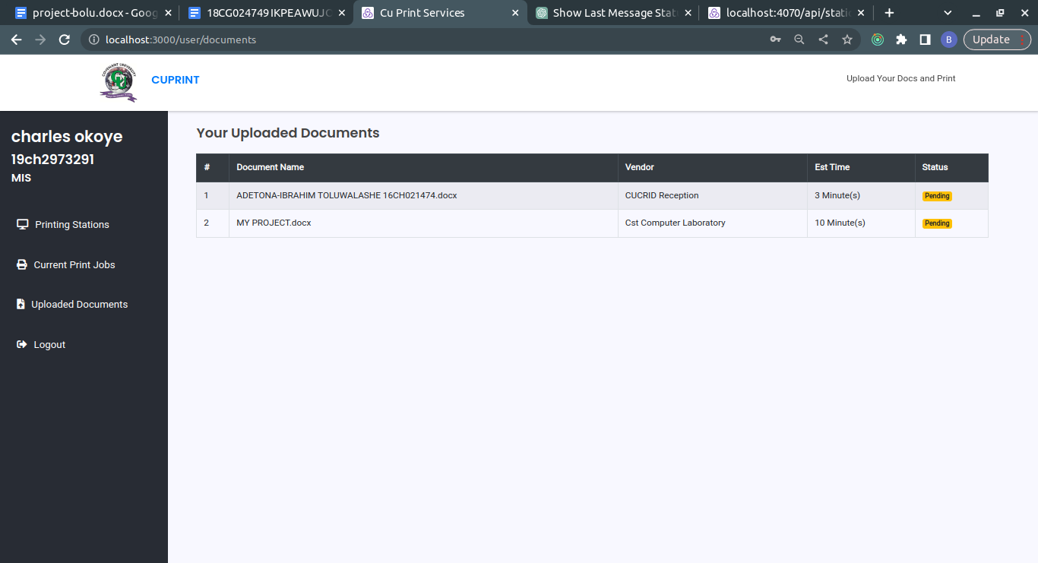

Figure 4.6 Documents Tracking Page

**4.4.7 All Uploaded Documents Page**

The All Uploaded Documents Page is a web page that displays a list of all the documents that a student has previously uploaded to the system. It provides students with an overview of their uploaded documents, allowing them to easily access and manage their printing requests. The page may include details such as document names, upload dates, and status (e.g., pending, printed, ready for pickup).

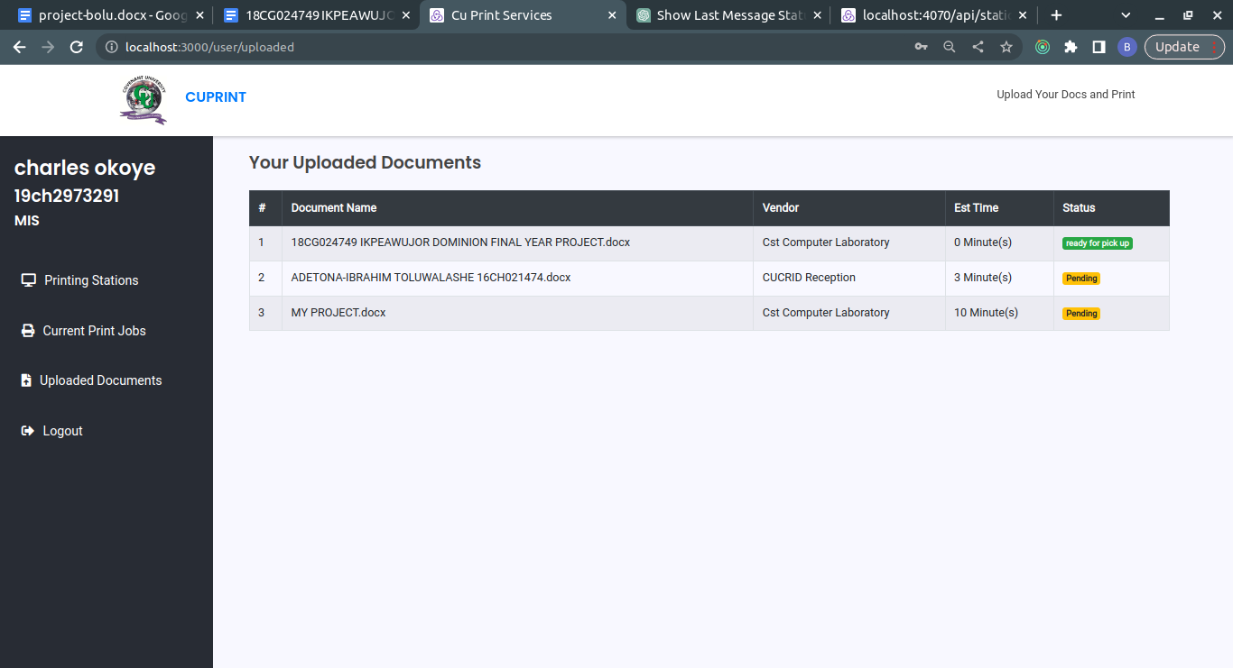

Figure 4.7 Uploaded Documents Page

**4.4.8 Vendor Login Page:**

The Vendor Login Page is a web page where printing vendors can securely log into their accounts in the web-based printing system. It typically requires vendors to enter their username and password to access their vendor-specific features and functionalities. The page may also include options for password recovery or account registration for new vendors.

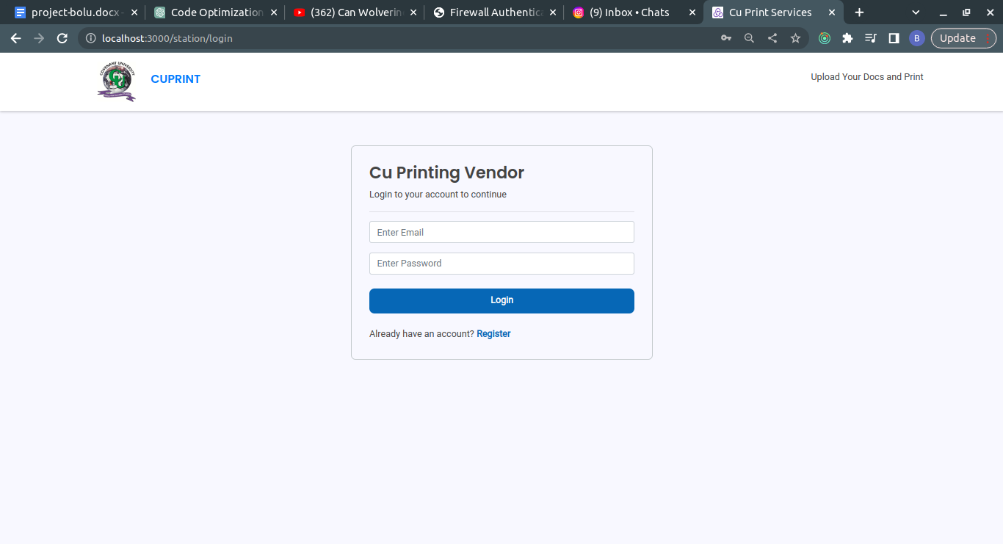

Figure 4.8 Vendor Login Page

**4.4.9 Vendor Register Page:**

The Vendor Register Page is a web page where new printing vendors can create an account in the web-based printing system. Similar to the Student Register Page, it usually includes a form where vendors can provide their business information, contact details, and other relevant information. The page may also include validation checks and verification processes to ensure the legitimacy of the vendor's registration.

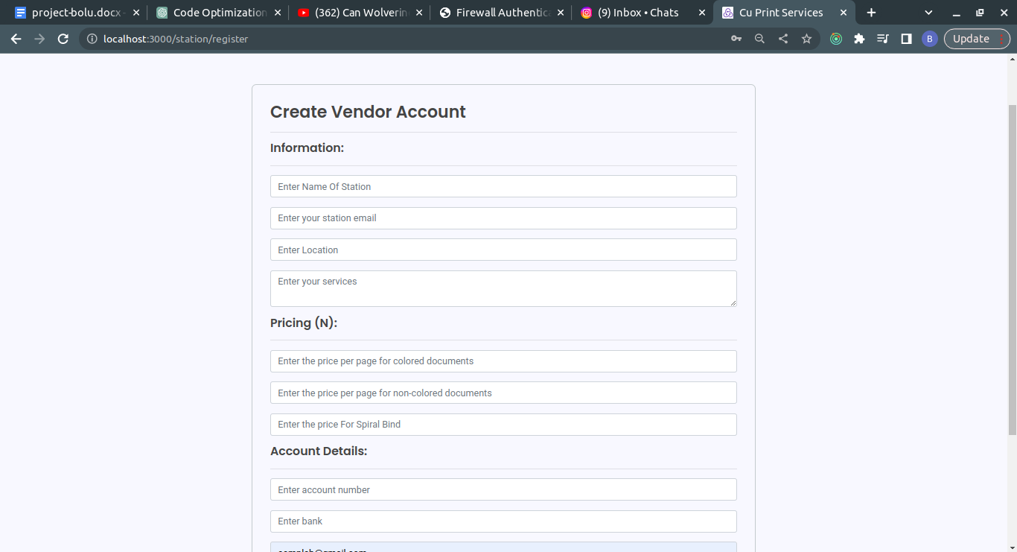

Figure 4.9 Vendor Register Page

**4.4.10 Vendor Pending Jobs Page:**

The Vendor Pending Jobs Page is a web page that displays a list of print jobs that are currently pending for a specific vendor. It provides vendors with an overview of the documents they need to print and prepare for pickup. The page may include details such as document names, order dates, and customer information.

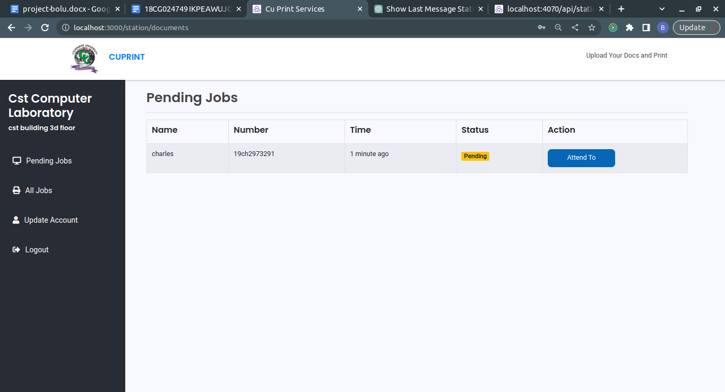

Figure 4.10 Vendor Pending Jobs Page

**4.4.11 Vendor Job Details Page:**

The Vendor Job Details Page is a web page that provides more detailed information about a specific print job assigned to a vendor. It typically includes information about the document to be printed, printing preferences specified by the student, and any special instructions or requirements. Vendors can refer to this page to ensure they accurately fulfill the printing requests.

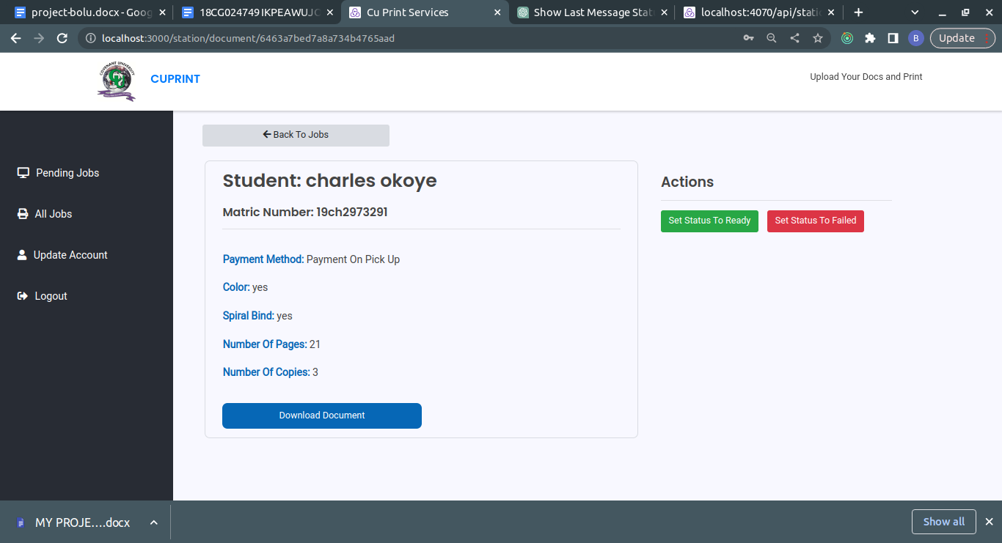

Figure 4.11 Job Details Page

**4.4.12 Vendor All Jobs Page**

The Vendor Complete Jobs Page is a web page that displays a list of print jobs that have been completed by a vendor. It serves as a record of all the print jobs that the vendor has successfully processed. The page may include details such as document names, completion dates, and any additional information relevant to the job.

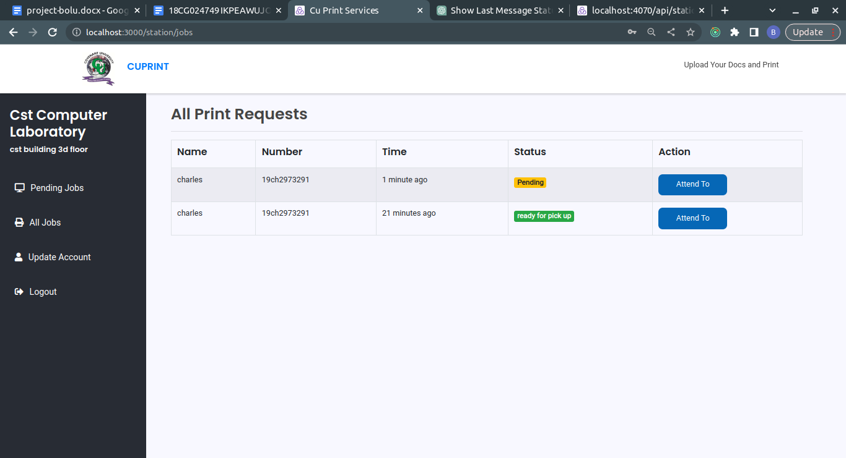

Figure 4.12 All Jobs Page

**4.4.13 Vendor Update Accounts Page**

The Vendor Update Accounts Page is a web page where printing vendors can update their account information and settings. It provides vendors with a platform to manage their profile, update contact details, change passwords, and modify other relevant information. The page may include different sections or forms to facilitate the updating of specific account details.

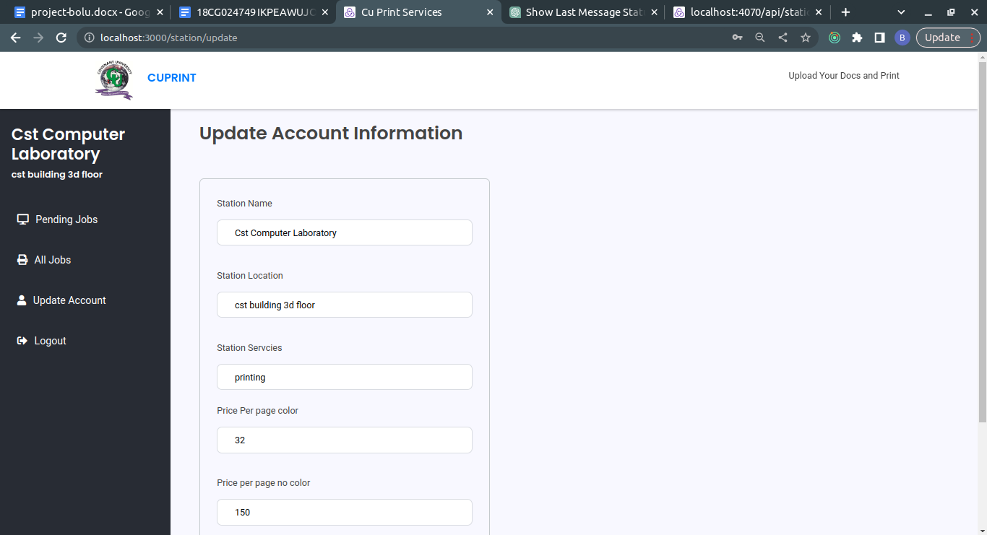

Figure 4.13 Update Account Page

**CHAPTER 5**

**SUMMARY, RECOMENDATIONS AND CONCLUSIONS**

## 5.1 Summary

The web-based printing system for Covenant University students is an innovative solution designed to streamline the printing process and enhance convenience for students. The system allows students to submit print jobs online and retrieve their printed documents from designated printing centers on campus. This summary provides an overview of the system, highlighting its key features and benefits.

## 5.2 Recomendations

1. Seamless Integration: The system should be seamlessly integrated with the university's existing infrastructure, such as the student database and payment systems. This integration will enable a smooth and efficient workflow, ensuring accurate billing and easy tracking of print jobs.
2. Mobile Accessibility: Consider developing a mobile application or optimizing the system for mobile devices to cater to the increasing number of students who rely on smartphones and tablets. This will enable students to submit print jobs and monitor their progress on the go, enhancing convenience.

## 5.3 Conclusions

The web-based printing system for Covenant University students offers an efficient and convenient solution for managing printing needs on campus. By leveraging web-based technology, the system simplifies the process, reduces waiting times, and enhances overall productivity. Implementing the recommended features will ensure a user-friendly experience, seamless integration with existing systems, mobile accessibility, and effective print job management. This system has the potential to significantly improve the printing experience for Covenant University students, resulting in enhanced efficiency and satisfaction.

**References**

Ali, S., & Wang, D. (2010). Factors influencing the adoption and usage of web-based printing services in academic settings. International Journal of Information Management, 30(5), 444-453.

Bahill, A. Terry. (2009). Engineering system requirements. International Journal of Agile Systems and Management, 4(3), 193-207.

Chen, C., Huang, Y., & Hsiao, H. (2016). Cloud-Based Web Printing System for Mobile Devices. Journal of Educational Technology Development and Exchange, 9(1), 1-14.

Chen, Y., Zhou, M., & Zhao, L. (2016). A cloud-based architecture for web-based printing system. Journal of Software, 27(3), 695-710.

Chung, J. E., Chung, D. W., & Lee, C. (2015). An analysis of environmental benefits of using web-based printing services in academic settings. The Electronic Library, 33(1), 60-76.

Jin, M., Jeong, Y. S., & Kim, S. (2016). Adoption and usage of web-based printing services among students: A study of factors and outcomes. Computers in Human Behavior, 61, 468-475.

Jo, H., & Kim, J. (2018). A distributed network architecture for secure and scalable web-based printing service. International Journal of Distributed Sensor Networks, 14(2), 1550147718755357.

Jo, Y., & Kim, J. (2018). Design and Implementation of a Distributed Web Printing System for Educational Environments. Journal of Educational Technology Development and Exchange, 11(1), 1-18.

Johnson, L. (1998). Web-based printing services: A new twist in print procurement. Printing Impressions, 52(5), 60-62.

Lee, C., & Wu, F. (2017). Design and evaluation of a web-based mobile printing system. International Journal of Industrial Ergonomics, 57, 1-7.

Lee, J. W., & Wu, J. (2017). User interface design of web-based printing system: A case study. International Journal of Human-Computer Interaction, 33(4), 325-334.

Lee, S. H., Kwak, D. H., & Jung, T. S. (2017). User experience of web-based printing services in a university setting: A case study. Library Hi Tech, 35(2), 207-223.

Wang, H., & Chen, H. (2016). Integration of web-based printing system with learning management system. In 2016 15th International Symposium on Distributed Computing and Applications for Business Engineering and Science (DCABES) (pp. 56-59). IEEE.

Wang, J., & Chen, Y. (2016). Integration of a web-based printing system with a learning management system. International Journal of Distance Education Technologies, 14(4), 1-10.

Zhang, X., & Wu, C. (2018). Security issues in web-based printing system. In 2018 International Conference on Artificial Intelligence and Big Data (ICAIBD) (pp. 184-187). IEEE.

Zhang, Y., & Wu, C. (2018). A Study on the Effect of Security on the Acceptance of Web-Based Printing Systems. International Journal of Human-Computer Interaction, 34(11), 982-992.

Brother iPrint&Scan. Retrieved from https://www.brother-usa.com/iprintandscan.

Canon PRINT Business. Retrieved from <https://www.usa.canon.com/internet/portal/us/home/support/details/print/mobile-printing/canon-print-business>.

PaperCut. Retrieved from https://www.papercut.com.

PrinterOn. Retrieved from https://www.printeron.com.

PrintNode. Retrieved from https://www.printnode.com.

XeroxMobilePrintSolution. Retrieved from https://www.xerox.com/en-us/services/mobile-print-solution.