Q1 - SCENARIO
A car rental company called FastCarz has a .net Web Application and Web API which are recently
migrated from on-premise system to Azure cloud using Azure Web App Service
and Web API Service.
The on-premises system had 3 environments Dev, QA and Prod.
The code repository was maintained in TFS and moved to Azure GIT now. The TFS has daily builds which
triggers every night which build the solution and copy the build package to drop folder.
deployments were done to the respective environment manually. The customer is planning to setup
Azure DevOps Pipeline service for below requirements:
1) The build should trigger as soon as anyone in the dev team checks in code to master branch.
2) There will be test projects which will create and maintained in the solution along the Web and API.
The trigger should build all the 3 projects - Web, API and test.
The build should not be successful if any test fails.
3) The deployment of code and artifacts should be automated to Dev environment.
4) Upon successful deployment to the Dev environment, deployment should be easily promoted to QA
and Prod through automated process.
5) The deployments to QA and Prod should be enabled with Approvals from approvers only.
Explain how each of the above the requirements will be met using Azure DevOps configuration.
Explain the steps with configuration details.

Please find a solution to this scenario below:
- Please see yaml file that contains a build trigger for every master branch commit
https://github.com/bolvinfernandes/MaerskDevopsTest/blob/main/FastCarz/pipelines/release-build.yml
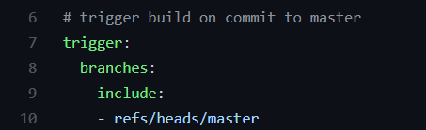

- Please see above yaml file
dotnet build task will build all (3) projects – input passed to build step is **/*.csproj
dotnet test task will build **/*.csproj under folder named testing/Testing (assuming such a folder exists)

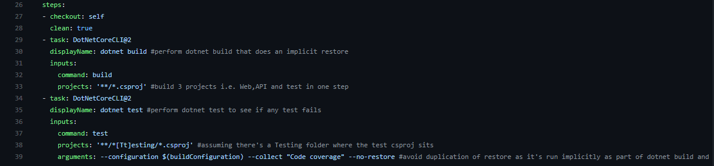

- Automated release creation and deployment to Dev environment

Here, first step is to link a release pipeline with the artifact generated by a build pipeline.

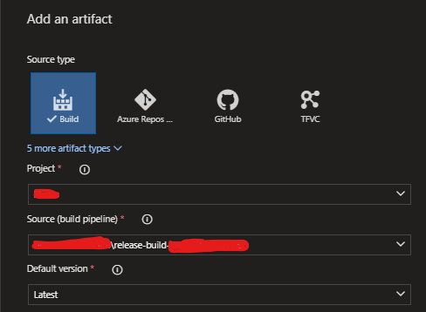

Next, enable Continuous deployment trigger to create a release after a successful build. Also, I’ve added in a branch filter to create automated releases for builds done from main/master/primary branch.

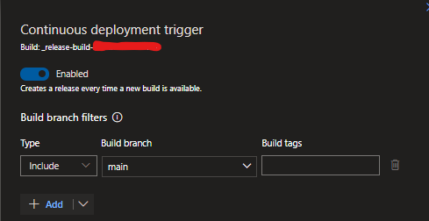

- And 5) Release pipeline will look like this. The two tasks under each stage would be to deploy Web App and Web API to Azure (There’s a marketplace task to perform that)

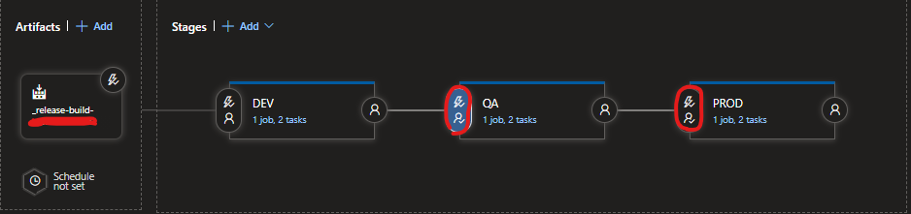

For automatic promotion to QA, following configurations need to be added.

‘After stage’ trigger needs to selected with DEV tickbox checked

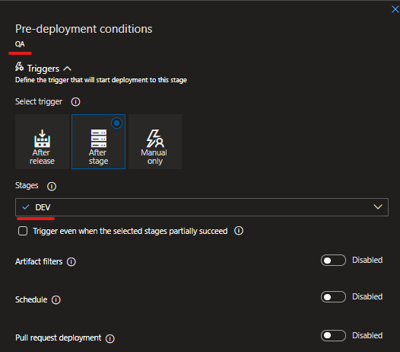

Pre-deployment approvals can be set in this fashion

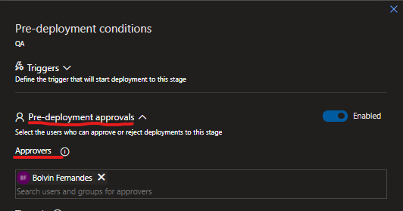

For automatic promotion to PROD, following configurations need to be added.

‘After stage’ trigger needs to selected with QA tickbox checked

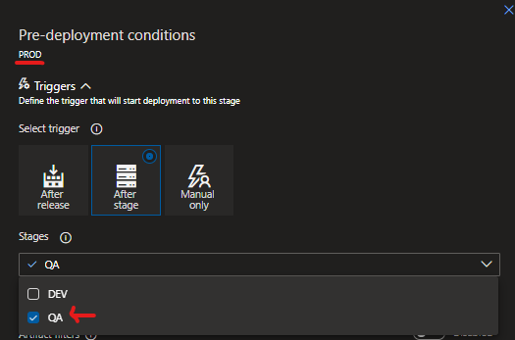

Pre-deployment approvals can be set in this fashion

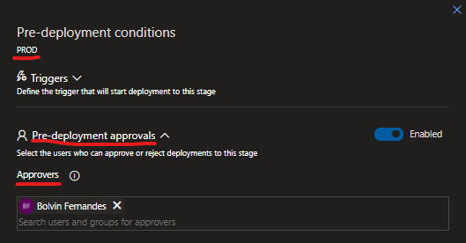

My proposal

- Developers should not be allowed to commit to master directly. They should use feature/dev branches and then submit a pull request (PR) to merge their changes to master/main/primary branch. Hence, it’s necessary to enforce branch policies on master/main/primary branch that include a minimum number of reviewers and a PR build that is triggered with every pull request to master/main/primary branch.

https://github.com/bolvinfernandes/MaerskDevopsTest/blob/main/FastCarz/pipelines/pr-build.yml

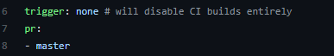

The difference between a PR and Release build is that PR build doesn’t produce any artifacts but is executed in order to make sure that changes coming in from a developer is not breaking the existing code base. As a result, PR build doesn’t necessitate versioning. Also, the type of merge into master/main/primary branch should be a squash merge – as part of a squash merge the feature branch should be deleted as it could create conflicts if reused.

Build and Release pipelines can be configured using either Classic UI editor or yaml. I used both to show a mix. The advantage of using yaml is that it lives with application source code. So, when you branch your code you branch your yaml pipeline as well. This allows a developer to modify the build in their branch without affecting other branches.

I work with Azure Devops on a daily basis hence, I was able to get screenshots as I created my own pipelines. Also, naming convention i.e. pr-build.yml and release-build.yml is something I’ve been using over the years with TFS and now, Azure Devops. I’ve tried to hide any company related information however, if you see it please ignore it 😊

