Xamarinbot V2 - Semi-Controlled BTC 5-Minute Trading Strategy
  - Detailed mathematical strategy, portfolio-control model, timing logic, and hybrid stochastic execution controller
Version 2.0 | 13 August 2026
Purpose. This document starts from the supplied Xamarinbot three-signal strategy and develops the revised design discussed in this session. Baseline behavior is distinguished from proposed V2 logic. Platform mechanics are verified against current official Polymarket documentation; empirical profitability remains to be validated by causal replay and live shadow testing.
Primary design goal: replace a high-win-rate / negative-PnL profile with a system that optimizes expected net PnL, worst-case settlement PnL, entry price, share quantity, and entry timing jointly.
Core thesis: TWAP should anchor settlement state; current BTC should lead timing; CLOB should reveal how much information is already priced; BESTASK/depth should determine executable economics; the portfolio controller should determine how much directional risk the account is allowed to carry.

Contents
1. Source Basis and Design Boundary
2. Market Model and Current Platform Constraints
3. Failure Mode of the Baseline Strategy
4. Notation and Exact Portfolio State
5. TWAP vs Current BTC: Lead-Lag Model
6. Time-Aware State Model for 0-300 Seconds
7. CLOB and Order-Book Confirmation
8. Seed Regime Matrix from the Middle-Ground Diagram
9. Probability / Fair-Value Model
10. Exact Portfolio-Control Mathematics
11. Pair Buffer and Directional Residual
12. Control Variables: When, Where, How, How Much
13. Taker Economics and BESTASK Sizing
14. Maker Economics, Fill Probability, and Adverse Selection
15. Hybrid Stochastic MPC / Semi-Controlled Controller
16. Proactive Place-Cancel-Replace Policy
17. Hedge / Portfolio-Repair Logic
18. Objective Function and Constraints
19. Complete Decision Algorithm
20. Replay, Calibration, and Statistical Validation
21. Parameter Registry
22. Operational Risk and Failure Handling
23. Implementation Interfaces
24. Research Hypotheses and Acceptance Criteria
25. References

1. Source Basis and Design Boundary
Baseline source [X1]. The supplied Xamarinbot document defines a buy-only BTC five-minute strategy that evaluates from 15 to 270 seconds, uses CLOB midpoint momentum, BTC spot momentum, and a Chainlink TWAP gap, requires unanimous direction, executes bounded FAK taker orders, and holds fills to settlement. The baseline also uses a fixed minimum clip, directional-lead sizing, an average-price guard, and risk caps.
Proposed V2. The revised design does not merely change signal thresholds. It changes the problem from Signal -> Side -> Fixed Size into State -> Fair Value -> Target Portfolio -> Optimal Action -> Re-optimize. The resulting system is a hybrid stochastic receding-horizon controller with a deterministic portfolio kernel and learned probabilistic components.
Important boundary. The mathematical framework can prove payoff identities and risk bounds, but it cannot prove trading alpha. Any q = P(UP) model, state transition probability, maker fill probability, or lead-lag edge must be estimated out-of-sample.

2. Market Model and Current Platform Constraints

2.1 Five-minute binary payoff
Each round is modeled on t in [0, 300]. UP and DOWN are complementary binary claims. A winning share settles at 1 unit and a losing share at 0. Therefore the economic value of an order is a function of both directional probability and the price actually paid.
Single-share expected value
Pi_one_share = q * (1 - c) + (1 - q) * (-c) = q - c
Here q is the estimated probability the purchased outcome wins and c is the all-in unit acquisition cost. Positive directional confidence is insufficient when c is too high.

2.2 Order-book and execution mechanics
- All CLOB orders are limit orders; a market-style order is a marketable limit order. [P3]
- FAK fills available liquidity immediately and cancels the unfilled remainder; post-only orders guarantee maker behavior. [P3]
- Selected crypto/finance up-down markets can apply a 250 ms taker delay. A marketable order is then revalidated before matching and cannot be canceled while pending. [P3]
- The lowest ask is the minimum immediately available resting sell price, but actual multi-share execution can walk depth and may be affected by the taker delay. [P4]
- Tick size must be fetched from the market. 0.01 is a valid/common grid, but Polymarket supports other tick sizes and can emit tick-size changes near price extremes; do not hardcode 0.01 as a universal invariant. [P2][P5]

2.3 Fees and TWAP integration
Current taker fee formula [P1]
fee = shares * feeRate * p * (1 - p), crypto feeRate = 0.07
Makers are not charged trading fees; takers are. Fee values should be taken from the market configuration and actual fills rather than hardcoded beyond fallback/testing logic. [P1]
Polymarket currently provides Chainlink-computed 30-second and 60-second TWAP feeds. The lookback window is not the update cadence. Production clients should use Chainlink observation timestamps for freshness and should maintain the correct feed/window mapping instead of inferring it from update frequency. [P6]
V2 requirement. Resolution-source configuration is market-specific runtime state. Subscribe to the exact TWAP window required by the market/rules and optionally to both windows for research features; never assume every BTC 5-minute market uses the same window.

3. Failure Mode of the Baseline Strategy
The observed weakness is payoff asymmetry: many correct trades produce small profits because the selected outcome is already expensive, while an incorrect high-price entry loses most of the share cost. This can yield high win rate but negative net PnL.
Break-even probability for a one-share binary claim when c is all-in cost
q_BE = c
For example, a taker entry near 0.85 has an all-in cost above 0.85 after fees, so the required break-even probability is correspondingly high. The correct optimization target is not raw win rate; it is expected net PnL under explicit tail-loss constraints.
Round-level expectancy
E[PnL] = WinRate * AvgWin - (1 - WinRate) * AvgLoss
Design consequence. The revised strategy must enter earlier when economically justified, improve prices with maker orders when waiting is valuable, and actively control the settlement payoff of the whole UP/DOWN inventory.

4. Notation and Exact Portfolio State
Symbol | Meaning
t | Elapsed seconds in round, 0 <= t <= 300
tau | Remaining time, tau = 300 - t
P0 | Price-to-beat / opening reference
S_t | Current BTC price used as leading input
T_t | Current Chainlink TWAP for the market-configured window
M_t | Polymarket UP midpoint / fair display proxy
A_U, A_D | Current UP and DOWN BESTASK
U, D | Total filled UP / DOWN shares
C | Total actual acquisition cost including taker fees
Pi_U | Settlement PnL if UP wins = U - C
Pi_D | Settlement PnL if DOWN wins = D - C
G | Worst-case settlement margin = min(U,D) - C
R | Directional share imbalance = U - D
q | Estimated probability P(UP | current information)
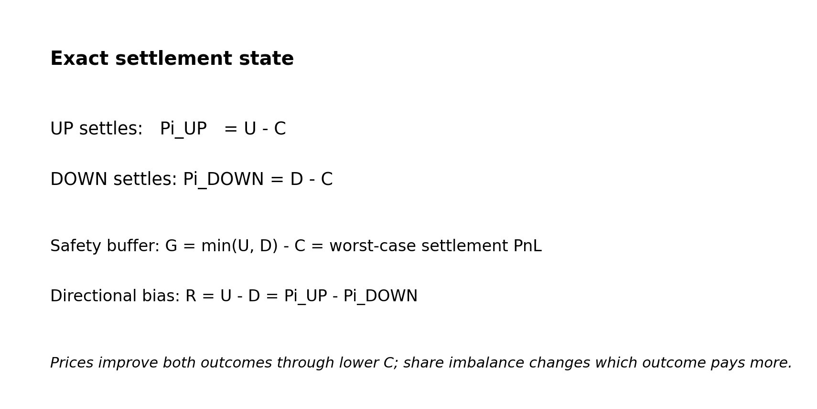

5. TWAP vs Current BTC: Lead-Lag Model

5.1 Settlement gap, spot gap, and lead gap
TWAP settlement-state gap (bp)
G_T(t) = 10,000 * (T_t - P0) / P0
Current-BTC gap (bp)
G_S(t) = 10,000 * (S_t - P0) / P0
Spot-to-TWAP lead gap (bp)
L(t) = 10,000 * (S_t - T_t) / T_t
G_T answers where the smoothing/settlement state currently stands. G_S answers where current BTC is relative to the threshold. L answers which direction current BTC is pulling the TWAP if the move persists.

5.2 TWAP pressure
For an idealized arithmetic rolling TWAP with window W, the derivative is related to the difference between current spot and the price leaving the window. Chainlink does not publish the custom feed sampling/weighting details, so this equation is a modeling feature rather than an attempt to reconstruct the official TWAP. [P6]
Approximate TWAP pressure feature
V_T,model(t) = (S_t - S_(t-W)) / W
Use the official Chainlink TWAP value as truth for the TWAP feature. Use V_T,model only as a predictive feature describing pressure on a rolling average.
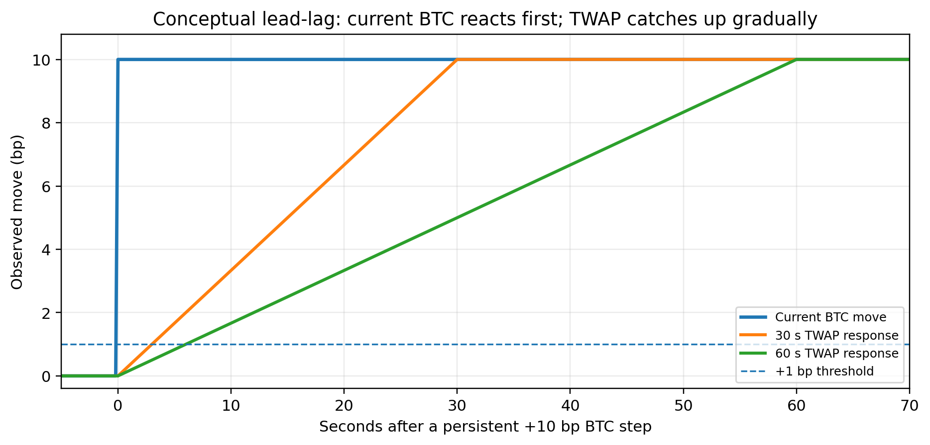
Decision hierarchy. TWAP is the structural/settlement anchor. Current BTC is the leading timing signal. Their relationship is more informative than either alone.

6. Time-Aware State Model for 0-300 Seconds
The same 1 bp gap has different meaning at 40 seconds and 292 seconds because remaining time and volatility change the probability of crossing the threshold. Replace fixed-gap interpretation with a volatility/time normalized state while retaining raw bp values for transparency.
Volatility/time normalized settlement distance
Z_gap(t) = ln(T_t / P0) / (sigma_t * sqrt(tau))
sigma_t must be consistently scaled to the time unit used in tau. In production, use empirical realized volatility from the same BTC reference stream or a robust external spot composite.

6.1 Soft time regimes
Time | Role | V2 interpretation
0-60 s | Discovery / early lead | High value of current-BTC lead; weak confidence in small TWAP gaps; favor observation and selective early alpha.
60-180 s | Core trading | Balance TWAP state, spot lead, CLOB repricing, order-book economics and portfolio buffer.
180-240 s | Compression | Increase weight on settlement distance; reduce patience for slow maker fills.
240-270 s | Late controlled | TWAP and remaining-move probability dominate; only take high-confidence/high-edge actions.
270-300 s | Settlement protection | Separate policy. Default to no new speculative exposure unless specifically validated; prioritize cancel/repair/settlement readiness.
These are initial engineering regimes, not immutable alpha rules. The learned model should use time continuously and may later replace the boundaries with smooth weights.

7. CLOB and Order-Book Confirmation
Baseline direction feature
CLOB_dir = sign(M_t - M_(t-h))
V2 should preserve the sign feature for regime interpretation but also retain magnitude. A robust implementation can use log-odds movement and book imbalance.
CLOB log-odds transform
L_clob(t) = ln(M_t / (1 - M_t))
Magnitude-aware CLOB state
Z_clob = (L_clob(t) - median(L_clob window)) / robust_scale
Order-flow / depth imbalance feature
OFI = (BidVolume - AskVolume) / (BidVolume + AskVolume)
CLOB is not independent evidence: BTC movement can cause both Chainlink movement and Polymarket repricing. Therefore the model should estimate joint conditional value rather than count three agreeing signs as three independent votes.

8. Seed Regime Matrix from the Middle-Ground Diagram
The handwritten ±1 / ±0.5 / 0 diagram is best treated as a seed policy for candidate actions, not as the final executor. The user correction that CLOB UP + Spot UP should produce a TAKER UP candidate in the bullish middle-ground takes precedence over the earlier ambiguous note in the sketch.
Gap regime | CLOB | Spot | Seed action | Interpretation
Positive / upper middle | UP | UP | TAKER UP candidate | Synchronized bullish momentum; act early only if executable edge and risk constraints pass.
Positive / upper middle | DOWN | UP | MAKER UP candidate | Spot/structural state bullish while CLOB pulls back; try to improve UP entry rather than chase.
Near center / weakening positive | DOWN | DOWN | TAKER DOWN candidate | Fast reversal can lead the slower TWAP state; require downside fair-value edge.
Negative / lower middle | DOWN | DOWN | TAKER DOWN candidate | Synchronized bearish continuation.
Negative / lower middle | UP | DOWN | MAKER DOWN candidate | Spot/structural downside with temporary CLOB rebound; seek cheaper DOWN entry.
Any region | Conflict / stale | Conflict / stale | WAIT / CANCEL | No new exposure until the candidate action has positive value and causal inputs are fresh.
Controller override. Every seed action is only an allowed action family. Final choice among TAKER, MAKER, WAIT, CANCEL, or REPLACE is determined by expected value, fill/timing value, and the post-fill portfolio state.

9. Probability / Fair-Value Model
The strategy must estimate q_t = P(UP | X_t). A calibrated logistic model is recommended for V1 because it is interpretable, fast, and easy to audit.
Initial probability model
logit(q_t) = beta0 + beta1*Z_gap + beta2*L + beta3*Z_spot + beta4*Z_clob + beta5*OFI + beta6*tau + interactions
Suggested interactions include Z_gap * tau, L * tau, Z_spot * Z_clob, and volatility * tau. Use regularization and walk-forward validation. Do not optimize directly on a single historical period.
Binary fair-value mapping
FairValue_UP = q_t, FairValue_DOWN = 1 - q_t
Calibration is mandatory. If the model predicts 0.70 repeatedly, approximately 70% of those observations should settle UP in the corresponding out-of-sample bucket.
Probability calibration / accuracy metric
Brier = mean((q_i - y_i)^2)

10. Exact Portfolio-Control Mathematics
Exact settlement PnL
Pi_U = U - C, Pi_D = D - C
Worst-case settlement margin
G = min(U, D) - C = min(Pi_U, Pi_D)
Directional payoff imbalance
R = U - D = Pi_U - Pi_D
These identities are exact regardless of how many fills, price levels, maker/taker orders, or partial fills created the inventory, provided C is the actual total cost.

10.1 Why prices and quantities have different jobs
Lower acquisition prices reduce C and therefore improve both Pi_U and Pi_D. Changing share imbalance changes R and therefore redistributes payoff between outcomes. Entry price controls portfolio efficiency; share quantity controls directional asymmetry.
Matched level and directional half-imbalance
m = (U + D)/2, d = (U - D)/2
Payoff decomposition
Pi_U = (m - C) + d, Pi_D = (m - C) - d

11. Pair Buffer and Directional Residual
For interpretation only, when matched inventory M has all-in average pair costs c_U and c_D and the favored side has residual R >= 0, define a pair buffer B. The exact live engine should still use U, D, and C.
Matched-pair settlement buffer
B = M * (1 - c_U - c_D)
Pair-buffer + UP-residual geometry
If UP favored: Pi_U = B + R*(1 - c_U), Pi_D = B - R*c_U
Expected value decomposition for UP residual
EV = B + R*(q - c_U)
If an incremental matched pair costs more than 1 all-in, that new pair consumes existing buffer rather than creating arbitrage. The total portfolio can still remain profitable on both outcomes if earlier fills created enough buffer.

12. Control Variables: When, Where, How, How Much
The semi-controlled model distinguishes observed state from controllable action. The market is stochastic; the bot controls orders.
Control vector
A_t = (side, mode, limit_price, quantity, TTL, cancel_replace_policy)
Control | Domain | Role
side | UP / DOWN / NONE | Which outcome exposure to add.
mode | POST-ONLY / GTC / GTD / FAK / FOK / WAIT / CANCEL | How aggressively to interact with liquidity.
limit_price | Valid current tick grid | Maximum buy price / resting bid price.
quantity | Non-negative shares/notional | How much exposure or hedge to request.
TTL | Milliseconds/seconds or event condition | How long the current thesis/order remains valid.
cancel/replace | Condition-driven | Re-optimize price/order when state changes.

13. Taker Economics and BESTASK Sizing
At a minimum, a taker buy can consume the current BESTASK, but the actual average execution cost for quantity x depends on depth, taker fees, and any applicable delay/revalidation. Therefore the engine must build an executable cost curve K_U(x) and K_D(x).
Incremental UP taker expected value
DeltaEV_U(x) = q*x - K_U(x)
Incremental DOWN taker expected value
DeltaEV_D(x) = (1 - q)*x - K_D(x)
Choose marginal size only while each additional book level preserves the required edge and the post-fill safety buffer.
Risk-constrained taker sizing
x*_UP = argmax_x DeltaEV_U(x) subject to G_after(x) >= G_min
For an UP-biased portfolio where DOWN remains the worst case, adding an UP taker order with total cost K_U(x) reduces worst-case settlement PnL by K_U(x).
Maximum directional risk-budget spend
K_U(x) <= G_current - G_min

14. Maker Economics, Fill Probability, and Adverse Selection
A maker order exchanges execution certainty for price improvement. Its value must include probability of fill, conditional probability after fill, opportunity cost, and adverse selection.
Maker fill probability
rho(p,h) = P(fill before horizon h | state, price, queue)
Maker value model
EV_maker_UP(p,x,h) ~= rho(p,h) * x * (q_fill - p) - opportunity_cost - risk_penalty
q_fill can differ from q because a resting UP bid is especially likely to fill when the market moves against UP. This is why a fill itself contains information.
The maker price should be optimized on the live tick grid. Do not use a fixed number of ticks from BESTASK as a universal rule.
Optimal maker placement
p*_maker = argmax_p EV_maker(p,x,h)

15. Hybrid Stochastic MPC / Semi-Controlled Controller
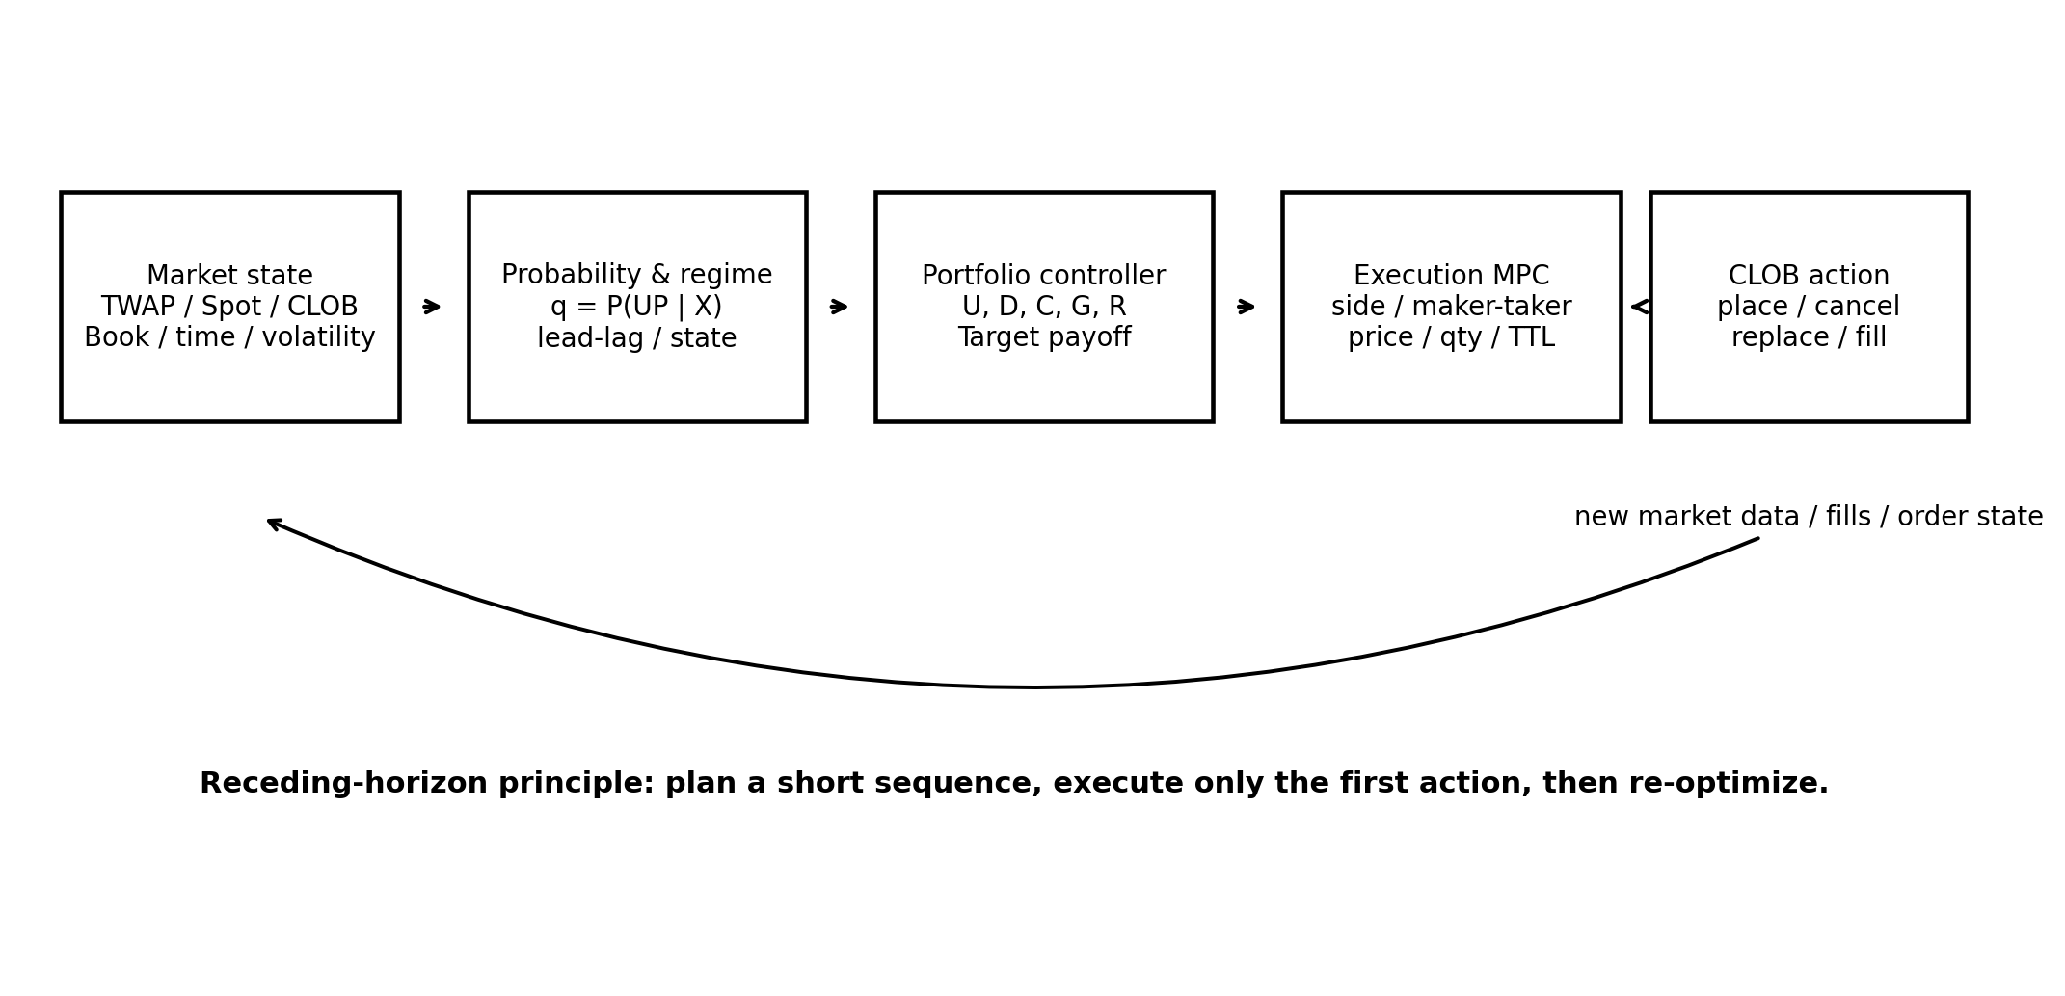
The controller uses receding-horizon optimization. At each event, it predicts a short sequence of possible market/portfolio states, optimizes a sequence of actions, executes only the first action, then re-solves on the next event.
Stochastic state transition
X_(t+dt) = F(X_t, A_t, W_t)
W_t represents uncontrollable market evolution: BTC movement, order-book changes, other participants, fill events, latency, and volatility shocks.
Receding-horizon optimization
A*_t = argmax_A E[J(X_(t:t+H), A_(t:t+H))]
Recommended first implementation: one-step / short-horizon MPC with discrete candidate actions. Do not begin with reinforcement learning. Build a deterministic, replayable controller first.

16. Proactive Place-Cancel-Replace Policy
Order timing is a first-class decision. A maker order should not simply live until a fixed timeout; the system should cancel when the hypothesis or economics no longer justify the order.
Trigger | Condition | Action
Edge failure | Expected filled edge falls below threshold | Cancel or reprice.
Regime flip | TWAP/spot/CLOB state leaves the regime that created the order | Cancel immediately.
Risk breach | Projected fill would push G below G_min | Cancel / shrink.
Time compression | Remaining time makes passive fill too slow | Cancel, convert to taker only if taker EV passes.
Book displacement | Queue/price becomes unattractive relative to new fair value | Replace on new optimal tick.
Feed freshness failure | TWAP/spot/book input stale or timestamp invalid | Cancel risky open orders / freeze new orders.
Condition-based cancellation
Cancel order o when V_o(t) < V_min or its originating state predicate is false

17. Hedge / Portfolio-Repair Logic
Alpha orders seek positive expected value. Hedge orders may have negative standalone EV if they efficiently improve the whole portfolio risk. They must be labeled separately in the journal and optimizer.
Opposite-side hedge effect
If UP favored and buying x DOWN at all-in c_D: DeltaPi_UP = -x*c_D, DeltaPi_DOWN = x*(1 - c_D)
Minimum DOWN hedge to restore loss floor
x_min_hedge = max(0, (-L_max - Pi_DOWN) / (1 - c_D))
Maximum hedge before violating favored-side profit floor
x_max_hedge = (Pi_UP - P_min) / c_D
Downside protection gained per unit favored-side profit sacrificed
HedgeEfficiency(c) = (1 - c) / c
Cheap opposite-side shares are disproportionately efficient for portfolio repair. This is a mathematical reason to use patient maker orders for hedging when timing permits.

18. Objective Function and Constraints
The execution/portfolio controller must optimize economics, not just prediction accuracy.
Primary control objective
J = E[PnL_T] + lambda_G*G_T - lambda_slip*Slippage - lambda_AS*AdverseSelection - lambda_churn*OrderChurn
An alternative risk formulation uses a hard G_min constraint and maximizes EV inside the feasible set. Start with hard limits for safety and interpretability.
Recommended V1 optimization
maximize EV_after subject to G_after >= G_min, spend <= B_max, size <= position limits, data fresh
When UP is favored, the controller may also impose Pi_UP >= P_target or a maximum payoff asymmetry ratio if required by the risk policy.
Optional tail-to-upside control
AsymmetryRatio = abs(min(Pi_U, Pi_D)) / max(Pi_U, Pi_D, epsilon)

19. Complete Decision Algorithm
- Load current market configuration: round timestamps, token IDs, resolution-source mapping, current tick size, fee parameters, minimum order size, and whether a taker delay is enabled.
- Subscribe to official TWAP feed(s), current BTC leading price stream, CLOB order-book stream, and user/order stream. Enforce causal timestamps and freshness.
- At every event, compute G_T, G_S, lead gap L, robust spot momentum, modeled TWAP pressure, CLOB log-odds momentum, OFI, volatility, and remaining time tau.
- Estimate calibrated q = P(UP | X).
- Update exact portfolio state from confirmed fills: U, D, C, Pi_U, Pi_D, G, R.
- Classify the seed regime from the middle-ground state matrix and generate allowed candidate actions: TAKER UP/DOWN, MAKER UP/DOWN, WAIT, CANCEL, REPLACE.
- Build executable taker cost curves from BESTASK and depth, including fee parameters and delay/slippage assumptions. Build maker candidates on the valid tick grid with fill/adverse-selection estimates.
- For every candidate action and quantity, simulate the post-fill portfolio and calculate EV_after, G_after, Pi_U_after, Pi_D_after, cost, and churn.
- Reject candidates that violate G_min, spend, stale-data, position, or operational constraints.
- Optimize the remaining candidates. For a multi-step MPC implementation, optimize a short future action sequence but execute only the first action.
- Before placing a new order, compare it with existing open orders; cancel or replace orders whose originating thesis, edge, or risk condition is no longer valid.
- Journal the full state, candidate set, chosen action, rejected actions/reasons, order lifecycle, fill details, and final settlement result.

20. Replay, Calibration, and Statistical Validation
The strategy must be validated causally. No TWAP, CLOB, BTC, fill, or market metadata observation may be timestamped after the simulated decision time. The baseline document already emphasizes causal replay; V2 expands this invariant to order lifecycle and cancel/replace events.
Layer | Metrics | Purpose
Probability | Brier score, calibration curve, log loss | q must be calibrated, not just directionally accurate.
Alpha economics | Net EV/share, EV/round, realized vs predicted edge | Prove early-entry improvement survives fees/slippage.
Execution | Fill rate, queue wait, taker delay loss, slippage | Maker/taker model must match observed fills.
Risk | G distribution, largest loss, 95/99% CVaR, max drawdown | Verify tail-loss objective.
Portfolio | Pair-buffer contribution, residual contribution, hedge efficiency | Separate inventory construction from directional alpha.
Timing | Value-now vs value-wait, action latency, cancel regret | Prove timing controller improves entries rather than churns.

20.1 Mandatory ablations
- Baseline three-way unanimous strategy.
- V2 TWAP-only probability model.
- V2 current-BTC-only model.
- V2 TWAP + current-BTC lead-lag model.
- Lead-lag + CLOB without portfolio repair.
- Full model with portfolio control but taker-only execution.
- Full model with maker/taker timing and cancel/replace.
- Full MPC versus one-step optimizer.

21. Parameter Registry
Parameter | Initial design | Group
decision/event cadence | event-driven + safety heartbeat | Execution
round start/end | 0 / 300 s | Market
normal speculative cutoff | research parameter; baseline 270 s | Risk/timing
TWAP window | runtime market configuration: 30 or 60 s supported | Signal
spot horizons | 0.25/0.5/1/3/5/10 s candidates | Signal
CLOB horizons | 0.25/0.5/1/3/5 s candidates | Signal
G_min | configured worst-case PnL floor | Portfolio risk
P_min | favored-side profit floor if used | Portfolio
edge_min | minimum predicted net edge | Alpha
maker TTL | state/time dependent | Execution
taker max price | derived from fair value/risk, not fixed delta | Execution
tick size | runtime market value | Execution
feeRate | runtime market value; current crypto table 0.07 | Economics
max spend | account/market limit | Risk
max order churn | rate/interval limit | Operational

22. Operational Risk and Failure Handling
- If official TWAP observation time is stale or feed mapping is uncertain, freeze new alpha orders and consider canceling resting orders whose thesis depends on that feed.
- If current BTC feed diverges materially across providers, degrade confidence rather than choosing the most favorable source.
- If CLOB book hash/timestamp sequencing breaks, resnapshot before further execution.
- If a taker order enters a market delay window, treat the position as pending exposure and do not assume cancellation is available until the order returns.
- If fill acknowledgement is ambiguous, reconcile from user/order stream before submitting replacement quantity.
- Enforce market spend, account notional, daily loss, open-order, and concurrent-market limits independently from predictive logic.
- Use a kill switch that cancels all cancellable orders and blocks new placements.

23. Implementation Interfaces

23.1 MarketState
Core state object
MarketState = {t, tau, P0, T_t, S_t, G_T, G_S, L, V_T_model, sigma, q, book, tick, fees, delayFlag}

23.2 PortfolioState
Exact economic state
PortfolioState = {U, D, C, Pi_U, Pi_D, G, R, openOrders, pendingOrders}

23.3 CandidateAction
Action record
CandidateAction = {purpose, side, mode, price, qty, TTL, expectedFill, EV_after, G_after, Pi_U_after, Pi_D_after}
Every decision should be reproducible from a journal row containing the input state, configuration version, model version, candidate actions, chosen action, and skip/reject reasons.

24. Research Hypotheses and Acceptance Criteria
ID | Hypothesis | Pass condition
H1 | Spot-to-TWAP lead improves entry timing versus TWAP-only. | Out-of-sample net EV improves after costs; not just win rate.
H2 | CLOB magnitude/OFI reveals whether spot information is already priced. | Conditional edge remains after controlling for spot/TWAP state.
H3 | State-dependent maker placement improves pair/hedge economics. | Fill-adjusted maker EV exceeds taker alternative in selected states.
H4 | G-based portfolio control reduces tail losses materially. | Largest loss/CVaR fall without eliminating positive EV.
H5 | Receding-horizon cancel/replace beats fixed TTL. | Lower cancel regret / adverse selection / realized slippage.
H6 | Dynamic time/volatility normalization beats fixed ±1 bp interpretation. | Better calibration and EV across early/mid/late round buckets.
Primary success criterion. Full V2 must show positive out-of-sample net expectancy after realistic fees, latency, depth, partial fills, maker adverse selection, and portfolio constraints. A higher win rate alone is not a pass.

25. References
Ref | Source
[X1] | User-supplied: xamarinbot - Core Trading Strategy & Algorithm (baseline strategy document).
[P1] | Polymarket Documentation - Fees, docs.polymarket.com/trading/fees.
[P2] | Polymarket Documentation - Orders Overview / Tick Sizes, docs.polymarket.com/trading/orders/overview.
[P3] | Polymarket Documentation - Order Lifecycle, docs.polymarket.com/concepts/order-lifecycle.
[P4] | Polymarket Documentation - Orderbook, docs.polymarket.com/trading/orderbook.
[P5] | Polymarket Documentation - Market WebSocket Channel / tick_size_change, docs.polymarket.com/market-data/websocket/market-channel.
[P6] | Polymarket Documentation - Chainlink TWAP Prices, docs.polymarket.com/market-data/chainlink-twap.

