def recursive_fibonacci(n):
if n<=1:
return n
else:
return recursive_fibonacci(n-1) + recursive_fibonacci(n-2)

def non_recursive_fibonacci(n):
first=0
second=1
print(first)
print(second)
while n-2>0:
third = first + second
first=second
second=third
print(third)
n-=1

if __name__=="__main__":
n=10
for i in range(n):
print(recursive_fibonacci(i))

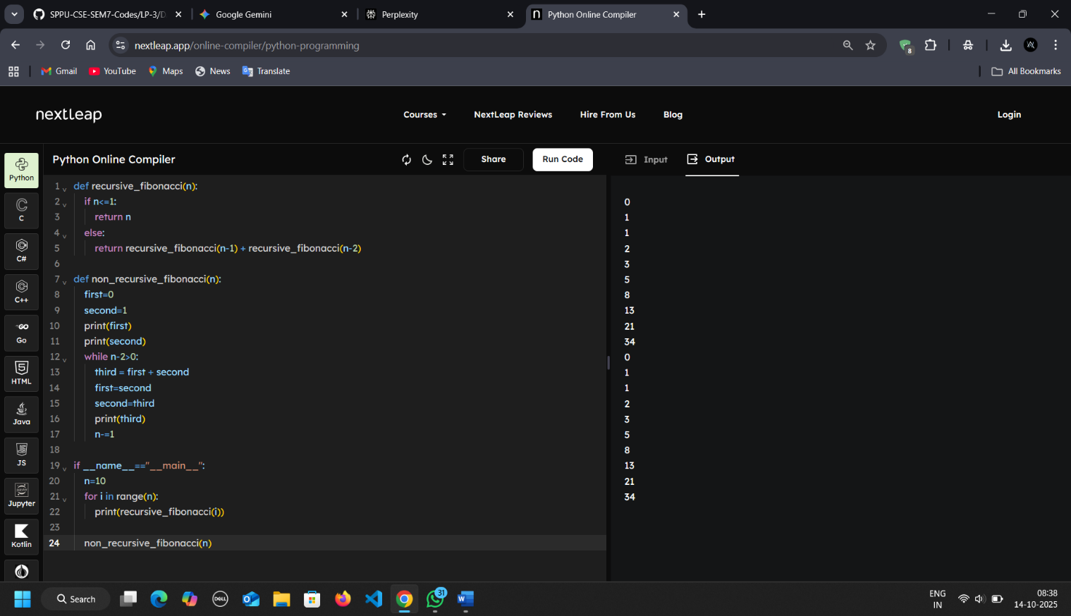
non_recursive_fibonacci(n)

