import heapq

# Creating Huffman tree node
class node:
def __init__(self,freq,symbol,left=None,right=None):
self.freq=freq # frequency of symbol
self.symbol=symbol # symbol name (character)
self.left=left # node left of current node
self.right=right # node right of current node
self.huff= '' # # tree direction (0/1)

def __lt__(self,nxt): # Check if curr frequency less than next nodes freq
return self.freq<nxt.freq

def printnodes(node,val=''):
newval=val+str(node.huff)
# if node is not an edge node then traverse inside it
if node.left:
printnodes(node.left,newval)
if node.right:
printnodes(node.right,newval)

# if node is edge node then display its huffman code
if not node.left and not node.right:
print("{} -> {}".format(node.symbol,newval))

if __name__=="__main__":
chars = ['a', 'b', 'c', 'd', 'e', 'f']
freq = [ 5, 9, 12, 13, 16, 45]
nodes=[]

for i in range(len(chars)): # converting characters and frequencies into huffman tree nodes
heapq.heappush(nodes, node(freq[i],chars[i]))

while len(nodes)>1:
left=heapq.heappop(nodes)
right=heapq.heappop(nodes)

left.huff = 0
right.huff = 1
# Combining the 2 smallest nodes to create new node as their parent
newnode = node(left.freq + right.freq , left.symbol + right.symbol , left , right)
# node(freq,symbol,left,right)
heapq.heappush(nodes, newnode)

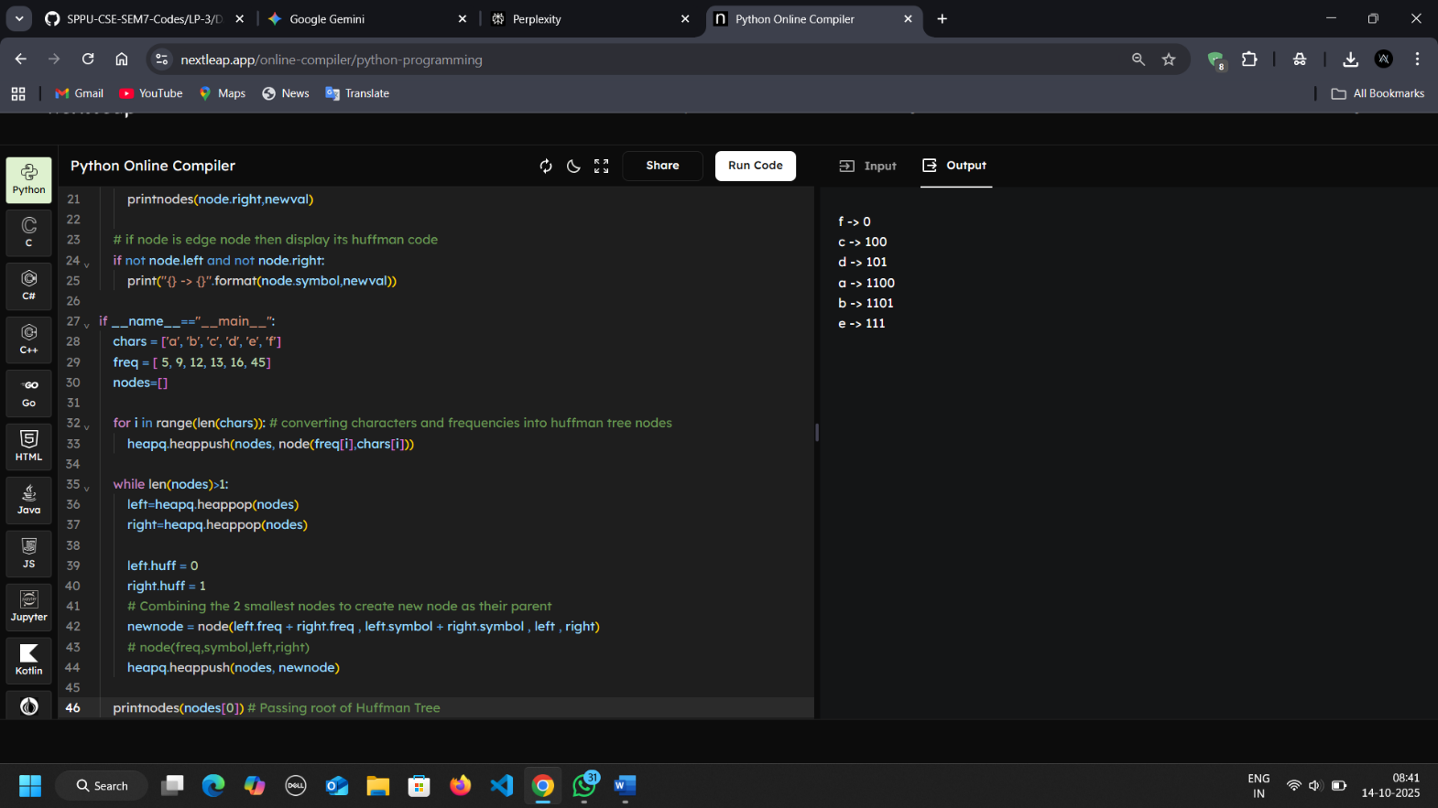
printnodes(nodes[0]) # Passing root of Huffman Tree

