4.1: Best Practices for Working with Human Test Subjects

Learning Goals

* Discuss best practices for recruitment and usability testing with human subjects

 Estimated Read Time: 40 Minutes.

Introduction

Welcome to Achievement 4 of your UX Immersion Course! At this point in the course, we’ve covered best practices in understanding the problem you’re trying to solve, user research and personas, and the principles of information architecture. The last Achievement culminated in the creation of an interactive prototype. How do you feel about your prototype? Is it a triumph of visual, information, and interaction design? It’s time to find out!

Now that you have a prototype, it’s time to test it with real people. Using evaluative research, we’ll test our design decisions and expectations against the attitudes, behaviors, and psychologies of real people. When we first began our exploratory research with potential users, we were interested in learning more about them and the problems they faced in order to start shaping a solution. Now that we have a potential solution, we want to validate and evaluate that solution with usability testing.

Throughout this Achievement, we’ll explore the importance of usability testing for a UX designer, as well as how to conduct a test for your own design. Let’s start by taking a look at why we’re doing this kind of research, followed by some best practices for engaging with and recruiting usability test participants.

The Importance of Evaluative Research

Evaluative research is an incredibly valuable component of the design process, and it’s something that will likely come up more than once in various stages of the process. You’ll want to run multiple usability tests as you refine and iterate on your designs, for example. This practice ensures companies are building the right things (and that those things are usable by people), but why else would we want to conduct this kind of research? Let’s take a quick moment to review.

**To create “useful” products and services that are designed with objectivity and empathy for others in mind.**

The ultimate goal of design research is to build something useful for real human beings. In order to be useful, our designs need to provide the appropriate utility, or features, as well as be usable (i.e., these features must be sufficiently simple and enjoyable to use). You may remember Jakob Nielsen’s formula from the UX Fundamentals Course, but let’s take a moment to revisit it in relation to usability testing.

* **Utility** = The features and functionality needed to complete important tasks
* **Usability** = How easy your project features are to use, as well as whether they bring satisfaction
* **Useful = Usability + Utility.** For something to be useful, it must address the functional and emotional requirements expressed by your target audience during research.

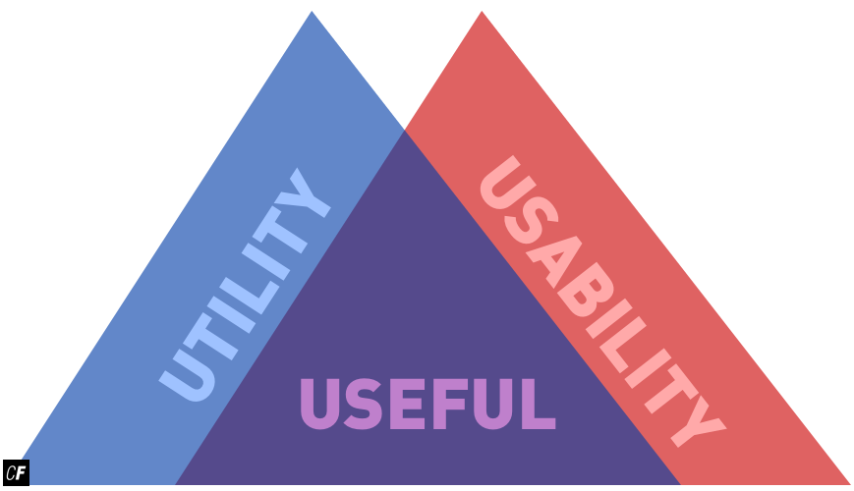

How do we build something useful for people we don’t know? People who might have radically different problems, goals, and environments than our own? Designing with genuine objectivity and empathy for others in mind is an incredible challenge as designers themselves are not immune to their own environment and influences. The only way to validate the usefulness of your design or prototype is to test it with real people using evaluative research methods such as usability testing.

**To design for people we don’t know or don’t understand.**

Communities around the world are trying to replicate and iterate on Silicon Valley’s design and technological prowess. From Bangalore’s Silicon Plateau to Berlin’s Silicon Allee, designers and technologists flock to specific geographical locations to build products for the rest of the world on an epic scale. The ability for like-minded and open-minded individuals to congregate has created some incredibly new and novel ideas, some of which have had a measured, positive impact on the world.

That being said, there exists a very real risk that designers “scratch their own itch” by only designing and building things that benefit those within these various “Silicon Sections” of the world. Again, the only way to find out if a design is useful is for others is to test it with valid evaluative research methods.

As you can imagine, designing for and researching with humans is a messy endeavor. Statistics and research methods are rigorous and rational, but our test participants and customers might not be. In addition to designing Useful and Usable products and services, they must also be Desirable, Accessible, Credible, and Findable to deliver real value to real people. Sound familiar? These traits come from Peter Morville’s UX Honeycomb model:

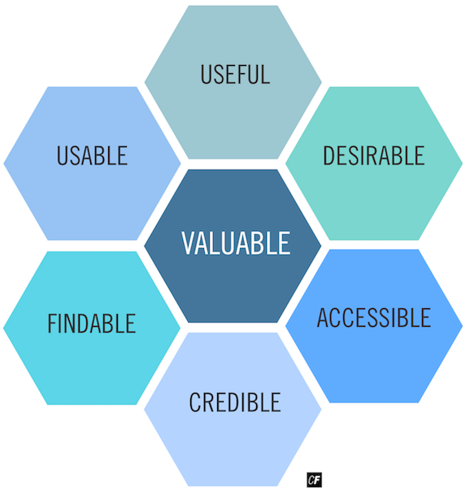

We’ll be talking more about the aspects of the honeycomb and how they relate to research later in this Achievement. For now, however, simply note the importance of involving people different from you and your colleagues in your research—this is one of the best ways to ensure your designs are driven by the positive impact you can make on people’s lives. On that note, let’s take a look into responsible methods of conducting research.

Usability Testing: Art or Science?

How does design research relate to research conducted in other disciplines? Design researchers often engage in activities associated with traditional research methods, from gathering and analyzing data to creating and testing hypotheses. Unlike in other areas of research, however, designers aren’t often held to particular standards and regulations. This means that it’s up to the designer to make sure they’re carrying out research in a responsible, ethical manner.

Design research falls in the same general area as research for the soft sciences—fields like psychology, sociology, and political science. Research of this type draws heavily on the attitudes, psychology, and behavior of real humans and is most often subject to strict regulations about what type of research can be done and the level to which participants must be informed about the studies in which they’re participating. Despite its focus on intangibles (human psychology, for instance), research in the soft sciences isn’t all guesswork. Researchers in these areas draw upon the same general experimental structure you see in the hard sciences (physics, chemistry, and medicine). Check out the scientific method chart below:

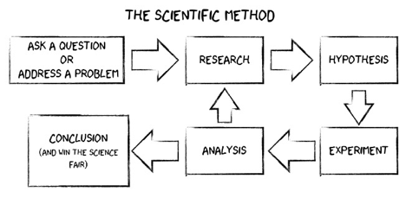

Source: [Wired](https://www.wired.com/2013/04/whats-wrong-with-the-scientific-method/)

Looks familiar, right? You probably remember it from high school science classes. We can follow a similar method in our design research process. In design, we start by asking questions and identifying a problem, then we create a hypothesis (often in the form of a prototype), and, finally, we conduct various iterations of evaluative testing to analyze the usefulness of the thing we’ve designed. While messy, research based on the scientific method is invaluable when making design decisions that best suit the real humans for which you’re designing. Here’s where it gets tricky, though. If the processes are so similar across the board, why is design research, or UX research, typically not subjected to the same level of oversight and regulation as other scientific research in the biomedical and social sciences?

According to the U.S. Department of Health and Human Services #46.102, research is officially defined as: “systematic investigation, including research development, testing, and evaluation, designed to develop or contribute to generalizable knowledge.”

As Nicholas Bowman explains in "[The Ethics of UX Research](http://www.uxbooth.com/articles/ethics-ux-research/)," the key clause in the formal definition of research is “generalizable knowledge.” Research, by legal definition, should contribute to some public body of knowledge. Typically, UX research is specific to a particular product and is private proprietary information, not published in the public domain. As long as data is aggregated and not focused on an individual's personal information, companies such as Facebook or Google can analyze mountains of data and conduct social experiments in the absence of formal regulation and ethics reviews.

There’s no set of hard and fast rules for designers when it comes to correctly and responsibly setting up their evaluative research studies. That being said, it’s important that designers operate in this grey area with conviction and integrity. It’s up to individual designers to ask themselves tough questions and engage in open debate with others in the field in an effort to focus on the mission of solving real problems for real people. If UX designers don’t fight for humans, who will?

Informed Consent



As a user researcher, you have an ethical duty to ensure your user research doesn’t harm those who take part. To do so, use some of the same practices prevalent in the hard and soft sciences when it comes to conducting research. The most critical of these is informed consent. **Informed consent** is the process of helping research participants make an educated decision as to whether they want to take part in your research. Informed consent describes the nature, intent, and details of your study to participants, allowing them to make a conscious decision on whether or not they want to participate.

You can find many examples of informed consent forms online. Check out the [adult remote usability test consent form template](https://www.usability.gov/how-to-and-tools/resources/templates/consent-form-remote-usability-test-adult.html) from Usability.gov to start. You’ll notice that the general pattern comprises informing the participant as to the goal of the study, how their information will be used, and that their participation is voluntary. In addition to informed consent, you’ll also want to tell your participants whether they’ll be recorded and how that recording will be used. We’ll take a look at some additional recording consent forms later in this Achievement.

You may be asking yourself what the harm is in not telling participants what they’ll be doing in a test or how their information will be used. As it turns out, such practices can lead to actual psychological harm or, at the very least, don’t allow participants to keep their best interests in mind. You may recall the uproar over a 2012 Facebook study that manipulated users’ feeds to see what impact doing so would have on users’ emotions. Some reactions to the study were released in 2014 in “[Facebook emotion study breached ethical guidelines](https://www.theguardian.com/technology/2014/jun/30/facebook-emotion-study-breached-ethical-guidelines-researchers-say)," by The Guardian. While personal data is collected routinely by websites that then use it to tailor marketing content to users, the big difference in this study was the lack of transparency and informed consent by the users, who arguably suffered as a result.

In a similar vein, it’s important to keep your users from suffering psychological or emotional harm in the midst of your test. When conducting a usability test, make sure your participants understand that you’re not testing them or their capabilities, but rather *your* design. Assure them that there’s no way for them to “fail,” and that if they can’t complete a task, it’s simply the fault of the designer. Highlighting and catching your own mistakes as a designer is, after all, the main point of performing usability tests. Later on in this Achievement, we’ll talk more at length about how to get this information across to your participants and look at what constitutes a participant's “Bill of Rights,” which outlines practical tips to ensure safety and security during research.

MORE ON ETHICS AND INFORMED CONSENT  
For more details on the above questions, read "[The Ethics of UX Research](http://www.uxbooth.com/articles/ethics-ux-research/)" by Nicholas Bowman and "[What User Researchers Ought to Know About Informed Consent](http://www.userfocus.co.uk/articles/what_user_researchers_ought_to_know_about_informed_consent.html)" by David Travis.

Responsible Recruitment

Now that we’ve thought about the *how* of running a test responsibly, let’s shift gears and look at some of the issues surrounding the *who*.

Ideally, when outlining your research and recruiting participants, you’ll want to find people who are different from you. In fact, testing edge cases of your design with participants who vary greatly from yourself/your typical target audience often creates incredibly insightful results, especially if there’s a known or unknown subset of users who might end up engaging with your design beyond your primary persona.



One group you may want to consider, for example, is those with disabilities. Clarifying your design to make it more accessible is helpful for all users, but especially for those with particular needs. We’ll talk more about accessibility in design in Achievement 6, but keep it in the back of your mind for now. You might also think back to the discussion we had at the beginning of this Exercise—about consciously or subconsciously designing only for those similar to you and your community. Are you talking to participants with a variety of gender identities, ages, ethnicities, backgrounds, and so on?

While it’s most important to test with your primary persona, ensuring that you run some usability tests with those *dissimilar* to you or your persona is a good way to ensure your designs are useful to as broad an audience as possible. This will also help you avoid general research issues such as **sampling bias**, which causes errors in results due to a non-random selection of test participants. While it’s obvious that design research requires you to test a specific type of person, sampling bias can mean your results aren’t generalizable to a larger audience or customer segment. Just remember to think carefully about who you’d like to have participate in your usability tests and be sure you have some variety.

Finding Participants for Your Research

As mentioned above, finding people to test with can be tricky even for experienced researchers. Every project is different and has a different target audience. It’s important to consider what you’re testing, who you’re designing for, and who you’d like to get feedback from when recruiting research participants. This often requires utilizing a third party service (or simply getting up from your desk and hunting for participants in the wild). There are many ways to go about this, and luckily for us, more sophisticated services are popping up as more and more companies recognize the importance of design research.

For this project, we recommend starting with people in your network for some “guerrilla testing” to help include some variety in the types of people you’re testing. For future projects, it’s likely your friends, family, and Twitter followers will be tired of testing your every design decision, and you’ll have to reach out beyond your network to find willing participants. Let’s touch on a few of the different ways to go about recruiting participants.

* **Personal Network:** It’s entirely possible that you might be able to test your product or service with people you already know. This is useful for designers new to the field as it’s easy and comfortable, but can be limited if your target audience has little overlap with your network.
* **Hallway Testing or “Guerrilla Testing”:** This type of recruitment simply involves approaching friends, coworkers, or strangers in their natural environment. This can be at the office, in the street, or in a cafe. This is a highly informal method that requires creativity and persistence. You’ll likely experience rejection from some people, but that’s okay! Not everyone has time at every given moment, and others might be shy. Try to strategically place yourself in gathering places and/or provide incentives such as a coffee or treat. This form of usability testing is common thanks to its low cost and simplicity, and it can even keep up with the big-budget methods of fast-paced technology companies.
* **Existing Users:** If you’re working on a live product or service, get in touch with current users to ask if they’d like to participate in your research. Talk to the marketing and customer service teams at your company as they often engage directly with customers.

OTHER PLACES TO LOOK FOR PARTICIPANTS  
While you’re not likely to use these services or strategies for finding participants in this course, it’s nice to know that there are other services out there. Feel free to bookmark these for use after you’ve graduated.

* **Third Party Online Services** help recruit participants using specific demographic information such as age, gender, and location. Tests are often online and unmoderated, and results are delivered as a report or video. [UsabilityTesting](https://www.usertesting.com/), [Userzoom](http://userzoom.com/), and [UsabilityHub](https://usabilityhub.com/) are a few.
* **Amazon’s Mechanical Turk** is useful if you need to recruit a high volume of participants at a low cost. It allows you to set up a test and pay anonymous people a small amount to complete quick tasks.
* **Classified Advertisements** such as Craigslist or local classifieds might be a good place to find local participants. Panel Agencies such as [ResearchNow](https://www.researchnow.com/) have large databases of potential participants available for unmoderated tests. Costs range between $15 and $55 per response.

Contacting Participants for Your Research

As mentioned above, you’ll likely be recruiting test participants from your existing personal network throughout this course. This might be as simple as asking a colleague, tweeting out a call for participation, or messaging a friend. If possible, conduct in-person usability studies with people in your network. This is the best way to practice without worrying too much about location or technological logistics getting in the way.

It’s still important, however, to get practice contacting potential participants in a more formal manner and including useful information about your study to ensure people can make a decision about whether to participate. When contacting potential participants you don’t know, it’s extra critical that you introduce yourself and the project properly and explain the expectations and incentives for the test participant. The circumstances of the project may vary, but in general, there are a few types of common templates/messages researchers use to contact potential participants. [Usability.gov](https://www.usability.gov/) is a great place to look for recruitment, confirmation, and reminder [email templates](https://www.usability.gov/how-to-and-tools/resources/templates/email-template-usability-study-recruiting.html).

Regardless of the type of template, there are some things that all good messages have in common. Here are some tips for writing effective templates/messages:

* Keep your message brief
* Format your message for easy reading
* Use simple language
* Clearly explain the expectations of the study
* Highlight the incentives
* Make the recipient’s desired action clear

TIP!  
For more details on the above tips and templates, check out "[Recruiting User Research Participants by Email](http://www.uxmatters.com/mt/archives/2014/11/recruiting-user-research-participants-by-email.php)" by Jim Ross/UXMatters and "[3 Email Templates for Recruiting All the Users You Need in 24 Hours](https://medium.com/user-research/3-email-templates-for-recruiting-all-the-users-you-need-in-24-hours-81a774a13bb6#.k3sh7cwn5)" by Charles Liu.

Summary

There are many considerations that go into running responsible, ethical, evaluative research studies with human test subjects, and it can be exhausting to try and think it all through. Don’t get discouraged! By building these processes into your designs even before your testing begins, you’re making great strides toward protecting your participants and obtaining the best possible results from your tests.

Remember to consider issues such as informed consent and variety in recruitment. You may find it useful to create a general informed consent template you can modify each time you conduct a usability test or evaluative research study. You’ll also want to create some general templates for yourself to use when recruiting participants that clearly present to potential participants what your study is about and what they’ll get out of participation. The templates provided in this Exercise are a great place to start. As we make our way through the rest of the Achievement, you’ll have the opportunity to put these best practices into actual practice as we conduct a usability test on your designs.

Resources

* [The Ethics of UX Research](http://www.uxbooth.com/articles/ethics-ux-research/)
* [Usability 101: Introduction to Usability](https://www.nngroup.com/articles/usability-101-introduction-to-usability/)
* [Subpart A - Basic HHS Policy for Protection of Human Research Subjects](http://www.hhs.gov/ohrp/humansubjects/guidance/45cfr46.html#46.102)
* [7 Ways to Find Users for Usability Testing](http://measuringu.com/finding-users/)
* [What User Researchers Ought to Know About Informed Consent](http://www.userfocus.co.uk/articles/what_user_researchers_ought_to_know_about_informed_consent.html)

Take the quiz to test your knowledge on this Exercise.

Take Quiz

Task

* [DIRECTIONS](https://careerfoundry.com/en/course/become-a-ux-designer/exercise/human-test-subjects#directions)
* [SUBMISSION HISTORY](https://careerfoundry.com/en/course/become-a-ux-designer/exercise/human-test-subjects#step_submission_history)

 Estimated Task Time: 3 Hours.

You’ll be conducting usability tests on the prototype you designed in Achievement 3 later on in this Achievement. In this Task, we’ll start laying the groundwork for those tests by setting up a plan of action and devising a couple of templates. Ready to get started?

In Exercise 4.5, you will be asked to record (audio/video) your tests, so be sure to include this foresight into your plans.

**Directions**

1. Create a concise informed consent form that you’ll be able to use to test your prototype with human test subjects. You’ll want to include the following information:
   * What the study is about
   * How information from the study will be used
   * That participation in the study is optional
2. Develop a short, 500-word-or-less plan of attack for recruiting test participants that answers the following questions:
   * How will you find test participants?
   * Where is your audience located? Do you have access to your audience? If not, how will you test with them?
   * How will you explain your project and research to your test participants?
   * How will you ensure your participants are fully informed about the purpose of your study, and how you will use their information?
3. Download the [Usability Study Recruiting Email Templates](https://www.usability.gov/how-to-and-tools/resources/templates/email-template-usability-study-recruiting.html) from Usability.gov. Then, modify the recruitment email, confirmation email, and reminder email templates with details of your own project, taking into consideration the goals and target audience of your project. (The template also says the test will be one hour long, but in fact, it should only take 10-15 minutes.)
4. Use your recruitment email to start searching for at least 6 potential test participants from your personal network to conduct testing with later in this Achievement.
5. Upload a single PDF that includes your informed consent form, your recruiting plan of attack (500 words or less), and your recruitment, confirmation, and reminder email templates. Feel free to share additional thoughts or ask questions on your submission page.

If you need some inspiration, check out and/or modify these consent forms from Usability.gov: [adult remote usability test consent form](https://www.usability.gov/how-to-and-tools/resources/templates/consent-form-remote-usability-test-adult.html) and [adult consent form](https://www.usability.gov/how-to-and-tools/resources/templates/consent-form-adult.html).