1.1: The Role of the UX Designer

#### **Introduction**

Welcome to the first Achievement of the UX Immersion Course! As you read in UX Fundamentals, the field of user experience design has a long history and has grown immensely over the last twenty years, and it continues to expand even today. That’s really no surprise considering how often people interact with their digital devices—most of us can’t get through a single meal without checking Facebook! With the commoditization of smartphones, laptops, televisions, cameras, and a multitude of other electronics, the concepts of design and user experience have become more important than ever. It’s no longer enough to offer a useful program if that same program isn’t well-designed and easy to use. Apps and websites have to be useful, accessible, appealing, and simple if they’re going to attract a following in today’s day and age.

Though this may seem daunting, this is great news for user experience designers. After all, who else is going to make all those apps easy to use?

#### **What Do UX Designers Do?**

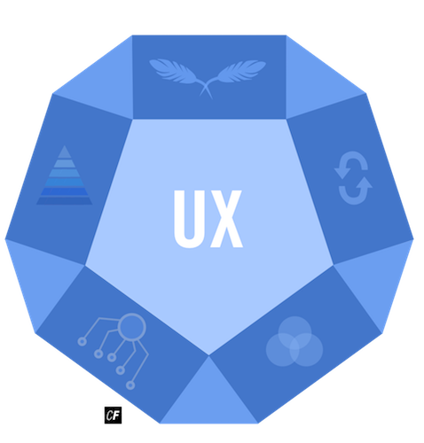

Let’s take a moment to review the role of the UX designer. **User experience designers**employ design skills, processes, and knowledge to improve customers' interactions and experiences with a variety of products and services, digital and otherwise. In most cases these days, this interaction is with a computer or mobile device, but other electronic devices such as television remotes, home thermostats, or even blood glucose monitors all fall under this umbrella, as do interactions from assembly lines to airport security lines and customer service experiences. In this course, we’ll be focusing on digital interactions.

A user experience designer is more than just a designer—they’re also a scientist and artist with a multidisciplinary background. Creating successful UX design requires the imaginative skills, techniques, and trainings of an artist, as well as the analytical research, discovery, and methodological processes of a scientist in order to fully explore and understand users’ needs.

For any given project, the UX designer maintains a balancing act between designer and scientist while adhering to the following stages:

* User Research
* Design
* Testing
* Implementation

While the design and implementation phases call upon artistic skills, the user research and testing phases are more akin to scientific methodology. It’s important to note that these four phases are not quite as linear as the outline suggests. In particular, the design and testing phases are often repeated in several ongoing iterations.

As you learned previously, once the research phase is complete, initial designs are first created, then tested. Depending on the outcome of the test, the design is revisited, then new designs are created and tested again. As before, the design may be reiterated depending on the new results. This recursive cycle can continue for several iterations before any actual implementation begins.

This is why, as a UX designer, your role on a product team is crucial. It’s up to you to ensure that everything being built is not only functional but meets the needs of your users, as well. After all, you can design and develop any program you’d like, but there’s no point if your users can’t understand or enjoy it.

#### **The Product Team**

As a UX designer, you’ll most likely be part of a **product team**. A typical product team consists of the following players:

* **Product Manager**: Oversees the entire development of the product. In addition to ensuring that the product is competitive and solves a problem in the market, the product manager oversees the work of the designers and programmers to make sure they’re working towards the agreed-upon vision.
* **Developers**: Engineers who work on the actual software code. This could include mobile, backend, frontend, machine learning, etc.
* **Designers**: Anyone working on the aesthetics of the software. This could include UX designers, UI designers, visual designers, and graphic designers.

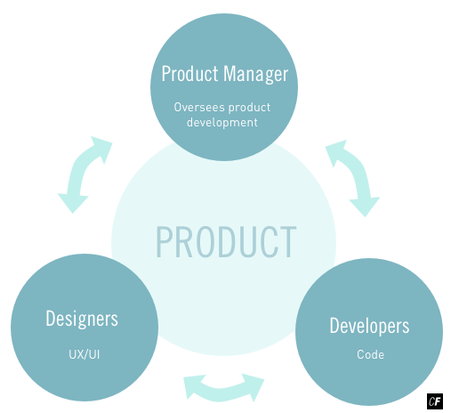

The job of the UX designer is to flesh out how the pieces of the product work together and conduct research to ensure that the product and its future iterations are effective for the users. Typical deliverables of a UX designer are multifold; they include, but are not limited to, user personas, usability testing results and analyses, user research findings, user flows, information architecture, wireframes or prototypes of various design fidelity, and so on.

When it comes to working with other team members within the product team, a general workflow goes something like this: finalized wireframes or prototypes are handed off to a UI designer to bring to life via visual details, and after all the design work has been finished, final implementation is then handled by the development team.

#### **Experience Design in the Real World**

When you hear the words “experience design,” you probably think of computers, mobile phones, or other digital systems you interact with on a daily basis. The truth is, however, that the roots of experience design extend far beyond digital design. The paths you walk on, the buses you ride, and the doors you open each provide you with their own “experience.”

Before we explore the specifics of “user” experience design, let’s take a look at experience design in the general sense for a glimpse at its important role in our day-to-day lives.

##### **Queue Psychology**

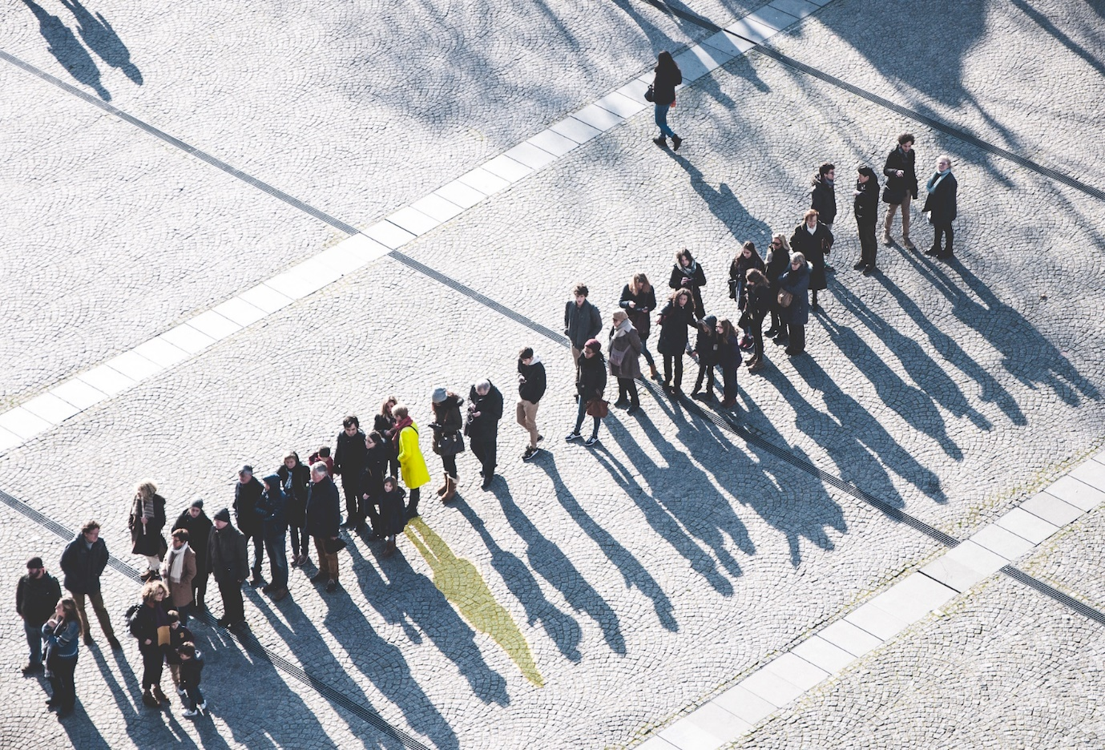

One very common experience we all share is waiting. Waiting in a queue, whether it be at a grocery store checkout or in traffic on a highway, can be extremely frustrating—but it doesn’t have to be!

When Walt Disney opened the Disneyland theme park in 1955, he pioneered much of what is now known as “queue psychology.” **Queue psychology** focuses on improving the experience of waiting.

There are several known factors that can make the waiting experience less excruciating. For example, time spent moving slowly in a line can feel shorter than time spent standing still. Simply knowing how long you have to wait makes time seem shorter than when waiting in the dark. Standing with acquaintances or friends can also make the wait feel shorter. And what about perceived fairness? Having someone cut in front of you increases not only your time spent waiting but your frustration, to boot.

Over the years, Disney parks have continued improving the experience of queues. So much, in fact, that it’s now difficult to tell where a queue begins. What was once a long line of people waiting to board a ride is now part of the attraction itself. In many cases, background story elements and interactive games are located at strategic points throughout the queue. Rather than seeing frustrated patrons in line, you now find people laughing and having fun, and that’s before the ride even begins.

Designers of Disney theme parks follow a set of principles they call “Mickey’s Ten Commandments.” Among them is one that underlines their emphasis on guest empathy. That principle is:

"Wear your Guest’s shoes: Insist that your team members experience your creation just the way the Guests do it.”

Note how Disney capitalizes the word “Guests”—a nice nod to the esteem and respect they try to maintain towards their customers.

##### **Wayfinding**

Over the years, science and design have collaborated in more ways than just this to improve the experiences of humans. One large (but often taken for granted) field is **wayfinding**—the orientation and navigation of people (or animals) in a physical space. Though we don’t often think about it, our physical environments provide us with cues as to where we are and where we’re going. An obvious example is signage on the highways. As we drive, we encounter signs pointing us to exits and on-ramps that ultimately guide us to our intended destination.

Large public spaces such as parks, airports, and sports arenas all employ wayfinding to help us get to where we’re going. In addition to obvious cues like signs and arrows, designers also employ a variety of subtle techniques to point us in the right direction. Graphics can be used to insinuate paths while distinct colors can mark differences in areas and functions.

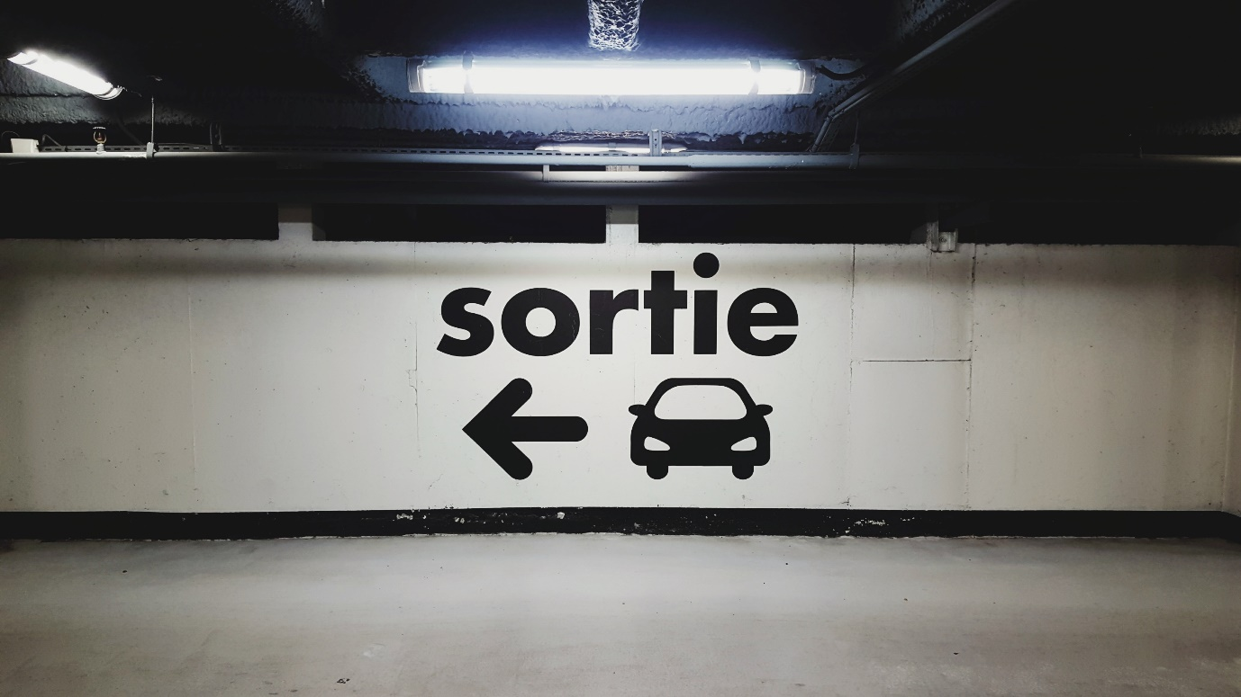

Sometimes, as humans, we violate these paths laid out for us. As a user experience designer, it’s up to you to analyze how a user interacts with your system and adjust accordingly to improve the overall user experience.

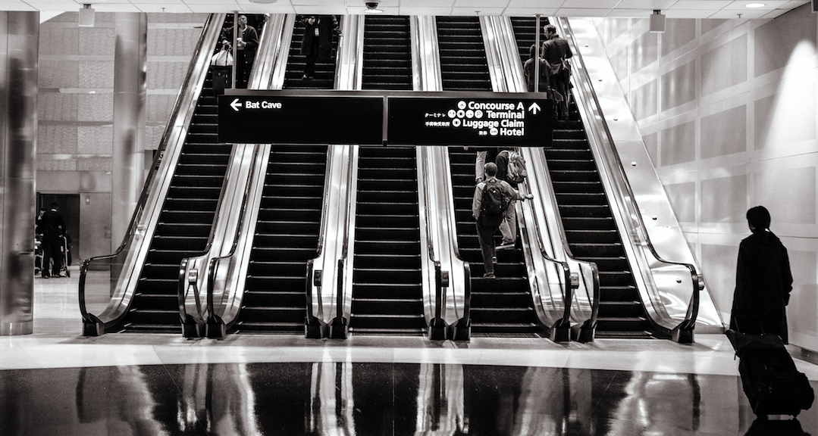

##### **Animal Experience**

Design can be used not only to provide better experiences for humans, but for non-humans, as well. Temple Grandin, for example, revolutionized animal well-being in the livestock industry with her improvement of animal environments. Now a professor of animal sciences at Colorado State University, her insights into animal UX came as a result of her personal struggles with autism. Grandin had always felt easily threatened by elements in her environment. Drawing on her own experience, she theorized that cattle might feel similarly anxious by the environment of a cattle ranch. To test her theory, she navigated through a cattle processing plant to experience for herself what cattle were going through and ultimately used her findings to improve their environment.

Grandin’s work resulted in massive environmental changes at slaughterhouses. While her work remains controversial among some animal rights activists (she is, after all, working for the meat industry), she contends that if humans are going to eat meat, they owe it to those animals to see that their lives—and deaths—are as pleasant and stress-free as possible.

These are but a few ways that human and animal experiences are being improved via experience design. It’s important to understand that design, as both a concept and skill, can be used to improve any number of experiences both real and digital.

TRY IT!  
In what other ways does experience design affect your non-digital life? See if you can find five examples, then share these examples with your fellow students on Slack or start a discussion with your Tutor.

#### **The Consumer Experience**

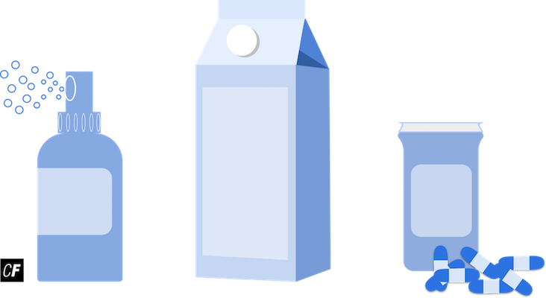

The concept of design is not only important for us as designers but for us as consumers, as well. Each time we open a bottle or sip coffee from a mug, we’re having an experience with that object. How many times have you found yourself twisting a bottle cap as hard as you could only to find it’s a pop-top? In the end, you’re left with nothing but a sore hand and a bruised ego, but where does the fault lie? With you? Or the bottle designer?

Much like in digital design, it’s important to iterate and reiterate on your products. Consider the following example: Years ago, child-proof prescription bottles were introduced in order to protect young children from accidental poisoning and overdose. Soon after, it was discovered that some elderly and handicapped patients were having difficulty getting into their prescription medication. While the child-proof caps were effective in keeping children out, the new bottles had the unintended effect of keeping some adults out, too.

#### **Meet Your Video Instructor**

Throughout your UX Immersion Course, you'll be given video tutorials regarding the various UX tools and processes you'll be learning. These videos will allow you to see a UX designer in action, talking you through each step of the process, demonstrating how to use the tools, and explaining how they approach and solve problems. The video below is a quick introduction to your video course instructor and the videos you'll be watching in future Exercises. You'll be seeing her face quite often!

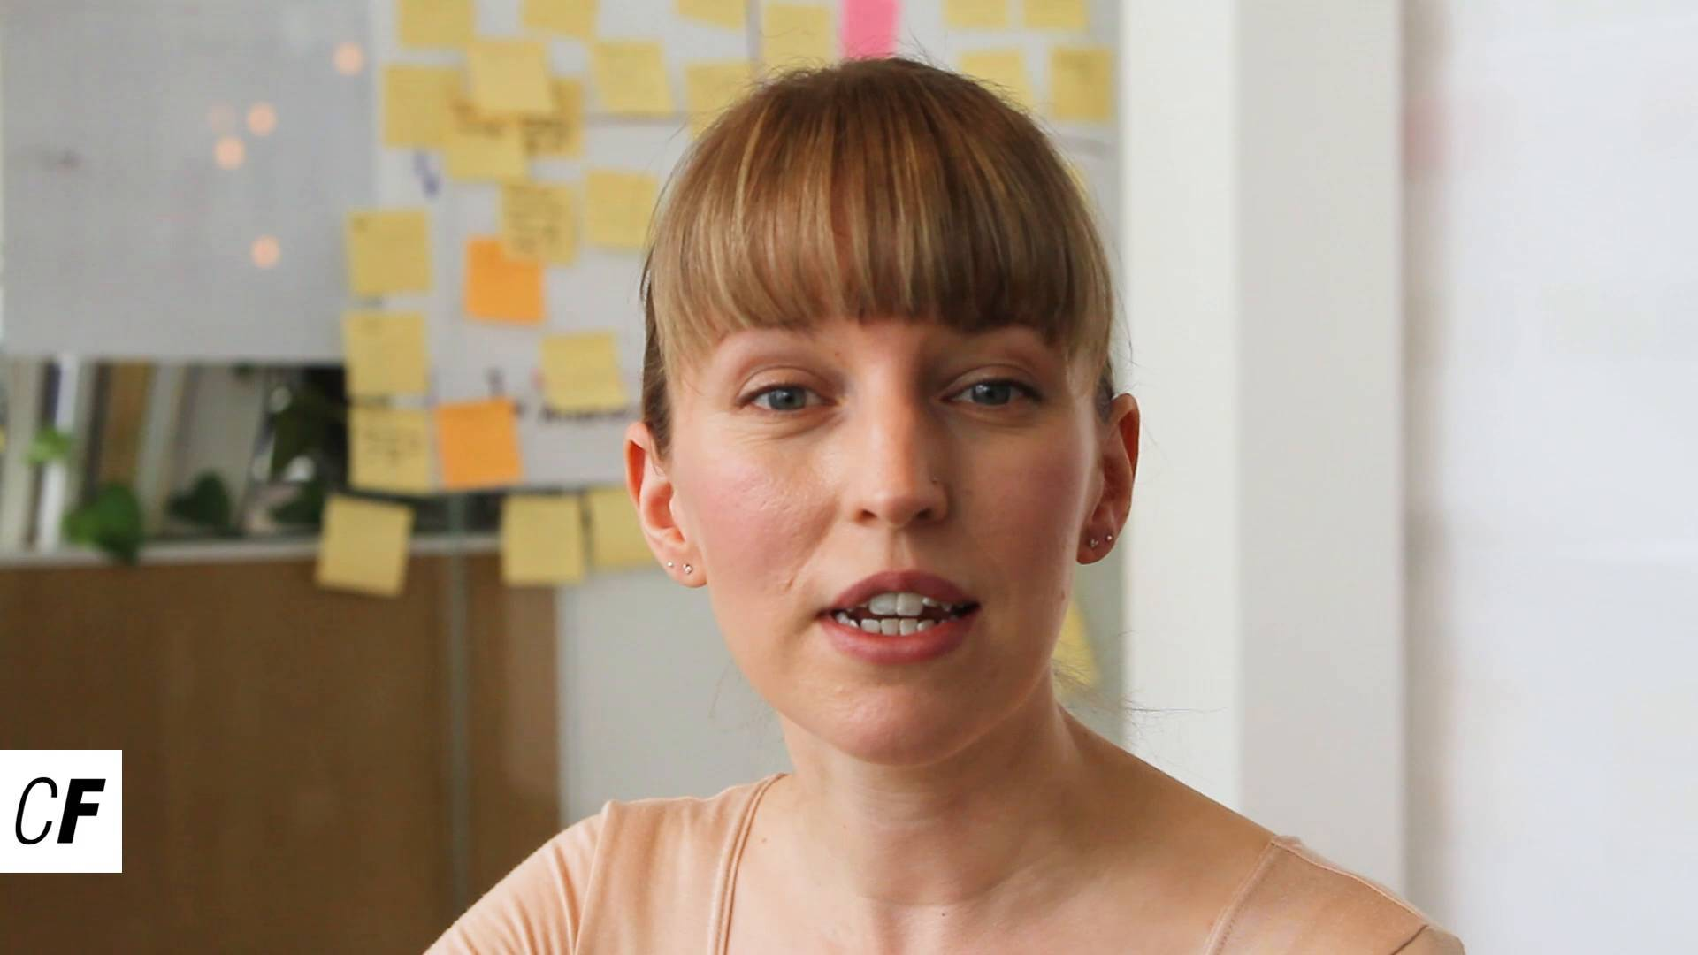

#### **Summary**

In this Exercise, we discussed the role of the UX designer on a product team, as well as the importance of their contribution. We also looked at examples of user experience in the real world and explored the reaches of user experience design beyond the digital realm. This is the first step in fully understanding what it means to be a UX designer.

In the next Exercise, we’ll dive into the unique origins of user experience design as a field, but for now, let’s put what we’ve learned into practice. In the following Task, you’ll use what you’ve learned to analyze the evolution of both real and digital products.