1.11: Portfolio Review

#### **Introduction**

Welcome back! In this Exercise—and the final Exercise of every Achievement going forward—you'll focus on curating pieces for your portfolio with the help of your Mentor. As you may already know, a strong portfolio is very important for UX designers. A well-thought out, polished portfolio says a lot about you and your professional skills, and sometimes (for example in a job application), your portfolio may be the first impression you make on a potential employer. While this may sound like a lot of pressure, don't worry! This is precisely why we're going to spend so much time putting together and polishing your portfolio throughout this course. When you graduate from CareerFoundry, you'll have a beautiful set of projects arranged in a clean portfolio that you can show off to everyone you know. Ready? Then, let's get started!

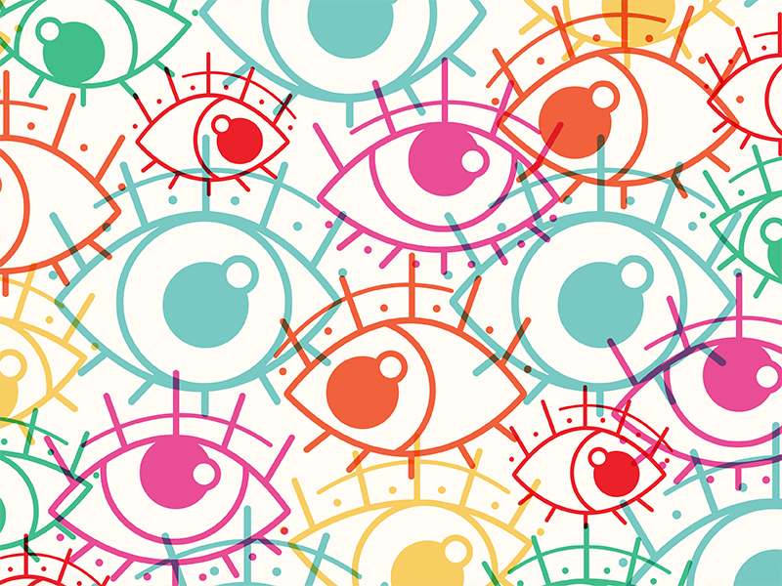

###### **Source:**[**Faith Gutzman**](https://dribbble.com/shots/3678257-Reflection-for-CRIS-Columbus)

#### **Focus Area**

As this is only your first Achievement, several of the deliverables here are more exploratory in nature. Therefore, not all of them should or will go into your portfolio. It’s recommended, however, that you and your Mentor use this initial review as an opportunity to practice discussing your design process and how your design decisions evolve over time. You may also want to lay the groundwork for documenting your designs throughout this course as, once things get rolling, it can become quite easy to get buried under piles and piles of (digital) files!

#### **Project Deliverables**

* Problem statement
* UX competitive analysis
* List of business requirements
* User stories for your app

#### **Portfolio Review Questions & Discussion Points**

Looking back at the design work you did in UX Fundamentals, discuss the following with your Mentor:

* What are the most memorable parts of the course?
* Are there pieces of work from the Fundamentals project that you want to include in your professional portfolio?
* Additionally, what would you like to focus on more in this course?

Performing a UX competitive analysis is a great way to showcase how you document, organize, and present UX-focused information. The analysis aspect will also show off your critical thinking skills. If you choose to include this piece in your portfolio, make sure the layout is intuitive and that the order of information is logical and engaging. You may also want to flag this deliverable and revisit it once you’ve completed Achievement 5: Refining the Design, as this Achievement covers aspects of visual design.

Similar to the discussion point for competitive analysis, you can also include your list of business requirements (BRD) in your portfolio. Before you do so, consider the following:

* Does your BRD have a layout that’s informative and visually appealing?
* Does your BRD contain information that will provide good insights into your thought process when it comes to scoping and managing projects?
* Do the functional requirements make sense for your app? Are they prioritized appropriately?

Lastly, as you continue to work on your project, you may need to revise these requirements based on your user personas and usability testing results, both of which will be developed by you in subsequent Achievements. Be prepared to make continual updates before wrapping up your portfolio at the end of the course!



###### **Source:**[**Igor Kozak**](https://dribbble.com/shots/3698525-Office-stuff)

Let’s take a look at your user stories. Including them can provide a more complete picture of the functional requirements of your app. Take a few moments to review your user stories alongside the requirements and discuss the following with your Mentor:

* Do your user stories, as a whole, paint a clear picture of the problem you’re trying to solve? To double-check, you may want to revisit the problem statement you wrote earlier in this Achievement.
* Is each user story at the appropriate level of granularity?
* Is your user story solving a specific problem related to the big-picture problem presented in your problem statement?
* Do your user stories demonstrate a clear understanding of who your users are? Which stories stand out? Which could use some improvement?

Ask your Mentor for advice or tips and tricks on keeping your user stories updated and relevant.

#### **Summary**

You've just finished the first Achievement of this course. Great work! In this Exercise, we focused on curating and polishing pieces to include in your portfolio. While you've only just begun your UX education, you've already submitted a lot of great work and should applaud your efforts. In the next Achievement, we'll focus on understanding your users via a number of different research methods. See you there!

#### **Task**

* [DIRECTIONS](https://careerfoundry.com/en/course/become-a-ux-designer/exercise/portfolio-review--1#directions)
* [SUBMISSION HISTORY](https://careerfoundry.com/en/course/become-a-ux-designer/exercise/portfolio-review--1#step_submission_history)

 Estimated Task Time: 2 Hours.

Using the guidance above, select one or more of the project deliverables listed, compile them into a single PDF, and submit it here to discuss with your Mentor. You're welcome to submit all of the following deliverables if you'd like:

* Problem statement
* UX competitive analysis
* List of business requirements
* User stories for your app