2.1: Research Methods

#### **Introduction**

Welcome back! How do you feel with the first Achievement of your UX design education under your belt? In the previous Achievement, we focused on learning to think like a UX designer, as well as why doing so is important to the success of a project. In this Achievement, we’ll be taking a deeper dive into user-centered design and the tools UX designers use to understand their users. No matter your field or profession, you’re likely to rely on a variety of tools to complete your tasks and projects, and UX design is no different. It’s these tools and methods that give UX designers the insight they need to solve real problems for real people and design a successful, intuitive user experience.

In this Exercise, we’ll be discussing some of the most commonly used research methods so that you can determine what tools are right for your project. Let’s get started!

#### **User Research Methods**

Understanding your users should be one of the first goals of any product team, which is why user research methods are designed to be used early on in the product development cycle. Your project team may employ any number of these methods, and they’re often more useful in combination as this paints a more complete picture of your users and their needs. It’s worth noting that even if your project doesn’t have the budget for more than one of these methods, the information you gather from even the most basic of user research can be invaluable to your project.

As discussed in Exercise 2 of UX Fundamentals, Christian Rohrer of the Nielsen Norman Group identified a grand total of twenty user research methods for UX designers. In this Exercise, we’ll take a look at five thorough and commonly used research methods for gaining insight into the thoughts and needs of your users. You might also want to start thinking about which method might best fit your project as you read through each description.

As you may remember, user research methods fall on a spectrum with traits like qualitative versus quantitative, attitudinal versus behavioral, and generative versus evaluative. Let’s take a second to review these definitions.

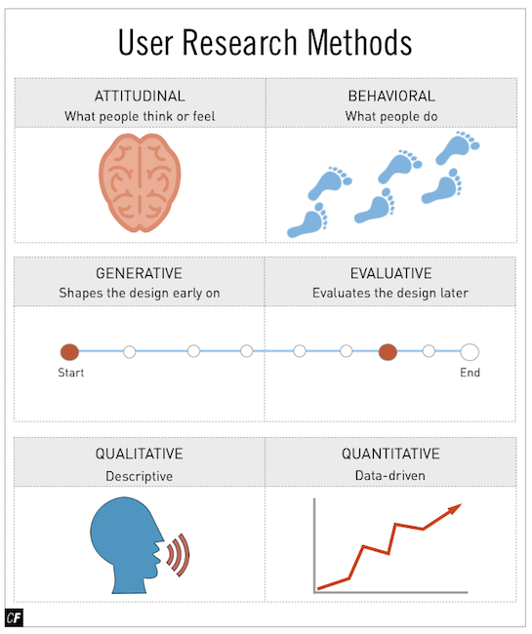

**Attitudinal research** looks at what people say or think (their attitude), while **behavioral research** looks at what people actually do. This can be an important and interesting distinction to make, as sometimes our users behave differently than they think they will. Attitudinal research consists of methods such as surveys and interviews, while methods like eye tracking look at user behavior in real-life situations. Don’t worry too much about classifying methods in this way—it merely aids in choosing a method (or two) that works best for what you’re trying to test.

**Qualitative research** involves direct observation of a subject and information that isn’t directly quantifiable. In-person interviews, for instance, would be a great example. **Quantitative research**, on the other hand, represents data-driven, indirect observations such as close-ended survey responses or customer usage data.

The last important distinction to make is between generative and evaluative methods. **Generative (or exploratory) research** is done at the beginning of a project and helps inform the shape and direction of a design. **Evaluative research** is done later in the process and evaluates the design, helping you look for issues in the product or service that you developed based on your initial generative research. In this Exercise, we’ll be focusing on generative research methods such as user interviews. Later in the course, we’ll focus on evaluative research methods such as usability testing. Let’s get started!

USER RESEARCH LANDSCAPE  
Rohrer and the Nielsen Norman Group published a useful diagram identifying the aforementioned twenty different user research methods. A user researcher—a UX designer who focuses solely on user research—would have a deep understanding of all twenty methods. A UX design generalist, however, would likely have only a surface understanding of each, with their skills focused in one of the other quadrants. That being said, even generalists should still have the knowledge necessary to regularly put a handful of these methods into practice.

If you’re interested in checking out all twenty of the research methods, see Rohrer’s full article ["When to Use Which User-Experience Research Method."](https://www.nngroup.com/articles/which-ux-research-methods/) Don’t worry about looking into every method on the chart. Some are only used in specific circumstances by experienced designers. As you gain more expertise in the field, you’ll become more familiar with these less common methods.

#### **User Interviews**



As you learned in Fundamentals, **user interviews** are one of the most common methods of user research and provide a simple, qualitative way for you to begin understanding a product through your users’ eyes. User interviews are examples of attitudinal and qualitative research as they’re designed to gauge users’ attitudes toward something and generate data based on direct observation. When conducting a user interview, UX designers start by creating a set of questions designed to identify users’ needs and goals, just as you did in the last course. Conducting a survey prior to moving on to interviews can be a great way to get a feel for the users’ goals and pain points and provide a useful basis for scripting interview questions that can dig deeper into survey findings. Once the interview script is set up, a group of sample users are then interviewed in person and their answers recorded. As a general rule, interviews should be kept light and informal. Users who feel comfortable are more likely to give honest (and useful) answers—no one likes an awkward interview, after all!

To ensure a productive and successful interview, an interviewer should be attentive, observant, and flexible enough to explore questions and issues outside the scope of the initial script. Your goal should be a complete understanding of your interviewee’s thought processes and opinions. At the same time, you want to avoid asking leading (and misleading) questions, offering your own opinions, or making your interviewee feel judged in any way.

**Pros of User Interviews**

* They’re an inexpensive method of gathering information directly from those who’ll be using your product. UX designers (like yourself) know how to use apps and websites too well to accurately portray the experience of an everyday user. After all, it’s their job to know how to use things!
* Well-worded interview questions can elicit a great amount of information—potentially confusing or problematic functions, certain designs users enjoy, techniques that can be used to overcome obstacles, and more.
* They can be a great way to learn about other apps or websites your users enjoy and use on a daily basis.

**Cons of User Interviews**

* Poorly-worded questions can lead to interviewer bias and skewed data. Leading questions, questions about design details, and questions stemming from designer opinions should all be avoided.
* Users can’t always remember specific details about past use of apps or websites—human memory is fallible, after all. It’s better to ask questions aimed at users’ general attitudes and feelings about an issue than any one certain detail.
* It’s hard for users to envision unbuilt features and designs. Avoid asking questions about possible functionality and stick with high-level thoughts and opinions.

**How to Conduct a User Interview**

We’ll be discussing user interviews more in-depth in the next Exercise (and have you conducting your own again!), so don’t worry about memorizing any details at this point in time. If you enjoyed conducting interviews and are excited to do another one, feel free to take a look at some other resources for a head start:

* [How to Improve Your Interview Skills](http://uxmastery.com/how-to-improve-your-interview-skills/)
* [Interviewing Users](https://www.nngroup.com/articles/interviewing-users/)

#### **User Surveys**



**User surveys** are generally employed to gather initial, or follow-up, insights from your users and are a great way to obtain findings from a large sample population—potentially hundreds of users! Surveys tend to be best suited for gathering quantitative data and often take the form of multiple-choice questions, which are then tallied into results during analysis. While surveys can certainly be done on paper, online survey services make your surveys easier to share and analyze. Some of the more popular services include:

* [Google Forms](https://www.google.com/forms/about/)
* [PollDaddy](https://polldaddy.com/)
* [SurveyGizmo](https://www.surveygizmo.com/)
* [SurveyMonkey](https://www.surveymonkey.com/)
* [Typeform](https://www.typeform.com/)
* [WuFoo](http://www.wufoo.com/)

**Pros of User Surveys**

* Surveys are an inexpensive and reliable way to reach a broad audience, and they provide an online, automated method of keeping, storing, and analyzing data.
* Survey results can quickly determine whether a product team is moving in the right direction. Positive survey results provide confidence, while negative or unexpected survey results give the team time to refocus and change course early on in the design process.
* Users may be more willing to answer questions honestly if they feel they’re not being judged or watched, and there’s no risk of an interviewer unintentionally biasing responses.

**Cons of User Surveys**

* Care must be taken when designing survey questions to avoid skewed or biased results.
* As surveys are remote and don’t involve an interviewer, this eliminates the possibility of asking follow-up questions for further clarification.
* While online survey services may expedite the process, an effective means of acquiring participants is still essential.

**How to Conduct User Surveys**

We’ll be talking more about how to actually conduct user surveys in the next Exercise. In the meantime, however, be sure to explore the online services listed above for a general idea of how they work and which would best fit your project. You might also check out some resources for more information on [How to Write Good Survey Questions](http://www.quickanddirtytips.com/education/grammar/how-to-write-good-survey-questions) and conduct [Better User Research Through Surveys](http://uxmastery.com/better-user-research-through-surveys/). Your own survey is just around the corner!

TIP!  
Testing your survey with friends or colleagues before posting it online can help you foresee any bias or ambiguity that might be present in your survey questions. This gives you the chance to revise and perfect your questions before presenting them to actual participants.

#### **Analytics Reviews**



**Analytics** refers to the measurement and collection of web traffic data from a currently existing site or app. UX designers can use this data to gain useful insights based on traffic patterns and visitor counts across all the pages and/or screens in a project. For obvious reasons, this method is only useful if the site or app already exists. It’s normally employed before redesigning a website or application in order to make it more successful.

**Clickstream**, which represents a user’s activities online through a series of clicks, provides an automated way to gather and track analytics. It’s a great method for answering additional questions about the site, such as what section of a webpage a user tends to click on before all else.

The most important thing for a UX designer to determine before starting an analytics review is what data will be most useful to their research goals: what content on the site has the highest visitor count, for example, or what content may be removed for the purpose of consolidation. Looking at web traffic data will reveal which pages users find the most engaging and relevant to their needs. It’s important to note, however, that this only reveals quantitative information—while the low-scoring pages may be performing poorly due to unengaging content, they could just as well be performing poorly due to subpar site navigation.

**Pros of Analytics Reviews**

* Analytics reviews are a great way to gain powerful insights about an app or website at the start of a redesign project. Designers can remove content that hasn’t been successfully engaging users to make room for new, more compelling content.
* They’re cheap and relatively quick to perform. Most reviews take less than a week to complete.
* Reviews can be used to create informative reports for the product team and client, giving early momentum to a project.

**Cons of Analytics Reviews**

* Analytics data isn’t always available or can be hard to obtain due to confidentiality issues, the age of your site, or a lack of an installed analytics package.
* A thorough analysis of this type of information requires at least six months of data (and an even larger window would be preferred).
* Analytics aren’t useful when designing a new project (but could still be employed on competitor sites or apps to learn about user behavior).

**How to Conduct Analytics Reviews**

Details on how to conduct analytics reviews are outside the scope of this Achievement; however, we encourage you to explore the following resources for your personal projects:

* [An Analytics-First Approach to UX](http://www.uxbooth.com/articles/an-analytics-first-approach-to-ux-part-1/)
* [Two Birds, One Stone: How to Increase Conversions While Building Your Brand with UX](https://blog.kissmetrics.com/increase-conversions-while-building-brand/)

#### **Diary Studies**

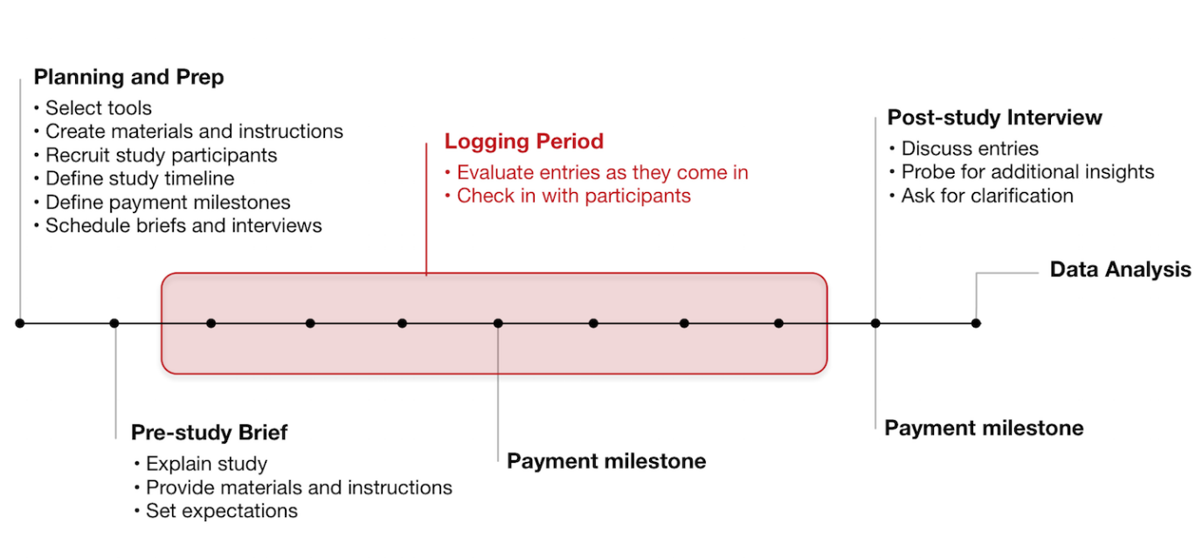

###### [**Click here**](https://s3.amazonaws.com/coach-courses-us/public/courses/ux-immersion/A2/E1/A2E1_diarystudy.png)**to zoom in**

A **diary study** is a type of research method used to collect data about user behaviors, activities, and trends over the course of a few days, weeks, or longer. During a diary study, participants are asked to keep records of their thoughts (much like they would in a diary) while performing activities or tasks the UX designer wishes to analyze. This provides the designer with a host of valuable qualitative data at the end of the study. Reminders and prompts via email or text message can also be used to help participants remember to record their behavior. Diary studies are most successful when used for behavior studies over a long period of time. The image above outlines the overall process for conducting a diary study. As a UX designer, you’ll typically be most involved in the planning and prep stage, as well as the post-study interview and data analysis stages.

**Pros of Diary Studies**

* Diary studies are the best way to learn about behaviors and activity over a significant period of time.
* A variety of behaviors can be studied ranging from daily habits, emotional states, motivations, changes in engagement, learning over time, and more.
* UX designers are able to analyze and respond to incoming data while the study is ongoing. This allows for follow-up questions and feedback from participants.

**Cons of Diary Studies**

* Diary studies are qualitative by nature, so they’re better suited for studying general behavior and activity rather than for collecting concrete data and numbers.
* Participants can become less engaged over time and will oftentimes need encouragement and motivation. For this reason, data from a diary study can sometimes be manufactured or incomplete.
* Because of the long-term nature of these studies, they tend to be more expensive per user than other research methods.

**How to Conduct a Diary Study**

While we won’t be discussing details on conducting diary studies in this Achievement, there are some great resources on the web to help you learn more about this fascinating research method. Check out [Jumpstart Design Research with a Diary Study](http://www.uxbooth.com/articles/jumpstart-design-research-with-a-diary-study/) or [Diary Studies: Understanding Long-Term User Behavior and Experiences](https://www.nngroup.com/articles/diary-studies/) if you’re interested in learning more.

#### **Contextual Inquiries**



One of the best ways to truly understand your users is to spend time with them in their own environment. **Contextual inquiries** (also known as **ethnographic field studies**) involve interviewing users in the same location or context in which they’ll engage with your app or website. A contextual inquiry for a recipe app, for example, might require you to talk to your users in their kitchen or at their local grocery store. Watching users perform tasks and activities that your app or website is going to facilitate can be eye-opening and very educational for a product team.

The process typically starts with an identification of the appropriate users based on the project. Traits like age, computer and internet experience, education, and language are all taken into consideration. Once a representative group of participants is found, in-person visits are scheduled. During the visit, a UX designer should take on the role of an apprentice, observing and learning about behavior and activity from the participant.

Designers can create their own scripts and questionnaires, or they can simply sit and observe the participant as they go about their daily routine. Notes and recordings taken during these visits are then analyzed to determine the types of tasks that were carried out, obstacles the participant faced, what could have helped the participant succeed with those tasks, and so on.

**Pros of Contextual Inquiries**

* A number of unique observations can be made during these visits, from environmental issues, to how users handle interruptions, to user workarounds, to task handling, and more.
* This is the only type of research that takes place in the participant’s place of work or residence, which can often shed light on user requirements and needs that other methods may not reveal.
* This type of research is effective in capturing personal information about your users and will often lead to additional insights you can use in your persona creation.

**Cons of Contextual Inquiries**

* Participants might become nervous during the observation, which means a UX designer should be capable of putting them at ease during their visit.
* Locations may come with logistical challenges (management approval, consent forms, nondisclosure agreements, etc.).
* Due to the involved nature of this research method, studies are usually limited to a small group of participants.

**How to Conduct a Contextual Inquiry**

This early on in your new UX career, you might find it best to try this method with close friends and family first. If you’re interested in learning more about contextual inquiries, check out the article [Conducting Contextual Inquiry](http://uxmastery.com/conducting-contextual-enquiry-or-site-visits/) by UXMastery.

#### **Summary**

In this Exercise, we discussed the importance of user research, as well as relevant research methods used by UX designers. Choosing the right combination of these methods for any given project is the key to understanding your users and designing an app or website that successfully meets their needs. Not all methods are useful for every project, and each project will have its own considerations. As you gain more experience as a UX professional, choosing the right research methods for your projects will become almost second nature.

In the next Exercise, we’ll be looking more in-depth at two of the above-discussed methods—user surveys and user interviews. You’ll even have a chance to conduct interviews for your own project. See you there!

#### **Resources**

* [When to Use Which User-Experience Research Methods](https://www.nngroup.com/articles/which-ux-research-methods/)
* [UX Techniques](http://uxmastery.com/resources/techniques/)
* [Complete Beginner's Guide to UX Research](http://www.uxbooth.com/articles/complete-beginners-guide-to-design-research/)

Take the quiz to test your knowledge on this Exercise.

Take Quiz

#### **Task**

* [DIRECTIONS](https://careerfoundry.com/en/course/become-a-ux-designer/exercise/research-methods#directions)
* [SUBMISSION HISTORY](https://careerfoundry.com/en/course/become-a-ux-designer/exercise/research-methods#step_submission_history)

 Estimated Task Time: 2 Hours.

Now that you’ve learned about a few of the research methods available to you, it’s time to determine which methods will be most suitable for your project needs. Remember to consider the problem statement you defined in Exercise 1.6, as well as any other limitations or issues you may face.

**Directions**

1. From the 5 methods discussed above (or another method you’ve found via your own research), choose the 3 methods you feel would be most effective in teaching you more about potential users in your project.
2. Draft a 1-page, single-spaced document discussing each of your chosen research methods in order of usefulness when it comes to addressing your problem statement. For each method, talk about your reasons for selecting it, as well as what you think it will help you learn.
3. In a closing paragraph, talk about whether you plan to use a single research method or a combination of methods and the rationale for your decision.
4. Save your analysis as a PDF file and upload it here. Feel free to share additional thoughts or ask questions in the submission box.