2.3: User Research Analysis

Learning Goals

Analyze user needs and pain points

 Estimated Read Time: 30 Minutes.

Introduction

Welcome back! Hopefully, you’re returning from an informative round of user interview research. By this point, you’re probably swimming in research notes, and you likely have some audio and video recordings, as well. You may even be intimidated by all that data, perhaps wondering how you can make sense of everything and put it to good use.

Thankfully, this Exercise is all about fixing that very problem. As we move forward, you’ll learn how to look for important trends and themes in your results—something that will help you create user personas and user journey maps down the road. We’ll also discuss a few techniques for sorting, organizing, and categorizing your data in helpful and informative ways. Finally, we’ll take a look at ways you can record your insights and prepare your user personas using what you’ve learned.

Where Do I Begin?

Diving into a big collection of data can seem like a monumental task. The best thing to do when faced with a large problem is to break it down into manageable chunks (or steps), which is exactly what we’ll be doing with our data. Remember, the end result you’re looking for is a set of trends and themes that will help you identify different types of users and complete the objectives you put forth for your research. Let’s take a look at the four stages of research analysis:

1. **Collect and organize your data:** Organize your results in a single place. Digital files, notes, recordings, drawings, photos, and anything else you might have collected during your research should all be put in the same place for easy access.
2. **Explore your data for findings:** Once you have everything organized, it’s time to dig in! This step involves analyzing your results and pulling out informative quotes, behaviors, facts, opinions, and more.
3. **Sort and map the data:** This is where the analytical picture of your research really starts to take shape. You’ll use affinity mapping to explore your findings further, creating visual maps of relationships and themes that will allow you to truly understand your participants.
4. **Identify user insights:** With all of your data organized and categorized, you can begin gathering insights about your users to determine successful design methods. You’ll be capturing these insights in future Exercises about personas and user journey maps.

Sounds pretty easy, right? When you break down your analysis into these four steps, the process is greatly simplified. Now, we’re going to take a detailed look at each stage and discuss how to use these techniques for your recently completed user research.

Collecting and Organizing Your Data

Before you venture too far into your analysis, it’s always a good idea to set up an organizational system for the artifacts you collected during your research. Without solid organization, mining your data becomes a much more challenging task, so it’s well worth the time and effort it demands. For most researchers, a system of digital organization, combined with a system of physical organization, is the most productive solution. Let’s explore both styles of organization.

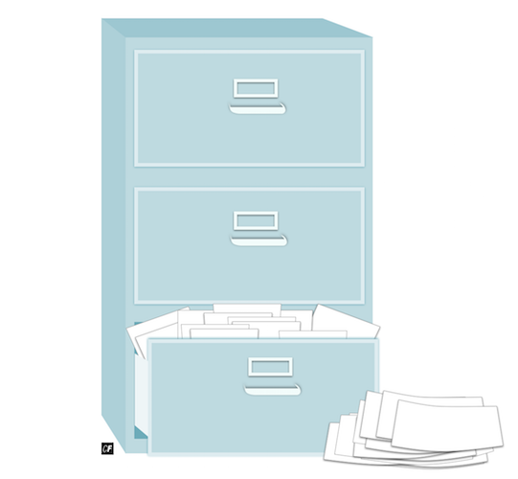

Digital Organization

The first step in organizing your data digitally is to collect any audio recordings, video clips, or hand-written notes and transcribe them in a digital format. While creating these files, think about the best way to organize them on your computer. Many researchers create folders for each interview participant to store all their related content. If you choose this approach, consider creating a quick profile document for each participant to help you quickly get up to speed as you explore their data.

Make sure you store the original audio and video recordings in your user folders, as well, as you may want to refer to the original material at some point during your research. These elements are great to pull from when making engaging presentations for your product team.

TIP!  
Use consistent file naming conventions to keep your files neat and tidy. Include your participants’ names and the creation date of the file to help you find what you need during analysis. For example, REBECCAAUDIO100617.MP4 will quickly give you information about what the audio recording contains without even having to open it.

Physical Organization

Data analysis can be a complex task. One of the best ways to approach it is via preparation of a physical space for the sole purpose of data analysis. In an office environment, such spaces are often called war rooms, but in your home office, a large whiteboard or clear wall will do just as nicely.

To prep your personal war room, write or print out your research goals and stick them to the wall. Descriptions and photos of the participants or the study environment would make great additions, as well. The idea is to make your research area feel like a physical representation of the study itself to put yourself in the right mindset for analysis.

As you analyze your research, fill this space with notes about each participant, as well as trends you identify along the way.

Keep Everything

It’s been mentioned before, but it’s worth repeating—keep everything you create and collect during your research. All of these notes, recordings, and sketches are valuable research artifacts and should be treated as such. They may be useful for presentations, further research in the field, as well as reflection. They’ll also be fantastic for your personal portfolio, as showing potential employers that you understand and can conduct research of this type is a valuable and impressive asset to have.

Exploring Data to Uncover Findings

Now that everything is organized, you’re ready to begin exploring your data! In this phase of analysis, you’re going to systematically look through all the data you’ve collected for each participant. Paying attention to every detail here is key. If you’re doing a good job, this phase should take considerable time, but it’s well-worth the effort.

What Should I Look For?

To begin the process, think about your research goals and what you need to understand about your participants in order to help you achieve them. Pay attention to the following findings as you comb through your data:

* **Watch for behaviors and attitudes that may help inform what you know about your research goals.** If your goal is to learn about attitudes for a travel guide app, for example, the quote “I think travel apps are too complex. I can never figure them out” would be a useful thought to record.
* **Pick out needs or goals your participants might mention.** Using the travel guide app as an example again, the quote “I would want to be able to use it quickly because when I travel I’m always on the go” is a great takeaway. From it, you can extract the user goal of wanting to use the app quickly.
* **Record any participant frustrations discussed, as well.** Frustrations represent an opportunity to develop a project that avoids pitfalls and pleases your users. Anything that irritates or annoys your participant should be recorded.
* **Gather any other useful quotes and facts that align with your goals.** Make a note of any other quotes or facts that stick out to you. Quotes such as “I like to take about a dozen small trips per year,” “When I take a trip, I want to discover things off the beaten path,” or even notes like “*Rebecca mentioned that she finds travel incredibly stressful*” can all be valuable to your research.

How Should I Record What I Find?

Now that you know what to look for, let’s talk about how to record it. Many researchers use color-coded sticky notes to record key findings in their analysis. Consider what kind of system would work best for you and your area and keep it consistent throughout your research. It’s a good idea to use a different color for each participant so you can quickly understand context at a single glance.

As you collect notes, attach them to your research area in consistent groupings. The easiest way to do this is to group by participants, so apply your sticky notes for each participant under their photo or description. The end result should be a research area filled with interesting behaviors, needs, frustrations, quotes, and facts. Take a photo of your research area at this point and be proud of all the work you’ve done so far! Next, we’ll talk about how to cluster and sort these collected notes.

Sorting and Mapping Data

At this point, you should have a research area filled with sticky notes loosely organized by participant. While you can learn a lot from this alone, taking things one step further will help you recognize themes at a higher level. This additional organization is the starting point for creating documents based on your data and will make identifying insights in the next step much easier. There are many ways to conduct this organization, but for our purposes, we’re going to use a common and powerful tool known as affinity mapping.

Affinity Mapping

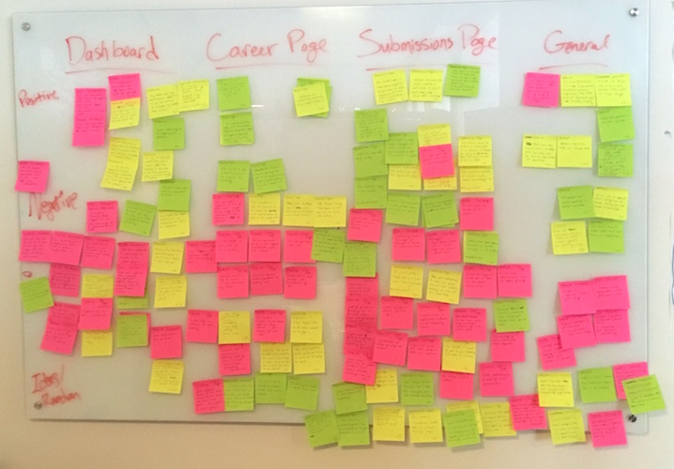

**Affinity mapping** (sometimes called **affinity diagramming**) is a simple but effective tool for grouping and understanding information. One of its particular strengths lies in the identification of relationships between many individual components, which is what makes it so useful for UX researchers. Affinity mapping can be done with a wide range of data and can be performed throughout your design process. In fact, you'll do affinity mapping again to help you sort different data in Achievement 4 of this course!

You don't need much to conduct an affinity map exercise. These are the tools you need to get started:

* **Sticky notes** or a **whiteboard**. (If you don’t have access to sticky notes or a whiteboard, you can simply use presentation software like PowerPoint or Keynote.)
* A **marker** (Or, if you’re typing, using a **large font** to encourage you to simplify the information).

After you've written out one point, quote, or observation on each sticky note, you're ready to create your affinity map. Here is the basic methodology:

1. Choose one of your sticky notes, move it to a clear area on the wall, then hunt through your data for additional similar notes.
2. Find similar notes (similar in whatever way you deem most useful) and place them near the first, creating a cluster of notes that all share a particular theme.
3. Once you’re done with the cluster, write or post a label beneath it to remind yourself why the notes are clustered together.
4. Repeat this process with new themes until your research area is filled with labeled clusters of notes. Feel free to duplicate notes if you feel like they belong in more than one cluster.

It’s that simple! There is, however, one other important part of the process to consider. After identifying insights with your current affinity map (see the next section), you might consider starting the process again with a new method of clustering. Each time you cluster your data, new insights will emerge, so don’t be afraid to start over.

For now, however, let’s move on to ways of identifying insights from our clusters.

PERSONA EMPATHY MAPS  
Another great way to breathe life into your interview notes is to create a **persona empathy map**. Empathy maps, initially outlined in [Dave Gray’s Gamestorming](https://gamestorming.com/empathy-mapping/), have been adopted by designers as a tool to better identify collective behaviors and pain points.

Take five minutes and watch this video on persona empathy maps by Paul Boag: [Adapting Empathy Maps for UX Design](https://boagworld.com/usability/adapting-empathy-maps-for-ux-design/). If you feel inspired to create one of your own, download this [Google Drawing template](https://docs.google.com/drawings/d/1bRelMAoHm8GRncRIyLeINgbRVBUc_hHYjLCUlFZfO3E/edit) or explore [Concept Board's interactive template](https://app.conceptboard.com/board/034h-pq0y-45ai-k1nm-kmyg) for persona empathy maps.

Identifying User Insights

Armed with your beautiful clusters of data, it’s time to use what UX researchers call synthesis to expose additional insights. **Synthesis** can be defined as the process of creating spontaneous concepts and ideas based on the facts you’re analyzing.

Before we continue, let’s first define the difference between findings and insights. Although these terms often get used interchangeably, they're *not* actually the same thing. A **finding** is usually a fact that tells us "what" is happening, but it doesn’t tell us the "why" nor provide us with a way to find a meaningful solution. An **insight**, on the other hand, is something that describes an aspect of human behavior/motivation and enables us to see how we might take actions to solve a problem.

Using our demo project, Triply, for example, one *finding* might be that “users often use multiple, travel-related apps at the same time.” Based on this finding, one *insight* might be that "no one travel guide app provides users with all the tools and information they need, so they need to use multiple sources to find it." Taking it one step further, we could then use these two statements to come up with a concrete solution. For instance, we could design an app that provides more comprehensive content (so that travelers don’t have to use multiple apps). These are the types of “aha!” moments you should be looking for when sorting your data, and they’ll prove to be the most useful insights when designing your project, as well.

Write down any themes you synthesize during your analysis, and, as mentioned above, feel free to re-sort your data into another affinity map for additional patterns and syntheses from a fresh perspective.

TIP!  
Aim for three rounds of affinity mapping for a good set of perspectives on your data. Don’t forget to take a significant break between each session—coming back to your data with a clear mind is always helpful.

Want to see what an affinity mapping session looks like in action? Watch below as Claire uses an affinity map of her own to organize and analyze the data from the interviews she's conducted:

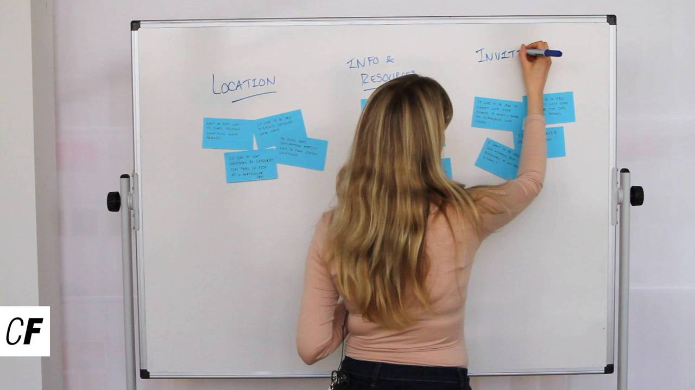

Sharing with Your Team

In a corporate team environment, the next logical step would be to create a document listing all the insights you’ve gleaned from your research and presenting or discussing the document as a group. These check-ins ensure everyone on your team understands your research goals, as well as what you’ve learned about them through your research.

As a CareerFoundry student, you also have a team—a team of fellow students in Slack! You might consider sharing your research and analysis experiences with students to share your knowledge and perhaps gain a few new perspectives, as well. Outside opinions on your insights will give you even more confidence that what you’ve identified as useful will resonate with your peers. If you find that many people don’t understand one of your insights, it could be a sign that you should reevaluate your data from a new perspective.

The Birth of User Personas

Now that you’ve created a great list of insights and vetted it with your peers, it’s time to add a human element to your findings. Turning your insights into a tangible concept allows you to refer back to them easily during the design process. To do this, UX designers create what are called **user personas**. The process of creating a user persona is very much like giving your insights a relatable face that captures the essence of your target users. We’ll be broaching this exciting subject in the next Exercise!

Summary

In this Exercise, we discussed how to collect and organize data from your user interviews. We also talked about data preparation and storage, data exploration, data sorting, and how to extract true insights from what you’ve collected.

It’s great to read and learn about these concepts, but to truly grasp the process, you should experience it yourself. In the following Task, you’ll be performing all of these steps to create a final list of insights and an organized account of your research analysis. Before getting started, take a few moments to review the [sample research analysis](https://s3.amazonaws.com/coach-courses-us/public/courses/ux-immersion/A2/E3/2.3DemoProjectResearchAnalysis_Rebecca.pdf) for the demo project, and remember to have fun!

Resources

* [Stuck in the Details? Mind Map User Tasks](https://www.uxbooth.com/articles/stuck-in-the-details-mind-map-user-tasks/)
* [Design Research From Interview to Insight: Part Two, Synthesising Insight](https://medium.com/design-research-methods/design-research-from-interview-to-insight-f6957b37c698)
* [Analysis, Plus Synthesis: Turning Data into Insights](https://www.uxmatters.com/mt/archives/2009/04/analysis-plus-synthesis-turning-data-into-insights.php)

Take the quiz to test your knowledge on this Exercise.

Take Quiz

Task

* [DIRECTIONS](https://careerfoundry.com/en/course/become-a-ux-designer/exercise/user-research-analysis#directions)
* [SUBMISSION HISTORY](https://careerfoundry.com/en/course/become-a-ux-designer/exercise/user-research-analysis#step_submission_history)

 Estimated Task Time: 6 Hours.

Using the steps provided in this Exercise, go through the four stages of research analysis. At the end of this Task, you should be able to present a document full of user insights obtained during the process and show how you created and used your research area.

**Directions**

1. Collect and organize your data both physically and digitally as explained in this Exercise.
2. Review your data for important findings, documenting them as sticky notes using the process outlined above. Be sure to focus on behaviors/attitudes, needs/goals, frustrations, quotes, and facts for each of your participants. At the end of this step, take a photo of your research area to help facilitate a discussion with your Tutor.
3. Create an affinity map to sort your data into manageable clusters based on interesting themes you’ve identified (take a photo of this, as well).
4. Gather insights from your clusters and record them in a document.
5. After you’ve generated a list of insights, review them with your student peers and revise if necessary.
6. Save your list of insights as a PDF file and upload it here. Also upload images of your research area and affinity map in action! As always, feel free to share additional thoughts or ask questions in the submission box.