2.4: User Personas

Learning Goals

Create user personas informed by research

 Estimated Read Time: 40 Minutes.

Introduction

Good to see you back! In the previous Exercise, you painstakingly analyzed your interview data and created meaningful user insights during the process. While a list of user insights alone can already be incredibly useful, there’s a fantastic tool we can use to make them really come alive for your product team and other key stakeholders. This tool, called a persona, is created with the goal of giving your research a human face and narrative. This not only makes your research more memorable, but more relatable, as well, ensuring your potential users always have a place within your product team when it comes to design decisions.

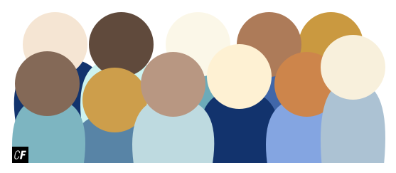

In the Fundamentals Course, we concentrated on creating a proto-persona, the simplest of the three types of personas we’ll cover in this Exercise. In this course, however, we’ll be looking more in-depth in order to create a design persona, a more complex document backed by extensive research.

In this Exercise, we’ll be digging into the details of persona creation. Before we do that, however, let’s take a moment to explore the different types of personas, their origins, and how UX designers and their teams successfully use them to keep user needs and goals in mind while they work.

What Is a Persona?

A **persona** is a fictional but realistic portrayal of a target user for your product. Each persona represents an entire audience of users, and most projects have more than one persona. This is because products generally have more than one target audience. Personas are detailed documents and normally contain information such as device usage patterns, daily challenges, personal goals, informative quotes, motivations, cultural backgrounds, and other demographic information.

We’ll look at some examples of personas later in this Exercise, but for now, consider our demo travel app. Based on your research analysis, you may have determined that one of your target audiences is a high-energy, globetrotting group of users with a mixed cultural background, a mobile-first device usage pattern, an extremely busy schedule, and an average age of 25–35. All these details can be difficult to remember (and cater to) for a product team! With a persona, however, your product team can refer to this audience by name during meetings, presentations, and other day-to-day work. This helps keep your user audiences at the forefront of your mind during every phase of the design process—a critical piece of the user-centered design process we talked about in Exercise 1.4.

There are three primary types of personas used in UX design today. While marketing and proto-personas can be useful in specific scenarios, throughout this course, we’ll focus on research-driven **design personas**, as they’re backed with solid data and are the most widely used for general product design. Let’s take a look at the three types of personas:

* **Marketing Personas:** This type of persona is focused on ecommerce projects and applications. They typically contain demographic information, buying habits and motivations, media usage habits, and marketing messaging reception. Marketing personas are good for determining which types of customers might be receptive to particular marketing techniques but aren’t great for defining the details on how a product should function or how it should be used.
* **Proto-Personas:** Proto-personas are used when a project doesn’t have the budget or time to conduct user research and create a full-fledged design persona based on research analysis. While they aren’t as informative in driving decision-making as design personas, they’re still better than not having personas at all. The benefit of providing a simple focal point for your team during discussions is invaluable, and they also serve to keep the audience first when making design decisions.
* **Design Personas:** This type of persona focuses on user motivations, behavior, and challenges and is based on user research and analysis of real people in the field. Design personas tell us a story about why the user employs and interacts with the web and applications in the way they do. Luckily for us, they’re great for communicating research insights and are the ideal type of persona to use when defining a product using the user-centered design process.

The Origin of Personas

In 1983, a software engineer named Alan Cooper decided that the best way to design his upcoming project was to begin by interviewing real users. He interviewed seven to eight real users (just like you did in the Exercise 2.2!) and recorded his findings. As he brainstormed for his project design, he found himself roleplaying certain interviewees and walking through their challenges and motivations. He found that this method of putting himself in the shoes of his users proved to be very successful at helping him design products with a user-centered focus.

Over the next decade, Mr. Cooper began formalizing this process until, in 1995, he created his first true persona documents to present to a client in a meeting. His personas were named “Chuck,” “Cynthia,” and “Rob,” and he found that discussing his project using these personas was dramatically more effective than talking about the general user audience. His clients quickly understood previously difficult topics, and he began to hear engineers referring to solutions via comments such as “That’s definitely what Cynthia would do.”

From then on, he started using personas in his design projects, and, in 1998, he published a book titled [*The Inmates Are Running the Asylum*](https://www.amazon.com/Inmates-Are-Running-Asylum-Products/dp/0672326140), in which he described his personas and their use in the UX community. For more about this fascinating story, read Mr. Cooper’s own words in his article, [The Origin of Personas](https://www.cooper.com/journal/2008/05/the_origin_of_personas).

Personas and the Design Process

Now that we’ve learned a bit about personas and their various types, let’s dig into how they’re used to design a product so we can create one of our own!

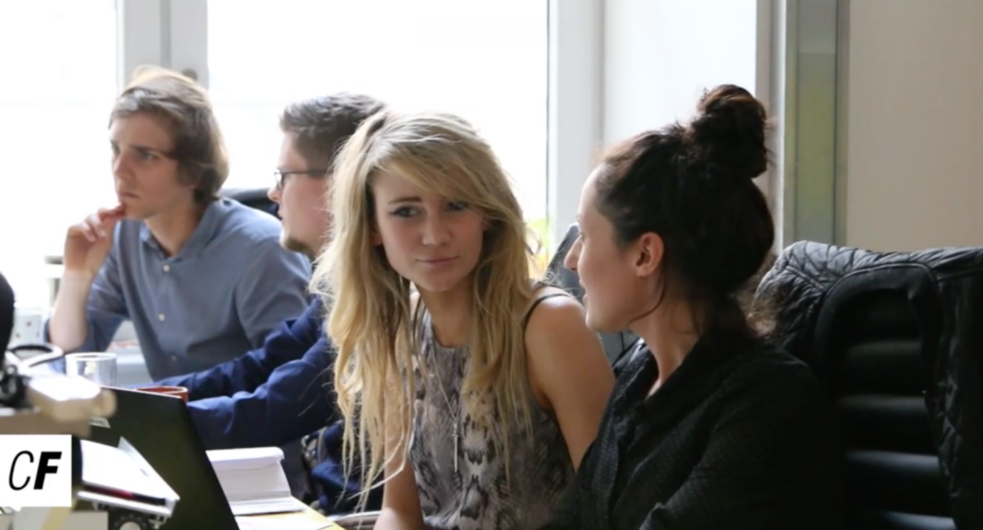

Personas act, most importantly, as a communication tool between internal project members, as well as between teams and their external clients (if they exist). By wielding a persona for each target audience of their product, design teams and their partners can be much more focused. Rather than designing for “the users” (a fairly nebulous concept), you can discuss designing a certain feature for a persona such as “Susan” or “Rebecca” to simplify the conversation. This ensures that everyone in the room is on the same page about exactly which audience is being discussed, which helps to eliminate confusion from the design process.

Personas help everyone on a team understand the same audiences as objectively as possible. Without a persona to guide each team member, their individual mental models (or what they believe they know about design) will interfere with their understanding of the target audience and create differing perspectives. With personas, each team member understands the audiences in the exact same way, which, in turn, ensures the design process will run more smoothly.

Making the Case for Design Personas

You can see how design personas are valuable tools for designers and teams alike. In some business environments, however, they may not be understood fully, and their value may not be so obvious. Sometimes, it’s up to the UX designer to make a case for a tool like design personas and assure the product team that the outcome is worth the effort.

In these cases, many UX professionals recommend creating a quick proto-persona to demonstrate what a persona would look like and talk about how it could be beneficial. It may also be helpful to remind key stakeholders of the negative consequences that could arise from not incorporating personas into the design process. Here are a few key concepts to remember when making the case for personas:

* Personas help **establish empathy with users.** Seeing a project through the lens of a persona will help designers like you make decisions with their personas’ needs and goals in mind.
* Personas help **prioritize functionality based on audiences** (one persona is oftentimes considered more important than another). If a piece of functionality is ideal for your most important persona, it makes sense to make that functionality a priority in your design. Similarly, if a piece of functionality is something only your least important persona will require, it may make sense to keep your design simple and remove that functionality from your design plan.
* For discussions with clients or team members not included in the research process, personas **allow designers to present their research analysis in an engaging and informative way**.
* Making design decisions based on personas means making **design decisions based on real data from real users**. These decisions become easier to explain and defend as they’re made with users’ needs and goals as the top priority.

While personas are a great tool for any UX project, that doesn't mean they don't have any drawbacks. Here are a few things to watch out for when working with personas in your project:

* Above all, **a good design persona has to be based on good research**. If your user research data isn’t up to snuff, it can be tempting to simply “fill in the gaps” by making up traits for a design persona. Avoid this at all costs, as the resulting persona won’t accurately reflect your audience or their needs.
* Make sure you **plan enough time for persona creation** in your project. They can be time-consuming documents to create, and rushing them results in nothing but ineffective, unusable personas. Remember, though, that while this can seem like a large time investment up front, the end result is well worth the effort.
* Most UX professionals agree that **well-constructed design personas are valuable tools**, but personas on their own are often not enough to completely understand your users. Plan to use additional tools like user journey maps or storyboards to compliment personas and round out your user research efforts.

With personas and their various uses out of the way (and hopefully ingrained in your brain), let’s move on to the persona you’ll be creating based on the list of insights you generated in the previous Exercise!

Creating Design Personas for Your Project

Thanks to your experience in user interviews, your collected data, and your synthesized insights, you already have all the building blocks necessary to create your persona. To begin, let’s take a look at your user insights list and identify the most important characteristics of your participants. If some characteristics look very similar, consider consolidating them into one clearly-defined characteristic. During this process, distinct roles will form. Characteristics can be demographic details such as age, occupation, marital status or even personal interests like hobbies.

Let’s take another look at the demo project travel app for some inspiration. Say that, as you’re grouping characteristics, three distinct types of users begin to take shape. The high-energy millennials interested in short getaways we identified earlier, an older group of travelers interested in relaxing, lengthy trips, and a middle-aged group of travelers looking for meaningful family vacations. Each of these distinct types of audiences can and should be captured in their own, unique persona. Depending on your research and your project, you may have fewer personas, or you may have several more—just remember that every target audience you identify needs to be shaped into its own persona.

Before you go any further, remember to revisit the resources on persona empathy maps presented in Exercise 2.3. Empathy mapping can be a useful activity to undertake before creating formal personas as they help you focus on the user as a person with thoughts and emotions rather than simply a list of characteristics. Try creating a few empathy maps right now—they'll help you more easily progress to design personas.

TIP!  
Avoid creating more than **five** personas, especially for your first project. Having too many can lead to confusion and unnecessary sidetracks when you’re designing your project, so consider consolidating attributes and insights if you find too many target audiences developing.

Starting Your Persona Design

The basic goal of any design persona is to answer the question “Who are we designing for?” Always keep this in mind as you move through the process as that basic principle will inform every decision you make along the way. Let’s start by taking a look at some core steps for creating your own persona:

1. Determine what information you want to include in each persona.
2. Create an identity for your persona, including a name, image, and some narrative background.
3. Create a template for organizing all the information on a single page.
4. Using the insights you’ve gathered from user research, fill out each template with the relevant information.

Now, let’s talk about these steps in detail to help you better follow them.

What to Include in a Design Persona

Information in a persona can vary widely by project and research results, but, like we mentioned above, it should always help you answer the question “Who are we designing for?” As you consider your own personas, include any information that pertains to the user group and would help you empathize with them as users. Here are a few things to include to get you started:

* Facts and information observed during research.
* Data that’s realistic rather than idealized. These are real users you’re representing!
* Information that can help you understand users’ environments.
* User behaviors related to your project.
* User attitudes about relevant projects or experiences.
* Particular needs from a user group.
* Challenges or common obstacles for your users.
* User goals and motivations.

After including these data points from your research, it’s time to make your persona come alive!

Making Your Design Persona Human

While we now have a solid skeleton for our persona, we still need to add a human element and make the persona more engaging, memorable, and relatable. In fact, your persona’s memorability is the entire point! Your product team should always have the persona’s needs on their minds throughout every step of the project.

To create a memorable and more human persona, we add extra details that help tell the stories of its represented users. The goal here is to create a believable, living character, which can be a very fun and rewarding process! Think about it like creating a character in a book or story—only you'll be using details based on research and data. Take a look at a few commonly added elements that can instill a little life into your new persona:

* **Name, age, gender, and a photo.** For the photo, you can either sketch out a character or find a convincing photograph.
* **Demographic information.** Create an outline containing your persona’s location, age range, education, ethnicity, family status, and occupation.
* **Needs and goals.** Identify goals and tasks your persona will want to achieve using your product or service.
* **Behaviors.** Take notes on your persona’s current behaviors or feelings towards your product, service, or industry. This could include context around how they'd use your product. Would they use it on the go? At home or at work? Try to paint a picture of your persona using your product in the most believable way possible.
* **Quotes from the persona’s perspective.** These are usually included to describe special challenges, needs, or motivations in the persona’s life. For example, “I’m always on the go, so using this needs to be quick!” or “I love to travel, but it can be pretty stressful coordinating everything!”

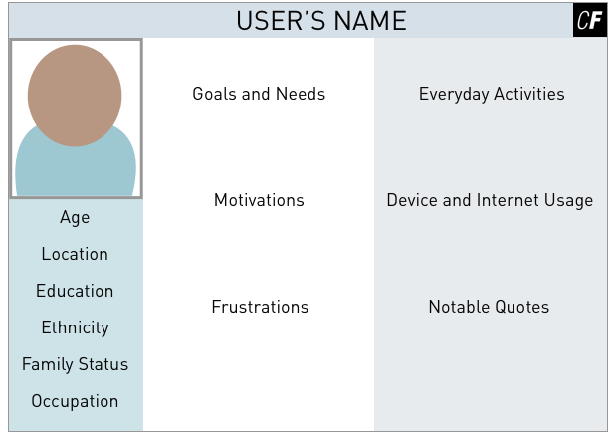

At this point, you should have a well-thought-out list of information describing your new persona that includes details to make it more believable. Now, let’s capture all of that useful data in a single document!

TIP!  
While it’s tempting to include all sorts of personal details and quotes in your persona, remember that their purpose is to enhance communication rather than make things more convoluted. Stick with details that are relevant to the design of your product.

Persona Layout and Formatting

There’s no right or wrong way to format a persona, and there are many, many examples all over the web. That being said, there are trends that will help you lay out your information in ways that have proven to be successful for other designers. Consider the following design guidelines when creating your own personas:

* Personas are normally designed to **fill a single page** so they can be easily printed and presented in meetings or pinned to office walls.
* **A simple two or three column approach** is often all that’s needed (with section headers for each important group of information). As is the case with most things in a UX designer’s world, the simpler the better!
* Most people can’t absorb a wall of printed text quickly or easily, and personas are no exception. Make sure to **include a nice image** representing your persona and **use bullet points or infographics** if they can more easily explain something than a paragraph of text.
* **Keep your content simple and engaging** and try to tell a story with your design. Remember, the same as when it comes to eating a certain peanut-buttery candy, there’s no wrong way to create a persona, so include what you think is important and be sure to have fun!

We can talk about creating personas all we like, but the best way to demonstrate how best to create a persona is through example, so why don’t we take a look at some real examples of personas? By looking at personas created by a variety of designers, you can quickly see the types of information and data other designers find important when creating and using their own personas.

TIP!  
Before you break out a digital design tool, consider sketching your persona on paper. Even a quick drawing with boxes to represent the main sections of information you want to include can be a great first step and get your creative juices flowing. It will also save you time once you begin laying out your persona on your computer!

Persona Examples

Here are a few personas you can use as inspiration for your own persona creation. Keep in mind that nothing is set in stone, and you can take as little or as much inspiration from these personas as you want.

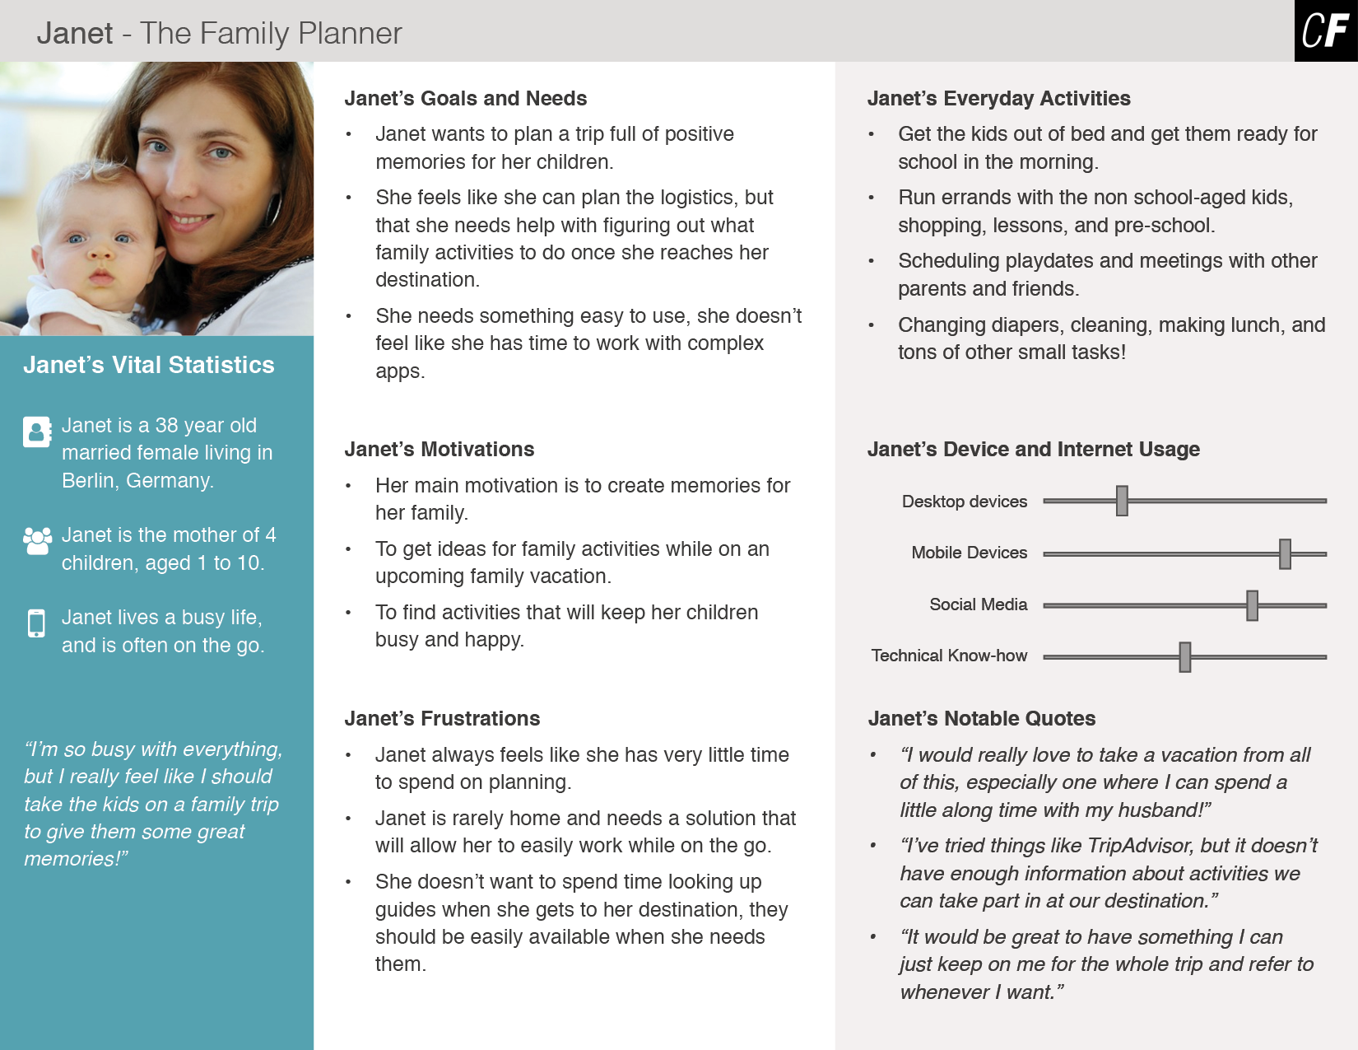

In this first example for Triply, the persona represents middle-aged, family-oriented audience members who are looking to get away. Note how Janet’s busy schedule is a driving force in her life—Triply has to be quick and easy to use for this audience!

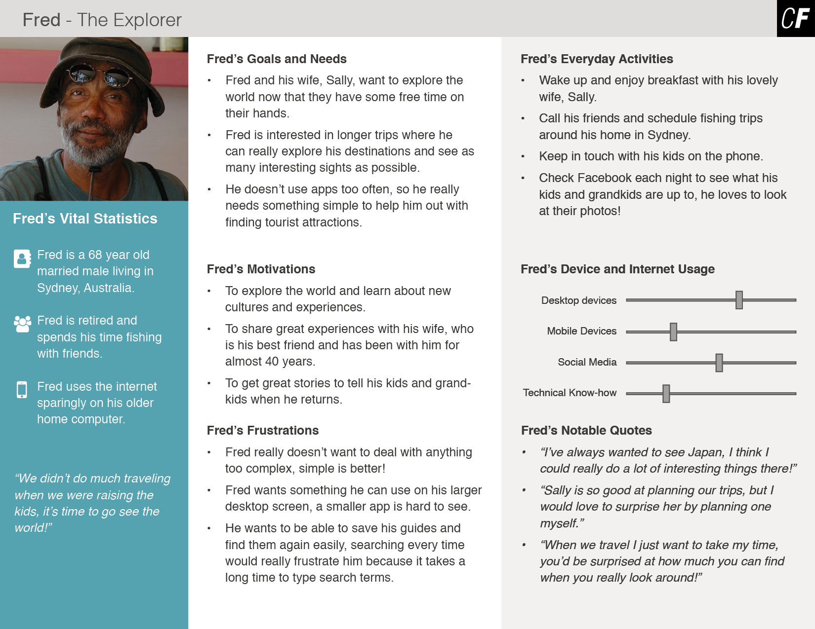

Our next Triply example is Fred. He’s more interested in relaxed trips and doesn’t like using small screens on mobile devices, so Triply will have to accommodate the needs of users like Fred as well.

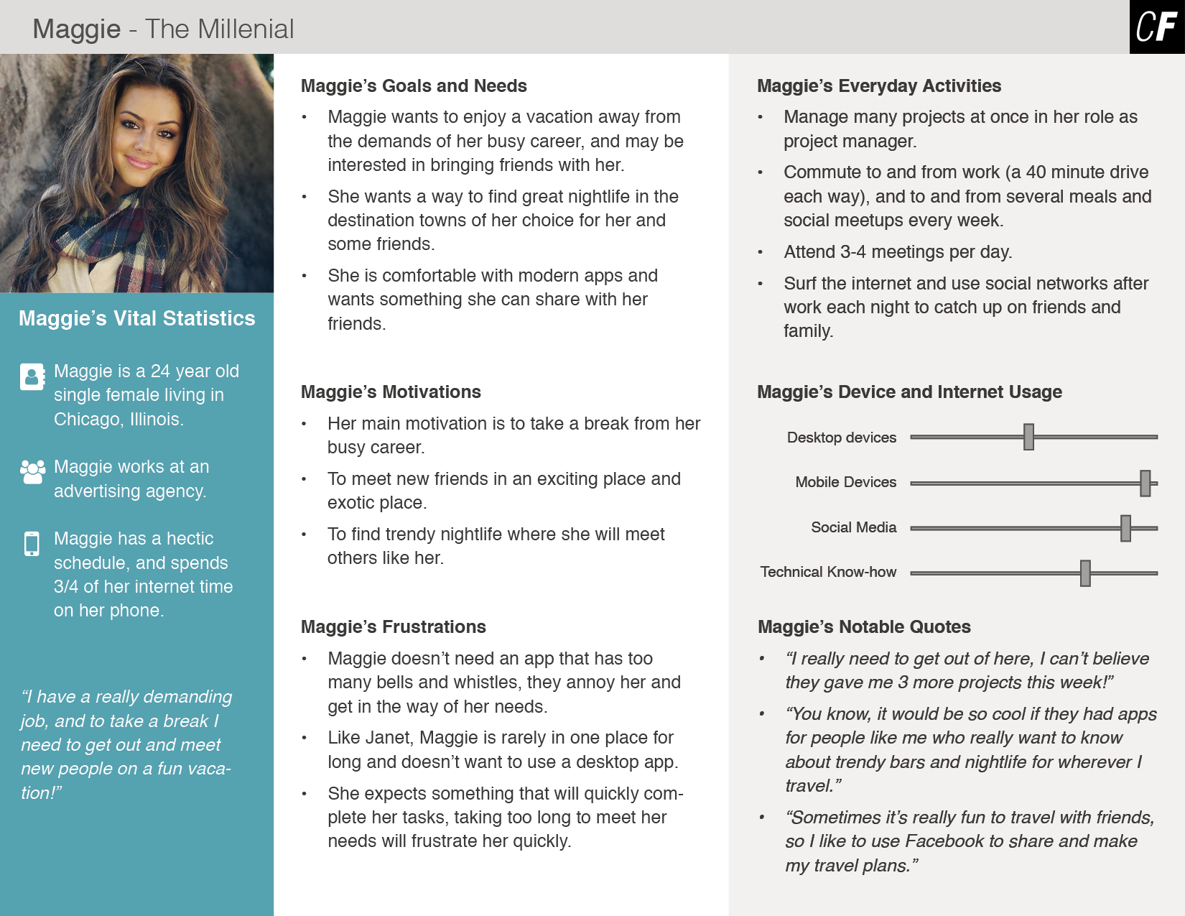

Finally, take a look at the Triply design persona for Maggie. Users like Maggie need a certain type of content and they expect to find it quickly. These users also love to share on social networks, so Triply should support that behavior!

Revisiting Your Problem Statement

Once you have your personas in place, it's always a good idea to revisit the problem statement you built in Exercise 1.6. After all, you want to make sure your personas are capturing the puzzle your application is aiming to solve.

Remember the problem-statement-and-hypothesis combo we looked at in the user personas Exercise of the Fundamentals course? Now that you’ve revisited your problem statement and aligned it with your personas, it's time to create a **hypothesis statement**—this is your attempt at solving the primary problem of your personas. Don’t worry too much about finding the "perfect solution." It’s still early in the project cycle, so nothing will be perfect. For now, simply use this as an opportunity to explore ideas and potential solutions. For a quick refresher, review the following format for a hypothesis statement:

**We believe that by** [doing this / building this feature / creating this experience] **for** [the name of your persona], **we will achieve** [this outcome].

Take a look at the two examples below, created using two of the three personas presented in this Exercise. Then, try writing some for your own personas!

**We believe that by** creating a simple web application that allows users to put together their own travel itinerary from a selection of mini travel guides **for** Fred, **we will achieve**having Fred successfully put together a complete travel itinerary for him and his wife to visit Japan.

**We believe that by** creating a mobile app that connects travellers through attending different nightlife events **for** Maggie, **we will achieve** having Maggie meet new people and experience the best nightlife in new destinations.

After filling in each component, does the statement still make sense? If something looks a bit odd, this could be a sign that you need to look into your personas, proposed features or experience, and desired outcomes more closely. Though it might feel like busy work at the moment, it'll save you a lot of time down the road!

Summary

Feel like you know everything there is to know about personas? We just dropped a lot of information on you, but some of it should have been familiar already with the introduction to personas you received in the Fundamentals Course. Now that you’re in the Immersion phase, however, it’s your job to dig deeper, reach further, and design *harder*. With your new, detailed knowledge about the various types of personas and their creation, you’ll be able to sketch out some in-depth design personas for your own upcoming project using cold hard facts, research, and data. Ready to give it a whirl?

In the next Exercise, we’ll continue learning more about user understanding in the form of mental models and user journeys. See you there!

Resources

* [Creating Personas](http://www.uxbooth.com/articles/creating-personas/)
* [A Closer Look at Personas: What They Are and How They Work](https://www.smashingmagazine.com/2014/08/a-closer-look-at-personas-part-1/)
* [Personas Make Users Memorable for Product Team Members](https://www.nngroup.com/articles/persona/)
* [Common Problems with User Personas](https://www.interaction-design.org/literature/article/common-problems-with-user-personas)

Here are some more design persona examples from around the web:

* [A design persona from NNgroup](https://s3.amazonaws.com/media.nngroup.com/media/editor/2015/01/19/examplepersona.png)
* [A persona created by GMAC](http://www.gmac.com/~/media/Images/gmac/WhyGMAC/GMNews/2015/july/personas.png?la=en)
* [The proto-persona Charlotte from the Fundamentals course](https://s3.amazonaws.com/coach-courses-us/public/courses/ux-immersion/A2/E4/A2E4_charlottepersona.png)

Take the quiz to test your knowledge on this Exercise.

Take Quiz

Task

* [DIRECTIONS](https://careerfoundry.com/en/course/become-a-ux-designer/exercise/user-personas#directions)
* [SUBMISSION HISTORY](https://careerfoundry.com/en/course/become-a-ux-designer/exercise/user-personas#step_submission_history)

 Estimated Task Time: 5 Hours.

Use the process outlined in this Exercise to create between 2 to 4 unique personas for your project. Each persona should represent a different audience group for your project, and, at the end of this task, you should feel confident in discussing your primary audience groups with your mentor and peers.

**Directions**

1. Using your list of insights from the last Exercise, organize your findings and determine the number of unique personas required for your project. For the purpose of building your portfolio, you should construct a minimum of **2 distinct personas**; however, if your research lends itself as such, feel free to construct up to **4 personas**. Remember, the number of your personas has nothing to do with the number of potential users you interviewed. They are different entities entirely and should only represent hypothetical *groups* of users rather than any one specific person you may have spoken to.
2. For each persona, record what information you think would be important to include, as well as personal details to make your persona feel more alive and believable. It should be easy to distinguish the different characteristics of each of your personas.
3. Check out the examples above and throughout the web for inspiration, then create your personas using any digital software you prefer. Some options to consider include Photoshop, Sketch, Illustrator, InDesign, PowerPoint, Google Slides, and Keynote.
4. Save your personas as a combined PDF file and upload it here. Feel free to share additional thoughts or ask questions in the submission box.