2.5: Mental Models & User Journeys

Learning Goals

Discuss mental models and then create a journey map informed by qualitative research

 Estimated Read Time: 40 Minutes.

Introduction

Good to see you again! In the previous Exercise, you learned about personas and why they’re such valuable tools for a UX designer. The good news is that there are many more techniques for bringing users to life and learning more about their behaviors and needs.

You may be wondering why all of these techniques are necessary. The answer, actually, is simple—in the world of UX design, every project is unique (which is one of the great things about this career!). By focusing on adding more tools to your UX toolbox, you’ll be well-equipped for any type of project that comes your way. In addition, using several of these techniques at once (say, a persona, a mental model diagram, and a user journey map) reveals a clearer picture of your users, their beliefs, and their behaviors, which allows you to communicate those nuanced details more easily to your product team.

Why don’t we get started, then, by looking at another great tool to add to your collection—mental models!

Mental Models

Designing an app or website requires that you understand exactly what a user wants to accomplish. Take this quote from the book [*Difficult Conversations*](http://www.penguinrandomhouse.com/books/331191/difficult-conversations-by-bruce-patton/9780143118442/) by Stone, Patton, and Heen:

“The deepest form of understanding another person is empathy... [which] involves a shift from... observing how you seem on the outside, to... imagining what it feels like to be you on the inside.”

This level of user empathy can be hard to pin down, but mental models are the most effective tools for doing so. In essence, a **mental model** is an assumption that a user has made about how a product should work. Investigating these mental models can provide the UX designer with a deeper understanding of user motivations and thought processes, along with the emotional context in which they’re using your product. Mental models are created using the same type of data you’ve already collected in your user interviews. Talk to real people and find out what they do, how they think, and how they approach situations. You may remember thinking about people’s different ideas of breakfast in the Fundamentals course. This was a way of reflecting on their mental models surrounding the concept of breakfast and the accompanying organization of foods. Now, let’s dig deeper into how to put these models together.

To start, we need a way to visualize this model and fully grasp its effectiveness for UX design. Luckily for us, [Indi Young](http://indiyoung.com/about/), author and founder of the UX agency [Adaptive Path](http://www.adaptivepath.com/), has developed a fascinating way to visualize these mental models. She calls them “mental model diagrams.” Let’s take a closer look!

Mental Model Diagrams

To create these diagrams, Young looks at one persona at a time to determine what types of motivations might be driving their behaviors. Take a look at the following simple mental model diagram:

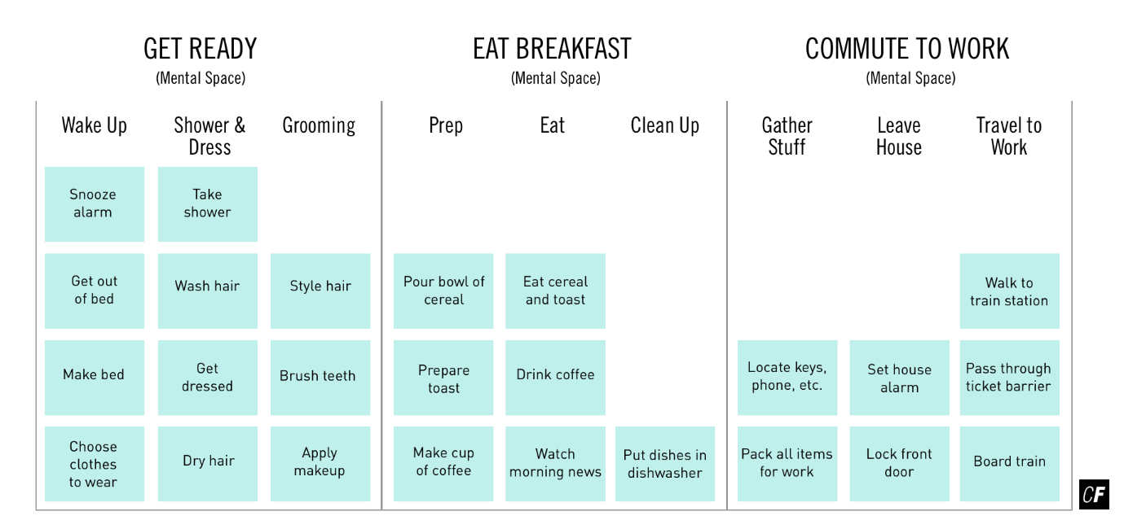

A Simple Mental Model. [Click here](https://s3.amazonaws.com/coach-courses-us/public/courses/ux-immersion/A2/E5/A2E5_simplementalmodel.png) to zoom in

You get up in the morning and get ready, you prepare and eat breakfast, and you get on a train. Each of these groups of activities are considered “mental spaces,” and the full mental model of your morning consists of a combination of several of these mental spaces.

Think back to the interviews you recently conducted. Consider the behaviors, thoughts, and feelings you recorded and implemented in one of your personas. By looking for patterns in these elements, you can create a mental model by grouping those patterns into “towers.” Each tower may contain any number of related behaviors, thoughts, and feelings, but it’s important that they be phrased as verbs to avoid recording simple facts or observations. Young believes that phrasing tower elements in this way helps designers get inside the user’s head. Remember, in a mental model diagram, we’re only interested in behaviors, thoughts, and feelings! After building towers, the towers are grouped further into larger mental spaces.

Things are already starting to get interesting, but in Young’s design, this is only half of the picture. Check out this completed mental model based on our previous example:

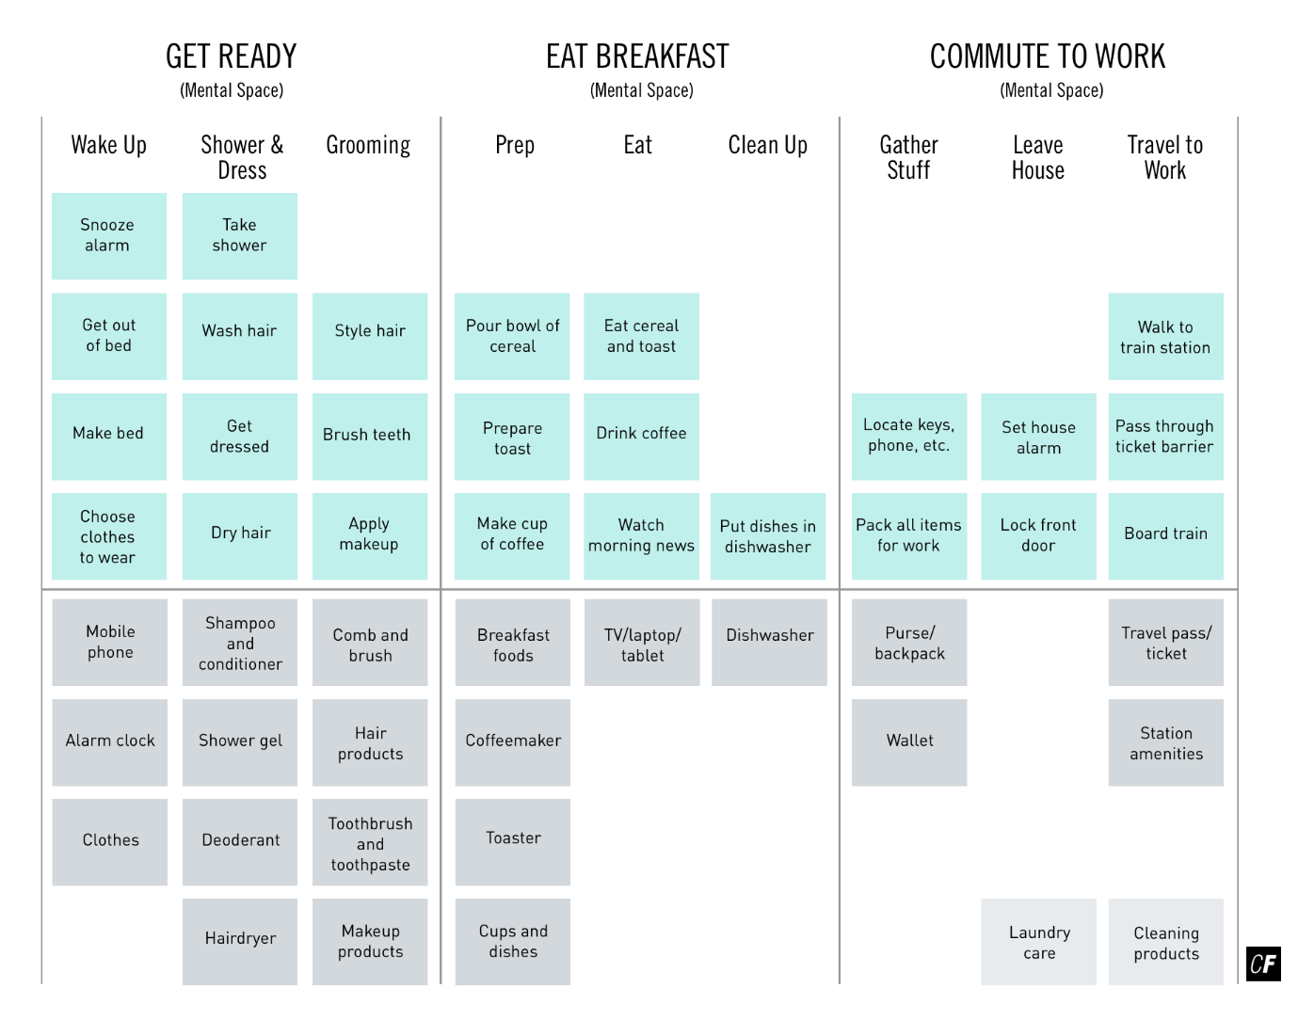

A Complete Mental Model. [Click here](https://s3.amazonaws.com/coach-courses-us/public/courses/ux-immersion/A2/E5/A2E5_completementalmodel.png) to zoom in

In that same morning routine example, we’ve added products from a fictional company under the towers they support. Note that some towers don’t have any products supporting them, and some products don’t really fit under any of the towers in the diagram (they’re listed in the lower-right corner).

To complete your own model, take product features you intend to create and align them beneath the towers they support. After completing this for all of the product features being considered, take a step back and analyze your completed diagram. What should become obvious quite quickly are the gaps between your features—towers with no corresponding features. You may also have features that don’t fit under any certain tower. These can be thought of as extra functionality.

Both of these pieces of information are useful to you as a UX designer. Take what you learn about how your product does and doesn’t support users’ behaviors, thoughts, and feelings and form a strategy around that information. Perhaps you’ll decide to add features in the future to cover gaps or remove features that don’t directly align to user needs. You may also find it necessary to do further research with more mental model diagramming. These documents are designed to be used throughout the product cycle. They may even come in handy months and years down the road when you’re considering new features to implement in your site or app.

Why Are Mental Model Diagrams Important?

At a high level, mental model diagrams can give a UX designer a snapshot of how their product design fits in with the behaviors, thoughts, and feelings of their user audiences, but that’s not all. Here are a few other precise benefits of using mental model diagrams in your design process:

* Mental model diagrams are based on a solid foundation of research, so **they can provide your team with confidence in your design**. This carries over into your users, as well. Users can feel confident using your product knowing it was designed with their own behaviors in mind.
* Mental model diagrams are very useful in **comparing personas at a glance**. Personas can oftentimes have very similar sets of experiences, which can make it a bit of a struggle determining whether it’s worth developing separate solutions for each persona. Looking at mental models can shed more light on this situation. Do the mental models for each persona have a lot in common, as well? If so, a common solution makes sense; however, if there are many differences in the mental models, unique solutions that map to the individual persona’s mental models would be more appropriate.
* In her book, [*Mental Models*](http://rosenfeldmedia.com/books/mental-models/), Young mentions another benefit of mental models—**validating design decisions**. Let’s say that a member of your organization really wants to add a stock ticker to a website you’re working on. You can validate that request by matching it to a “track stock market prices” tower in one of your persona’s mental models. If such tower doesn’t exist, you can point this out respectfully and avoid unnecessary features and information in your design.

You’ve seen how mental models can help with the design process, and you’ll definitely see them again in Exercise 3.1: Information Architecture Principles and Frameworks, as a methodology for information architecture. For now, however, let’s take a look at another interesting technique to add to your UX toolbox—**user journey maps**.

Mental Models and User Journey Maps are in practice quite different, but similar in that they both allow you to gain a deeper understanding of your users. Whereas mental models help UX designers empathize with their user’s motivations, however, user journey maps provide a way to *present* those motivations and behaviors over time in the form of an engaging narrative. Let’s dive in!

User Journey Maps

We’ve already discussed how mental models are fantastic when it comes to empathizing with users. In this same vein, user journey maps are great for visualizing processes a user goes through in order to accomplish a goal. Why is this such a powerful tool? Journey maps are, by nature, narrative documents, and if a UX designer can tell a memorable story about a user’s goals, the entire product team will be able to enjoy a focused, shared vision as they progress through the design process.

It’s important to note that regarding “Journey Maps,” the terms “User” and “Customer” are often used interchangeably (User/Customer Journey Map). The term “User” stems from an emphasis on technology, while “Customer” tends to highlight the business perspective. Don’t worry about the jargon! Instead, focus on communicating and clarifying useful information for the benefit of yourself and your team.

Building a Journey Map

As with the personas we discussed in the previous Exercise, there’s no right or wrong way to build a user journey map. Your objective with this document is to convey a visual story of the process one of your personas will work through in order to accomplish a goal.

Let’s turn again to our travel guide app. Our high-energy younger persona might have a goal to book a trip through the app we’re designing. As a UX designer, recognizing that goal and creating a user journey map of the process will help us tell this story to our product team, ensuring that everyone involved will share a focused vision on how to help this persona accomplish that goal.

When building your user journey map for this Exercise's Task, you can adapt the numbered elements using the diagrams we'll provide below for your own project. Let’s talk about each element in more detail from the perspective of our demo travel app for a better idea of what you’ll be doing.

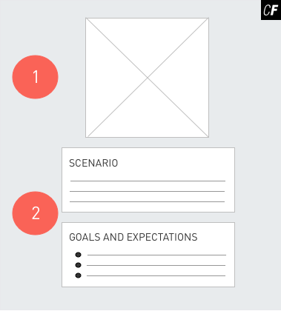

**1:** User journey maps should capture the journey of a **single persona**. Put the name, photo, age, and occupation of the persona you’ll be using here.

**2:** The journey or process you’re trying to capture should go in this space. A sentence or two will usually suffice. In the case of our demo app, we may write something such as “Justin wants to book a weekend away with his fiancé, but doesn’t have a lot of time to do detailed planning (finding unique places to visit at his destination, etc.). In this **scenario**, his goal is to quickly use our travel app to find a guidebook that speaks to his and his fiancé’s interests.” A simple sentence or two describing the scenario is enough. While our demo app doesn’t cover advanced functionality such as actual trip-booking, your app might include such a feature. In this case, include the more advanced feature in your user journey so you can begin understanding how your users might engage with that experience.

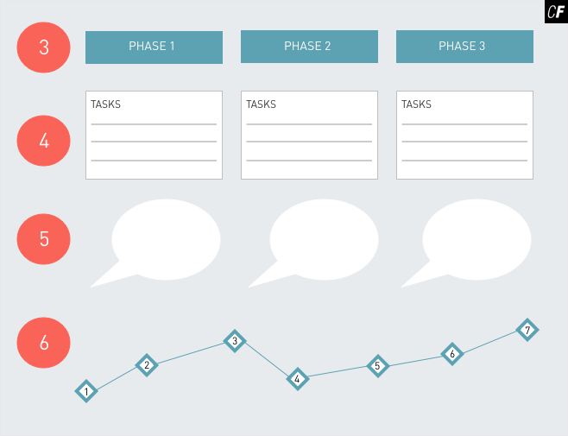

**3:** This area usually consists of several elements, one of which is a breakdown of the **phases** of the journey. Most user journey maps will use three to five basic phases to keep the document simple. For our demo app example, something along the lines of “Determine destination,” “Shop for a good deal,” “Get travel guides for the trip,” and “Book the trip” could be appropriate phase descriptions.

**4:** For each phase, list the primary **tasks** a user might take to work through that phase of the process. For the phase “Determine location” we came up with above, for example, you might write something like “Create a top five list,” “Weigh the pros and cons of that list,” and “Decide on a location with fiancé.”

**5:** **Thoughts** are also listed for each phase. These are commonly illustrated as speech bubbles, but they can take any format. At this point, it’s a good idea to refer back to your user interview data and find relevant snippets of conversation from your participants.

**6:** The final piece of this central section is the **emotional experience**, which normally (but not always) takes the form of a line moving through all phases of the process. During some phases, the user will be emotionally “high,” while in other phases, when faced with setbacks or hurdles, for example, they may become emotionally “low.” Recording these emotional ups and downs will help your team understand the user and what they’re going through as they complete a task.

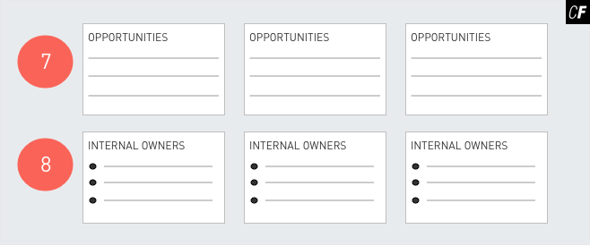

**7:** The last two sections vary the most by project. Everything here depends on the goals of your journey map and what you want to accomplish with the document. In most cases, this area will include a short series of insights or recommendations, called **opportunities**, for the product based on what the user is going through during that phase. For our demo app example, we determined that “Create a top five list” would be one of the actions our persona performs during the first phase, so one of our recommendations for this area of the journey map might be “Since creating lists is a part of many users’ decision processes, we should allow users to create lists of favorites within our app.”

**8:** In some cases, **internal ownership** is also explained in this last area. If you were part of a larger UX team or if one of the recommendations fell on someone else’s shoulders, for example, that could be recorded here for team discussion. Feel free to leave this section out in your user journey map for the purposes of the Task below.

TIP!  
While it helps to use a template like the one above, remember that there’s no wrong way to develop a user journey map. If you’re feeling adventurous, design your own template! Just don’t forget to include the important elements discussed above. To get an idea of the variety involved in Journey Maps, check out the [10 Most Interesting Examples of Customer Journey Maps](http://blog.uxeria.com/en/10-most-interesting-examples-of-customer-journey-maps/).

Creating Successful User Journey Maps

Creating a user journey map can be a time-consuming process, but if done well, it will prove to be an invaluable asset for your team as they advance through the user-centered design process. Remember that other UX designers have tread these waters before. Searching for examples and reading articles online from professionals who’ve created successful user journey maps is a great idea for discovering ideas, inspiration, and some words of advice. Here are a few guidelines for creating successful journey maps:

* Always base the user journey map on your research and establish a truthful and believable narrative to make your journey map as effective as possible.
* Creating user journey maps can be very effective in a group environment. Just by being involved in the process, you can learn a lot about your user and product. If you’re working on a team, invite others to take part. Having everyone on the same page will help with future design decisions.
* Create the visualization part of the journey map last. The important parts of the map are your data, recommendations, and narrative. While visual design is also important, it should take a back seat to an effective and cohesive story.
* Remember to make the journey map an actionable document. While visualizing the process in a narrative way is a very important component of the map, it’s just as important to capture recommendations and insights your team can use to move forward.

Remember these guidelines when you begin working on your own user journey maps and you can be confident you’re walking a path paved by successful UX professionals!

Want a closer look at how you can create a user journey map for your own personas? Take a look below as Claire, your video instructor, creates a user journey map for one of her personas, Dennis, to use in designing her new fishing app:

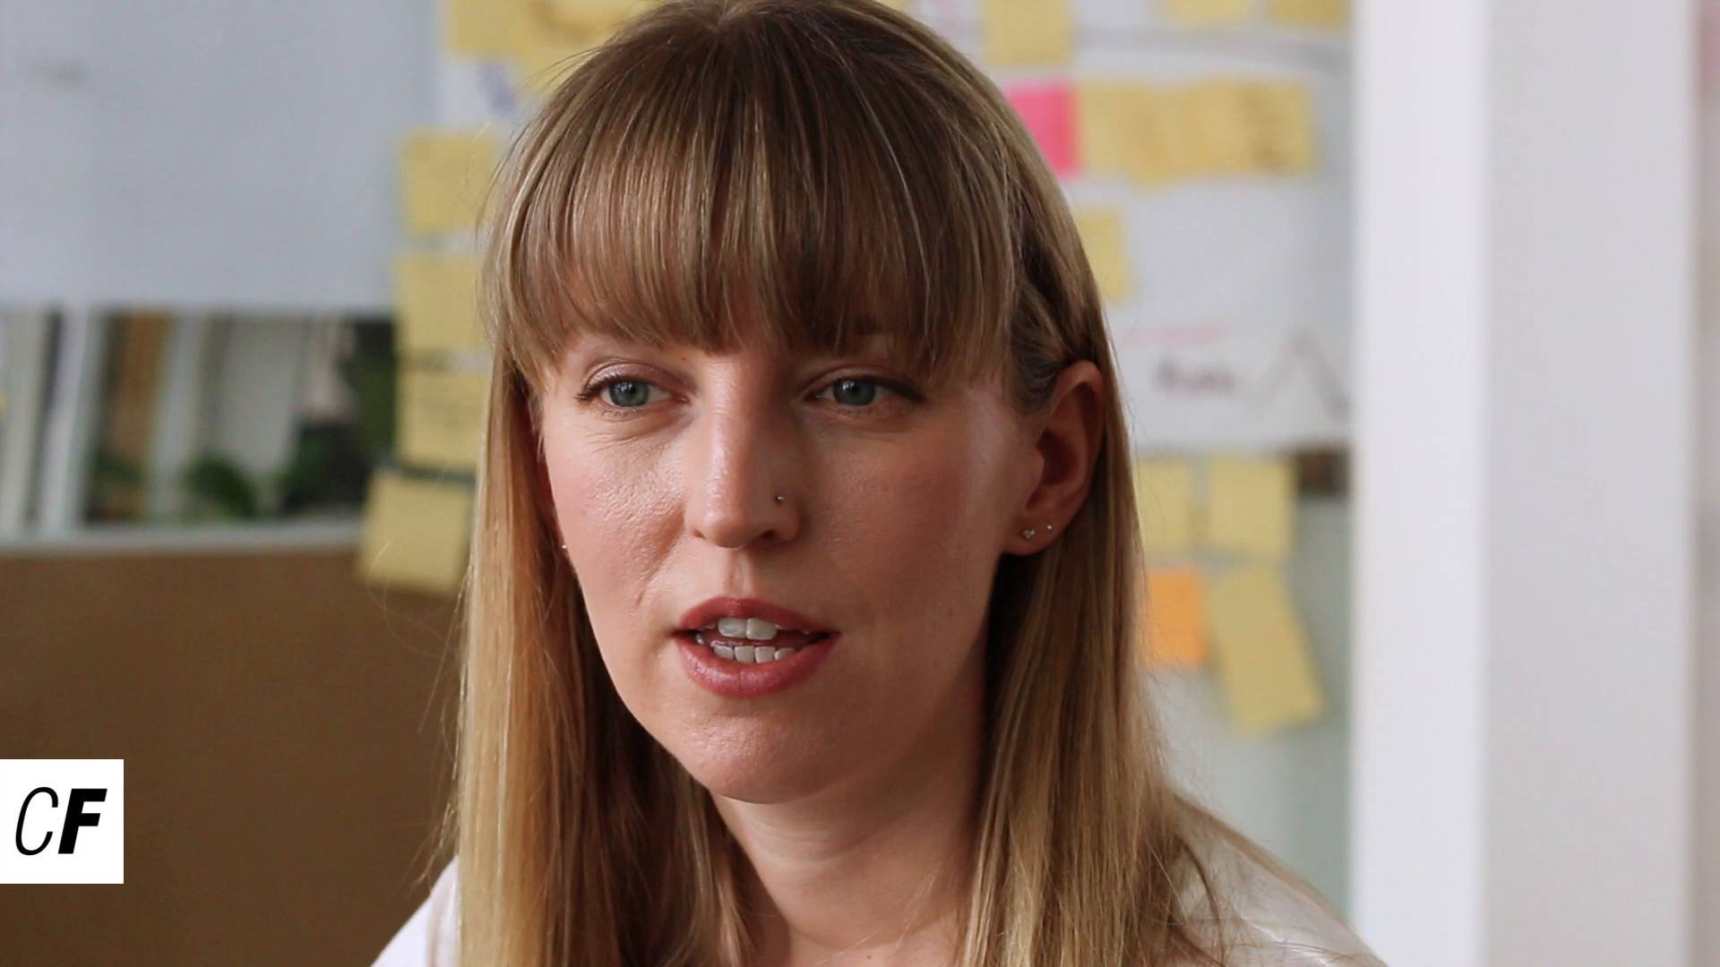

Other Useful Techniques

Both mental models and user journey maps are valuable tools, but there are many more you should spend time learning about on your own. Having a working knowledge of all of these tools looks great on your resume and will make you a more effective UX designer. Ready to take a peek?

Storyboards

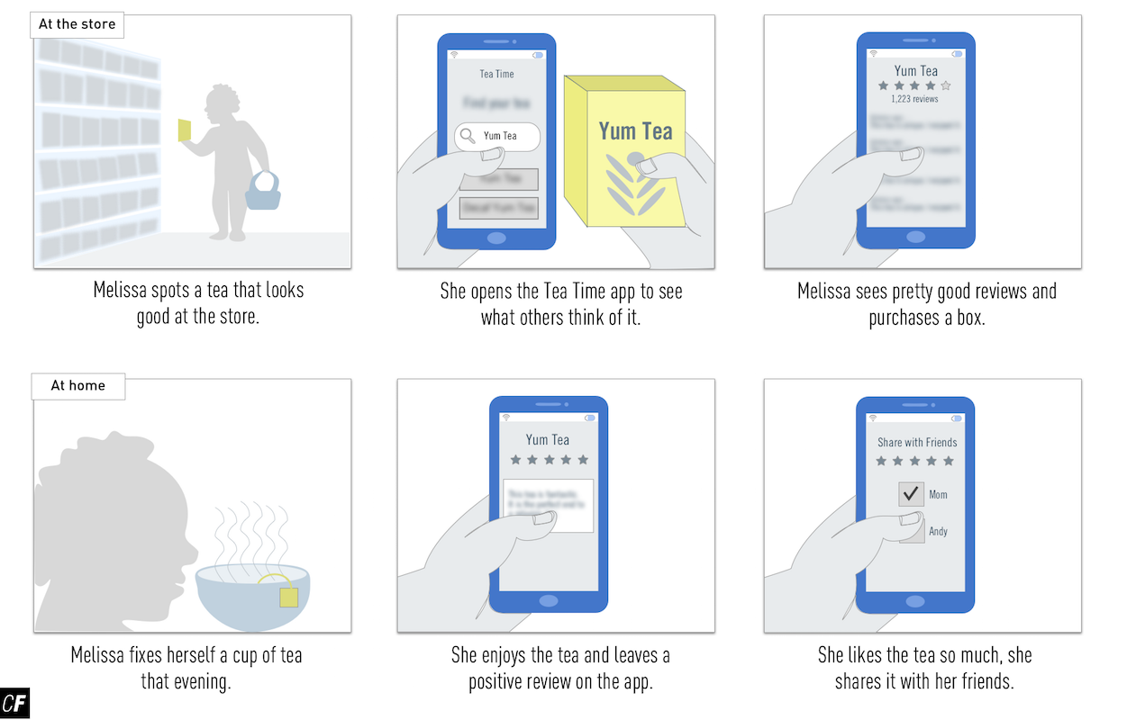

A storyboard is a visual series of events that depicts a user’s journey or use of a particular product. They’re normally captured in a series of sketches (like a comic strip) and can be as focused or as general as needed. Many storyboards revolve around a single user completing a single task and include challenges or frustrations the product team should be aware of. These narrative documents, like user journey maps, serve as a memorable way to highlight issues or considerations throughout the design process.

Storyboards are inspired by the film and animation industry, where they’re commonly used to depict a complex series of events in a simple format. For more information about storyboards, check out the article [Storyboarding in the Software Design Process](https://uxmag.com/articles/storyboarding-in-the-software-design-process).

Scenarios

Scenarios are very similar to storyboards but convey the information differently (with written accounts as opposed to drawn pictures). Scenarios typically depict a day in the life of one of your personas complete with all the details relevant to the design of your product. Scenarios are great for lending additional context to your user’s story, and they can be another helpful tool in achieving a shared vision of your persona within the product team environment.

Like storyboards, scenarios are quick to build and can be used in many parts of the product development process (or even in later development cycles when considering adding functionality to an existing product). To read more about scenarios and how to use them in your work, read [Using Scenarios](https://uxthink.wordpress.com/2010/11/30/using_scenarios/) or [How to Perfect Your UX with Persona Scenarios](https://www.webdesignerdepot.com/2015/04/how-to-perfect-your-ux-with-persona-scenarios/).

User Flows (or Use Cases)

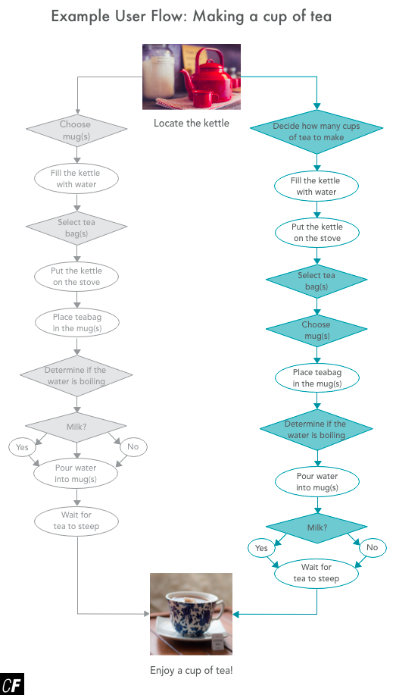

[Click here](https://s3.amazonaws.com/coach-courses-us/public/courses/ux-immersion/A2/E5/A2E5_userflow.png) to zoom in

Remember the tea-making example from UX Fundamentals? Every step in the process of making a cup of tea was outlined in a user flow. User flows help UX designers map out the “flow” of a specific action a persona might take while attempting to accomplish a goal. They’re great for identifying every point of interaction within an app or website, and they’re often used as one of the first building blocks of information architecture.

Since user flows are an especially important transitional document between user research and information architecture, we’ll be covering them in detail in the next Exercise. In the meantime, you can read [Build it With the User in Mind: How to Design User Flows](https://conversionxl.com/how-to-design-user-flow/) for more information.

Summary

This Exercise was full of information. From mental models to user journey maps and more, you’ve added quite a few tools to your UX toolbox. You should feel proud of yourself! Be sure to keep these tools in mind as you work on your own UX projects. Each tool has a slightly different use. As we mentioned before, a complete understanding of your users only comes with a wide variety of tools and a great many insights, so keep your tools polished and ready to be used when the time is right.

Before we move onto user flows in the next Exercise, let’s take this opportunity to work on a user journey map for your project—another important step to fully understanding your users.

Resources

* [A Very Useful Work of Fiction – Mental Models in Design](https://www.interaction-design.org/literature/article/a-very-useful-work-of-fiction-mental-models-in-design)
* [The Value of Customer Journey Maps: a UX Designer's Personal Journey](http://www.uxmatters.com/mt/archives/2011/09/the-value-of-customer-journey-maps-a-ux-designers-personal-journey.php)
* [When and How to Create Customer Journey Maps](https://www.nngroup.com/articles/customer-journey-mapping/)
* [How Snow White Helped Airbnb's Mobile Mission](https://www.fastcompany.com/3002813/how-snow-white-helped-airbnbs-mobile-mission)

Take the quiz to test your knowledge on this Exercise.

Take Quiz

Task

* [DIRECTIONS](https://careerfoundry.com/en/course/become-a-ux-designer/exercise/mental-models#directions)
* [SUBMISSION HISTORY](https://careerfoundry.com/en/course/become-a-ux-designer/exercise/mental-models#step_submission_history)

 Estimated Task Time: 5 Hours.

Use the processes discussed in this Exercise to create a user journey map for each of your selected personas. This is an opportunity for you to focus on not only *who* your persona represents, but which *goals*, *habits* and *behaviors* they exhibit in reference to your project.

Keep in mind that a user journey does not represent a map of your entire product or service but rather an overview of a particular action or flow using your product or service; for example, purchasing a specific product, searching for a particular item, or accessing a specific piece or information. Any user journey is fine so long as you make sure you're focusing on the overall context and that the insights uncovered during the creation of your journey map will help you design your project!

**Directions**

1. Choose 2-4 personas from your project and define key goals that each persona might have while using your project.
2. For each persona, create a user journey map based on the process of achieving that goal. Remember that user journey maps can take any form, but there are useful examples in the Exercise if you’d prefer to use them.
3. Save your user journey maps as a PDF file and upload them here. Feel free to share additional thoughts or ask questions in the submission box.

**Bonus Task**

If you’re looking to diversify your portfolio, consider including 2-3 mental models of your personas, as well. Remember, this Bonus Task is optional. While you’re encouraged to share your work with your peers, please keep in mind that your Tutor and Mentor are not required to review optional tasks.