1.2: A History of User Experience Design

#### **Introduction**

Welcome back to the start of your new career as a UX designer! In the previous Exercise, you learned about the role of a UX designer on a product team, as well as their importance in the development of a product. We also had you analyze several products from a user experience perspective.

Before we dive straight into the concepts and theories that make up UX design, however, why don’t we take a step back for a quick review on how the field came to be? What are the origins of user experience design, and what’s the historical basis for this practice?

#### **An Origin Story**

To properly understand the current state of user experience design as a field, as well as the direction it might take in the future, we have to first understand how it all started. In UX Fundamentals, we talked about experience design concepts reaching all the way back to the beginning of the Industrial Age before ramping up in the mid-20th century. Now, let’s take a look at the history of UX in the digital era.

##### **The Origins of User Experience Design**

Each technological age throughout human history has only been made possible by influential people paving the way for others. In the field of user experience, Don Norman’s name is a frequent sight. You may remember that Norman is widely regarded as a pioneer and expert in the field of user experience. In fact, he’s credited with popularizing the very phrase “user experience (UX)” during his tenure with Apple. Most people consider him the first true user experience designer.

##### **The Birth of the Graphical User Interface**

Modern human-computer interaction was born in 1977 in Xerox’s PARC research center. There, the Xerox team developed resource upon resource for interacting with computers such as laser printing, bitmap images, and the **GUI (graphical user interface)**.

Before the GUI, most computer interaction happened via keyboard. A user would type in a command, and the computer would execute it. This required learning hundreds of commands that were often cryptic and hard to understand, making any sort of interaction with a computer a daunting task. There were no graphical representations of files—just plain old text on a screen. When the GUI arrived on the scene, however, everything changed.

The GUI made it possible to see documents and files on a computer as if they were laid out in front of you on a desktop. In fact, the Xerox Star was the first computer to coin the term “desktop.”

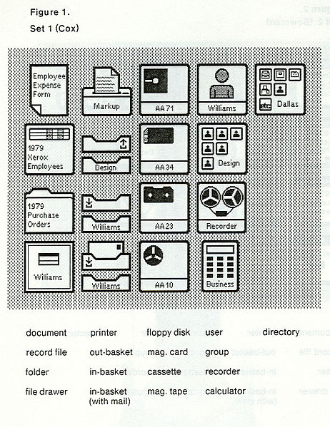

###### **Source: [Interactiontechniques](https://commons.wikimedia.org/wiki/File:Icons_on_the_Star.jpg" \t "_blank)**

This sort of interaction was made possible by one simple little invention—the mouse. The computer mouse, which has its own vibrant history (for more information, see the resources section down below), enabled users to point and click on items on the screen instead of relying solely on the keyboard for navigation. This set a new precedent for the ease with which humans and computers could interact.

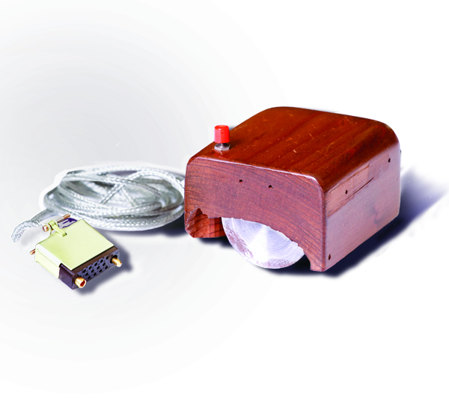

###### **Source:**[**SRI International**](https://en.wikipedia.org/wiki/File:SRI_Computer_Mouse.jpg)

##### **The Rise of the Personal Computer**

Before laptops dominated coffee shops and smartphones invaded every pocket in the world, there was the personal computer. In an age where most computing was done via green text on black screens, computers weren’t exactly the easiest to operate for the average user. With the adoption of the GUI and the mouse, however, computers became increasingly more accessible to the common man. As computers grew cheaper and more user-friendly, they would evolve to become a staple in homes across the world. By the year 2000, over half of the households in the United States owned at least one computer.

##### **A Technological Revolution**

With more people having access to a computer, user experience design grew more relevant than ever. Software was no longer designed for computer nerds and PhDs but for the everyday user.

Then, in 2007, a new type of electronic device was released—one that would revolutionize how people interacted with technology on a daily basis. Computer technology had grown so affordable and compact that it could now be condensed into a tiny little package and carried around in your pocket. These devices were just as powerful as any desktop computer but only a fraction of the size.

This little device was the iPhone, and its super-fast processor, multi-touch screen, and accelerometer paved the way for a multitude of new user interactions. The age of moving a mouse and punching keys on a keyboard was ending, and the age of touch screens was just beginning.

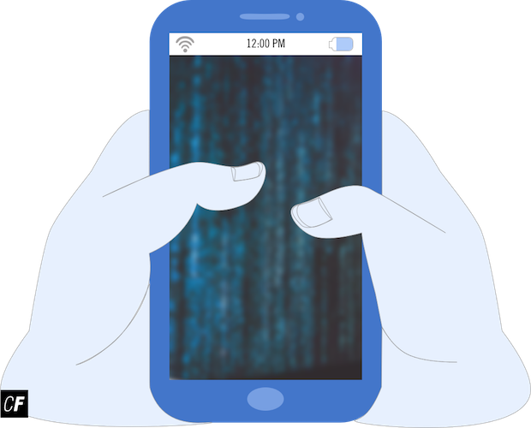

Since the dawn of the iPhone, many others have entered the smartphone scene, from Google to Windows to Samsung. Screens have grown larger and crisper than ever, placing even more emphasis on the user interface.

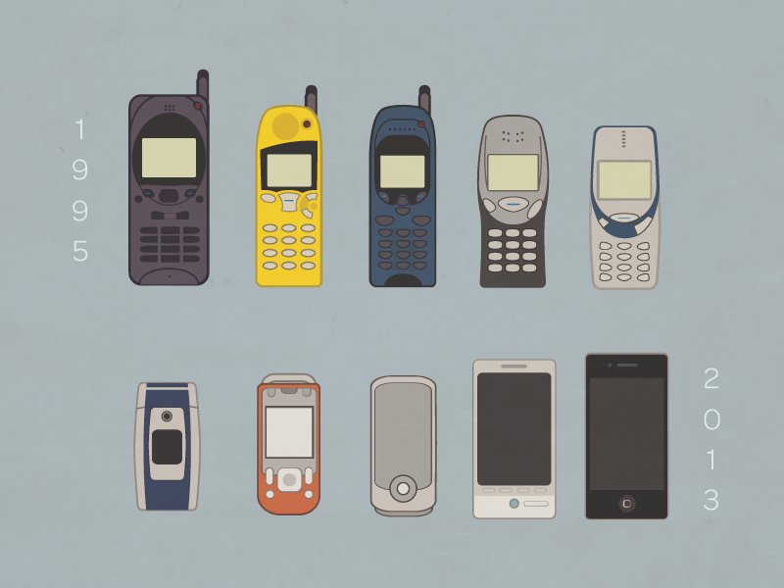

###### **Source:**[**Lars Lundberg**](https://dribbble.com/shots/1301255-My-phones-for-the-past-18-years)

The technological revolution didn’t stop at smartphones, however. Laptops also became smaller, more mobile, and more affordable. Additionally, tablets were born as a sort of middle ground between laptops and smartphones.

##### **The Modern UX Landscape**

Thanks to the ongoing technological revolution, the modern UX landscape looks considerably different than it did even a decade ago. Nowadays, nearly every person in the world has a smartphone in their pocket that’s faster than even some of the most powerful computers of 2007. With hardware being so commoditized, it’s up to the user experience to set individual phones apart. Ask anyone why they prefer iPhone over Android (or vice versa)—it usually comes down to one being easier for them to use than the other.

The same goes for apps. If a user feels even the least bit frustrated when using your location-based recommendation app, they can easily turn to one of a multitude of competitors'.

If you're interested in learning more about the history of UX, check out [this CareerFoundry blog post](https://careerfoundry.com/en/blog/ux-design/the-fascinating-history-of-ux-design-a-definitive-timeline/).

#### **The Human vs. The Computer**

**Human-computer interaction (HCI)** is the science and study of how humans interact with computers and other digital systems. It’s a higher-level concept than UX design itself and is more focused on study and research than actual implementation.

Before the 1980s, you had to be an information technology professional to interact with a computer system. As you’ve learned, however, the GUI and computer mouse changed all that for the better. These advancements turned using a computer into an intuitive experience. After all, people already understood the concepts of pointing and tapping on things. This change put the user at the center of the computer’s design, which ultimately led to the creation of the field of HCI.



##### **The Human Element**

Remember Don Norman, the first UX designer? In addition to inventing the role of user experience designer during his time at Apple, he also coined the term **user-centered design (UCD)**, sometimes referred to as human-centered design (HCD). This term was popularized in Norman’s 1986 publication, [User Centered System Design: New Perspectives on Human-computer Interaction](https://www.amazon.com/User-Centered-System-Design-Human-computer/dp/0898598729). See the resources section at the end of this Exercise for more info.

In its most basic form, UCD puts the user at the center of all design decisions by prioritizing user needs and requirements. This approach is beneficial for a number of reasons:

* It makes computer systems less complex and easier to understand for the everyday user.
* It reduces the need for support and help desks as users can understand software without having to consult guides.
* It ultimately reduces costs and increases revenue for companies by producing more effective software with a higher chance of turning a profit.

A good UX designer uses UCD principles to ensure that the user is always at the center of the design process. After all, we build products for humans, so doesn’t it make sense that humans should love using them?

#### **Summary**

In this Exercise, we gave you a brief history of user experience design and looked into how user-centered design became so prevalent in the worlds of technology, industry, and beyond. We also discussed the role of the smartphone in user experience design and how it was partly responsible for the paradigm shift to a user-centered focus.

This should have given you a solid understanding of how the field of user experience design has evolved into the systems you’ll be designing for today. In the next Exercise, we’ll dive right into some key concepts of UX design by looking into human needs and motivations, as well as how important they are when it comes to product interaction. See you there!

#### **Resources**

**Blogs and Articles**

* [History of Computers: A Brief Timeline](http://www.livescience.com/20718-computer-history.html)
* [Human-Centered Design (HCD)](https://en.wikipedia.org/wiki/Human-centered_design)
* [Definition of User Experience from the N/N Group](http://snip.ly/1prrb#https://www.nngroup.com/articles/definition-user-experience/)
* [The History of Human-Computer Interaction](https://www.interaction-design.org/literature/book/the-encyclopedia-of-human-computer-interaction-2nd-ed/human-computer-interaction-brief-intro)
* [Don Norman Discusses Activity Centered vs. Human-Centered Design and Why Activity Centered Design is Imperative](https://www.researchgate.net/profile/Donald_Norman/publication/200086092_Human-centered_design_considered_harmful/links/0c9605208fca197c2e000000.pdf)
* [The Origins and Principles of User-Centered Design](http://citeseerx.ist.psu.edu/viewdoc/download?doi=10.1.1.94.381&rep=rep1&type=pdf)

**Videos**

* [Interview with Jony Ive “Designed by Apple in California” Chronicles 20 Years of Apple Design](https://youtu.be/IkskY9bL9Bk)
* [Designed by Apple in California - The Book (Full Walkthrough)](https://www.youtube.com/watch?v=9zEcGE4umuc)
* [Video from the UX Conference 2016 in San Francisco, Don Norman: The Term "UX"](https://youtu.be/9BdtGjoIN4E)

**Books**

* [Iconic: A Photographic Tribute to Apple Innovation by Jonathan Zufi](http://iconicbook.com/work/)
* [Designed by Apple in California by Andrew Zuckerman](http://www.apple.com/shop/product/MLXF2LL/A/designed-by-apple-in-california-102-x-128-inches)
* [User-Centered System Design: New Perspectives on Human-Computer Interaction by Don Norman](https://www.amazon.com/User-Centered-System-Design-Human-computer/dp/0898598729)