2.9: Portfolio Review

Learning Goals

* Discuss the strengths and weaknesses of your portfolio

 Estimated Read Time: 15 Minutes.

Introduction

Welcome to the final Exercise of Achievement 2 (and your second portfolio review)! We hope the review from the previous Achievement left you with some food for thought, as well as some guidance you can apply to all reviews going forward. In this second Achievement, you spent a great deal of time on research methods, user personas, user flows, task analyses, and more—all of which are paramount to the work of a UX designer. Let's take a closer look at the focus areas to better understand your deliverables.

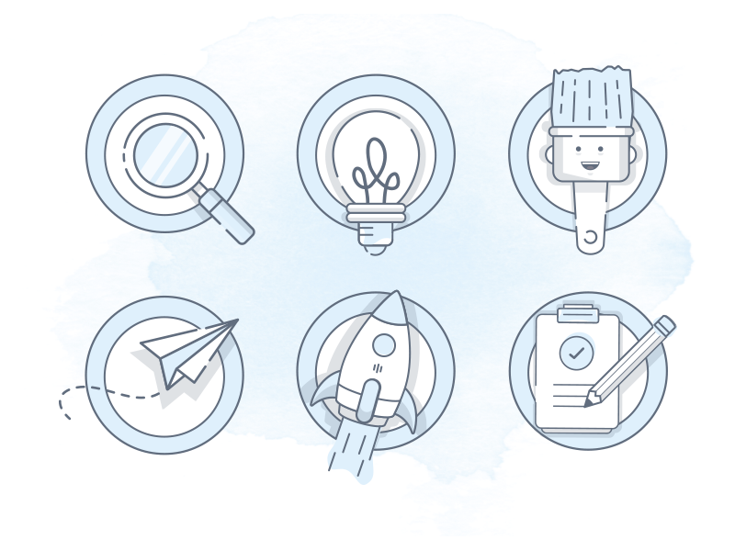

Source: [Al Power](https://dribbble.com/shots/3525477-Design-Process)

Focus Area

This Achievement focuses on getting to know your intended users through user research, journey mapping, and user flow diagramming. These research-oriented tasks allow you to closely examine your users’ needs, motivations, pain points, and thought processes. Keep in mind that most of the project deliverables here contain some type of visual element. Therefore, it’s a good idea to revisit these deliverables and refine the visual elements (as needed) upon completion of Achievement 5. For now, simply pay special attention to the content and structure of these deliverables.

Project Deliverables

* User personas
* User journey map
* Illustration of user flows
* Mobile-first design plan

Portfolio Review Questions & Discussion Points

User personas are important to include in your portfolio. While a visually appealing layout will help you make a good first impression, you’re working to become a UX designer rather than a visual designer, so be sure to keep your focus on the user experience for which you’re researching. While reviewing your user personas, consider discussing the points below with your Mentor:

* What are the main differences between a proto-persona and a design persona? Which one(s) do you plan to include in your portfolio?
* What makes an excellent, portfolio-worthy design persona?
* Is there enough distinction among the user personas you’ve created so far?
* What are some of the overlaps, if any?
* What’s your plan for maintaining and updating your user personas as you progress through the course?

User journey maps provide a great way to visually convey qualitative data, such as the thoughts and emotional experiences of a user. As you review your user journey maps and determine whether they should be included in your portfolio, check with your Mentor about the following:

* Does each journey map capture the goal of each of your personas?
* Does each journey map contain at least three phases of the journey?
* Does each journey map clearly illustrate the process of achieving the persona’s goal? If there’s any ambiguity, what can you do to improve it?

If you’re looking to diversify your portfolio, consult with your Mentor about creating mental models of your personas. Note that this is a challenge task from Exercise 2.5: Mental Models & User Journeys.

* If you’ve already done this, great! Ask your Mentor how you can further refine your mental models.
* If not, work with your Mentor to determine the best way to timeframe and tackle this part of your portfolio.

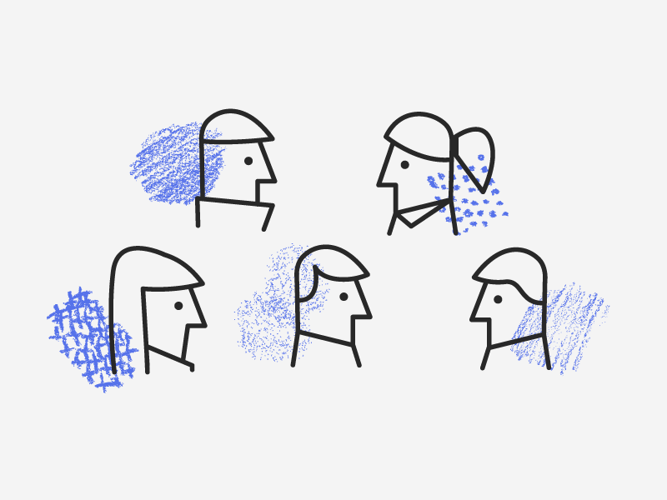

Source: [Francisca Veloso](https://dribbble.com/shots/3256639-Textured-Personas)

User flows are a lot like blueprints that show off how your user personas accomplish specific tasks, step by step. Including them in your portfolio can help provide more complete pictures of your personas. When reviewing the user flows you’ve created, check with your Mentor about the following:

* If you created three user flows for one persona, ask your Mentor for advice on whether you should dive deeper (i.e., focus on refining the existing user flows) or go wider (i.e., create a user flow for another persona), as this will be contingent upon your personal interests and professional goals.
* Does each user flow have a well-defined objective as well as an entry point and success criteria that make sense for the corresponding persona?
* Does each user flow illustrate intuitive movement and alternate paths?
* Are there simple tweaks that can help make the good “better” and the better “great”?
* What are some of the pain points you encountered while creating your first set of user flows?

At this stage, your mobile-first design plan is probably a simple spreadsheet with the three required sections, “Mobile Content,” “Tablet Content”, and “Desktop Content.” If you want to include this in your portfolio, refresh your understanding of progressive enhancement and ask your Mentor about the following:

* Are the personas’ needs and rationales for content adequately covered by the design plan?
* Remembering that “mobile-first is not mobile-only,” does the design plan follow the progressive enhancement process?
* The spreadsheet is great for documenting and sorting information, but are there other (more appealing) ways of visually presenting your design plan? Ask your Mentor for advice!

As you may have noticed, it can sometimes be difficult to present research work visually. While your design focus should be on the user experience rather than the user interface, take a few moments to explore fun and effective ways of showing off your research work. Ask your Mentor about infographics, pie charts, Venn Diagrams, and more!

Summary

In this Exercise, we took a look at the deliverables you produced in Achievement 2: Understanding the User and provided you with many great questions and discussion points relevant to the focus areas. In the next Achievement, we'll talk about Foundational Design, which will provide you with the building blocks you'll need to begin constructing your website or app. But first, the Task!

Task

* [DIRECTIONS](https://careerfoundry.com/en/course/become-a-ux-designer/exercise/portfolio-review--2#directions)
* [SUBMISSION HISTORY](https://careerfoundry.com/en/course/become-a-ux-designer/exercise/portfolio-review--2#step_submission_history)

 Estimated Task Time: 2 Hours.

Using the guidance above, select one or more of the project deliverables listed, compile them into a single PDF, and submit it here to discuss with your Mentor. You're welcome to submit all of the following deliverables if you'd like:

* User personas
* User journey map
* Illustration of user flows
* Mobile-first design plan