1.3: Human Needs & Motivations

#### **Introduction**

Hello again! Glad to see you back for another round of UX design tutelage. In the previous Exercise, we covered the history of UX design and touched on relevant concepts such as human-computer interaction and user-centered design. We also observed, by way of UCD, how putting the user at the center of the design process can result in more effective, usable software.

In this Exercise, we’ll start looking at the key concepts and theories you’ll need to understand in order to be a successful UX designer. Namely, the needs and motivations of your users. Ready to hit the ground running? Then, let’s go!

#### **Maslow’s Hierarchy of Needs**

As a UX designer, it’s not enough to understand what a user needs. You need to go one step further and understand what motivates your users.

The first person to describe human motivation in a structured framework was Abraham Maslow in 1943. If you’ve taken any psychology, business, or professional development courses, you may have heard of his famous theory before—the appropriately titled **Maslow’s Hierarchy of Needs**. Maslow would go further in 1954 by releasing his book [*Motivation and Personality*](https://www.amazon.de/Motivation-Personality-Abraham-H-Maslow/dp/0060419873), which expanded on his original theory by describing five stages through which human motivation generally moves:

* **Physiological Needs:** Basic human needs such as air, food, and water.
* **Safety and Security:** Needs such as personal security, financial security, and health. A home, steady job, and secure income can go a long way towards fulfilling these needs.
* **Social Belonging:** Needs related to the feelings of love and belonging. Human beings have a need to belong to groups. These groups can be big, like a workplace or sports team, or small, like a family or significant other.
* **Self-Esteem:** Needs related to how we feel about ourselves. Human beings have a need to be respected and valued, both by others and themselves.
* **Self-Actualization:** Once all the previous needs have been fulfilled, humans reach what Maslow calls self-actualization. Only then can we attempt to realize our full potential and be all that we can be.

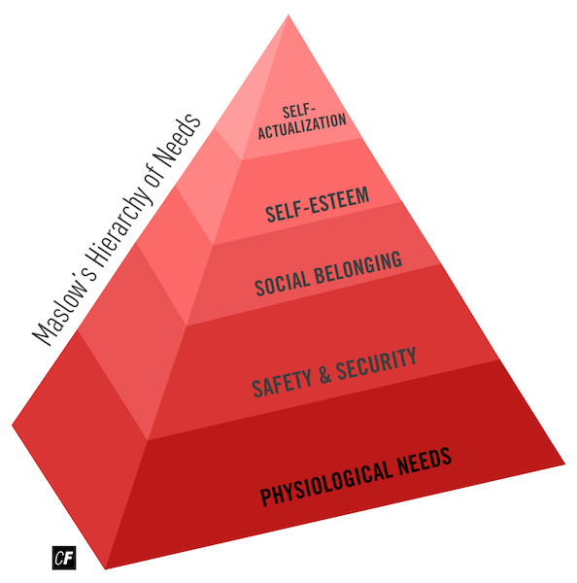

These five stages are usually represented as a pyramid, though it should be noted that any of these can occur at any given time. Maslow himself wrote that certain needs dominate the human organism at certain times, but the needs are not mutually exclusive or dependent upon one another.

Maslow’s Hierarchy of Needs is not without its criticisms. The specific needs, as well as their order within the hierarchy, have been debated among psychologists. Some also argue that Maslow’s Hierarchy doesn’t account for more virtuous acts such as charity, bravery, and other forms of altruism.

Nevertheless, Maslow’s model gives us helpful insight into what drives us as humans. Once our primary, survival needs have been met, we can focus on higher-level, cognitive needs. You may be wondering why this is so important for us as UX designers. This is because when it comes to technology, our needs and wants for interactive products follow a similar hierarchical priority.

#### **Design Hierarchy of Needs**

Most complex consumer goods are not necessities by nature. On a deserted island, for example, an iPhone would be considerably less useful than, say, a lighter or knife. This means that we need a new, tweaked hierarchy of needs in order to ensure that your consumer product is fulfilling a human need (or, more accurately, a desire).

Luckily for us, such a hierarchy already exists. Stephen Bradley of Smashing Magazine constructed a hierarchical model of consumer needs for products that lists consumers’ product needs in the order they must be met—the **Design Hierarchy of Needs**.

As with Maslow’s hierarchy, this is just an approximate model. Always keep in mind that users’ needs are not mutually exclusive or dependent upon one another.

* **Functionality:** If basic functionality needs are not met, users will abandon the product. Eventually, the product will cease to exist.
* **Reliability:** The product must function consistently, and the user’s documents and data must be safe.
* **Usability:** The design of the product must be intuitive and easy to use, reducing the likelihood of user errors.
* **Proficiency:** This level speaks to product maturity. The product not only meets base-level functionality but also goes above and beyond by helping the user meet goals they may not have otherwise anticipated.
* **Creativity:** This is where form, function, and usability come in. A product that achieves this level moves beyond having “users” and, instead, “fans.” These fans evangelize and promote the product. Think about the major competitors in various industries. Some users live by Apple products while others wouldn’t be caught dead using Apple products. A similar phenomenon exists in the game industry, with some gamers preferring Sony, some Microsoft, and others Nintendo.

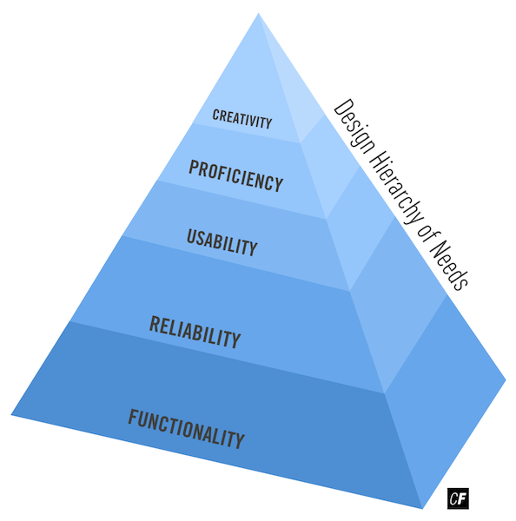

Let’s take a look at a real-world example for a glimpse of this hierarchy in action. Before the release of the iPhone, most cell phones’ capabilities were limited to making calls and sending text messages via a T9 keyboard. These functions fulfilled users’ needs of functionality, reliability, and, to an extent, usability, but didn’t do much else.

When the iPhone came on the market, however, it offered features such as a full-size digital keyboard, a full-fledged web browser, and a large touchscreen. This took the Design Hierarchy of Needs much further by meeting the needs of proficiency and creativity.

Let’s take a closer look at how the iPhone met the needs of each tier:

* **Functionality:** The iPhone met basic needs such as making and receiving calls and sending text messages.
* **Reliability:** The software and hardware were both very reliable. You could check your email without the app crashing, and accidentally dropping the device wouldn't necessarily lead to a cracked or broken phone.
* **Usability:** The iPhone’s design and user-centered focus made it intuitive and easy to use.
* **Proficiency:** The iPhone introduced features users didn’t even know they needed. In the beginning, things as simple as email and internet-access were revolutionary concepts for a mobile device, but nowadays we can even call taxis, check our bank balances, and identify catchy songs using an assortment of mobile apps.
* **Creativity:** The iPhone sported a sleek design and came with unique, touch-based interactions.

Of course, the iPhone is no longer the only player when it comes to smartphones. Since its release, a multitude of other manufacturers have made their own smartphones with similar features, and today, the Android operating system has surpassed Apple’s original iOS, commandeering more than 80% of the global mobile OS market share. High competition makes for higher standards in quality and lower prices, which has been good for the market as a whole. The smartphone revolution has turned how we think about communication and handheld devices on its head—the only thing smartphones can’t do yet is read our minds!

TRY IT!  
How do other products in your daily life satisfy a user’s needs at each tier? Pick one and try putting together your own list like the one above. You can even pick a product similar to the app you’ll build for your course project. When done, keep the list in your notes or share it with your fellow students on Slack.

#### **The Fogg Behavior Model**

Have you ever tried creating a new habit for yourself? How about trying to quit a bad habit? It’s tricky business! Now imagine you work for a company, and your job is to create a new habit or behavior in other people. This requires serious Jedi mind tricks. Luckily, we can leverage the thinking and frameworks of prominent researchers in the field to help us out.

BJ Fogg, founder of Stanford University’s [Persuasive Technology Lab](http://captology.stanford.edu/) and creator of the Fogg Behavior Model (FBM), knows a thing or two about behavior extension, change, and creation. Fundamentally, the Fogg Behavior Model states that three components must occur simultaneously to have a tangible effect on behavior: motivation, ability, and trigger. These components can be summarized as a formula:

Behavior = Motivation x Ability x Trigger

If the desired behavior is not present, then one of the above components must be missing. In essence, the creation or extension of a behavior must involve the following:

* A motivated group or individuals
* The fundamental ability to complete the action itself
* A trigger to engage, remind, prod, or coax a group or individual to complete an action

Let’s take a look at what this looks like mapped out on a basic graph with “ability” on the X-axis and “motivation” on the Y-axis.

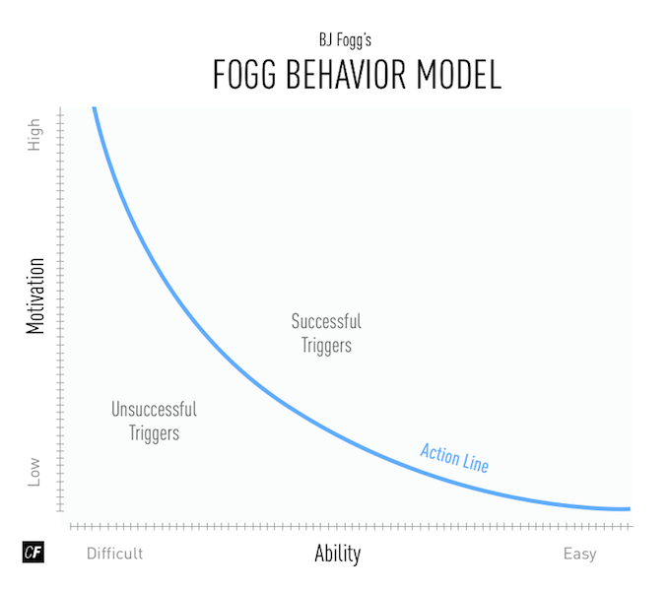

###### **Adapted from**[**BJ Fogg**](http://www.behaviormodel.org/)

Pay careful attention to the “action line,” otherwise known as the “Behavior Threshold.” As you can see, one side of the “action line” separates the successful triggers from the unsuccessful ones on the other side. Fogg emphasizes that it’s difficult to manipulate an individual's personal motivation or ability, so it’s best to focus on fine-tuning triggers to elicit the desired behavior. Now, here's the billion-dollar question: how do we design effective triggers?

Fundamentally, there are two types of triggers: internal and external. **Internal triggers**include loneliness, boredom, hunger—feelings that are universal to the human condition. **External triggers** typically involve outside factors like the ease of using a mobile app or finding a local restaurant. As designers, we typically focus on external triggers as elements we can build into our products and services, for example:

* Text message
* Push notification
* Sales call
* Advertisement
* In-application or on-site notifications (i.e., red Facebook notification)
* Event scheduled in calendar
* Alarm or alert
* Contextual notifications based on time or location

Once we’ve identified the type of external trigger that we want to design for, how do we ensure that it’s designed effectively? Luckily, Fogg outlines seven strategies to influence behavior:

* **Reduction**: simplifies a task that the user is trying to do.
* **Tunneling**: guides the user through a sequence of activities, step by step.
* **Tailoring**: provides custom information and feedback to the user based on their actions.
* **Suggestion**: gives suggestions to the user at the right moment and in the right context.
* **Self-monitoring**: enables the user to track their own behavior in order to change it and achieve a predetermined outcome.
* **Surveillance**: observes the user overtly to increase a target behavior.
* **Conditioning**: relies on providing reinforcement (or punishment) to the user in order to increase a target behavior.

Now, can you think of any products or services that use external triggers to get you to complete actions or exhibit certain behaviors? Do you ever find yourself checking Instagram, Facebook, or some news site without remembering your initial motivation for opening the page? Why do you think that happened? What motivation, ability, and trigger created that behavior? Take some time to reflect on these questions.

Want to see how Runkeeper, a fitness tracking app for runners, influences behavioral change by utilizing five of the seven persuasive technology strategies outlined by Fogg? Read all about it in Dexter Zhuang’s article: [Designing For Behavioral Changes in Health](http://www.uxbooth.com/articles/designing-for-behavioral-change-in-health/).

#### **Friction: The Enemy of Motivation**



“In user experience, friction is defined as interactions that inhibit people from intuitively and painlessly achieving their goals within a digital interface.”  
VICTORIA YOUNG

People use products to fulfill specific goals. Perhaps they want to compose an email, order a latte, share a photo with a friend, or simply unwind while playing a casual game. As we see from both Maslow’s hierarchy and the Design Hierarchy of Needs, humans are goal-oriented creatures. Regardless of where in the hierarchy that goal appears, the blocking of a goal results in frustration and anger.

As with any kind of impediment that stands between an individual and their goal, friction in a product, app, or service creates frustration. If the frustration is great enough, the user will attempt to find other ways to achieve that goal. This could mean frantically clicking around to find what they need, or worse, finding another product that meets their needs.

As a UX designer, your primary goal is to reduce (and ideally, eliminate) any friction within the user interface of a product. You want to make sure the product performs consistently (e.g., the app opens and responds with one click) and is easy to navigate (no hunting and pecking for functions). On top of that, providing additional motivation and value for your users can help garner loyal fans. This is what can elevate your product to the “creativity” stage of the hierarchy. We’ll discuss this further in upcoming Achievements.

The video below will walk you through locating friction and triggers in an existing app, which is exactly what you'll be doing for this Exercise's Task!

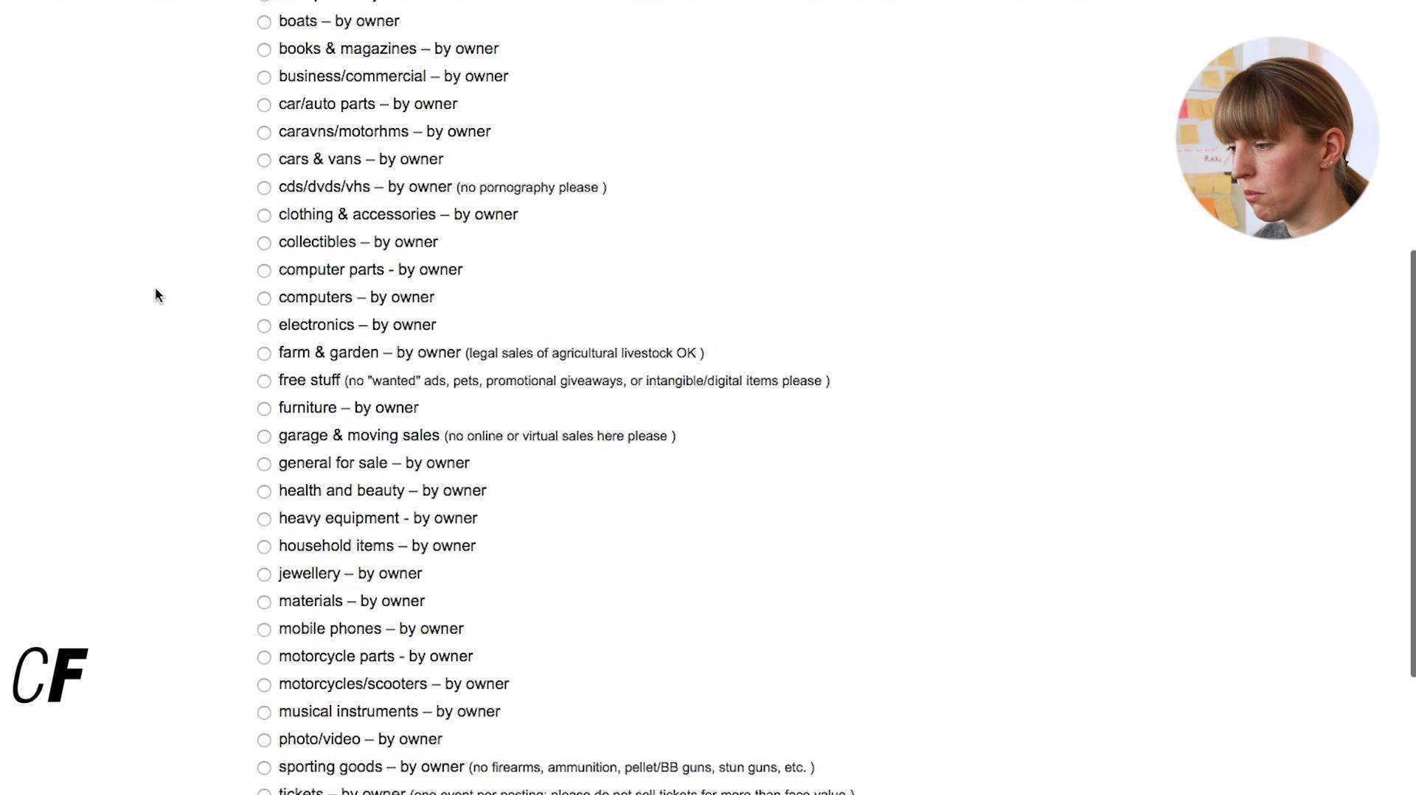

#### **Summary**

In this Exercise, we discussed Maslow’s Hierarchy of Needs, an organized framework of our most basic needs as humans. We also went a step further and looked at the Design Hierarchy of Needs, which represents higher level needs that come into play within the products we design. Finally, we approached the concept of product friction and how your goal, as a UX designer, is to reduce points of conflict and frustration in order to create a usable and enjoyable product.

In the following Task, we’ll let you try your hand at spotting friction in an existing app. To add to the challenge, we’ll have you choose something you already enjoy using. For extra practice, feel free to do the same thing for an additional app similar to the one you’ll be building for your course project. This can be a good way to kick off the competitive analysis you’ll conduct in Exercise 1.7. Your course project is a design you'll be working on over the entirety of this course. Go ahead and take a look at the [four options for your project](https://careerfoundry.com/en/dashboards/become-a-ux-designer/course-home#course_project) now and think about which one most interests you. You'll be making your final decision in Exercise 1.5.

STUDENT PROJECT OPTIONS  
The project briefs available for your course project have been carefully designed and written to allow you to develop the skills you need to get your foot in the door of the UX design industry. Therefore, you must choose one of the four options provided rather than a project of your choosing.

This doesn't mean you can't be creative with your project. You can change the name, and each of the briefs can be interpretted in any number of ways. For example, say you were given a course project brief for a shopping website, you may decide to design an online garden center!

Nothing is stopping you from working on a personal project in addition to your course project if you have the time. However, your Tutor and Mentor will only be responsible for providing you with feedback on your course project.

#### **Resources**

**Books and Articles**

* [Designing for a Hierarchy of Needs](https://www.smashingmagazine.com/2010/04/designing-for-a-hierarchy-of-needs/)
* [Maslow’s Hierarchy](https://en.wikipedia.org/wiki/Maslow's_hierarchy_of_needs)
* [Motivation and Personality by Abraham Maslow](https://www.amazon.de/Motivation-Personality-Abraham-H-Maslow/dp/0060419873)

**Tools**

* [Skitch](https://evernote.com/skitch/)
* [Greenshot](http://getgreenshot.org/downloads/)
* [Jing](https://www.techsmith.com/download/jing/)