1.5: Design Thinking

#### **Introduction**

Hey, great to have you back! In the previous Exercise, we covered the principles of user-centered design and the various phases that make up the product iteration cycle. We went into detail for each sub-stage and explained how important it is to get into the mindset of the user when designing a software solution.

In this Exercise, we’re going to add a familiar slice to the UX pie—Design Thinking. In its simplest terms, **Design Thinking** is a solution-focused discipline that aims to match a customer’s needs with well-designed, technologically feasible solutions. While this process is most often used by designers, it isn’t necessarily exclusive to designers. It can be applied to virtually any common problem in order to find creative solutions.

By now, you should have a fairly solid idea of the project you want to build throughout this course. Remember when we talked about the Design Thinking process in the UX Fundamentals Course? In this Exercise, we'll be taking a more in-depth look at the history of Design Thinking. Then, we'll use what we learned in Fundamentals to repeat the process and plan for our new project. We’ll also be providing examples from a demo project as reference along the way. Be sure to start documenting your own project plan using the Design Thinking process!

#### **A Focus on What Could Be**

In the past, design was pushed toward the end of the product development process. The focus was on sprucing up what was already there in order to make a product marketable and aesthetically pleasing. Design Thinking, however, follows an opposing mindset. Design is put at the forefront of the product development process, which leads to products that are better suited to meet a user’s needs and more likely to be the best possible solution.

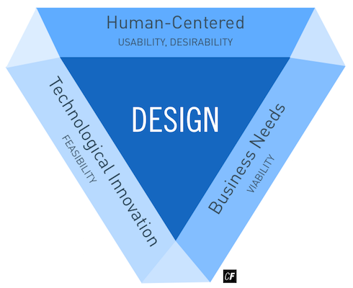

Design Thinking is unique as it’s not problem-focused but solution-focused. When you focus solely on the problem, it’s easy for the problem to become an insurmountable task in your mind. Design Thinking, on the other hand, is all about dreaming big and imagining what could be, then transforming these dreams into technologically feasible solutions.

To see Design Thinking in practice, check out [IDEO](https://www.ideo.com/), a highly influential multi-disciplinary design firm that uses the Design Thinking methodology to foster innovative solutions to complex business and social problems on a global scale. For them, Design Thinking is a core methodology for creating solutions for their customers. Everything they design revolves around finding solutions to the needs and problems of the people who actually use their product. This focus has earned them high regard in the design consultancy business as well as contracts with huge brands like Apple, Coca-Cola, and Ford among others.

Tim Brown is the current CEO and president of IDEO. He became a prominent figure in the world of Design Thinking with his 2009 book [*Change by Design: How Design Thinking Transforms Organizations and Inspires Innovation*](https://www.harpercollins.com/9780061766084/change-by-design). It posits that Design Thinking can help transform problems into opportunities. IDEO is a great example of what can be accomplished when the focus is shifted to solutions rather than problems. Head over to the resources section at the end of this Exercise to learn more about IDEO and their client case studies.

#### **A Brief History of Design Thinking**

Now that you’ve gotten a refresher on what Design Thinking is, it’s important that we take a look at how Design Thinking started before evolving into what it is today.

Design Thinking first began to take shape in the 1960s when the use of computer programs shifted towards high-level problem solving (e.g., how to improve package delivery, how to improve health services access, etc.). This was called the “soft-systems approach.” In 1969, Herbert A. Simon, a researcher in artificial intelligence, established the “science of design,” which was a doctrine that solidified design as a science by systemizing design methodologies for a variety of design disciplines such as computer science, architecture, urban planning, and more. Simon’s idea behind the science of design also cultivated the development of design research and the scientific inquiry of design. From that point on, the concept of design became more than a craft-based skill.

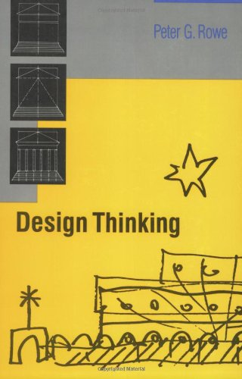

###### **Book cover for Design Thinking**

With the evolution of “first generation” design processes from the previous decade, the Design Thinking Process solidified even further in the 1970s. Then, in the late 1980s, Peter Rowe published his book, [*Design Thinking*](https://mitpress.mit.edu/books/design-thinking), which described methods and approaches used by architects and urban planners. The book was one of the earliest and most significant mentions of the term “Design Thinking.” Shortly after, in 1991, the design firm IDEO was born with a focus on showcasing their design process, which was heavily inspired by the Stanford Design School (d.School) curriculum. Stanford's curriculum focuses on the importance of the user and how to best uncover potential solutions to users’ problems. It offers a specific process that can be used to determine what it is you should be building.

Throughout the 21st century, design slowly but surely morphed into the important field of research and practice it is today. It developed its own key terms—HCI, UCD, and HCD—and boasted a focus on the end user, promising better solutions for clients and users via its ideology and frameworks. For a more detailed account of the history of Design Thinking, see the resources section at the end of this Exercise. For now, however, let’s revisit an image you’ll probably recognize from the Fundamentals Course.

#### **Applying the Design Thinking Process to Your Project**

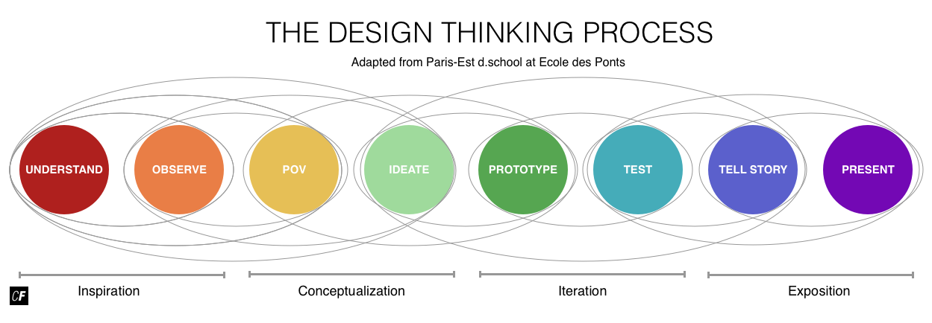

###### **Adapted from**[**Paris-Est d.school at Ecole des Ponts**](http://www.dschool.fr/en/design-thinking/)

Is the above image familiar? In Fundamentals, we went through each stage of the Design Thinking Process as we worked through your very first project (remember your vocabulary app?). We’ll be doing the same thing for your course project in Immersion! To ensure we’re all on the same page before moving forward, let’s briefly outline each stage of the Design Thinking Process once more:

* **Understand:** In order to solve a problem, you need to understand a problem. This first stage in the Design Thinking Process is all about taking the initial steps towards understanding the problem at hand. You’ll create problem statements (like we’ll be doing using the Double Diamond Strategy in the next Exercise!) and perform competitor analyses to ensure you understand not only what you’ll create but the landscape you’ll be creating it in, as well.
* **Observe:** In this second stage of the Design Thinking Process, you’ll be performing user research in order to observe your potential users and determine their needs and goals. User interviews and surveys fall under this stage.
* **POV:** In this stage, your goal is to step into the shoes of your users and “see” your product from their point of view. This is the reason why we create design personas! The closer we can get to our users, the greater our chance of fulfilling their needs efficiently.
* **Ideate:** Now that you’ve collected all these observations, it’s time to make ideas out of them. This is the part of the creative process that allows you to explore a wide variety and large quantity of diverse possible solutions. The purpose of ideation is to move beyond the obvious in order to explore a full range of ideas. User flows/journeys and card sorts fall under this category.
* **Prototype:** This is the experimental stage of the process. Transform your ideas into a physical format so that they can be experienced and interacted with by others. Build wireframe after wireframe, then turn them into interactive prototypes (after receiving feedback, of course). Throughout this process, additional insights and empathy-building will occur.
* **Test:** In this stage, you’ll be testing your prototypes with real users, collecting feedback, then improving and iterating on your designs again and again. Validating your designs in the early stages is a great way to solve problems before they reach a product development team. Use observations and feedback from people to create new hypotheses before starting the process over.
* **Tell Story:** As designers, we oftentimes must justify our design solutions to colleagues, managers, and stakeholders. This step is all about explaining and defending design decisions via effective storytelling while still being open to critique and feedback.
* **Present:** This comes after you've prepared all of your research, design solutions, and prototypes and are confident that your design is ready to be handed off to developers. Your goal at this point is to communicate what developers should code based on your blueprints.

There are additional steps that happen outside of the Design Thinking Process. These may or may not be relevant to you depending on the circumstances of your project, the type of company you work in, or the employment status you have.

* **Pilot:** In this late stage, you’ll work with other teams to correctly implement and pilot your designs. This is where your design comes to life! This is especially relevant in a highly collaborative working environment.
* **Business Model:** This step could either come before or after the product is built. At this stage, your product is complete; however, you need a business model to manage it. How will you monetize your product? What teams do you need to operate your product? How will you respond to customer feedback and problems? Design a business model that will enable your team(s) to successfully manage your new product. Oftentimes, it makes sense for the business model to come first, but consider the following situation: Imagine that one of the apps you design for this course is popular among your testers; you receive positive feedback and realize there's a demand for your creation. You'd like to turn this idea into a fully functional app sold on the App Store. In this scenario, you'll have completed the UX design first and will need to come up with the budget, hire a team, and everything else related to this new business as the last step.

You may have noticed that User-Centered Design (UCD) from the previous Exercise and Design Thinking share some striking similarities. This is because they're both methodologies for UX designers, so they follow similar paths. There are, however, some important distinctions to note.

Design Thinking explores a problem space—in the context of understanding users, technological feasibility, and business requirements—to discover possible solutions. UCD, on the other hand, is focused on how to make the solution itself useful and usable by taking into account the user’s capabilities and limitations. Therefore, UCD is likely to be most useful when you've already identified a solution or are working on making improvements to an existing solution. Design Thinking, with its focus on ideation, is better suited to understanding and defining a problem space in order to discover innovative solutions.

As with all design practices and methodologies, however, it might be the case that you combine certain aspects of both UCD and Design Thinking for the projects you work on. It really depends on the nature of each project and the team or organization you’re working in.

In the Task for this Exercise, you'll be asked to apply the Design Thinking Process to your course project. Before you do that, watch the video below for a look at how you can do just that!

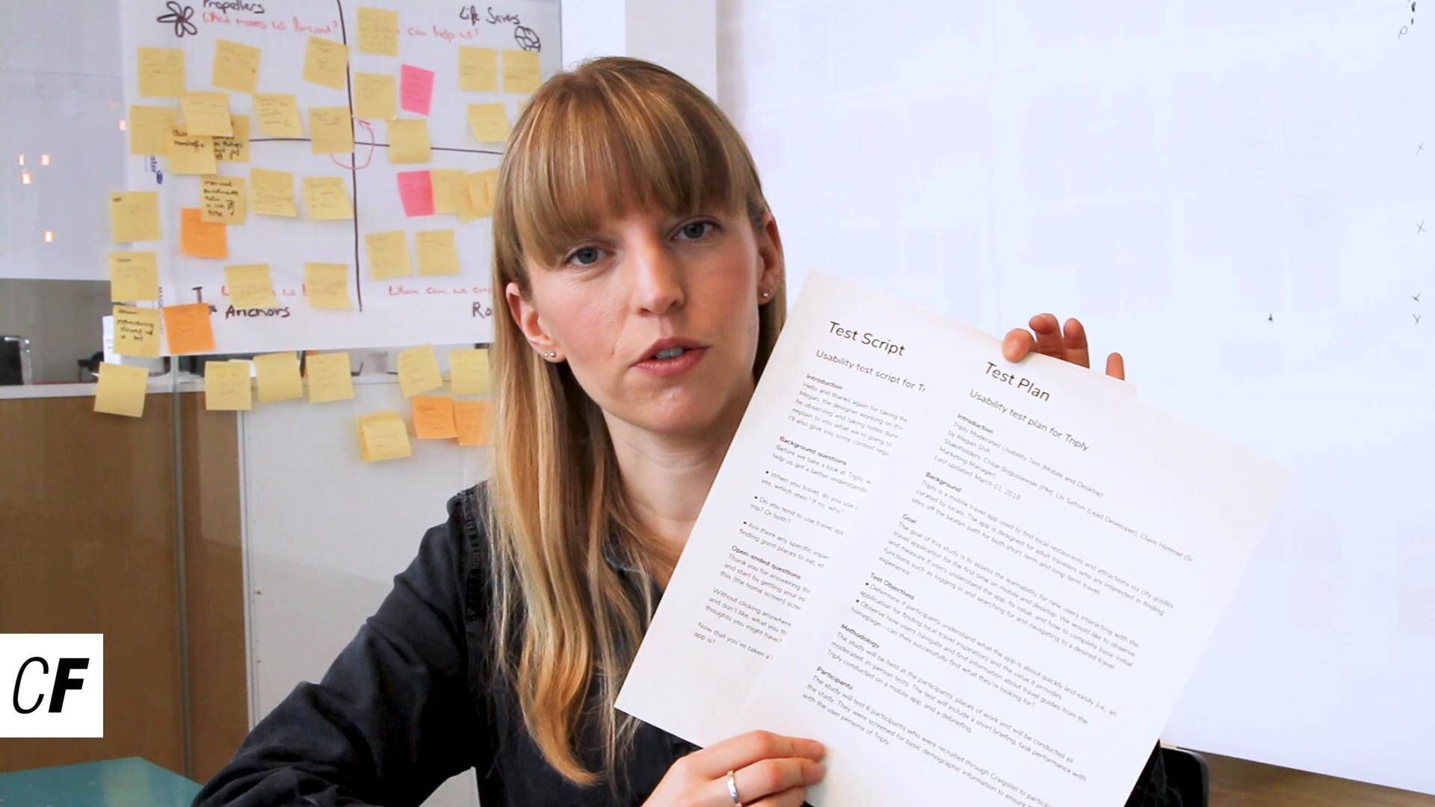

#### **Summary**

In this Exercise, we refreshed ourselves on the Design Thinking Process and its importance in organizing and planning the stages of your design. We then took a more in-depth look at its origins with IDEO and the Stanford Design School before diving into how you can apply the Design Thinking Process to your own projects in order to create more user-friendly solutions.

You already got some experience applying the Design Thinking Process to your project in Fundamentals. We’re going to do the same thing now with an even bigger project—your course project. By the end, you should be familiar enough with the process that you’ll be able to apply it to your many projects in the future. Ready to start incorporating the Design Thinking Process into your designs?

#### **Resources**

* [The Field Guide to Human-Centered Design](http://www.designkit.org/resources/1)
* [The History of Design Thinking](https://ithinkidesign.wordpress.com/2012/06/08/a-brief-history-of-design-thinking-how-design-thinking-came-to-be/)
* [Tim Brown - Designers Think Big](https://www.ted.com/talks/tim_brown_urges_designers_to_think_big)
* [Learn More About Tim Brown](https://www.ideo.com/people/tim-brown)
* [IDEO Case Studies](https://www.ideo.com/work)